V.Shiltsev (12/03/2002): First look into the SBD operation and bunch length growth analysis

It was of a concern what does the Single Bunch Display (SBD) system report and why most of the proton bunch length data do have “S-shape kink” way into almost each store. Below is a 5 store plot of T:SBDMS (green line, protons) – one can see increase of the bunch length growth rate above some 1.94 ns. [Blue - rms antiproton bunch length.]

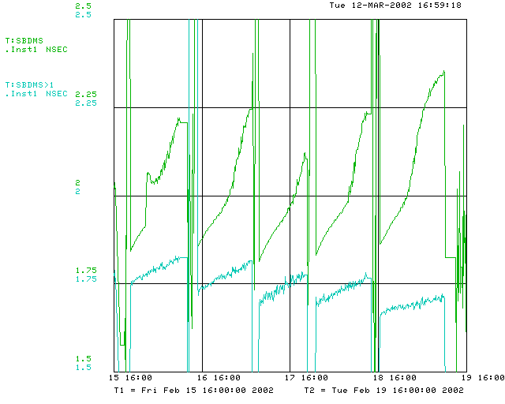

Several dozens SBD scope traces were saved in ASCII files every ½ hour during stores 1002 and 1028 (February, 2002). A typical one is show below.
36 proton bunches are seen (plot starts with P33). The scope sampling rate is 2GHz.

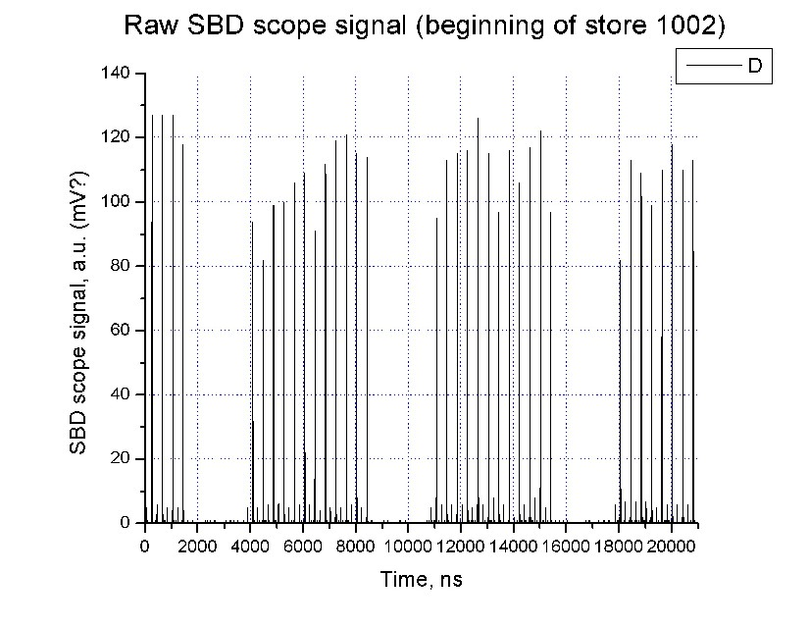
Next Figure shows traces of the same bunch P34 at the beginning and at the end of the store. The rms pulse width has changed from 2.11 ns to 2.5ns (rms of the fit error some 0.03 ns). Bunch-to-bunch length variation is of the order of 0.08 ns rms (average length 2.21 ns at the beginning), intensity variation was some 8% rms (some N_b=147e9/bunch average).

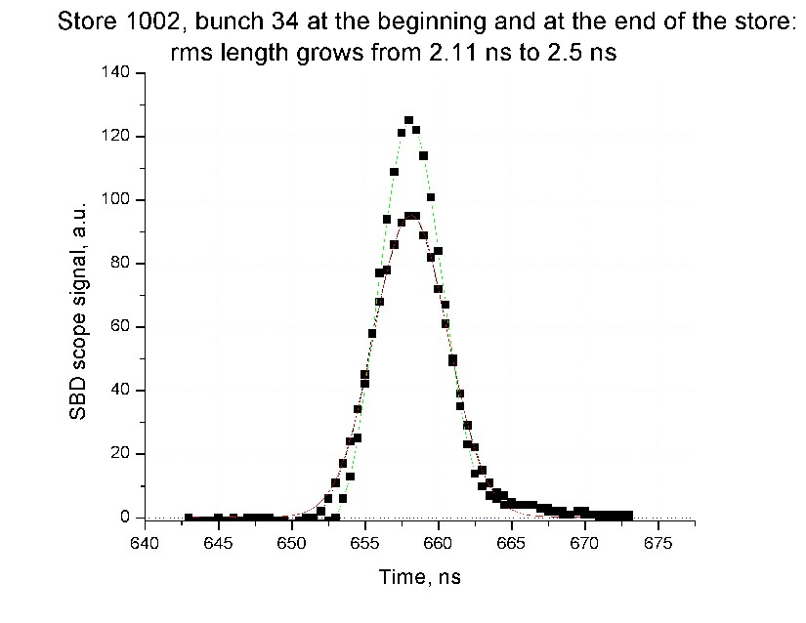
Due to beam loading, the bunches are slightly unequally spaced. Figure below shows RF phase slippage vs bunch position. Straight lines represent transient beam loading model with d(Phase)=dU/U_RF= eN_b x (R/Q) x Ω_RF , where R/Q=(104 Ohm per cavity) x 8 cavities.
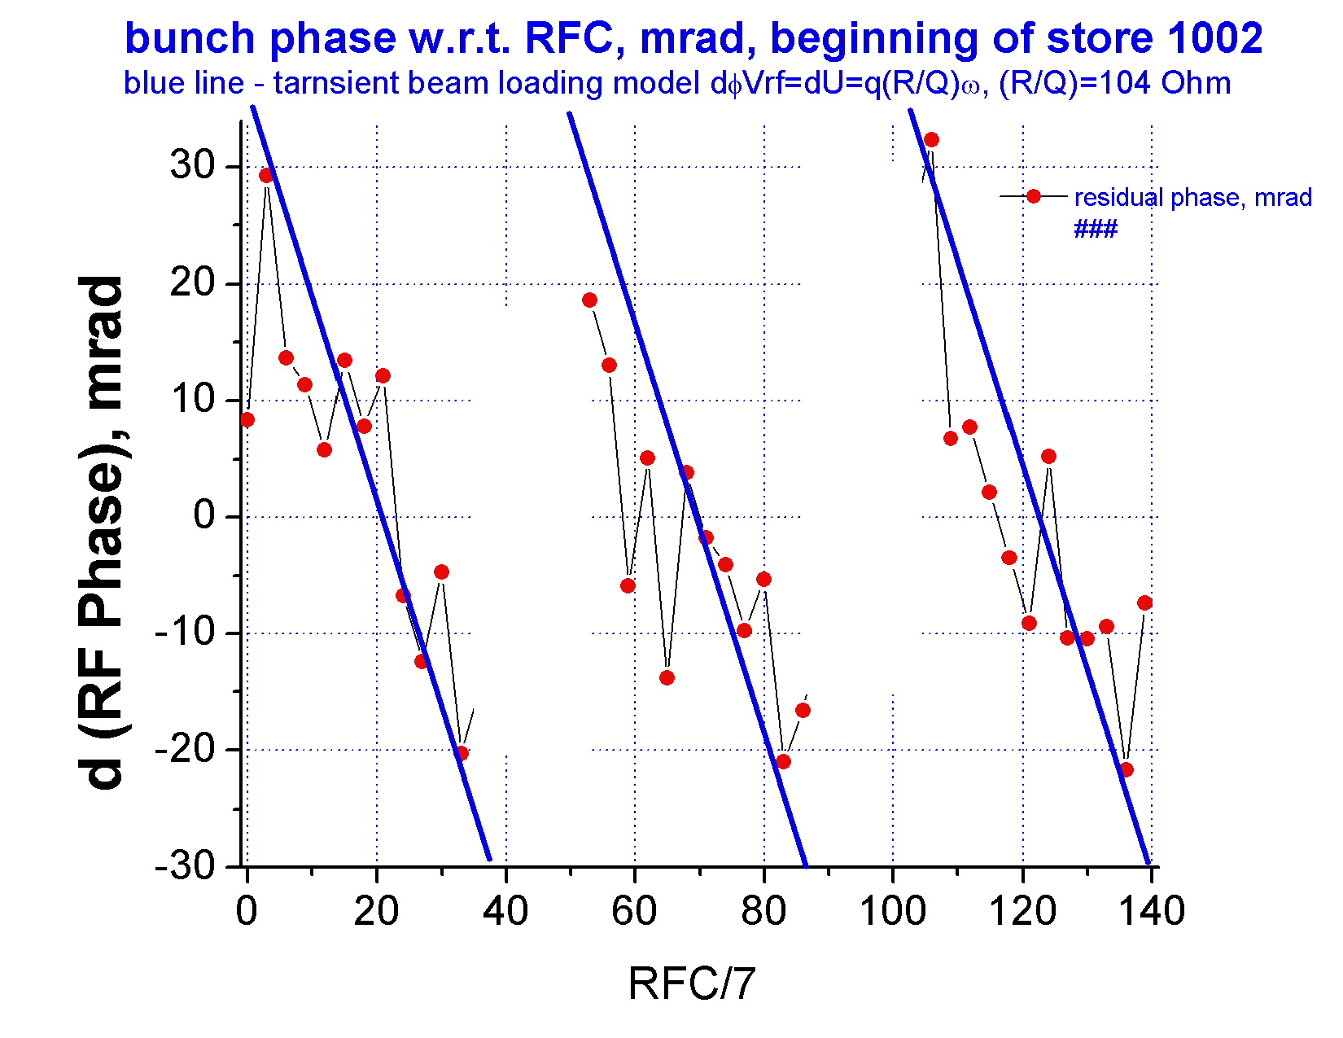
Figure below presents development of the average bunch length reported by the SBD and the average of the manual Gaussian fit of bunches P33-36 in 17 scope traces. Obviously, there is no “S-shape” behavior in the manual fit data. The SBD bunch length growth rate is about 0.02 ns/hr at the beginning of the store and some 0.038 ns/hr in the Gaussian fit data. Discrepancy between the SBD and the fit values will be discussed below.

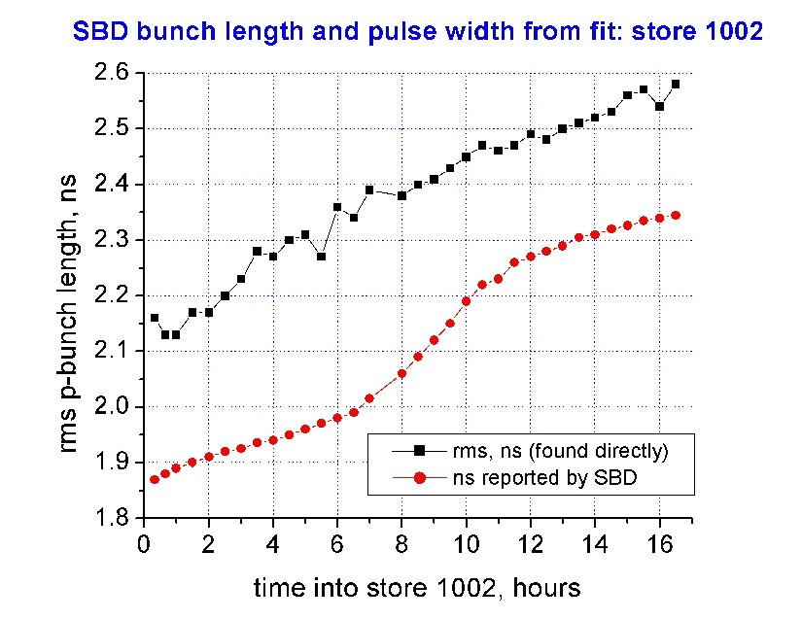

There are indications that the “S-shape” inm the SBD data is due to the SBD scope problems. For example, two Figures below show typical bunch traces with obvious
Spikes at around bit 96 (64+32) at the beginning of the store (left) and at around bit 32
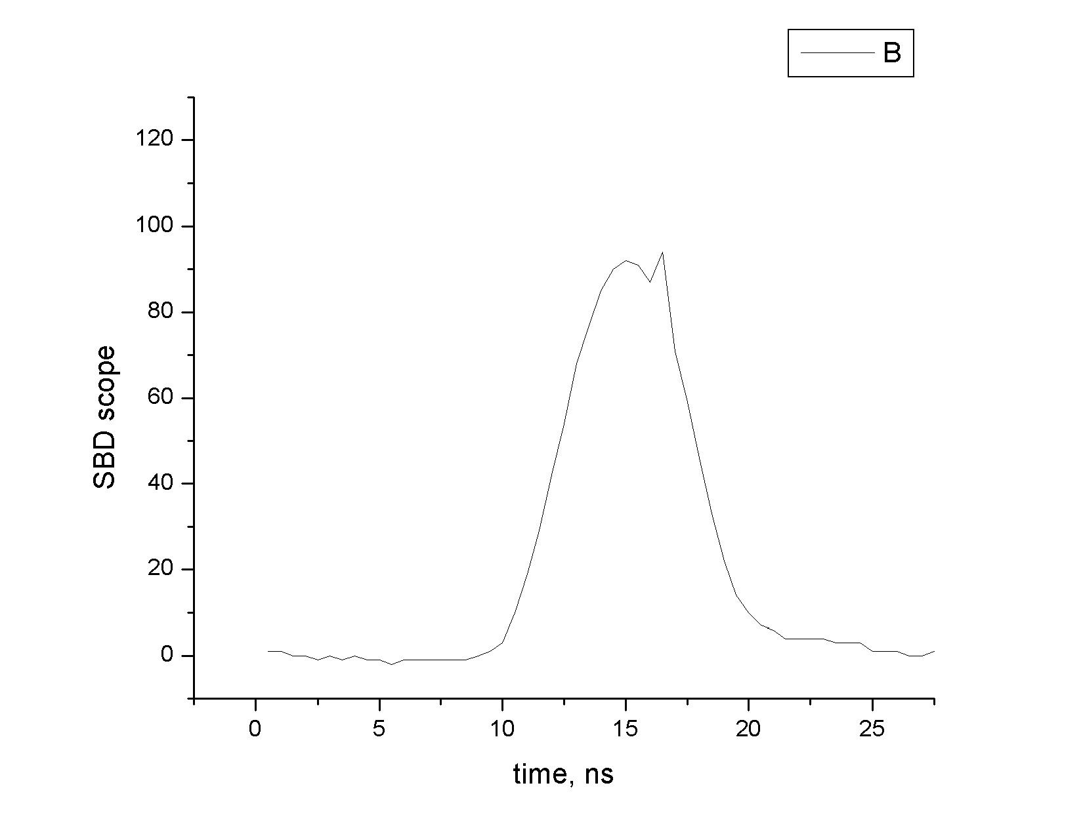
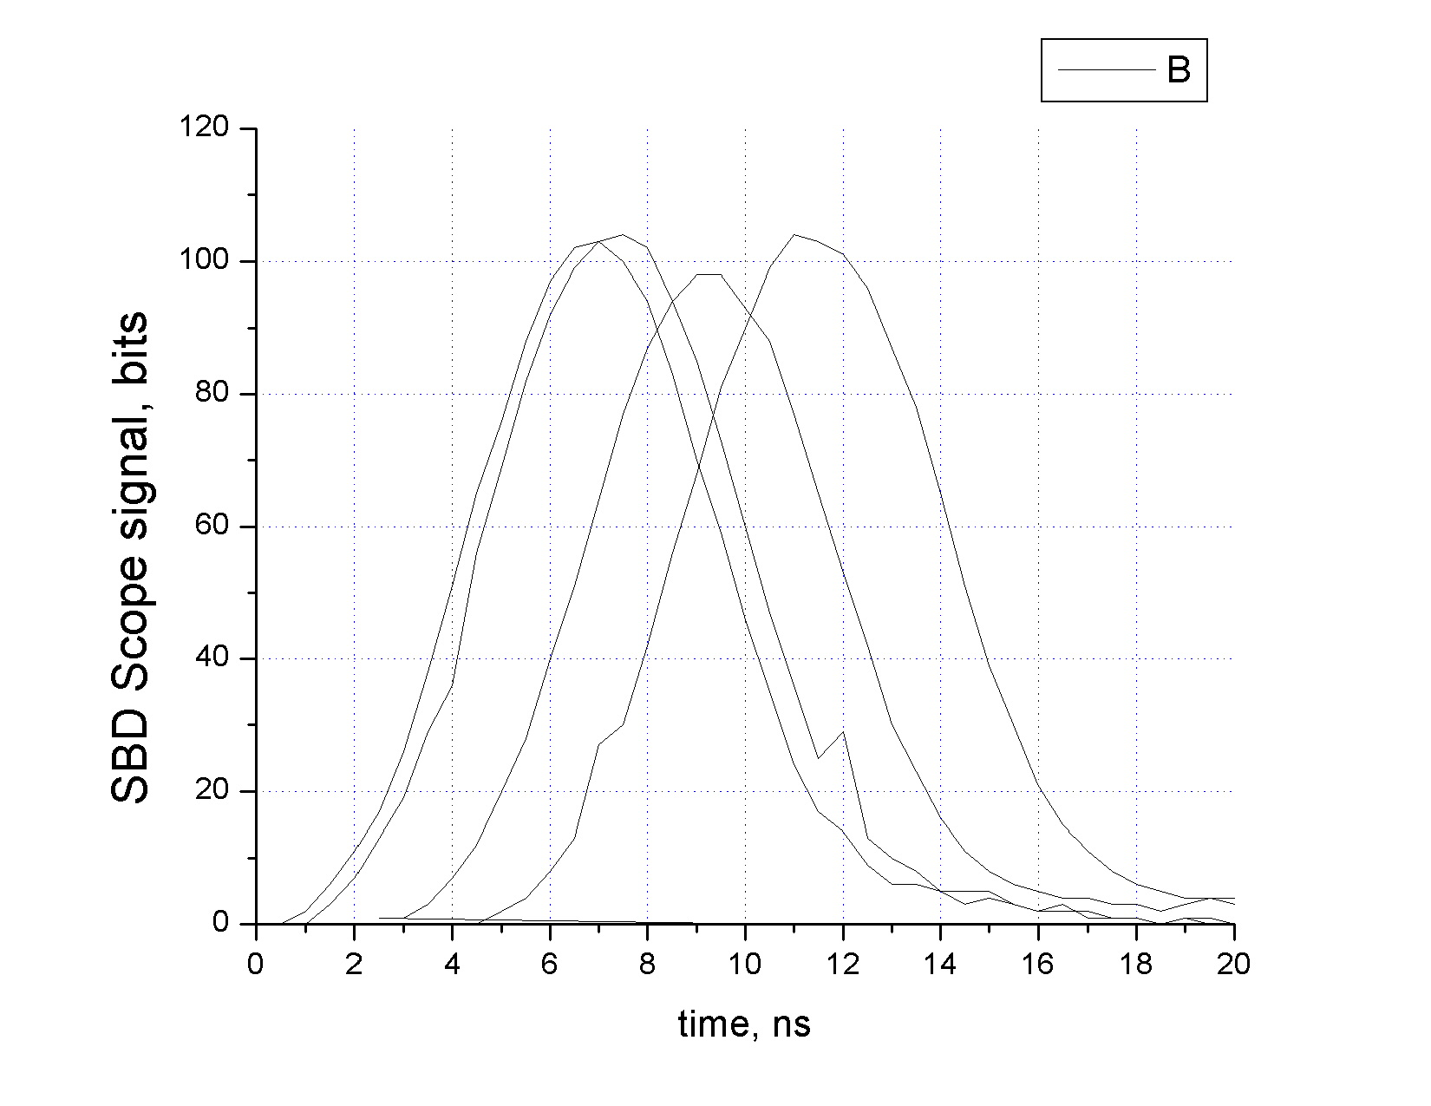
at the end of the store (right plot). In both case the resulted rms length is larger than it should be without the spikes.

Very similar spikes occurred during store 1028. There were 3 different trains in the Tevatron at that time – one train of 12 bunches with 167e9/bunch, one with 100e9, and one with about 30e9/bunch. Figure below shows “bit-8” error spikes in the SBD scope trace of four low intensity bunches (long 400 ns intervals are taken out, so the bunches appear close to each other). Interesting to note that signal of the same 4 bunches in the pbar channel of the SBD (which has additional 5-fold amplifier – see red curve) has no spikes. For these particular traces there is not much difference in therms width of read and black curves (some 0.03 ns while the fit error is 0.05 ns) but there is no guarantee that the spikes are aalways insignificant for the bunch length measurements.
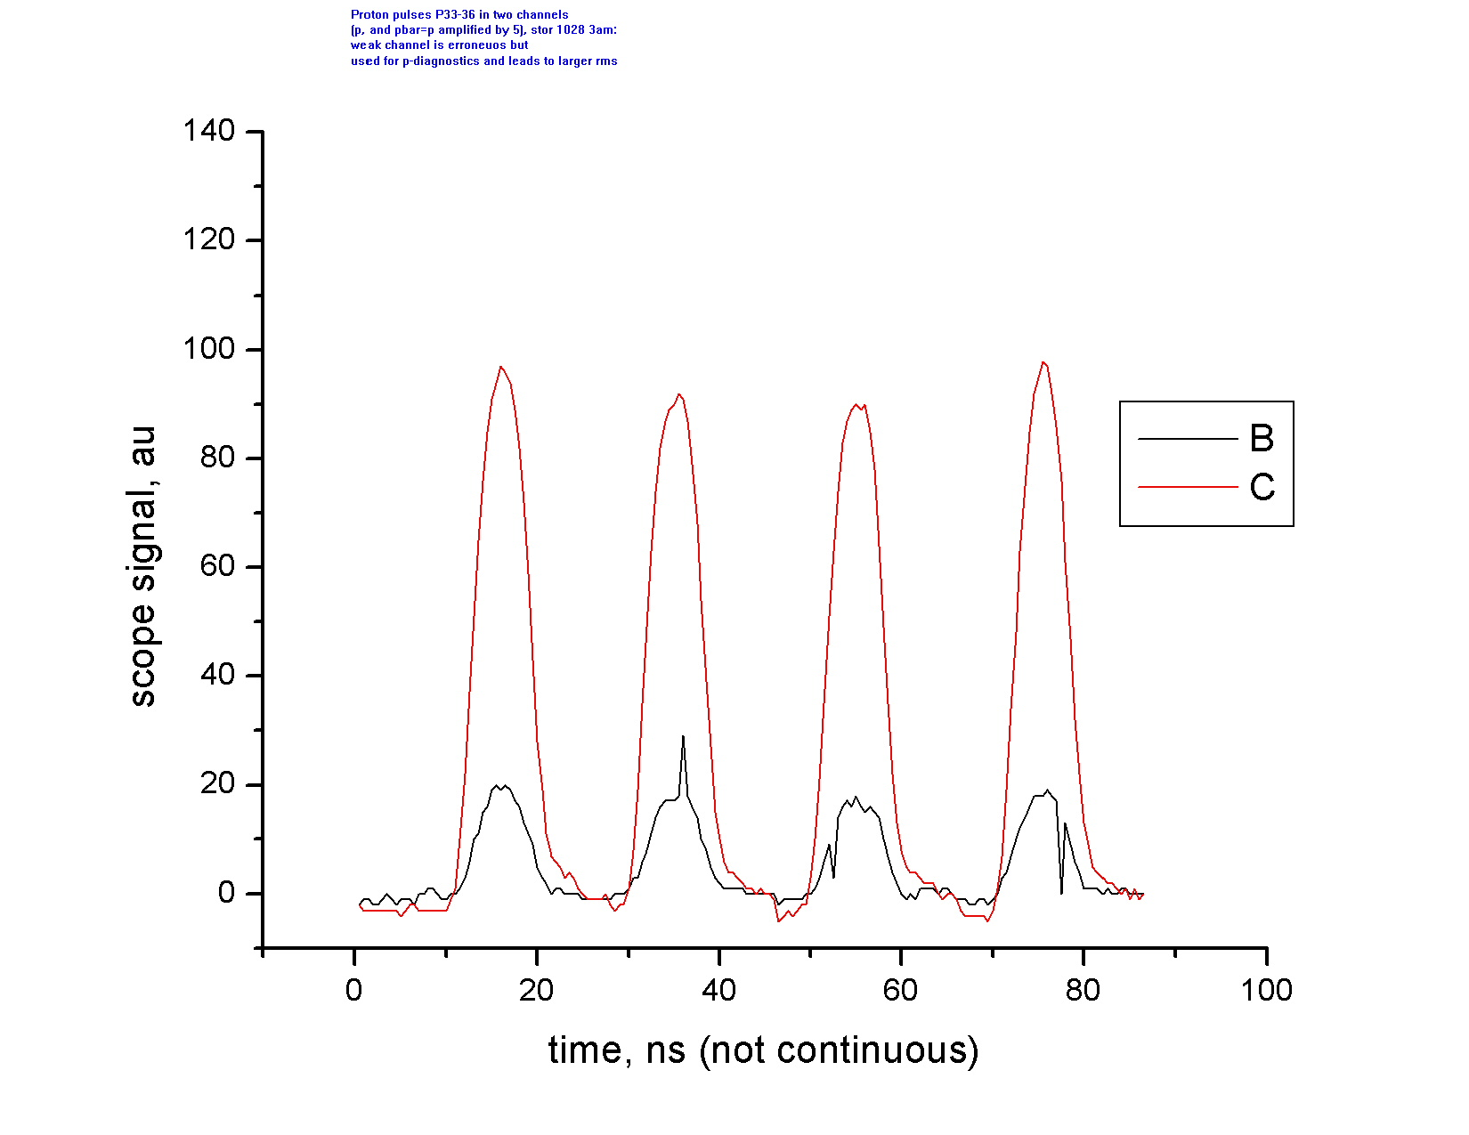

It was found that while rms pulse width is somewhat larger for low intensity bunches, the bunch lengthening rate is about the same 0.013 ns/hour for bunches with very different intensities – see Figure below. For each intensity, the presented bunch length is average of four bunches at the end of the train (e.g. P33-36 for lowest intensity and P9-P12 for the highest intensity trains). It was not clear why random(?) variation in the low intensity bunch length plot (green line) was some factor of two larger then for higher intensity bunches.
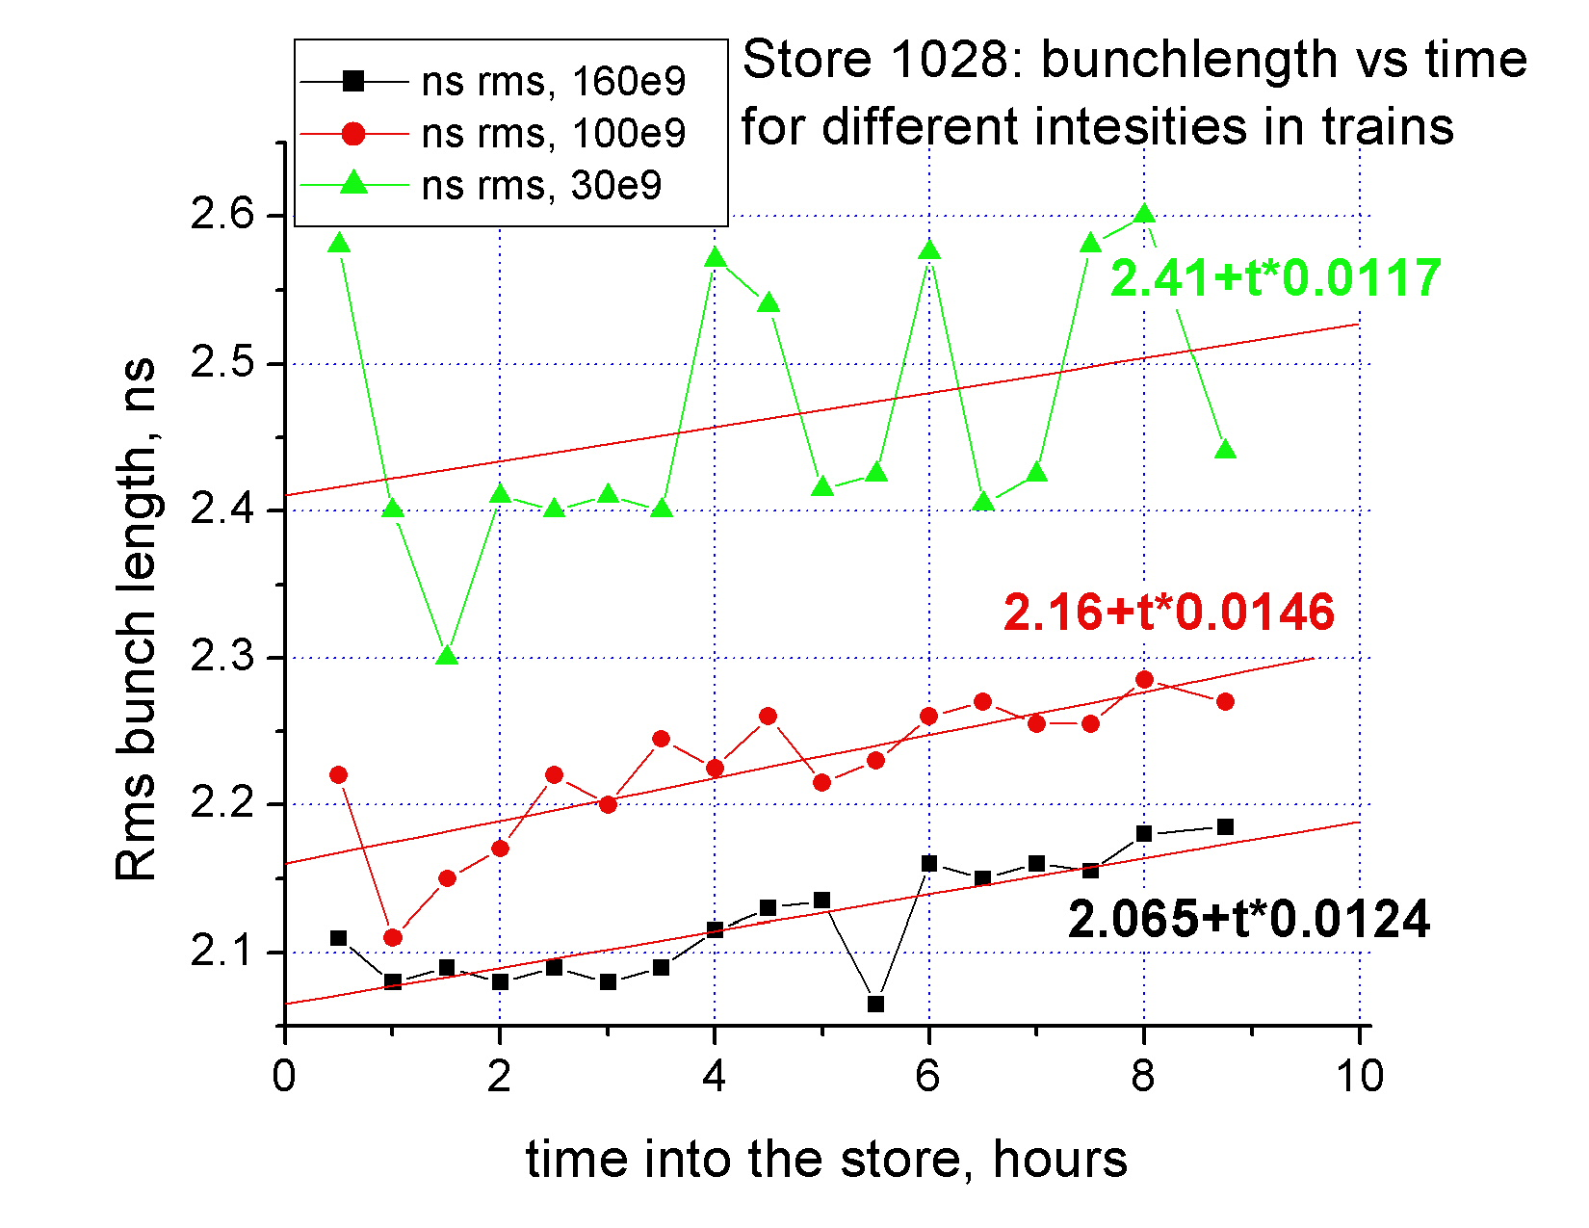

The sigma reported by the SBD is corrected for the bandwidth of the scope by subtracting the contribution of the scope’s bandwidth to the sigma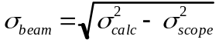. The scope variance is derived from 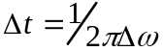 with assumption of 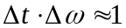. When the scope is set to 200MHz, the 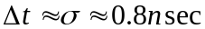. Seems that this correction includes dipersion in the cables as well. Two Figures below show the rms bunch length from the SBD (left plot) taken from the Tev DataLogger and the Guassian fit data with 1ns in quadrature correction. One can see a decent agreement between the data.

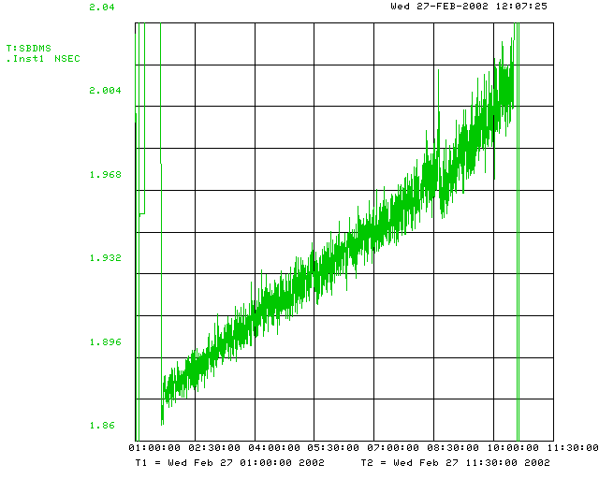
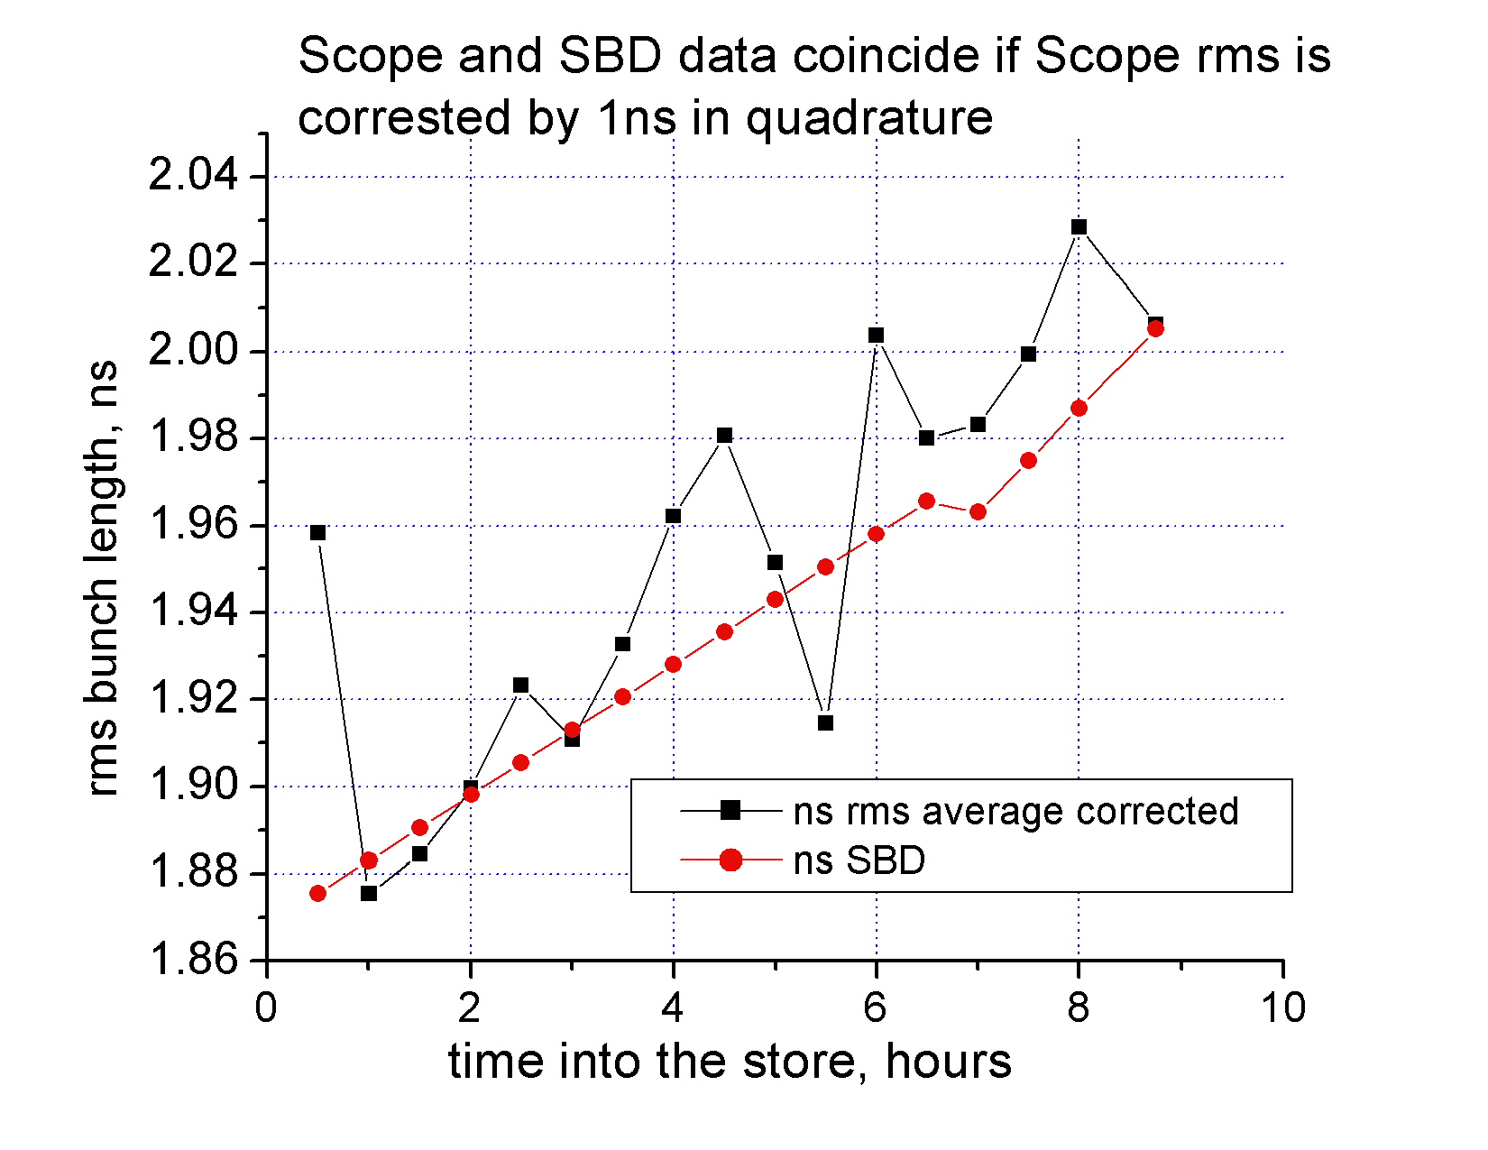

For the Tevatron at 980 GeV with 1.1 MV RF, the longitudinal emittance can be estimated as ε_{L}=1.21[eVsec]σ²[ns]. (“Emittance” is so-called 100% emittance of a beam with parabolic distribution, while “sigma” is the rms bunch length, similar to what we found by fitting the SBD scope traces. At 150 GeV, the coefficient in the formula is 0.47 eVsec). Bucket size is about 11 eVsec, so sigma can not be more than 3ns. Longitudinal emittance of the high intensity bunches calculated from the Gaussian fit is presented in the Figure below.
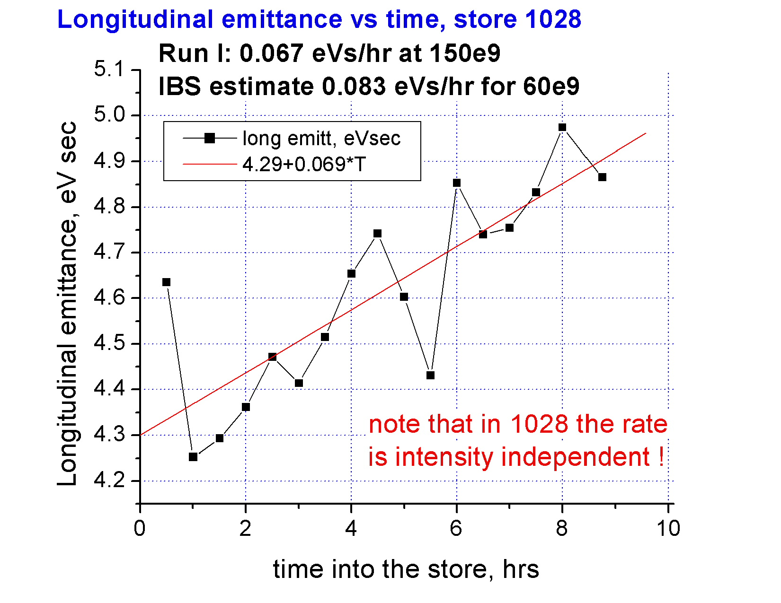
For comparison, under current conditions (Feb.2002) the beam emittance at 150 GeV is some 4.3 eVs (beam fills the RF bucket completely). The emittance growth rate is about 0.069 eVs/hour that is very close top the Run I results. At the same time, Run I longitudinal beam size growth agreed well with the intrabeam scattering (IBS) predictions, while now it is intensity independent and, most probably, is dominated by the the RF noise (there will be a separate Tev note on that subject). In that case, one has to explain why the antiproton bunch lengthening is factor of 3 slower than for protons – see the very first Figure above.

Conclusions:

- the “S-shape” in the bunch lengthening reported by the SBD does not seem to be real
- possible reasons for that might be a) scope bit errors; b) flaws in the data processing
- store 1028 results show that the rms bunch length growth does not depend on the bunch intensity
- such “intensity independence” supports the RF noise hypothesis

