
Fermilab/BD/TEV
Beams-doc-437
February 7, 2003

Measurement of the tunes and coupling as a function of helix size at 150 Gev and adjustment of feeddowns.

M. Martens, J. Annala
Fermilab, Beams Division

The tunes and coupling at 150 Gev were measured as a function of helix size and the feeddown circuits were used to correct the differential tune and coupling. The adjustment of the feeddowns, done on 12/18/02, was motivated by previous reports of difficulty decoupling both the proton and pbar helices. This tune up of the Tevatron feeddowns differed from previous attempts in two important ways: 1) we measured the tunes and coupling at five different helix strengths instead of just the usual proton helix, no helix, and pbar helix and 2) we paid careful attention to the tune and coupling measurement process. With this additional attention we succeeded in decoupling both the proton and pbar helices to a minimum tune split of less than 0.002 and set the differential tune on the proton and pbar helix to less than 0.0005. During this study we observed that the tunes are a non-linear function of helix size at 150 Gev and therefore the tunes on the central orbit differed from the proton and pbar helix by 0.0015 units.

When adjusting the feeddowns we typically measure the tune and coupling on the proton helix, central orbit (no helix), and pbar helix. For this study we gathered additional measurements on the proton helix and pbar helix but with the separator strengths at 50% of their nominal value. Thus we had measurements at five values of the separator strengths -- 100% proton, 50% proton, no helix, 50% pbar, and the 100% pbar helix. At this time the Tevatron was operating with the so-called “new-new” helix. The 100% helix for the “new-new” helix is defined as 36.994 kV on C:B0SHx, 64.357 kV on C:B1SHx, 22.62 kV on C:B0SVx, and 58.848 kV on C:C1SVx.

The tunes and coupling were measured with uncoalesced proton beam. During the coupling measurement, the tunes were split far enough apart to clearly identify the horizontal and vertical tune. The tunes were then slowly brought together and the tune lines were manually “tracked” as the tunes were pushed closer together. This method gave an accurate measurement of the minimum tune split by eliminating the confusion of choosing a tune line from amongst the many synchrotron sidebands. We feel that this attention to detail was important for the successful tune up of the feeddowns.

Measurement of differential coupling

With the Tevatron in its “as found” state on 12/18/02, we measured the minimum tune split as a function of helix size and the results are shown in Figure 1. The minimum tune split is a measure of the magnitude of the coupling, but it leaves an ambiguity in the sign of the coupling. So in Figure 1 we also show the minimum tune split with the sign included where we have surmised that the coupling changes sign on the pbar helix. With a differential minimum tune split of 0.011 the Tevatron had a large amount of differential coupling between the proton and pbar helix when the study began.

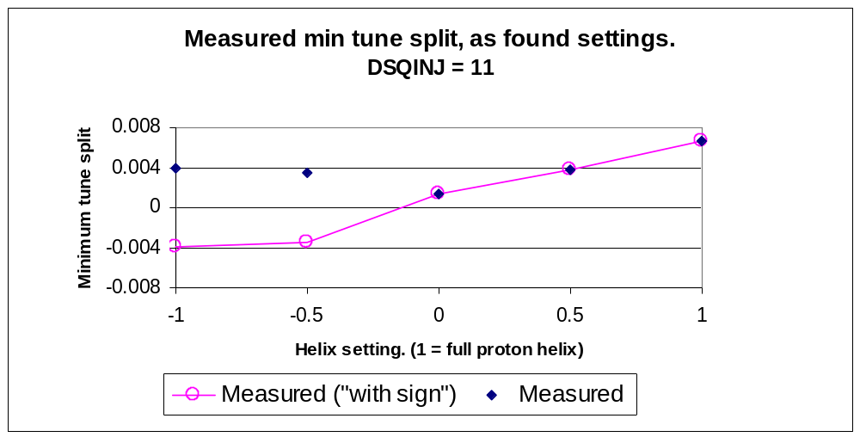
Figure 1 Measured minimum tune split as a function of helix size. In addition to the usual proton helix, no helix, and pbar helix, the coupling was also measured on the 50% proton helix and the 50% pbar helix.

In the addition to the minimum tune split, we also measured the amount of current in T:SQ and T:SQA0 needed to decouple the Tevatron at all five helix strengths. These are shown in Figure 2 and Figure 3. Both T:SQ and T:SQA0 were needed to decouple the tunes. From a calculation using the design lattice at 150 Gev we expect that the T:SQ (T:SQA0) circuit adds a minimum tune split of 0.1 (0.008) per amp in the circuit. Thus the measured minimum tune split is consistent with corrections needed in T:SQ and T:SQA0.

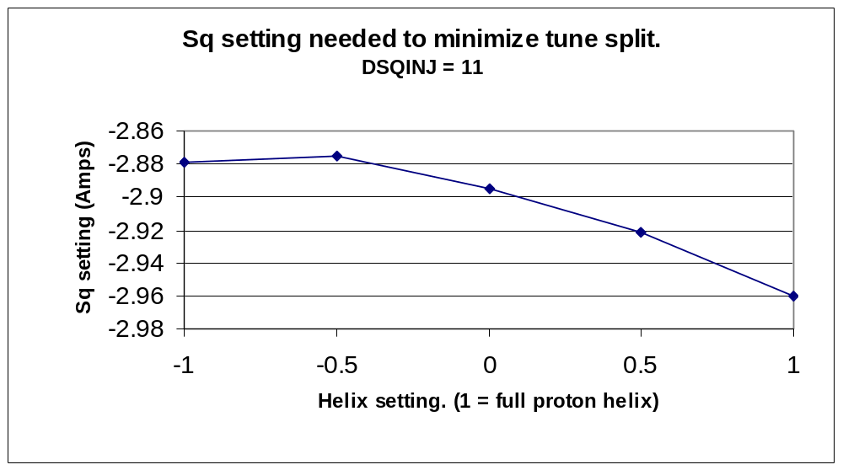
Figure 2 Setting of T:SQ (in amps) needed to minimize the tune split as a function of helix size. In each case the T:SQA0 circuit was adjusted along with T:SQ. These measurements were made with the Tevatron in its “as found” condition on 12/18/02.

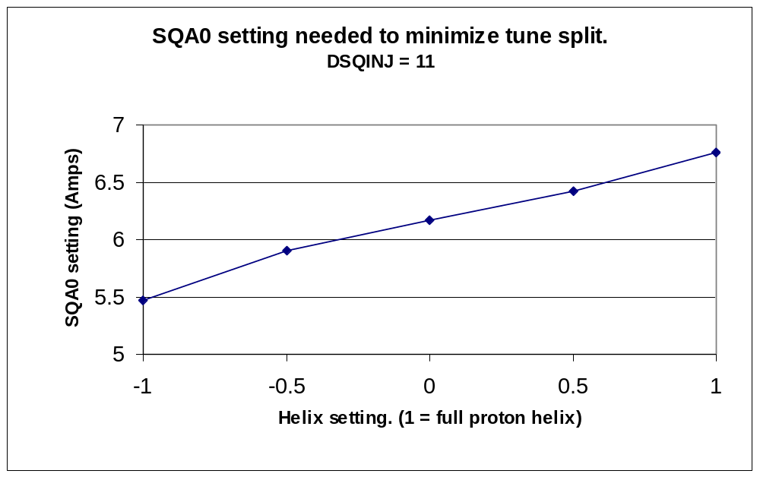
Figure 3 Setting of T:SQA0 (in amps) needed to minimize the tune split as a function of helix size. In each case the T:SQ circuit was adjusted along with T:SQA0. These measurements were made with the Tevatron in its “as found” condition on 12/18/02.

Adjustment of differential coupling

After making the measurements of the differential coupling we adjusted the feeddown settings to correct for the differential coupling. The adjustments were made in two steps. First we changed from (dSQ0Inj, dSq) = (11, 0.0) to (15, 0.0) then changed from (dSQ0Inj, dSq) = (15, 0.0) to (15, -0.05) where the settings are quoted in C49 units. (With 15 units of dSQ0Inj there is 22.1 amps in the S6 feeddown circuits, and with –0.05 units of dSqInj there is –0.389 amps in the S3 feeddown circuits.)

After each change to the differential coupling circuits we repeated the decoupling of the Tevatron at the five different helix strengths. The currents needed in T:SQ and T:SQA0 to decouple the different helices are plotted in Figure 4 and Figure 5. After the second iteration the tunes were decoupled for all helix strengths to less than 0.002 units and the only change required was a –0.04 amp change to the T:SQ circuit on the proton helix. Thus we were able to effectively decouple the Tevatron on both the proton and pbar helix by using the feeddown coupling circuits. (See later sections of this note for final conclusions.)

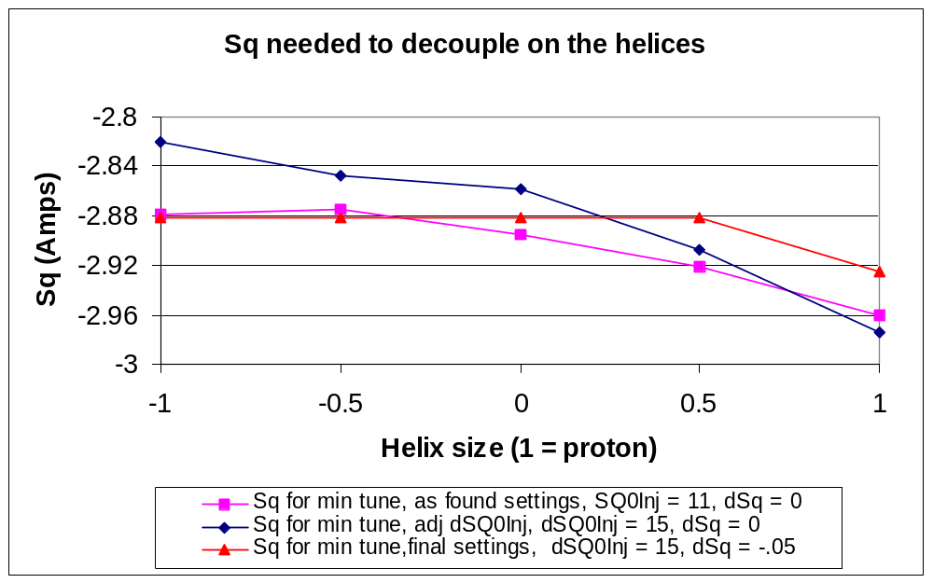
Figure 4 Settings needed in T:SQ to decouple the Tevatron at 150 Gev for five different helix settings and for three different settings of the feeddown coupling circuits. Both T:SQ and T:SQA0 circuits were changed for each helix setting.

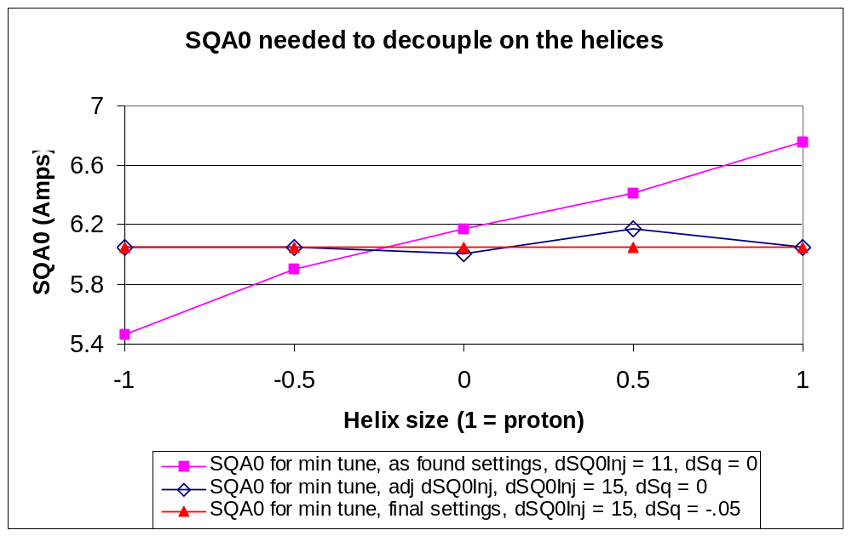
Figure 5 Settings needed in T:SQA0 to decouple the Tevatron at 150 Gev for five different helix settings and for three different settings of the feeddown coupling circuits. Both T:SQ and T:SQA0 circuits were changed for each helix setting. Note that it was unnecessary to change the setting of the T:SQA0 circuit after the feeddowns were adjusted to their final values of dSQ0Inj = 15 and dSqInj = -0.05.

These measurements also provide a rough calibration of the feeddown coupling circuits. Table 1 shows results from the coupling measurements for the three settings of dSqInj and dSQ0Inj. Using the data in Figure 4 and Figure 5 we calculate the slope of the correction needed in T:SQ and T:SQA0 in units of amps/helix size. For instance, we find that T:SQA0 must change by 1.25 amps when going from the pbar helix to the proton helix. This gives a slope of 1.25 amps/(2 units of helix strength) = 0.62 amps/helix strength. Thus adding 4 units of dSqInj is equivalent to adding –0.62 amps/helix to T:SQA0 and +0.031 amps/helix to T:SQ. And adding –0.05 units to dSqInj is equivalent to adding +0.024 amps/helix to T:SQ and adding nothing to T:SQA0. The conversion between C49 settings of dSqInj and dSQ0Inj to amps in the feeddown circuits is given in Table 2.

 | dSQ0Inj  setting  C49 units | dSqInj  setting  C49 units | Slope of T:SQ  Amps/helix strength | Slope of T:SQA0  Amps/helix strength
Initial | 11 | 0 | -0.073 | 0.62
1st iteration | 15 | 0 | -0.042 | 0.00
2nd iteration | 15 | -0.05 | -0.018 | 0.02
Table 1 Slope correction needed in T:SQ and T:SQA0 for different settings of dSqInj and dSQ0Inj. The slope is a linear fit to the five measured values of the coupling circuit as a function of helix strength. See text for explanation.

C49 Calculational constants for the feeddown circuits

E is the energy in TeV.
Current in the circuits is in Amps.

S1i/(E^1.5)= -3653 * dQxInj + -1368 * dQyInj + 0 * dSQInj + -3.04 * dSQ0Inj

S2/(E^1.5)= 1671 * dQxInj + 4642 * dQyInj + 0 * dSQInj + 1.42 * dSQ0Inj

S3/(E^1.5)= 0 * dQxInj + 0 * dQyInj + -260 * dSQInj + 0 * dSQ0Inj

S6/(E^1.5)= 0 * dQxInj + 0 * dQyInj + 0 * dSQInj + 25.4 * dSQ0Inj

S4/(E^1.5)= 9186 * dQxCol + 491.8 * dQyCol + 0 * dSQCol + 0 * dSQ0Col

S5/(E^1.5)= 1095 * dQxCol + 5060 * dQyCol + 0 * dSQCol + 0 * dSQ0Col

S1c/(E^1.5)= 0 * dQxCol + 0 * dQyCol + 625 * dSQCol + 0 * dSQ0Col

S7/(E^1.5)= 0 * dQxCol + 0 * dQyCol + 0 * dSQCol + 625 * dSQ0Col

S1 = S1i + S1c
Table 2 Coefficients relating settings of differential feeddown circuits in C49 units to the current in the feeddown circuit families S1, S2, S3, S4, S5, S5, S6, and S7.

Adjustment of differential tunes

After the differential coupling was corrected, the differential feeddown circuits, dQhInj and dQvInj, were used to correct differential tunes. During this process we found a non-linear dependence on the tune shift as a function of helix size. Although this has been noted before, the quadratic nature of the tune shift versus helix size becomes clearer when measurements are made at five different helix strengths rather than just the usual three (proton helix, no helix, and pbar helix.) The data are plotted in Figure 6 and .

These plots show the horizontal and vertical tunes as a function of helix strength for three different settings of dQhInj and dQvInj. Using the data from the first measurement the feeddown circuits were changed from (dQhInj, dQvInj) = (-0.024, 0.004) to (-0.027, 0.003) in an attempt to correct for the differential tune. However we found that the dQhInj and dQvInj circuits are not calibrated and the changes over corrected by roughly a factor of two. Therefore a second iteration of adjustment was done and the feeddown circuits were adjusted to (dQhInj, dQvInj) = (-0.0255 and 0.0035). With these final settings of dQhInj and the vertical (horizontal) tunes on the proton and pbar orbit are within 0.0005 (0.0005) of each other. Due to the quadratic nature of the tune shift versus helix size both the vertical and horizontal tune on the central orbit differ by 0.0015 from the proton and pbar helices.

These measurements also provide a rough calibration of the feeddown tune circuits. For instance, changing the dQhInj by –0.003 units changed the differential horizontal tune by –0.0045 units and changing dQvInj by –0.001 units changed the differential vertical tune by –0.0018 units. These calibrations are not precise since both the dQhInj and dQvInj circuits were changed at the same time. Therefore “cross talk” between them might be a source of confusion. The results are summarized in Table 3 where the slope of the tune versus helix size is listed as a function of the dQhInj and dQVinj circuits. The slopes in Table 3 are the linear coefficient from the fits in Figure 6 and Figure 7.

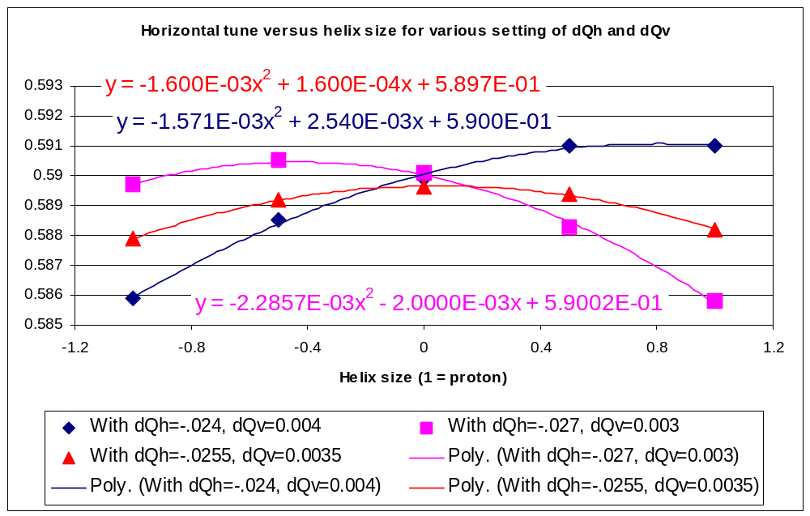
Figure 6 Measured horizontal tune as a function of helix strength for the three settings of dQhInj and dQvInj. These measurements were taken after the differential feeddown coupling circuits were adjusted.

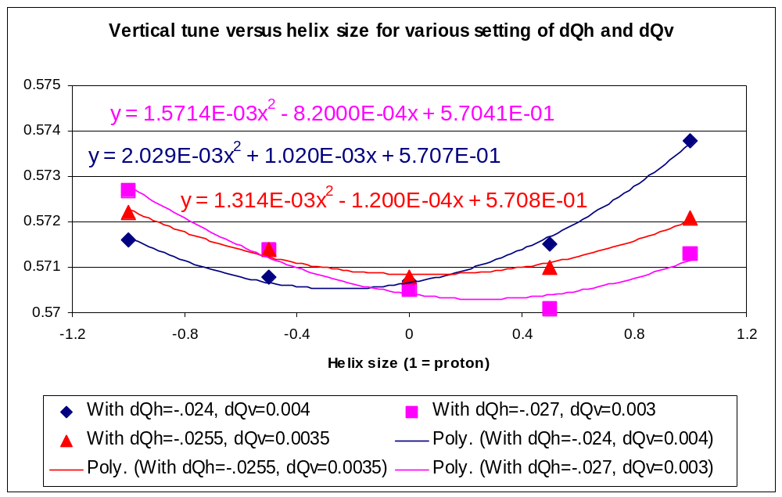
Figure 7 Measured vertical tune as a function of helix size for three settings of dQhInj and dQvInj. These measurements were taken after the differential coupling circuits were adjusted. Quadratic fits to the data are also shown.

 | dQhInj  setting  C49 units | dQvInj  setting  C49 units | Differential  Horz tune slope | Differental  Vert tune slope | Horz tune difference | Vert tune difference
As found setting | -0.024 | 0.004 | .00254 | 0.0010 | 0.0051 | 0.0022
1st iteration | -0.027 | 0.003 | -.0020 | -.00082 | -0.0039 | -.00014
2nd interation | -0.0255 | 0.0035 | 0.00016 | -0.00012 | -0.0003 | 0.0001
Table 3 Changes in the measured tune slope (tune/helix size) for three different settings of dQhInj and dQvInj.

Final test of coupling

After all of the changes were made to the differential feeddown coupling and tune circuits we made a final check of the coupling as a function of helix size. The tunes were pushed close together and then the tunes were measured as a function of helix size. This is shown in Figure 8. This demonstrates that we could use the feeddown circuits to adjust the coupling on the helices and keep the minimum tune split below 0.003 for the proton, central, and pbar helices.

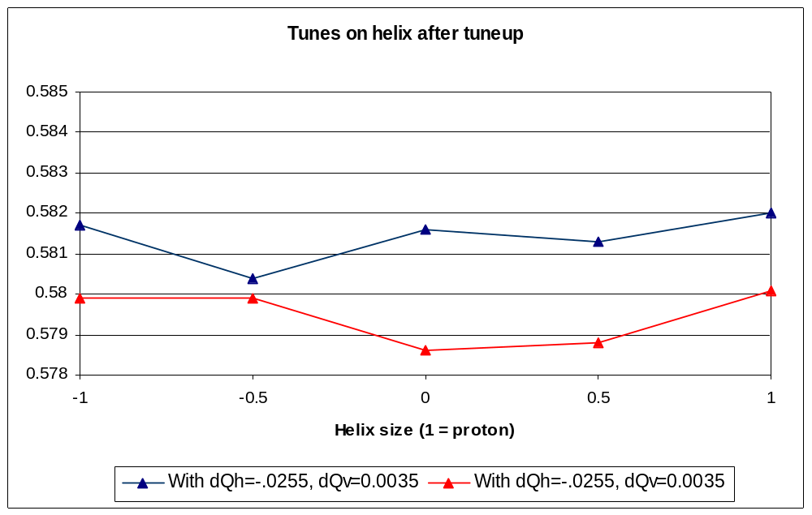
Figure 8 Measured tunes as a function of helix size with tunes pushed close together. No changes other that the separator voltages were made during these measurements. This demonstrates that the feeddown circuits could be adjusted to keep the minimum tune split less than 0.003 tune units on the proton, central, and pbar helices.

Calibration of the S6 circuit

The tune shift from changes in the S6 circuits (which consists of C:S6A4A and C:S6C4A) were measured during these studies. The tune shift was measured as function of current in the circuits with the separators turned off. In an ideal world, the Tevatron orbit would be passing though the center of these sextupoles and no change in the tunes would be observed. As shown in Figure 9 Figure 10 there is an observed horizontal tune shift when the current in the S6 circuits is changed. This implies that the Tevatron closed orbit is not going through the center of these magnets. We have not analyzed this data further in order to estimate the orbit offset.

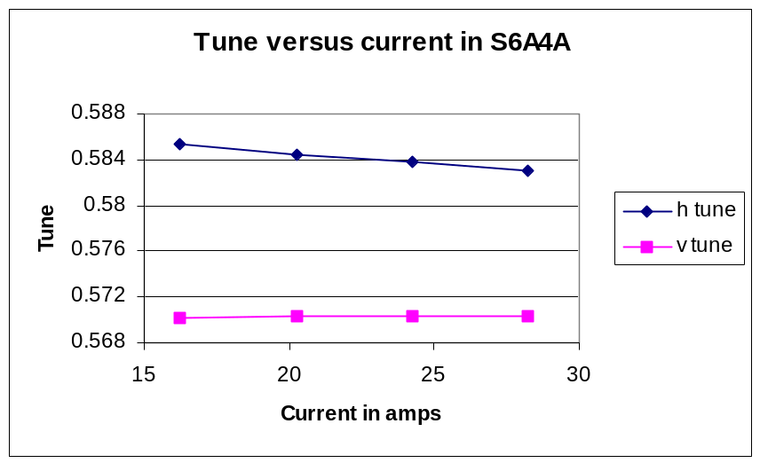
Figure 9 Measured tune as a function of current in the C:S6A4A feeddown circuit. These were measured with the helix off.

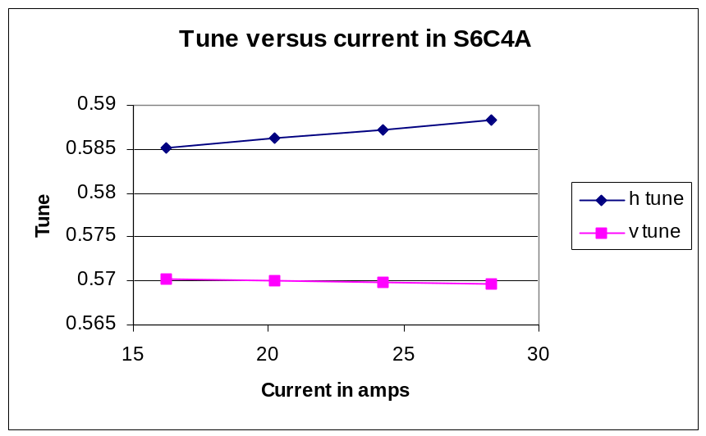
Figure 10 Measured tune as a function of current in the C:S6C4A feeddown circuit. These were measured with the helix off.

