NuMI Extraction Lambertson Configuration at MI60

David Johnson
April 19, 2002

Numerous improvements to the NuMI primary beamline have been proposed due to the change from slow spill, concern for ground water activation, sensitivity to errors, the reduction of the carrier pipe length, and tuneability. The improvements have lead to a re-design of the transport section of the primary beamline to keep the lattice functions (beta and dispersion) smaller. The most notable changes have been to carry the FODO lattice of the MI through the line breaking up the long bend strings.. Since the carrier pipe distance was cut by a factor of two to about 50 m, the more practical approach of creating a straight section, similar to the Tevatron was possible. Additional effort has gone into optimizing the extraction section by investigating the closed orbit, kicker strengths, and Lambertson configurations to improve aperture and reduce extraction losses. This note examines the current Lambertson configuration proposed at the last review.

The proposed extraction scenario reduced the upstream Lambertson angle by ~50% and increased the 2nd and 3rd by 25% presented a concern for the geometrical layout. In addition, all the Lambertson roll angles were identical at 115 mr. These calculations ignore any horizontal or vertical alignment of the vertical septa about the MI centerline. This bend angle change along with an increased kicker amplitude (the addition of a third kicker) appeared to increase the aperture through the extraction channel. However, since the vertical trajectory at the end of the downstream Lambertson is on the order of 100 mm, the 115 mr roll angle effectively reduces the extraction beam aperture by about 11 mm. I wanted to get a feeling for how these changes impacted the elevation of the c-magnet (V100) and the first beamline quad, Q101 and the elevation of the beamline at the entrance to the MI quad 309.

I used the extraction layout from a previous version described in MI note 0258 (Jan 2000). I believe the longitudinal location of the Lambertsons, c-magnet, and beamline quad have not substantially changed since then. This note had effectively suggested the reduction of the roll angles from the MI52 design to 124 mr for the first Lambertson and 25 mr on the second and third. All Lambertsons were kept at the same bend angle of 6.25 mr (18.9 kG) . In addition, the c-magnet was un-rolled. The layout is shown in Figure 1 with the longitudinal distances of the flanges shown. Note that the free space between quad 608 and quad 609 flanges is shown as 15.144 whereas the steel-steel distance is 15.155 m. The half height of the Q609 steel is approximately 22.35 cm or 8.8”.

Location of first beamline quad

In the extraction lattice described in MI note 0258, the first beamline quad was placed longitudinally such that it is between the c-magnet and Q609, at a beamline distance of about 12.4 m downstream of the end of Q608 approximately 1.6 m downstream of the c-magnet. The quad should be installed on the beamline central orbit. One must be careful shifting the beamline quad upstream or downstream because of interference with MI beam pipe or the installed MI vertical corrector just upstream of Q609, respectively.

The cross section of the new style 3Q60 is 15” x 17”. The minimum elevation needed to install this magnet over the MI beam pipe with a ¼” clearance is 15/2+1+.25 = 8.75” or 222 mm at the upstream flange. If an older style magnet (with a cross section of 13” x15”) is used one can save an inch to get a minimum separation between the MI and the beamline central trajectory of 7.75” or 197 mm. Moving the quad any closer to the c-magnet would reduce this minimum distance. Moving the quad downstream by more than 0.5 meters would interfere with the vertical corrector installed upstream of Q609. Additionally, I do not believe that the quad could be installed above Q609 because one would require an elevation of at least 15.5” (394 mm) above the MI centerline (with the use of an old style 3Q120, 13”x15” cross section).

In this configuration, the beamline central trajectory (assuming the beam is centered in the beam pipe) over the entrance to the MI quad Q609 must be at least ~11.0” (280 mm) above the MI centerline to give minimum 1/8” clearance between the 4” beam pipe and the MI quad steel. For reference, the design elevation of the MI is 218.15314 m. This says that the beamline elevation (in a beam pipe) at Q609 should be 218.41794 m, minimum.

Elevation of the c-magnet

The MI style c-magnet is located downstream of the third Lambertson. There are various considerations regarding the placement of the magnet. The magnet must not only fit at the upstream end, the pitch of the magnet should not allow the beam to scrape in the magnet, the beam needs to exit the magnet in a manner to enter the downstream quad on axis, and the beam needs to travel in the good field region of the c-magnet. In the 1993 conceptual design the strength, placement, and roll of this magnet was initially copied from the MI52 extraction design. But, due to the simplicity of the MI60 extraction (i.e. single energy, single beam scenario) a study (MI note 0258) showed that the roll angle of the Lambertsons could be reduced and roll of the c-magnet could be eliminated, to first order. I think additional calculations are needed to fully understand the impact of the roll angle on the new downstream beamline.

Figure 2 shows a cross section of the MI c-magnet steel in relationship to the MI beampipe. From the steel septa to the flange centerline is 87 mm. Note that the MI beampipe is shown ¼” below the steel of the c-magnet. This is the minimum elevation of the steel due to the interference of potted coil pack, which extends about 8” beyond the steel. Installing the c-magnet at a pitch of approximately 24 mr [i.e. (θ_{out}-θ_{in})/2], the difference in elevation of the flange is approximately 0.192” . From this cross section, the MI to c-magnet flange centerline is approximately 4.6” (117 mm). This defines the minimum geometrical vertical placement of the c-magnet. The magnet is shown horizontally offset by ~1.5”. This represents the maximum horizontal offset. The expected offset in the NuMI case is more like 0.72”.

The magnet has approximately 3.2 mm sagatti calculated from {δ = (L/θ) (1-cos θ/2) }. To maximize the vertical aperture through the c-magnet, the beam should enter and exit the magnet approximately δ/2 (1.6 mm) above the magnet centerline This implies that the optimum elevation of the beam trajectory at the entrance to the c-magnet should be approximately 119 mm above the MI centerline.

C-magnet magnetic field quality

Figure 3 shows the field uniformity of one of the new MI c-magnets, ICA001, across the 4-inch aperture on axis. The magnet was rotated 90 degrees such that the 4” aperture was horizontal. The “c” of the c-magnet is toward negative x (i.e. figure 2 rotated clockwise). The data was for an excitation of 2800 A for an integrated strength of about 3.5 T-m or about 10 kG. This is close to the excitation required by NuMI. Data are plotted for three positions of a rotating coil and are compared to the measurements by a stretched wire system. The y-axis is ΔB/B in units of 10⁻⁴ . The field is clearly uniform between –1” and +0.5” . The gradient between +.5 and +1.2 inches is on the order of 5-6 kG/m and falls off rapidly beyond 1.2”. The main concern is the rapid fall off of the field beyond –1.2”. The dB/dx of 10kG*200*10⁻⁴ /0.2 inches gives a gradient of about 40 kG/m. The field shape is fairly independent of excitation until saturation becomes dominate at about 3500 A when the field starts falling off closer to the center of the aperture.

Calculations

I did some quick calculations with TRANSPORT using different combinations of Kicker and Lambertson strength ratios. I looked at five different cases. The results are shown in the following table. The first column shows the multiplier for extraction kicker, the next three numbers show the three Lambertson ratios, and the last number is the c-magnet ratio. The next three columns under the heading of Q608 are the horizontal, X, and vertical, Y, beam position (in mm) and the radial trajectory at the downstream end of Q608. The pole tip radius of a 3Q84 style is about 37.44 mm to the inside of the beam pipe. The calculated radial offset of the beam, R, gauges the relative closeness to the pole tip. The horizontal position includes a –8 mm closed orbit bump, so the separation at the downstream of Q608 ranges from 27 mm to 32 mm depending on kicker strength. ( I should note that in this model I used only one kicker with the effective kick, so the detailed horizontal orbit is not quite correct, but I wasn’t looking at this.) The next two columns are the vertical position and angle at the entrance of the c-magnet, then the exit. The column labeled Q1 is the elevation at the entrance to first beamline quad, and the last column is the elevation of the beam at the location of the MI quad Q609.

The first row shows the positions in the Jan 2000 configuration. Here, all Lambertsons had a 6.25 mr bend and the c-magnet had a bend angle of 8.4 mr. The nominal value of the kicker was set to 282.68 ur. This corresponds to our running at about 45 kV (A/D read back) and about 2.15 kA. The first Lambertson had a tilt of 124 mr (7.1 degrees), the last two had a tilt of 25.4 mr (1.45 degrees), and the c-magnet was not rolled.

Setting | Q608 DS |  |  | V100 US |  | V100 DS |  |  | Q1 US |  | Q609
K /L1/L2/L3/CM | X | Y | R | Y[mm] | Y’[mr] |  | Y[mm] | Y’[mr] |  | Y[mm] |  | Y[mm]
1 / 1 /1 /1 / 1 | 19 | 26 | 32 | 124 | 20.3 |  | 216 | 28.7 |  | 261 |  | 332
1.2/.5/1.25/1.25/1 | 23 | 13 | 26.4 | 94 | 19.5 |  | 183 | 28 |  | 228 |  | 297
1.2/.6/1.2 /1.2 /1 | 24 | 16 | 28.8 | 100 | 19.65 |  | 189 | 28.0 |  | 235 |  | 304
1.2/.8/1 /1 /1 | 24 | 21 | 31.9 | 112 | 19.95 |  | 203 | 28.4 |  | 248 |  | 317
1.2/.8/1.2 /1.2/.85 | 24 | 21 | 31.9 | 116 | 21.2 |  | 209 | 28.3 |  | 255 |  | 325

The second row shows the orbits obtained with the proposed excitations (but not the roll angles). The 1.2 corresponds approximately to the increased kick due to the addition of a third kicker. Here the entrance into the c-magnet is about 3.7” above the MI, which is about 1.2” below the ideal trajectory. From figure 3 it places the design orbit perilously close to the edge of the good field region. So, it looks like it would physically fit, but the orbit through the c-magnet is marginal. Looking at the trajectory at the entrance of Q1, it is 228 mm above the MI centerline which gives an additional 6mm clearance from the minimum required for the “new style” 3Q60. It would be more comfortable with the “old style” which has the smaller cross section. The elevation at Q609 is already about 18 mm above the minimum distance, so no real problem here unless the beamline quad is moved downstream.

As the field in the first Lambertson is decreased and the field in the 2nd and 3rd are increased, the field in the c-magnet can be adjusted to keep the same vertical pitch out of the c-magnet. The elevations at Q1 and Q609 only improve and they should not present any problems.

Circulating Orbit

Inspection of the proposed circulating orbit raises some questions. The 120 GeV orbit is defined by quad displacements such that no correctors are needed at flattop. The correctors are then used at 8 GeV and up the ramp. With this philosophy, the correctors have plenty of strength for any orbit manipulation. The quad displacements taken from the design note are: Q602 = 1.582 mm, Q606 = -1.9642 mm, Q610 = -1.708 mm, Q612 = 0.0588 mm, and Q614 = 1.54 mm. These are used to create a counterwave bump centered on 604 for the kicker at 602 and control the circulating beam orbit through the Lambertsons. Whether quad displacements or correctors are used these two functions should be separated (i.e. the use of 602, 604, and 606 for the counterwave bump and 606, 608, 610, and potentially 612 for the Lambertson bump). Figure 4 shows the beam envelope for the orbit due to quad displacements, solid line, and the Lambertson septa (for all three lambertsons) as a box centered about –2 mm to the outside of the ring. Also shown is the approximate closed orbit utilized in MI note 0258 shown as a dashed line. Here, the position at both Q608 and Q610 are kept to the inside, effectively keeping the beam farther to the inside through all the Lambertsons. As a side benefit this can be used to reduce the horizontal extraction angle out of the c-magnet. The counterwave bump at Q604 is about twice that is the current proposal, which will reduce the amplitude of the excursion due to the kicker. This was some with the superposition of a three bump (H602,H604,H606) and a four bump (H606, H608, H610, and H612). The exercise left to do is to optimize these orbit at all energies.

Lambertson Speta Offsets

The current proposal lists horizontal and vertical septa offset for all three Lambertsons. The offsets are the same for both the entrance and exit of each magnet. They are:
LAM60A: x = 3.2 mm y = -4.0 mm
LAM60B : x = 4.0 mm y = -1.0 mm
LAM60C : x = 2.0 mm y = +2.0 mm

Since the orbit should be vertically flat, the vertical relative displacement of 6 mm effectively reduces the vertical aperture near the septa.

Figure 5 shows the Lambertson aperture shifted by the 3.2 mm (H) and –4 mm (V). The circulating and extraction beam ellipse represent the 4σ of a 40 π beam at the downstream face of the first Lambertson. The circulating beam is shown at –12 mm and the extracted beam is shown at +20 mm and about +8 mm in the vertical. These positions are tunable and are used only as an example. One can see that shifting the septa down by 4 mm at this location is a bit too far.

Figure 6 is used to illustrate the reduction of the effective vertical aperture due to the proposed vertical offsets, particularly when the beam comes closer to the septa. This would effectively reduce circulating aperture and produce a narrower beam loss free channel. The ellipses again represent the circulating beam (tuneable) and the extracted beam at the end of the first Lambertson , at the entrance to the Q608, and at the exit of Q608 next to the BPM HP608.

Conclusions

Based upon these quick calculations, the separate powering of the first Lambertson is a good thing to do. It is not clear, however that the proposed relative bend angles of the Lambertsons will provide the desired results. I think the first Lambertson needs to be stronger than the 0.5 nominal proposed. Once the Lambertson field of the first is increased the elevation of the beam at the exit of Q608 increased and the benefit of the large separations given by adding a third kicker are diminished.

Careful inspection of the second calculation and the c-magnet geometry, it is conceivable that the c-magnet can be installed at the less than the 4.6” from MI centerline with steel touching (< 100mils) the MI beampipe. The beam could enter the magnet roughly 1” below the flange centerline and potentially still in the good field region (fig.3). It would exit slightly above the centerline. The pitch of the magnet would be adjusted to less than the previously calculated sagitta.

I think the extraction design needs more work to optimize
the Lambertson strengths and roll angles,
circulating beam closed orbits,
extraction kick angles,
c-magnet excitation and roll angle
looking at the trajectories through these elements (and their installation issues) and the impact on the remainder of the beamline, particularly the footprint and elevation of the beamline as it crosses the A1 beamline.

There has been a lot of discussion of beam sizes and tails. Numerous plots compare 25 π or 40 π with varying number of sigma’s trying to guess what the extent of the beam tails might be at high intensity. Folded into this discussion need to be the limiting apertures of other devices around the ring. A criteria of just how much aperture is needed at the extraction Lambertsons (such as MI #0044, S. Holmes, etc) should be adopted which takes these other constraints. In other words we shouldn’t require the beam to be 12 mm from the Lambertson steel is the limiting aperture is 3 mm elsewhere.

Note: Some elevations for reference:
MI elevation 218.15314 m
A1 (B4A DS) 218.8977 m
NuMI elevation 219.13 m
RR elevation 219.5755 m

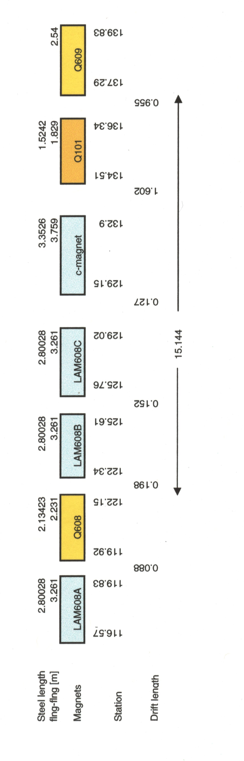

Figure 1. Layout of extraction elements in the Jan 200 lattice

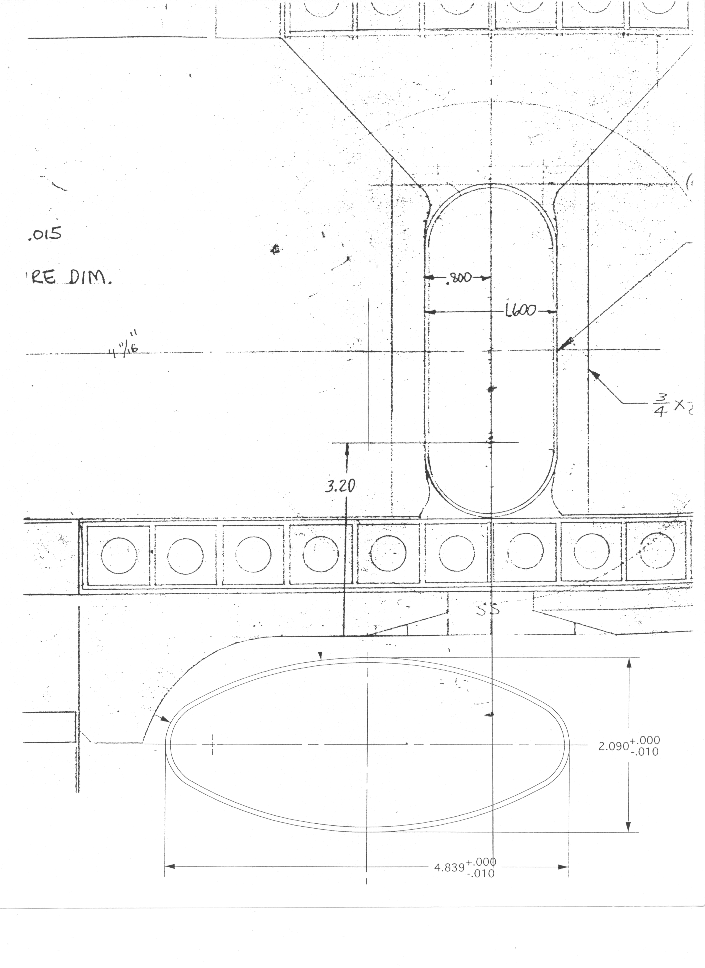

Figure 2. Cross section of MI c-magnet with the MI beam pipe. Centerline of c-magnet to MI is 4.6 inches. The horizontal offset for the NuMI is approximately .72 inches from MI centerline (offset as shown is greater). The inside aperture of the c-magnet beam pipe (.060) is 1.48”H x 3.88” H.
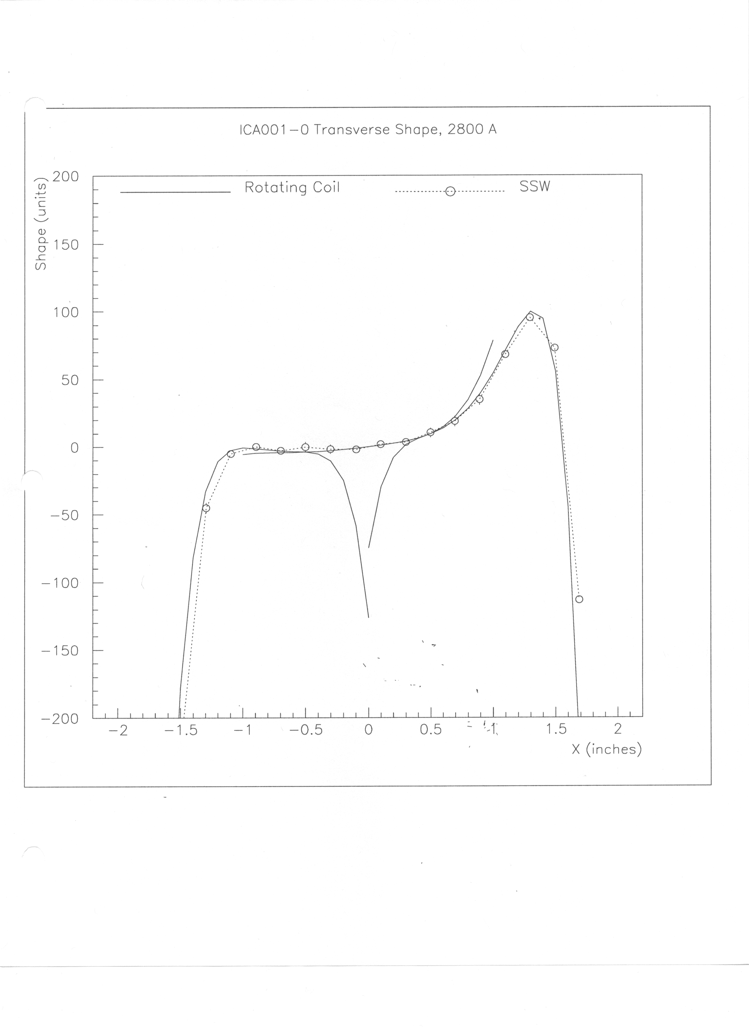

Figure 3. Field uniformity of ICA001 at 2800 A (nominal operating current at 120 GeV/c)
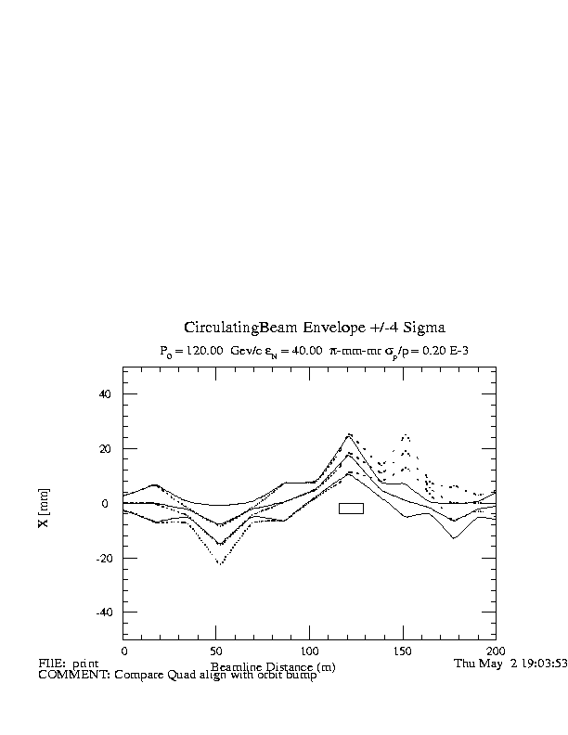
Figure 4: Comparison of closed orbit at 120 Gev for that a) quad displacements defined in the current design (A. Drozhdin) - solid line and b) utilizing corrector/quad displacement from the design described in MI note 0258 – dashed line. Beam envelope shown is 4 σ of a 40 π-mm-mr beam.
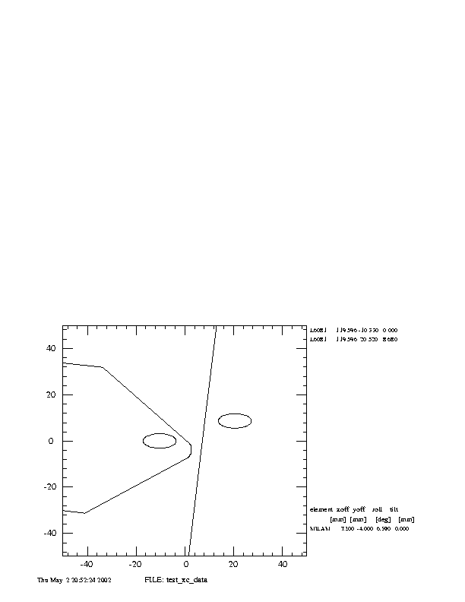

Figure 5: Circulating and extracted beam 4σ envelope at the face of LAM60A for the reduced current in the first Lambertson. The placement of the Lambertson is from the current proposal
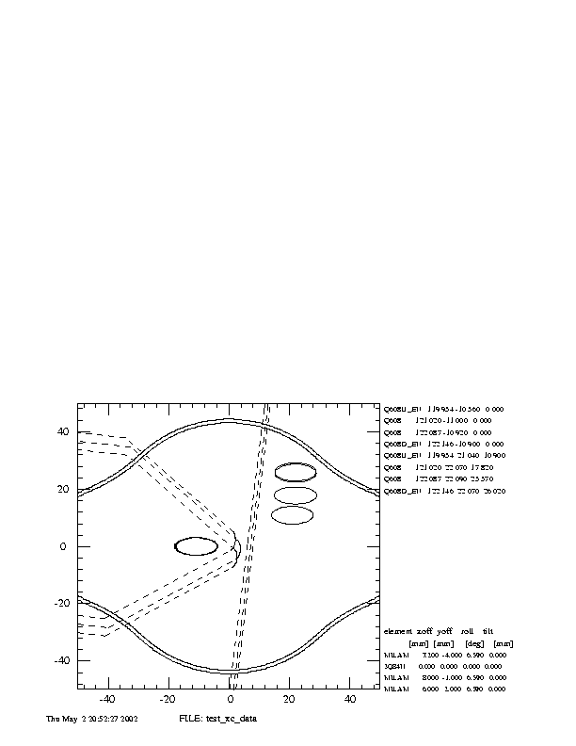
Figure 6: Shows the effective septum thickness with respect to the MI centerline. The septa have been aligned according to the positions listed for the current proposal.

