Beam Signals From A14

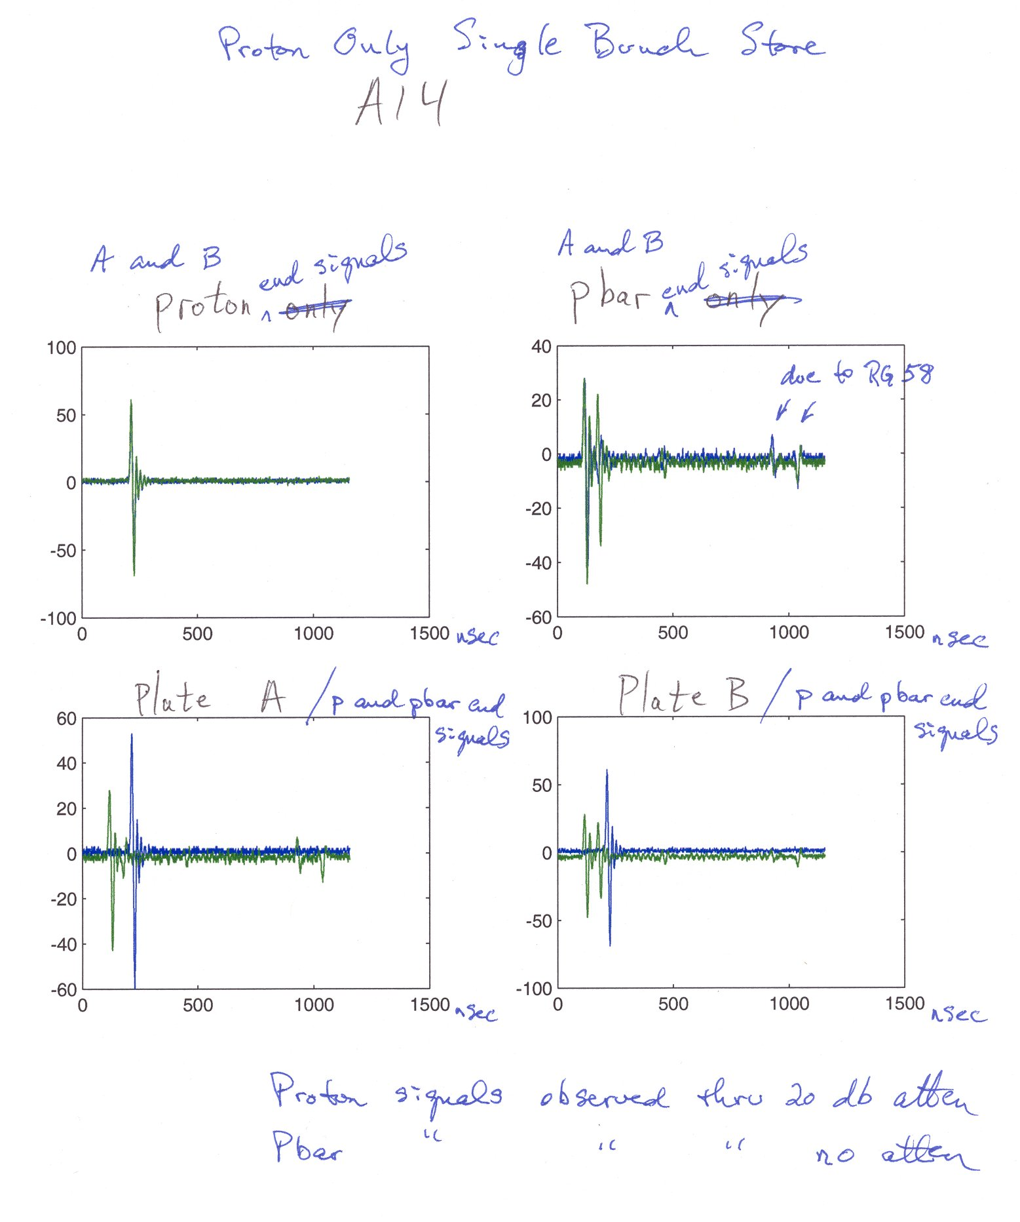
All signals through 70 MHz low-pass filters.

Beam Signals From A15
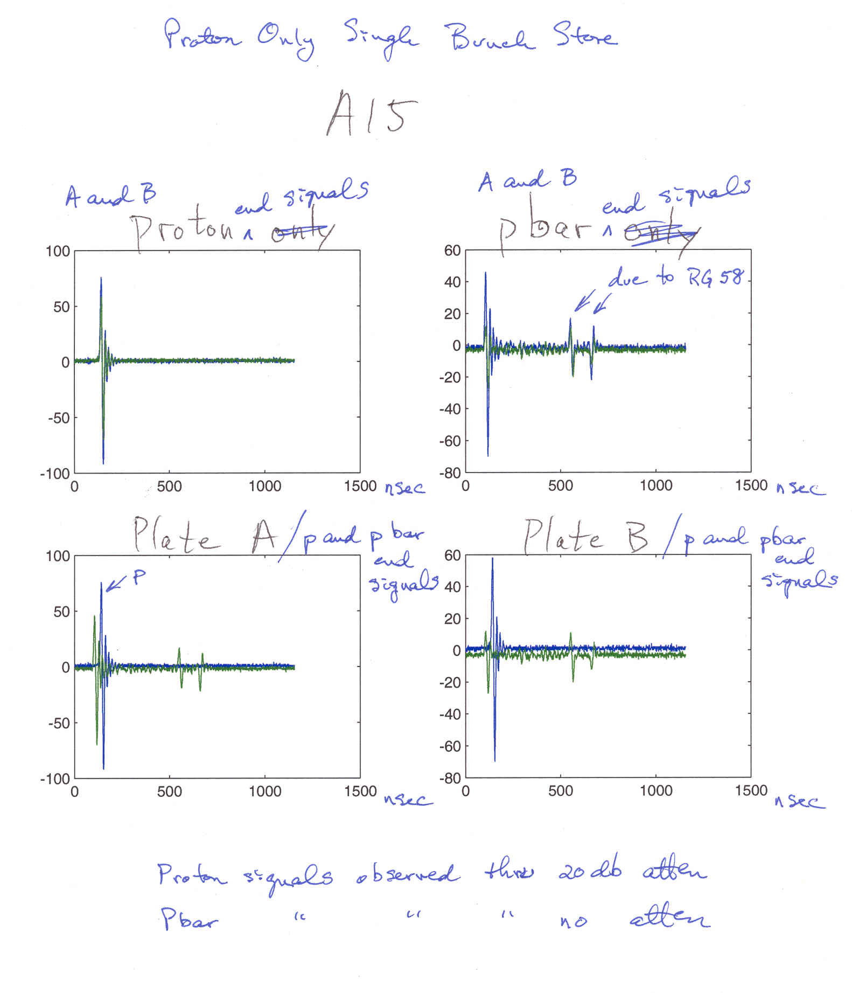

All signals through 70 MHz low-pass filters.

TDR Tests of A14 and A15 Signal Paths

Test pulse injected into Pbar cable in service building and reflections observed.

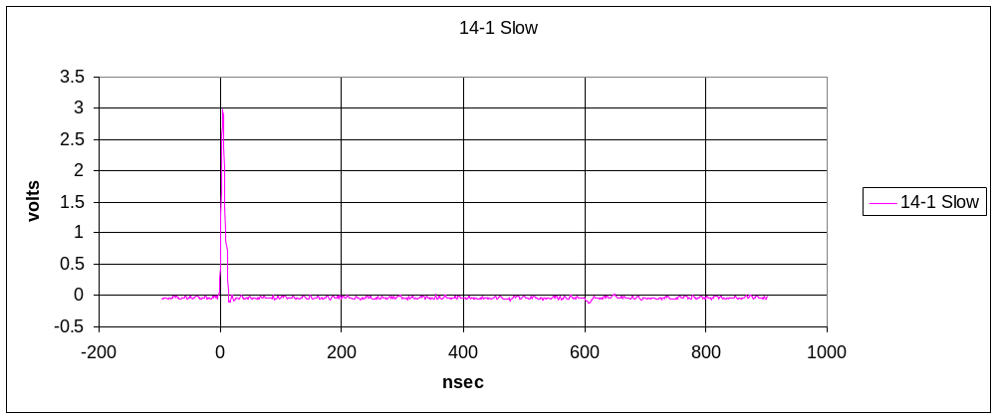
Reflections from BPM
Incident pulse
A14-1 path showing injected pulse and reflections.
Test Pulse

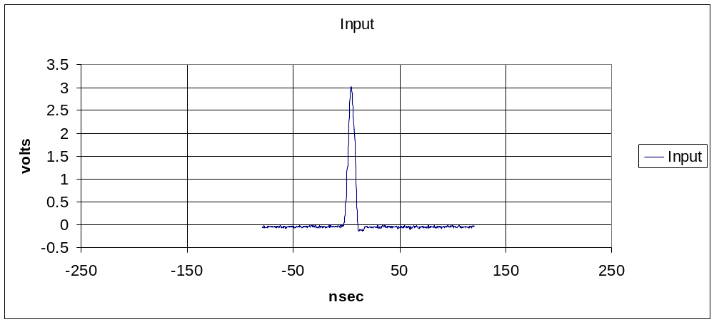
Reflections From Near BPM

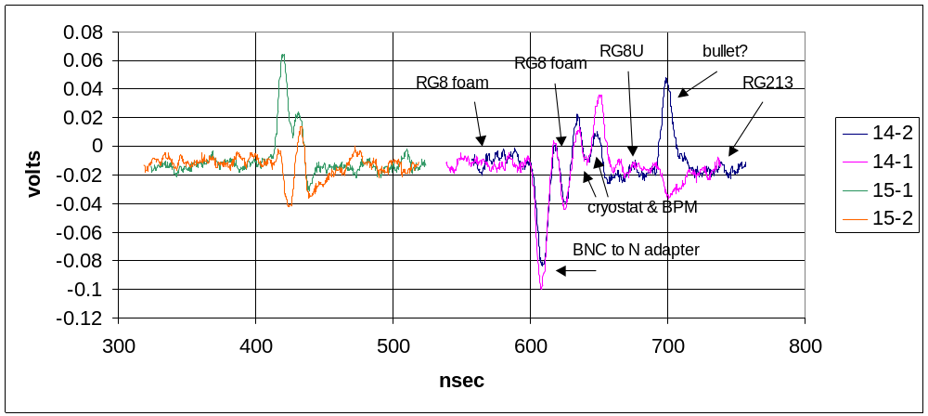
A14 had multiple extensions and adapters in tunnel; from pbar foam RG8 cable to BNC-to-N adapter to 12’ foam RG8 jumper to cryostat pbar signal feed-through through cryostat cables and BPM to proton signal cryostat feed-through to 20’ RG8/U extension to RG213 cable to service building.

