
Fermilab

April 21, 2003

To: Mike Church

From: George Krafczyk

Subject: Resonant Charging A0 Abort Kickers

Dan Wolff has asked me to look at the abort magnet current during resonant charging of the A0 Abort Kickers. Currently the kickers are held at a voltage that is appropriate for aborting the beam in less than 2 turns of the Tevatron. The current in the abort magnets is given here for reference. The measurement and simulation were made on 8/8/2001 by Chris Jensen. The peak current was about 21K Amps at a charging voltage of 35K Volts. Today the system is routinely run at a charging voltage of 36K Volts (and ~22K Amps) for 980 Gev aborts.
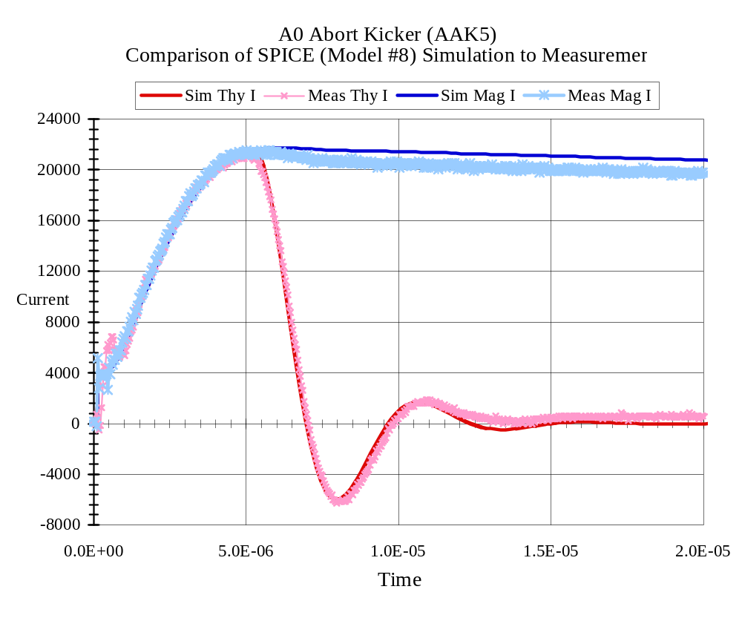
The equivalent circuit that was used to simulate the above measurement is given below. In the simulation the storage capacitor is 2.5μF and the load inductance is 4.6μH (magnet + cable).

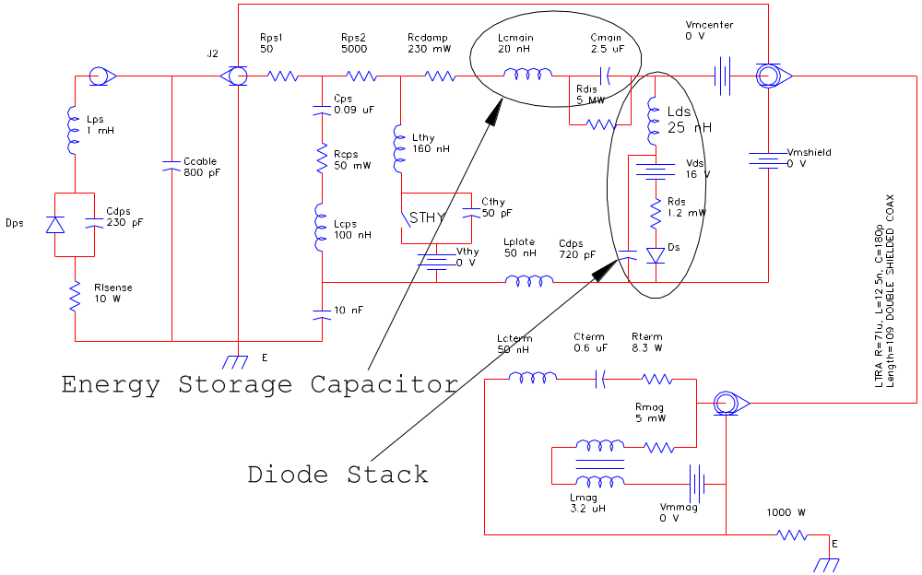

The diode stack that is in parallel with the magnet conducts the magnet current when the voltage on the magnet tries to reverse during discharge. During charging of the energy storage capacitor, a forward current in the diode is created if the voltage on the magnet is greater than the turn-on the diode stack.

In fact it is now felt that a complication in turning these diodes off after they are turned on during resonant charging is the fundamental reason that the earlier attempt at resonant charging caused diode failures.

Now to the resonant charging current and magnet voltage calculation. This effort will assume a sign wave current with varying base time “T”.

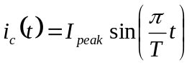 , 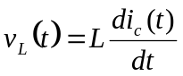 , 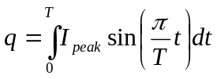 , 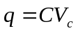
and thus:
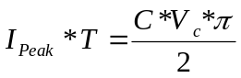 , 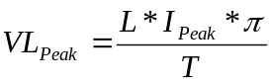

From the above:

Time  [sec] | Ipeak  [Amps] | Percent  Full Kick | VL_peak  [Volts]
4.E-03 | 35.3 | 0.16% | 0.13
3.E-03 | 47.1 | 0.21% | 0.23
2.E-03 | 70.7 | 0.32% | 0.51
1.E-03 | 141.4 | 0.64% | 2.04
5.E-04 | 282.7 | 1.29% | 8.17

From the above calculations, it seems possible to keep the diodes OFF during the resonant charging if the charging time is longer that 0.5m sec. Since the charging current flows through the magnet, the beam will receive a small kick during the charging cycle. Column 3 above indicates the size of that kick in percentage of the nominal peak kick. My bias is to attempt a design around 2m sec. Please get back to us if we can be of further help.

CC: Dan Wolff
Chris Jensen

