Fermilab/AD/TEV
Beams-doc-1236
January 5, 2005
Version 1.4

Tevatron chromaticity and tune drift and snapback studies report

G. Annala†, P. Bauer∗, M. Martens†, D. Still†, G. Velev∗
†Fermilab, Accelerator Division, Tevatron Department
∗Fermilab, Technical Division, Development and Test Department

1) 3
Introduction 3
1.1) Summary of Beam Studies 4
2) Conversion of chromaticity to b2 in dipole magnets 5
2.1) Calibration of the T:SF and T:SD circuits 7
2.2) TCHROM calculation of the C:SFB2 and C:SDB2 currents 8
3) Calculation of tune and coupling drift related to dynamic effects. 9
4) Beam Study 04/22/04 12
4.1) Tevatron b2 Drift after 5 min Back-Porch 12
4.2) Comparison of Tevatron b2 Drift to Magnet Measurement Data 14
4.3) Tevatron Tune Drift after 5 min Back-Porch 16
5) Beam Study 04/27/2004 (Tevatron in a ramping State) 18
5.1) Tevatron b2 in the Ramping state 18
6) Beam Study 06/29/2004 26
6.1) Tevatron b2 Drift after 5 min Back-Porch 26
6.2) Tevatron Tune Drift after 5 min Back-Porch 28
6.3) Tevatron Coupling Drift after 5 min Back-Porch 31
7) Beam Study 07/23/04 33
7.1) Tevatron b2 Drift after 5 min Back-Porch 33
7.2) Tevatron Tune Drift after 5 min Back-Porch 34
7.3) Tevatron Coupling Drift after 5 min Back-Porch 36
8) Beam Study 08/10/04 38
8.1) Tevatron b2 Drift after 5 min Back-Porch 38
8.2) Tevatron b2 on the Ramp 39
8.3) Tevatron Tune Drift after 5 min Back-Porch 46
8.4) Tevatron Coupling Drift after 5 min Back-Porch 48
9) Summary 49
9.1) b2 drift on injection porch after a 5 min back-porch 49
9.2) b2 snapback 50
9.3) Tune drift on injection porch after a 5 min back-porch 53
9.4) Coupling drift on injection porch after a 5 min back-porch 54
10) Appendices 55
10.1) Appendix 1 55
10.2) Appendix 2 56
10.3) Appendix 3 57
10.4) Appendix 4 57
10.5) Appendix 5 58
11) References 60

1) Introduction

An increase in the integrated luminosity of up to 3% may be achieved by eliminating the beam-less pre-cycle (the so-called “dry squeeze”) of the Tevatron energy ramp currently performed between every Collider fill. The elimination of the pre-cycle, when coming from an intentionally ended store, would consist of returning, via the back-porch and reset, directly to the next injection porch (without the additional ~20 min flat-top “dry squeeze” pre-cycle). This would reduce the time needed for the shot setup process and allow more time for luminosity integration. The beam studies reported here have, in part, been conducted as part of an effort to implement a new Tevatron ramp protocol including the elimination of the pre-cycle.

In addition to reducing shot setup time, understanding the behavior of the tune, coupling, and chromaticity at the start of the ramp is an important part of understanding the observed 5-10% loss in beam intensity at the start of the Tevatron ramp. The cause of the beam loss is not well understood and there are many factors which can play a role in it, including orbits, aperture, helical orbits, beam-beam tunes shifts, feed-down effects, tune, coupling, and chromaticity. Although good control of the tune, coupling, and chromaticity during the start of the ramp may not eliminate the beam loss, it is important that these parameters are well controlled before progress can be made understanding more complicated beam dynamics such as for instance beam-beam tune shifts.

Without the additional pre-cycle the Tevatron ramp cycle of the previous shot, with typical flat-top durations of 10-20 hr, becomes the pre-cycle of the subsequent shot. It is well known that dynamic field effects of superconducting magnets depend on the history of the magnet excitation and so the correction algorithms must be updated to reflect the change in ramp history. Sextupole measurements on select magnets indicate that the effect of the pre-cycle flattop time on the sextupole drift saturates beyond ~40 min at the flattop and that a 5 minute back-porch reduces the magnitude of the sextupole drift on the 150 GeV front porch by ~30% with respect to the currently used 1.5 min back-porch. By eliminating the pre-cycle the correction algorithms for the front porch drift and snapback must be updated from a 20 minute flattop time with a 1.5 minute back porch to pre-cycle flattop times greater than one hour with a 5 minute back porch.

In preparation for a change in the Tevatron operational procedure there was a number study periods related to this topic performed in the summer of 2004 culminating in a successful shot setup without the “dry squeeze” on August 22, 2004. The purpose of the beam studies was to investigate the sextupole component drift in the Tevatron during the injection porch following a long flattop and 5 min back-porch pre-cycle as well as measure and characterize the tune and coupling drift. Also, one of the studies was aimed at measuring the tunes and chromaticity in the Tevatron while it was in a state of continual ramping. In the ramping state the Tevatron has very short (~ 6 second) front and back porch times and the drift and snapback effects should therefore be minimal.

This report documents the results of the beam studies and presents some analysis of the b₂ component in the Tevatron. All of the measurements were conducted during dedicated beam-studies with un-coalesced protons-only beam on the central orbit (i.e. with the electrostatic separators turned off.) A brief summary of the studies is given below.

Summary of Beam Studies

On 4/22/2004 the tune, coupling, and chromaticity drift were measured on the front porch after a flattop duration of 2.7 hours with a 5 minute back porch on the previous Tevatron ramp. During these measurements the original (and outdated) drift correction algorithms were used and the tune, coupling, and chromaticity all drifted on the front porch. An analysis of the data was used to update the parameters of the tune, coupling, and chromaticity algorithms to better compensate for the drifting magnetic fields.

On 4/27/2004 the chromaticity was measured on the early portion of the Tevatron ramp from 150 to 200 GeV while the Tevatron was in a state of continual ramping. In this state the Tevatron energy ramp has a minimum dwell time on both the back porch and on the injection plateau. The purpose of this beam study was to measure the chromaticity on the Tevatron ramp in a situation where the front porch drift and snapback are minimal.

On 6/29/2004 the tune, coupling, and chromaticity drift were measured on the front porch after a flattop duration of 25.7 hours with a 5 minute back porch on the previous Tevatron ramp. This study was used to check the quality of the improved b₂ algorithm (which was updated based on the 4/22/2004 results) and further refine the parameters for the tune and coupling drift algorithms. With the updated b₂ algorithm the horizontal and vertical chromaticity drifted by less than 1 unit over about two hours (compared to about 35 units of expected drift without compensation.) The horizontal (vertical) tune drifted by 0.0016 (0.0024) units over about two hours. The observed tune drift was larger than expected based on the 4/22/2004 results. It is speculated that the tune measurements data from the 4/22/2004 may have been confounded by coupling drift.

On 7/23/2004 the tune, coupling, and chromaticity drift were measured on the front porch after a flattop duration of 3.7 hours with a 5 minute back porch on the previous Tevatron ramp. This study was used to check the quality of the updated tune correction algorithm (which was updated based on the 6/29/2004 results) and to focus on a more careful measurement of the coupling drift in the front porch. With the updated tune and chromaticity algorithms the measured chromaticity drifted by less than one unit and the measured tunes drifted by less than 0.0005 units over about a two hour period on the front porch. The coupling was observed to change by 0.007 units of minimum tune split over about a two hour period. A new version of TCHROM was also implemented and tested.

On 8/10/2004 the tune, coupling, and chromaticity drifts were measured on the front porch after a flattop duration of 39.4 hours with a 5 minute back porch on the previous Tevatron ramp. This study was used to check the quality of the updated coupling correction algorithm (which was updated based on the 7/23/2004 results.) With the updated tune, coupling and chromaticity algorithms the measured chromaticity drifted by less than .5 units, the measured tunes drifted by less than 0.001 units, and the minimum tune split remained below 0.003 units over about a two hour period on the front porch. At the conclusion of these measurements there was confidence that the drift compensation algorithms were sufficiently well adjusted to operate the Tevatron without a “dry squeeze.”

Also on 8/10/2004 the tunes were measured on the early part of the Tevatron ramp at two different RF frequencies in order to calculate the chromaticity at the start of the ramp and determine the amount of b₂ snapback. Each to the two ramps was preceded by a pre-cycle with a 1 hour flattop, a 5 minute back porch, and the energy ramp began after 1 hour on the front porch. During the measurements the snapback algorithm was updated from a quartic to a Gaussian function of time. This change was based on recent measurements of the snapback behavior of Tevatron magnets at the Technical Division Magnet Test Facility (MTF), but a transcription error led to an incorrectly used time constant in the snapback function during these particular measurements. A later analysis of the measured snapback data showed that it was consistent with the magnet measurement data.

The results of the above beam based studies combined with magnet measurement data were analyzed to determine the final drift and snapback algorithms for Tevatron operations with long flattops and 5 minute back porches on the previous ramp cycle. The updated algorithms were implemented successfully on 8/22/04 during store 3745. This was a nominal store with protons and pbars except that the previous ramp cycle had a long flattop and a 5-minute back porch and the latest version of the drift and snapback compensations were used. The store was successful in that the beam loss at the start of ramp was no worse than other stores, but no improvements in beam loss were seen.

The next sections of this report give details, results, and analysis of the various beam studies.

Conversion of chromaticity to b2 in dipole magnets

It is assumed that the total chromaticity in the Tevatron, which is the same as the measured chromaticity, is the sum of the chromaticity originating in the sextupole (b₂) of the magnets (geometric, hysteretic and dynamic), the chromaticity supplied by the C:SFB2 and C:SDB2 correctors, the chromaticity supplied by the T:SF and T:SD correctors, and the natural chromaticity. Equation 1 shows the relation of the various contributions to the total chromaticity according to this assumption. Ideally the chromaticity added by the T:SF and T:SD sextupole correctors will cancel the natural chromaticity, the chromaticity related to the static (geometric + hysteretic) b₂ contribution from the dipole magnets, and supply the set-point chromaticity. The chromaticity added by the C:SFB2 and C:SDB2 sextupole correctors will cancel the dynamic b₂ contribution (drift and snapback) from the dipole magnets. As will be shown when presenting the studies results, the b₂ correction injected into the C:SFB2 and C:SDB2 sextupole correctors does not perfectly track the b₂ drift behavior in the magnets and therefore the chromaticity changes during the injection porch. It is exactly the goal of the beam studies presented here to improve the b₂ correction in the Tevatron.

Equation 1

The b₂ component in the magnets can be extracted from the measured chromaticity if the natural and corrector-supplied chromaticity is known by using Equation 2 and Equation 3 where the corrector-supplied chromaticity is separated into the dynamic (drift + snapback) and static (geometric + hysteretic) components.

Equation 2

Equation 3
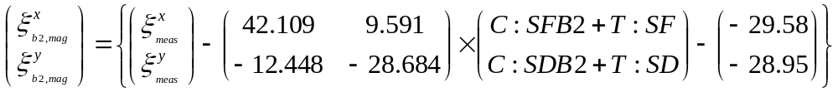

Equation 3 is as in Equation 2 except that it contains the various contributions explicitly. The T:SF and T:SD corrector currents are extracted from the Tevatron control system for each beam study separately since they can change from case to case. (Also to be included in this contribution is the so-called H-table correction, which is typically configured by C49 to inject additional chromaticity before the start of the ramp to prevent beam instabilities during the ramp.) The C:SFB2 and C:SDB2 corrector currents are determined from the b₂ algorithm used by TCHROM and converted into currents as discussed in Section 2.2) below. The matrix relating sextupole corrector currents to the chromaticity was measured during studies in the Tevatron on 4/22/2004 and this measurement is discussed in Section 2.1) below. The natural chromaticity is calculated from a MAD model of the Tevatron at 150 GeV since it cannot be measured directly.

With the measured chromaticity and the known current in the sextupole correctors the chromaticity from the b₂ component of the dipoles, ξ_{b2,mag}, can be determined. Finally the magnet chromaticity ξ_{b2,mag} is converted into b₂ with the calculated conversion coefficients; 26.38 units of horizontal chromaticity and –24.12 units of vertical chromaticity, both per unit of b₂ as given in Equation 4. These conversion coefficients are calculated from a MAD model of the Tevatron at 150 GeV since there is no way to measure them independently. Equation 4b shows an approximate calculation of these parameters using analytical formulae. Comparison with Equation 4b reveals that the MAD calculated values are reasonably close to the analytical estimates. Equation 4 implies that there are two separate measurements of b₂; one value determined from the horizontal chromaticity and one value determined from the vertical chromaticity. In theory these two values should be the same.

Equation 4
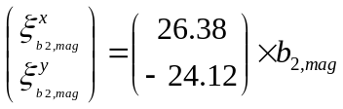

Equation 4b
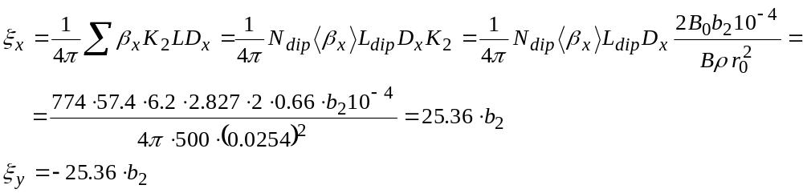

Calibration of the T:SF and T:SD circuits

Once the drift had been reduced following a 2 hr dwell on injection, measurements of the chromaticity for different current settings were performed during the April 22, 2004 beam study to determine the corrector excitation to chromaticity conversion parameter matrix needed for the data analysis. The results of these measurements are given in Equation 5. The matrix elements in Equation 5 were calculated from the derivatives (slopes) dξ_{h,v}/dI_{SF,SD} calculated from the data in Table 1. These are the same values used

Table 1: Measurement of the corrector current to chromaticity (C) conversion coefficients in the Tevatron chromaticity corrector circuits SD and SF. Currents are in Amps.
T:SF | T:SD | Ch | Cv
3.496 | 1.071 | 13.86 | -0.46
3.349 | 1.071 | 7.48 | 1.4
3.178 | 1.071 | 0.46 | 3.5
3.349 | 0.9 | 5.84 | 6.31
3.349 | 1.071 | 7.48 | 1.4
3.349 | 1.242 | 9.12 | -3.5
Equation 5
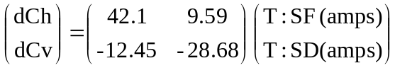

in Equation 3 and in the analysis described above.

For comparison we give the values calculated by MAD with the design 150 GeV lattice and using the integrated sextupole field strength of 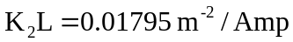at 150 GeV. The MAD calculated values are

Equation 6
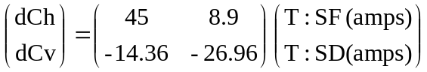

And, for the record, we also include the values presently used in the C49 program to convert chromaticity changes into changes in current in T:SF and T:SD. The later are believed to be out-dated.

Equation 7
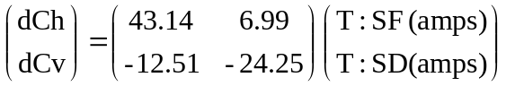

Note that it is the parameters in Equation 7 that need to be used to convert chromaticity tables extracted from C49 to the corrector currents actually used in the b₂ data-analysis with Equation 3 as discussed above.

TCHROM calculation of the C:SFB2 and C:SDB2 currents

The currents in the C:SFB2 and C:SDB2 sextupole corrector circuits are calculated with the dynamic b₂ algorithm by the program TCHROM^{[1]}. The b₂ algorithm for the calculation of the b₂ drift and snapback as a function of pre-cycle back-porch and flat-top duration is discussed in further detail elsewhere^{[2]}. TCHROM converts the predicted b₂ into the C:SFB2 and C:SDB2 corrector currents with the conversion coefficients given in Equation 8.

Equation 8
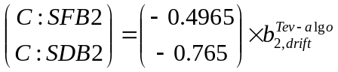

The TCHROM conversion of b₂ into the currents in C:SFB2 and C:SDB2 in Equation 8 is not consistent with the most up-to-date values. This means that the amount of b₂ correction applied to the Tevatron is actually slightly different from the amount of b₂ used in Equation 8. This error does not affect the analysis of the b₂ component in the magnets because Equation 3 uses the most recently measured values and the actual currents in the sextupole correctors (and those are calculated with the TCHROM constants in Equation 8).

The newly measured T:SF and T:SD calibration shown in Equation 5 can also be used to update the coefficients that TCHROM uses to convert b₂ into currents in drift compensation sextupole circuits C:SFB2 and C:SDB2. They can be obtained from the relationship between b₂ in the dipoles and chromaticity and from the inverse of the relationship between chromaticity and current. This then gives the updated TCHROM coefficients shown in Equation 9.

Equation 9
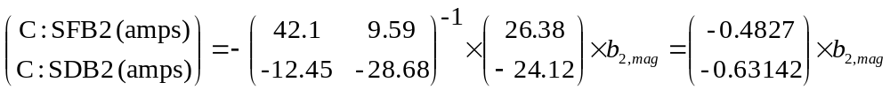

The difference between these coefficients derived from recent measurements and the coefficients used by TCHROM means that one unit of b₂ correction in the TCHROM algorithm actually compensates for about 1.12 units of b₂ in the Tevatron.

The issue of obsolete conversion factor settings in the Tevatron control system was taken into account in the procedure with which the measured chromaticity were converted into the sextupole contribution from the dipole magnets. In particular we made sure that we knew exactly what currents had been sent to the correctors via TCHROM, C49 and H-table. If currents were not directly available we calculated these current from derived parameters such as b₂ or chromaticity using the particular conversion coefficients with which each card (would have) converted them into currents.

Calculation of tune and coupling drift related to dynamic effects.

In addition to the chromaticity drift, the tune and coupling also drift during the Tevatron 150 GeV front porch. There is also a tune drift snapback at the start of the energy ramp and, though it has not been measured directly, presumably a coupling snapback as well. These drifts and snapback are compensated with trim quadrupole and skew quadrupole correctors according to algorithms used in TCHROM.
In the previous section the chromaticity drift was interpreted as a drift in the b₂ components of the dipoles but this report makes no attempt to explain the source of the tune or coupling drift. Possible sources of tune and coupling drifts could include drifts in the quadrupole component in the dipoles, changes in the b₂ component in the dipoles combined with orbit offsets in the dipoles, changes in the trim sextupole correctors combined with orbit offsets in the correctors, drifts in the strength of the main focusing quadrupoles, or even drifts in the strength of the dipole field in the dipole magnets^{[3]}.

Although the source of the tune drift is not explored, the total amount of tune drift, which is the same as the measured tune drift, can be expressed as a sum from dynamic magnetic effects and corrector magnets as shown in Equation 10 and Equation 11.

Equation 10
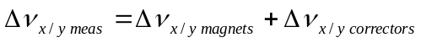

Equation 11
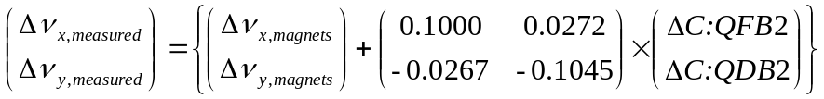

Equation 11 is as in Equation 10 except that it contains the various contributions explicitly. The matrix relating trim quad corrector currents to the tunes are those used by TCHROM and were measured on 9/23/02 when the tune drift correction was first implemented^{[4]}. The corrector currents that compensate for the tune drift, C:QFB2 and C:QDB2, are determined from the tune drift algorithm used by TCHROM^{[1]}. The form of the tune drift is a log function shown in Equation 12 with the values that depend on the pre-cycle parameters. In fact the parameters of Equation 12 used in TCHROM do not depend on the pre-cycle parameters such as the flattop or back-porch duration. They have been derived for a particular and fixed pre-cycle profile. The time,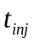, is the time from the start of the front porch in seconds. The calculated drifts are converted into currents in the C:QFB2 and C:QDB2 circuits using the coefficients in Equation 13. The matrix in Equation 13 is the inverse of the matrix in Equation 11.

Equation 12
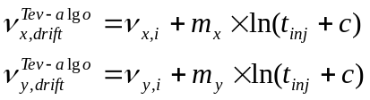

Equation 13
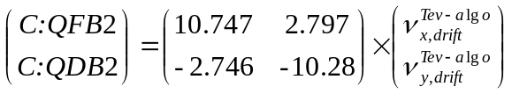

Using Equation 11 with the measured tunes and the known current in the quadrupole the tune component from the magnets we can calculate the total tune drift related to magnetic effects at 150 GeV.

The coupling drift algorithm was applied in a similar manner as the tune drift correction. Since the coupling has both a magnitude and phase (or a sine and cosine term) two separate coupling circuits are needed to completely correct the coupling. In practice the correction is limited to the T:SQ circuit and the T:SQA0 component of the coupling is not corrected. In Equation 14 the algorithm is the amount of coupling that is added to the Tevatron by the C:SQB2 circuit to compensate for the drift. The units are values of minimum tune split. The algorithm in Equation 14 is converted to current in the C:SQB2 and C:SQ0B2 circuits as in Equation 15.

Equation 14
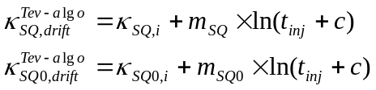

Equation 15
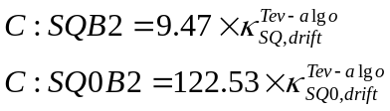

The coefficients in Equation 15 were calculated with MAD using design values for the Tevatron lattice and for the gradient strength of the skew quadrupole correctors.

The coupling drift correction consisted in applying the negative value of the coupling drift measured during a beam study. Since the minimum tune split always measures a positive value for the coupling there is an ambiguity in the sign of the correction that should be applied. This ambiguity was resolved during the study by adjusting the current in the T:SQ circuit to reduce the minimum tune split and recording the sign of the T:SQ correction. In all cases the current in T:SQ was increased to reduce the minimum tune split.

Beam Study 04/22/04

Following a lost store during the early morning hours of Thursday April 22nd 2004 the beam-study was initiated by ramping the Tevatron up to a long, 9823 sec (2.7 hr), flat-top to 980 GeV followed by a 5 min back-porch. As soon as the machine arrived at the injection porch an un-coalesced, proton-only beam was injected and chromaticity measurements performed approximately every 2 minutes by changing the RF frequency and measuring the tune changes. Independent tune measurements were also performed to assess the tune drift. The tunes were systematically spread further apart than during a regular store to prevent interference of coupling with the tune drift measurement. Finally measurements of the coupling drift were also performed. For this purpose the horizontal tune was brought as close as possible to the vertical tune to record the minimum tune-split. During these measurements the electrostatic separators were off and the proton beam was on the central orbit (i.e. no helical orbit.) Table 5 of Appendix 1 contains the raw data gathered during the 04/22/2004 beam-study.

Tevatron b2 Drift after 5 min Back-Porch

Figure 1 shows the measured chromaticity during the ~100 min injection porch following the 2.7 hr (9823 s) flattop and 5 min back-porch pre-cycle. The chromaticity
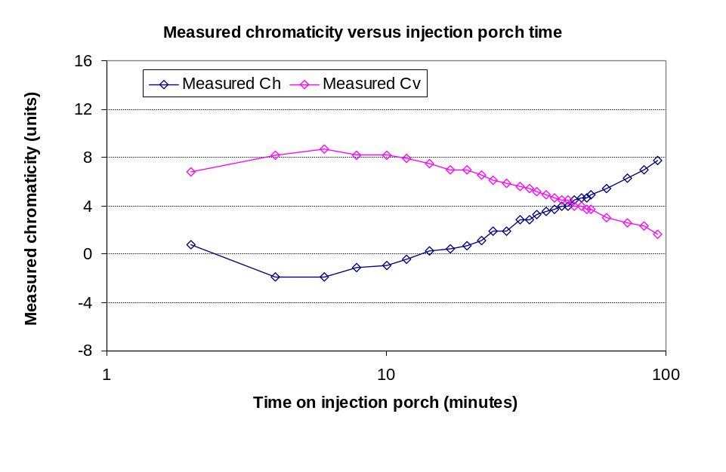
Figure 1: Chromaticity as a function of time on injection porch as measured on 04/22/2004 with un-coalesced protons-only beam on center orbit following a 2.7 hr flattop and 5 min back-porch.
grows during the first few minutes and then steadily decreases. The total variation over the entire injection porch duration is of the order of 8 units, which is consistent with a mismatch of the order of <0.3 b₂ units between the Tevatron sextupole correction algorithm and the actual b₂ drift in the Tevatron dipole magnets. It is not surprising that a chromaticity drift was observed in this study since the outdated correction algorithms were used until they could be updated using the results of this study. As will be shown later the used b₂ algorithm overestimates the magnet b₂ drift at first and under-estimates it at t>10 min, which explains the shape of the chromaticity curves in Figure 1. The measured chromaticity was converted to the b₂ of the average Tevatron dipole magnet with the procedure outlined in section 2) and the results were used to modify the drift correction algorithm.

The T:SF and T:SD corrector currents were constant during this beam study, with T:SF at 3.349 Amps and T:SD at 1.0712 Amps. The currents in the C:SFB2 and C:SDB2 are calculated by the program TCHROM. For the studies on 4/22/2004 the b₂ drift algorithm implemented in the Tevatron, which for the pre-cycle parameters in this case (2.7 hr flat-top and 5 min back-porch), is as given in Equation 16. The time,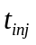, is the time from the start of the injection porch (in seconds). Note that, as discussed in Section 2), the actual b₂ correction delivered by C:SFB2 and C:SDB2 was actually slightly different from Equation 16 because of the outdated conversion coefficients in TCHROM (Equation 8).

Equation 16

Figure 2 shows the results for the measured Tevatron magnet b₂ during the injection porch as computed from the horizontal and vertical chromaticity. The so obtained b₂’s are expected to agree and they do so to the level of < 0.1 units. Using the average of the b₂’s determined from the horizontal and vertical chromaticity, the measured b₂ as a function of time at the injection porch is fitted to Equation 17 and the results of the fit are given in Equation 18 and included in Figure 2. Note that this fit is only valid for the 5 min back-porch, >40 min flattop condition.

Equation 17
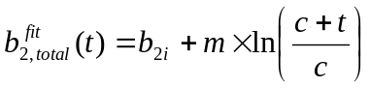

Equation 18
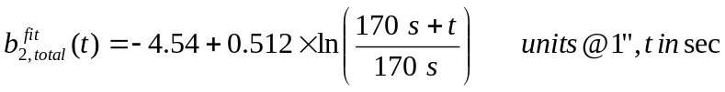

The b₂ measurements and the fit in Equation 18 determine the total amount of b₂ in the Tevatron but it remains to determine what fraction of the total of b₂ is hysteretic and what fraction is dynamic. To make this determination it is assumed that the amount of b₂ originating from the dynamic effects is equal to zero at the start of the injection porch (time t = 0.) The remaining amount of b₂ from Equation 18 is then assumed to be the hysteretic component of the b₂ and is equal to -4.54 units. The best fit to the measured b₂ drift is then given with Equation 19.

Equation 19
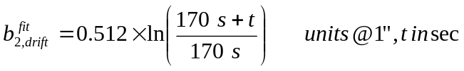

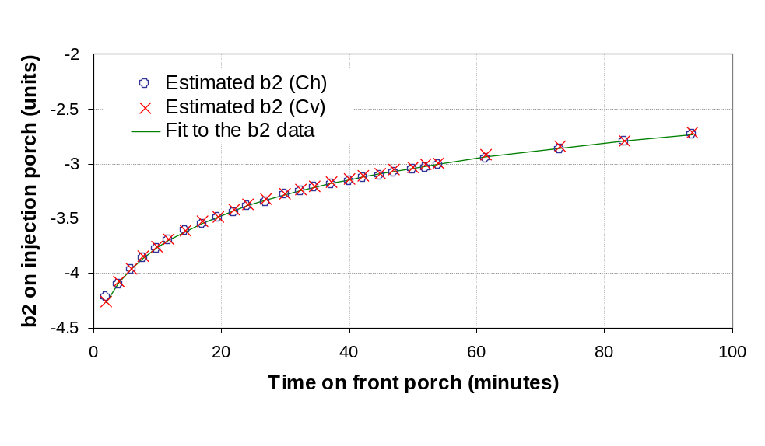
Figure 2: Average sextupole in Tevatron during the injection porch derived from the chromaticity measured on 04/22/2004 with un-coalesced protons-only beam on center orbit following a 2.7 hr flattop and 5 min back-porch. Data were calculated from the measured chromaticity as described in the text and the solid line is a fit to the data (Equation 19).

Comparison of Tevatron b2 Drift to Magnet Measurement Data

Equation 20 gives a fit of the b₂ drift measured at MTF in the Tevatron dipole TB0834 following a 5 min back-porch and 1 hr flat-top pre-cycle. Comparison with the beam based measurements discussed above will allow us to check if the average b₂ drift in the Tevatron can be scaled from one magnet. Note that it doesn’t matter that the flattop in the pre-cycle in the magnetic measurement on TB0834 was not exactly 2.7 hr but only 1 hr. Extensive measurements on several spare Tevatron dipoles at MTF have shown that the drift parameters do not change anymore beyond a ~40 min flat-top^{[5]}. Figure 3 shows the comparison of the b₂ drift measured in the Tevatron (the average of the two data-sets in Figure 2), the currently used Tevatron b₂ drift algorithm (Equation 16) as well as the drift data measured in TB0834.

Equation 20
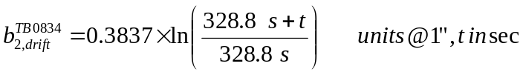

Also note that the drift algorithm and TB0834 drift data were offset by –4.5 b₂ units. This offset is needed to compare the drift data with those obtained in the Tevatron, which include also the average geometric and hysteretic b₂ components of all magnets. The average hysteretic and geometric b₂ of all Tevatron dipoles together is estimated according to [5] to be ~-4.5±0.3 b₂ units.

It is obvious from this plot that neither the current algorithm, nor the drift in TB0834 agrees with the drift measured in the Tevatron. As shown in Figure 3, it is possible, however, to make the TB0834 drift data agree with the b₂ measured in the Tevatron when scaling with a factor 1.75. The agreement is not perfect (~ ±0.15 b₂ units), but encouraging because it indicates that the behavior found in a small number of magnets

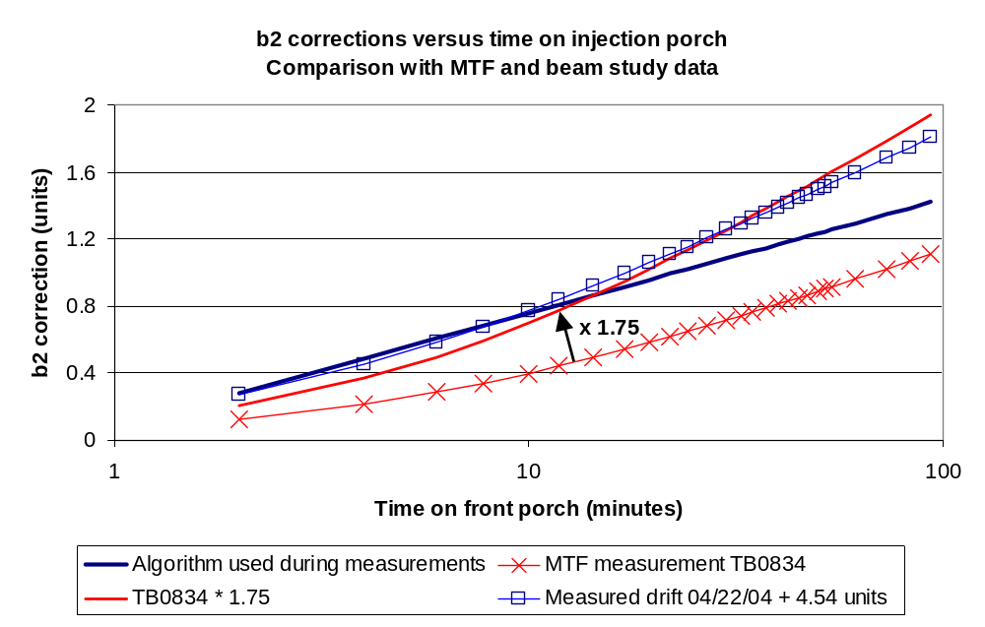
Figure 3: Average sextupole in Tevatron during the injection porch, derived from the chromaticity measured on 04/22/2004 with un-coalesced protons-only beam on center orbit following a 2.7 hr flat-top and 5 min back-porch. Also shown are the then used Tevatron drift correction algorithm and the result of a magnetic measurement in Tevatron dipole TB0834 following a 60 min flattop and 5 min back-porch. Note that the beam study result was offset corrected by +4.54 units.
can be extrapolated with a simple scaling factor to that of the entire magnet ensemble installed in the ring. Note that the curve representing the current algorithm is not corrected for the effect of the outdated conversion coefficients (see Section 2.2) and should be multiplied by a factor of approximately 1.12 to ensure that the intended functional b₂ profile is actually played out in the Tevatron b₂ correctors.

Tevatron Tune Drift after 5 min Back-Porch

The tune drift at 150 GeV as a function of time on the front porch was also measured during this study period. Figure 4 shows the horizontal and vertical tunes measured during the ~100 min injection porch following the 2.7 hr flat-top and 5 min back-porch pre-cycle. The total variation over the entire injection porch duration is of the order of 0.004 units in the horizontal plane and 0.0015 units in the vertical plane. The raw data are listed in Table 5 in Appendix 1.
Ideally the tune added by the trim quadrupole correctors C:QFB2 and C:QDB2 should cancel the drift in the tunes related to drifting fields in the Tevatron. As will be shown next the tune correction does not perfectly track the tune drift behavior in the magnets and therefore the tune changes during the injection porch. It is not surprising that a tune drift was observed in this study since the outdated correction algorithms were used until they could be updated using the results of this study. The outdated algorithms were based on beam studies conducted in 2002 and were therefore optimized for a different pre-cycle condition (30 min flattop, 1.5 min back porch).

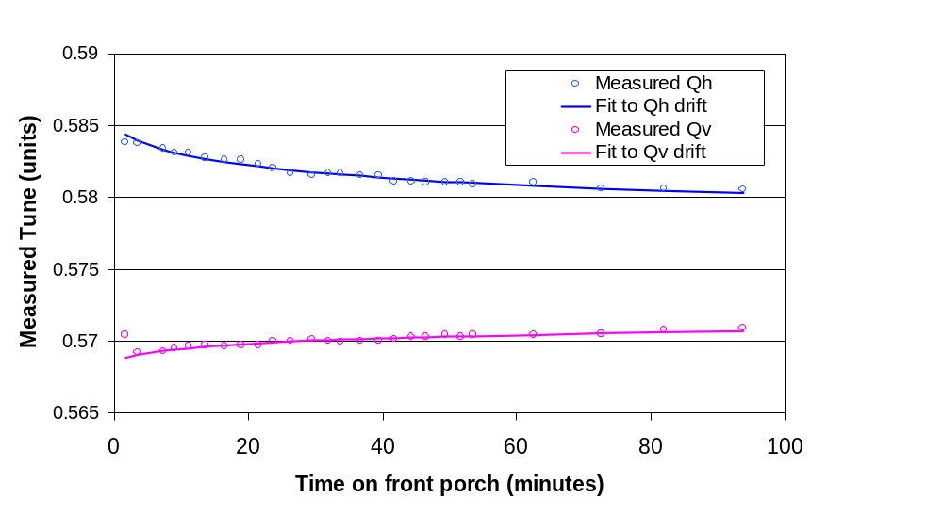
Figure 4: Horizontal and vertical tunes measured as a function of time on the front porch on 04/22/2004 with un-coalesced protons-only beam on center orbit following a 2.7 hr flat-top and 5 min back-porch. The solid lines are fits to the data.
The tune drift caused by dynamic magnetic field effects can be extracted from the measured tune and the corrector-supplied tune as discussed in Section 3).

The currents in the C:QFB2 and C:QDB2 are calculated by the program TCHROM^{[1]}. For the studies on 4/22/2004 (and the pre-cycle parameters in this case: 2.7 hr flat-top and 5 min back-porch), the tune drift algorithm implemented in the Tevatron is as given in Equation 21. The time,, is the time from the start of the front porch (in seconds.)

Equation 21
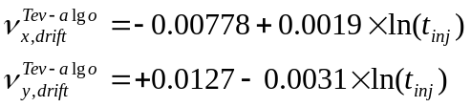

Using Equation 11 with the measured tunes and the known current in the quadrupole the tune component from the magnets we can calculate the total tune drift at 150 GeV. This is shown in Figure 5. The fits to the data are given in Equation 22. For these fits the assumption was made that the behavior of the tune drift has the same time structure as the b₂ drift and therefore the time constant in the fit for the tune was set to 170 seconds and was not a free parameter in the fit.

Equation 22
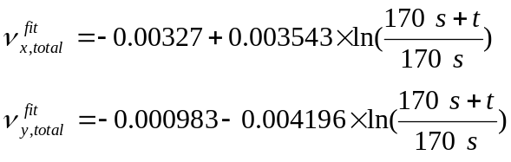

In the absence of a true understanding of the cause of the tune drift the offset in Equation 22 cannot be interpreted because there are not tune measurement data for the t=0 on the injection porch. We will assume that the tune drift follows a purely logarithmic function such as in Equation 22 on top of the tune set-point. The offset in Equation 22, must then be some residual remaining after an incomplete removal of the tune set-point. Equation 22, without the offset, will be the basis of the new Tevatron tune drift compensation.
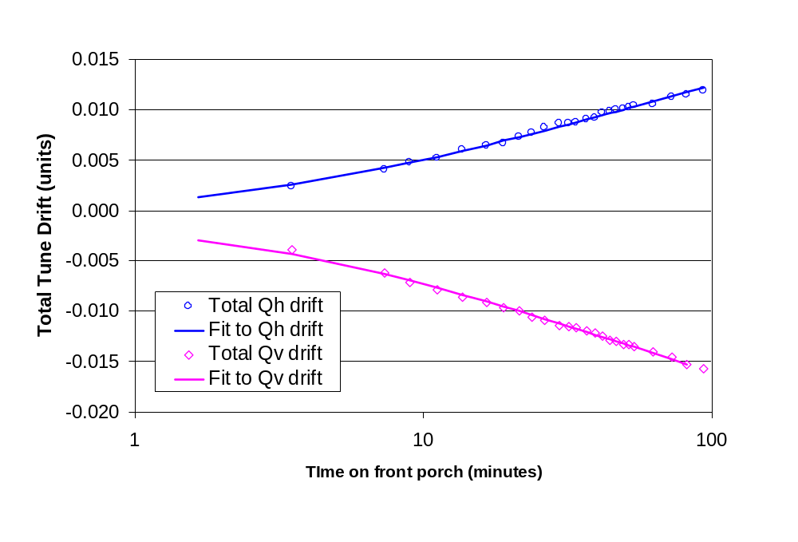
Figure 5: Total horizontal and vertical tune drift derived from the tune drift measured on 04/22/2004 with un-coalesced protons-only beam on center orbit following a 2.7 hr flat-top and 5 min back-porch. The solid lines are fits to the data (Equation 22).

Beam Study 04/27/2004 (Tevatron in a ramping State)

On 4/27/2004 the chromaticity was measured on the early portion of the Tevatron ramp from 150 to 200 GeV while the Tevatron was in a state of almost continual ramping. Following a minimum dwell at injection of ~2 secs, beam was injected and the ramp initiated 4 secs later. In this state the Tevatron energy ramp has a minimum dwell time on the injection plateau. The beam was subsequently dumped at collision energy and the Tevatron ramped back down for the next injection, with a minimum waiting time at the back-porch of ~6 secs. The purpose of this beam study was to measure the chromaticity on the Tevatron ramp in a situation where the front porch drift and snapback are minimal. The chromaticity was derived from the tunes recorded during subsequent ramps with varying RF frequency (-80, -40, 0, +40, and +80 Hz). The raw measurement data are listed in Table 6 in Appendix 2.

Tevatron b2 in the Ramping state

The average hysteretic b₂ (which, strictly speaking also includes some residual geometric b₂ component) of the Tevatron dipole magnets is known only from the magnetic measurement data archive (or approximations thereof). The details of this derivation from former and recent magnetic measurements at MTF are discussed elsewhere^{[5]}. One of the difficulties in this respect is that the magnetic measurement archive data need to be corrected for the dynamic effects, not known at the time of the measurement. Especially the estimate of the hysteretic b₂ in the Tevatron dipoles at 150 GeV from the Tevatron dipole magnetic measurement archive is difficult, if not impossible at this stage. The average hysteretic and geometric b₂ of all Tevatron dipoles together is estimated according to [5] to be ~-4.5±0.3 b₂ units. The average of all Tevatron dipoles to which the geometric b₂ tends at 980 GeV, is somewhat easier to obtain, but also not straight forward. On the basis of a combination of Tevatron magnetic measurement archive and recent magnetic measurement data it is estimated to be ~1.23 units (@ 1”)^{[5]}.

The purpose of the beam-study conducted on April 27, 2004 was to estimate the average hysteretic b₂ of the superconducting Tevatron dipole magnets at injection and on the ramp from injection from the beam chromaticity. For this purpose the Tevatron was put into a state of continual ramping with a minimum dwell time on the front and back porches in order to minimize the magnitude of drift and snapback. The idea is that minimizing the dynamic b₂ effects makes it easier to extract the b₂ contribution from the static (hysteretic + geometric) effects.

The ramping cycle for the study is shown in Figure 6. The ramps were stopped a minimum time at all porches. The flattop is at 980 GeV with a duration of 10 seconds, the back porch is at 150 GeV with a duration of 6.12 seconds, the reset is at 90 GeV, and the injection porch is at 150 GeV with a duration of 6.12 seconds. Un-coalesced proton only beam was injected every ramp cycle on the front porch and accelerated to 980 GeV with the electrostatic separators turned off so that the protons were on the center orbit. The tunes were recorded in a buffer (using the fast capture mode of the oscilloscope) that collected 27 seconds data beginning 4.8 seconds before the start of the acceleration and ending at about the 200 GeV point on the ramp. Tune data was collected on five different ramps with varying offsets in the RF frequency, Δf₀=80 Hz, Δf₁=40 Hz, Δf₂=0 Hz, Δf₃=-40 Hz, Δf₄=-80 Hz. This data is then used to calculate the chromaticity of the beam on the ramp.

Figure 7 shows the measured fractional tunes (lower and upper stands for vertical and horizontal tunes) for the different ramps. The fractional tunes were obtained from the

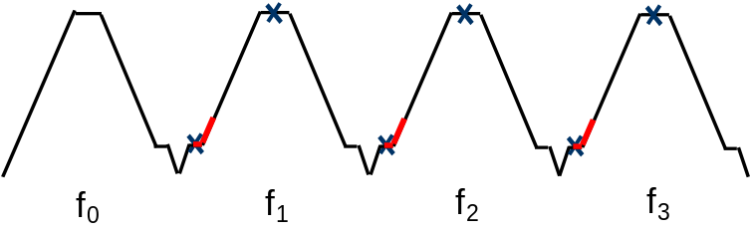
Figure 6: Sketch of the ramping cycle for beam study. The ramps were stopped a minimum time at all porches, where the injection porch and flat-top are longer for beam injection and extraction (indicated with blue crosses). The part of the ramp during which chromaticity measurements were performed is outlined in red.
tunes via division by the revolution frequency (47,713 Hz). The chromaticity in Figure 8 was calculated from the fractional tunes q (for a given frequency) with Equation 23. Note that the chromaticity is calculated separately either from the ±40 Hz tune data set or the ±80 Hz tune data set. As can be seen in Figure 8 the chromaticity calculated from the two data sets agree very well. The chromaticity is also summarized in Table 6 in Appendix 2.

Equation 23
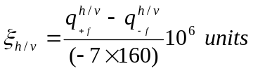

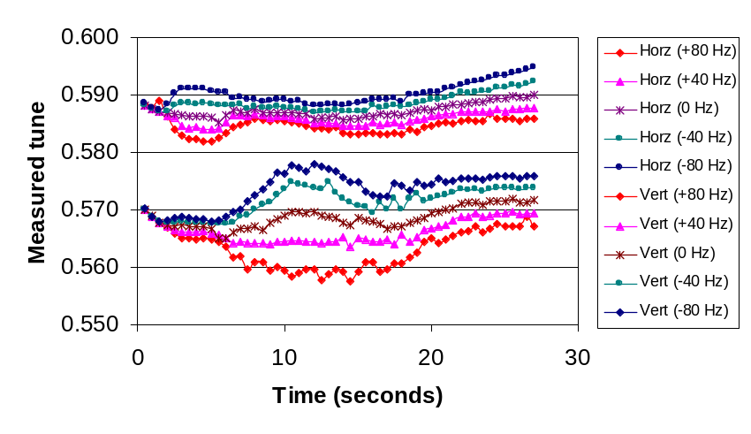
Figure 7: Results of fractional tune measurements during the first 27 seconds of the Tevatron ramp using the Schottky fast time capture mode. The start of the Tevatron acceleration begins at 4.8 seconds on this plot and the Tevatron reaches the energy of 200 GeV at about 27 seconds.

Figure 8 shows the following characteristics:

- During the first two seconds of the ramp the chromaticities converge toward each other and finally cross over, a clear signature of (short – in this case) an uncompensated b₂ snapback.
- ξ_{x} varies strongly on the ramp between ~160 and 170 GeV. The cause for this chromaticity bump is not understood, possibly a result of the b₂ corrector settings.

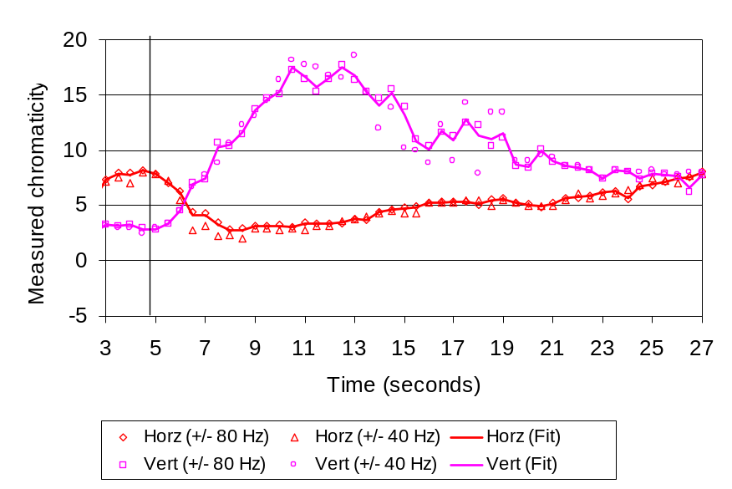
Figure 8: Lower and upper (vertical and horizontal) chromaticity in Tevatron during first 27 seconds of ramp as derived from the fractional tunes. The start of the Tevatron acceleration begins at 4.8 seconds on this plot (indicated by line) and the Tevatron reaches the energy of 200 GeV at about 27 seconds. The chromaticity clearly varies by up to 20 units.

During this study only the “static” chromaticity corrector protocol is played out and the “dynamic” chromaticity correctors (C:SFB2 and C:SDB2) are de-activated. In Table 2 the sextupole corrector settings as they were during these measurements are listed at each energy breakpoint. The settings of chromaticity, Ch and Cv, in the Tevatron ramp control program are converted into currents in the sextupole correctors, T:SF and T:SD, at each energy breakpoint. The conversion from the chromaticity set-values in C49 to the T:SF and T:SD corrector currents is performed with Equation 24 according to a long established (but not anymore understood) procedure. The <b₂> function, given in Equation 25, is a fifth order polynomial fit of the hysteretic b₂, implemented during Tevatron startup.

Equation 24
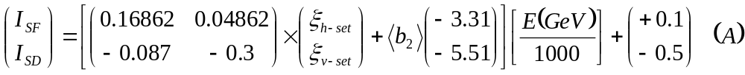

Equation 25
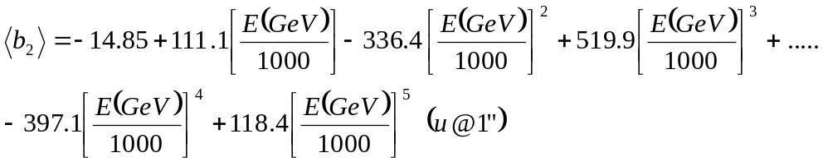

During the ramp the currents in T:SF and T:SD are linearly interpolated between the two nearest energy breakpoints. The interpolation is done as a function of energy as it is done real time as the Tevatron energy increases. The times in Table 2 refer to the start of Tevatron acceleration, which occurs 4.8 seconds after the collection of tune data began. Table 6 in Appendix 2 lists the so-found corrector currents for each time-point at which the chromaticity was measured. Note that the SD corrector family crosses through zero current between 180 and 200 GeV. Possible issues related to the hysteresis in the superconducting sextupole correctors were not further investigated here. Also note the settings from the so-called H-table, also listed in Table 2. The H-table allows adding chromaticity without going through the regular procedure. In this particular study two units of chromaticity were removed at the injection porch and then gradually returned during the ramp, since the H-table corrector currents are not scaled with the ramp energy.

Table 2: Sextupole corrector currents at each breakpoint in the Tevatron ramp control program. *set-values from h-table.
Ch set value  (C49 units) | Cv set value  (C49 units) | Energy (GeV) | Time  (seconds) | T:SF  (Amps) | T:SD  (Amps)
47-2* | 22-2* | 150.06 | 0 | 3.465 | 1.218
47 | 32 | 153.09 | 5.410714 | 3.548 | 0.697
45 | 31 | 162.5 | 11.0119 | 3.509 | 0.545
42 | 31 | 180 | 17.15657 | 3.436 | 0.143
41 | 34 | 200 | 22.15657 | 3.419 | -0.563
36 | 38 | 300 | 36.45863 | 3.093 | -3.691

With these chromaticity corrector settings, the chromaticity data shown in Figure 8 were converted into the average b₂ of the Tevatron using the methods described in Section 2) of this report. Since the energy of the beam changes during the ramp, the conversion between corrector currents and chromaticity in Equation 3 was scaled appropriately with an energy factor (E(GeV)/150).

Using the average of the b₂’s determined from the horizontal and vertical chromaticity, the measured b₂ as a function of energy is plotted in Figure 9. The same data as a function of time is plotted in Figure 10. The b₂ data from 160 GeV to 200 GeV was used to determine a linear fit to the b₂ as a function of energy and this is also plotted in Figure 9 and Figure 10. The result of the linear fit is given in Equation 26.

Equation 26
.

The data in Figure 9 and Figure 10 show an unexpected dip after 2-3 secs into the ramp. Is the sudden change during the first 3 seconds of the ramp a snapback? Since no significant drift is expected to occur during the first few seconds of the injection porch, such a snapback is unexpected. Possible explanations for this effect are discussed next.

As a first possible explanation for the “fast b₂ drift” found in the ramping state measurement, is that is simply the effect of the very short (6 sec) back-porch condition on the b₂ drift at injection. The 6 secs back-porch condition was not explored in the magnet test campaign (the shortest back-porch was 1 min). An extrapolation of the function describing the average back-porch dependence of five Tevatron dipoles for back-porches between 1 and 30 mins indicates an increase of drift amplitude by 25% for a 6 secs back-porch compared to a 5 min back-porch. Equation 19 can be used to predict the drift amplitude after 6 secs on the injection porch for a 5 min back-porch condition, giving 0.016 units (@ 1”). An additional 25% would bring the expected b₂ snapback amplitude for the conditions of the 04/27/04 beam study to 0.02 units (@ 1”), which is ten times

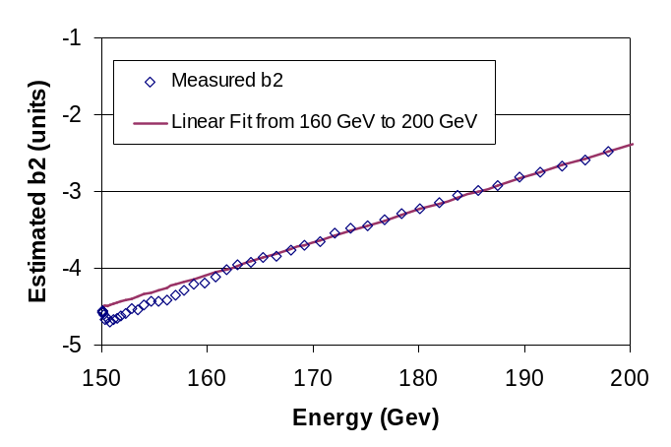
Figure 9: Measured value of b₂ as a function of energy as while the Tevatron was in a ramping state. The value of b₂ is the average value of that determined from the horizontal and the vertical chromaticity. The solid line is a linear fit to the measured b₂ using only the data from 160 GeV to 200 GeV in the fitting.
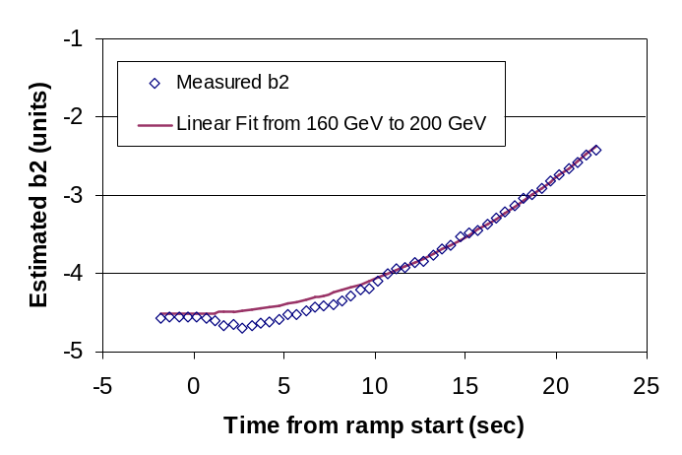
Figure 10: Measured value of b₂ as a function of time as while the Tevatron was in a ramping state. In this plot, time t=0 is the beginning of acceleration. The value of b₂ is the average value of that determined from the horizontal and the vertical chromaticity. The solid line is a linear fit to the measured b₂ as a function of energy using only the data from 160 GeV to 200 GeV in the fitting. The linear fit as a function of energy appears as a quadratic in this plot since the energy is a quadratic function of time at the start of the Tevatron acceleration.
smaller than the observed effect of ~0.13 units. It is, however, possible that the extrapolation of the back-porch effect to very short back-porch times is not accurate. A magnetic measurement on a Tevatron dipole pre-cycled with a 6 secs back-porch could further clarify this issue.

Another possible explanation for the “fast b₂ drift phenomenon” could be very short time constant drifts, for which there are already hints in the results of magnetic measurements on select Tevatron dipoles^{[5]}. A separate, small time constant term would be required to represent the fast drift contribution. A fast drift during the first few secs would not be included in fits of the kind as in Equation 19. Also, beam chromaticity measurements on the injection porch can be performed at the earliest after several minutes, therefore such fast drifts would not be revealed. If a fast drift is related to a de-magnetization, an ensuing snapback of the same magnitude is to be expected on the ramp.

To be consistent with a snapback, however, the backwards extrapolation of the ramp b₂ needs to lead to a hysteretic b₂ in the Tevatron at 150 GeV of –4.7 units (@ 1”). Figure 11 shows the same data as in Figure 10, except that the baseline extrapolation was constrained to reach to –4.7 units at 150 GeV.

Figure 12 shows a comparison of the hysteretic b₂ baseline according to Equation 26 and the result of a former b₂ on the ramp beam study (12/04/2002). The results agree to within 0.1 b₂ units at 150 GeV. Note that the ramp study in 2002 was performed after a
long injection porch and a severe snapback needed to be removed from the data. The hysteretic b₂ in the Tevatron, however, should not depend on the parameters that strongly affect the drift and snapback (only average magnet temperature counts).

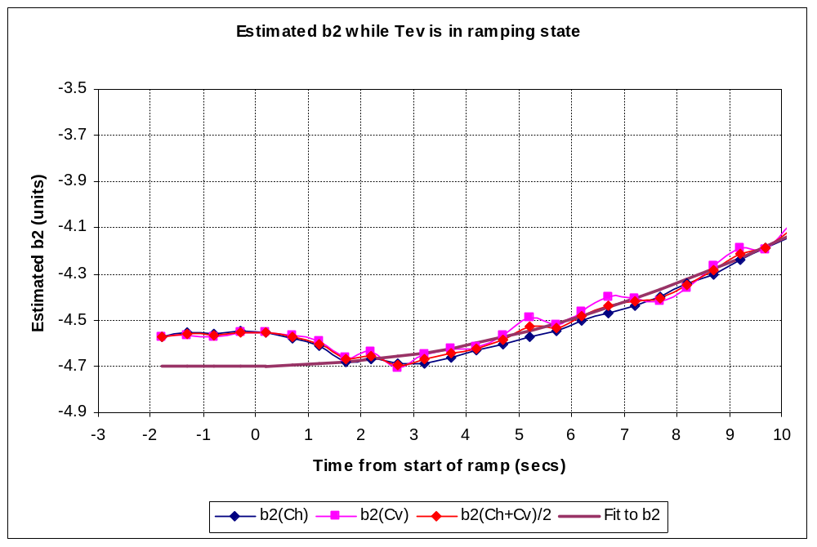
Figure 11 Average Tevatron dipole b₂, first 27 secs of ramp (150-200 GeV). A drift is observed, followed by a 0.13 unit (~ 2secs) snapback. The snapback is not strong and can be expected despite the very short (max 6 secs) injection porch duration. A back-wards extrapolation of the ramp indicates a hysteretic b₂ in the Tevatron at 150 GeV of –4.7 units (@ 1”).
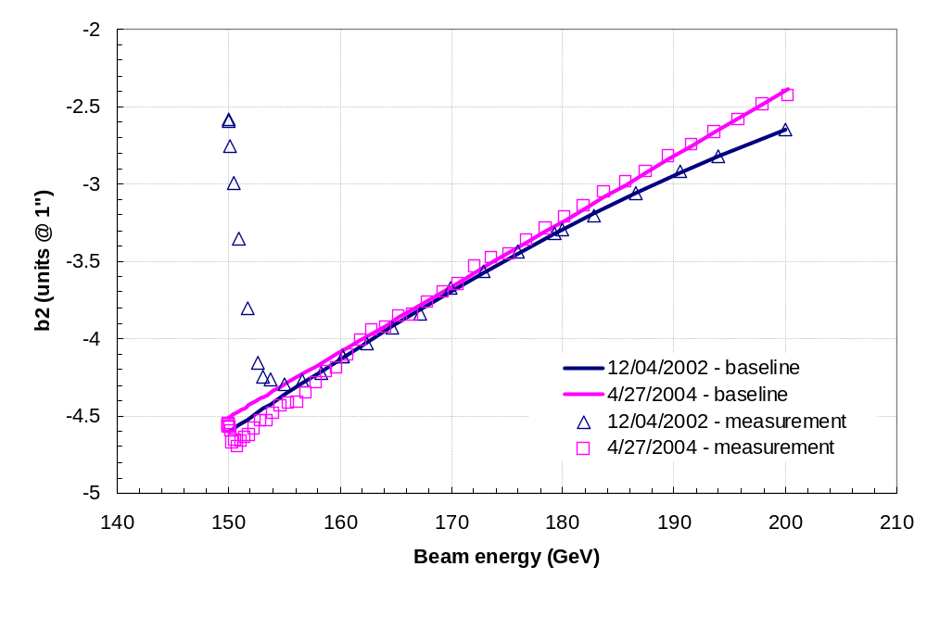
Figure 12: Comparison of average hysteretic b₂ in the Tevatron dipoles derived from two beam chromaticity measurements separated by two years. Note that the extrapolation was calculated from the data for the 160-200 GeV beam energy range.

Beam Study 06/29/2004

The beam-study conducted on 06/29/2004 consisted of checking the improved drift correction algorithm derived from the 04/22/04 beam study and further refining the parameters for the tune and coupling drift. Following a 25.63 hr flattop the Tevatron was ramped down to a 5 min back-porch in the morning of June 29th 2004. As soon as the machine arrived at injection an un-coalesced, protons-only beam was injected and chromaticity measurements performed every ~5 min. In addition tunes and minimum tune split measurements were performed. Table 7 in Appendix 3 summarizes the beam study data collected on 06/29/2004.

Tevatron b2 Drift after 5 min Back-Porch

As discussed in Section 2.2) the outdated b₂-to-current conversion coefficients in TCHROM result in the fact that the b₂ correction in the Tevatron is actually larger than the amount of b₂ given by the TCHROM algorithm. To compensate for this effect the measured b₂ drift from the 4/22/04 beam study in Equation 19 should be divided by a factor of 1.12 to produce the b₂ drift algorithm needed for input to TCHROM. The initial analysis of the 4/22/04 beam study data had not taken into account this effect and therefore resulted in the suggestion of a new correction algorithm (Equation 27) for the 06/29/2004 studies, which was not exactly as desired. Fortunately the algorithm in Equation 27 (or the equivalent in Equation 28) was quite close to the desired TCHROM algorithm.
Equation 27
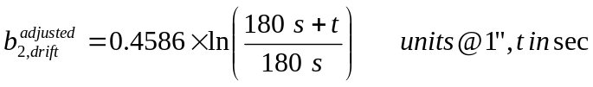

Equation 28

With the correction function for the b₂ drift implemented in TCHROM as given in Equation 28 the chromaticity was measured on the injection porch. Figure 13 shows the measured chromaticity during the ~120 min injection porch following a store with a
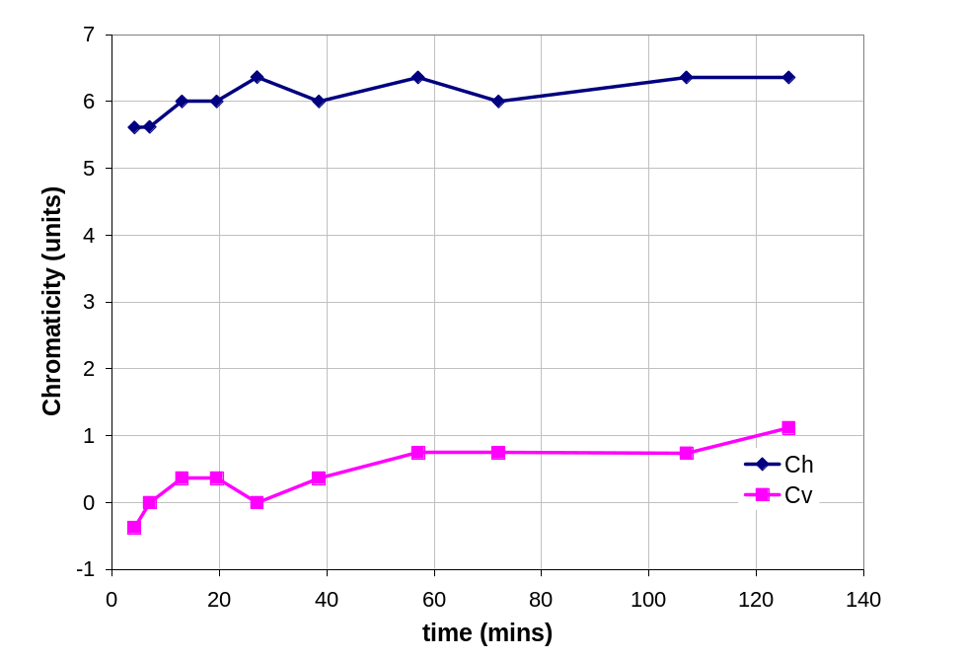
Figure 13: Chromaticity on injection porch measured on 06/29/2004 with un-coalesced protons-only beam on center orbit following a 25.63 hr flattop and 5 min back-porch.

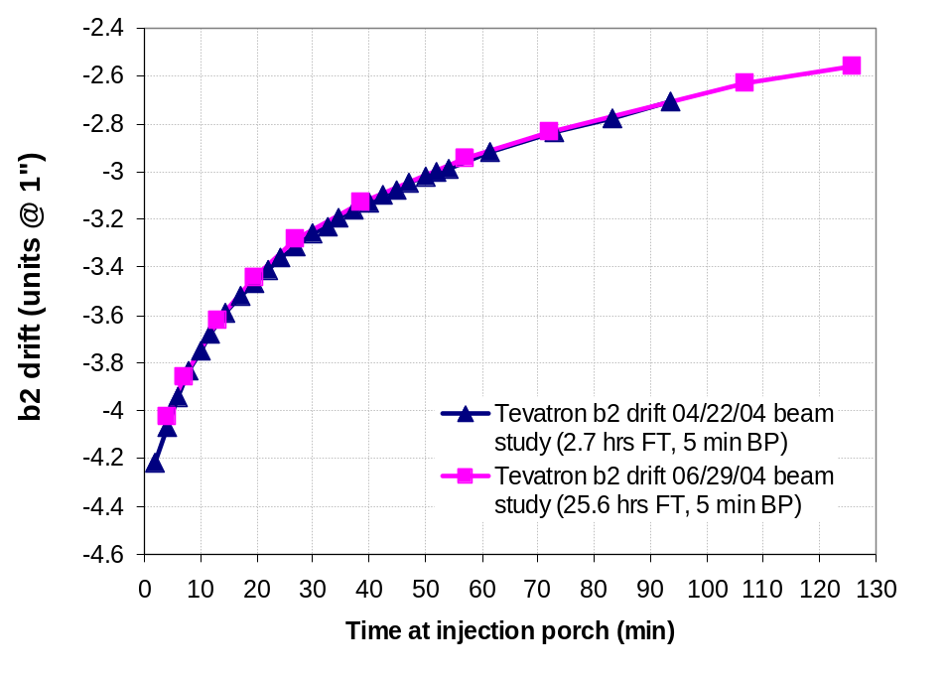
Figure 14 Average sextupole in Tevatron during the injection porch, derived from the chromaticity measured on 06/29/2004 with un-coalesced protons-only beam on center orbit following a 25.63 hr flattop and 5 min back-porch. The measured b₂ drift agrees very well with the b₂ drift found on 04/22/04 following a 2.7 hr flattop and 5 min back porch.

25.63 hr flat-top and a 5 min back-porch. The chromaticity is stable to within one unit indicating that the adjusted drift correction algorithm tracks the b₂ in the magnets to within <0.05 units. The measured chromaticity was converted to the b₂ of the average Tevatron dipole magnet with the procedure outlined in Section 2). The only difference with respect to the 04/22/04 beam study (see Section 3)) is that the currents were 3.371 A in T:SF and 1.225 A in T:SD.

Figure 14 shows a comparison of the results of the b₂ drift in the Tevatron magnets as derived from the 04/22/2004 and the 06/29/2004 beam studies. The results agree very well. This not only proves that the Tevatron is stable in time, but also further corroborates the evidence from the magnetic measurements at MTF: Beyond a flattop time of ~40 min, the effect of the pre-cycle flattop duration on the slope of the drift saturates. The flattop durations explored here are: 2.7 hr for the 04/22/04 study and 25.7 hr for the 06/29/04 study.

Tevatron Tune Drift after 5 min Back-Porch

The tune drift at 150 GeV as a function of time on the front porch was also measured during this study period. Figure 15 shows the horizontal and vertical tunes measured during the ~100 min long injection porch following the 25.6 hr flat-top and 5 min back-porch pre-cycle. The total variation over the entire injection porch duration is +0.0024 units in the vertical plane and -0.0016 units in the horizontal plane. The raw data are
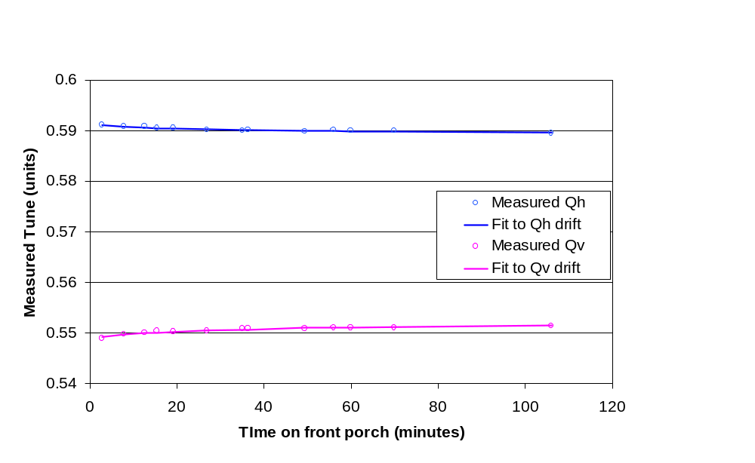
Figure 15 Horizontal and vertical tunes measured as a function of time on the front porch on 06/29/2004 with un-coalesced protons-only beam on center orbit following a 25.6 hrs flat-top and 5 min back-porch. The solid lines are fits to the data.
listed in Table 7 in Appendix 3. Ideally the tune added by the trim quadrupole correctors C:QFB2 and C:QDB2 should cancel the drift in the tunes related to drifting fields in the Tevatron. As will be shown next the tune correction does not perfectly track the tune drift behavior in the magnets and therefore the tune changes during the injection porch. The tune drift was much better controlled than during the 04/22/04 beam study.

The tune drift caused by dynamic magnetic field effects can be extracted from the measured tune and the corrector-supplied tune as discussed in Section 3). The currents in the C:QFB2 and C:QDB2 are calculated by the program TCHROM^{[1]}. For the studies on 6/29/04, the tune drift algorithm implemented in the Tevatron, which for the pre-cycle parameters in this case (25.6 hrs flat-top and 5 min back-porch) is as given in Equation 29. The time,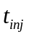, is the time from the start of the front porch (in seconds). This algorithm was derived from an analysis of the tune drift data on 4/22/04. Due to a typing error when entering the coefficients for the updated tune drift algorithm the vertical tune was lower than expected and therefore the tunes were widely separated. Instead of a +0.002038 for the coefficient, a value of +0.02038 should have been entered and as a result the vertical tune was lower than expected by about 0.018 tune units.

Equation 29
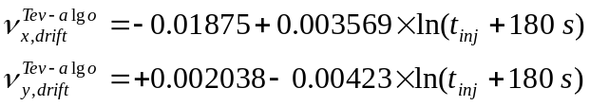

According to the procedures outlined in 3) we can calculate the total tune drift at 150 GeV from the data shown in Figure 15. This is shown in Figure 16. The 06/29/04 data for the vertical tune drift were shifted by +0.02 units in this plot to correct for the “offset error”. The fits to the data are given in Equation 30. For these fits the assumption was made that the behavior of the tune drift has the same time structure as the b₂ drift and therefore the time constant in the fit for the tune was set to 170 seconds and was not a free parameter in the fit. As explained before, the offset in Equation 30 is only an artifact of the data-reduction procedure and void of any significance (at this point).

Equation 30
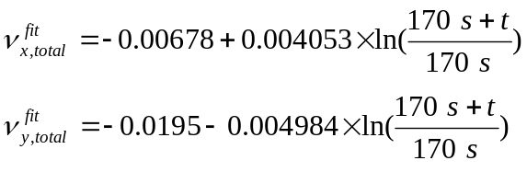

Since we cannot measure the tune immediately after the start of the front porch (at time t = 0) the amount of tune drift at time t = 0 is determined from an extrapolation of the data. However, a constant offset can always be added to the data which makes the tune drift at time t = 0 undetermined. Therefore we choose to make the assumption that the tune drift at time t = 0 is equal to zero resulting in the tune drift correction algorithm given in Equation 31. The right hand side implementation of the drift formula in Equation 31 is for the purpose of implementation in TCHROM, which uses the 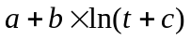 form.

Equation 31
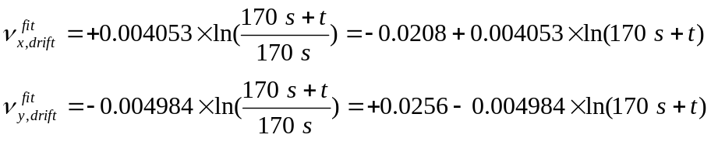

In principle the adjustments made to the tune drift algorithm coefficients from the 4/22/04 studies should have kept the tunes constant during the front porch. Instead, the results of the 6/29/04 measurements showed more tune drift than expected (see Figure 16). Therefore a re-iteration in the update of the coefficients is needed. It is speculated that the data from the 4/22/04 studies may not have measured the total tune drift because of coupling effects.

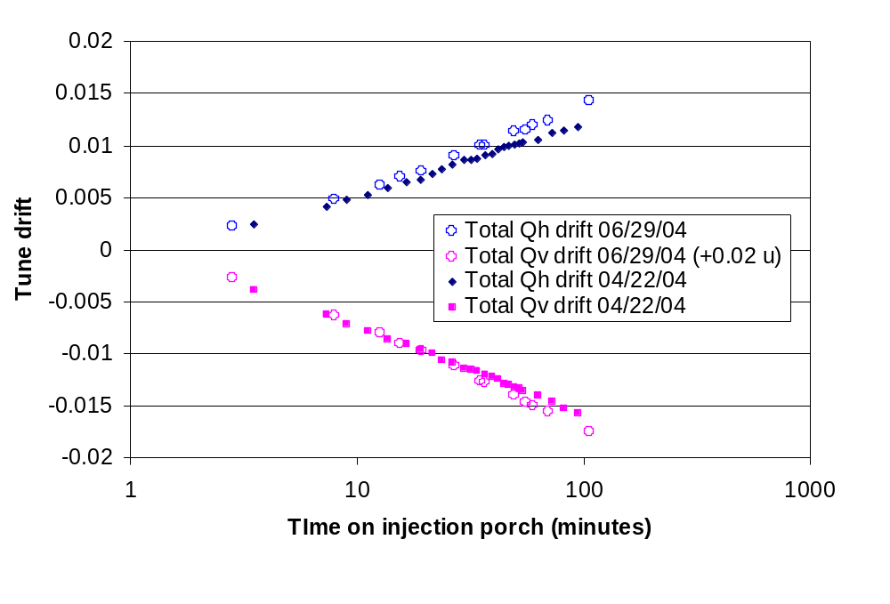
Figure 16 Total horizontal and vertical tune drift derived from the tune drift measured on 06/29/2004 with un-coalesced protons-only beam on center orbit following a 25.6 hrs flattop and 5 min back-porch. Also shown are the data from 04/22/04. The vertical tune of 06/29/04 was shifted by +0.02 units to correct for the “offset-error”. Good agreement between the two sets of beam study data was found. The solid lines are fits to the data shown.

Tevatron Coupling Drift after 5 min Back-Porch

For the 6/29/04 study the coupling drift algorithm was applied as shown in Equation 32.
Equation 32
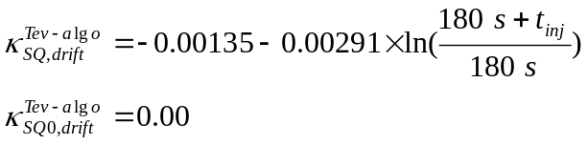

With this coupling drift algorithm active during the front porch the coupling was measured as a function of time on the front porch and the data is shown in Figure 17. With this algorithm active, minimum tune splits as large as 0.011 were measured. This should be compared to a desired goal of less than 0.003 for Tevatron collider operations. Since the measured minimum tune split is always a positive value there is an ambiguity in the sign of the coupling correction that should be applied. This ambiguity was resolved during the study by adjusting the current in the T:SQ circuit to reduce the minimum tune split and recording the sign of the T:SQ correction. In all cases the current in T:SQ was increased to reduce the minimum tune split. This implies that the correction algorithm used in Figure 17 over-compensated for the coupling.

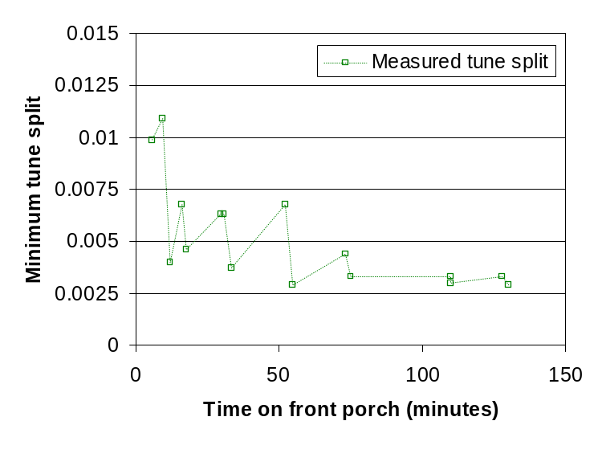
Figure 17: Measured minimum tune split as a function of time on the front porch after a 25.6 hour flattop and a 5 minute back porch on the preceding Tevatron ramp. The data were taken on 6/29/04 and the minimum tune split was determined measured by using the tune correction circuits to push the horizontal and vertical tunes. The coupling correction algorithm was active during these measurements.

Using the data shown in Figure 17, a fit to the total coupling was determined and the results shown in Figure 18. From this result we can see that the amount of coupling drift was larger than measured on 6/22/04 (which is the amount corrected by the algorithm).

Equation 33
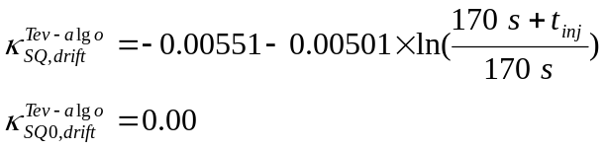

Since we cannot measure the coupling immediately after the start of the front porch (at time t = 0) the amount of coupling drift at time t = 0 is determined from an extrapolation of the data. However, a constant offset can always be added to the data which makes the coupling drift at time t = 0 undetermined. Therefore we choose to make the assumption that the coupling drift at time t = 0 is equal to zero resulting in the coupling drift correction algorithm given in Error: Reference source not found.

Equation 34
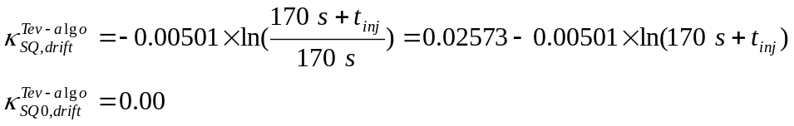

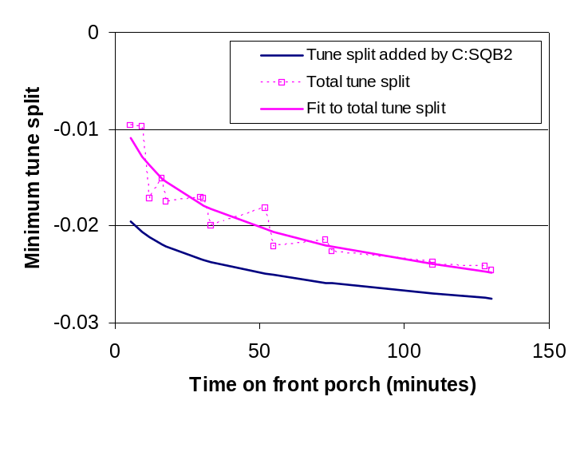
Figure 18: Amount of coupling drift on the front porch during the 6/29/04 studies. The dark blue line represents the amount of coupling that was added to the Tevatron by the C:SQB2 circuit as part of the coupling correction algorithm. The open squares are the estimated total amount of coupling drift based on the measured tune split and the solid line is a fit to the coupling drift.

Beam Study 07/23/04

On 7/23/2004 the tune, coupling, and chromaticity drift were measured on the front porch after a flattop duration of 3.7 hours with a 5 minute back porch on the ramp-down from the previous Tevatron ramp. This study was used mostly for a more careful measurement of the coupling drift on the front porch. The quality of the updated tune correction algorithm (which was updated based on the 6/29/2004 results) was also checked. With the updated tune and chromaticity algorithms the measured chromaticity drifted by less than one unit and the measured tunes drifted by less than 0.0005 units over about a two hour period on the front porch. The coupling was observed to change by 0.007 units of minimum tune split over a two hour period. A new version of TCHROM was also implemented and tested. The complete set of measurement data are in Table 8 of Appendix 4.

Tevatron b2 Drift after 5 min Back-Porch

Figure 19 shows the measured chromaticity during the ~120 min injection porch following a store with a 3.70 hr flattop and a 5 min back-porch. As expected the chromaticity was stable to within one unit using the correction algorithm given in Equation 27. The b₂ of the average Tevatron dipole magnet as derived from the measured chromaticity is compared to that of recent beam studies (04/22/2004, the 06/29/2004 and the 07/23/2004) in Figure 20. The only difference with respect to the former beam studies discussed here is (see section 3)) is that the currents were 3.2772 A in T:SF and 1.2329 A in T:SD. A small discrepancy between the latest and the older data was noted but could not be explained.

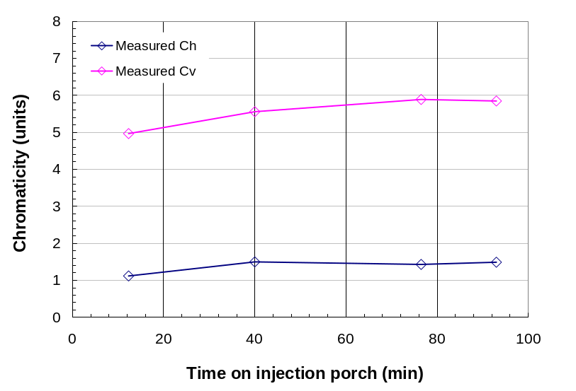
Figure 19: Chromaticity on injection porch measured on 07/23/2004 with un-coalesced protons-only beam on center orbit following a 3.7 hr flattop and 5 min back-porch.

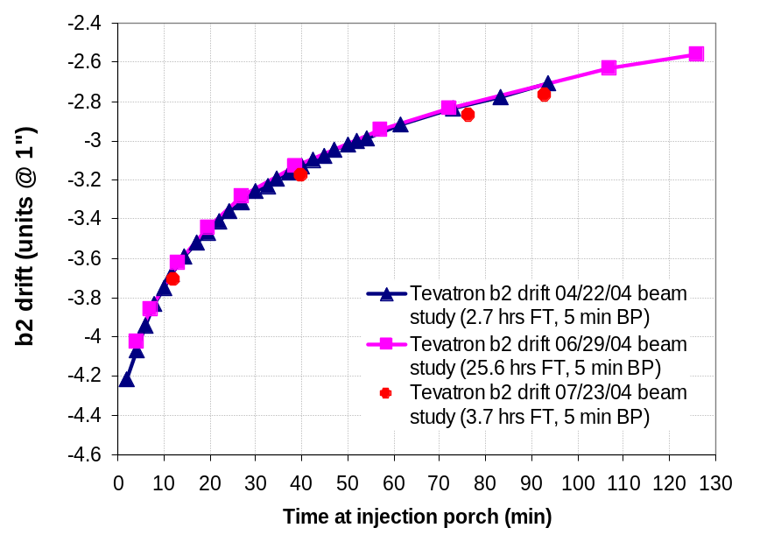
Figure 20: Average sextupole in Tevatron during the injection porch, derived from the chromaticity measured on 06/29/2004 with un-coalesced protons-only beam on center orbit following a 25.63 hr flattop and 5 min back-porch.

Tevatron Tune Drift after 5 min Back-Porch

The tune drift at 150 GeV as a function of time on the front porch was also measured during this study period. Figure 21 shows the horizontal and vertical tunes measured during the ~100 min injection porch following the 3.7 hrs flat-top and 5 min back-porch pre-cycle. The total variation over the entire injection porch duration is less than 0.0005 units in both the vertical plane and horizontal plane. The raw data are listed in Table 8 in Appendix 4.
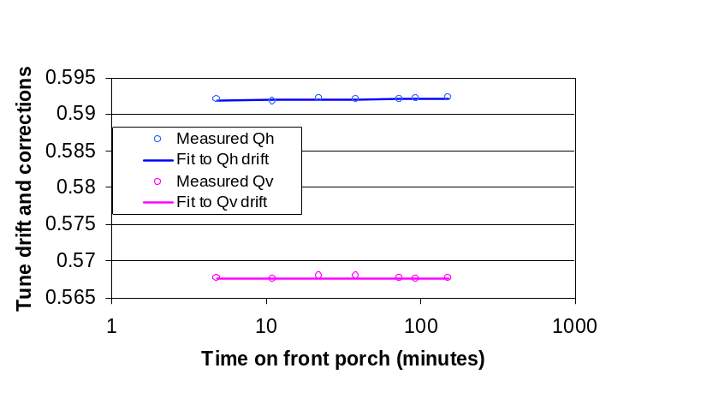
Figure 21: Horizontal and vertical tunes measured as a function of time on the front porch on 07/23/2004 with un-coalesced protons-only beam on center orbit following a 3.7 hrs flat-top and 5 min back-porch. The solid lines are fits to the data.
The tune drift algorithm used during the study on 7/23/04 is shown in:

Equation 35
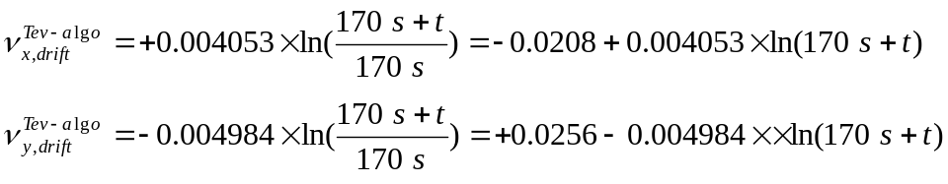

From these results we conclude that tune compensation algorithm is good enough to keep the tune drift below acceptable values. An analysis to fine tune the algorithm even further gives the results

Equation 36
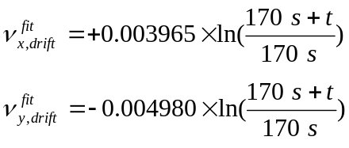

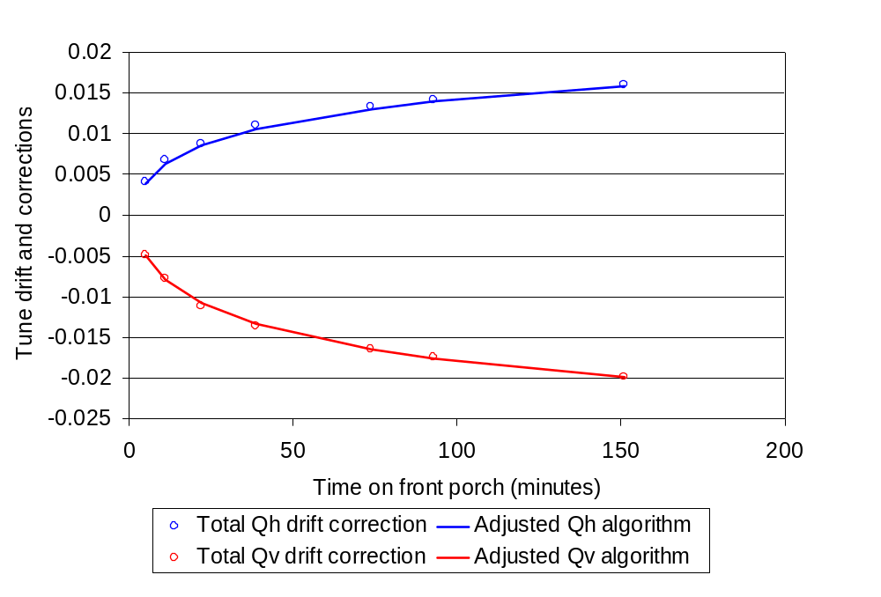
Figure 22: Total horizontal and vertical tune drift derived from the tune drift measured on 07/23/2004 with un-coalesced protons-only beam on center orbit following a 3.7 hrs flattop and 5 min back-porch. The solid lines are fits to the data shown (Equation 36).

Tevatron Coupling Drift after 5 min Back-Porch

For the 7/23/04 study the coupling drift algorithm was applied as shown in Equation 37. Since the coupling has both a magnitude and phase (or a sine and cosine term) two separate coupling circuits are needed to completely correct the coupling. In practice the correction is limited to the T:SQ circuit and the SQAO component of the coupling is not corrected. In the Equation 37 algorithm is the amount of coupling that is added to the Tevatron by the C:SQB2 circuit to compensate to the drifting coupling. The units are values of minimum tune split.

Equation 37
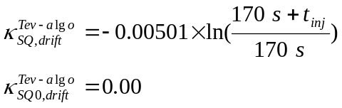

With this coupling drift algorithm active during the front porch the coupling was measured as a function of time on the front porch and the data is shown in Figure 23. During this measurement the T:SQ and T:SQA0 coupling circuits were constantly adjusted to minimize the tune split. With this algorithm active, minimum tune splits between 0.001-0.005 were measured. This should be compared to a desired goal of less than 0.003 for Tevatron collider operations.

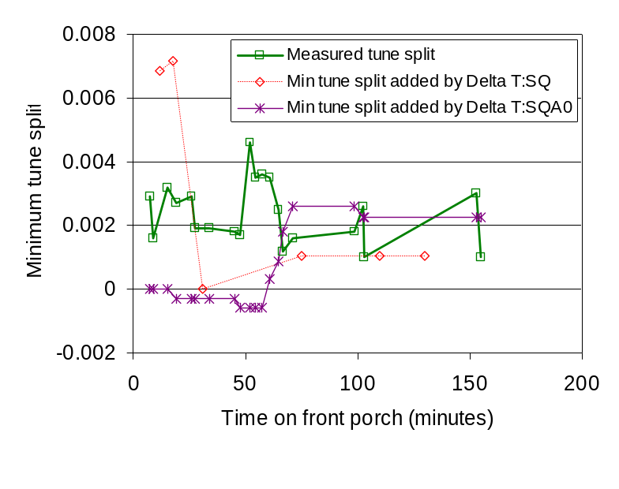
Figure 23: Measured minimum tune split during studies (07/23/04).
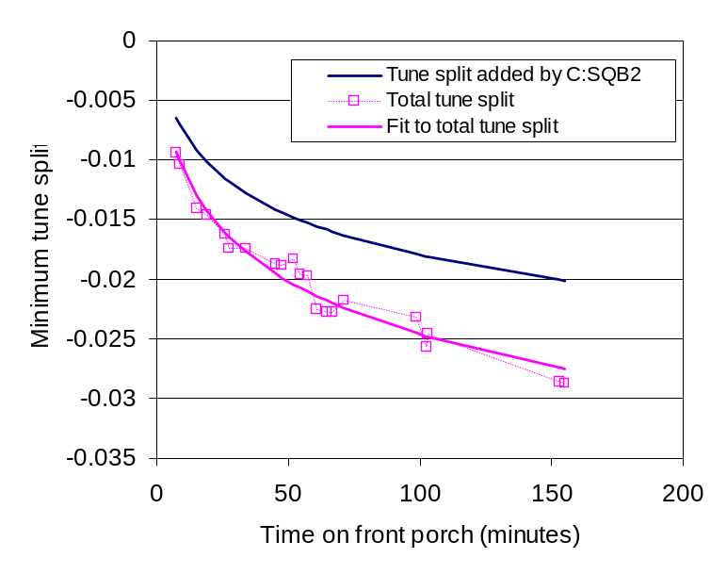
Figure 24: Amount of coupling drift on the front porch during the 7/23/04 studies. The dark blue line represents the amount of coupling that was added to the Tevatron by the C:SQB2 circuit as part of the coupling correction algorithm. The open squares are the estimated total amount of coupling drift based on the measured tune split and the solid line is a fit to the coupling drift.

Using this data, a fit to the total coupling was determined and the results are shown in Figure 24. From this result we can see that the amount of coupling drift was larger as measured on 6/22/04 than the amount corrected by the algorithm.

Equation 38
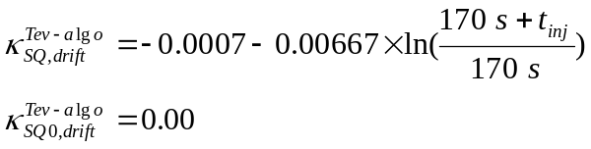

Equation 39
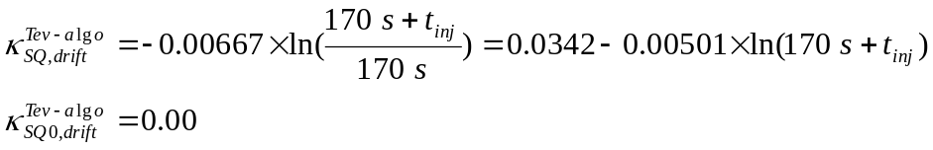

Beam Study 08/10/04

The Aug. 10th beam study was intended to be the final check of the b₂, tune and coupling drift algorithm before implementation of the new drift corrections. During an injection porch following a 39.45 hr flattop and a 5 min back-porch, the tune and coupling drifts were measured (as well as the b₂ drift). Indeed, as shown in Figure 34, the tune drift was reduced to less than 0.001. Similarly the coupling drift was less than resolvable with our measurement technique and the minimum tune split remained less than 0.003 units over the several hours on the injection porch.

Following the drift measurements a chromaticity measurement was performed on the ramp. This measurement consisted of two ramps performed at ±40 Hz from the nominal RF frequency with the tunes measured on the ramp. These ramps were performed following a one hour flattop and a one hour injection porch. As a result of a misunderstanding regarding the exact definition of the b₂ Gaussian snapback correction function, the snapback correction did not perfectly track the b₂ in snapback in the machine. This can clearly be seen in the plot of the chromaticity at the start of the ramp (Figure 27). The b₂ snapback in the machine, however, evolved according to the expectation. The raw data for the 08/10/04 beam study are given in Table 9, Table 10, and Table 11 in appendix 5.

Tevatron b2 Drift after 5 min Back-Porch

The 08/10/04 study comprised three measurements of the chromaticity, tune and coupling drift during the injection porch following a long flat-top, 5 min back-porch pre-cycle. The first drift measurement on the injection porch was performed following a 39.45 hr flat-top and a 5 min back-porch. The other two drift measurements were part of the b₂ on the ramp measurement. In each of those two runs the Tevatron was prepared with a ~1 hr flattop and 5 min back-porch pre-cycle and ramped after 1 hr on the injection porch. During the front porch measurement the “adjusted” b₂ correction algorithm in Equation 27 was used to compensate for the drifting b₂. It stabilized the chromaticity drift during injection porch to less than 1 unit. It was therefore decided after this beam study to apply Equation 27 to the correction of the b₂ drift on the injection porch for a regular Tevatron run. Figure 25 shows the chromaticity measurements during the three injection porches of 08/10/04.

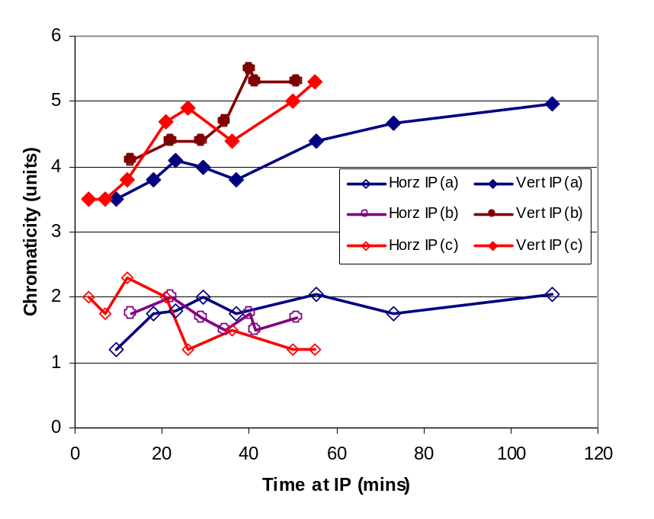
Figure 25: Chromaticity drift in the Tevatron measured on 08/10/04 during three different injection porches following a long (>1 hr) flat-top and 5 min back-porch pre-cycle. Injection porch (a) followed a 39.5 hours long flattop, injection porch (b) followed a 1 hour long flattop, and injection porch (c) followed a one hour long flattop.

Tevatron b2 on the Ramp

After each of the injection porches during the 8/10/04 studies, the Tevatron was ramped to flattop and the tunes were measured and shown in Figure 26. The first set of tunes was taken with the Tevatron RF frequency at its nominal value (0 Hz) after the 39.5 hour flattop and 2 hour front porch. The second set of tunes was taken on two consecutive Tevatron ramps (each following a 1 hour long flattop, a 5 minute back porch and a 1 hour long front porch) with a +40 Hz and -40 Hz offset in the RF frequency. The tune trim quad settings were adjusted between the first set of measurement and the second, but were the same for both measurements in the second set. The chromaticity in Figure 27 was calculated from the fractional tunes q using the tunes measured on the ramp with the +40 Hz and -40 Hz RF frequency offsets and using Equation 23. The measured chromaticity is also listed in Table 11 in Appendix 5. The data clearly show evidence of a b₂ snapback, indicating that the b₂ algorithm was not optimized.

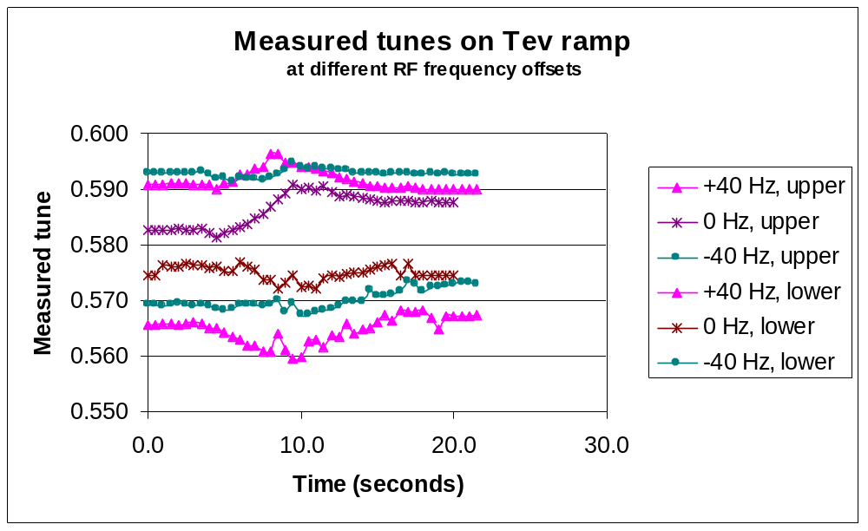
Figure 26: Results of fractional tune measurements during the first 17.38 seconds of the Tevatron ramp using the Schottky fast time capture mode. The start of the Tevatron acceleration begins at 4.12 sec seconds on this plot and the Tevatron reaches the energy of 180.8 GeV at about 21.5 seconds.
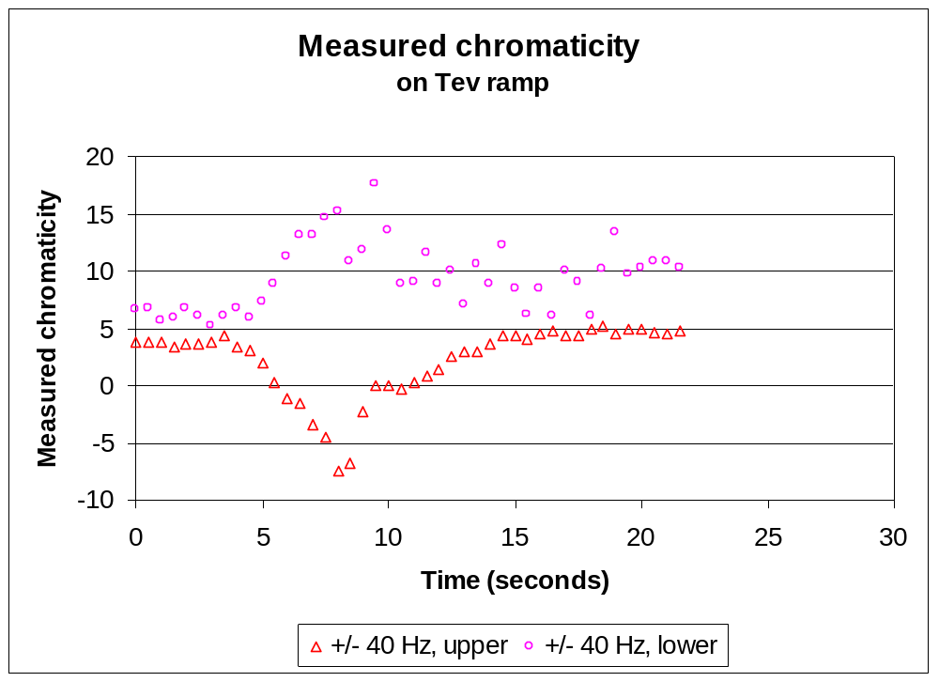
Figure 27: Lower and upper (vertical and horizontal) chromaticity in Tevatron during first 17.38 seconds of ramp as derived from the fractional tunes. The start of the Tevatron acceleration begins at 4.12 seconds on this plot and the Tevatron reaches the energy of 180.8 GeV at about 21.5 seconds. The chromaticity clearly varies by up to 20 units. During the snapback the horizontal chromaticity becomes negative. That is a situation that should be avoided in the Tevatron.
As was found in extensive magnetic measurements on select Tevatron dipoles^{[5]}, the snapback evolves in time according to a Gaussian function, with a time-constant that depends on the drift amplitude b_{2,drift}(t_{inj}) at t_{inj}, the end of the injection porch. Equation 40 describes the snapback function, where t is the time counted from the start of the ramp and t_{SB} is the snapback time constant, which can be calculated with Equation 41 from the drift amplitude. For this study the intention was to use the “dynamic” correctors C:SFB2 and C:SDB2 to compensate for the b₂ snapback in the Tevatron dipoles by playing out the Gaussian function shown in Equation 40 and Equation 41.

In fact, for the 08/10/04 beam study an error was made in the calculation of the time constant t₀ (caused by confusion over the definition of the time constant in the exponent of Equation 40). As a result of this confusion, the actual snapback time constant used for the study was t_{SB} = 6.239 seconds rather than the value t_{SB} = 4.418 appropriate for a drift amplitude of 1.4 units after one hour on the injection porch. As will be shown later, the measurement data supports the conclusion that the value of t_{SB} = 4.418 is indeed the correct time constant. The difference between the applied and the “correct” snapback functions is shown in Figure 28. The drift amplitude in the figure was calculated with Equation 19 for a 60 minute injection porch. The chromaticity excursions in Figure 27 are more or less the result of the difference between implemented and “correct” b₂ snapback functions.

Equation 40
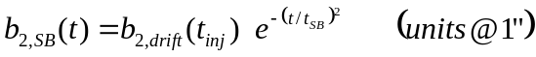

Equation 41
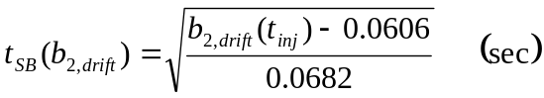

In Table 3 the sextupole corrector settings as they were during these measurements are listed at each energy breakpoint. The settings of chromaticity, Ch and Cv, in the Tevatron ramp control program (C49) are converted into currents in the sextupole correctors, T:SF and T:SD, at each energy breakpoint using Equation 24 and Equation 25 as discussed in further detail for the 04/27/04 study. Table 11 in appendix 5 contains the T:SF and T:SD currents calculated from the settings in Table 3 and via interpolation.

With these chromaticity corrector settings, the chromaticity data shown in Figure 27 were converted into the average b₂ of the Tevatron using Equation 3 and the methods described in Section 2) of this report. Since the energy of the beam changes during the ramp, the conversion between corrector currents and chromaticity in Equation 3 was scaled appropriately with energy.
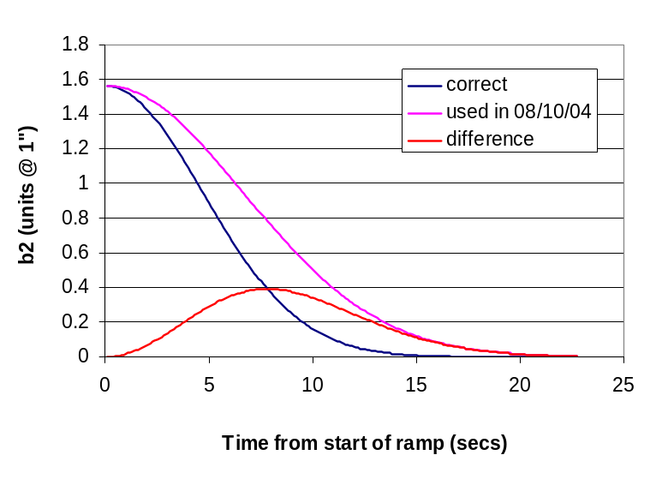
Figure 28: Snapback functions: as implemented on 08/10/04, as should have been implemented and the difference. The drift amplitude was calculated with Equation 19.

Table 3: Sextupole corrector currents at each breakpoint in the Tevatron ramp control program.
Ch set value  (C49 units) | Cv set value  (C49 units) | Energy (GeV) | Time  (seconds) | T:SF  (Amps) | T:SD  (Amps)
41 | 22 | 150.06 | 0 | 3.379 | 1.180
47 | 22 | 153.09 | 5.41 | 3.539 | 1.040
45 | 25 | 162.5 | 11.01 | 3.527 | 0.721
42 | 31 | 180 | 17.16 | 3.501 | 0.027
41 | 34 | 200 | 22.16 | 3.484 | -0.679
36 | 38 | 300 | 36.46 | 3.158 | -3.808

Using the average of the b₂’s determined from the horizontal and vertical chromaticity, the measured b₂ is plotted as a function of energy in Figure 29 and plotted as a function of time in Figure 30. Furthermore in Figure 30 the b₂ hysteretic baseline was subtracted from the total measured b₂ in order to show the snapback only. The b₂ data from 160 GeV to 180 GeV was used to determine a linear baseline fit to the b₂ as a function of energy. The result of the linear fit is given in Equation 42 and is also plotted in Figure 29. Assuming this linear fit of the b₂ accurately predicts the b₂ hysteretic baseline below 160 GeV, the measured snapback amplitude is 1.52 units as can be seen in Figure 30. The snapback is well described with a Gaussian fit in time with a time constant of 4.32 seconds (), which is only 7% smaller than the value calculated from the 1.52 units drift amplitude (Equation 41). This is also within 3% of the 1.56 units calculated with the b₂ drift function derived from this and earlier beam studies (Equation 19).

Equation 42
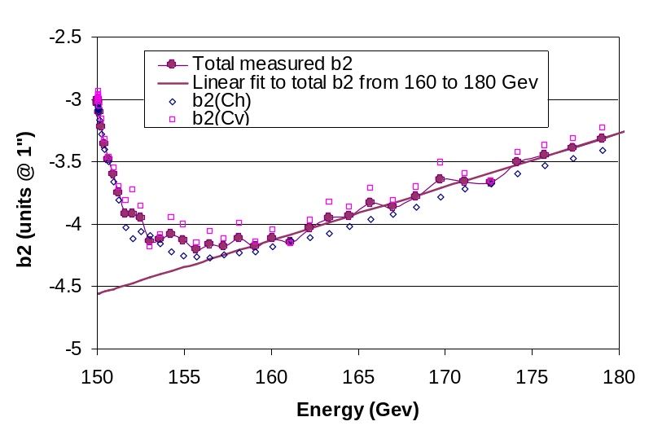
Figure 29: Measured value of b₂ as a function of energy in the Tevatron during the first 18.4 sec of the ramp from a one hr injection porch. The value of b₂ is the average value of that determined from the horizontal and the vertical chromaticity. Both these curves as well as their average are shown. The solid line is a linear fit to the measured b₂ using only the data from 160 GeV to 180 GeV in the fitting.

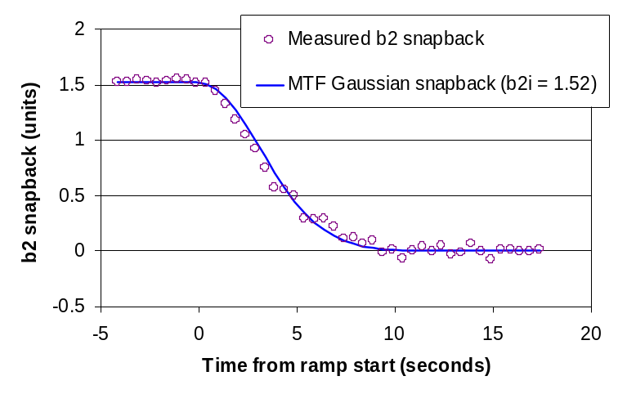
Figure 30: Average Tevatron dipole b₂, first 18.4 seconds of ramp (150-180.8 GeV) after subtraction of the hysteretic baseline (Equation 42). The snapback amplitude is 1.52 units. The data are well fitted with a Gaussian function according to Equation 43.

Equation 43
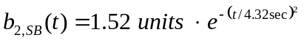

As discussed in Section 5) the results of the ramping study on 04/27/04 were not fully understood and two possible interpretations were discussed. The first interpretation, according to which the hysteretic b₂ at 150 GeV is -4.54 units, leaves an unexplained dip in the hysteretic b₂ at the start of the ramp. The second interpretation, according to which the hysteretic b₂ at 150 GeV is -4.75 units, leaves an unexpectedly large snapback of ~0.2 units for only a six second front porch time. The alternate constrained, quadratic baseline fit for the second interpretation is given in Equation 44.

Magnet measurements need to be performed to verify the latter option. However, the measurements of the b₂ drift discussed in this report all point to a b₂ at t_{inj} = 0 of between –4.5 to -4.55 units. Furthermore all the linear extrapolations of ramp b₂ data, both the 04/27/04 and the 08/10/04 data, also give a hysteretic b₂ at 150 GeV of –4.54 units.

Equation 44

Figure 31 shows the 04/27/04 and 08/10/04 ramp b₂ measurements. The solid lines are the base-line fits (obtained using only the data from 160 GeV to 180 GeV in the fitting).

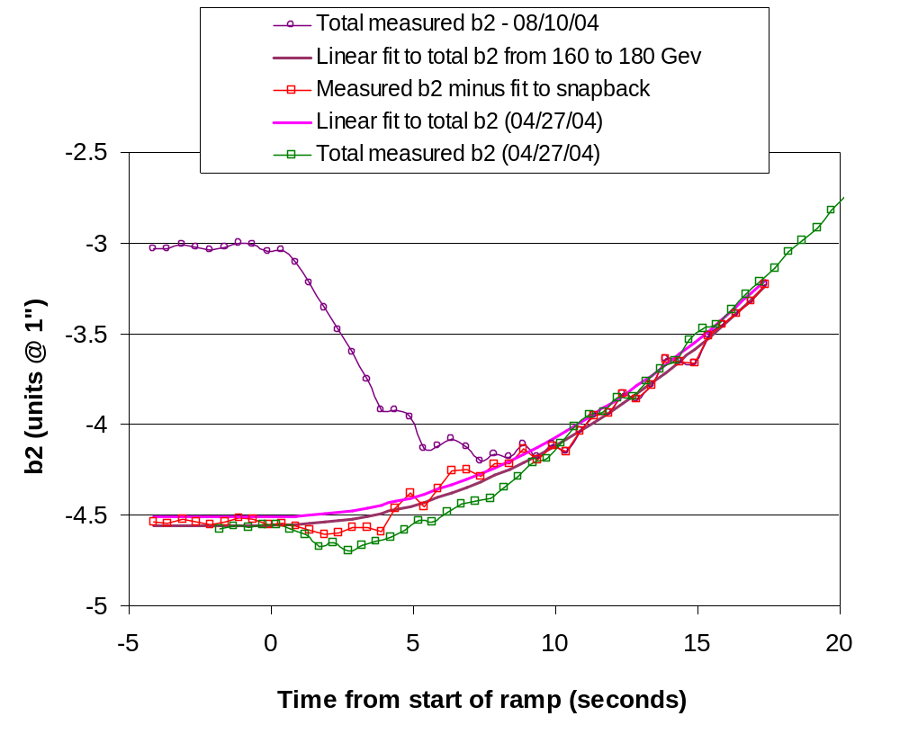
Figure 31: b₂ as a function of energy in the Tevatron during the first 20 sec of the ramp as measured on 04/27/04 and 08/10/04. The solid lines are the linear fits to the measured ramp b₂ using only the data from 160 GeV to 180 GeV in the fitting. Also shown is the 08/10/04 data after subtraction of the snapback as shown in Figure 30.

Also shown is the 08/10/04 data after subtraction of the snapback as shown in Equation 30. This curve could be interpreted as having a similar dip at ~2-3 secs after the start of the ramp as the 04/27/04 data. Unfortunately this cannot be said without doubt, since the data are “noisy”. Should that be the case, one could argue that in both the 04/22/04 and the 08/10/04 cases, an additional 0.1-0.2 unit of snapback were not recognized as such using the linear baseline fit. The data could be re-interpreted using a constrained baseline fit (Equation 42), with –4.75 units as the 150 GeV hysteretic b₂ value and an additional ~0.2 units of drift amplitude and snapback.

This additional drift could occur during the first few seconds of the injection porch, which are out of the reach for beam based b₂ measurements. Figure 32 shows the picture one obtains by constraining the baseline fit to –4.75 units at t = 0 (E = 150 GeV). In this case the 04/27/04 ramping state data look like a clear snapback. The snapback amplitude of the 08/10/04 data has increased by ~0.2 units.

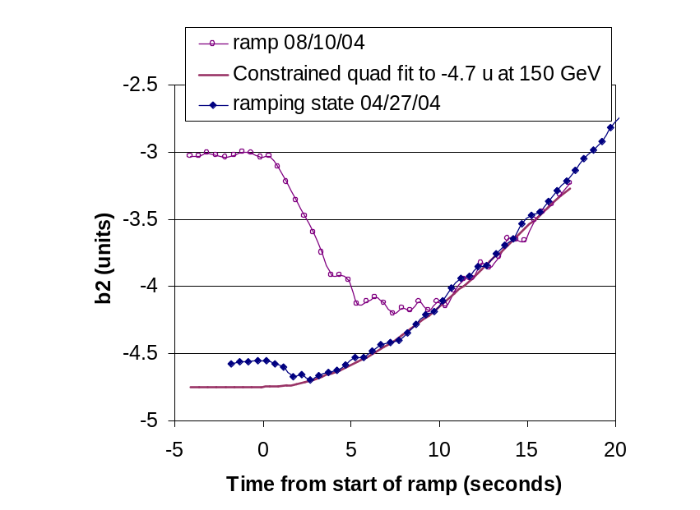
Figure 32: b₂ on the ramp in the Tevatron during the first 20 sec of the ramp as measured on 04/27/04 and 08/10/04. The solid line is the quadratic, constrained fit to the ramp b₂ measured on 08/10/04 using only the data from 160 GeV to 180 GeV in the fitting and constraining the t=0 value to –4.75 units.

Figure 33 shows the baseline corrected snapback data from 08/10/04 for both baseline implementations, Equation 42 and Equation 44. As shown in Figure 33 the data do not allow discrimination between the two possible data interpretations. The larger snapback amplitude for the constrained baseline is 1.7 units, and the Gaussian time constant obtained from fitting the curve is 4.76 sec, very close to that calculated with Equation 41 and the above drift amplitude (4.9 sec). The smaller snapback was already discussed in the context of Figure 30 and is perfectly consistent with the expectation on the basis of the drift formula (Equation 19) and the time constant formula (Equation 41).

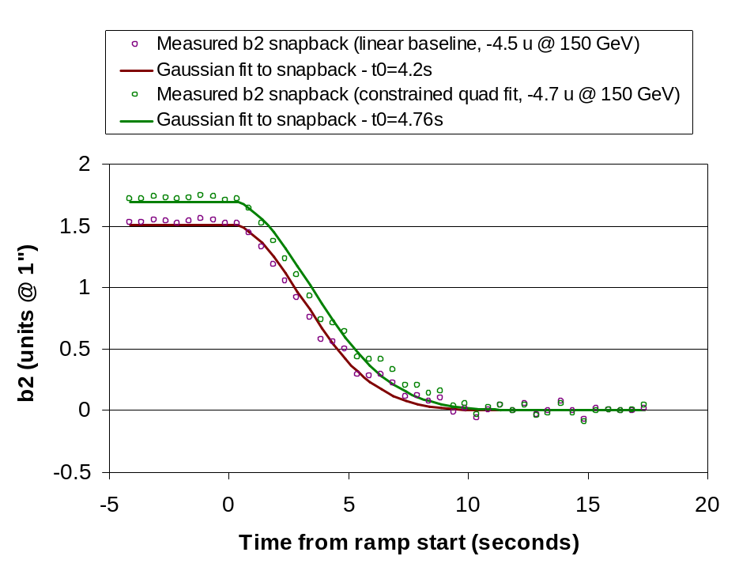
Figure 33: Average Tevatron dipole b₂, first 18.4 secs of ramp (150-180.8 GeV) after subtraction of two possible hysteretic baselines (Equation 42 and Equation 44). The snapback amplitude is 1.52 and 1.7 units in these cases. Both data are well fitted with a Gaussian function according to with time constants of 4.32 and 4.76 sec.

Tevatron Tune Drift after 5 min Back-Porch

The tune drift at 150 GeV as a function of time on the front porch was also measured during this study period. Figure 34 shows the horizontal and vertical tunes measured during the ~100 min injection porch following the 39.45 hrs flat-top and 5 min back-porch pre-cycle. The total variation over the entire injection porch duration is less than 0.001 units in both the vertical plane and horizontal plane. The raw data are listed in Table 11 in Appendix 4.

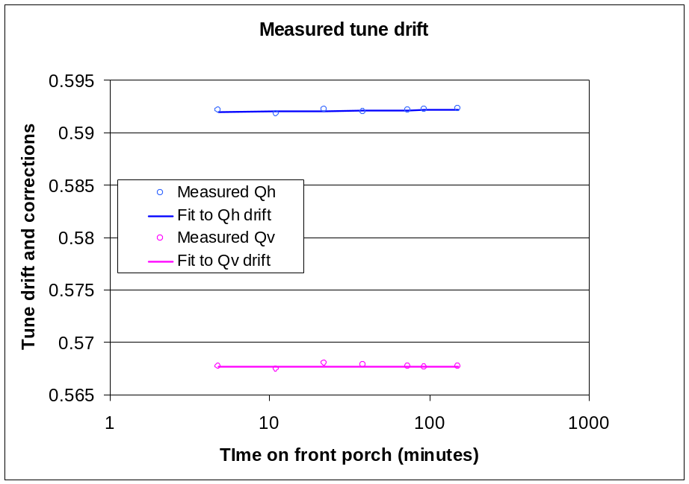

Figure 34: Horizontal and vertical tunes measured as a function of time on the front porch on 08/10/2004 with un-coalesced protons-only beam on center orbit following a 39.5 hrs flat-top and 5 min back-porch. The solid lines are fits to the data.

The tune drift algorithm used during the study on 8/10/04 is shown in Equation 45.

Equation 45

From these results we conclude that tune compensation algorithm is good enough to keep the tune drift below acceptable values. An analysis to fine tune the algorithm even further gives the results

Equation 46
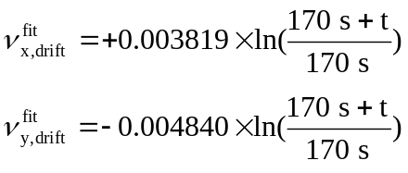

Tevatron Coupling Drift after 5 min Back-Porch

For the 8/10/04 study the coupling drift algorithm was applied as shown in Equation 47. Since the coupling has both a magnitude and phase (or a sine and cosine term) two separate coupling circuits are needed to completely correct the coupling. In practice the correction is limited to the T:SQ circuit and the SQAO component of the coupling is not corrected. In the Equation 47 algorithm is the amount of coupling that is added to the Tevatron by the C:SQB2 circuit to compensate to the drifting coupling. The units are values of minimum tune split.

Equation 47
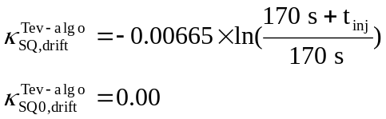

With this coupling drift algorithm active during the front porch the coupling was measured as a function of time on the front porch. The largest minimum tune split was 0.0023 tune units, which is less than the desired goal of less than 0.003 for Tevatron collider operations.

Summary

b2 drift on injection porch after a 5 min back-porch

The b₂ drift data derived from beam chromaticity measurements collected over several months are summarized in Figure 35. The pre-cycle back-porch time was fixed in all cases to 5 min, as planned for the future Tevatron operational procedure. Since in most cases the machine was brought to the injection porch straight out from a store for these measurements, the pre-cycle flat-top times were all longer than 40 min. In confirmation of the results of the MTF magnetic measurements there is no effect of variations of the pre-cycle flat-top time as long as it is longer than 40 min. Equation 48 represents the best fit of the data shown in Figure 35.

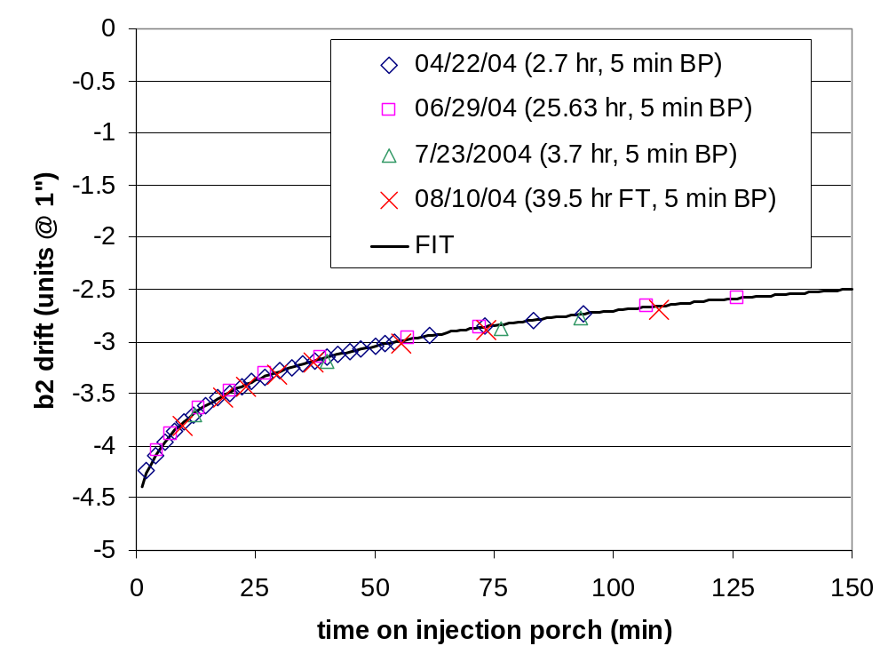
Figure 35: b₂ on injection porch plot – all studies together. Also shown is the fit function (Equation 48).

Equation 48
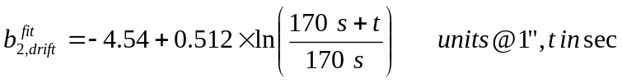
The offset of –4.54 units are interpreted to be the hysteretic b₂ at 150 GeV. As discussed amply in chapter 8) it could very well be that part of the hysteretic “offset” is actually a fast drift, which is not described by the logarithmic function in Equation 48. This issue needs to be investigated further. As a result of a set of “faulty” set of b₂ to chromaticity corrector current coefficients (see the discussion in Section 2), an adjusted algorithm needs to be implemented in T:CHROM to actually deliver a b₂ drift protocol that compensates for a drift as given with Equation 48. Such an adjusted algorithm is given in Equation 49.

Equation 49

b2 snapback

Figure 36 shows all recent b₂ snapback measurements, performed on 04/27/04, 08/10/04, together. Also shown is an older beam study performed on 12/04/02 and reported in detail elsewhere. All these measurements consisted in measuring the beam tunes during the start of the ramp for un-coalesced, center-orbit beam with varying offsets in the RF frequency to derive the beam chromaticity. The machine was prepared in the same way (identical pre-cycle and dwell on injection porch) for all different frequency runs within one beam study. The dwells at the injection porch (6 sec, 1 hr, 2 hrs) and pre-cycle back-porch (6 sec, 5 min, ~1.5 min) as well as flat-top (10 sec, 1 hr min, ~30 min) were different for all three beam studies. As can be seen in the plot the study results vary not only in the amount of snapback but also on the ramp. Once past the snapback the ramp should evolve according to the hysteretic b₂, which only depends on the magnet temperature (or average ring temperature) and not on the powering history (e.g. pre-cycle parameters). In the energy range 150-200 GeV the hysteretic b₂ can be approximated with a linear fit. However, as discussed amply in Sections 5&8, different baseline approximations, linear and quadratic as well as constrained and unconstrained, have been applied in an attempt to better understand the b₂ snapback.

The parameters of the linear and quadratic baseline fits for the three cases shown are given in the following.

Equation 50

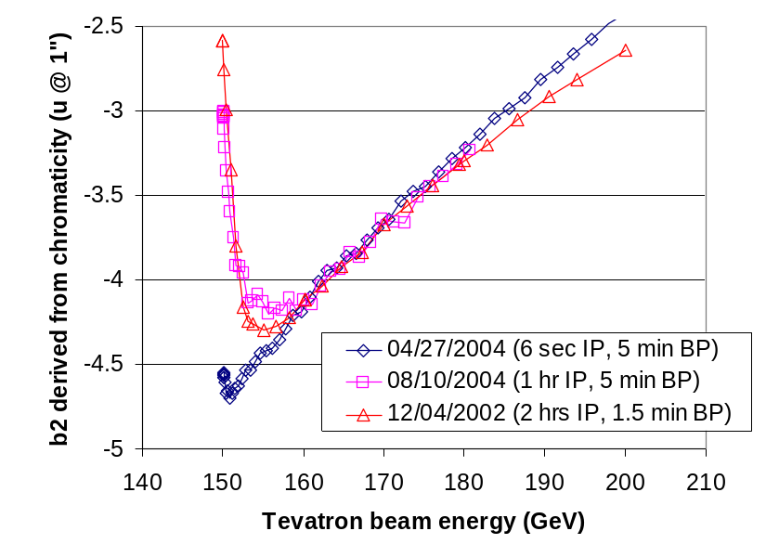
Figure 36: b2 during the start of the ramp as derived from the beam chromaticity during three different beam studies (04/27/04, 08/10/04 and also 12/04/02). The dwell at the injection porch was different in all cases (6 sec, 1 hr, 2 hrs). Also the back-porch duration was different for all cases (6 sec, 5 min, ~1.5 min).

Table 4 lists the base-line fit parameters for all three studies. Both linear and quadratic base-line fits are listed. The linear baseline fits tend to give more consistent results. They cannot explain the 0.2 unit dip in the 04/27/04 beam study, however. The quadratic and constrained fit explains the 04/27/04 dip as a snapback. This snapback cannot be explained on the basis of magnetic measurements in select Tevatron dipoles. Also the snapback amplitude obtained with the quadratic and constrained fit in the case of the 08/10/04 data is larger than expected. Only the linear baseline fit produces snapback amplitudes, which are consistent with the drift amplitudes calculated with Equation 48 or Equation 49.

Table 4: Baseline fit parameters for different b₂ snapbacks as measured during different beam studies. This baseline is assumed to be the hysteretic b2 in the Tevatron between 150 GeV and 200 GeV.
parameter |  | b_{2,hyst} | a | b | Comment
units |  | u @ 1” | u/GeV | u/GeV²
12/04/2002 | linear | -4.54 | 0.042 | 0 | 3rd order was also used
04/27/04 | linear | -4.51 | 0.042 | 0 | -
04/27/04 | quad | -4.75 | 0.0607 | 0.00030 | constrained to –4.75 @ 150 GeV
08/10/04 | linear | -4.56 | 0.0428 | 0
08/10/04 | quad | -4.75 | 0.0633 | 0.00049 | constrained to –4.7 @ 150 GeV

The baseline corrected data are shown in Figure 37. Only the cases using the linear baseline correction are shown. The baseline corrected data from 04/27/04 are not understood. The 08/10/04 snapback is well fitted with:
Equation 51
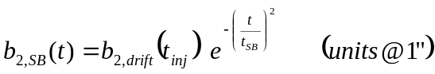,

Equation 52
,

which describe the snapback function, where t_{SB} is the time counted from the start of the ramp and t₀ is the time constant, which can be calculated from the drift amplitude.

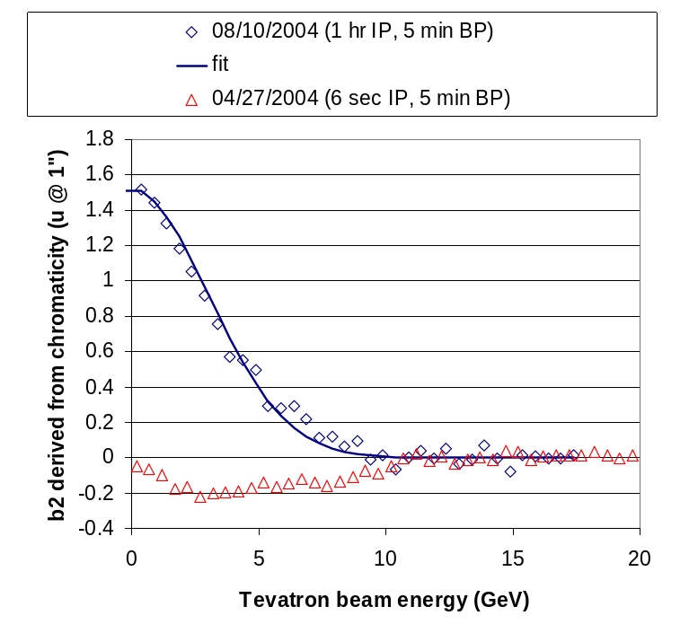
Figure 37: Tevatron dipole b₂ snapback after subtraction of the (linear) hysteretic baseline (Equation 42) obtained during the beam studies on 04/27/04 and 08/10/04. The snapback data for 08/10/04 are well fitted with a Gaussian function according to Equation 51.

Tune drift on injection porch after a 5 min back-porch

Figure 38 shows the summary of all vertical and horizontal (fractional) tune drifts measured over a period of several months in the Tevatron for a >40 min flat-top, 5 min back-porch pre-cycle condition. As becomes clear from the plot, Equation 53 describes the tune drift with good accuracy in all cases. This is therefore the function on which the future tune drift correction algorithm for the long flat-top and 5 min back-porch pre-cycle should be based.

Equation 53
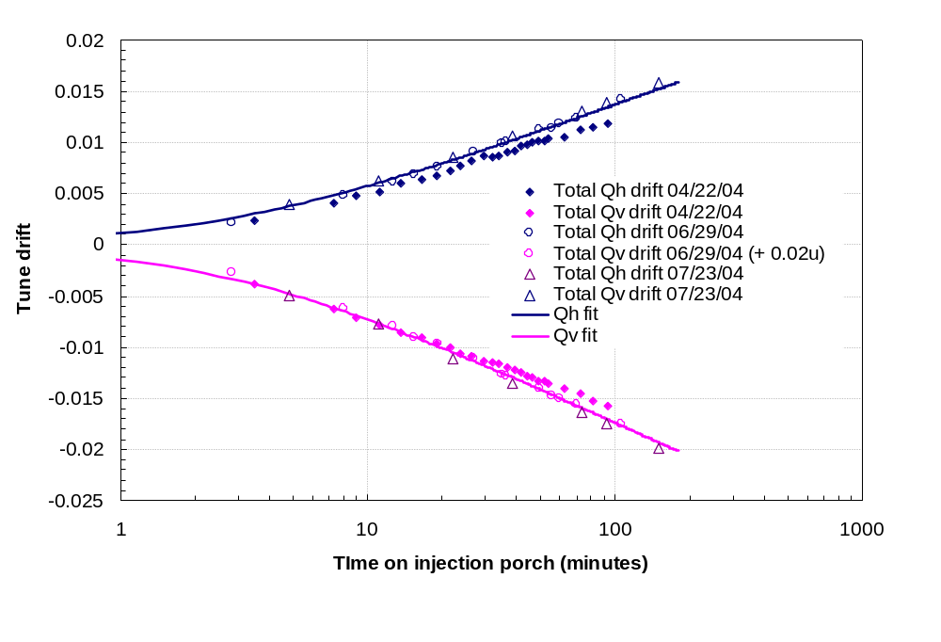
Figure 38: Summary of the total tune drift measured in the Tevatron during the injection porch in March, June and July 2004. Also shown is the fit function Equation 53.

Coupling drift on injection porch after a 5 min back-porch

Figure 39 shows the summary of all minimum tune split drifts measured over a period of several months in the Tevatron for a >40 min flat-top, 5 min back-porch pre-cycle condition. As becomes clear from the plot, Equation 54 describes the minimum tune split drift with good accuracy in all cases. This is therefore the function on which the future coupling drift correction algorithm for the long flat-top and 5 min back-porch pre-cycle should be based.

Equation 54

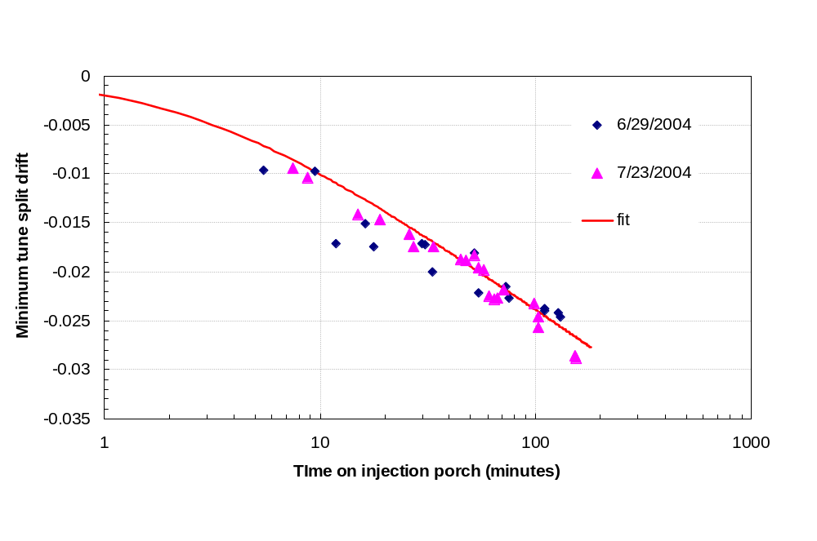
Figure 39: Summary of the minimum tune split drift measured in the Tevatron during the injection porch in June and July 2004. Also shown is the fit function Equation 54.

Appendices

Appendix 1
Table 5: Results of the 04/22/04 beam-study with un-coalesced protons-only beam on center orbit at injection following a 2.7 hr flattop, 5 min back-porch pre-cycle. Ch and Cv are the horizontal and vertical chromaticities; Qh and Qv are the horizontal and vertical tunes; dνmin is the minimum tune split and SQ0 is the skew quad corrector current setting.
t (min) | Ch | Cv |  | t (min) | Qh | Qv |  | t (min) | Qh | Qv | dνmin |  | t (min) | SQ0 (A)
2 | 0.8 | 6.78 |  | 1.66 | 0.5838 | 0.5704 |  | 2.83 | 0.5667 | 0.5725 | 0.0058
4 | -1.87 | 8.18 |  | 3.5 | 0.5837 | 0.5692 |  | 5 | 0.5654 | 0.5716 | 0.0062 |  | 12.67 | -2.56
6 | -1.87 | 8.65 |  | 7.3 | 0.5834 | 0.5693 |  | 7 | 0.5712 | 0.5642 | 0.007 |  | 23 | -2.515
7.8 | -1.16 | 8.18 |  | 9 | 0.5831 | 0.5695 |  | 8.6 | 0.5654 | 0.5707 | 0.0053 |  | 25.3 | -2.522
10 | -0.93 | 8.18 |  | 11.17 | 0.5831 | 0.5696 |  | 10.67 | 0.5704 | 0.5649 | 0.0055 |  | 28.5 | -2.542
11.83 | -0.46 | 7.95 |  | 13.67 | 0.5827 | 0.5697 |  | 12.67 | 0.5712 | 0.5679 | 0.0033 |  | 31.67 | -2.522
14.33 | 0.23 | 7.48 |  | 16.5 | 0.5826 | 0.5696 |  | 15 | 0.5726 | 0.5687 | 0.0039 |  | 36 | -2.533
17 | 0.46 | 7.01 |  | 19 | 0.5826 | 0.5697 |  | 16 | 0.5717 | 0.5695 | 0.0022 |  | 39 | -2.522
19.5 | 0.7 | 7.01 |  | 21.5 | 0.5823 | 0.5697 |  | 18 | 0.5714 | 0.5682 | 0.0032 |  | 41.17 | -2.525
22 | 1.16 | 6.54 |  | 23.67 | 0.582 | 0.57 |  | 18.67 | 0.568 | 0.5695 | 0.0015 |  | 44 | -2.521
24.17 | 1.87 | 6.08 |  | 26.3 | 0.5817 | 0.57 |  | 20 | 0.5707 | 0.5672 | 0.0035 |  | 46 | -2.515
27 | 1.87 | 5.84 |  | 29.5 | 0.5815 | 0.5701 |  | 21 | 0.5676 | 0.5687 | 0.0011 |  | 48.67 | -2.51
30 | 2.8 | 5.61 |  | 32 | 0.5817 | 0.57 |  | 22.5 | 0.5714 | 0.5687 | 0.0027 |  | 51 | -2.501
32.5 | 2.8 | 5.38 |  | 33.83 | 0.5817 | 0.5699 |  | 23 | 0.5713 | 0.5692 | 0.0021 |  | 74 | -2.502
34.67 | 3.27 | 5.14 |  | 36.7 | 0.5815 | 0.57 |  | 25 | 0.5687 | 0.5714 | 0.0027 |  | 93.67 | -2.481
37.3 | 3.5 | 4.91 |  | 39.5 | 0.5815 | 0.57 |  | 25.3 | 0.5705 | 0.5697 | 0.0008
40 | 3.74 | 4.67 |  | 41.67 | 0.5811 | 0.5701 |  | 28 | 0.5688 | 0.5704 | 0.0016
42.3 | 3.97 | 4.44 |  | 44.33 | 0.5811 | 0.5703 |  | 28.5 | 0.5682 | 0.5708 | 0.0026
44.83 | 3.97 | 4.44 |  | 46.5 | 0.581 | 0.5703 |  | 31.17 | 0.5716 | 0.5689 | 0.0027
47 | 4.44 | 3.97 |  | 49.33 | 0.581 | 0.5704 |  | 31.67 | 0.5708 | 0.5696 | 0.0012
50 | 4.67 | 3.97 |  | 51.67 | 0.581 | 0.5703 |  | 33.17 | 0.5705 | 0.5705 | 0
52 | 4.67 | 3.74 |  | 53.5 | 0.5809 | 0.5704 |  | 35.67 | 0.5708 | 0.5686 | 0.0022
54 | 4.91 | 3.74 |  | 62.5 | 0.581 | 0.5704 |  | 36 | 0.5691 | 0.5705 | 0.0014
61.5 | 5.38 | 3.04 |  | 72.67 | 0.5806 | 0.5705 |  | 38.5 | 0.5682 | 0.5671 | 0.0011
73 | 6.31 | 2.57 |  | 82 | 0.5806 | 0.5708 |  | 39 | 0.5682 | 0.5699 | 0.0017
83.17 | 7.01 | 2.33 |  | 93.67 | 0.5805 | 0.5709 |  | 40.83 | 0.5712 | 0.5691 | 0.0021
93.67 | 7.71 | 1.63 |  |  |  |  |  | 41.17 | 0.5705 | 0.5695 | 0.001
 |  |  |  |  |  |  |  | 43.3 | 0.5716 | 0.5695 | 0.0021
 |  |  |  |  |  |  |  | 44 | 0.5709 | 0.5699 | 0.001
 |  |  |  |  |  |  |  | 45 | 0.572 | 0.5693 | 0.0027
 |  |  |  |  |  |  |  | 46 | 0.5718 | 0.57 | 0.0018
 |  |  |  |  |  |  |  | 47.83 | 0.5717 | 0.571 | 0.0007
 |  |  |  |  |  |  |  | 48.67 | 0.5705 | 0.57 | 0.0005
 |  |  |  |  |  |  |  | 50.67 | 0.5724 | 0.571 | 0.0014
 |  |  |  |  |  |  |  | 51 | 0.5716 | 0.5704 | 0.0012
 |  |  |  |  |  |  |  | 53 | 0.571 | 0.571 | 0
 |  |  |  |  |  |  |  | 63.3 | 0.5705 | 0.5705 | 0
 |  |  |  |  |  |  |  | 74 | 0.5735 | 0.5704 | 0.0031
 |  |  |  |  |  |  |  | 74 | 0.5738 | 0.5708 | 0.003
 |  |  |  |  |  |  |  | 83.17 | 0.571 | 0.5707 | 0.0003
 |  |  |  |  |  |  |  | 93.67 | 0.5709 | 0.5712 | 0.0003

Appendix 2
Table 6: Results of the 04/27/04 beam-study with un-coalesced protons-only beam on center orbit during the ramp from injection. T:SF and T:SD are the sextupole corrector currents derived from interpolation from the chromaticity set-value tables. Ch and Cv are the measured horizontal and vertical chromaticities
t (sec) | t from ramp start (s) | Energy (GeV) | T:SF (A) | T:SD (A) | Ch | Cv
3 | -1.8 | 150.06 | 3.4652123 | 1.217996 | 7.305586 | 3.271046
3.5 | -1.3 | 150.06 | 3.4652123 | 1.217996 | 7.859493 | 3.136312
4 | -0.8 | 150.06 | 3.4652123 | 1.217996 | 7.747215 | 3.226135
4.5 | -0.3 | 150.06 | 3.4652123 | 1.217996 | 8.128962 | 2.859358
5 | 0.2 | 150.0641 | 3.4653252 | 1.217284 | 7.829552 | 2.859358
5.5 | 0.7 | 150.1107 | 3.4665963 | 1.209277 | 7.081029 | 3.398295
6 | 1.2 | 150.209 | 3.4692795 | 1.192373 | 6.160346 | 4.528565
6.5 | 1.7 | 150.3591 | 3.473375 | 1.166572 | 4.079451 | 6.931324
7 | 2.2 | 150.5609 | 3.4788827 | 1.131874 | 4.079451 | 7.42535
7.5 | 2.7 | 150.8145 | 3.4858026 | 1.088279 | 3.248591 | 10.28471
8 | 3.2 | 151.1198 | 3.4941348 | 1.035787 | 2.717139 | 10.44938
8.5 | 3.7 | 151.4769 | 3.5038793 | 0.974398 | 2.76205 | 11.59462
9 | 4.2 | 151.8857 | 3.5150359 | 0.904113 | 3.121342 | 13.5857
9.5 | 4.7 | 152.3463 | 3.5276048 | 0.82493 | 3.121342 | 14.58872
10 | 5.2 | 152.8586 | 3.5415859 | 0.736851 | 3.166253 | 15.31478
10.5 | 5.7 | 153.4224 | 3.5465373 | 0.691694 | 3.031519 | 17.4855
11 | 6.2 | 154.0363 | 3.5440184 | 0.681769 | 3.353384 | 16.66213
11.5 | 6.7 | 154.7002 | 3.5412945 | 0.671035 | 3.353384 | 15.71899
12 | 7.2 | 155.4141 | 3.5383654 | 0.659494 | 3.353384 | 16.49745
12.5 | 7.7 | 156.178 | 3.5352313 | 0.647145 | 3.443207 | 17.44059
13 | 8.2 | 156.9918 | 3.531892 | 0.633987 | 3.832439 | 16.75195
13.5 | 8.7 | 157.8557 | 3.5283477 | 0.620021 | 3.712675 | 15.26987
14 | 9.2 | 158.7696 | 3.5245982 | 0.605248 | 4.393831 | 14.08721
14.5 | 9.7 | 159.7334 | 3.5206437 | 0.589665 | 4.618388 | 15.17256
15 | 10.2 | 160.7472 | 3.516484 | 0.573275 | 4.753122 | 13.18149
15.5 | 10.7 | 161.8111 | 3.5121192 | 0.556077 | 4.842945 | 10.78622
16 | 11.2 | 162.9248 | 3.5075149 | 0.535179 | 5.202236 | 10.09009
16.5 | 11.7 | 164.0882 | 3.5026469 | 0.508451 | 5.299544 | 11.77427
17 | 12.2 | 165.301 | 3.497572 | 0.480587 | 5.33697 | 10.86856
17.5 | 12.7 | 166.5633 | 3.49229 | 0.451587 | 5.351941 | 12.8222
18 | 13.2 | 167.8751 | 3.486801 | 0.42145 | 5.16481 | 11.3551
18.5 | 13.7 | 169.2363 | 3.4811049 | 0.390176 | 5.426793 | 11.01078
19 | 14.2 | 170.647 | 3.4752019 | 0.357765 | 5.606438 | 11.56468
19.5 | 14.7 | 172.1072 | 3.4690918 | 0.324218 | 5.217206 | 8.697839
20 | 15.2 | 173.6169 | 3.4627747 | 0.289535 | 5.082472 | 8.518194
20.5 | 15.7 | 175.176 | 3.4562506 | 0.253714 | 4.887856 | 9.970329
21 | 16.2 | 176.7846 | 3.4495195 | 0.216757 | 5.157325 | 9.012219
21.5 | 16.7 | 178.4427 | 3.4425814 | 0.178664 | 5.621409 | 8.608016
22 | 17.2 | 180.1503 | 3.4359381 | 0.137585 | 5.748658 | 8.428371
22.5 | 17.7 | 181.9102 | 3.4344514 | 0.075514 | 5.838481 | 8.158902
23 | 18.2 | 183.7246 | 3.4329187 | 0.011524 | 6.15286 | 7.485232
23.5 | 18.7 | 185.5933 | 3.4313401 | -0.05438 | 6.302565 | 8.158902
24 | 19.2 | 187.5164 | 3.4297155 | -0.12221 | 5.718717 | 8.024168
24.5 | 19.7 | 189.4939 | 3.428045 | -0.19196 | 6.706768 | 7.485232
25 | 20.2 | 191.5259 | 3.4263286 | -0.26362 | 6.931324 | 7.889434
25.5 | 20.7 | 193.6122 | 3.4245661 | -0.3372 | 7.148396 | 7.799611
26 | 21.2 | 195.7529 | 3.4227577 | -0.41271 | 7.462776 | 7.619966
26.5 | 21.7 | 197.948 | 3.4209034 | -0.49013 | 7.59751 | 6.572033
27 | 22.2 | 200.1976 | 3.4190031 | -0.56946 | 8.001713 | 7.7547
27 | 22.2 | 200.1976 | 3.4190031 | -0.56946 | 8.001713 | 7.7547

Appendix 3
Table 7: Results of the 06/29/04 beam-study with un-coalesced protons-only beam on center orbit at injection following a 25.63 hr flattop, 5 min back-porch pre-cycle. Ch and Cv are the horizontal and vertical chromaticities; Qh and Qv are the horizontal and vertical tunes; dνmin is the minimum tune split and SQ is the skew quad corrector current setting.
t (min) | Ch | Cv |  | t (min) | Qh | Qv |  | t (min) | Qh | Qv | dνmin |  | t (min) | SQ (A)
4.17 | 5.61 | -0.4 |  | 2.83 | 0.591 | 0.549 |  | 5.5 | 0.5958 | 0.586 | 0.0099 |  | 0 | -2.554
7 | 5.62 | 0 |  | 8 | 0.591 | 0.55 |  | 9.5 | 0.5937 | 0.583 | 0.0109 |  | 11.83 | -2.489
13 | 6 | 0.37 |  | 12.7 | 0.591 | 0.55 |  | 11.83 | 0.5934 | 0.589 | 0.004 |  | 17.8 | -2.486
19.5 | 6 | 0.37 |  | 15.5 | 0.591 | 0.55 |  | 16.3 | 0.5943 | 0.588 | 0.0068 |  | 30.8 | -2.554
27 | 6.36 | 0 |  | 19.3 | 0.591 | 0.55 |  | 17.8 | 0.5953 | 0.591 | 0.0046 |  | 75 | -2.544
38.5 | 6 | 0.37 |  | 27 | 0.59 | 0.55 |  | 29.6 | 0.5926 | 0.586 | 0.0063 |  | 110 | -2.544
57 | 6.36 | 0.75 |  | 35 | 0.59 | 0.551 |  | 30.8 | 0.5926 | 0.586 | 0.0063 |  | 130 | -2.544
72 | 6 | 0.75 |  | 36.5 | 0.59 | 0.551 |  | 33.3 | 0.5917 | 0.588 | 0.0037
107 | 6.36 | 0.74 |  | 49.5 | 0.59 | 0.551 |  | 52 | 0.5918 | 0.585 | 0.0068
126 | 6.36 | 1.12 |  | 56 | 0.59 | 0.551 |  | 54.7 | 0.5911 | 0.588 | 0.0029
 |  |  |  | 60 | 0.59 | 0.551 |  | 73 | 0.5926 | 0.588 | 0.0044
 |  |  |  | 70 | 0.59 | 0.551 |  | 75 | 0.592 | 0.589 | 0.0033
 |  |  |  | 106 | 0.59 | 0.551 |  | 110 | 0.5922 | 0.589 | 0.0033
 |  |  |  |  |  |  |  | 110 | 0.5922 | 0.589 | 0.003
 |  |  |  |  |  |  |  | 128 | 0.5932 | 0.59 | 0.0033
 |  |  |  |  |  |  |  | 130 | 0.593 | 0.59 | 0.0029

Appendix 4
Table 8: Results of the 07/23/04 beam-study, during which the chromaticity and tune drift during injection was measured with un-coalesced protons-only beam on center orbit. The pre-cycle parameters were 2.70 hr at flattop and 5 min at the back-porch. Ch and Cv are the horizontal and vertical chromaticities; Qh and Qv are the horizontal and vertical tunes; dνmin is the minimum tune split and T:SQ and T:SQA0 are the currents in the skew quad correctors. Times are as in MDAT52. The last column in the table notes what type of measurement was conducted at each time point.
t (min) | Qh | Qv | Ch | Cv | T:SQ (A) | T:SQA0 (A) | dνmin | meas type
4.8 | 0.5921 | 0.5677 |  |  | -2.544 | 4.022 |  | tune
7.5 | 0.5851 | 0.588 |  |  | -2.602 | 4.022 | 0.0029 | coupling
8.8 | 0.5851 | 0.5867 |  |  | -2.618 | 4.022 | 0.0016 | coupling
11 | 0.5918 | 0.5685 |  |  |  |  |  | tune
12.3 |  |  | 1.12 | 4.97 |  |  |  | chrom
15 | 0.5886 | 0.5854 |  |  | -2.618 | 4.022 | 0.0032 | coupling
19 | 0.5874 | 0.5847 |  |  | -2.618 | 3.983 | 0.0027 | coupling
22 | 0.5922 | 0.568 |  |  |  |  |  | tune
26 | 0.5874 | 0.5845 |  |  | -2.618 | 3.983 | 0.0029 | coupling
27.3 | 0.5863 | 0.5844 |  |  | -2.637 | 3.983 | 0.0019 | coupling
33.6 | 0.5827 | 0.5808 |  |  | -2.628 | 3.983 | 0.0019 | coupling
38.5 | 0.592 | 0.5679 |  |  |  |  |  | tune
40 |  |  | 1.5 | 5.56 |  |  |  | chrom
45 | 0.5865 | 0.5847 |  |  | -2.628 | 3.983 | 0.0018 | coupling
47.7 | 0.5861 | 0.5844 |  |  | -2.628 | 3.951 | 0.0017 | coupling
50 |  |  |  |  | -2.678 | 3.951 | 0 | coupling
52 | 0.588 | 0.5834 |  |  | -2.678 | 3.951 | 0.0046 | coupling
54.5 | 0.5876 | 0.5841 |  |  | -2.678 | 3.951 | 0.0035 | coupling
57.5 | 0.5893 | 0.5857 |  |  | -2.678 | 3.951 | 0.0036 | coupling
61 | 0.5892 | 0.5857 |  |  | -2.634 | 4.059 | 0.0035 | coupling
64.5 | 0.5884 | 0.5859 |  |  | -2.644 | 4.129 | 0.0025 | coupling
66.83 | 0.5869 | 0.5857 |  |  | -2.654 | 4.243 | 0.0012 | coupling
71.2 | 0.5855 | 0.5839 |  |  | -2.669 | 4.34 | 0.0016 | coupling
73.7 | 0.5921 | 0.5677 |  |  |  |  |  | tune
76.5 |  |  | 1.43 | 5.89 |  |  |  | chrom
93 | 0.5922 | 0.5676 |  |  |  |  |  | tune
93 |  |  | 1.49 | 5.85 |  |  |  | chrom
98.5 | 0.5855 | 0.5837 |  |  | -2.669 | 4.34 | 0.0018 | coupling
102.5 | 0.5865 | 0.5839 |  |  | -2.698 | 4.3 | 0.0026 | coupling
102.5 |  |  |  |  | -2.654 | 4.3 | 0.001 | coupling

Appendix 5
Table 9: Results of the 08/10/04 beam study data. Ch and Cv are the measured horizontal and vertical chromaticities during the injection porch for three different injection porches.
Injection Porch I |  |  | Injection Porch II |  |  | Injection Porch III
FT=39.45 hr, BP=5 min |  |  | FT=0.99 hr, BP=5 min |  |  | FT=1 hr, BP=5 min
t (min) | Ch | Cv | t (min) | Ch | Cv | t (min) | Ch | Cv
9.5 | 1.2 | 3.5 | 13 | 1.75 | 4.1 | 3.3 | 2 | 3.5
18 | 1.75 | 3.8 | 22.3 | 2 | 4.4 | 7 | 1.75 | 3.5
23 | 1.8 | 4.1 | 29 | 1.7 | 4.4 | 12 | 2.3 | 3.8
29.3 | 2 | 4 | 34.5 | 1.5 | 4.7 | 21 | 2 | 4.7
37 | 1.75 | 3.8 | 40.3 | 1.75 | 5.5 | 26 | 1.2 | 4.9
55.5 | 2.05 | 4.39 | 41.5 | 1.5 | 5.3 | 36 | 1.5 | 4.4
73.17 | 1.75 | 4.67 | 51 | 1.7 | 5.3 | 50 | 1.2 | 5
109.5 | 2.05 | 4.97 |  |  |  | 55 | 1.2 | 5.3

Table 10: Tunes measured during three Tevatron injection porches on 08/10/2004.
Injection Porch I |  |  |  | Injection Porch II |  |  |  | Injection Porch III
FT=39.45 hr, BP=5 min |  |  |  | FT=0.99 hr, BP=5 min |  |  |  | FT=1 hr, BP=5 min
t (min) | Qhor | Qver |  | t (min) | Qhor | Qver |  | t (min) | Qhor | Qver
3 | 0.5915 | 0.5666 |  | 8.8 | 0.591 | 0.5679 |  | 1.6 | 0.591 | 0.5676
8.5 | 0.5916 | 0.5666 |  | 13 | 0.591 | 0.5679 |  | 6.5 | 0.5913 | 0.5672
17 | 0.5915 | 0.5662 |  | 21 | 0.5912 | 0.5677 |  | 11.3 | 0.5913 | 0.5671
22.5 | 0.5915 | 0.5662 |  | 28 | 0.5912 | 0.5676 |  | 20.2 | 0.5916 | 0.5669
28.5 | 0.5916 | 0.5662 |  | 33.3 | 0.5913 | 0.5674 |  | 26 | 0.5919 | 0.5667
36 | 0.5915 | 0.5662 |  | 39.5 | 0.5913 | 0.5676 |  | 34.67 | 0.5918 | 0.5666
55 | 0.5918 | 0.5662 |  | 52.5 | 0.5916 | 0.5674 |  | 48.83 | 0.592 | 0.5666
72.3 | 0.592 | 0.5664 |  |  |  |  |  | 54.3 | 0.5918 | 0.5664
109 | 0.5923 | 0.5661

Table 11: Results of the 08/10/04 beam-study with un-coalesced protons-only beam on center orbit during the ramp from injection. T:SF and T:SD are the sextupole corrector currents derived from interpolation from the chromaticity set-value tables in C49 (see Table 3). Ch and Cv are the measured horizontal and vertical chromaticities.
t (sec) | t from ramp start (s) | Energy (GeV) | T:SF (A) | T:SD (A) | Ch | Cv
0 | -4.12 | 150.06 | 3.3785916 | 1.180181 | 3.854894 | 6.549578
0.5 | -3.62 | 150.06 | 3.3785916 | 1.180181 | 3.854894 | 6.774135
1 | -3.12 | 150.06 | 3.3785916 | 1.180181 | 3.854894 | 5.65135
1.5 | -2.62 | 150.06 | 3.3785916 | 1.180181 | 3.40578 | 5.875907
2 | -2.12 | 150.06 | 3.3785916 | 1.180181 | 3.630337 | 6.774135
2.5 | -1.62 | 150.06 | 3.3785916 | 1.180181 | 3.630337 | 6.100464
3 | -1.12 | 150.06 | 3.3785916 | 1.180181 | 3.854894 | 5.202236
3.5 | -0.62 | 150.06 | 3.3785916 | 1.180181 | 4.341434 | 6.100464
4 | -0.12 | 150.06 | 3.3785916 | 1.180181 | 3.40578 | 6.811561
4.5 | 0.38 | 150.0749 | 3.3793812 | 1.17949 | 3.143797 | 5.913333
5 | 0.88 | 150.1401 | 3.3828259 | 1.176478 | 2.021013 | 7.260675
5.5 | 1.38 | 150.2571 | 3.3890045 | 1.171075 | 0.224557 | 8.832573
6 | 1.88 | 150.4258 | 3.3979171 | 1.16328 | -1.160211 | 11.22785
6.5 | 2.38 | 150.6463 | 3.4095636 | 1.153095 | -1.609325 | 13.13658
7 | 2.88 | 150.9185 | 3.4239439 | 1.140519 | -3.40578 | 13.13658
7.5 | 3.38 | 151.2424 | 3.4410582 | 1.125552 | -4.528565 | 14.70848
8 | 3.88 | 151.6181 | 3.4609064 | 1.108194 | -7.485232 | 15.15759
8.5 | 4.38 | 152.0456 | 3.4834885 | 1.088445 | -6.774135 | 10.85359
9 | 4.88 | 152.5248 | 3.5088045 | 1.066306 | -2.245569 | 11.78924
9.5 | 5.38 | 153.0557 | 3.5368545 | 1.041775 | 0 | 17.66515
10 | 5.88 | 153.6376 | 3.5379927 | 1.021632 | 0 | 13.5857
10.5 | 6.38 | 154.2695 | 3.5372151 | 1.000217 | -0.224557 | 8.832573
11 | 6.88 | 154.9514 | 3.5363759 | 0.977108 | 0.224557 | 9.05713
11.5 | 7.38 | 155.6833 | 3.5354752 | 0.952304 | 0.898228 | 11.56468
12 | 7.88 | 156.4652 | 3.5345129 | 0.925807 | 1.347342 | 8.832573
12.5 | 8.38 | 157.2971 | 3.5334892 | 0.897616 | 2.507553 | 9.992784
13 | 8.88 | 158.1789 | 3.5324039 | 0.86773 | 2.956666 | 6.998692
13.5 | 9.38 | 159.1108 | 3.5312571 | 0.83615 | 2.956666 | 10.62903
14 | 9.88 | 160.0926 | 3.5300488 | 0.802877 | 3.630337 | 8.832573
14.5 | 10.38 | 161.1245 | 3.528779 | 0.767909 | 4.304008 | 12.23835
15 | 10.88 | 162.2063 | 3.5274476 | 0.731247 | 4.304008 | 8.383459
15.5 | 11.38 | 163.3379 | 3.5258497 | 0.688036 | 4.079451 | 6.13789
16 | 11.88 | 164.5191 | 3.5241068 | 0.641157 | 4.528565 | 8.383459
16.5 | 12.38 | 165.7497 | 3.5222908 | 0.592315 | 4.753122 | 6.100464
17 | 12.88 | 167.0298 | 3.5204019 | 0.541509 | 4.341434 | 9.955358
17.5 | 13.38 | 168.3594 | 3.51844 | 0.48874 | 4.304008 | 9.05713
18 | 13.88 | 169.7385 | 3.516405 | 0.434007 | 4.977679 | 6.100464
18.5 | 14.38 | 171.167 | 3.5142971 | 0.37731 | 5.16481 | 10.17992
19 | 14.88 | 172.645 | 3.5121162 | 0.31865 | 4.528565 | 13.36114
19.5 | 15.38 | 174.1725 | 3.5098622 | 0.258027 | 4.977679 | 9.730801
20 | 15.88 | 175.7494 | 3.5075353 | 0.195439 | 4.977679 | 10.21734
20.5 | 16.38 | 177.3759 | 3.5051353 | 0.130889 | 4.715696 | 10.89101
21 | 16.88 | 179.0518 | 3.5026624 | 0.064374 | 4.528565 | 10.89101
21.5 | 17.38 | 180.7776 | 3.5006062 | -0.000686 | 4.753122 | 10.21734

References

[1] M. Martens et al., “Chromaticity, Tune and Coupling Drift and Snapback Correction Algorithms in the Tevatron”, Fermilab/AD/ internal note, Beams-doc 467, Feb. 2003;
[2] P. Bauer et al., “Analysis of the Sextupole Correction in the Tevatron”, Fermilab/TD/internal note TD-03-008, Fermilab/AD/internal note Beams-doc 480, March 2003;
[3] P. Bauer et al., “Analysis of Possible Magnet Related Causes of the Tevatron Tune and Coupling Drift and Snapback during Injection”, Fermilab/TD/internal note, TD-04-052, Dec. 2004;
[4] M. Martens et al., “Commissioning of Tune Drift Compensation System in the Tevatron”, Fermilab/AD/ internal note, Beams-doc 575, Mar. 2003;
[5] G. Velev et al., “Measurements of Geometric, Hysteretic and Dynamic Sextupole in Tevatron Dipoles”, Fermilab/TD/internal note TD-04-043, Dec. 2004;

TCHROM is the program that controls the corrector circuits used to compensate for the drifting and snapback of the chromaticity, tune and coupling.
Note that in the sign convention chosen in Equation 1 and Equation 2 the sign of the corrector-supplied chromaticity is implicit, in other words the “corrective minus” was not explicitly stated.

