Fermilab Recycler Ring BPM Upgrade Based on Digital Receiver Technology.

R. Webber, J. Crisp, P. Prieto, D. Voy, C. Briegel, C. McClure, R. West, S. Pordes, M. Mengel

Fermi National Accelerator Laboratory, Batavia, IL. 60501-0500, USA

Abstract. Electronics for the 237 BPMs in the Fermilab Recycler Ring have been upgraded from a log-amplifier based system to a commercially produced digitizer-digital down converter based system.
The hardware consists of a pre-amplifier connected to a split-plate BPM, an analog differential receiver-filter module and an 8-channel 80MHz digital down converter VME board. The system produces position and intensity with a dynamic range of 30 dB and a resolution of +/- 10 microns. The position measurements are made on 2.5 MHz bunched beam and barrier buckets of the un-bunched beam. The digital receiver system operates in one of six different signal processing modes that include 2.5MHz average, 2.5MHz bunch-by-bunch, 2.5MHz narrow band, un-bunched average, un-bunched head/tail and 89kHz narrow band. Receiver data is acquired on any of up to sixteen clock events related to Recycler beam transfers and other machine activities. Data from the digital receiver board are transferred to the front-end CPU for position and intensity computation on an on-demand basis through the VME bus. Data buffers are maintained for each of the acquisition events and support flash, closed orbit and turn-by-turn measurements. A calibration system provides evaluation of the BPM signal path and application programs.

System Overview:

- Beam position split-plate capacitive pickups in the beamline vacuum.
- Signal preamplifiers in the beam enclosure near the beamline.
- Analog signal receiver (transition modules) and digital signal processing electronics in the service buildings.
- Timing signal generators.
- VME based “front-end” data acquisition and control computers and support hardware.
- Integrated position and intensity calibration system.

Pre-Amp
GC-814
Software
Position

(A-B)/(A+B) *
(-1)*Scale Factor + Offset
B
A
A
B
Calibration
Trans. Mod.
VME 2401

A
C
N
E
T

There are 211 BPM locations (104 horizontal, 107 vertical) served by this system in the Recycler Ring and 26 locations in the associated beam lines.

Beam position is determined from the relative amplitude from opposing electrodes in a BPM pick-up. In this design, the individual A and B signals follow parallel, but independent, signal processing paths from the pick-up through digitization and hardware digital processing. Signal differencing and normalization to obtain beam position information is done in software in the VME CPU. The accuracy of the BPM system is limited by how well the A and B channel pairs are matched, calibrated, and controlled in gain, offset, and frequency response. The BPM system is required to report the A+B signal sum as well as beam position.
The BPM signals are a function of pick-up design, beam intensity, the temporal structure of the beam current, and the beam position. BPM system design is thus influenced by each of these parameters. The Recycler functional specification identifies two beam structures (2.5 MHz, and un-bunched) to be measured, the range of beam intensities for each, and the required accuracy for each. This sets the required scale for determination of signal magnitude dynamic range, bandwidth, and A/B channel matching. This BPM system uses existing tunnel-to-service building twisted pair cabling with runs ranging from 150 ft to 1300 ft. Signal attenuation over this range of cable lengths varies by about a factor of six, impacting the overall system dynamic range requirements
Signal digitization and hardware digital processing is performed in EchoTek GC814 VME digital down-converter/digital receiver (DDC) modules. The EchoTek module requires different set-ups for processing signals from the different beam structures and for different measurement modes, e.g. single bunch, head vs. tail, etc.

The Timing Signal Generator interfaces to the Recycler Beam Sync Clock and provides programmable triggers to the EchoTek modules. This is an Industry Pack (IP) style module that resides on a carrier board on each VME CPU module.

The VME front-end computer receives digital A and B signal data from the EchoTek modules, performs final beam position and intensity (sum) signal processing, controls the numerous aspects of timing and the EchoTek module. It also provides calibration system set-up, and interfaces to ACNET.

Beams in The Recycler

The BPM system is required to measure proton beams and anti-proton beams. The Recycler has up to three partitions of beam at a time-cold “de-bunched” beam, warm “de-bunched” beam, and injected or to be extracted beam with 2.5 MHz structure.

The 2.5 MHz structure is made up of four bunches in successive 2.5 MHz RF buckets (396 ns spacing). Bunch lengths range from a gaussian sigma of 25 ns to 50 ns. The intensity range for bunched beam is 2.0e10 to 30e10 particles in four bunches. The required absolute position relative to the center of the BPM is +/- 1.0 mm. The relative difference between two measurements on subsequent pulses with stable beam is +/- 0.40 mm.

A partition of de-bunched beam is contained between RF barriers created by a wideband RF system. The width of a typical barrier is 906 ns, it can be as small as 679 ns and as large as 1132 ns. The de-bunched beam has no intentional modulation structure over the length of the bunch. The dynamic range is 20e10 to 400e10 particles for de-bunched beam.

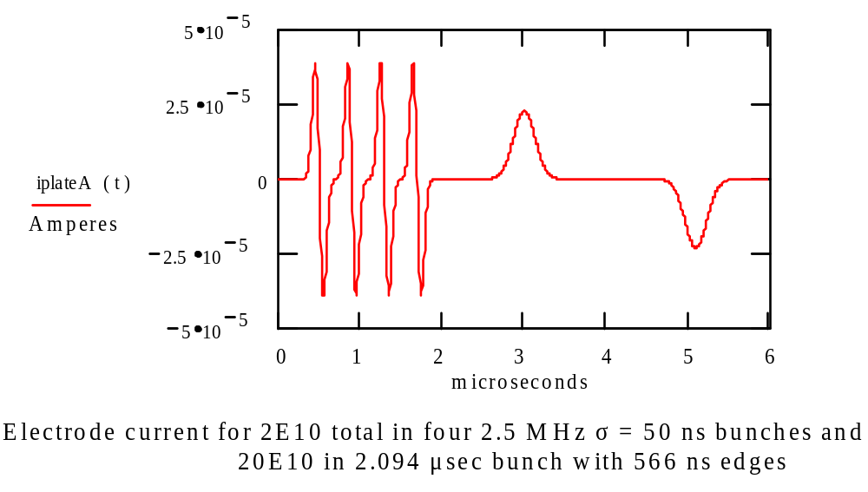

Hardware Signal Processing Modes

The Recycler BPM system allows selection of one of six signal-processing modes in the EchoTek digital receiver boards. The modes are:

- 2.5 MHz Ensemble.
This mode results in measurement of the magnitude of the 2.5 MHz signal integrated over an interval corresponding to about 1.6 microseconds (four 2.5 MHz periods), the full extent of the 4-bunch beam structure.

- 2.5 MHz Bunch-by-Bunch .
This mode results in measurement of the magnitude of the 2.5 MHz signal integrated over an interval corresponding to about 0.4 microseconds (one 2.5 MHz period). The measurement duration is about 1.6 microseconds (four 2.5 MHz periods) allowing measurement of each of the four 2.5 MHz bunches.

- 2.5 MHz Narrow Band.
This mode results in measurement of the magnitude of the 2.5 MHz signal integrated over an interval corresponding to about 700 microseconds (about 64 TBD Recycler turns).
This mode may be used to measure the closed orbit of all beam in the Recycler Ring that generates 2.5 MHz signal frequency components.

- Un-bunched Ensemble.
This mode results in measurement of the magnitude of the signal from beam confined in a barrier bucket otherwise lacking intentional modulation. The signal is effectively integrated over an interval corresponding to the full barrier bucket length. The actual EchoTek setup is determined algorithmically based on the barrier bucket length as determined from MDAT, the accelerator data distribution system.
This mode is used to measure the “average” position of the barrier bucket structure beam.

- Un-bunched Head or Tail.
This mode results in measurement of the magnitude of the signal from beam in the leading or trailing edges of a barrier bucket. The signal is effectively integrated over an interval corresponding to the typical rising or falling time of the barrier bucket beam structure.
This mode measures the position of the head and/or the tail of the barrier bucket structure beam.

- 89 kHz Narrow Band.
This mode results in measurement of the magnitude of the 89 kHz signal integrated over an interval corresponding to about 700 microseconds (about 64 Recycler turns).
This mode is used to measure the closed orbit of all beam in the Recycler Ring that generates 89 kHz signal frequency components.

PreAmp Design:

Each preamp is a two-channel circuit required to:
- Receive via coaxial cables and into well-controlled impedances two beam signals (A and B) from the respective BPM electrodes.
- Provide suitable gain and impedance matching to drive the beam signals on twisted-pair cables to the service buildings.
- Provide suitable connections and necessary DC isolation from the electronics to apply ion clearing voltages up to 500 volts to the BPM electrodes.
- Provide connections, control, and signal conditioning for BPM calibration signals for application to the normal beam signal paths at the preamp inputs.
- Sustain without damage the peak input signal levels presented by specified beams (e.g. 53 MHz) outside the normal functional range for beam position measurement.

The preamp is designed to present a resistive load impedance of 1.5 kΩ to beam signals from the pick-up electrodes. This resistance coupled with the parallel electrode and coaxial cable capacitance provides a “high-pass” transfer function from beam current to preamp input voltage with a corner frequency of about 1.5 MHz. The preamplifier is designed for a mid-band voltage gain of about 3.5 with a bandwidth of approximately 23 MHz. The final amplifier stage provides a differential output to drive a 100Ω twisted-pair cable in a balanced fashion. Series resistors provide a back termination for the cable. The preamp is capable of driving a differential voltage up to 3.7 V peak-to-peak on the cable downstream of the back-terminating resistors.

RG58 cables with SMA connectors connect the preamp to the BPM electrodes. The calibration signal waveform is connected to and daisy chained through the preamp on RG58 cables with BNC connectors. A calibration control signal is connected to and daisy chained through the preamp on RG58 cables with BNC connectors. Ion clearing voltages connect to and daisy chain through the preamp on RG58 cables with SHV connectors. A cable with four twisted-pair wires connects the preamp in the tunnel and the Transition Module crate in a service building to carry the preamp A and B output signals from the tunnel and to provide DC power to the preamp.

Transition Module:

The transition module input is configured using a differential receiver op-amp (AD8130) converting the differential input to a single ended signal. The main function of the transition module is to compensate for cable attenuation, provide an anti-aliasing filter, and normalize the input voltage to use the full dynamic range of the A/D converter.

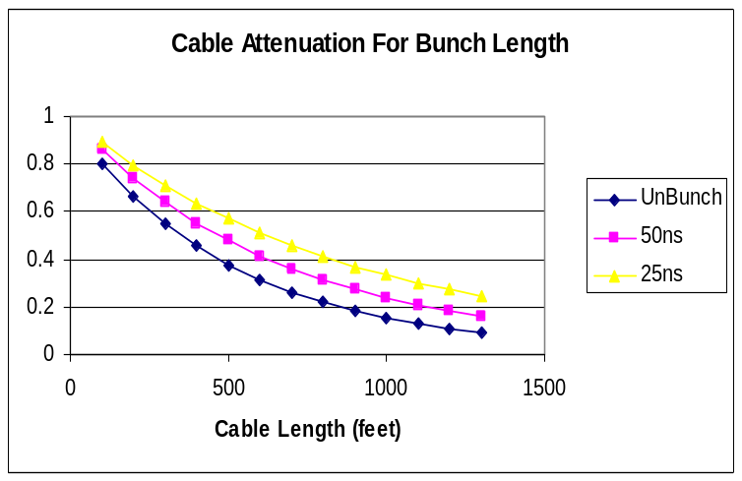
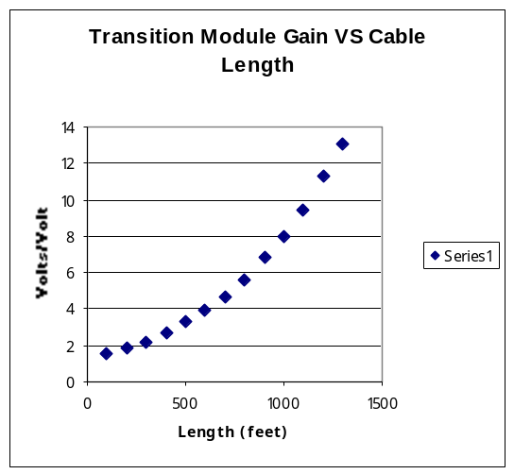

The figure on the left shows the range of gains vs. cable lengths needed to normalize the pre-amp signal to 1.1 Vpp at the input of the DDC. The figure on the right shows the attenuation due to cable length on bunches of different sigma_t.
Each of the 6 houses in the ring has 10-12 eight-channel transition modules, their gains were selected based on the cable lengths attenuation.
- 150 to 400 ft, G = 2.0
- 400 to 600 ft, G = 2.5
- 601 to 900 ft, G = 4.0
- 900 to 1300 ft, G = 6.0

System Frequency Response Measurements:
wire
Pre-Amp
Trans. Mod.
Vertical BPM
50Ω
HP 37899
Network Analyzer

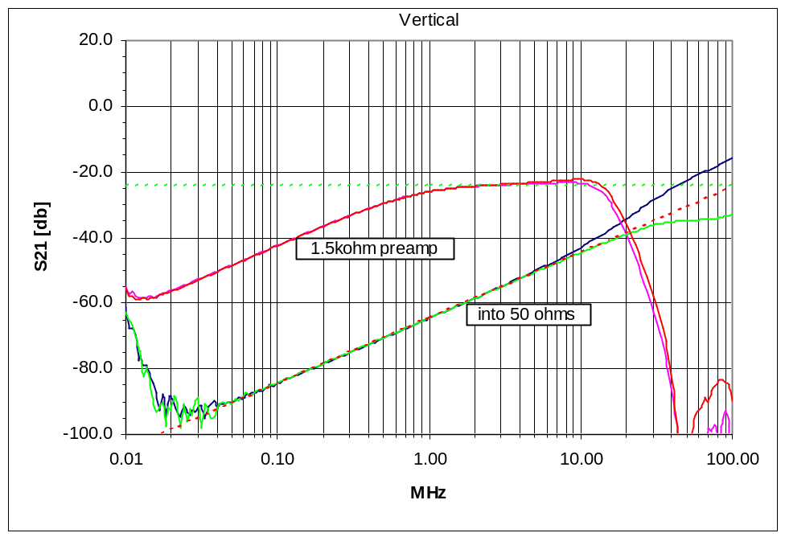

The figure above shows the transfer function of a vertical split plate BPM with the transition module as well as the BPM by itself. The network analyzer drives the wire in the BPM terminated in 50 Ω. The first measurement made was with the BPM plate directly terminated in 50 Ω. Shown as the lower trace as the high pass response. In the second measurement the BPM plate was terminated in 1.5 kΩ at the input of the pre-amp. The measurement was made at the output of the transition module. The upper trace shows the frequency response of the BPM and the corner frequency shifted down in frequency toward 1.5 MHz.

Signal Digitization and Processing on EchoTek Board (DDC)

EchoTek GC814 cards have eight independent channels each structured as a set of A/D converter, digital down-converter and FIFO memory elements. Each channel digitizes and filters one of the A and B beam signals from the transition module at 80 MHz asynchronously.
Each digital down converter (DDC) device has four channels in parallel of a NCO, CIC filter and two user-programmable LPF. Each channel can produce an I and Q pair as a 16-bit word and stored in the FIFO as one 32-bit longword. The data are transferred to the front-end processor where position and intensity are computed by processing the I and Q pair.
Our system uses two of the four DDC device channels, one channel generates the I term, and the second channel the Q term. This reduces decimation in the CIC filter, increases computation speed, and allows for the design of a fairly wide bandwidth filter. It also allowed us to meet the more narrow bandwidth requirements where high decimation rates were needed in the case of turn averaging.
The DDC programmable filters were setup in asymmetric mode. The first filter stage (CFIR) was coded with an 11 tap gaussian filter with the purpose of reducing data jitter introduced by asynchronous sampling. The second filter (PFIR) was setup as a boxcar averaging filter whose length was determined by the clock rate at the input of the 64 tap filter, the number of taps used, and the period of the data being sampled.

Data transfers between the Echotek board and the front-end processor (MVME 2401) are done under DMA control (DMA32 or DMA64) or direct bus transfers depending on the type of measurement performed. Data transfer rate measurement provide a figure-of-merit determining the number of data points produced at the output of different types of filters as well as set the maximum number of transfers achievable in the most stringent case where data is obtained every turn (turn-by-turn) as opposed to single shot data acquisition mode.

Calibration Signal Distribution

The calibration signal from the Calibration Signal Driver module is attenuated by about 14dB (a factor of five in voltage) down the 1300 ft RG58 calibration signal cables. The signal is locally adjusted to a common level in each preamp by a resistive attenuator network and split equally into A and B channels. Remotely controlled JFET switches connect/disconnect the A and B calibration signal channels to the respective preamp inputs. The A channel contains a JFET controlled attenuator to allow reduction of that signal by a factor of two relative to the B channel. Circuitry in the preamp decodes the –5 to +5 volt state control signal to set the JFET switches as required. The three calibration circuit states, OFF, ON w/A=B, ON w/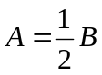, are thus supported.

The calibration signal source impedance presented to each preamp input is approximately 2KΩ. This is suitable to verify the voltage gain of the preamp and the transition module. However, the impedance is low enough to load the 1.5KΩ preamp input and thus provide only a rather insensitive test of the preamp input circuit, i.e. the pick-up and signal cable capacitance and the preamp input impedance.
To meet the requirements specification, the relative A and B signal amplitudes within a preamp must be controlled to approximately 0.5%.
The calibration application lets the operator do a thorough set of calibration tests, and
generates graphs and reports that let him/her quickly spot problem BPM’s. It does this by taking advantage of the Closed Orbit mode of the BPM Data Acquisition hardware, and the signal generating hardware. The results are also logged in a database, allowing historical review of any particular BPM's calibration results. To perform a calibration test set, at the operator’s request, we do 6 separate iterations of turning on the signal generation, and then do a Closed Orbit 16-turn reading of that signal. Each iteration gives us an average position, and RMS error for each BPM. The six iterations
consist of three voltage levels with a balanced (1:1) and unbalanced signal (2:1). The operator is then presented with a choice of graphs to examine, or the option of generating a "bad BPM" list. Two graph types provide useful diagnostic information, the un-scaled position graphs, and the A/B ratio graph. In the former, one expects to see the un-scaled position come back with the balanced (1:1) signal reading dead center, and the unbalanced (2:1) signal reading just over 0.3. Also one expects the RMS error to decrease as the voltage goes up. In the A/B ratio graph, we examine the A/B ratio for
the balanced(1:1) signal at all three voltages; this shows if we have a different amplification gain between the two channels, which would lead to an intensity-dependent position error. The operator also decides whether to log this run in a database, or save the raw data to a spreadsheet. In this fashion, the application lets the operator do a set of calibration tests, and generates graphs and reports that quickly spot problem BPMs, and usually the type of problem with a glance at the graphs.

Position Error due to Component Noise

The Position error has contributions due to noise in the circuits in the pre-amp, the transition module, and the noise of the A/D converter. The noise of the pre-amp and the transition module can be expressed as power noise density calculated using the following expression:
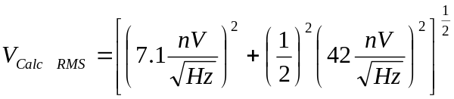

The voltage noise density is multiplied by the bandwidth at the final stage to obtain the noise factor that can be added in quadrature with the noise factor of the A/D to be applied in the computation of position noise.

A/D Converter Noise

SNR for a sinusoidal input is the ratio of the RMS signal at the output to the RMS noise excluding harmonics and DC term. If harmonic and DC terms are included, one obtains the term SINAD.

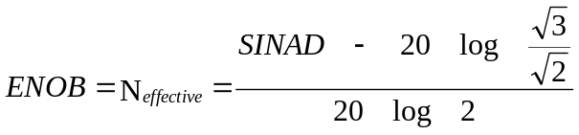

The effective number of bits, ENOB, reflects the accuracy the A/D will have when digitizing a signal relative to the inherent noise.
Over-sampling can compensate for loss of bits from the ideal. The increased resolution (R) is given by the expression:

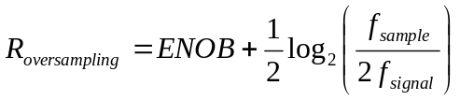

The A/D RMS voltage noise can be computed from the ratio of the full input RMS voltage to the ratio of the RMS noise or the ENOB.

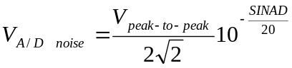 (1) ; 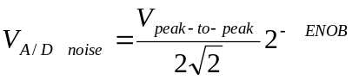 (2)

The total noise can be calculated from the expression, 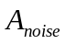=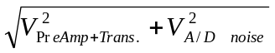

The system dynamic range ,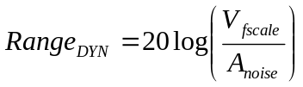
The position error, 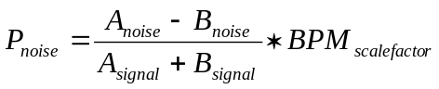

making the approximation A=B for beam on-center and since noise is un-correlated 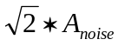 can be substituted in the numerator.

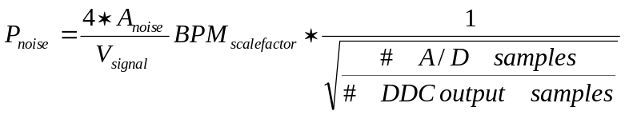
The factor of 4 is the multiplication of  with 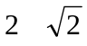 factor, which is required to convert peak-to-peak voltage at the input of the A/D to RMS.

Numerical Calculation :

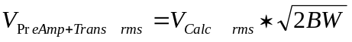 , 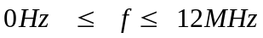
The factor accounts for noise present beyond the cutoff frequency and it follows the filter attenuation.

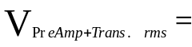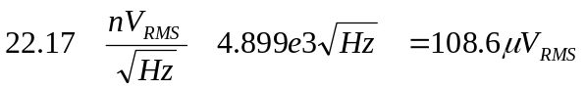

Using equation (1) to compute the A/D noise
SINAD = 75 dB from AD6645 data sheet; 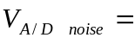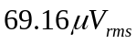

then the total RMS noise is given by
The largest BPM scale factor in the Recycler is 62 mm per Volt, the number of A/D samples =128 and the number of DDC output samples are 4 after averaging and decimation.

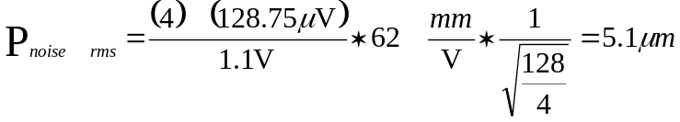
The position error must be scaled by the difference between the maximum allowed signal and the signal intensity at which the measurements were taken, given that at lower signal levels fractional noise level increases.

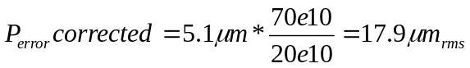

Recycler Ring BPM Measurements:

Turn-by-Turn BPM data shown below was obtained during injection. All horizontal and vertical BPM’s in the ring Data for turns 20 up to turn 50 were fitted to a sine wave, shown as green dots on the plot. The sine wave was extended to earlier and later turns to show the uniformity of measurements before and after the selected turns.

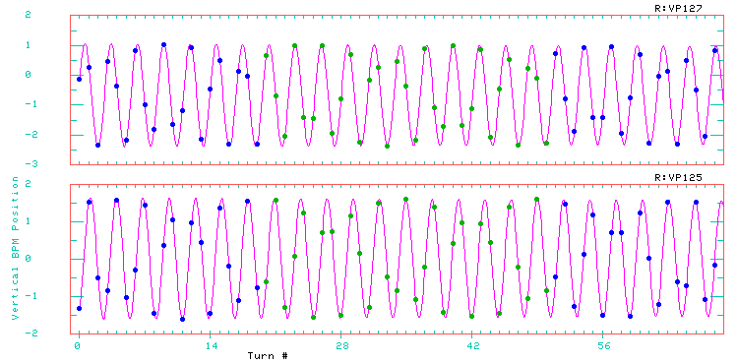

Histogram of RMS position deviation for vertical and horizontal BPM’s.
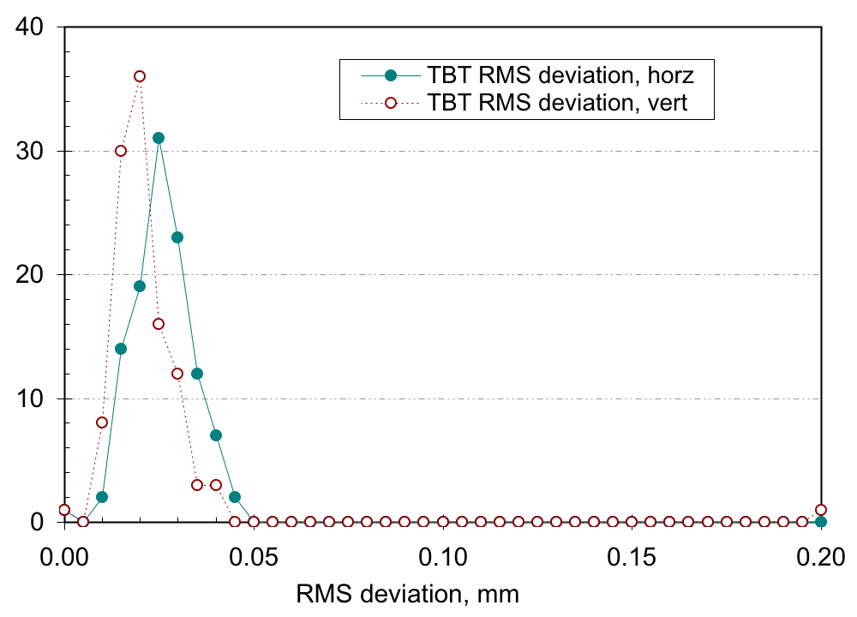

The plot above shows a histogram of the deviation of the measured BPM data (turns 20 to 50) from the fitted sine wave.

Acknowledgements

We want to thank Dr. Ming-Jen Yang for providing this Recycler BPM data.

