Gustavo Cancelo
CEPA/ESE-CD
Nov. 29th 2004

The BPM signal

The purpose of this document is to introduce some simplified models of the BPM pickup signals to be used in BPM filtering and position estimation. The idea is to have signal models simple enough to make analytical comparative analysis of filtering options. Signal complexity like the effects of synchrotron and betatron oscillations and systematic errors generated by system unbalances will be considered later.

Signal model

A crude model of the BPM pickup signal is a “doublet” as shown in Figure 1. A good representation of a doublet is the sum of 2 Gaussians displaced in time:

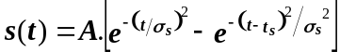 (1)

The value of σ_{s} is in the order of 2 to 4 ns.
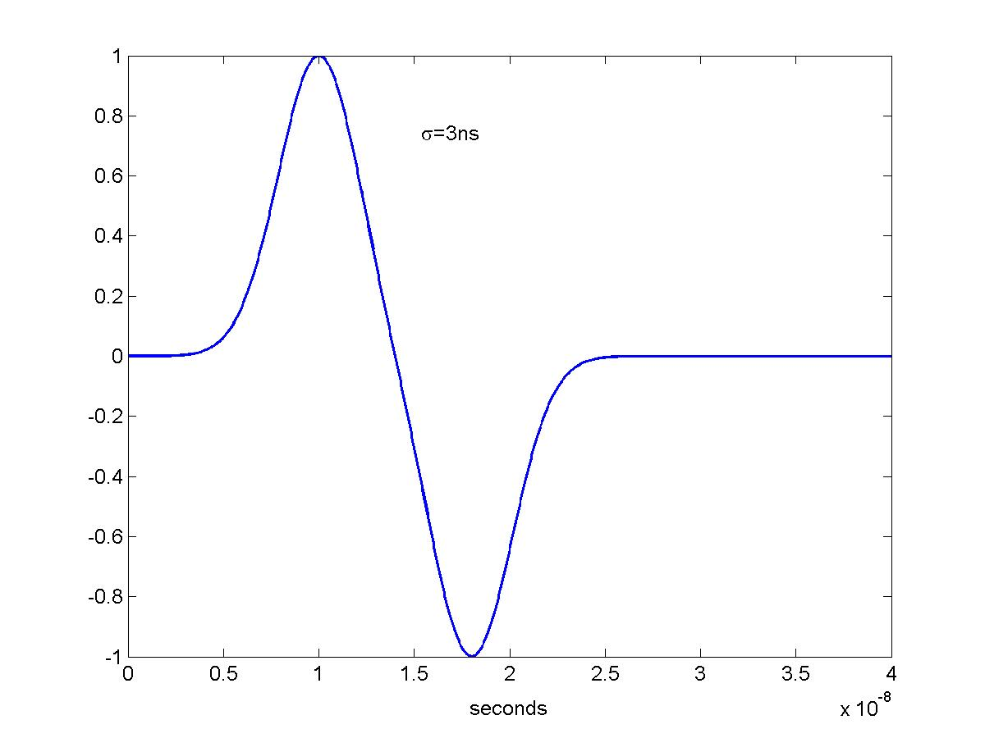

The Fourier transform of a Gaussian is also Gaussian:

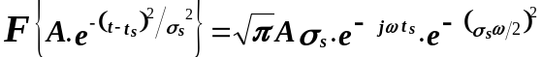 (2)

The t_{s} delay originates a phase rotation in the transform but it does not change the magnitude.

Hence, the doublet’s Fourier transform is

(3)

In equation (3) it has been assumed that the first Gaussian in the time domain is centered at t_{s}=0. The Fourier transform of the doublet is depicted in Figure 2. Note that the combination of the transforms of the two Gaussians is not a Gaussian but a sum of Gaussians with different weighting coefficients.

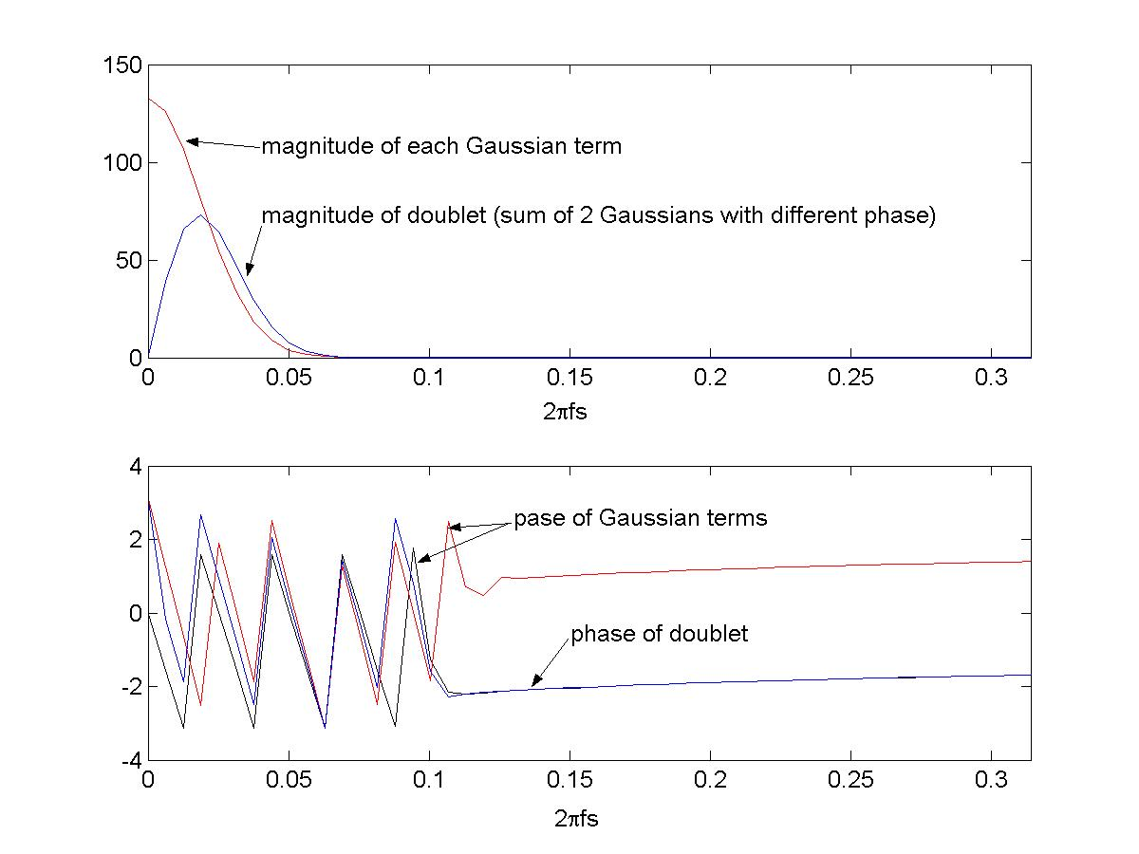

The 53MHz ringing filter

The first filtering stage is a pass-band ringing filter centered at 53.104MHz. Since the width of a bunch is only a couple of ns, the purpose of the ringing filter is to generate a signal long enough to be used for beam position measurement with low error. Position is defined as

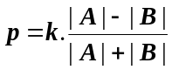, where A and B can be considered a differential pair. |A|+|B| defines the beam intensity.
The function p is only linear for constant intensity. However, offline corrections can be applied.

The ringing filter plays the roll of a charge amplifier. The size of the envelope of its output is proportional to the input’s amplitude. The ringing filter can be modeled by:

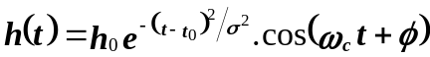 (4)

Figure 3 shows h(t) and its envelope for ω_{c}=53.1MHz, σ=33ns and t₀=120ns.

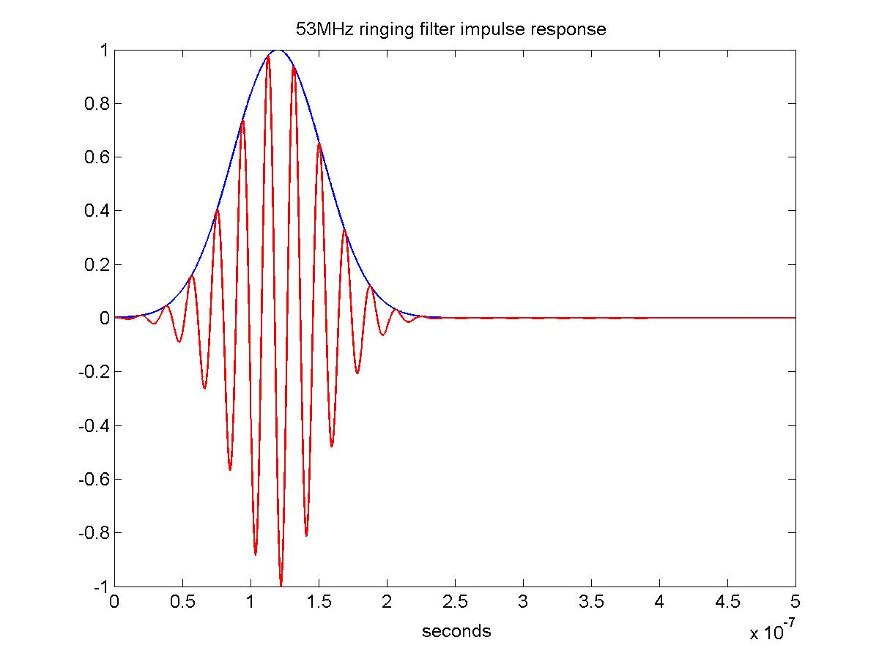
Figure 1

The calculation of the Fourier transform of h(t) is tedious but I’m including it here to have it somewhere:

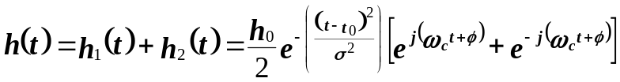, (5)
where we have use the equivalence between cosine and complex exponentials. The right hand side of (5) has two terms that we called h₁(t) and h₂(t) respectively. We are going to work with the exponents of each term individually.
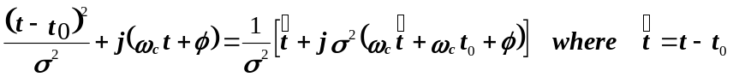

after completing the binomial

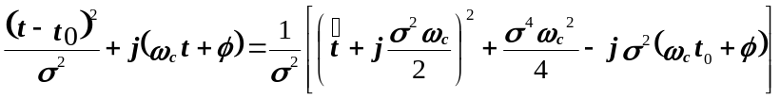

Let 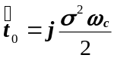, then

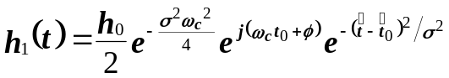

Let 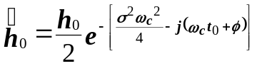then

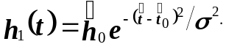 (6)

The Fourier transform of h(t) can be calculated from equation (6) using the property

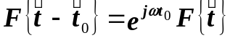

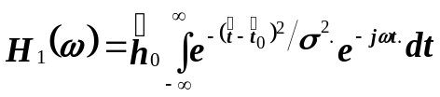

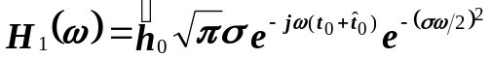

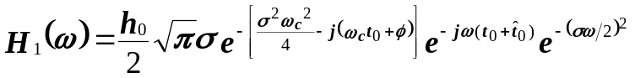

rearranging the exponents H₁(ω) becomes:

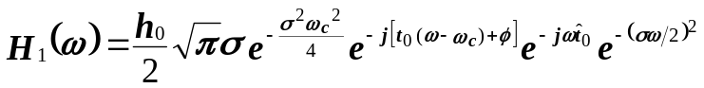

but 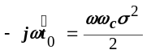, then

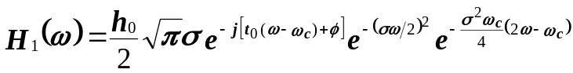 (7)
The first exponential in (7) is a phase rotation proportional to the difference between ω and the modulation frequency ω_{c}. The second and third exponentials can be combined as follow:

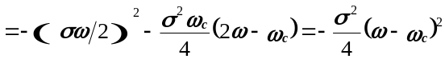

hence,
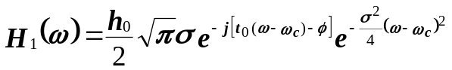

similarly, H₂(ω) can be written as

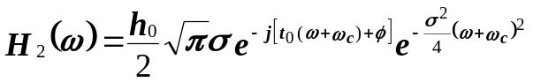

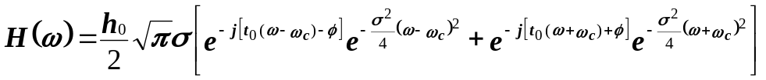

As expected, the Fourier transform of h(t) has two terms centered at ±ω_{c}. The phase of each term is delayed proportionally to t₀.

The ringing filter’s output

The output of the ringing filter u(t) is the convolution of s(t) and h(t). In the frequency domain this is expressed by the product of the Fourier transforms, U(ω)=S(ω).H(ω).

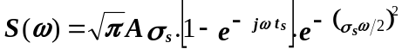 (10)

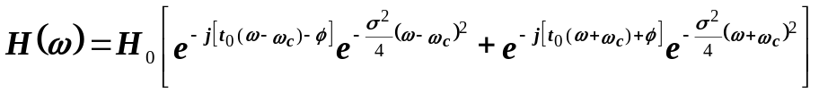 (11)

(12)
where 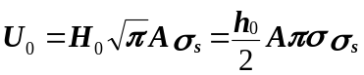 (13)
We can work U(ω) amplitude and phase terms independently. U(ω)‘s amplitude gain has two terms coming from H(ω), which are now modulated by the S(ω) amplitude’s gain. The two H(ω) Gaussians centered at ±ω_{c} are now going to be shifted. Let’s look at the 1st of them:

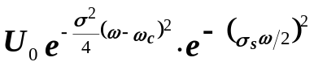

The exponents can be rearranged as follow:

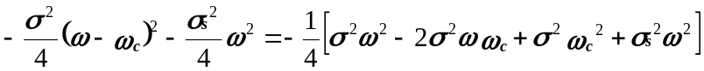

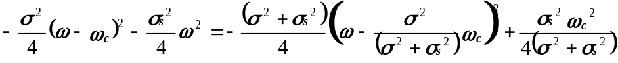

hence the 1st term of the amplitude gain of U(ω) can be expressed as:

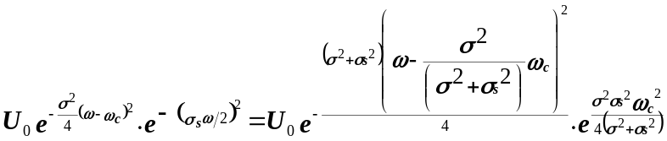 (14)

Equation (14) shows that the 1st term of the output signal’s amplitude is also Gaussian. The center of this Gaussian has shifted from ω_{c} to (σ²/ σ_{s}²+σ²).ω_{c}. The output signal’s amplitude is proportional to a 2nd exponential term that is a function of the system and signal constants (i.e. σ_{s}²,σ² and ω_{c}).
In the BPM system σ_{s}²<<σ² so the frequency shift is negligible and so is the effect of the 2nd exponential.
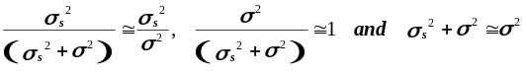 (15)
Let ω_{c}=53.1MHz, σ=33ns and σ_{s}=4ns, then σ²/ σ_{s}²+σ² = 0.985. The 2nd exponential is equal to 1.0011.

The second summand of U(ω) amplitude gain in equation (12) is

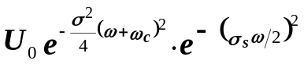, which can be turned into

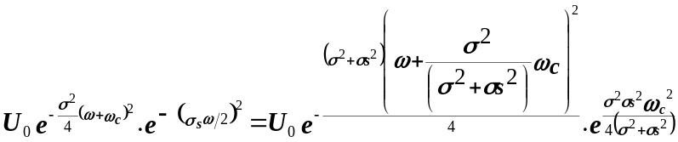 (16)

So the total U(ω) amplitude gain can be expressed as:

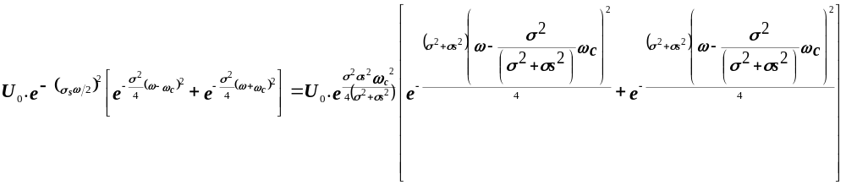 (17)

We can simplify equation (17) by using the following notation:
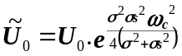, 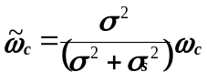, and 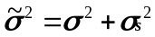

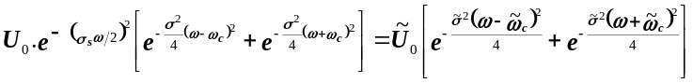

The phase of U(ω) can also be calculated from equation (12),

The phase of the 1st summand in (12) involves:

, the two Gaussians that make a doublet are rotated by the phase introduced by the filter. Similarly the phase of 2nd summand in (12) is:

Finally, combining the amplitude and phase results, U(ω) can be written as:

(18)

Figure 4 shows the Fourier transforms for H(ω) and U(ω) using the following parameters: for ω_{c}=53.1MHz, σ=33ns and σ_{s}=3ns. Note that the two transforms are very close to each other and the approximations of equation (15) are well justified. U(ω) is not Gaussian but is very close to H(ω) which is Gaussian.
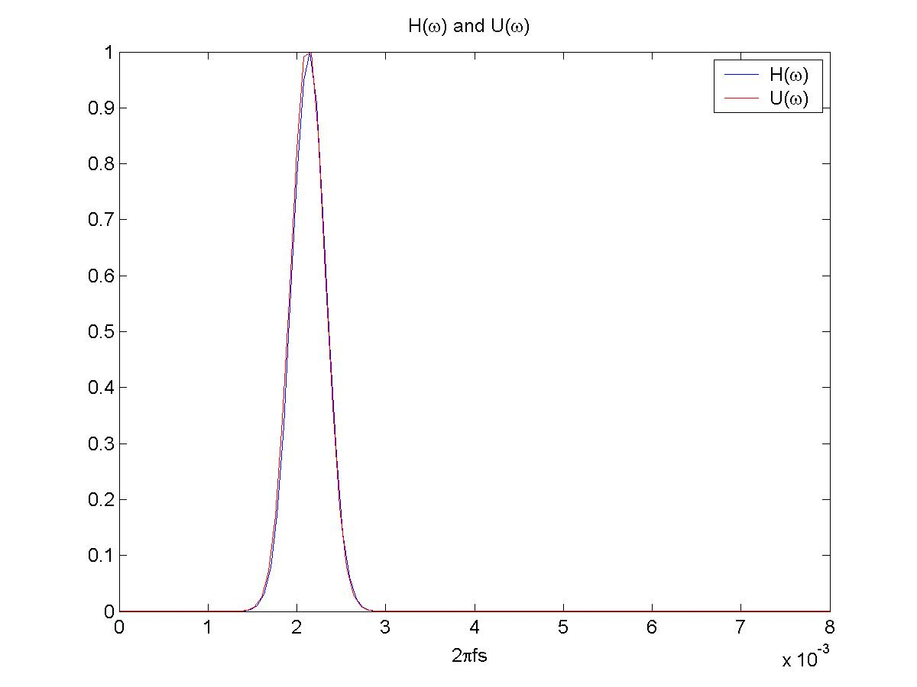
Figure 2

Inverse transforming equation (18) we obtain the output of the ringing filter in time domain:

, where u₀=A.h_{0.}

Signal model with multiple bunches

A signal with multiple bunches creates a train of doublets. Equations (1) and (3) can be used to generate a time domain and a frequency domain of such signal. We can define the train of doublets as the sum of N doublets with an increasing delay t_{k}=kT. T is 396ns for coalesced bunches and 18.83ns for uncoalesced mode.

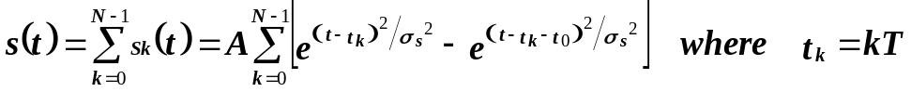

The Fourier transform of the train of doublets can easily be expressed as a function of the transform of a single doublet.

but 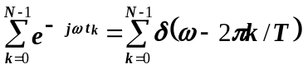 then, 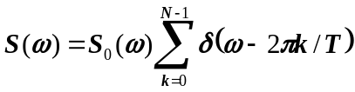 (17)

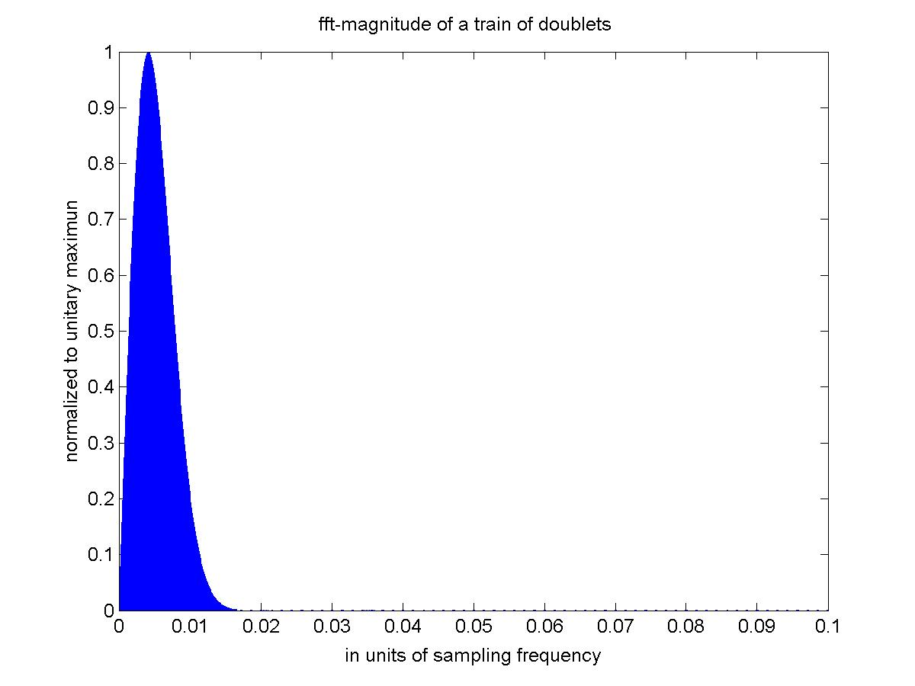
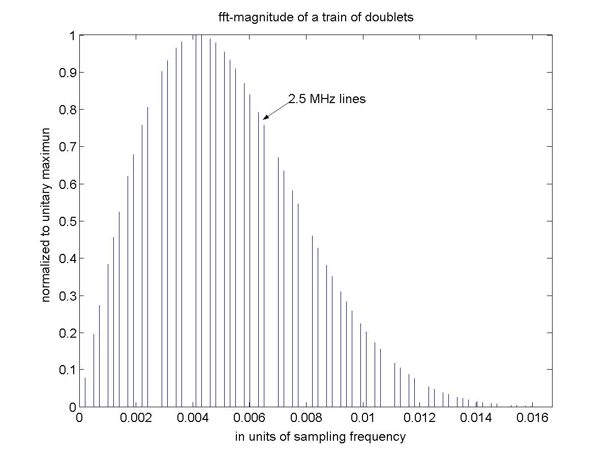
Equation (17) shows that the Fourier transform of a train of doublets is equal to the sampling of the transform of one doublet at the frequency 2π/T. Figure 5 shows the Fourier transform of a train of 12 doublets in coalesced mode. We can see that the envelope is the same as in Figure 2 but now the transform is non-zero at frequencies multiple of ~2.5MHz.
Figure 3

A typical Tevatron beam load has 3 trains of 12 bunches separated by abort gaps. That beam structure will add spectrum lines at ~144KHz that is the frequency at which the train of bunches repeat.

The phase shift problem

The BPM position measurement is computed from two signals A and B that are individually transmitted and processed by hardware that can introduce phase errors. For instance, the cable length from the BPM pickups to the BPM analog filtering boards can be up to 600ft long. A propagation delay mismatch between A and B in the cables will traduce in an A to B relative phase shift. 1.5cm of cable length mismatch introduces ~1º of phase shift. A mismatch in the phase characteristic of the analog “ringing” filters to process A and B will also generate an A to B relative phase shift. This section analyzes how the A to B relative phase error affects the calculation of position.

For the sake of simplicity we can use the single bunch signal model of equation (15). The extension to multiple bunches is straightforward. Let the individual signals A and B be represented by equations (20) and (21) below

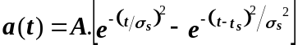 (20)

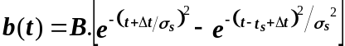 (21)

Where Δt can be positive or negative. After the ringing filter the signals become:

(22)

(23)

According to equation (18) the Fourier transforms of u_{a}(t) and u_{b}(t) are:
(24)
(25)
where U_{0A} and U_{0B} are given by equation (13) and are independent of ω. Note that the time shift introduced in b(t) shows up only as a phase rotation in the Fourier transform.

Clearly, if we calculate position using the unfiltered signals u_{a}(t) and u_{b}(t), we’ll have an error that is a function of the phase mismatch between A and B. Now, the question is how that error propagates to the output of a filter.

The Graychip has three levels of digital filtering and is able to achieve narrowband filters that are very close to an ideal lowpass filter. For the current analysis we can assume that A and B signals go through an ideal lowpass filter with a cutoff frequency ω₀. This assumption does not modify the validity of the result as long as the filters applied to A and B signals are identical, which is the case in digital filtering. The Fourier transforms of A and B at the output of the ideal lowpass filter become:

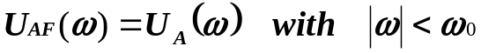 (26)

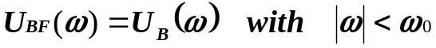 (27)

To be able to compute the position error due to A to B phase shift we must inverse transform equations (26) and (27) first. This is not an easy task because the limits of the integral in the inverse transform are ±ω₀ and not ±∞.

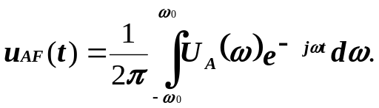

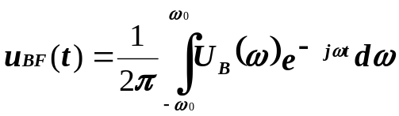

However, we can take a simpler approach. The spectrums of the BPM signals U_{A} and U_{B} only have lines with amplitude different from zero at DC and at multiples of 144KHz. Since the digital filters are narrowband, they only let few spectrum lines pass. For instance the cutoff frequency of the “envelope” filter is 300KHz. The only meaningful frequency components at the output of the filter are at DC, 144KHz and 288KHz. We can compare the amplitude of the spectrums lines of U_{A} and U_{B} for those three lines.

Before filtering, the Graychip down-converts A and B signals generating the in-phase and quadrature components I_{A}, Q_{A}, I_{B}, and Q_{B}. To simplify the notation, instead of working with I’s and Q’s we can work with equations (24) and (25) and assume that the 300 KHz filter is located around ±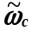.
We can do the analysis of spectrums U_{A}(ω) and U_{B}(ω) in the positive range of frequencies. The other half is identical.
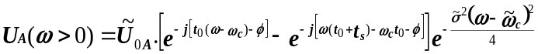 (28)
(29)

We observe form (28) and (29) that the DC component of U_{A}(ω) and U_{B}(ω is independent of the phase shift. Letting ω= ω_{c,}
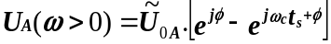
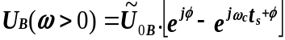
If the amplitude of the signals is the same, then U_{0A}(ω) = U_{0B}(ω) what implies that U_{0A}(0) = U_{0B}(0).
Let’s now see how the phases behave at a frequency ω₁.
Phase tern in U_{A}(ω) 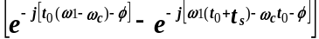
Phase tern in U_{B}(ω)
To better appreciate the phase delay effect we can use the equivalence:
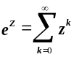

Then, the 1st summand in the phase tern of U_{A}(ω)is:
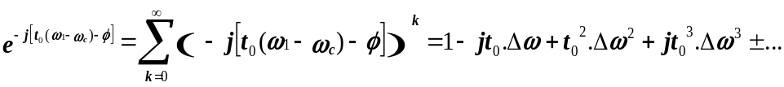
and the 2nd summand of U_{A}(ω)is:
where we have assumed that Δω=ω₁-ω_{c}, and Φ=0 because it does not have any relevance in the phase shift error. Similarly, the 1st summand in the phase tern of U_{B}(ω)is:
and the 2nd summand of U_{A}(ω)is:
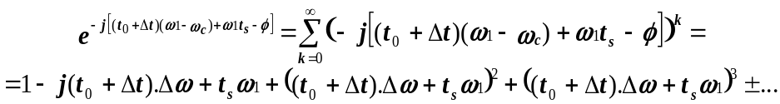

Now, let’s define the error as the amplitude of the complex number defined by the difference between the phases of U_{A}(ω) - U_{B}(ω).
, because 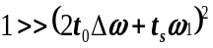

So, 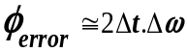. The error caused by relative phase shift is proportional to the time shift between the A and B signals and increases linearly with frequency. In other words the phase shift error is proportional to the filter’s bandwidth.

We have simulated the BPM problem using the following numbers:
ω_{c}=53.1MHz, σ=33ns and σ_{s}=4ns, t₀=120ns, t_{s}=10ns, Δω=300KHz, Δt=0.1ns

So, the phase shift error should be 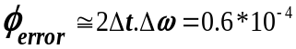. This number represents the “error gain” of the system at a specific frequency. An input signal of, say, ¼ of the maximum dynamic range (i.e. 26mm) will produce a phase shift error of ¼*0.6*10⁻⁴*26mm=0.39μ.

Phase shift error simulations

The simulation computes the error in position calculation as a function of the phase shift. A and B signals are generated using the models described in the previous sections of this document. (i.e Equations (2), (4), and (17)). To better visualize the effect of the ringing filters and some Fourier transforms, A and B signals are created using a high sampling rate 100 times faster than the 74.3MHz sampling frequency used by the Echotek card.
The phase of B is advanced with respect to the phase of A in steps of 2.57º (degrees) in the interval [0º,36º]. Figure 6a and 6b show the A and B signals. The blue trace represents the A signal at the output of the ringing filter. The red traces represent 15 phase shifted versions of the B signal. It is hard to see all the 15 B traces in Figure 6a, so Figure 6b zooms into a detail of the same signal plot.

Figure 7a and 7b show A and B traces after the signals have been resampled at 74.3MHz. Figure 7a shows the A signal in blue and 15 phase shifted versions of the B signal in red. A detail of the same plot is zoomed in Figure 7b.

We can consider that the simulation runs 15 times, one for each increment in B’s phase shift. The A and B signals used as inputs of each simulation run are about 320 accelerator laps long. The simulator processes the signals through the Graychip down-converters and filters. The simulator also calculates position using Equation 30 and (31). The A and B signal generator uses A and B equal in size and about ¼ of maximum dynamic range. So, position p should be equal to 0 for every measurement.

(30) 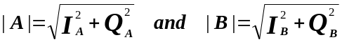 (31)
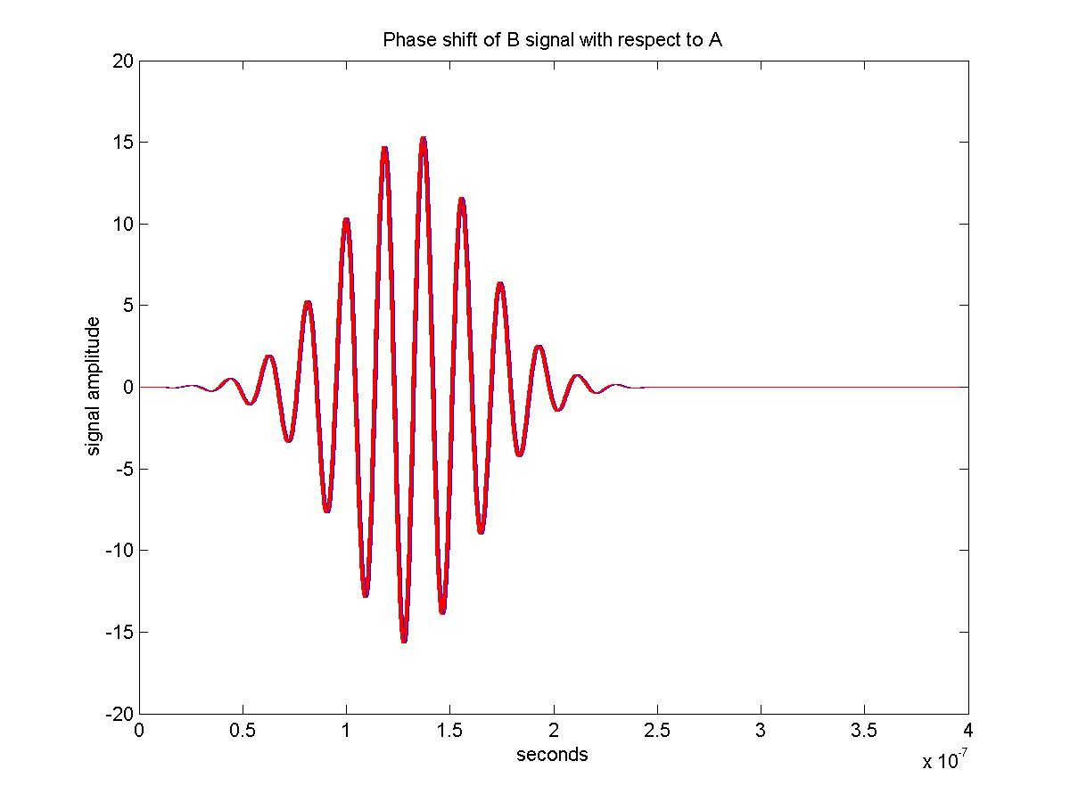
Figure 6a

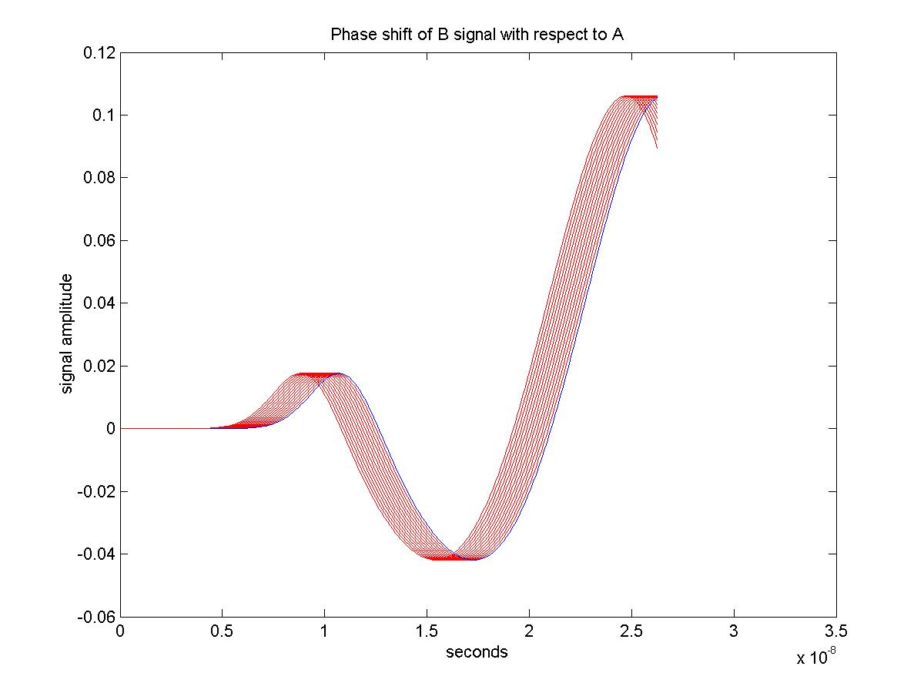
Figure 6b

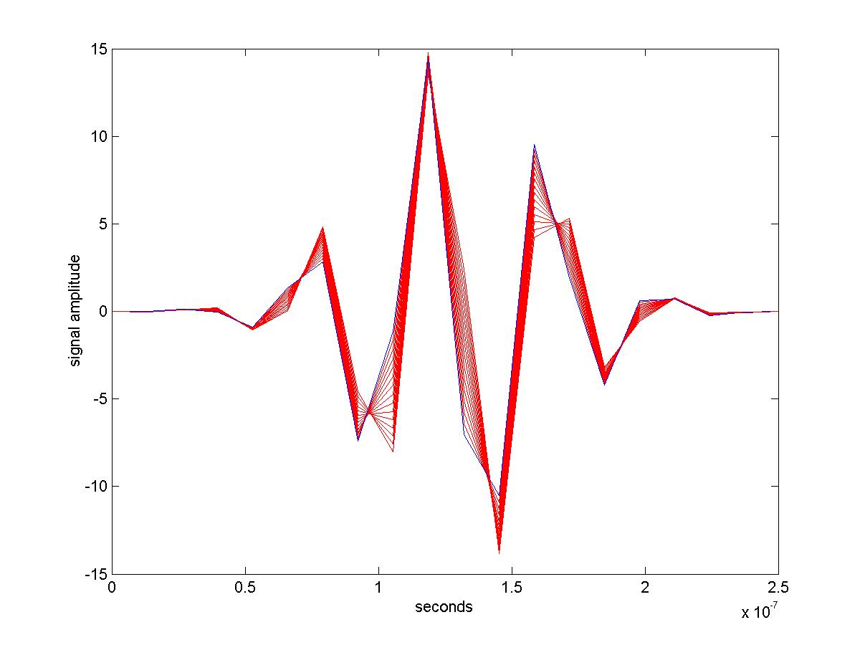
Figure 7a
36º of total
phase shift in 2.57º
increments

1 A waveform
15 B waveforms

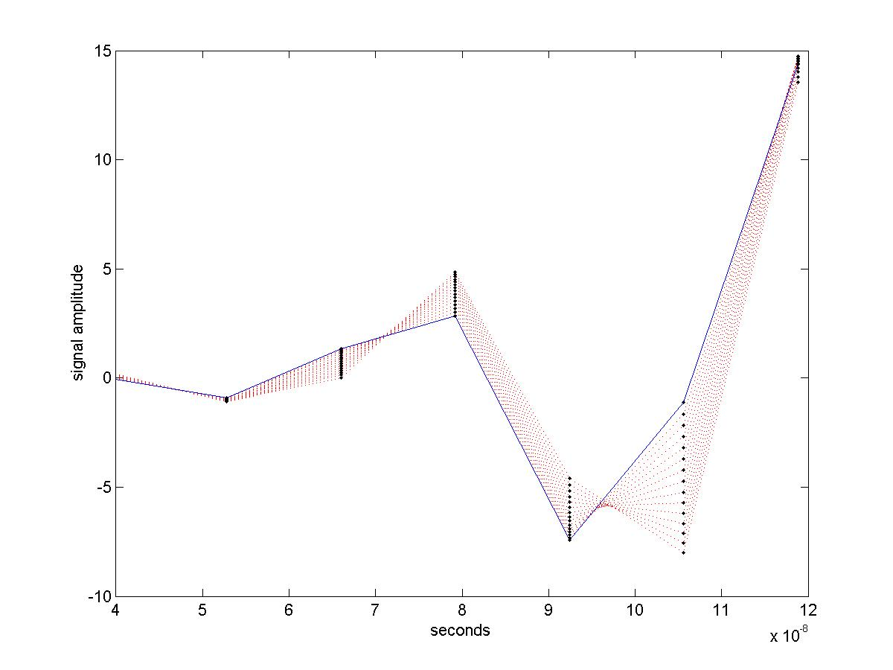
Samples
1 A waveform
15 B waveforms
Figure 7b
The simulation uses the “envelope” filter which has a bandwidth of 300KHz. A position point is calculated averaging samples in 3 envelopes (i.e. a position measurement per lap). Figure 8 shows the position simulation error for the 15 runs. The mean error increases in absolute value until about 25 degrees and then starts decreasing. This is consistent with our model for small phase shifts. The expected values of position error for each phase shift are, also, in agreement with the ones obtained by modeling. As the phase shift increases, the sigma in the distribution of position error increases. I have looked at the data and this seems to be caused by the sampling phase of the signals A and B. I will keep investigating this problem a little more.

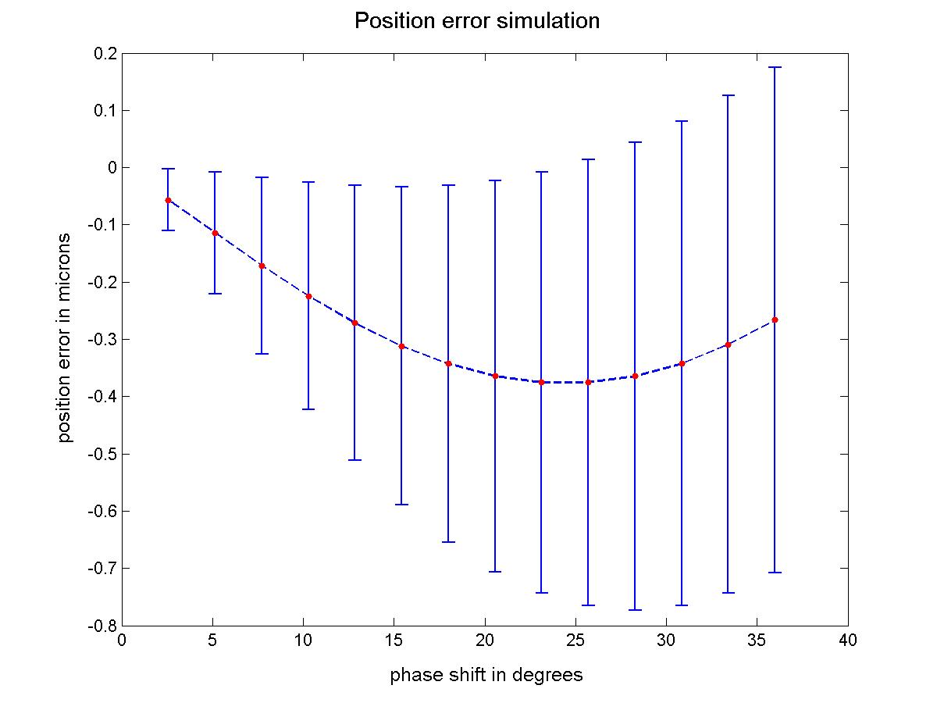
Figure 8

