Test of TEL-2 Magnetic System

Report

I. Bogdanov

Institute for High Energy Physics, Protvino, Moscow region

2005

The alignment of the magnetic system was described in “Preliminary Test of TEL-2 Magnetic System” report. The electrical circuits of superconducting magnetic system, resistances of electrical circuits of TEL2 superconducting magnets at room temperature and electrical strength of superconducting magnets respectively to cryostat at room and helium temperature are also presented in preliminary report.

Cool-down.

During cool-down the resistances of magnet coils were measured. Next formula was used for calculation of temperature in the SC magnets:
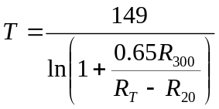 ,
where R₃₀₀ is resistance of magnet at room temperature, R_{T} is resistance of magnet during cool-down, R₂₀ is residual resistance of the magnet at 20 K temperature.
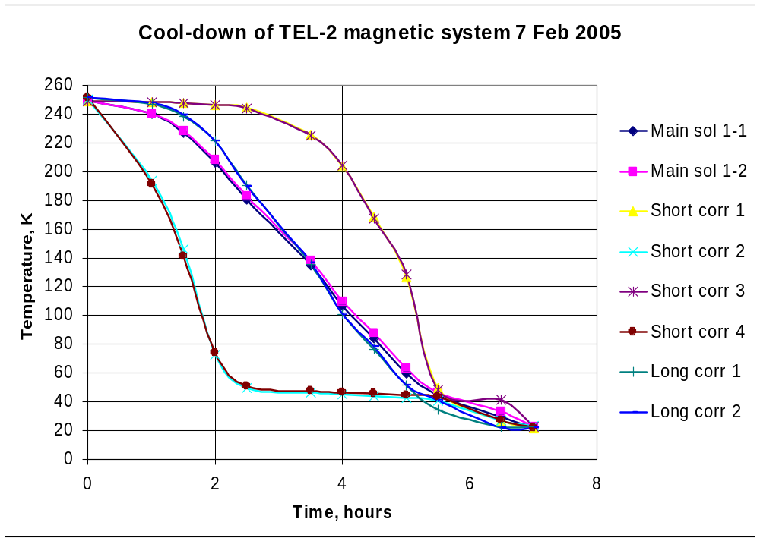
Figure 1. Cool-down of the TEL2 magnetic system.
Figure 1 shows the cool-down process of superconducting magnetic system of TEL-2. In the whole the shape of curves and characteristic cool-down time for each magnet are the same as early obtained (see preliminary report). The some difference in temperature values is caused by the influence of resistance of additional wires, which were absent in previous case.

Training.

TEL-2 superconducting magnets had no training. The nominal currents for each magnet were achieved without quenches. At nominal current main solenoid operates stable.

Magnetic measurements.

For magnetic measurements Lake Shore model 460 teslameter was used with 3-component Hall probe.
During measurements it was found that the used teslameter has big error. Teslameter was checked in IB-1 with the help of reference magnet. This test confirmed that the device has inadmissible great error up to 13%, in spite of this device was repaired and calibrated by manufacturer a month ago. Then the Z channel of teslameter was calibrated with respect to Metrolab PT2025 NMR teslameter in main solenoid. But X and Y channels were calibrated with the help of precision DTM-151 Hall teslameter in magnetic fields generated by short dipole correctors. By this way the correction coefficients were found. Coefficients for cannels X, Y and Z are equal to 1.117, 1.118 and 1.136, accordingly. Then the measurements were continued with the Lake Shore teslameter and obtained data were corrected.

Transfer function B(I) and longitudinal distribution of magnetic field B(z) were measured for all superconducting magnets.
Full set of measured dependencies is presented in Appendix 1. In figures the positive direction of the longitudinal axis is the direction from electron gun solenoid to collector solenoid.

Main magnetic parameters of superconducting magnets.

Main magnetic parameters of superconducting magnets are presented in Table 1. The following denotations are used:
- I - current;
- B₀ – central field;
- I₁ = ∫_{z}B₀(z)dz;
- I₂ = ∫_{z}B_{t0}(z)/B_{z0}(z)dz;
- I₃ = ∫_{z}(B_{t0}(z) - <B_{t0}>)/B_{z0}(z)dz;
- B_{t0} – transversal component of magnetic field B_{x0} or B_{y0}
- V – vertical dipole;
- H – horizontal dipole;
- L – long dipole;
- S – short dipole;
- C – collector side;
- G – gun side.

Table 1. Main magnetic parameters of superconducting magnets.
Magnet |  | I, A | B₀, kG | B₀/I, G/A | I₁, MG×mm
Main solenoid |  | 1782.2 | 65.66 | 36.84 | 163.36
Short 1 | HC | 189.23 | 5.717 | 30.21 | 1.082
Short 2 | HG | 190.1 | 5.710 | 30.04 | 1.078
Short 3 | VC | 188.69 | 5.928 | 31.42 | 1.109
Short 4 | VG | 178.7 | 5.569 | 31.11 | 1.0058
Long 1 | H | 46.97 | 0.824 | 17.54 | 1.4995
Long 2 | V | 47 | 0.879 | 18.67 | 1.5684

In the corrector dipoles the magnetic field was measured at currents, which were close to 95% of maximum current of power supply (~190 A for short correctors and ~45 A for long correctors). The design of long corrector dipoles for TEL-2 was modified. Now long dipole has one shell coil only. Operating current is 100 A. But the experimental stand is equipped by 50 A power supplies for long dipoles in accordance to TEL-1 specification. So maximum achieved fields were low.

Main magnetic parameters of superconducting magnets at 1.6 T in main solenoid are presented in Table 2. The values of integral I₃ at de-energized dipole correctors and B_{z0} = 1.6 T are equal to 0.0188 and 0.0359 for horizontal B_{x0} and vertical B_{y0} components of magnetic field, correspondingly.

Table 2. Main parameters of superconducting magnets at B_{z0} = 1.6 T.
Magnet |  | I, A | B₀, kG | B₀/I, G/A | I₁, MG×mm | I₂, mm
Main solenoid |  | 434.0 | 16.09 | 37.07 | 39.96 | -
Short 1 | HC | 189.15 | 5.773 | 30.52 | 1.104 | 101.3
Short 2 | HG | 190.22 | 5.759 | 30.28 | 1.0446 | 84.12
Short 3 | VC | 189.02 | 5.958 | 31.52 | 1.0415 | 92.41
Short 4 | VG | 188.76 | 5.906 | 31.29 | 1.0463 | 93.15
Long 1 | H | 46.9 | 0.884 | 18.84 | 1.678 | 118.0
Long 2 | V | 47.065 | 0.940 | 19.98 | 1.384 | 97.5

Magnetic fields versus current dependencies for all superconducting correctors are hysteretic due to influence of iron yoke. It is obvious that the transfer functions are dependent on the longitudinal magnetic field B_{z} of Main solenoid. This effect is stronger for long correctors, because of the maximum field of long correctors was few times lower than the one for short correctors.

Conclusions:

- Superconducting magnetic system for TEL-2 is efficient.
- Operating currents of superconducting magnets were achieved without training.
- Main magnetic parameters of Main solenoid, Short correctors and Long correctors are very close to the parameters of TEL-1 magnets.
- It is necessary to increase the current of Long correctors up to 100 A.

Test of TEL-2 Magnetic System

Appendix 1.

Figures.

I. Bogdanov

Institute for High Energy Physics, Protvino, Moscow region

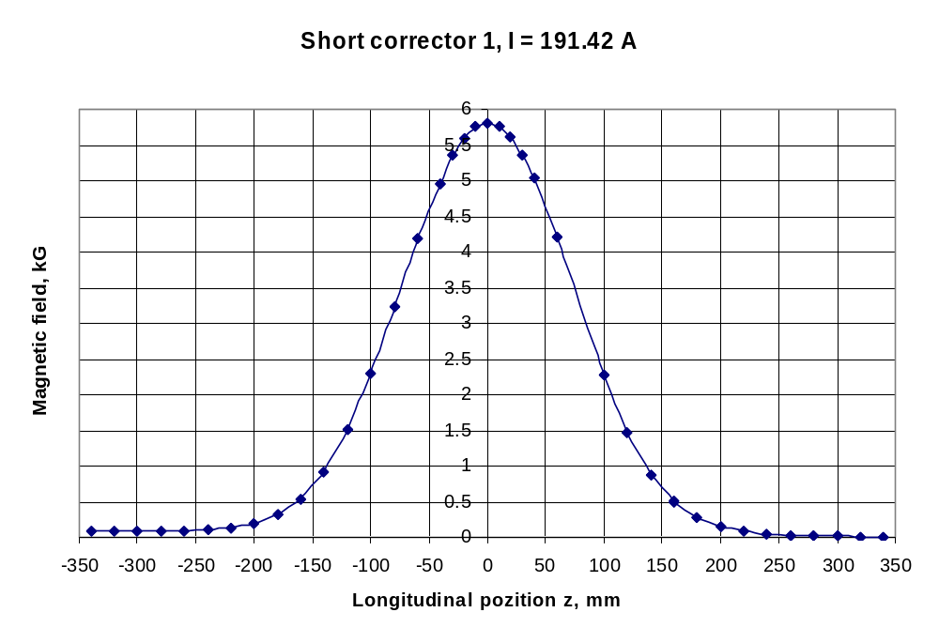
Figure 1. Magnetic field in short corrector 1.
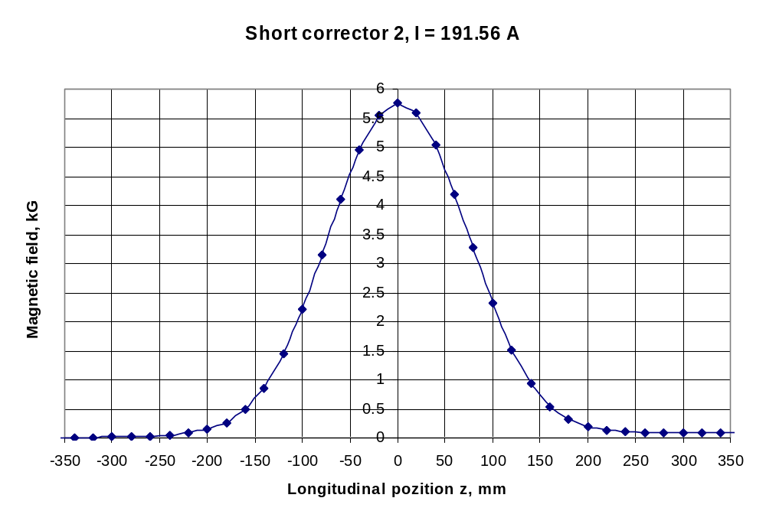
Figure 2. Magnetic field in short corrector 2.

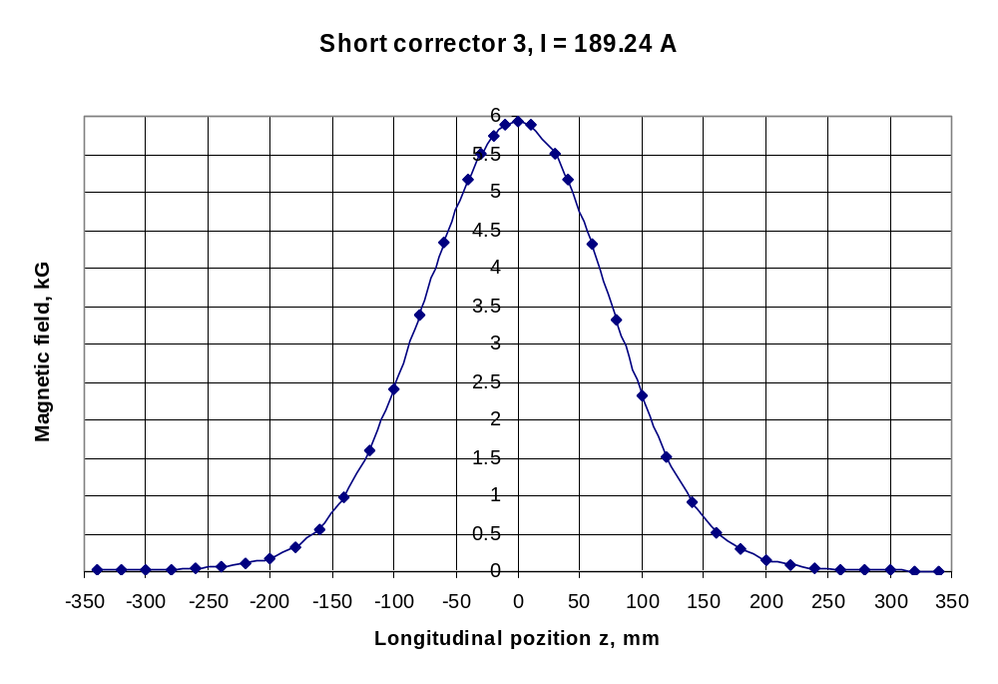
Figure 3. Magnetic field in short corrector 3.
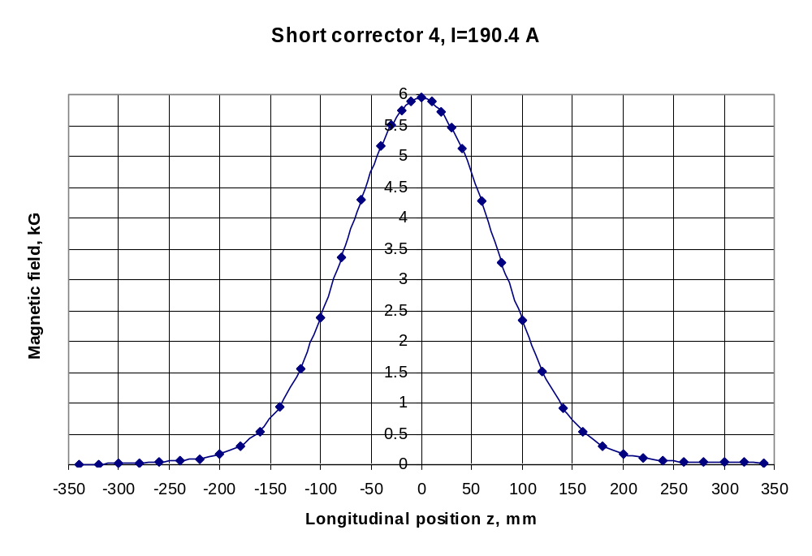
Figure 4. Magnetic field in short corrector 4.

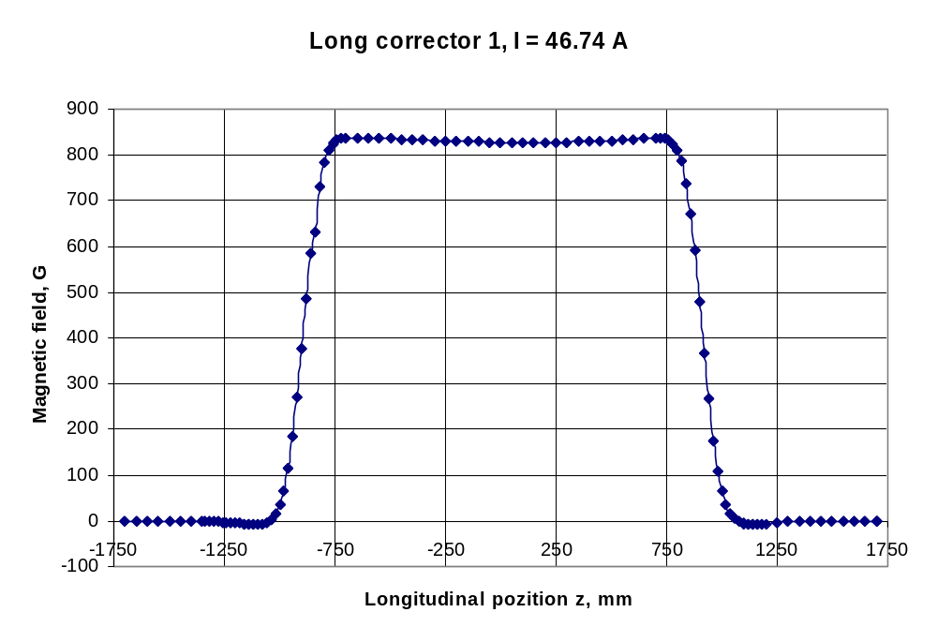
Figure 5. Magnetic field in Long corrector 1.
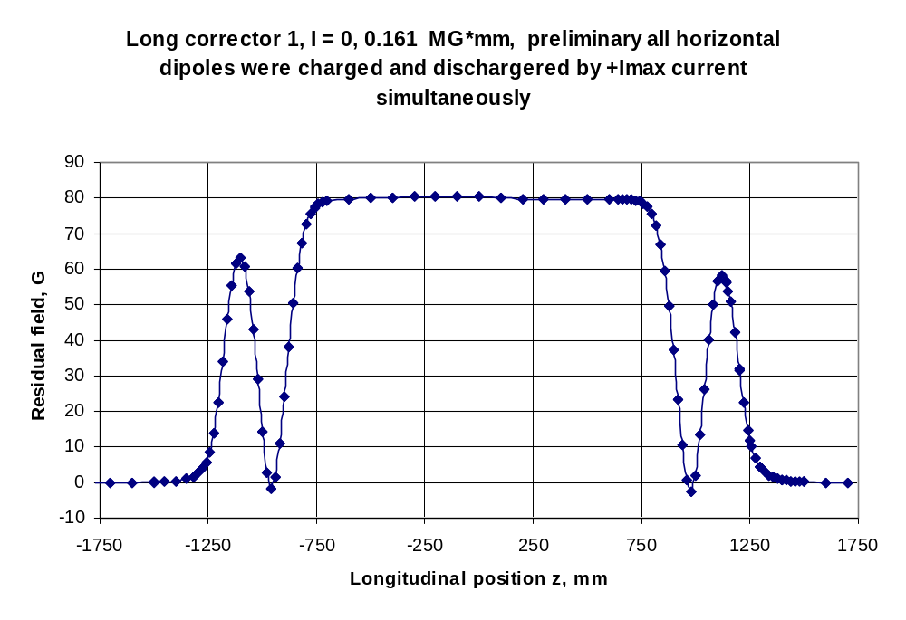
Figure 6. Residual magnetic field in horizontal correctors.

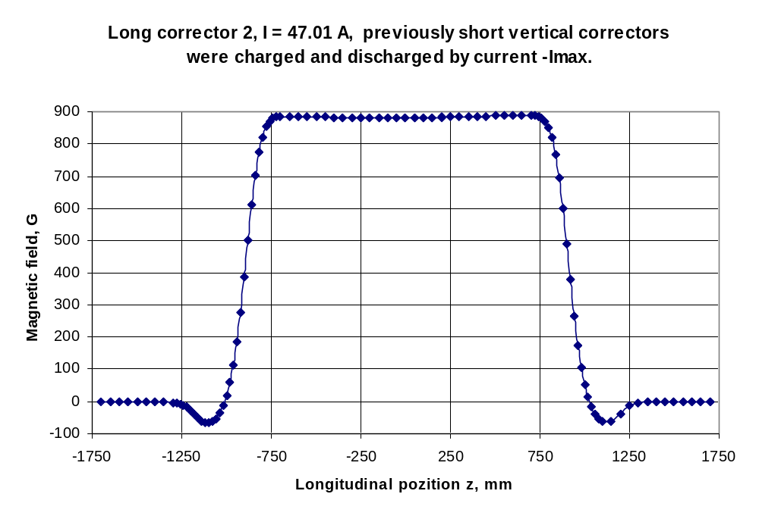
Figure 7. Magnetic field in Long corrector 2.
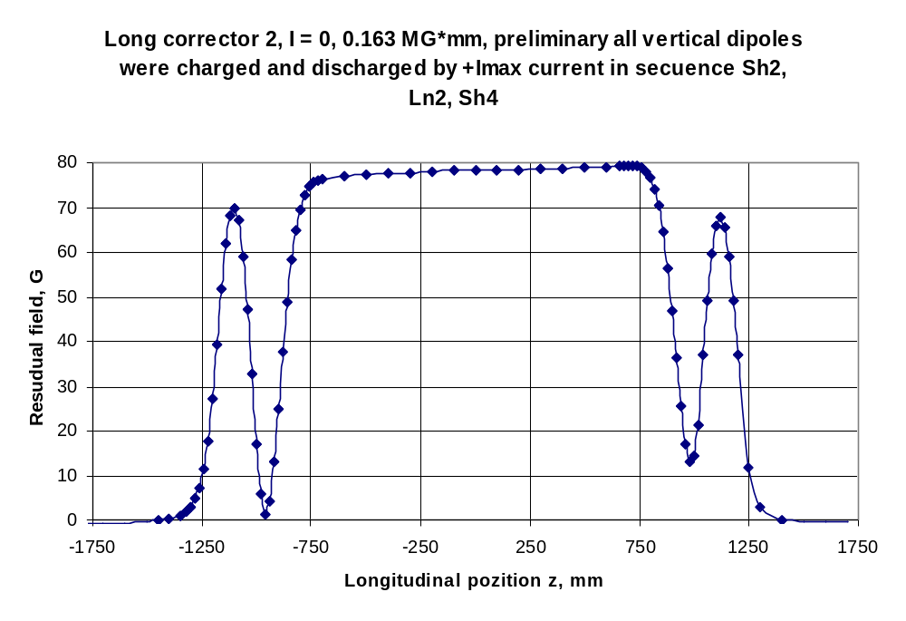Figure 8. Residual magnetic field in vertical correctors.

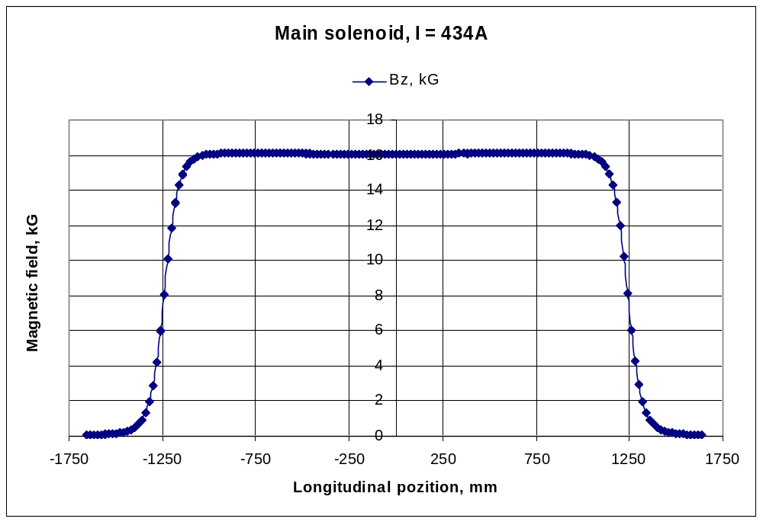
Figure 1. Axial magnetic field in Main solenoid at I = 434 A.
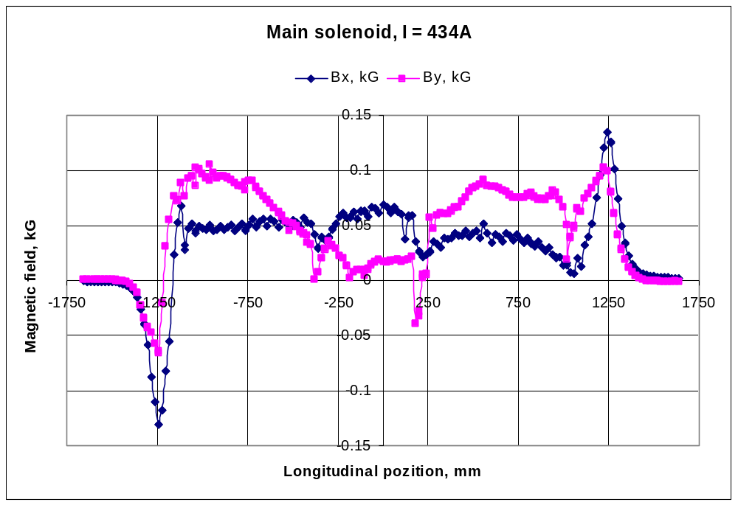
Figure 2. Transversal magnetic field in Main solenoid at I = 434 A.

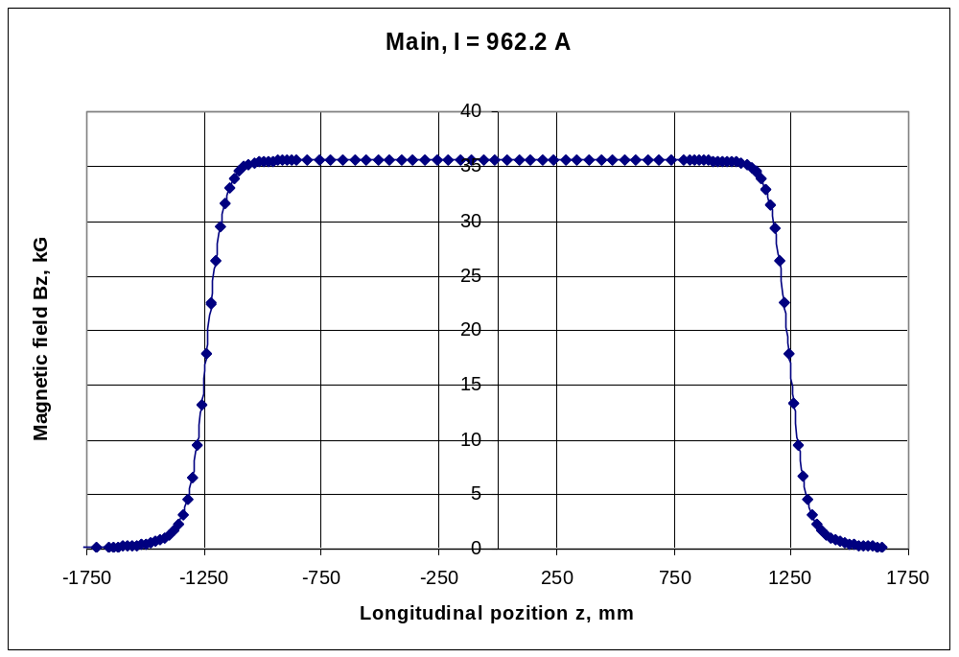
Figure 3. Axial magnetic field in Main solenoid at I = 962 A.
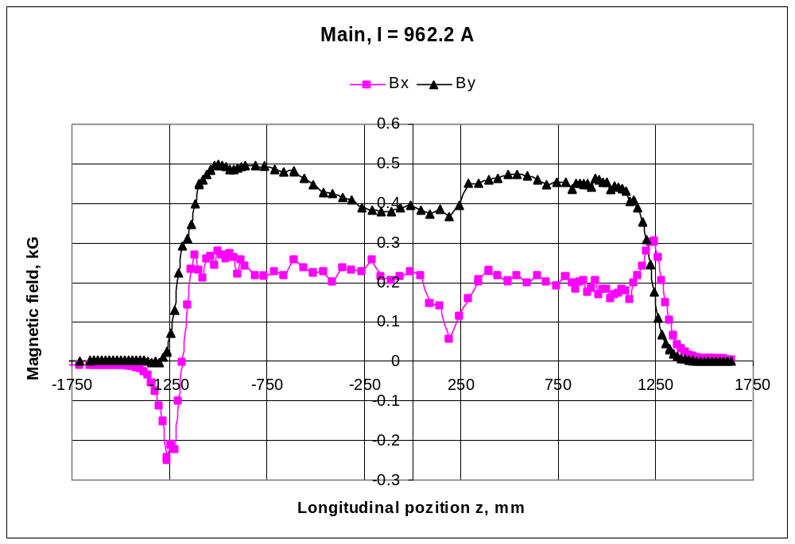
Figure 4. Transversal magnetic field in Main solenoid at I = 962 A.

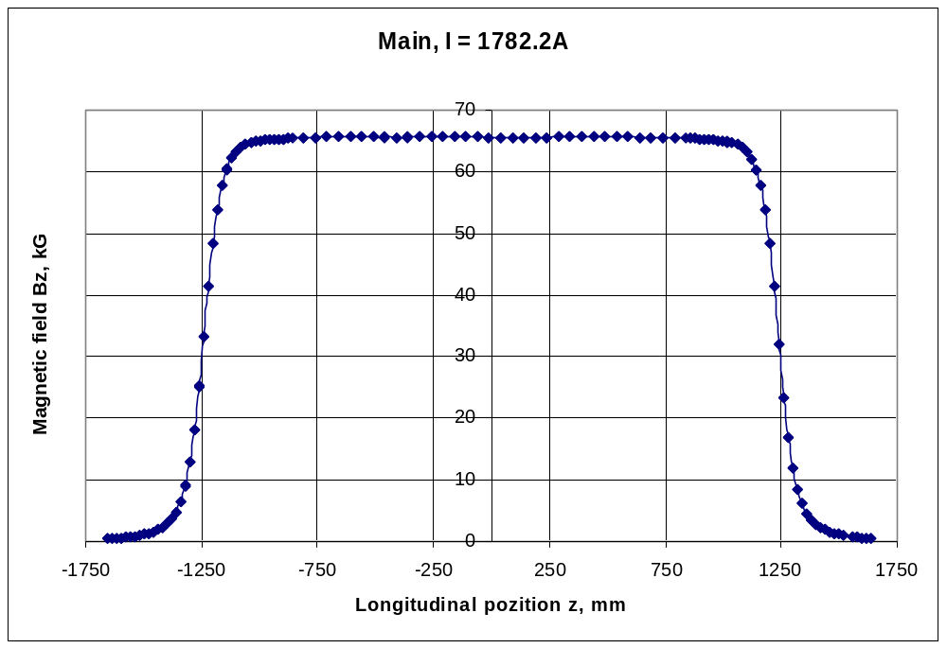
Figure 5. Axial magnetic field in Main solenoid at I = 1782 A.
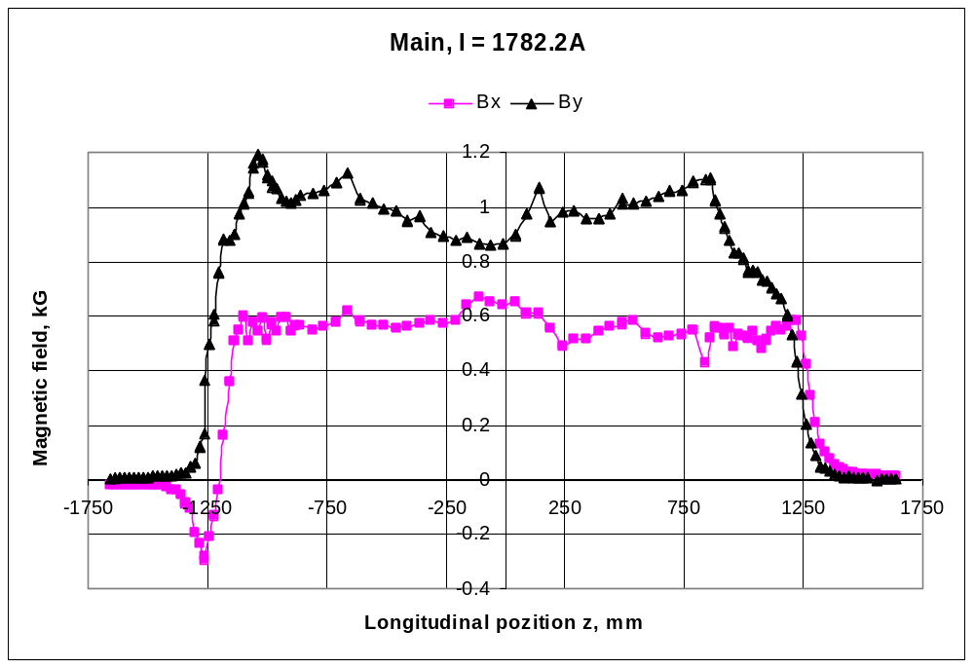
Figure 6. Transversal magnetic field in Main solenoid at I = 1782 A .

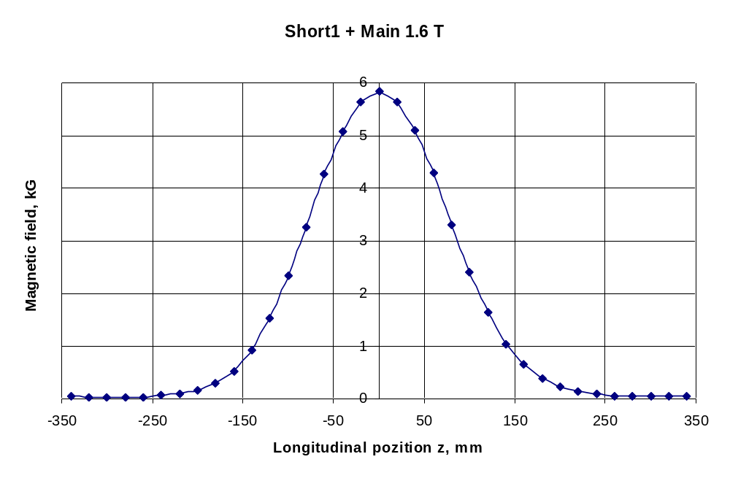
Figure 1. Magnetic field in short corrector 1.
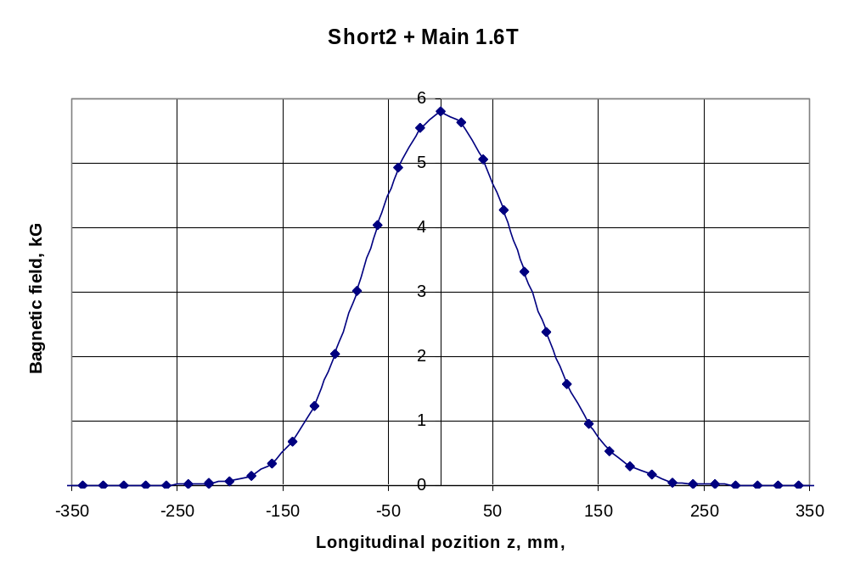
Figure 2. Magnetic field in short corrector 2.

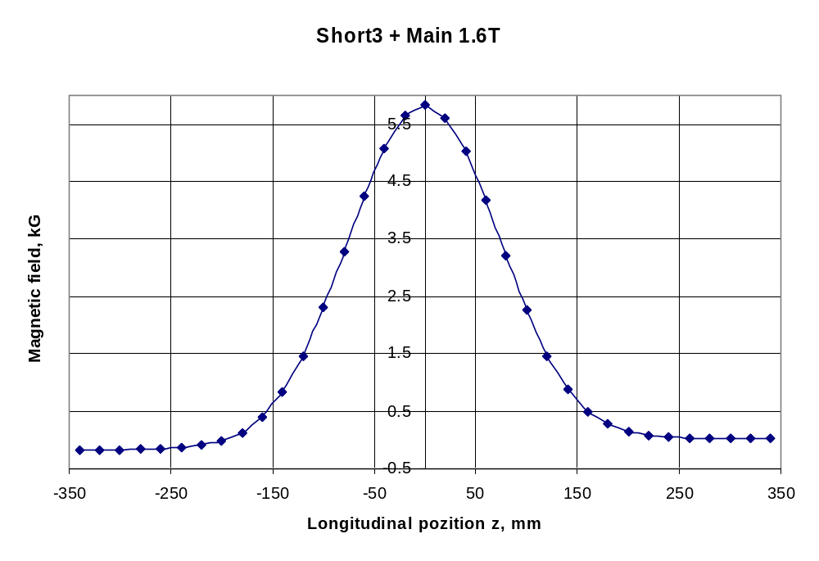
Figure 3. Magnetic field in short corrector 3.
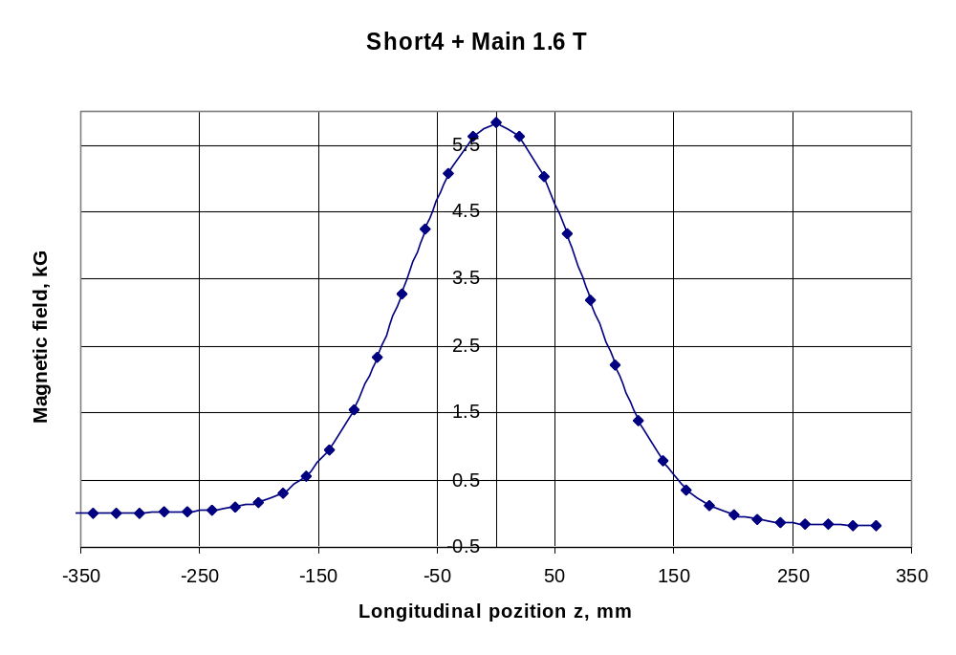
Figure 4. Magnetic field in short corrector 4.

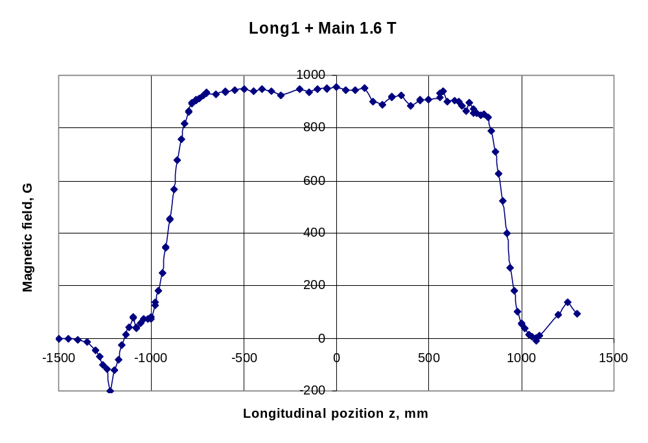
Figure 5. Magnetic field in Long corrector 1.
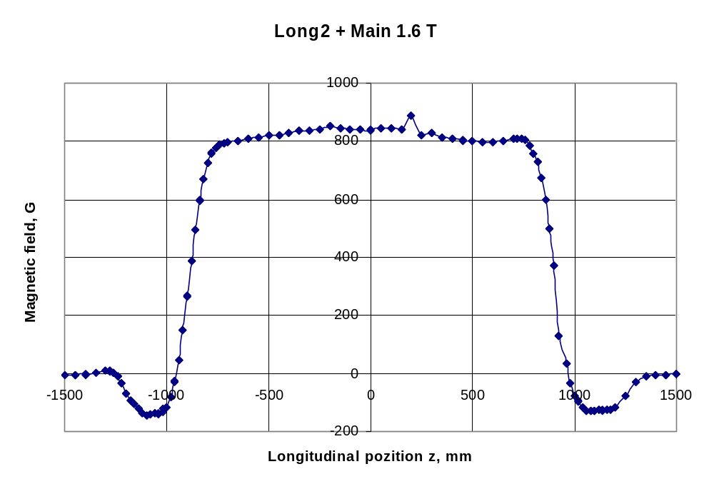
Figure 6. Magnetic field in Long corrector 2.

Longitudinal distribution of main magnetic field component in corrector dipoles at zero field in main solenoid.

Longitudinal distribution of main magnetic field component in corrector dipoles at 1.6 T in main solenoid.

Longitudinal distribution of magnetic field in main solenoid.

Figure 7. Magnetic field in Long corrector 2.
Figure 8.Residual magnetic field in vertical correctors.

Figure 7. Magnetic field in Long corrector 2.
Figure 8.Residual magnetic field in vertical correctors.

2005

