ON PROTON EMITTANCE GROWTH IN STORES

Vladimir Shiltsev to Alvin Tollestrup

Abstract: Alvin reported another interesting observation of a possible beam-beam effect in the Tevatron – (dEmm/dt) for protons is proportional to N_pbars (doc-1997). Sensational is the scale of the effect – the growth is faster than the IBS one, thus should affect significantly luminosity lifetime. Here I try to analyse the effect from a different point of view.

Evolution of the Effective Emittance calculated from Luminosity:

Effective emittance calculated from luminosity is presented in SuperTable II (STII). It usually a bit larger then the one calculated from FWs (13.3 pi vs 12.1 pi for the 20 stores prior to #4449). FWs tell us that in average pbar emittances are about 2/3 of proton ones, while for RR only shots they are smaller – about ½ of proton emittances. Thus, one expects that effective emittance growth – the quantity calculated in STII from luminosities and thus of the only importance for luminosity lifetime and integral – should be strongly dependent on the pbar intensity if Alvin is right. Fig.1 below shows statistics for all HEP stores:
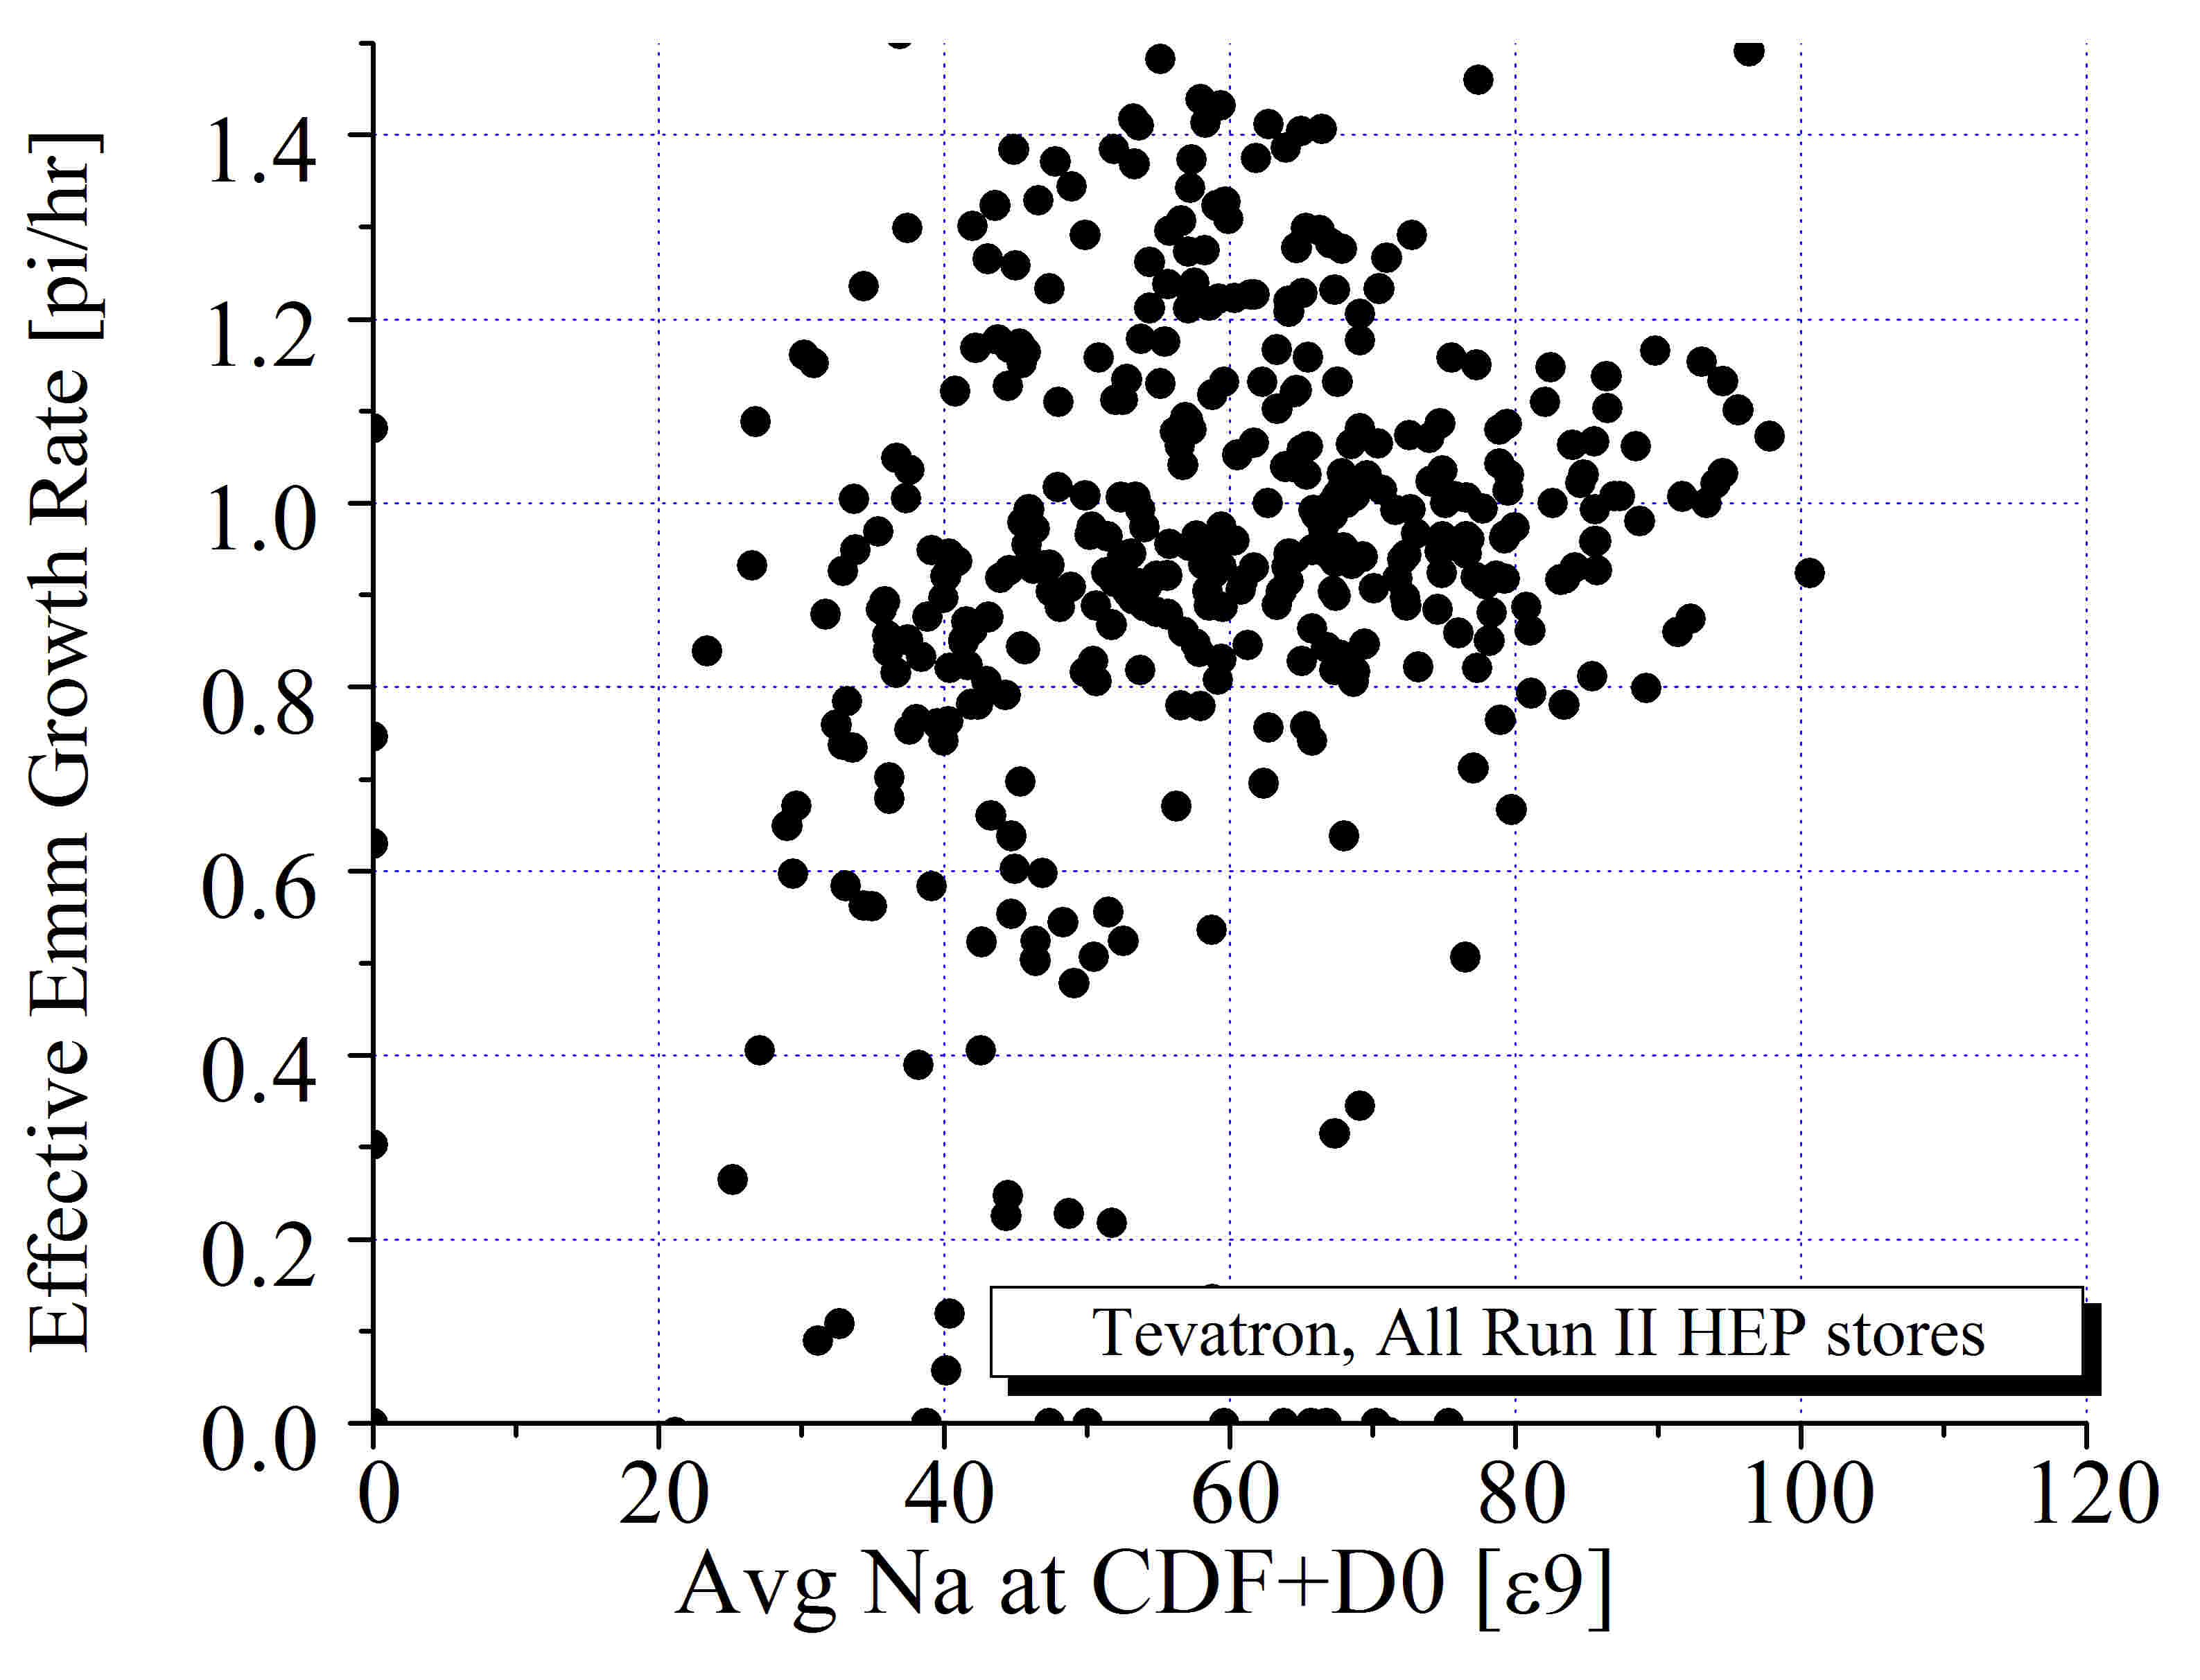
Fig.1: Effective emittance growth rate from STII vs Alvins’ “Interaction Strength”= sum of pbar intensities per bunch colliding with protons at CDF and D0 (here calculated as N_a (total)/36 x2).

It’s not clear whether there is any effect at all in Fig.1, so I selected only 50 recent stores – see fig.2:
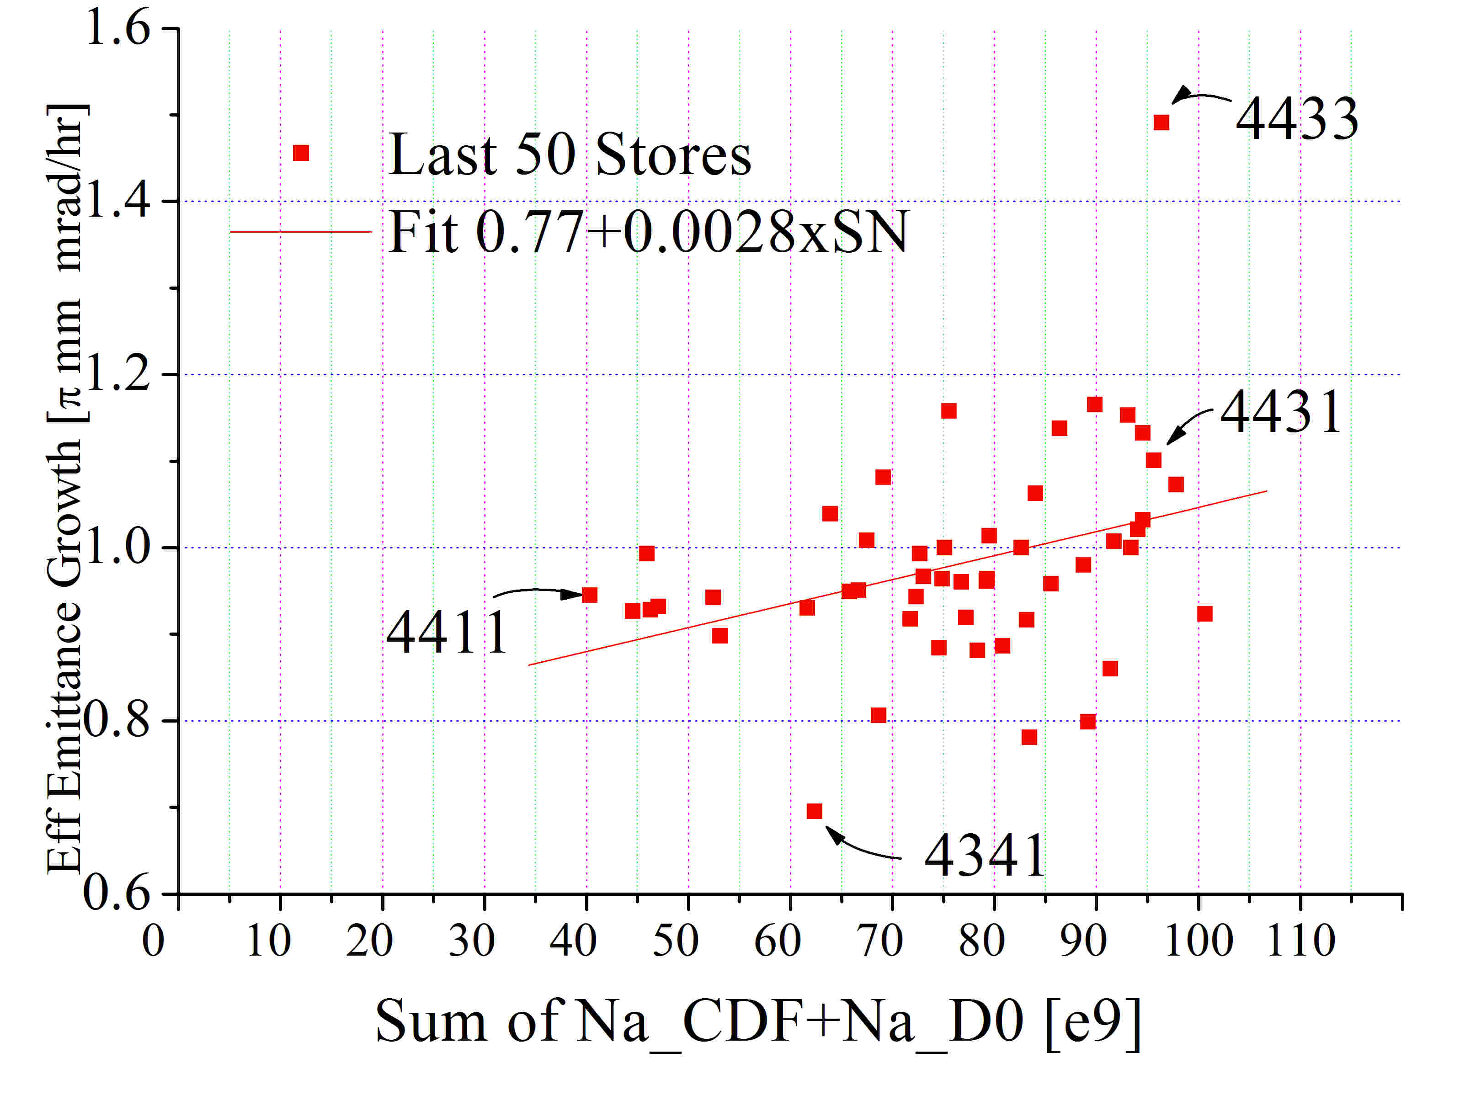
Fig.2: as in Fig.1 but for 50 stores prior to #4449.

Alvin analyzed #4411 and #4431. The effect was obvious only in #4431 (high pbar intensity one). Other remarkable stores are #4433 and #4341 (max and min growth rate). Some of their features are presented in the Table:

Store # Lumi Lumi lifetime Tunes AV/AH PV/PH
4433 140 6.4 .588/.588 .580/.579
4431 139 6.7 .588/.590 .580/.581
4411 63 7.2 .590/.584 .578/579
4341 61 13.5 .584/.577 .575/576

Thus, #4341 is remarkable by the fact that tunes of protons ad pbars were much lower than usual, and luminosity lifetime was outstandingly high even for low luminosity of 60e30.

If one gets rid of #4433 and #4341, then for “usual, good” HEP stores we have – see Fig.3 – 20% effect related to N_a for high antiproton intensity stores. In absolute units it is equal to 0.2 +- 0.07 pi/hr for average N_a/bunch of 50e9. There are two reasons for the effect: a) beam-beam induced proton emittance emittance growth (as proposed by Alvin); b) IBS in pbar beam.
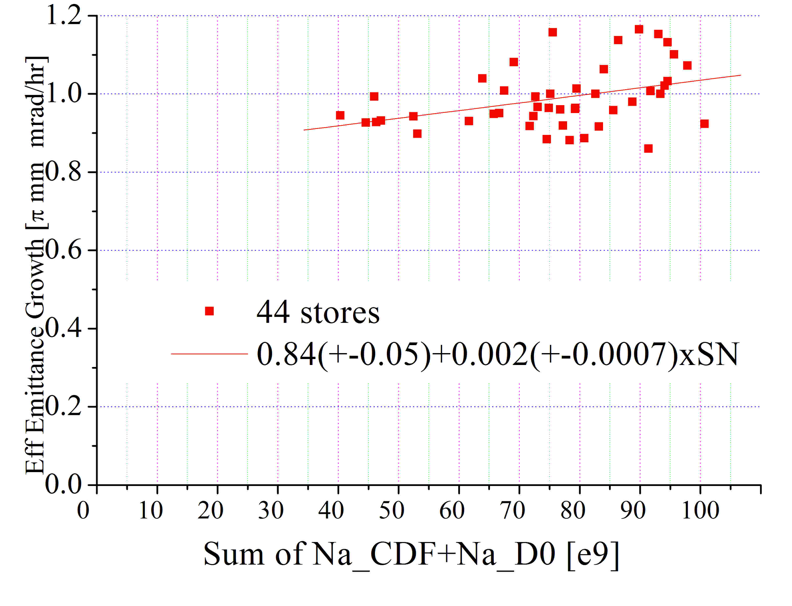

Fig.3: as in Fig.2 but for 44 stores prior to #4449, excluding extreme ones, like #4433 and #4341.

Let’s estimate how IBS should affect effective emittance growth: according to Alvin, the IBS growth rate is

dEmm_v/dt = 0.8 [pi/hr] * (N/250) /(emm/15)^3/2 / (sigma_z/1.73)

that gives dEmm/dt of about 0.3 pi for N_a=50, emm=10 and sigma_z=1.56 (typical parameters of pbars) or , for the effective emittance, dEmm_eff/dt=1/2 dEmm_a/dt =0.15 pi/hr.

Another way to figure out the IBS contribution is to look into SL emittance growth. According to Fig.4, in recent stores with beta*=28 cm SL and FW emittances of pbars agreed very well (within 10%), while in the last 50 stores SL was higher by some 30%.
Fig.5 demonstrates that SL emittance growth rate scales linearly with N_a, suggesting that it is mostly due to IBS with rate 0.47+-0.15 pi/hr for average bunch intensity of 50e9 if measured by SL. Taking into account 30% discrepance btw SL and FW (see above), one gets dEmm/dt ~ 0.3+-0.1 pi/hr and consequently, dEmm_eff/dt =0.15+-0.05 pi/hr.

Thus, both ways to estimate IBS contribution result in the estimate of about 0.15+-0.05 pi/r of dEmm_eff/dt. That leaves only (0.2+-0.07) – (0.15+-0.05)=(0.05+-0.10) pi/hr for the contribution of the beam-beam effects in the proton emittance growth (the latter should be equal to twice the effective emittance number or 0.1+-0.2 pi/hr).
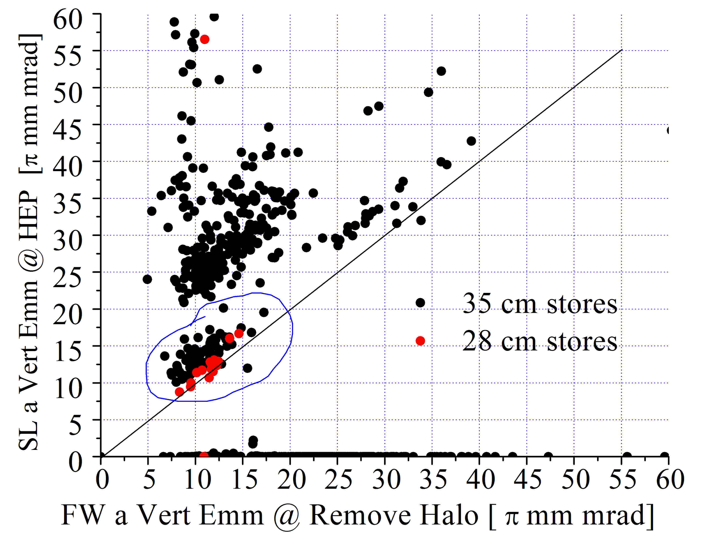

Fig.4: SL vertical pbar emittance vs FW emittance at the start of HEP stores. Last 50 stores prior to #4449 are circled.

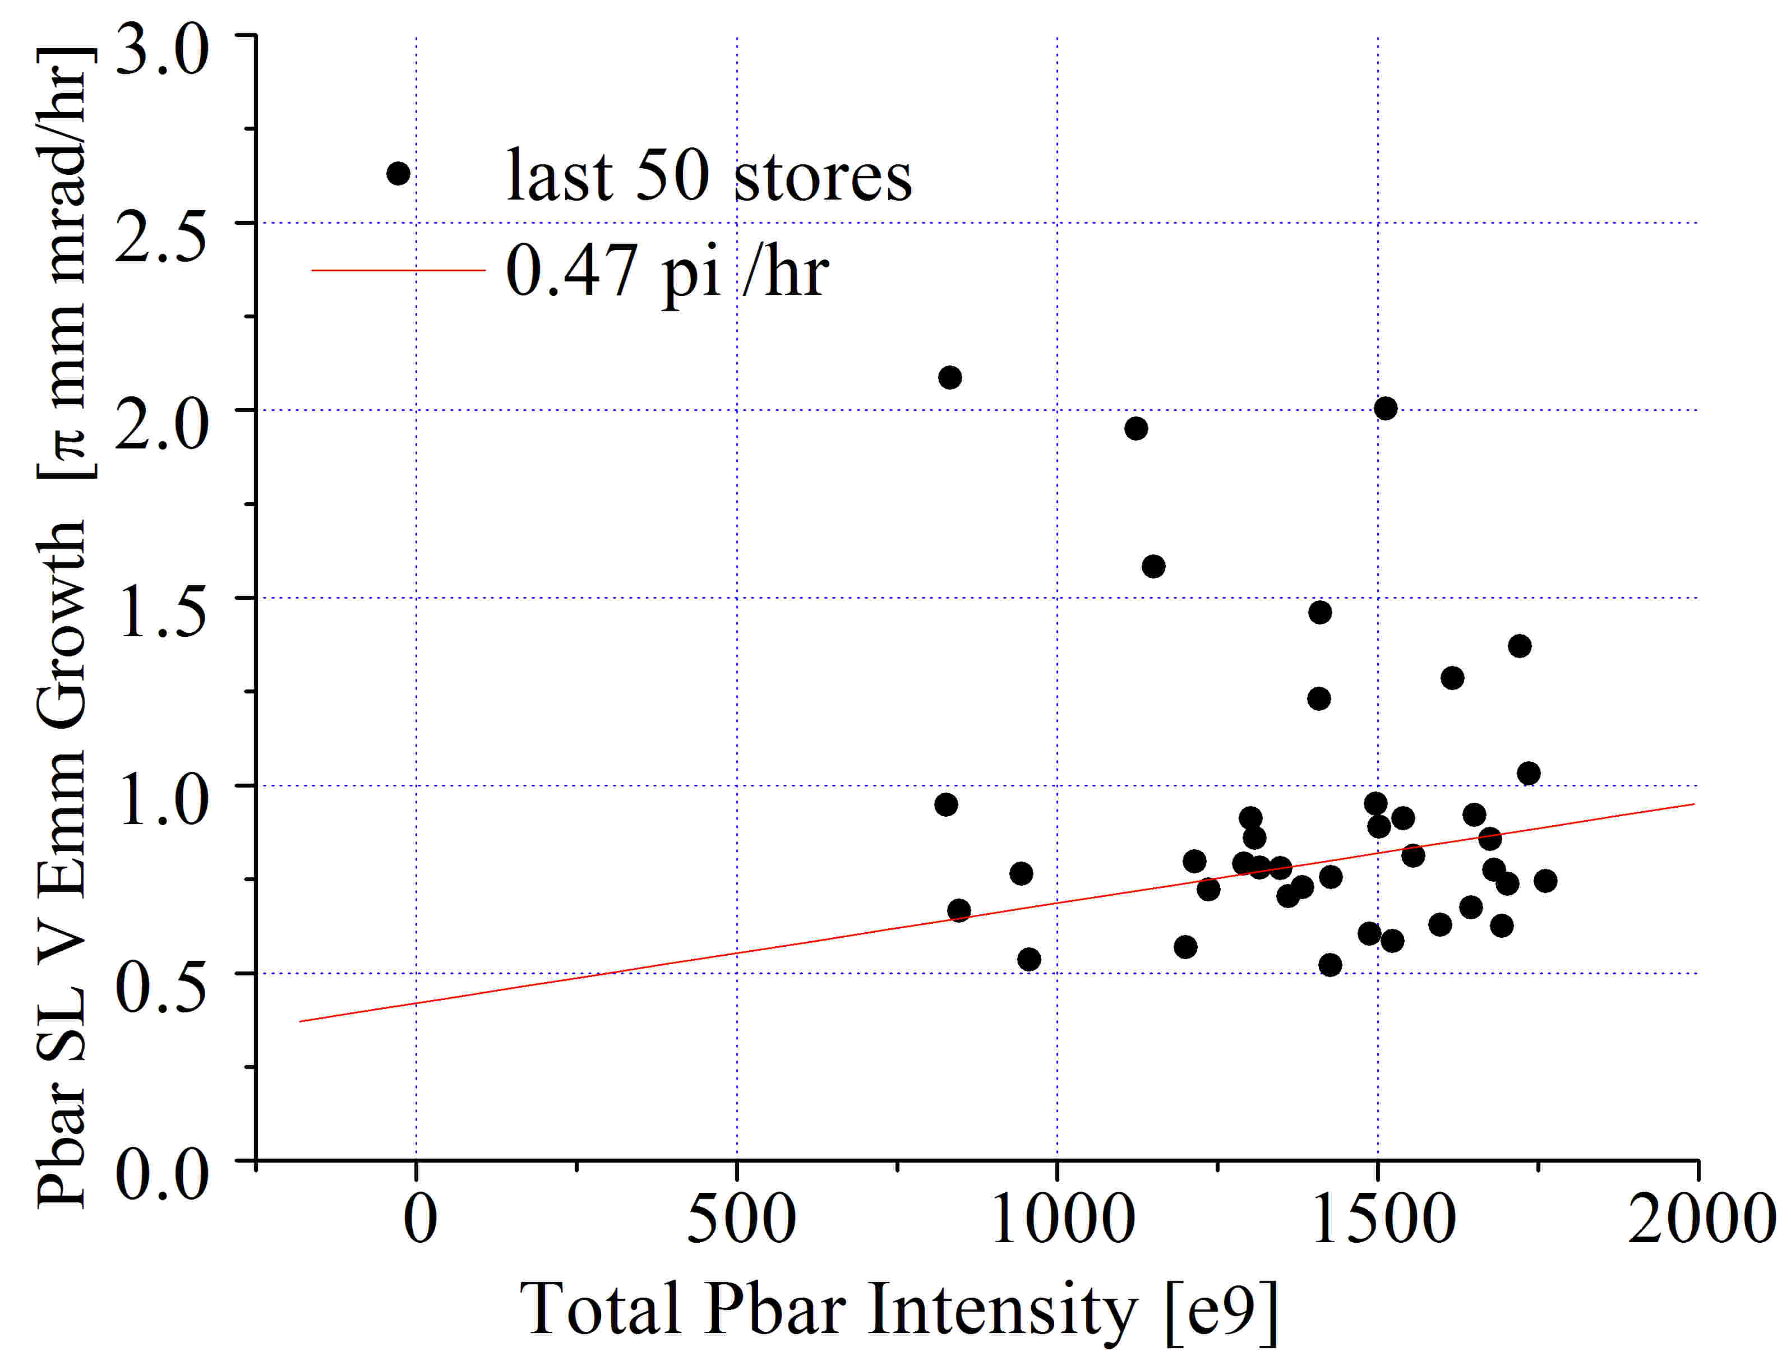

Fig.5: SL vertical pbar emittance growth vs total pbar intyensity at start of HEP.

Conclusions

From analysis of emittance growth measured from luminosity, FWs and SL in the last 40-50 stores, I conclude that beam-beam contribution found by Alvin (emittance growth of protons proportional to pbar intensity) is about (0.1+-0.2) pi or (10+-20)% of the total protom emitance growth rate dominated by IBS. Contribution of Alvin’s effect to the effective emittance growth rate – calculated from luminosities – is about (5+-10)%; contribution to the luminosity lifetime and luminosity integral per store is (2.5+-5)%.
All these numbers are much smaller then what would Alvin’s results suggest – thus, requiring an explanation. Several factors need to be taken into account/considered:
- Alvin’s results refer to growth at the very beginning of the stores i.e. at t=0; whiel all STII data are averaged over the first two hours of HEP store
- Beam-beam effects should be dependent on tunes and bunch#
- More detail analysis of dynamics of all the bunches in many stores would be helpful

References:
[1] V.Shiltsev, et.al, Beam-Beam Effects in Tevatron, PRSTAB Oct 2005

