Table of Contents
1. Table of Contents 1
2. Introduction 1
3. Setup for Reverse Protons 2
a. Pbar Annex Sequencer: Fast Recycler Start 3
b. Pbar Annex Sequencer: Fast Recycler Reverse Protons 13
c. Pbar Annex Sequencer: Fast Recycler Finish Reverse Protons 13
d. Pbar Sequencer: Reverse Protons to the Debuncher 15
e. De-tune the DRF1 Rotator Cavities 16
4. Circulating Beam in the Debuncher 17
a. $16/$2D in the TLG 17
b. One Shots 17
5. Debuncher Orbits 18
a. Java Orbit Preparation 18
b. Java BPM Orbits 18
6. Debuncher Admittance Measurement 19
a. Pbar Sequencer: Deb Hor aperture scan rev p 19
b. Pbar Sequencer: Deb Vert aperture scan rev p 20
c. FTP versus Lumberjack Manual Measurements 22
d. Java Fit of Lumberjack Data 22
7. Beam up AP2 22
a. Establishing beam up the AP2 line 22
b. Beam Modes 23
i. Partial Debuncher Turn to AP2 23
ii. Circulating Debuncher beam to AP2 23
8. D/A Orbit Studies 23
9. Return to Stacking 23

Introduction

The purpose of this document is to outline the procedural steps required to enter various Reverse Proton Studies modes. When we are stacking, the P1, P2 and AP1 lines are all configured for 120 GeV protons. When switching to Reverse Protons, we must stop stacking and setup the lines for 8 GeV protons. The 8 GeV protons then are sent down the AP3 line, where they are injected onto the injection orbit in the Accumulator. From there, we can extract the 8 GeV beam down the D/A line to the Debuncher. We can either circulate the reverse protons in the Debuncher or extract them up the AP2 line. We will outline how to configure the Antirproton Source in a number of different Reverse Proton studies configurations.

First, we will outline how to establish Reverse Protons circulating in the Debuncher from either dedicated TLG events or “one shots.” We will then outline how to extract the Reverse Protons from the Debuncher down the AP2 line either from circulating Debuncher beam or using partial turn Debuncher extraction. We will then cover how to setup for up D/A line studies. Lastly, we will cover how to return Pbar to normal stacking.

Many of the steps needed to enter and exit these study modes are consolidated into two Pbar sequencers called the Pbar Sequencer and Pbar Annex Sequencer. Other steps require manual intervention. We will assume that we are starting with the Pbar source configured in stacking mode.

Setup for Reverse Protons

From stacking mode, our first goal is to configure the Antiproton Source for reverse protons. To do so, we will run the first three aggregates in the Pbar Annex sequencer, followed by the first portion of the Pbar Sequencer “Reverse Protons to Debuncher” aggregate.

We will start by entering the Pbar Sequencer, which can be found on Acnet page P64.

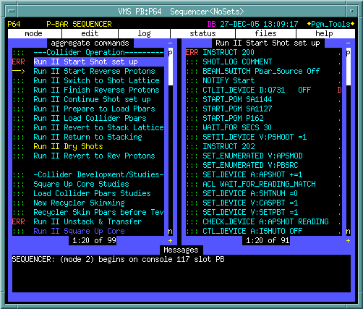
Figure 3-1: The Pbar Sequencer.

After entering the Pbar Sequencer, click on the menu bar item “mode” in the upper left corner of the screen. Select the Pbar Annex (Mode 17) from the selection menu.

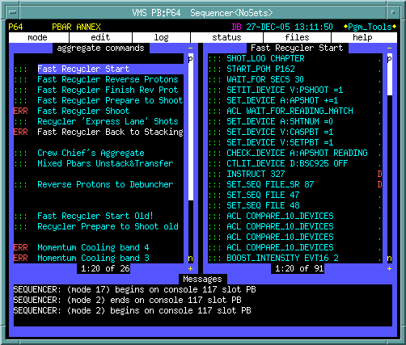
Figure 3-2: The Pbar Annex Sequencer.

We will now run the first three aggregates in the Pbar Annex Sequencer. The same three aggregates are used in the initial stages of the Accumulator to Recycler transfers so there are some commands that may not be necessary for our Reverse Proton studies. We will attempt to point these out as we go along.

Pbar Annex Sequencer: Fast Recycler Start
Click on “Fast Recycler Start” in the left column of the sequencer. The right column now shows the commands in this sequencer. To start this aggregate, click on the green “:::” on the first command in the sequence. We will now step through each command in the sequencer.

- SHOT_LOG CHAPTER

This command starts a new shot log chapter in the Recycler shot scrapbook at http://www-bd.fnal.gov/cgi-mach/machlog.pl?nb=rscrap03&load=no. Since we are not completing a Recycler shot, we can actually skip this command and start the aggregate at the next command.

- START_PGM P162

Starts the Accumulator BPM TBT Page P162 (keeper is Keith Gollwitzer). This page, as shown below, checks the status of the Accumulator BPM houses and issues resets to any house that is not online. This allows plenty of time for the BPM houses to reboot before they are need in the beam line tune-up. Upon completion, this application self terminates and the window will close on its own.

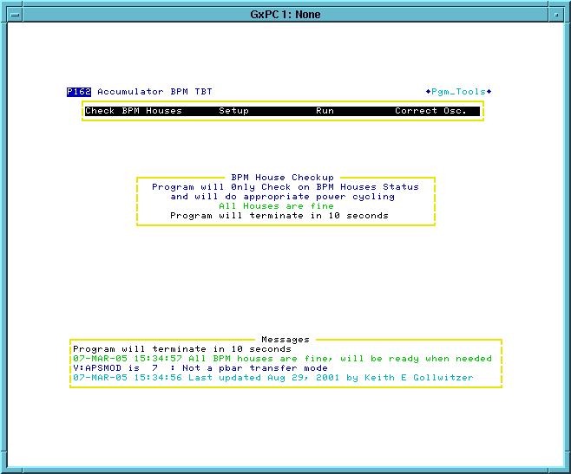
Figure 3-3:

- WAIT_FOR SECS 30

This command waits 30 seconds for the previous command to complete.

- SETIT_DEVICE V:PSHOOT =1

Sets the state parameter V:PSHOOT to 1, then pauses long enough to verify that the setting was completed successfully.

Devices that start with V: are called state parameters. State parameters define the operational state of a device or accelerator, allow the sequencers to be more automated, and prevent the different sequencers from getting out of sequence with each other. Often one sequencer waits at a certain spot until another sequencer changes a state parameter.

V:PSHOOT is a state parameter for the Pbar transfer state. V:PSHOOT state 1 means “not ready for transfer.” Later in this aggregate, V:PSHOOT is set to 4 (“Ready for Main Injector Tune up”). The Main Injector Shot Transfer Line Tuneup aggregate waits for PSHOOT to be set to 4 (“Ready for Main Injector Tune up”) before starting its beam line tune-up.

- SET_DEVICE A:APSHOT +=1

Increments A:APSHOT by 1. This is the Pbar transfer series number, which is incremented before and after any Pbar transfer from the Accumulator to the Tevatron or Accumulator to the Recycler. This command is not necessary for Reverse Proton Studies.

- ACL WAIT_FOR_READING_MATCH

A Runs an Accelerator Command Language (ACL) script called WAIT_FOR_READING_MATCH that waits for "SDA Shot/Store #" (A:FILE) to read the same value as the Pbar transfer series number (A:APSHOT). More information on ACL scripts can be found at http://adcon.fnal.gov/userb/www/controls/clib/intro_acl.html.

- SET_DEVICE A:SHTNUM =0

Sets the “Pbar transfer series Shot #” parameter (A:SHTNUM) to zero. Later on A:SHTNUM is incremented by one for every Pbar transfer. This is not used during Reverse Proton Studies.

- SET_DEVICE V:CASPBT =1

The "Pbar transfer SDA case trigger" state (V:CASPBT) is set to 1, which represents "Set up." Possible values for this state parameter include: 1 = Set up, 2 = Unstack Pbars, 3 = Transfer Pbars from Accumulator to Main Injector, 4 = Accelerate Pbars in the Main Injector, 5 = Coalesce Pbars in the Main Injector. This is not necessary for Reverse Proton Studies.

- SET_DEVICE V:SETPBT =1

Sets the "Pbar transfer SDA set in case" state device to 1. D88 currently shows no state information descriptions for the different states of this parameter.

- CHECK_DEVICE A:APSSHOT READING

Prints the value of the “Pbar Transfer Series Number” parameter (A:APSHOT) in the message window at the bottom of the sequencer in the following format.

COM: A:APSHOT present value = #####.00000

- CTLIT_DEVICE D:BSC925 OFF

Puts in the AP3 beam stop to prevent reverse proton beam from being injected into the Accumulator.

- INSTRUCT 327 D

This is a bypassed command that is not needed at this time.

- SET_SEQ FIEL_SR 87 D

This is a bypassed command that is not needed at this time.

- SET_SEQ FILE 47

Executes sequencer file #47 which resets AP3 line devices. This will clear any trip status before trying to turn the supplies on. Devices in this list are located in AP30 (D:Q901, D:V901, D:Q903, D:Q907 and D:Q909), F27 (D:Q913, D:Q914, D:Q916, D:Q917, D:Q919), and AP0 (D:H914, D:Q924, D:Q926 and D:H926).

- SET_SEQ FILE 48

Executes sequencer file #48 which turns on the same AP3 line devices that were reset in the previous sequencer command. With the AP3 line supplies on we will be able to run reverse proton beam up the AP3 line toward the Accumulator.

- ACL COMPARE_10_DEVICES
- ACL COMPARE_10_DEVICES
- ACL COMPARE_10_DEVICES
- ACL COMPARE_10_DEVICES

The above four commands each runs an Accelerator Command Language (ACL) script called COMPARE_10_DEVICES. The script verifies that all 8GeV values are the same on all cycles for ramped P1 and P2 line devices. There are a limited number of devices that can be verified in one ACL script, so the script is run four times in order to cover all of the trims. More information on ACL scripts can be found at http://adcon.fnal.gov/userb/www/controls/clib/intro_acl.html.

- BOOST_INTENSITY EVT16 2

This command sets the Booster $16 event to an intensity of 2 turns each with 35 bunches. This intensity ensures that the P1-P2 line BPMs have enough intensity to report reliable read backs. At this intensity, one must be cautious not to run beam continuously as radiation trips will result.

- CHECK_DEVICE A:R2DDS1 SAVE_SET

Reads and saves the present setting of A:R2DDS1. This is the stabilizing RF frequency.

- CHECK_DEVICE A:R2LLAM SAVE_SET

Reads and saves the value of A:R2LLAM. This is the stabilizing RF amplitude.

- CHECK_DEVICE A:DPHATT SAVE_SET

Reads and saves the value of A:DPHATT. This is the Accumulator horizontal damper attenuator setting.

- CHECK_DEVICE A:SCRES SAVE_SET

Reads and saves the value of A:SCRES. This is an Accumulator timing event.

- WAIT_DEVICE V:MSHOOT

The commands waits for the Main Injector transfer state parameter V:MSHOOT to equal 4. A state of 4 indicates that the Main Injector has finished the Main Injector reverse proton tune-up.

- SPECTRUM_LOAD 2 7

Loads P41 file #7 to Spectrum Analyzer #2 at AP30. This is the unstacking display and can be viewed on CATV Pbar #28.

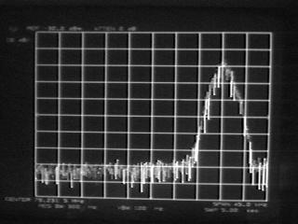
Figure 3-4

- SEQ_PGM REQUEST Unstack SA D

This is a bypassed command that is not needed at this time.

- SEQ_PGM REQUEST AP0 Scope D

This is a bypassed command that is not needed at this time.

- SEQ_PGM REQUEST Acc Gap Mon

Starts the Pbar GBIP command editor program P188 (keeper is Jim Budlong). The Request qualifier tells the application to load file 6, which is used to setup the Accumulator AP10 gap monitor scope for capturing Pbar unstacking events. The P188 window automatically closes when the file load is complete. This is used for Pbar transfers and is not necessary for Reverse Protons.

- ACKNOWLEDGE

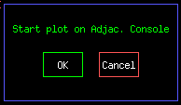
Figure 3-5

- AUTO_PLOT Core Emittances

Starts a Fast Time Plot to monitor emittances. Operators should monitor this plot while the Pbar experts do their studies.
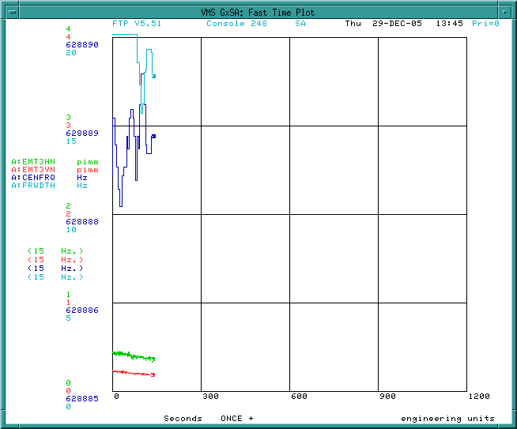
Figure 3-6

- START_PGM SA1127

Pbar Radiation Detector Display (keeper is Tony Leveling)on comfort display 102. This SA can be used during the beam line tune-up to verify that radiation levels are not high enough to cause a radiation trip. The program emulates the actions of the radiation detector cards. It updates every 60 seconds and takes a 15 minutes rolling average of the radiation losses and normalizes each radiation detector so that a value of 1 corresponds to the radiation trip level. The parameters for the individual radiation detectors can be found on D106 ACC/DEB < 1> to < 3>. G:RA{####} is an integrating real-time read back of the radiation detector. Every 60 seconds, which is not concurrent with the supercycle, G:RA{####} is reset to zero and starts integrating all over again. G:RD{####} takes the number of G:RA{####} before it is reset and keeps that value until G:RA{####} is reset again. When doing the reverse proton tune-up later in the shot, if any radiation detector gets near to 1 on the plot, the beam switch should be taken to avoid a radiation trip. If the SA1127 plot dies, it can be restarted by reissuing this command, or manually through Acnet page P151. A screen capture of SA1127 is shown below.

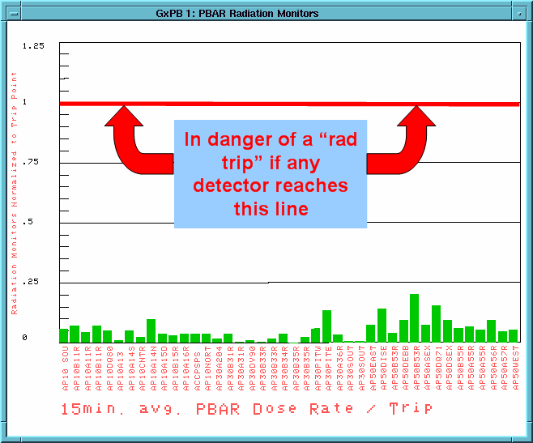
Figure 3-7

- BEAM_SWITCH Pbar_Source Off

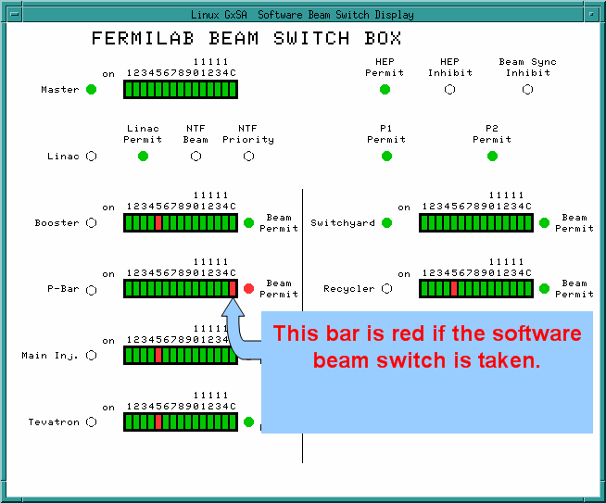
Figure 3-8

- NOTIFY Start

Sends a Channel 13 Notify message to http://www-bd.fnal.gov/cgi-bin/notify_mes.pl?ch13=text

- SET_ENUMERATED V:APSMOD

V:APSMOD is a state parameter representing the operational mode of the Pbar Source. The set_enumerated command asks the user to selected from a menu of V:APSMOD state values as shown below. When setting up for Reverse Proton Studies, the operator should chose state 8 = Reverse Protons.

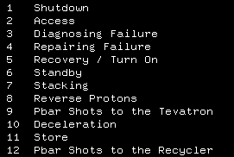
Figure 3-9

- SHOT_LOG COMMENT

Adds the following comment to the Pbar portion of the shot log chapter. This is not necessary for Reverse Proton Studies.

{Time}- Beginning shots to the Recycler, the starting stack size is ###.######. – Sequencer

- ABORT_MASK PBAR_SOFT ENABLED

This command enables the “PBAR_SOFT” Pbar abort mask. The logic is confusing, but when the abort mask is enabled, no aborts are seen.

This is the Pbar Software abort which is connected to the 204 module (viewed from P103) that monitors 120 GeV AP1 line power supply analog outputs. Since we are not running 120 GeV protons in the AP1 line when we do 8 GeV reverse proton studies, we can mask this entry.

- ABORT_MASK AP1_120_PS ENABLED

This command enables the “AP1_120_PS” Pbar abort mask. This abort monitors the digital status of the AP1 line 120GeV power supplies. Again, since we are not running 120GeV protons in the AP1 line while we are doing 8 GeV reverse proton studies, we can mask this entry.

- INSTRUCT 206 D

This command is bypassed and not needed at this time.

- ALARM_LIST PBAR 2

This command bypasses 120 GeV power supplies.

- SET_SEQ FILE 37
- INSTRUCT 307
- SET_SEQ FILE_SR 79
- SET_SEQ FILE 41
- SET_SEQ FILE 42
- ALARM_LIST PBAR 12
- EVENT 91 DISABLE
- WAIT_FOR SECS 10
- CTL_DEVICE M:Q102 RESET
- CTLIT_DEVICE M:Q202 ON
- ALARM_LIST PBAR 3
- SET_ENUMERATED V:APSMOD
- LOAD_TLG 101 REPEAT
- ABORT_MASK AP1_8_PS DISABLED
- EVENT 88 TRIGGER

- SETIT_DEVICE V:SHOOT =4
- BEAM_SWITCH Pbar_Source On
- ALARM_LIST PBAR 52
- WAIT_FOR SECS 3
- ALARM__LIST PBAR 23
- SET_SEQ FILE 1
- SET_SEQ FILE 83
- SET_SEQ FILE 85
- CTL_DEVICE A:ISHUTO OFF
- CTL_DEVICE A:ESHUTO OFF
- CTL_DEVICE A:ISHUTC ON
- CTL_DEVICE A:ESHUTC ON
- START_PGM SA1144
- START_PGM SA1144
- INSTRUCT 302

- SET_DEVICE A:VSARST =9
- WAIT_DEVICE A:VSARST
- START_PGM SA1156
- START_PGM SA1136
- WAIT_FRO SECS 15
- ACL SET_FROM_READING
- SET_DEVICE A:VSAFWD -=5
- SETIT_DEVICE A:DTMHVE =.5
- SETIT_DEVICE A:VSARST =5
- CHECK_DEVICE A:VSAFWS READING
- INSTRUCT 303
- CUSTOM COOL_GAIN
- SET_DECICE A:DPHATT =5
- SET_DEIVCE A:SCRES +-1.8
- ALARM_LIST PBAR 76
- SET_SEQ FILE 92

Pbar Annex Sequencer: Fast Recycler Reverse Protons
- ACKNOWLEDGE
- CTLIT_DEVICE A:SPPS01 OFF
- SET_SEQ FILE 28
- SET_SEQ FILE 94
- SET_SEQ FILE 30
- CTLIT_DEVICE A:CMTW01 ON
- CTLIT_DEVICE A:CMTW02 ON

- CHECK_DEVICE A:ISHTST READING
- CHECK_DEVICE A:ESHTST READING
- CHECK_DEVICE A:R2HLSC ON
- CHECK_DEVICE A:R2HLGS ON
- ALARM_LIST PBAR 38
- CHECK_DEVICE A:FRWDTH READING

- SETIT_DEVICE A:VSARST =3
- ACKNOWLEDGE
- WAIT_FOR SECS 20
- WAIT_DEVICE A:VSARST
- SETIT_DEVICE A:VSARST =7
- ACKNOWLEDGE

Pbar Annex Sequencer: Fast Recycler Finish Reverse Protons

- SHOT_LOG COMMENT

- EVENT 9C DISABLE
- BEAM_SWITCH Pbar_Source Off
- BOOST_INTENSITY EVT16 1
- CTLIT_DEVICE D:BSC925 ON

- CTLIT_DEVICE D:ESEPV ON
- CTLIT_DEVICE A:ISEP1V ON
- CTLIT_DEVICE A:ISEP2V ON

- CTLIT_DEVICE A:EKIK ON
- CTLIT_DEVICE A:EKIKQ ON

- EVENT 88 TRIGGER
- AUTO_PLOT Beamline tuneup
- BEAM_SWITCH Pbar_Source On
- INSTRUCT 231
- START_PGM P150
- INSTRUCT 214
- BEAM_SWITCH PBAR_SOURCE OFF
- SETIT_DEVICE V:PSHOOT =7
- ACKNOWLEDGE
- BOOST_INTENSITY EVT16 1
- BEAM_SWITCH Pbar_Source On
- INSTRUCT 316
- AUTO_PLOT TBT eff
- START_PGM P162
- BEAM_SWITCH Pbar_Source On
- INSTRUCT 215
- ACKNOWLEDGE
- COPY_SCREEN LCL MY SLOT
- COPY_SCREEN LCL MY SLOT
- SHOT_LOG IMAGE
- SHOT_LOG Comment
- BEAM_SWITCH Pbar_Source Off

- CHECK_DEVICE A:CENFRQ READING
- CHECK_DEVICE A:VFACCM READING
- SET_DEVICE A:RLLEXF =628767.50

- CTLIT_DEVICE A:EKIK ON
- CTLIT_DEVICE A:EKIKQ ON
- ACKNOWLEDGE
- CTLIT_DEVICE A:EKIK OFF
- CTLIT_DEVICE A:EKIK OFF
- CTLIT_DEVICE A:IKIK OFF
- CTLIT_DEVICE A:ISEP1V OFF
- CTLIT_DEVICE A:ISEP2V OFF
- CTLIT_DEVICE D:IKIK OFF
- CTLIT_DEVICE D:ESEPV OFF
- CHECK_DEVICES A:SCRES RESTORE
- SET_DEVICE D:H926PB D:H9267RP
- SET_DEVICE M:V105PB M:V105RP
- SET_DEVICE M:H100PB M:H100RP
- SET_DEVICE M:V101PB M:V101RP
- SET_DEVICE M:V11APB M:V11ARP
- SET_DEVICE M:H105PB M:H105RP
- SET_DEVICE M:H107PB M:H107RP
- ACKNOWLEDGE
- LOAD_TLG 103 REPEAT

After completing the above three aggregates, we will switch to the Pbar Sequencer to establish the Reverse Proton Beam to the Debuncher.

Pbar Sequencer: Reverse Protons to the Debuncher

- ACKNOWLEDGE
- SET_SEQ FILE 90
- CHECK_DEVICE D:R1HT02 SAVE_SET
- CHECK_DEVICE D:R1HT03 SAVE_SET
- CHECK_DEVICE D:R1HT04 SAVE_SET
- CHECK_DEVICE D:R1HT05 SAVE_SET
- CHECK_DEVICE D:R1HT06 SAVE_SET
- CHECK_DEVICE D:R1HT07 SAVE_SET
- SET_DEVICE D:R1HT02
- SET_DEVICE D:R1HT03
- SET_DEVICE D:R1HT04
- SET_DEVICE D:R1HT05
- SET_DEVICE D:R1HT06
- SET_DEVICE D:R1HT07
- ACKNOWLEDGE
- BOOST_INTENSITY EVT16 1
- ALARM_LIST PBAR 72
- WAIT_FRO SECS 5
- ALARM_LIST PBAR 76
- ACL SET_FROM_READING
- SETIT_DEVICE A:VSARST =5
- CTL_DEVICE A:R1HLSC RESET
- CTLIT_DEVICE A:R1HLSC ON
- SETIT_DEVICE A:EKIKTG =13.8365
- CHECK_DEIVCE D:IKIKP SAVE_SET
- CHECK_DEVICE D:AP10T0 SAVE_SET
- CHECK_DEVICE D:DAP2X SAVE_SET
- CHECK_DEVICE D:R1LLT4 SAVE_SET
- CTLIT_DEVICE A:ISHUTO OFF
- CTLIT_DEVICE A:ESHUTO OFF
- CTLIT_DEVICE A:ISHUTC ON
- CTLIT_DEVICE A:ESHUTC ON
- WAIT_DEVICE A:ISHTST
- WAIT_DEVICE A:ESHTST
- CTL_DEVICE A:EKIK ON
- CTL_DEIVE A:IKIK ON
- CTL_DEVICE A:ISEP1V ON
- CTL_DEVICE A:ISEP2V ON
- CTL_DEVICE D:EKIK ON
- CTL_DEVICE D:ESEPV ON
- CTL_DEVICE D:Q731 RESET
- CTL_DEVICE D:Q731 ON
- ACKNOWLEDGE
- CTLIT_DEVICE D:VAREVT ON
- CHECK_DEVICE A:SCRES SAVE_SET
- SET_DEVICE A:SCRES +=2
- FTP beam 0
- AUTO_PLOT Deb/AP2 rev prot
- ACKNOWLEDGE
- ACKNOWLEDGE

We can now circulate beam in th

De-tune the DRF1 Rotator Cavities

Asdf

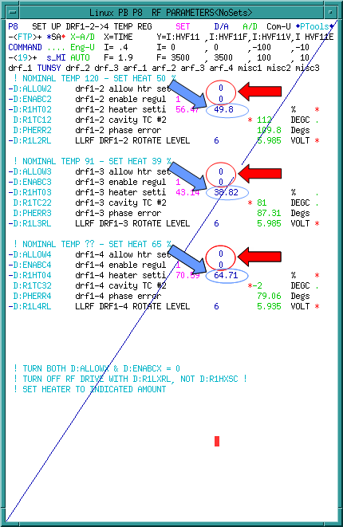 | 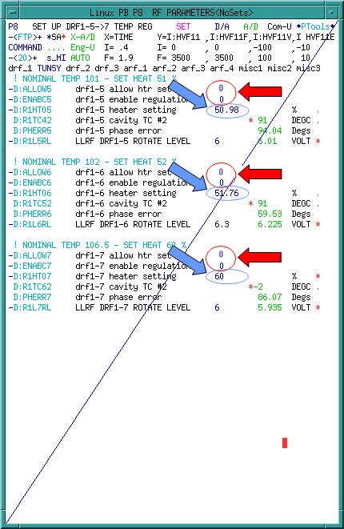
Figure 3-10:

Circulating Beam in the Debuncher

$16/$2D in the TLG

One Shots

We issue the last five commands of the aggregate and then start from the top.

- CHECK_DEVICE D:HT609S RESTORE
- CHECK_DEVICE D:HT606S RESTORE
- CHECK_DEVICE D:HT605S RESTORE
- ACKNOWLEDGE
- ACKNOWLEDGE

With the last five commands run, we will go to the top of the same aggregate.

- FTP Deb Rev Prot 0
- CTL_DEVICE A:EKIK ON
- CTL_DEVICE A:ISEP1V ON
- CTL_DEVIOCE A:ISEP2V ON
- CTL_DEVICE A:IKIK ON
- CTL_DEVICE D:ESEPV ON
- CTL_DEVICE D:EKIK ON
- CHECK_DEVICE D:HT609S SAVE_SET
- CHECK_DEVICE D:HT606S SAVE_SET
- CHECK_DEVICE D:HT605S SAVE_SET

- BEAM_SWITCH Pbar_Source On
- START_PGM D47
- ACKNOWLEDGE
- LOAD_TLG 75 ONESHOT
- ACKNOWLEDGE
- BEAM_SWITCH PBAR_SOURCE OFF

- CTL_DEVICE A:EKIK OFF
- CTL_DEVICE A:ISEP1V OFF
- CTL_DEVICE A:IKIK OFF
- CTL_DEVICE D:ESEPV OFF
- CTL_DEVICE D:EKIK OFF
- SETIT_DEVICE D:HT609S =0
- SETIT_DEVICE D:HT606S =0
- SETIT_DEVICE D:HT605S =0

- ACKNOWLEDGE

Debuncher Orbits

Java Orbit Preparation

asdfasdfa

Java BPM Orbits

asdfasdfa

Debuncher Admittance Measurement

Pbar Sequencer: Deb Hor aperture scan rev p

We issue the last five commands of the aggregate and then start from the top.

- CHECK_DEVICE D:HT609S RESTORE
- CHECK_DEVICE D:HT606S RESTORE
- CHECK_DEVICE D:HT605S RESTORE
- ACKNOWLEDGE
- ACKNOWLEDGE

With the last five commands run, we will go to the top of the same aggregate.

- FTP Deb Rev Prot 0
- CTL_DEVICE A:EKIK ON
- CTL_DEVICE A:ISEP1V ON
- CTL_DEVIOCE A:ISEP2V ON
- CTL_DEVICE A:IKIK ON
- CTL_DEVICE D:ESEPV ON
- CTL_DEVICE D:EKIK ON
- CHECK_DEVICE D:HT609S SAVE_SET
- CHECK_DEVICE D:HT606S SAVE_SET
- CHECK_DEVICE D:HT605S SAVE_SET

- BEAM_SWITCH Pbar_Source On
- START_PGM D47
- ACKNOWLEDGE
- LOAD_TLG 75 ONESHOT
- ACKNOWLEDGE
- BEAM_SWITCH PBAR_SOURCE OFF

- CTL_DEVICE A:EKIK OFF
- CTL_DEVICE A:ISEP1V OFF
- CTL_DEVICE A:IKIK OFF
- CTL_DEVICE D:ESEPV OFF
- CTL_DEVICE D:EKIK OFF
- SETIT_DEVICE D:HT609S =0
- SETIT_DEVICE D:HT606S =0
- SETIT_DEVICE D:HT605S =0

- ACKNOWLEDGE
- SPECTRUM_LOAD 4 25
- FTP Deb Horz 0

- REPLAY P60 d;rj306 to edge
- ACKNOWLEDGE
- CTLIT_DEVICE D:DPENI OFF
- CTLIT_DEVICE D:DPENI POSITIVE
- ACKNOWLEDGE
- CHECK_DEVICE D:DPHATT SAVE_SET
- SET_DEVICE D:DPHATT = 0.75
- ACKNOWLEDGE
- CHECK_DEVICE D:DPHATT RESTORE
- CTLIT_DEVICE D:DPENI NEGATIVE
- CTLIT_DEVICE D:DPENI ON
- CTL_DEVICE D:LM30CL ON

- FTP Deb 0
- ACKNOWLEDGE
- ACKNOWLEDGE
- CTL_DEVICE D:LM30CL OFF
- REPLACE P60 Deb Horz scrape
- ACKNOWLEDGE
- COPY_SCREEN 0 SB
- COPY_SCREEN 0 SB

- REPLAY p60 d;rj306 retract
- WAIT_DEVICE D:RJ306
- CTL_DEVICE D:LM30CL ON
- CHECK_DEVICE D:HT609S RESTORE
- CHECK_DEVICE D:HT606S RESTORE
- CHECK_DEVICE D:HT605S RESTORE
- ACKNOWLEDGE
- ACKNOWLEDGE

Pbar Sequencer: Deb Vert aperture scan rev p

We issue the last five commands of the aggregate and then start from the top.

- CHECK_DEVICE D:HT609S RESTORE
- CHECK_DEVICE D:HT606S RESTORE
- CHECK_DEVICE D:HT605S RESTORE
- ACKNOWLEDGE
- ACKNOWLEDGE

With the last five commands run, we will go to the top of the same aggregate.

- FTP Deb Rev Prot 0
- CTL_DEVICE A:EKIK ON
- CTL_DEVICE A:ISEP1V ON
- CTL_DEVIOCE A:ISEP2V ON
- CTL_DEVICE A:IKIK ON
- CTL_DEVICE D:ESEPV ON
- CTL_DEVICE D:EKIK ON
- CHECK_DEVICE D:HT609S SAVE_SET
- CHECK_DEVICE D:HT606S SAVE_SET
- CHECK_DEVICE D:HT605S SAVE_SET

- BEAM_SWITCH Pbar_Source On
- START_PGM D47
- ACKNOWLEDGE
- LOAD_TLG 75 ONESHOT
- ACKNOWLEDGE
- BEAM_SWITCH PBAR_SOURCE OFF

- CTL_DEVICE A:EKIK OFF
- CTL_DEVICE A:ISEP1V OFF
- CTL_DEVICE A:IKIK OFF
- CTL_DEVICE D:ESEPV OFF
- CTL_DEVICE D:EKIK OFF
- SETIT_DEVICE D:HT609S =0
- SETIT_DEVICE D:HT606S =0
- SETIT_DEVICE D:HT605S =0

- ACKNOWLEDGE
- SPECTRUM_LOAD 4 25
- SPECTRUM_LOAD 5 25
- FTP Deb Horz 0

- REPLAY P60 d;tj308 to edge
- ACKNOWLEDGE
- CTLIT_DEVICE D:DPENI OFF
- CTLIT_DEVICE D:DPENI POSITIVE
- ACKNOWLEDGE
- CHECK_DEVICE D:DPVATT SAVE_SET
- SET_DEVICE D:DPVATT = 3.75
- ACKNOWLEDGE
- CHECK_DEVICE D:DPVATT RESTORE
- CTLIT_DEVICE D:DPENI NEGATIVE
- CTLIT_DEVICE D:DPENI ON
- CTL_DEVICE D:LM30CL ON
- TIMER A:VAREVT ENABLE
- FTP Deb 0
- ACKNOWLEDGE
- ACKNOWLEDGE
- CTL_DEVICE D:LM30CL OFF
- REPLACE P60 Deb Vert Scan
- ACKNOWLEDGE
- COPY_SCREEN 0 SB
- COPY_SCREEN 0 SB

- REPLAY p60 d;tj308 retract
- WAIT_DEVICE D:TJ308
- CTL_DEVICE D:LM30CL ON
- CHECK_DEVICE D:HT609S RESTORE
- CHECK_DEVICE D:HT606S RESTORE
- CHECK_DEVICE D:HT605S RESTORE
- ACKNOWLEDGE
- ACKNOWLEDGE

FTP versus Lumberjack Manual Measurements

Java Fit of Lumberjack Data

Beam up AP2

Establishing beam up the AP2 line

- ACKNOWLEDGE

- SETIT_DEVICE D:IKIKP =0
- SETIT_DEVICE D:IKIK =64
- CTLIT_DEVICE D:IKIKTG OFF
- CTLIT_DEVICE D:IKIKRV ON
- EVENT 82 ENABLE
- EVENT 76 ENABLE
- EVENT 87 ENABLE
- WAIT_FOR EVENT 87
- CTLIT_DEVICE D:IKIK ON
- CTLIT_DEVICE D:ISEPV ON
- ACKNOWLEDGE
- CHECK_DEVICE A:SCRES RESTORE
- CHECK_DEVICE D:IKIKP RESTORE
- CTLIT_DEVICE D:IKIKRV OFF
- CTLIT_DEVICE D:IKIKTG ON
- CTL_DEVICE D:Q731 OFF
- CTL_DEVICE A:EKIK OFF
- CTL_DEVICE IKIK OFF
- CTL_DEVICE A:ISEP1V OFF
- CTL_DEVICE A:ISEP2V OFF
- CTL_DEVICE D;EKIK OFF
- CTL_DEVICE D:ESEPV OFF
- SETIT_DEVICE D:IKIK =0
- CHECK_DEVICE D:R1HT02 RESTORE
- CHECK_DEVICE D:R1HT03 RESTORE
- CHECK_DEVICE D:R1HT04 RESTORE
- CHECK_DEVICE D:R1HT05 RESTORE
- CHECK_DEVICE D:R1HT06 RESTORE
- CHECK_DEVICE D:R1HT07 RESTORE
- SET_SEQ FILE 91
- ALARM_LIST PBAR 72
- WAIT_FOR SECS 5
- ALARM_LIST PBAR 76
- ACKNOWLEDGE

Beam Modes

Partial Debuncher Turn to AP2

Circulating Debuncher beam to AP2

D/A Orbit Studies

Return to Stacking

