1. Motivation for Predicting Luminosity Behavior 3
2. Luminosity Models 3
a. Simple Exponential Model 4
b. Modified Exponential Model 5
c. Simple Inverse Time to Power Model 6
d. Modified Inverse Time to Power Model 8
e. Chi Square Test of Merit 9
3. Building a Spreadsheet Tool 10
a. Spreadsheet Setup 10
b. External Data Spreadsheets 13
i. SuperTable II 13
ii. Lumberjack Data 13
c. Luminosity Predictor Spreadsheet: How to Analyze the Data 14
i. Input Data Workbook (Procedure for using the spreadsheet) 15
d. Luminosity Predictor Spreadsheet: Workbooks in Detail 23
i. LBOE Workbook 23
ii. Lumberjack Data import 26
iii. Input Data for the Luminosity Models 29
iv. The Luminosity Models 30
v. Error Sums 34
vi. Summaries 35
vii. Fits over time 36
viii. Plots 38
e. VBA Scripts 39
i. Clear All Data Script (Ctrl-Shift-C) 39
ii. Analyze the Data Script (Ctrl-Shift-A) 39
iii. Archive (Write) the Data Script (Ctrl-Shift-W) 40
a. Archive Data Files 41
i. Individual store{####}-fit-data.xls files 41
ii. Store-fit-summary.xls file 42
4. How luminosity fits improve over time 43
a. Simple Exponential Fit (Equation 1) 43
b. Modified Exponential Fit (Equation 2) 46
c. Inverse Time to Power Fit (Equation 3) 47
d. Modified Inverse Time to Power Fit (Equation 3) 49
5. Beginning of Store 51
a. Simple Exponential Fit (Equation 1) 52
b. Modified Exponential Fit (Equation 2) 52
c. Inverse Time to Power Fit (Equation 3) 54
d. Modified Inverse Time to Power Fit (Equation 4) 54
6. End of Store 55
a. Simple Exponential Fit (Equation 1) 55
b. Modified Exponential Fit (Equation 2) 56
c. Inverse Time to Power Fit (Equation 3) 57
d. Modified Inverse Time to Power Fit (Equation 4) 58
7. Comparing Fit Numbers for Top 5 Stores 59
a. Simple Exponential Fit (Equation 1) 59
b. Modified Exponential Fit (Equation 2) 60
c. Inverse Time to Power Fit (Equation 3) 62
d. Modified Inverse Time to Power Fit (Equation 4) 63
8. Conclusions 65
9. References and Useful Sources 65

Motivation for Predicting Luminosity Behavior

When planning Collider store turn around times, it would be beneficial to have a tool that could be used anytime in the store to predict the Luminosity behavior later in that store.

We have three existing tools that can help us determine the Luminosity behavior of a store. First, there are models of the Tevatron luminosity¹⁻⁴. Tevatron experts have models that closely predict the luminosity behavior of a store given a few constants including the initial luminosity and luminosity lifetime. If we could determine the correct values for the above mentioned constants early on in the store, we could use a luminosity model to predict the Luminosity behavior over the entire store. Second, we have the SuperTable. Experts examine the luminosity data during the first few hours of each store and calculate an initial luminosity and luminosity lifetime of the store based on a simple exponential fit. These numbers are placed in the SuperTable, and can be easily retrieved in an Excel Spreadsheet. These values provide early feedback as to the initial health of the store. We will see that a simple exponential fit using the SuperTable values does not provide a good long term prediction of the Luminosity behavior of the store, but does provide a good starting point. Last, we have the datalogger. The luminosity readings are datalogged for each store. We can easily export this data to an Excel spreadsheet and plot how the Luminosity has progressed anytime during the store.

The goal of this exercise is to build an Excel spreadsheet to help predict the Luminosity behavior of a store. We will construct the spreadsheet so that can be used at anytime during a store. The spreadsheet would use existing Luminosity Models to calculate Luminosity behavior. The initial guesses at the initial luminosity and luminosity lifetimes would be gathered from the SuperTable. The Luminosity Model constants would then be fit to the Lumberjack data for that store. As the store progressed, the tool could be used repetitively to get better and better Luminosity behavior predictions. When the store is finished, we could then examine how accurate the predictions from the various models matched the actual luminosity data.

Luminosity Models

We will look at four basic Luminosity Models. The constants for each of these fits are calculated at the end of each store by Elliot McCrory²⁻⁴ and are displayed online at http://mccrory.fnal.gov/tevatronDecayFits/. Future additions of this website will also calculate the fits at different times during the store. In this exercise, we will make a tool to complete these calculations on demand. For each fit, we will show example store data. I have chosen store 4639, which holds our record for integrated luminosity. The store was long-lived and thus provides a large data sample for us to analyze.

Simple Exponential Model

The Simple Exponential fit is what is used to create the luminosity lifetime numbers posted in the SuperTable and is given by Equation (1)
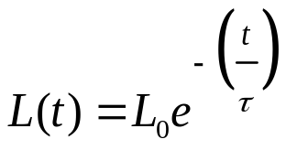 (1)

where L(t) is the Luminosity at time t, L₀ is the initial luminosity, t is the time, and τ is the luminosity lifetime.

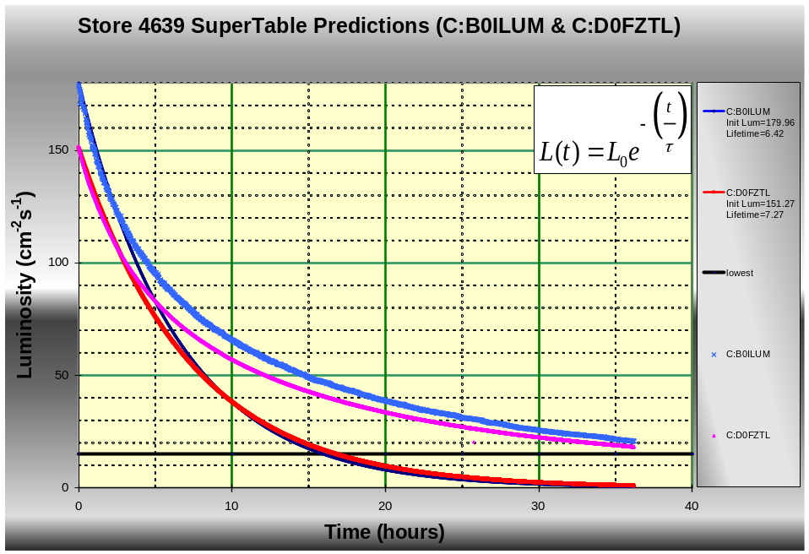
Figure 2-1: The medium blue and pink traces are the luminosity over time for CDF and D0 for store 4369. The dark blue and red traces are luminosity distributions for CDF and D0 calculated from lifetime and initial luminosity data in the SuperTable II .

Figure 2-1 shows the exponential curve and the lumberjack data for store 4369. The x-axis is time in hours from the beginning of the store, and the y-axis is store luminosity. The dark blue and red curves are the exponential curves for CDF and D0. The curves are generated using Equation (1) with the initial luminosity and luminosity lifetime numbers from the SuperTable II. The medium blue and pink traces are the luminosity data for CDF and D0 collected from the lumberjack. If the luminosity truly followed the exponential expression in Equation (1) then we would expect the CDF predicted (red line) and actual (pink) to be aligned, and the D0 predicted (dark blue) and actual (blue) to be aligned. We see in the first few hours of the store there is very good agreement between the exponential curve and the lumberjack data; however, as we look later in the store the data soon diverges. If we were to use the exponential fit with the SuperTable numbers to predict the Luminosity later in the store, we would not make a very good prediction.

What happens if we modify the values of initial luminosity and luminosity lifetime in Equation (1) to try to make the experimental and real data better match? The results are shown in Figure 2-2.

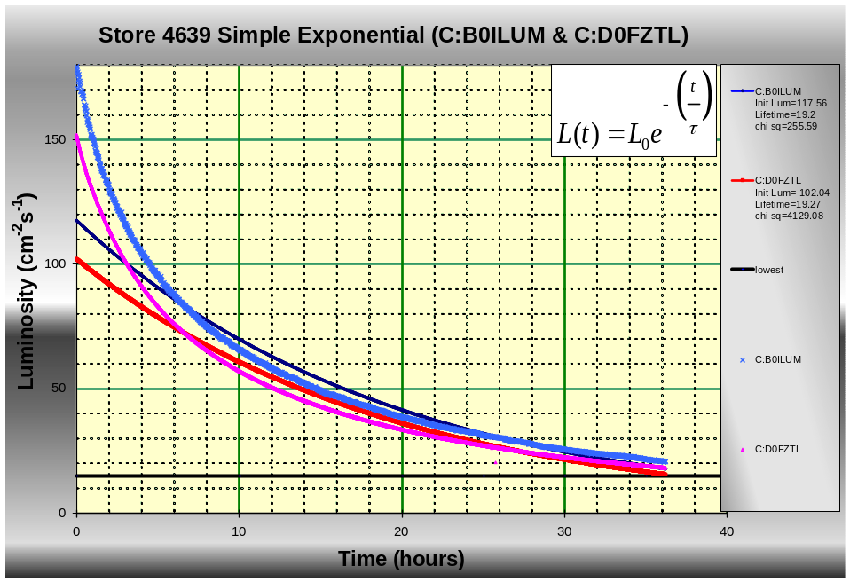
Figure 2-2: Here we attempt to match the luminosity data with the Simple Exponential model of Equation (1). We modify the initial luminosity and luminosity lifetime constants in the equation to attempt to make the best fit.

Figure 2-2 shows that the luminosity data and the curve from Equation (1). Using the Excel solver, we were not able to find values for the initial luminosity and luminosity lifetime that would make the curves generated by Equation (1) match the lumberjack data. We will find better results in our next model.

Modified Exponential Model

The second fit is a modification of the exponential fit given in Equation (1). We still use the exponential fit, but assume that the lifetime in the denominator varies with time. We add a constant multiplied by the time raised to another constant to the initial lifetime. The result is shown in Equation (2).

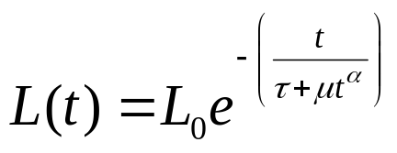 Equation (2)

where L(t) is the Luminosity at time t, L₀ is the initial luminosity, t is the time, τ is the luminosity lifetime, μ is a positive constant and α is a positive constant.

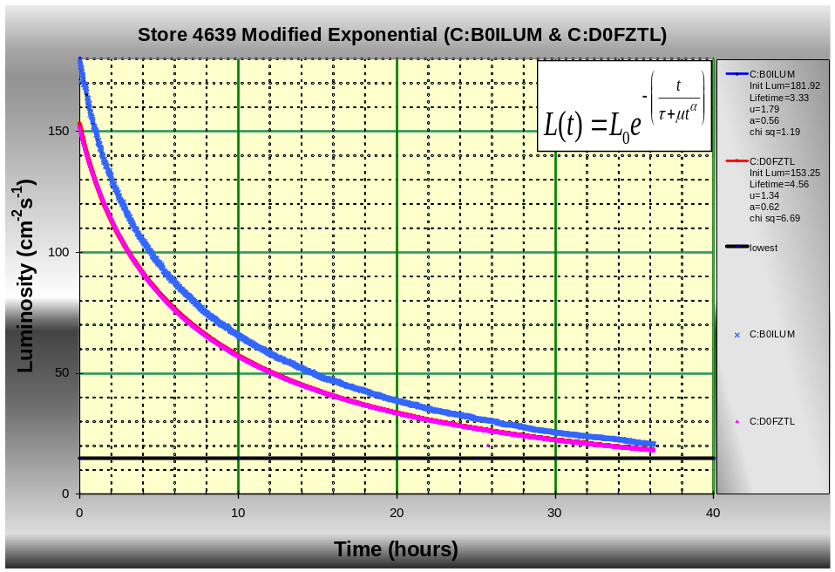
Figure 2-3: The constants in the modified exponential fit of Equation (2) were modified with the Excel Solver to obtain a very good match with the luminosity data from Store 4369.

Figure 2-3 shows data from Store 4639. We used the Excel Solver to modify the four constants in Equation (2) to match the lumberjack data. Unlike the simple exponential fit, our modified exponential fit gives us very good agreement between the curves and the lumberjack data.

Simple Inverse Time to Power Model
Another model, found in “Recycler-Only Operations Luminosity Projections” by Dave McGinnis¹ provides a luminosity fit with only three constants. This equation is given in Equation (3)
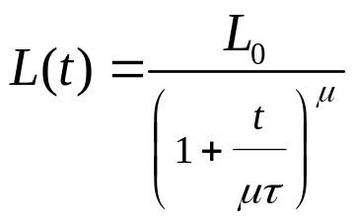 Equation (3)
where L(t) is the Luminosity at time t, L₀ is the initial luminosity, t is the time, τ is the luminosity lifetime, and μ is a positive constant.

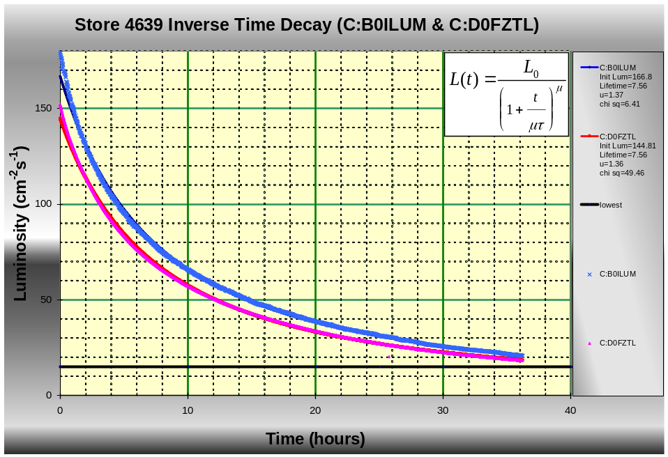
Figure 2-4: Modifying the constants in equation (3) we were able to obtain a fairly good fit for the Store 4369 luminosity data. Careful inspection of the graph shows that the model is least accurate in the first few hours of the store.

Figure 2-4 shows data from Store 4639. We used the Excel Solver to modify the three constants in Equation (3) to match the lumberjack data. This fit works very well; however, a closer inspection shows that it is not quite as accurate at the beginning of the store as Equation (2). We will take a closer look.

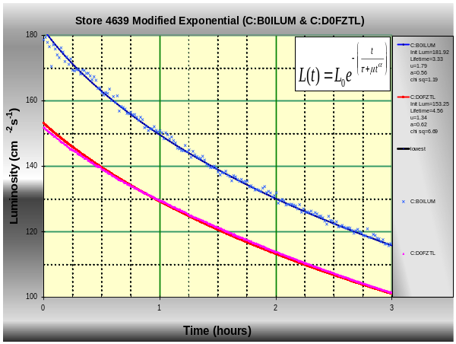 | 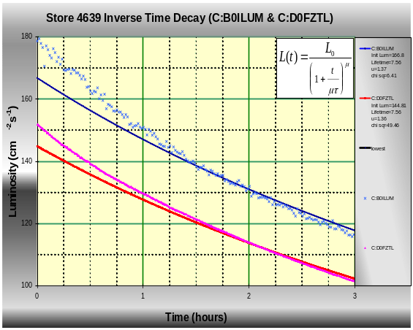
Equation (2)  Modified Exponential Fit | Equation (3)  Inverse Time Decay Fit
Figure 2-5: Comparing how well Equations (2) and (3) fit the data from Store 4639 during the first few hours of the store.

Figure 2-5 shows the same data plotted in Figures 3 and 4, only blown up to look at the first three hours of store 4639. This is an attempt to show the relative accuracy of the two fits at the beginning of the store. We can see that during the first hour and a half of the store, Equation (3) does not fit the data as well as Equation (2).

Modified Inverse Time to Power Model
Our fourth fit is a modification of the fit given in Equation (3). We will assume that the exponent varies with time. We add a constant multiplied by the time to the initial exponent. The result is shown in Equation (4).

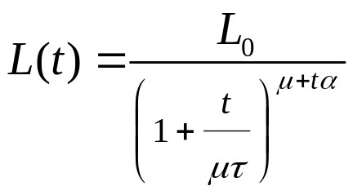 Equation (4)

where L(t) is the Luminosity at time t, L₀ is the initial luminosity, t is the time, τ is the luminosity lifetime, μ is a positive constant and α is a positive constant.
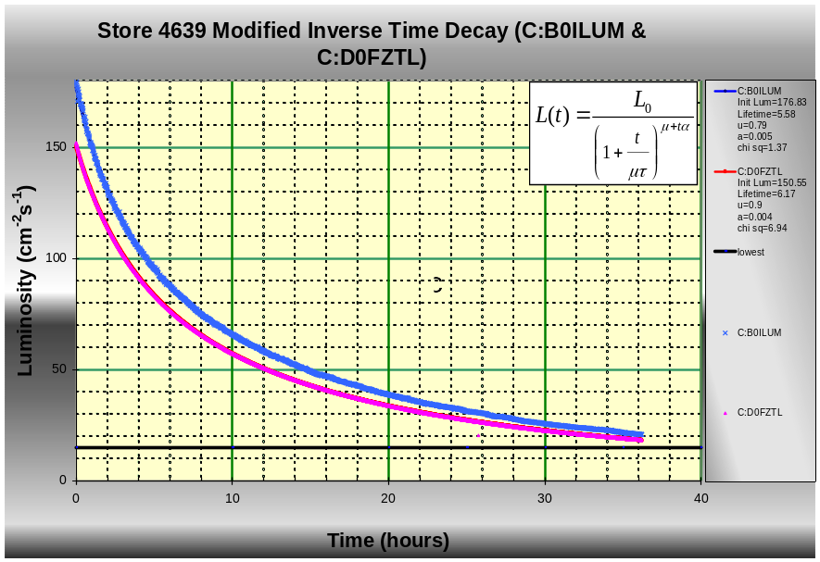
Figure 2-6: The constants in the modified time decay fit of Equation (3) were modified with the Excel Solver to obtain a very good match with the luminosity data from Store 4369.

Figure 2-6 shows data from Store 4639. We used the Excel Solver to modify the four constants in Equation (4) to match the lumberjack data. This fit works very well and fits the live data better at the beginning and end of the store than does Equation (3). We will see that Equations (2) and (4) appear to give the best results.

Chi Square Test of Merit

When comparing how well each of our models fit the actual luminosity data, it would be helpful to calculate a statistical value representing the quality of the fit. We have chosen a chi square fit as shown in Equation (5)

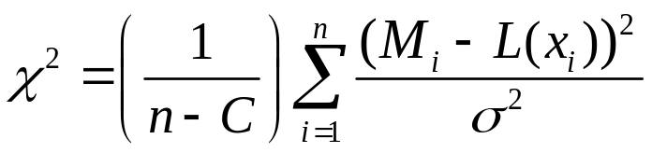 Equation (4)

where n is the number of lumberjack sample points, C is the number of constants in our luminosity model, M_{i} is the measured luminosity , L(x) is the calculated luminosity, σ is the sigma of the measured luminosity.

So to calculate our χ² value we will simply subtract the calculated luminosity (from our luminosity models) from our measured luminosity (from the lumberjack data) and square that number. At each point, we will divide by the σ² of the luminosity measurement, where σ is the half height of the error bar of the measured value. We then sum this value over each of our luminosity readings and divide by the total number of data points less the number of constants in our model.

For this exercise, we will assume that σ values quoted by Elliot McCrory¹, which is 0.006*(Measured Luminosity)_{CDF} and 0.0015*( Measured Luminosity)_{D0} for CDF and D0 respectively. If the σ values are incorrect, the χ² value will be scaled incorrectly, but we will still get a relative comparison between the fits. The smaller the χ² value, the better the fit.

Building a Spreadsheet Tool

So far we found that three of our fits work well, two of which work extremely well. However, we have only examined data from one store. We will need to verify that the fits behave similarly for other stores. In addition, we have only fit the data using all of the lumberjack data after the store has been completed. We have not yet covered how well our equations predict luminosity behavior when only given a limited amount of luminosity data. For example, if we are four hours into a store, can we predict what the luminosity will be at 30 hours into the store? How about if we are six hours into the store? Eight hours? How do our luminosity model constants change as we get more and more lumberjack data? Also, how do the constants in our fits change from store to store? Do they always have similar values, or do they change a lot from store to store? Our goal is to build a tool with Excel to help us answer these questions.

Spreadsheet Setup

The default Excel spreadsheet configuration provided in the AD drive image does not have all of the features that we will need enabled. In order to run the spreadsheet we will need to enable the analysis toolpak and solver. Go to Tools -> Add-ins. Check the boxes next to “Solver Add-in,” “Analysis ToolPak,” and “Analysis ToolPak - VBA.”

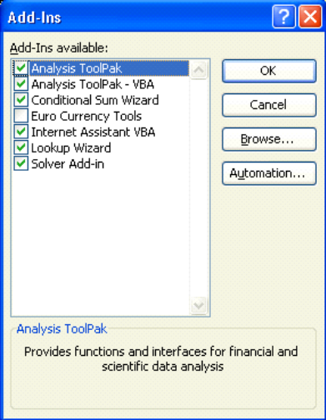
Figure 3-7: Enable the Solver and Analysis Toolpak.

We next need to verify that our security settings allow us to run Macros. Go to Tools -> Macros -> Security. Select “Medium” and click ok.


Figure 3-8: Set the macro security setting to medium. This allows the user to choose if macros are enabled at the time that a spreadsheet with macros is opened. Be careful! Only enable macros on spreadsheets that you are absolutely sure of their source. Macros are a popular way to spread viruses on Windows computers.

We will also need to setup the VBA editor to run scripts with Solver. With out this step, we would have to run the solver manually to do our analysis. Go to Tools>Macro>Visual Basic Editor. The visual basic editor will open. On the Visual Basic Editor, use Tools>References. A dialog box of references will open. Select Solver.

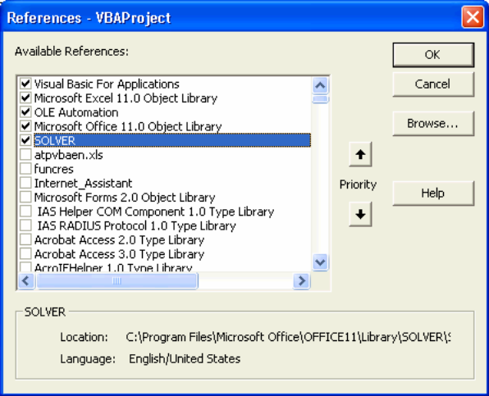
Figure 3-9: Allowing the Solver to run inside of VBA.

Excel has a great feature that automatically saves your work every 10 minutes. This feature helps the user recover their edits when Excel crashes unexpectedly. Unfortunately, this feature can interfere with our data analysis that we will run from VBA scripts. In order to maximize the resources during our data analysis, we turn off the “Save AutoRecover” feature before we run the data analysis VBA script. Go to Tools -> Options -> Save Tab and uncheck the box next to “AutoRecover.” We do not want to forget to turn this feature back on after the data analysis is complete, since the “AutoRecover” feature is very useful.

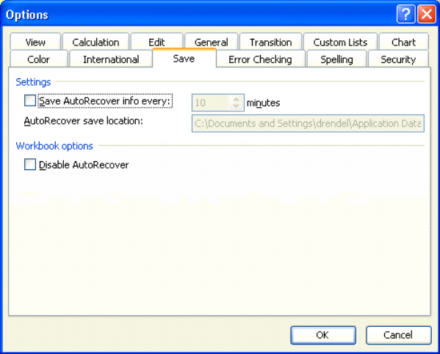
Figure 3-10: Turn off the “AutoRecover” feature when running an Excel data analysis. Turn “AutoRecover” back on when the data analysis is complete.

Excel should now be configured with all of the settings that we need to analyze our Collider luminosity data!

External Data Spreadsheets

We will want to call data from two external spreadsheets.

SuperTable II

An Excel version of the SuperTable is readily available for Windows users at \\daesrv\java_engines\files\SupertableExport. Copy this file to the same directory as our master Excel spreadsheet with the filename new_supertableII.xls.

One of the Excel lookup functions that we will use requires that the SuperTable spreadsheet have the store numbers listed in ascending order. By default the SuperTable spreadsheet is sorted by store number, but in descending order. Open the SuperTable spreadsheet, then sort all of the data by store number in ascending order, and save the file as an Excel Spreadsheet.

Update the SuperTable as necessary to ensure that you have the data required for the stores that you want to analyze.

Lumberjack Data

We next need to gather the Lumberjack data for the store we are interested in looking at. From Acnet D44 we can start a luminosity plot by going to Users -> Brian Drendel and then Recall -> ShotSetup. The default dataloggers and sample rates for the luminosity readings for this plot are:

        - C:B0ILIM: .CDF sampled at a 1 minute rate.
        - C:D0FZTL: .DZero sampled at a 15 second rate.

We next plot the data from the store in question. Once the plot has been made, we export the data to an Excel spreadsheet using the following steps.
- Select Export Data.
- We only want to export the Luminosity parameters (top two choices). De-select the others and click ok.
- Change the time format for both luminosity parameters from “Lumberjack format” to “hours.”
- Select “Excel File”
- Use the name shot{four digit shot number}.xls.

The data has been exported, but we still need to make a local copy.
- Open a web browser to http://www-ad.fnal.gov/excel or http://adcon.fnal.gov/pic/capture/excel, depending on if your D44 instance was run from a Linux console or a VMS console.
- Right-click on desired file and save it in the same directory as the Luminosity Predictor spreadsheet. Use the name shot{four digit shot number}.xls.

We now need to cleanup the data file before we can analyze it.
- Open the shot{four digit shot number}.xls file (luminosity-predictor.xls should remain closed).
- We want our Luminosity data to start exactly when the luminosity readings show their initial luminosity values. This will give us the best fit later on. D0 data and CDF data should be done separately.
- CDF: Select any data in the first two columns starting with cells A2 & B2 down to where the luminosity signal comes online. Select Edit->Delete and then select to "shift the cells up."
- D0: Select any data in the first two columns starting with cells C2 & D2 down to where the luminosity signal comes to full value. Make sure to include in your selection the early luminosity data where the luminosity is not at full value. Select Edit -> Delete and then select "shift the cells up."
- Repeat the above two steps for any zero or bad luminosity data at the bottom of the list (When deleting the cells, select to shift cells up)
- Also scan the file for any bad luminosity data and remove those cells (When deleting the cells, select to shift cells up)
- Save the file as shot{four digit shot number}.xls as an Excel workbook.

The data is now in a format ready to be analyzed. Repeat the above procedure for each store that you want to examine.

Luminosity Predictor Spreadsheet: How to Analyze the Data
The above section concentrated on getting our data formatted in Excel spreadsheets. We will not modify those spreadsheets. We have a separate Excel Spreadsheet that has the tools built in to analyze that data. We call that spreadsheet Luminosity-Predictor-Plus.xls

Input Data Workbook (Procedure for using the spreadsheet)

By default, all workbooks in the Luminosity Predictor spreadsheet are protected. Most user interaction with the workbook will occur in the “InputData” workbook. There are interactive buttons connected to VBA scripts that complete a majority of the tasks. To use this spreadsheet, start at the top and work your way down. We will start by selecting a store number, opening the external SuperTable and Lumberjack spreadsheets, verifying the data inside of the external spreadsheets, and then analyzing the data.

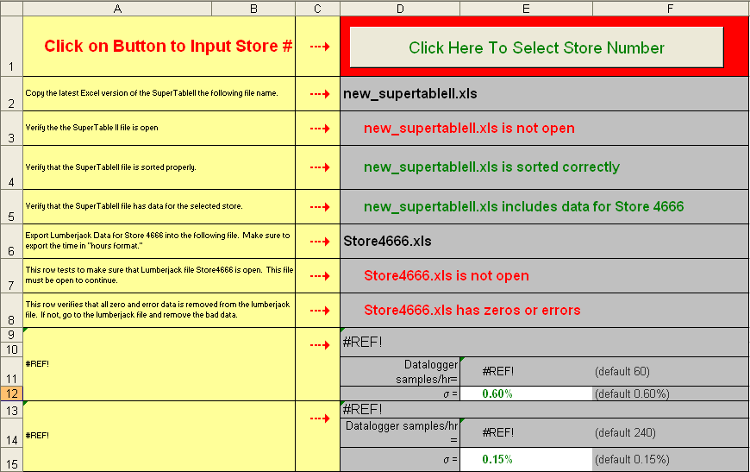
Figure 3-11: The Luminosity Predictor Spreadsheet opened to the “InputData” workbook. We start at the top. Click on the interactive button in Cell D1 to choose a Collider store.

Start by clicking on the interactive button in cell D1.

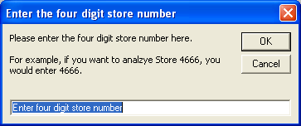 | 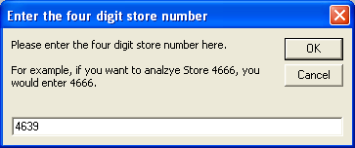
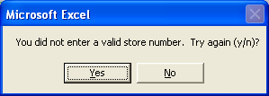 | 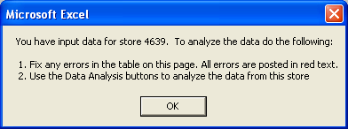
Figure 3-12: Clicking on the interactive button to choose the store number, there are a number of message boxes that the user may encounter. The first message box (upper left) asks the user to input the desired store number. In this example, we want to analyze store 4639, so we enter the store number (upper right) and then click OK. The VBA script has some error checking, so that if we type a store number not recognized by the VBA script, we get an error (lower left). If we chose a number that is a possible store number, we receive a message box (lower right) with some simple instructions on how to continue.

As shown in Figure 3-6, we are greeted with a message box asking us to input our desired store number. Type the desired store number and then click OK. In this example, we will type 4369 to analyze store 4369. There is built in error handling if we try to enter a store number outside of the range of the current store numbers. If we chose a valid store number, we get prompted with another message box, as shown in Figure 3-6, providing simple instructions on how to continue. After reading the instructions click OK. We will now walk through the steps needed to complete our data analysis.

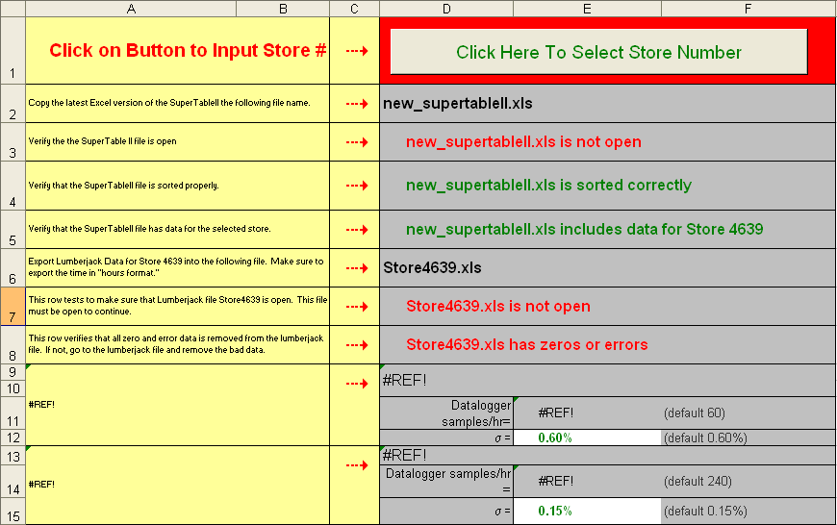
Figure 3-13: Once the desired store number is entered, we need to collect the data for this store from the external SuperTable and Lumberjack spreadsheets. Cell range D2:F15 provide feedback on our external spreadsheets. Fields that are not in the desired state are displayed in red text. We start with D2 and work our way down.

Cell D2 reminds the user the name of our SuperTable II spreadsheet. If a filename was used, it will not work with the Luminosity Predictor spreadsheet. Cell D3 checks to see if the SuperTable II spreadsheet is open and has conditional formatting to notify us as to its status. In Figure 3-7, we see that the SuperTable II file is not open. The user should now open the file.

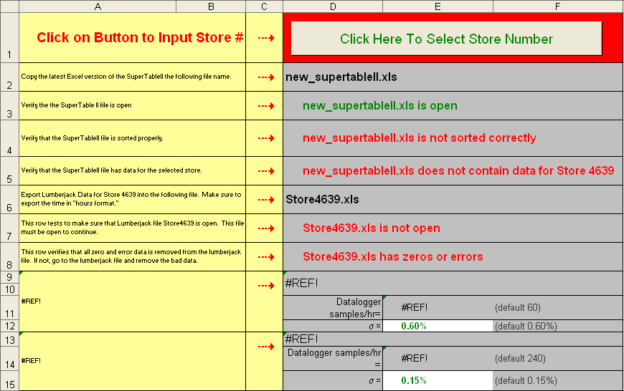
Figure 3-14: We have selected to analyze Store 4639. Cell D3 shows that the SuperTableII spreadsheet is open, but Cell D4 shows that it is not sorted correctly.

Figure 3-8 shows the status after we open the SuperTable II file. Cell D4 checks to ensure that the SuperTable has data sorted by store number in ascending order. One of our Excel lookup functions that we will user later requires that the data be sorted in this manner. In this example, the data is not sorted correctly. The user should now sort the data.

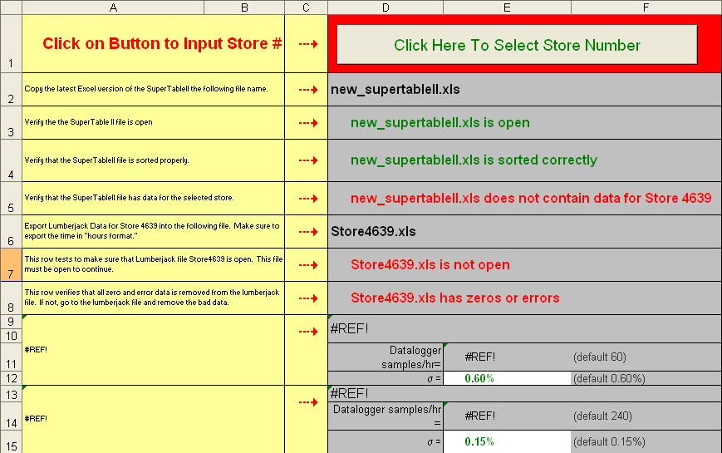
Figure 3-15: Cell D3 shows that the SuperTable spreadsheet is open, and Cell D4 shows that it is sorted properly. However, Cell D5 shows that there is no SuperTable II data for Store 4639 in our spreadsheet. We will either need to change store numbers, or replace the SuperTable II spreadsheet.

Figure 3-9 shows us that the SuperTable II file is open and sorted correctly; however Cell D5 shows that the file does not have data for the selected store. The two most likely causes of this problem are that we have selected a store number that does not exist, or our SuperTable II spreadsheet is old or corrupt. Store 4639 is a valid store number, so we replace our SuperTable II spreadsheet with the latest version from \\daesrv\java_engines\files\SupertableExport\. This file is readily available from the user desktop; however, it is not accessible via wireless or from home without a Controls VPN connection.

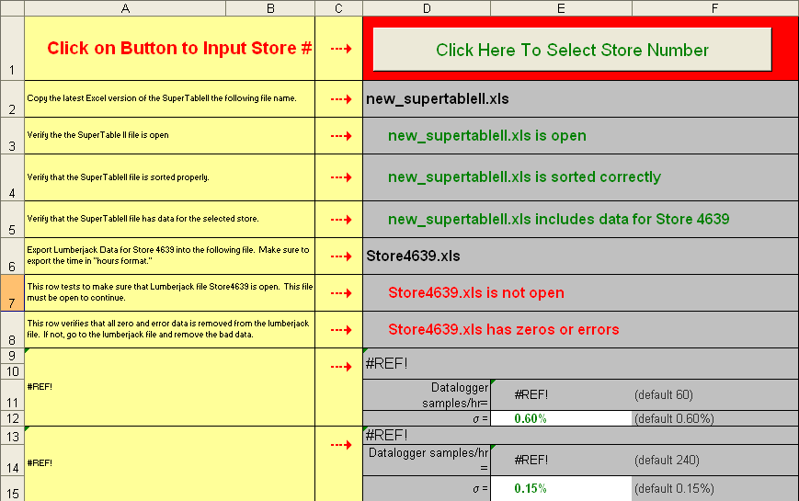
Figure 3-16: The SuperTable II spreadsheet is open, is sorted properly and has data for Store 4639. We will next need to open our Lumberjack data file for Store 4639.
.
Figure 3-10 shows the results of obtaining the latest SuperTable II spreadsheet and having it sorted by store number in ascending order. Cell D3 shows that our SuperTable II spreadsheet is open, cell D4 shows that it is sorted properly, and cell D5 shows us that it contains data for Store 4639. We next turn our attention to the Lumberjack data for Store 4639. Cell D6 provides the file name that the Luminosity Predictor is looking for. Follow the earlier given directions on generating the Excel file from D44.

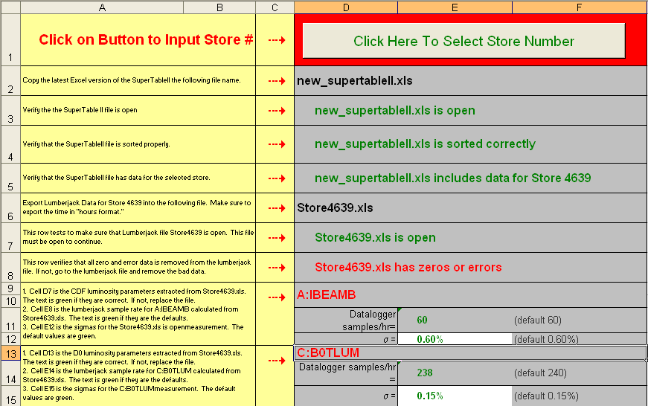
Figure 3-17: Cell D7 shows that we have opened our Lumberjack spreadsheet; however, cells D9 and D13 shows that we had exported the wrong data.

Figure 3-11 shows that we have opened the Store4639.xls spreadsheet; however, Cells 9 and 10 show that we had exported the wrong parameters to our spreadsheet. We must now go back and recreate our Store4639.xls file from our earlier instructions.

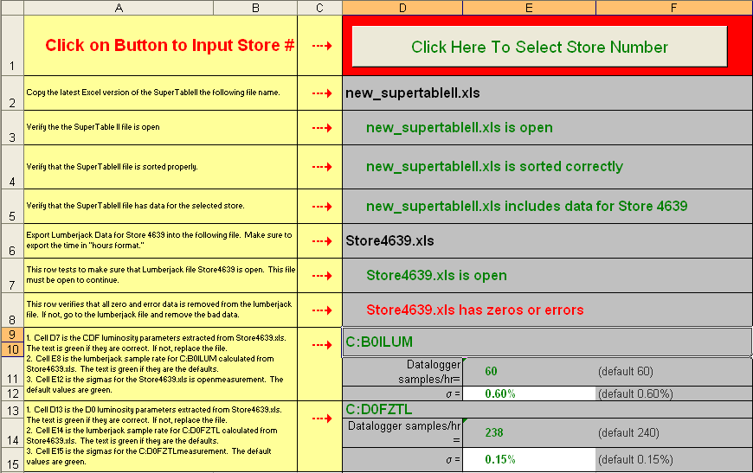
Figure 3-18: Cell D7 shows that we have our Lumberjack spreadsheet open for Store 4639, and Cells D9 and D13 show that we have exported the correct devices; however, Cell D8 still shows an error. The most likely cause are the zero Luminosity values at the beginning and end of the store.

In Figure 3-12, Cells D7 and D8 show that we have our Lumberjack spreadsheet open for Store 4639 and we have exported the correct parameters; however, Cell C8 shows that there are some problems with the data. This most likely cause of this problem is the zero luminosity readings at the starting or end of a store. Follow the directions given earlier to trim the errant data from our file.

It should be noted that cells E11 and E14 look at the Lumberjack data file and calculate the sample rate from entries in the time column. The default values are listed and cells will be posted in green if they are equal to those values. The spreadsheet was built so that if you export the lumberjack data from other dataloggers sampled at different rates, the spreadsheet will automatically adjust. Also note that cells C12 and C15 are the sigma of the luminosity reading. This is the half height of the error bar on the reading. At this point, we are using sigma values provided by Elliot McCrory². These numbers are important in that they impact the scaling of our χ² quality of fit test.

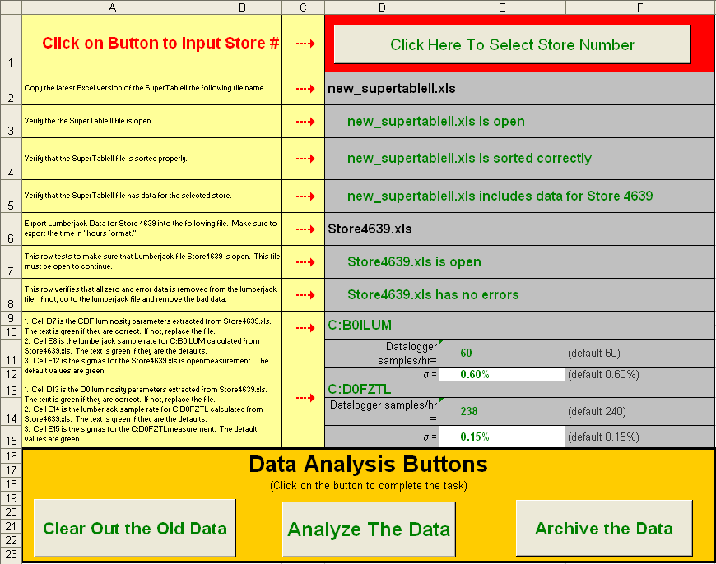
Figure 3-19: All cells in the range D1:F15 are green, which means that we have both a valid SuperTable II and Lumberjack spreadsheet open for Store 4639. We can now analyze the data from this store. In the box starting at cell A16 are interactive buttons. These buttons point to VBA scripts which do all of the data manipulation and analysis.

Cell range D2:D5 in Figure 3-13 shows that the SuperTable II spreadsheet open, is sorted correctly, and contains data from Store 4639. Cell range D6:F16 show us the Lumberjack spreadsheet is open, with the correct luminosity parameters and the data has no zero or error values. We are now ready to analyze the data. In the box starting in cell A16, there are three buttons. These buttons are attached to VBA scripts that do all of the data manipulation and analysis. Simply click on the button to complete the task assigned to that button.


Figure 3-20: The data analysis buttons provide shortcuts to completing all of the necessary data analysis tasks.

The three interactive buttons shown in Figure 3-14 complete the following tasks. More details on the precise steps that each VBA script executes can be found in Section 4 later in this document.
- Clear out the old data: Runs a VBA script that clears all calculated values from cells that may be leftover from previous data analysis runs. This script is run anytime we change which store we want to analyze.
- Analyze the data: Runs a VBA script that analyzes the data. This is an interactive script that interfaces the user asking the user over how much lumberjack data to analyze the store and which Tevatron model to use for analysis. This script can be run repeatedly until all of the desired analysis is completed on a store.
- Archive the data: Runs a VBA script to archive the analyzed data. Once we have completed our analysis on a store and want to move on, we archive the data to two Excel spreadsheets: One with all of the analyzed data from this store and one with a selection portion of the analyzed data

Luminosity Predictor Spreadsheet: Workbooks in Detail

In the last section, we covered the procedure of how to complete a round of data analysis using the “InputData” workbook in the Luminosity Predictor spreadsheet. Inside of the Luminosity Predictor spreadsheet are a number of workbooks that compete all of the number crunching. We will now discuss the functions of each of these workbooks.

LBOE Workbook

Many of the miscellaneous functions needed for the Luminosity Predictor spreadsheet are handled in the “LBOE” workbook (LBOE is an old acronym borrowed from AD\Controls that stands for “little bit of everything”). Cell range B12:E16 contains initial luminosity, luminosity lifetime and store duration numbers that are imported from the SuperTable spreadsheet. Anytime we need any of these numbers in this spreadsheet, we point back to these cells. This is done so that if our source of these parameters ever changes, we only have to edit this location. The title of this table contains the store number obtained from Cell D1. The title changes automatically when the user inputs a new store number.

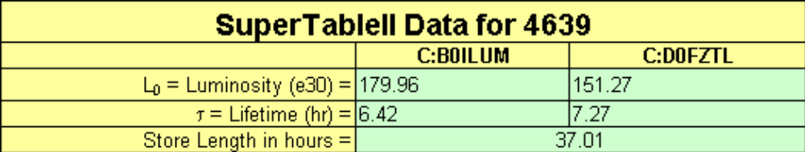
Figure 3-21: Cell Range B12:E16 displays of the data that is imported from the SuperTable II.

The SuperTable II numbers in Figure 3-15 are obtained by doing a VLOOKUP of data in our SuperTable II spreadsheet. The VLOOKUP command looks for the store number in the first column of the SuperTable II spreadsheet. Once the store number is found, the function collects the data for that row in columns #7 (store duration), #13 (SDA CDF initial luminosity), #14 (SDA D0 initial luminosity), #23 (CDF luminosity lifetime), and #24 (D0 luminosity lifetime). When the store number is changed from the interactive button in cell D1, the VLOOKUP function automatically updates the data in this table to match the new store number.

The VLOOKUP function requires that the first column of the SuperTable II spreadsheet be sorted in ascending order. This explains why we sorted the file earlier.

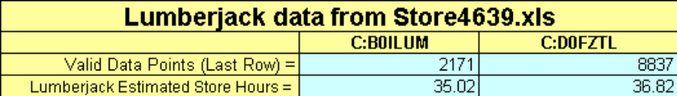
Figure 3-22: Cell Range B18:B21 examines the lumberjack data file. It determines the number of valid data points and calculates an estimated time of available data.

Figure 3-16 shows cell range B18:B21 on the “LBOE” Workbook. Here we look at the lumberjack luminosity data. The Excel count function is used to count the number of valid luminosity data points in the lumberjack file for this store. In this example, the CDF and D0 lumberjack data were sampled at different rates. This explains why there are more data points for D0 than there are for CDF. Using the calculated sample rate from “InputData” workbook cells E11 and E14, we calculate an estimated time of store data that we have to analyze. If all of the data is good, these times should be close to the store duration number in cell C5 of the “LBOE” workbook, which was obtained from the SuperTable II.

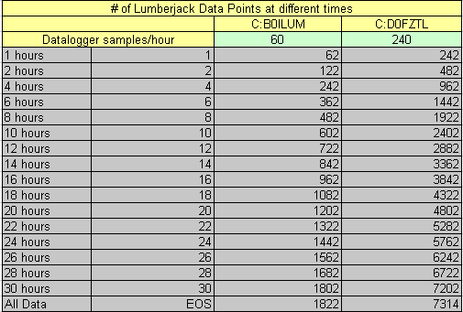
Figure 3-23: The cell range A12:D31 in the “LBOE” workbook contains the last row of lumberjack luminosity data at different slices in time.

Cell range A12:D31 calculates how many datalogger data points exist at various hour breakpoints. This data is used to build the cell names that correspond to different time slices of the data.

Figure 3-24: Cell range A33:K52 contains the cell names at various slices in time for the workbooks that we will use to calculate the difference between our luminosity curves and the lumberjack data. Due to space limitations, not all of the columns in this spreadsheet are shown.

Cell Range A33:K52 contains the cell names for our data fit spreadsheets at the time slices specified in Figure 3-7. We will need these cell names later to calculate errors between the predicted and actual data at various hour breakpoints.

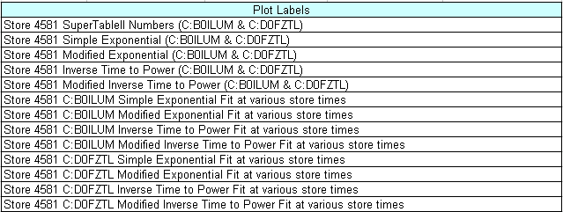
Figure 3-25: Plot labels are generated based on data in the Luminosity Predictor spreadsheet. If we change the store number or other parameters the plot labels will automatically adjust.

The labels for our plots are concatenated by colleting data from various cells in the spreadsheet. The resulting plot titles are output to cell range A54:E67 in the “LBOE” workbook. If we change the store number, name of the fit, or luminosity parameters, the plot labels automatically adjust.

Figure 3-26: Cell range B84:F86 shows the number of constants in luminosity model.

The last data displayed on the “LBOE” workbook are the number of constants for each available luminosity model. We will need these numbers to help calculate our χ² test of merit between our luminosity curve and our lumberjack data. These numbers are manually entered.

Lumberjack Data import

As discussed earlier, Lumberjack data is imported from another Excel Spreadsheet named Store{Store Number}.xls, where “Store Number” is obtained through the interactive button in the “InputData” workbook cell D1. When analyzing the data from this store, we do not modify the original Store{Store Number}.xls file. Instead, we mirror the data and manipulate it inside of the Luminosity Predictor spreadsheet.
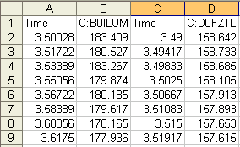
Figure 3-27: Lumberjack data for store 4639 is stored in Store4639.xls.

Store{Store Number}.xls has four columns of data that we need to import that represent Luminosity/Time pairs for both experiments. We will complete this task using the “ReformatLumberjack” workbook in our Luminosity Predictor spreadsheet.

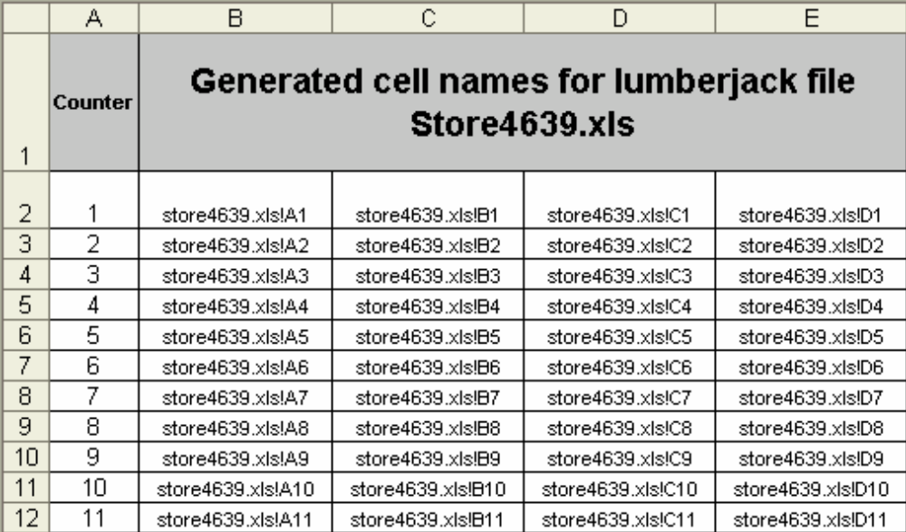
Figure 3-28: Columns A through E of the “Reformat Lumberjack” workbook.

The A Column contains a counter to help construct names in the B, D, F, and H Columns. The B, D, F, and H columns in the “Reformat Lumberjack” workbook construct the file and cell names for the A, B, C, and D Columns of Store{Store Number}.xls. These names change depending on what store number we have entered using the interactive button in cell D1 of the “InputData” workbook. If we change the store number, the names in these cells automatically change.

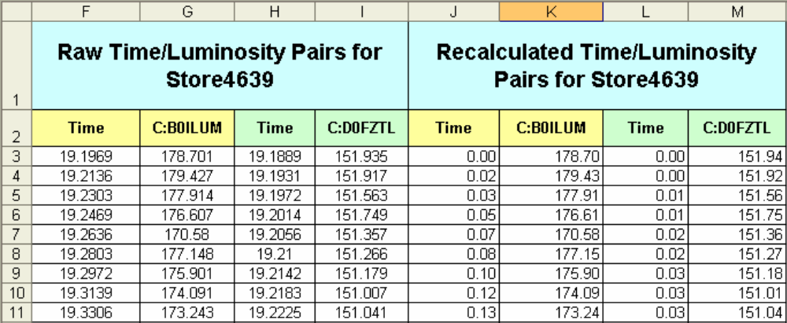
Figure 3-29: Columns F through M of the “ReformatLumberjack” workbook.

The F, G, H, and I Columns of the “Reformat Lumberjack” workbook use the Excel INDIRECT command with the values in columns B, C, D and E. This provides a mirror of the Store{Store Number}.xls A, B, C, and D Columns. Again, if we change the desired store number from the interactive button in cell D1 of the “InputData” workbook, these cells change to look at the spreadsheet from that store.

Columns F through I gives us time/luminosity pairs, but they are not quite ready for data analysis. Note that the times in columns F and I are in hours starting at the hour that the store began. We instead want to construct our time columns to be the number of hours since the store started. We use the following IF statement to construct the time columns.

=IF(AND(ExtractLumberjack!C3>0, NOT(ExtractLumberjack!C3=" "),NOT(ExtractLumberjack!C3=" ")), ExtractLumberjack!C3-ExtractLumberjack!$C$3, NA() )

The verification that a cell does not have 7 or 8 blank spaces was added after it was discovered that sometimes the Lumberjack data has cells with 7 or 8 blank spaces where no real data exists. If this check is not added, some of my later calculations are give errors since they do not know how to handle the empty spaces.

We now have successfully imported our lumberjack store data. Columns J through M of the “Reformat Lumberjack” workbook are now time/luminosity pairs for CDF and D0 with the time columns starting at zero. Now that we have the luminosity data for a specified store, we will try to fit our Collider luminosity model equations to the data to see how well we can make them agree.

Input Data for the Luminosity Models

We now turn our attention to building curves for the four luminosity models that were outlined in Equations (1) through (4) of Section 2 in this document.

We first create a location for the constants in our four models. We do this on the “FitNumbers” Workbook.

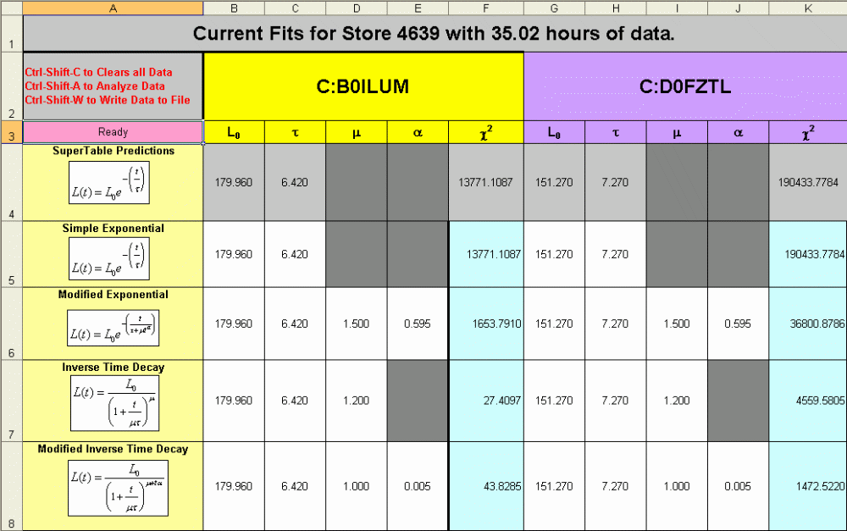
Figure 3-30: The “FitNumbers” workbook in the Luminosity Predictor spreadsheet.

Columns B through F are the constants for CDF and columns G through K are the same for D0. Recall from Equations (1) through (4), that we had.
- L₀ = Initial Luminosity
- τ = Luminosity Lifetime
- μ = constant (if applicable)
- α = constant (if applicable)
- χ² = chi square test of merit (We will see later these cells have a blue background because they are mirrored from another location in this spreadsheet).

Each row of the “FitNumbers” workbook contains constants from a different Collider luminosity model.

- Row 4: SuperTable II numbers that were derived from the Simple Exponential Fit of Equation (1). These cell backgrounds are colored grey since we do not change these values.
- Row 5: Simple Exponential Fit of Equation (1)
- Row 6: Modified Exponential Fit of Equation (2)
- Row 7: Time Decay Model of Equation (3)
- Row 8: Modified Time Decay Model of Equation (4)

It is important to note that we never manually change anything in this workbook. The interactive buttons in the “InputData” workbook point to VBA macros that complete all of the data analysis for us. The analysis script will automatically minimize the χ² value for each model by varying the constants for that model. For example, if we chose to analyze the Modified Exponential luminosity model for CDF, the script would vary the parameters in the “FitNumbers” workbook cell range B6:E6 to minimize the χ² value in “FitNumbers” workbook cell F6.

The Luminosity Models

There are four separate workbooks dedicated to calculating the CDF and D0 luminosity/time pairs for each of the luminosity models given in Equations (1) through (4), with one workbook dedicated to each luminosity model. Recall, that the “ReformatLumberjack” workbook contains the CDF and D0 luminosity/time pairs from the lumberjack data. For each model, we calculate the CDF and D0 luminosity at each time value given in the “ReformatLumberjack” workbook along with the constants from the “FitNumbers” workbook. The result is columns A through E in each of our model workbooks contain the CDF and D0 time/luminosity pairs from the model equation at all of the same times as the time/luminosity pairs gathered from the lumberjack data. We can then compare the luminosity values predicted by the model against the luminosity values from the lumberjack data. Columns E and F of our model workbooks contain the square of the differences between the measured CDF and D0 luminosity and the CDF and D0 luminosity calculated from our model, divided by the square of the sigma of our measurement. Equations (5) and the data from these columns will be used to determine our χ² quality of fit test. We will now examine the workbooks from each luminosity model.

      - SuperTable II Prediction:

We start by plugging in the initial luminosity and luminosity lifetime numbers into our simple exponential decay model that was given in Equation (1). This is done in the “SuperTable Predictions” Workbook.

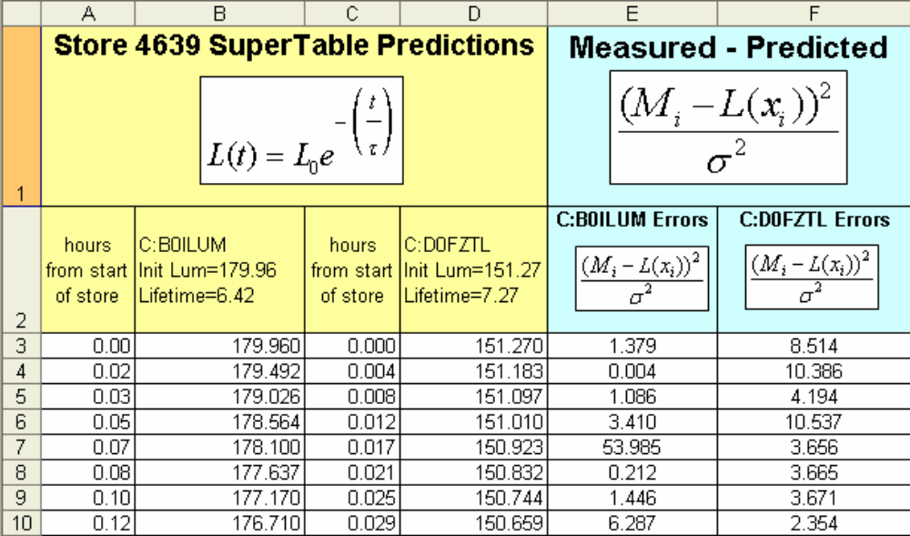
Figure 3-31: The “SuperTable-Prediction” workbook calculates time/luminosity pairs in columns A through D. The times are a mirror of the times in our lumberjack date file. Columns E and F show the square of the differences between the measured and predicted divided by the square of the sigma of our measurement. These columns will be used to determine our χ² merit of fit.

This method was determined not to be very useful, but is still completed for comparison sake.

      - Simple Exponential Fit

The “SimpleFit” Workbook uses Equation (1) and the corresponding input parameters from the “FitNumbers” Workbook to create Luminosity/Time pairs. The “FitNumbers” values are modified via a script to optimize the agreement between the lumberjack luminosity values and the calculated luminosity values.

Figure 3-32: The “SimpleFit” workbook calculates values for the Simple Exponential luminosity model. Columns A and C mirror the time values in our lumberjack file. Columns B and D are the calculated CDF and D0 luminosity based on the simple Exponential Model given in Equation (1) with the constants from the “FitNumbers” workbook. Columns E and F calculate an error between the measured and calculated luminosity numbers. These errors are used to calculate our χ² quality of fit test.

      - Modified Exponential Fit

The “ModSimpleFit” Workbook uses Equation (2) and the corresponding input parameters from the “FitNumbers” Workbook to create Luminosity/Time pairs. The “FitNumbers” values are modified via a script to optimize the agreement between the lumberjack luminosity values and the calculated luminosity values.

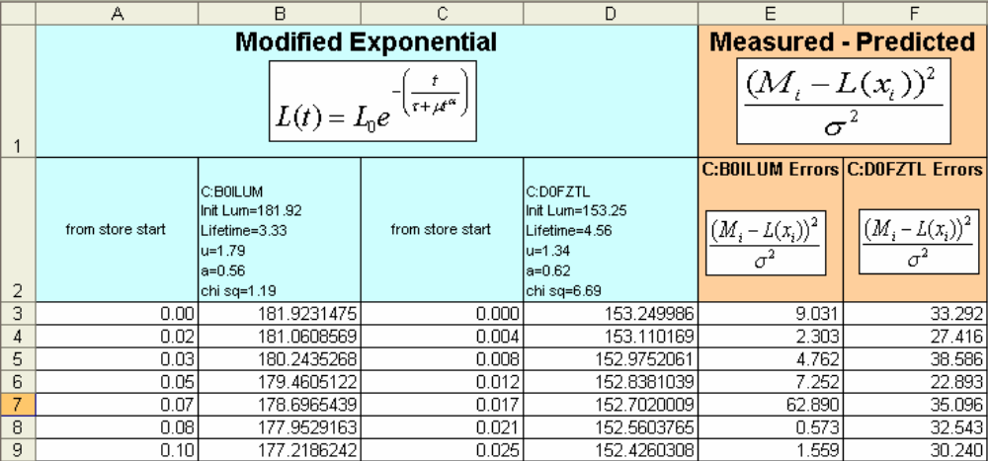
Figure 3-33: The “ModSimpleFit” workbook calculates values for the Modified Exponential luminosity model of Equation (2). Columns A and C mirror the time values in our lumberjack file. Columns B and D are the calculated CDF and D0 luminosity based on the Modified Exponential Model given in Equation (2) with the constants from the “FitNumbers” workbook. Columns E and F calculate an error between the measured and calculated luminosity numbers. These errors are used to calculate our χ² quality of fit test.

      - Inverse Time to Power Fit

The “t-1Fit” Workbook uses Equation (3) and the corresponding input parameters from the “FitNumbers” Workbook to create Luminosity/Time pairs. The “FitNumbers” values are modified via a script to optimize the agreement between the lumberjack luminosity values and the calculated luminosity values.

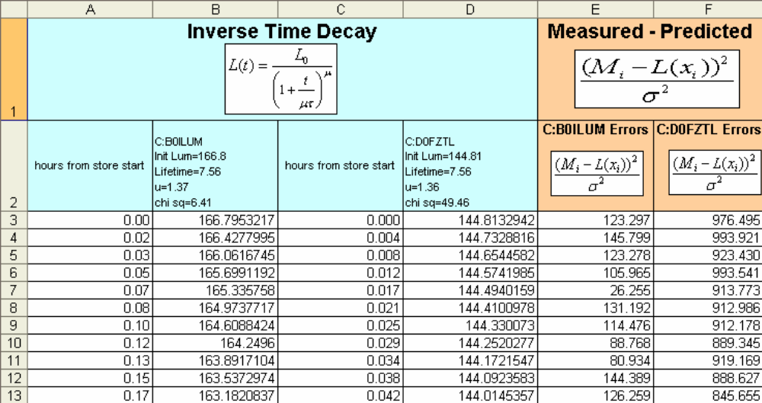
Figure 3-34: The “t-1Fit” workbook calculates values for the Time Decay luminosity model of Equation (3). Columns A and C mirror the time values in our lumberjack file. Columns B and D are the calculated CDF and D0 luminosity based on the Time Decay Model given in Equation (3) with the constants from the “FitNumbers” workbook. Columns E and F calculate an error between the measured and calculated luminosity numbers. These errors are used to calculate our χ² quality of fit test.

      - Modified Inverse Time to Power Fit

The “t-1ModFit” Workbook uses Equation (4) and the corresponding input parameters from the “FitNumbers” Workbook to create Luminosity/Time pairs. The “FitNumbers” values are modified via a script to optimize the agreement between the lumberjack luminosity values and the calculated luminosity values.

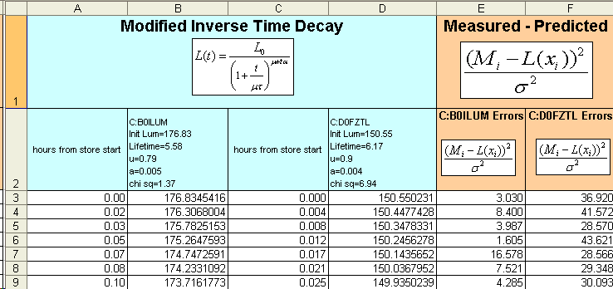
Figure 3-35: The “t-1ModFit” workbook calculates values for the Modified Time Decay luminosity model of Equation (4). Columns A and C mirror the time values in our lumberjack file. Columns B and D are the calculated CDF and D0 luminosity based on the Modified Time Decay Model given in Equation (4) with the constants from the “FitNumbers” workbook. Columns E and F calculate an error between the measured and calculated luminosity numbers. These errors are used to calculate our χ² quality of fit test.

Error Sums

We recall that our χ² quality of fit calculations in Equation (5) sums the error terms that we calculated in the workbook for each model and then divides that number by the number of data points minus the number of constants in the model equation. We have a separate χ² calculation for each luminosity model. We don’t end there.

One of the goals of this project is to also look at how these fits project the luminosity with varying lengths of lumberjack data. For example, we may want to see how well we project the luminosity after the first two hours of data, then after four hours of data, etc. We will have a different χ² calculation for every time slice of data we want to examine. We don’t want to have to manually trim our lumberjack data every time we want to look at a different time slice of data, so we’ll make the Luminosity Predictor spreadsheet do the work for us.

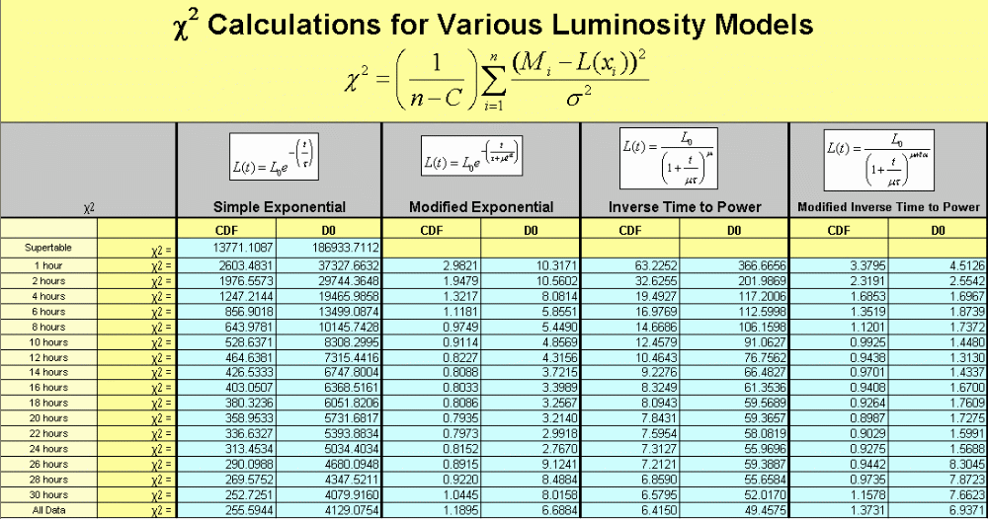
Figure 3-36: The “ErrorSums” workbook makes all of the possible χ² calculations based on the numbers input to the “FitNumbers” workbook and the errors calculated for each time/luminosity pair in the model workbooks.

The “ErrorSums” workbook calculates the χ² quality of fit number for each fit at each possible time slice based on the numbers input in the “FitNumbers” workbook and the errors calculated in the luminosity model workbooks. A script automatically copies the correct χ² values depending on what fit the spreadsheet user is attempting to make.

Summaries

After we complete our first set of fits at one time slice, we will want to save that data away so that we can move on to our next set of fits at a different time slice for the current store. The “D0_Results” and “CDF_Results” are used to store the data after we complete a fit.

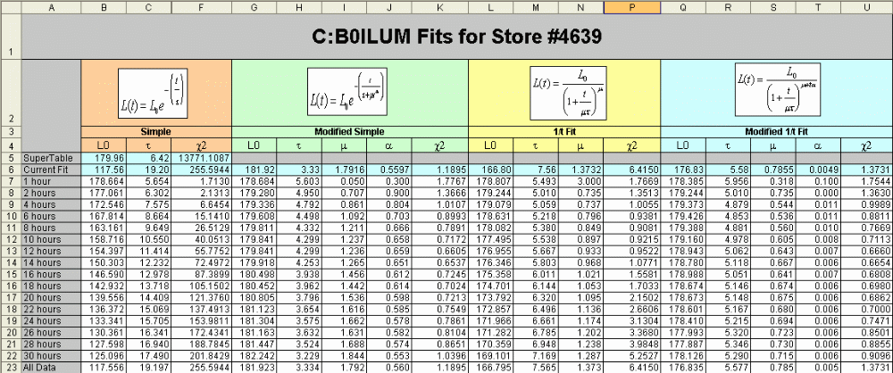
Figure 3-37: Summary of all CFD fits that were completed for Store 4639. If we chose not to complete certain fits for that store, those cells will be empty.

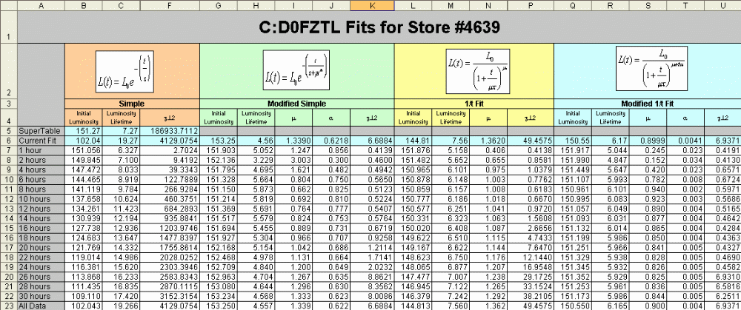
Figure 3-38: Summary of all D0 fits that were completed for Store 4639. If we chose not to complete certain fits for that store, those cells will be empty.

Figures 3-31 and 3-32 are summary spreadsheets that contain all of the fit model constants and χ² values at each time slice. Each row represents a different slice in time. For example, if we fit the store with 2 hours of lumberjack data, those fit values would be copied into row 8 of the spreadsheet. Row 6 is a mirror of whatever the current fit is on “FitNumbers” workbook. Row 23 is for all store data after the store has been completed.

Fits over time

If data is fit over multiple time slices, it may be worthwhile to be able to plot the data for each of the fits over time to see how the predicted luminosity curves change over time. This could help us answer the following question? After how many hours of lumberjack data would we expect to be able to make an accurate prediction of the luminosity value at the end of the store?

To add this functionality an additional workbook for each Tevatron luminosity model was added. The new workbooks take all of the values for that fit from the “CDF_Results” and “D0_Results” workbooks and create time/luminosity pairs for plotting. In this case the times are constructed from 0 to 40 hours at 0.05 hour increments. Figures 33 through 36 show the workbooks for our four luminosity models outlined in Equations (1) through (4).

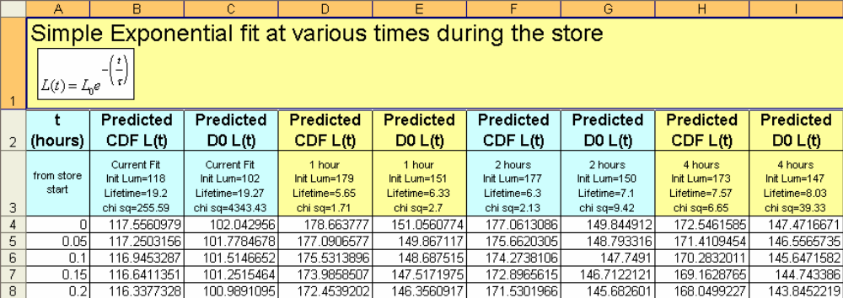
Figure 3-39: Time/Luminosity pairs from 0 to 40 hours based on the Equation (1) simple exponential fit values obtained by running the data fitting scripts in this spreadsheet. Parameters for the luminosity equation are take from the “CDF_Results” and “D0_Results” workbooks.

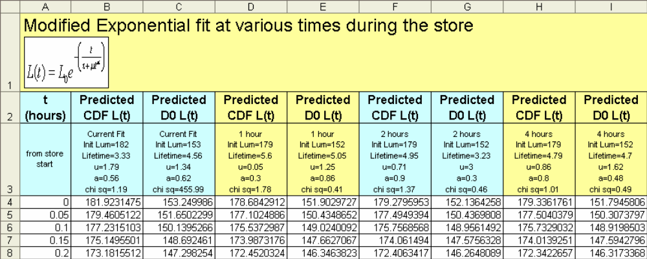
Figure 3-40: Time/Luminosity pairs from 0 to 40 hours based on the Equation (2) modified simple exponential fit values obtained by running the data fitting scripts in this spreadsheet. Parameters for the luminosity equation are take from the “CDF_Results” and “D0_Results” workbooks.

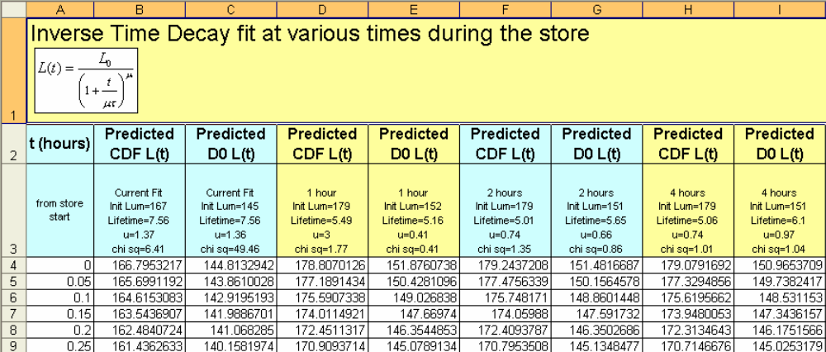
Figure 3-41: Time/Luminosity pairs from 0 to 40 hours based on the Equation (3)time decay fit values obtained by running the data fitting scripts in this spreadsheet. Parameters for the luminosity equation are take from the “CDF_Results” and “D0_Results” workbooks.

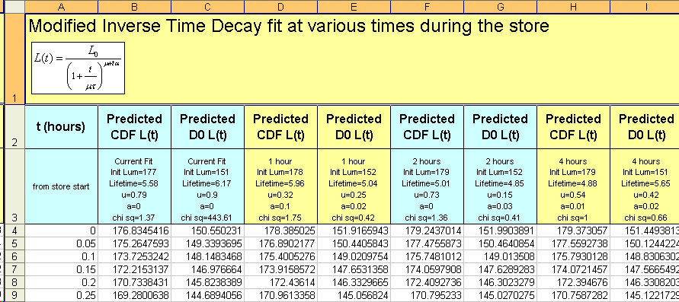
Figure 3-42: Time/Luminosity pairs from 0 to 40 hours based on the Equation (4) modified time decay fit values obtained by running the data fitting scripts in this spreadsheet. Parameters for the luminosity equation are take from the “CDF_Results” and “D0_Results” workbooks.

Plots

We generate two different types of plots for each of our luminosity models. The first set of plots show the current store data and the current fits. The second set of data shows how the fit equations change over time. Both types of plots will be shown in the data results section below.

VBA Scripts

We have discussed all of the major internals of the Luminosity Predictor spreadsheet. There are portions of the spreadsheet that are complex. The goal is to make the analysis of the data as streamlined as possible, with as little user interaction as possible. To complete this goal, all data analysis occurs by running three VBA Scripts launched through interactive buttons in the “InputData” workbook. Below is an explanation of each of these VBA scripts.

Clear All Data Script (Ctrl-Shift-C)

If we are switching our analysis from one store to another store, we want to clear out any old data from other store before we begin. The Clear All Data script completes this task and is launched by clicking on the “Clear Out the Old Data” button in the “InputData” workbook, or by pressing the keyboard shortcut Ctrl-Shift-C. This script completes the following steps:
- Clears out all entries in the “CDF_Results” and “D0_Results” workbooks. We are starting over!
- Enters an initial guesses in the “FitNumbers” Workbook for each of constants for each of the models. The SuperTable II initial luminosity and luminosity lifetimes are used as the initial guess for those values in each of the fits.

Since this script uses the SuperTable II data, we want to be sure to have completed the steps outlined in Section 3.c.i before running this script.

Analyze the Data Script (Ctrl-Shift-A)

All of the data analysis occurs with the Analyze Data Script, which is launched by pressing the “Analyze the Data” button in the “InputData” workbook, or by pressing the keyboard shortcut Ctrl-Shift-A. The spreadsheet completes the following tasks.

- Prompts the user with a message box asking how many hours of data to analyze.
  - Choices include 1, 2, 4, 6, 8, 10, 12, 14, 16, 18, 20, 22, 24, 26, 28 or 30 hours. This option cuts the lumberjack data to the number of hours that you specify.
  - We can also select all available data, which will make the fit with the entire contents of the lumberjack file. When analyzing a store that is in progress, this will be the most likely option.
  - We can also select all data over all times. This option is intended to analyze a store after the fact. It loops through all data fits at every available time slice. Warning, this option normally takes on the order of 8 hours to complete.
- Next the user is prompted for which luminosity model to make the fit. Options include the Equation (1) simple exponential fit, the Equation (2) modified exponential fit, the Equation (3) time decay fit, the Equation (4) modified time decay fit, or all four fits. It normally takes on the order of 5 minutes to complete the fit on a single luminosity model for a single time slice and on the order of 20 minutes to complete the fit for all luminosity models for a single time slice.
- Based on the user input, the desired χ² calculations from the “ErrorSums” workbook are copied to the “FitNumbers” workbook.
- Based on the user input, the desired fits are completed for the selected luminosity models over the selected slice in time. This is completed by using the Excel Solver to minimize our χ² calculations by changing the model parameters in the “FitNumbers” workbook.
- The results of any data fit(s) completed are then copied over to the “CDF_Results” and “D0_Results” workbooks.

We can now examine our plots and re-run the script to analyze more data from this store. When using this script to look at a store that is still in progress, we periodically update our lumberjack data file with the latest data and re-run the analysis until we have enough lumberjack data to be confident of our fit.

Archive (Write) the Data Script (Ctrl-Shift-W)

Once we have completed analysis on one store, we will want to save this data away before we move on to analyzing the next store. The Archive the Data Script completes this task and is called by pressing the “Archive the Data” button in the “InputData” workbook, or by pressing the Ctrl-Shift-W keyboard shortcut. This script does the following:
- Archive the store data in a file dedicated to the current store.
  - Copies the “values” of each cell in each workbook of the Luminosity Predictor spreadsheet to the template store-fit-data.xls.
  - Saves the file as store####-fit-data.xls (where #### is the store number).
- Copy the end of store results to a spreadsheet containing the end of store results for all stores.
  - Opens the file store-fit-summary.xls.
  - Creates a new row.
  - Copies the end of store fit data from the “CDF_Results” and “D0_Results” workbooks into the newly created row.
  - Saves and closes the file.

Archive Data Files

When we archive our data set via or VBA script, we write to two Excel files. We will briefly mention the function of both files..

Individual store{####}-fit-data.xls files

We archive each set of store data in a spreadsheet named store{####}-fit-data.xls. The “value” of each cell from each workbook from the Luminosity Predictor spreadsheet is copied here. The workbook names mirror that of the Luminosity Predictor spreadsheet. The only difference is that we only copy the “values” of the cells. This means the equations and references are not copied, just the results. This allows us to remove the VBA scripts from our archive file and reduce the file size down from 50MB to 12MB. In addition, by removing the calculations, the spreadsheet opens must faster. The plots are left in place so that they can be easily examined later on.

If we want to backtrack and reanalyze the data for this store, or analyze it with more time slices, we can do so fairly easily. The “InputData” workbook of the Luminosity Predictor spreadsheet has an “Import Data From Previously Analyzed Store” button that calls a VBA script to open the archived in store####-fit-data.xls file and copy the “CDF_Results” and “D0_Results” workbook data into the same workbooks in Luminosity-Predictor.xls. The Luminosity Predictor is then ready to go.

Store-fit-summary.xls file

We want to examine results across multiple stores, so there is also a store-fit-summary.xls spreadsheet. Each row in this spreadsheet contains the results from one store. The end of store fit numbers for both CDF and D0 using all four Tevatron luminosity models are included in this file. We can use this spreadsheet to plot store data from multiple stores.

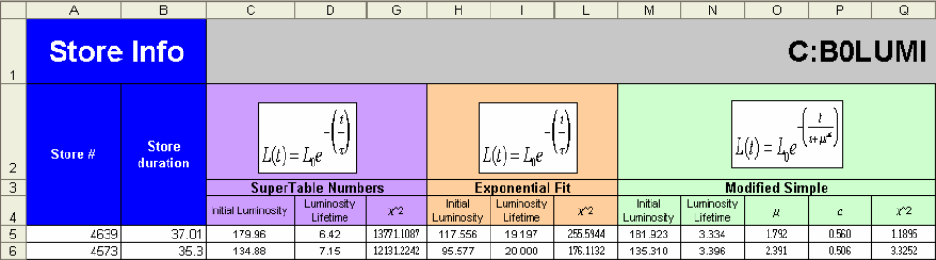
Figure 3-43: The summary spreadsheet that contains our fit data for our four luminosity models. Not all columns are displayed due to lack of space.

In addition, this spreadsheet has plots that allow us to compare how the model constants change with datalogger time sample size across multiple stores.

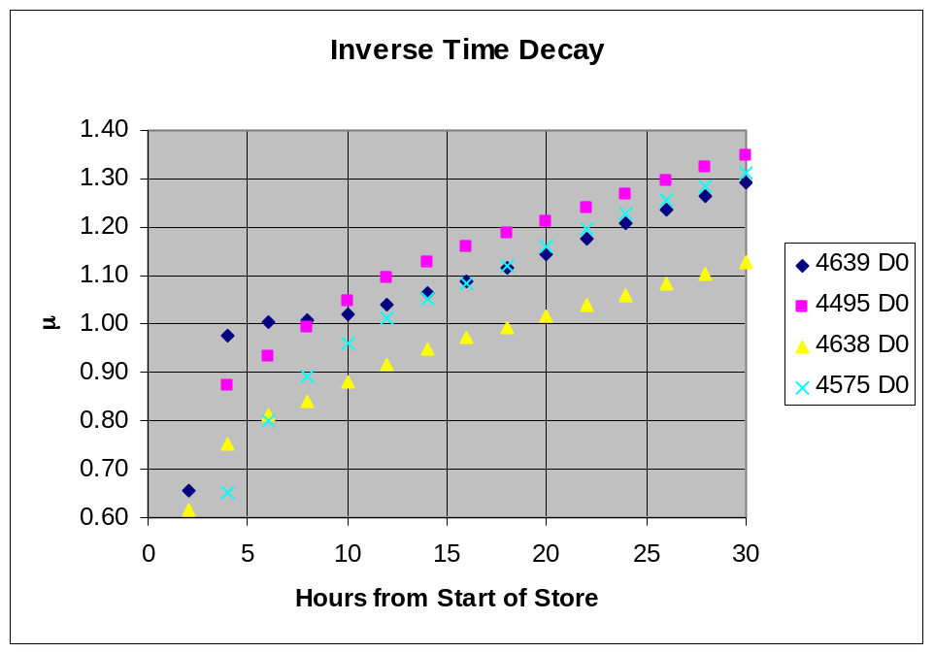
Figure 3-44

Figure 3-38 shows number of hours of luminosity data to fit on the x-axis and the constant μ from Equation (3) on the y-axis. We see that across multiple stores, the behavior of the fit for this parameter is consistent.

How luminosity fits improve over time

This section graphically shows how the predictions from each of luminosity models given by Equations (1) – (4) fairs over with different amounts of available lumberjack data. I took the first hour of lumberjack luminosity data, and used the Luminosity Predictor to make a predicted luminosity curve for the store. I then repeated with the first two, four, six, …, twenty-eight, and thirty hours of lumberjack luminosity data. I then plotted each of the predictions as well as the complete set of lumberjack luminosity data. The intent is to see how well the predicted curves follow the actual lumberjack data, and to see how well our predictions improve with an increased amount lumberjack data.

One might expect that the luminosity prediction for a store after only having the first hour of lumberjack luminosity data would not be as precise as a luminosity prediction made with multiple hours of Lumberjack data. If a Tevatron Luminosity Model equation is an accurate representation of luminosity, we would expect the fits to get better and better with more luminosity data, and we would expect be able to make a very good fit once we have all of the lumberjack luminosity data from the store. If we are to use the Luminosity Predictor to predict our luminosity behavior during a store, it would be worthwhile to understand how many hours of store data are needed to make a reasonable prediction of the end of store luminosity..

Again, I used Store 4639 for the plots. Other stores showed similar results.

Simple Exponential Fit (Equation 1)

The Simple exponential fit proves not be a good predictor of the luminosity behavior. Figure 4.1 shows the CDF lumberjack data for the entire store (thick blue line) and each of the predicted luminosity curves.

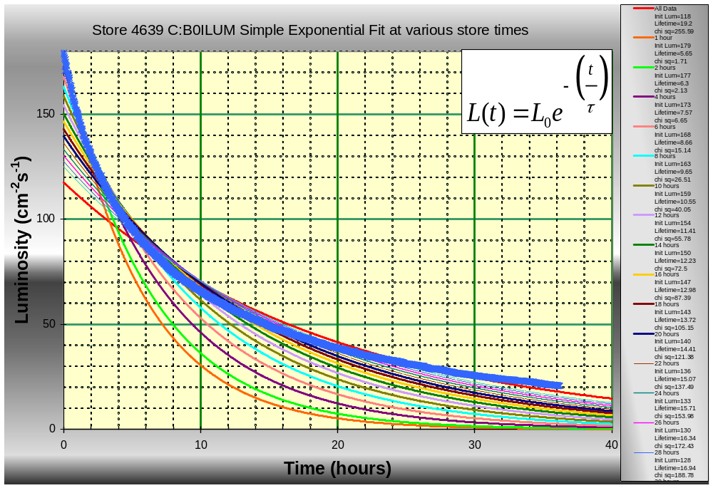
Figure 4-45: Simple Exponential fit of CDF Luminosity data for store 4639 taken with varying samples of lumberjack data.

It is clear that the fits never match store data.

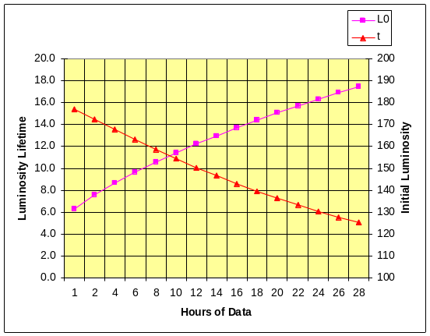 | 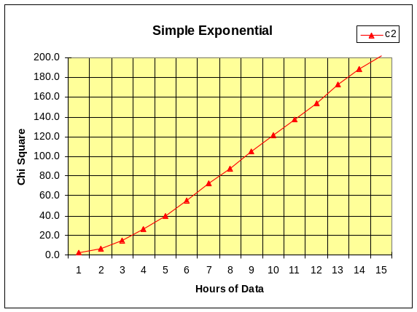
CDF Initial Luminosity and Lifetime | Chi Square
Figure 4-46: These plots show how the Simple Exponential fit (Equation 1) predictions change over the number of hours of lumberjack luminosity data used to make the prediction. We are looking at the CDF data for Store 4639. The x-axis in both plots is the number of hours of luminosity data from the lumberjack ( 1= first hour of data, 2= first two hours of data, etc…). The plot on the left shows the Initial Luminosity and Luminosity Lifetime for each sample of luminosity data. The plot on the right shows the chi square value for those fits.

Figure 4-2 shows how the two constants in our fit change as we increase the amount of Lumberjack luminosity data. We see that neither of our constants reaches a stable value and the chi square value gets larger as you increase the amount of lumberjack data. In fact the chi square value exceeds 200.0 when fitting 30 hours of luminosity data. This shows that the simple luminosity fit (Equation 1) is not a good model for our luminosity behavior. The results for the D0 Luminosity fits showed similar results.

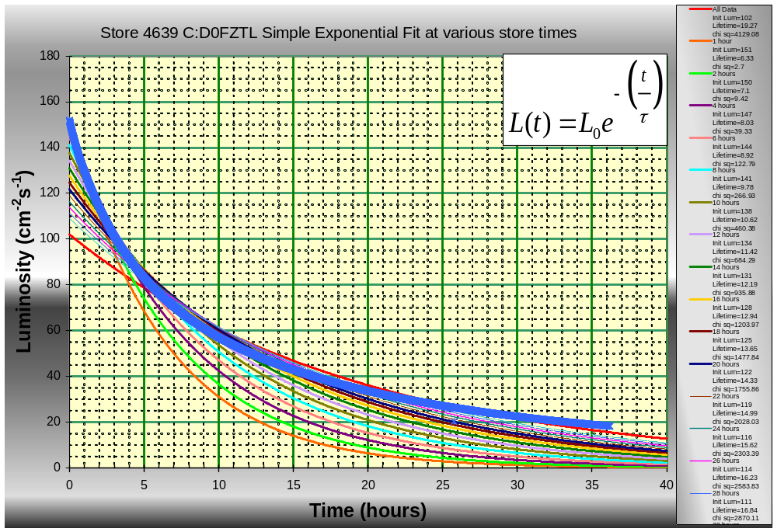
Figure 4-47

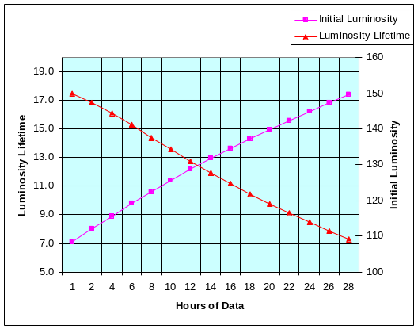 | 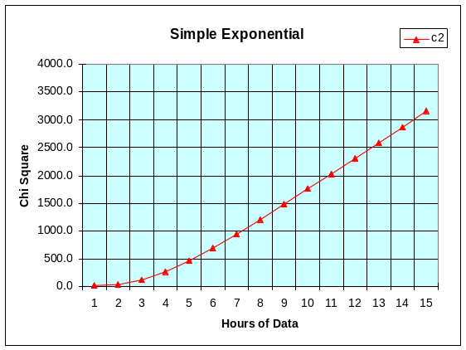
D0 Initial Luminosity and Lifetime | Chi Square
Figure 4-48

Modified Exponential Fit (Equation 2)

The modified exponential fit proves to be a very good predictor of the luminosity behavior. Figure 4.5 shows the CDF lumberjack data for the entire store (thick blue line) and each of the predicted luminosity curves.

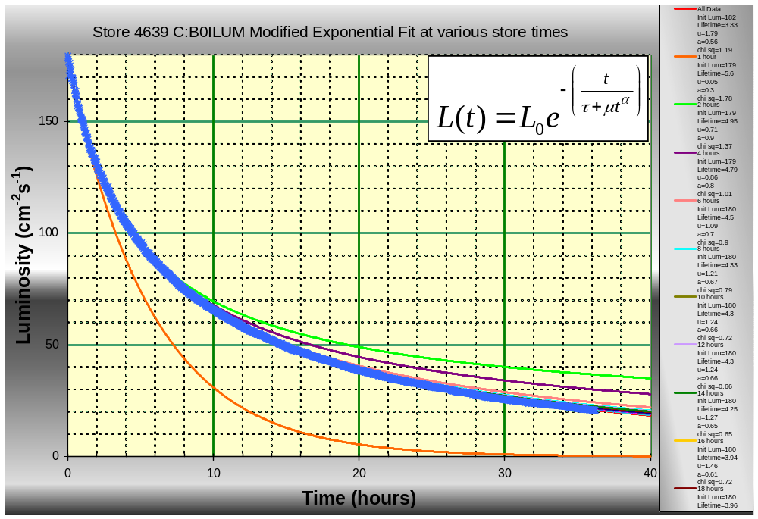
Figure 4-49: Modified Exponential fit at various times in the store.

A

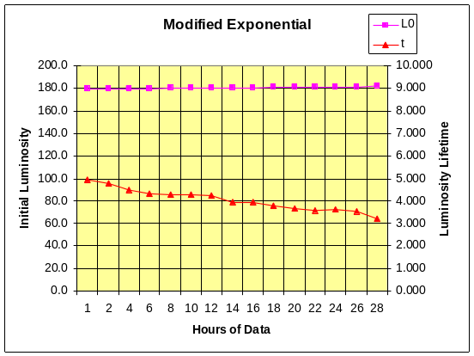 | 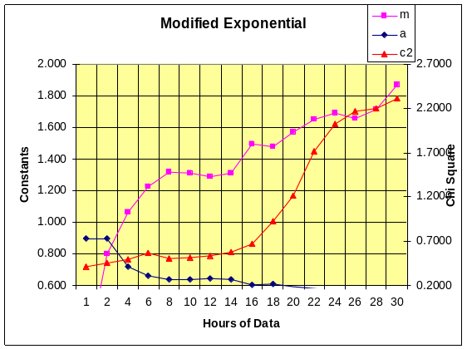
CDF Initial Luminosity and Lifetime | Constants and Chi Square
Figure 4-50

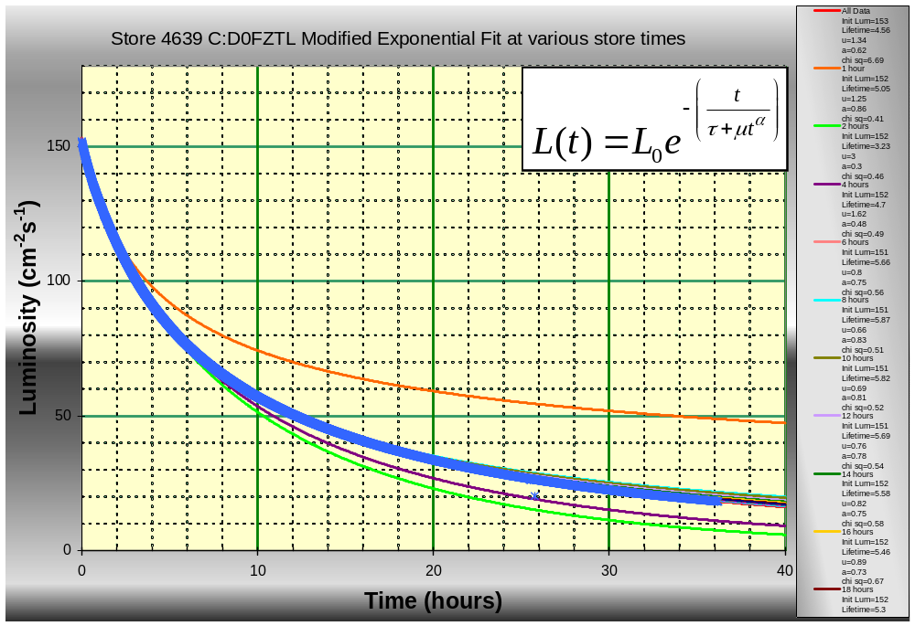
Figure 4-51

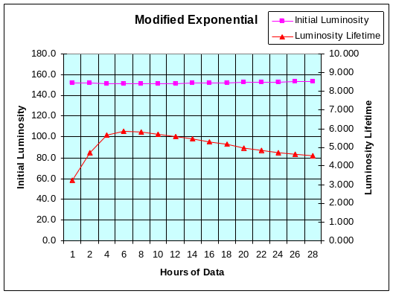 | 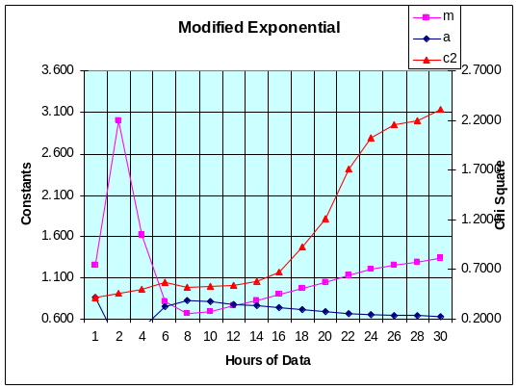
D0 Initial Luminosity and Lifetime | Constants and Chi Square
Figure 4-52

Inverse Time to Power Fit (Equation 3)

The inverse time to power fit proves to be a good predictor of the luminosity behavior. Figure 4.9 shows the CDF lumberjack data for the entire store (thick blue line) and each of the predicted luminosity curves.

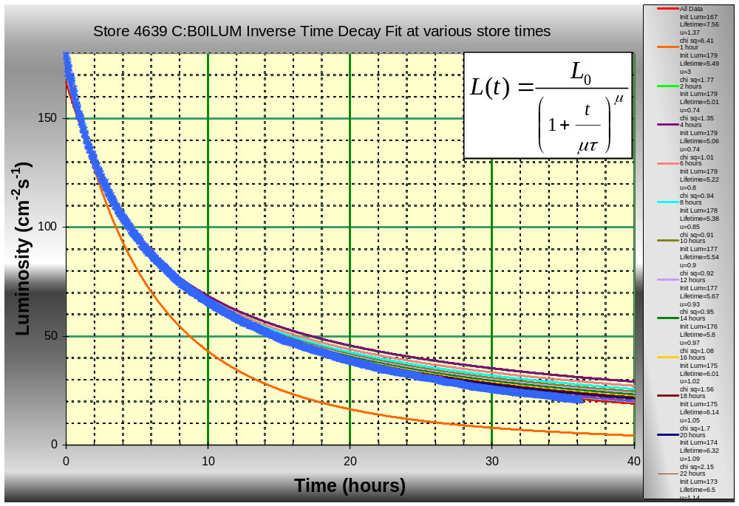
Figure 4-53: Time Decay fit at various times in the store.

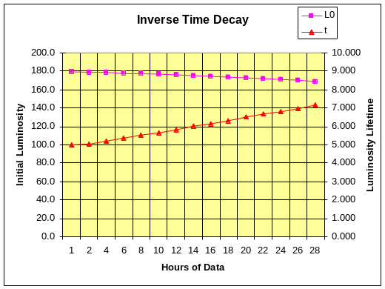 | 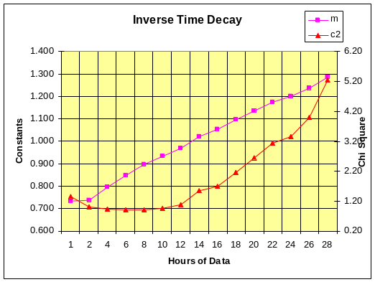
CDF Initial Luminosity and Lifetime | Constants and Chi Square
Figure 4-54

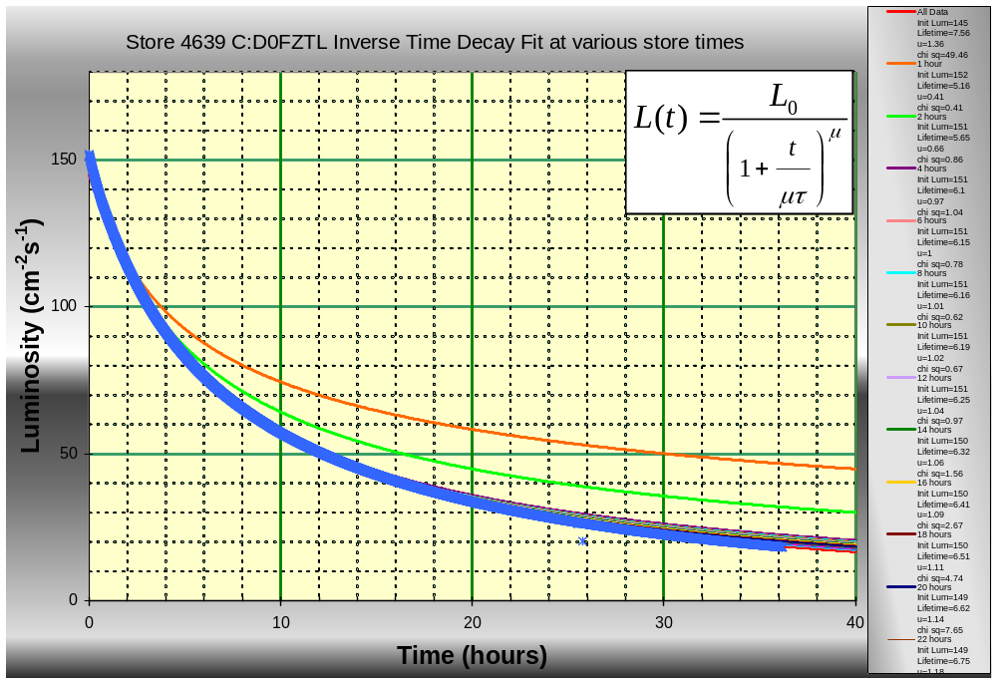
Figure 4-55

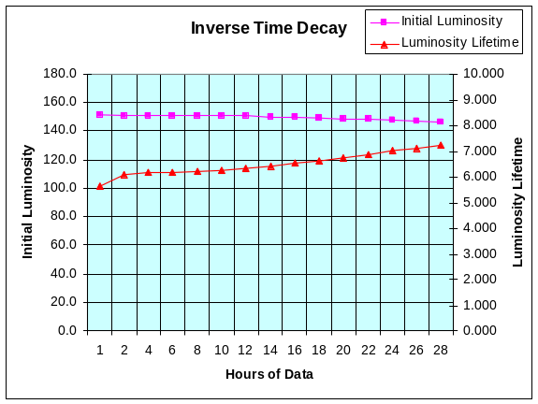 | 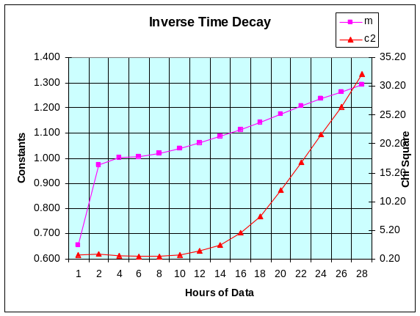
D0 Initial Luminosity and Lifetime | Constants and Chi Square
Figure 4-56

Modified Inverse Time to Power Fit (Equation 3)

The modified inverse time to power fit proves to be a very good predictor of the luminosity behavior. Figure 4.13 shows the CDF lumberjack data for the entire store (thick blue line) and each of the predicted luminosity curves.

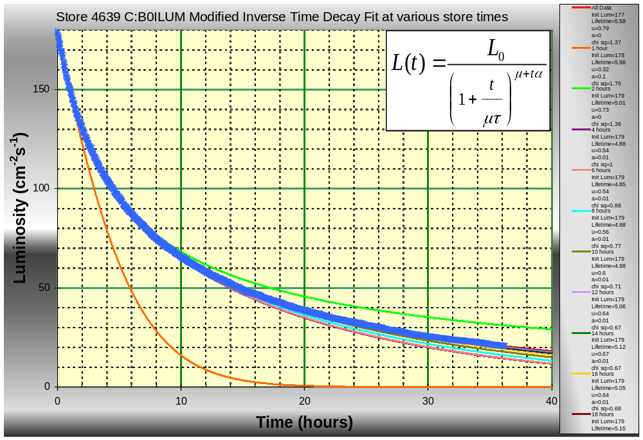
Figure 4-57: Modified Time Decay fit at various times in the store.

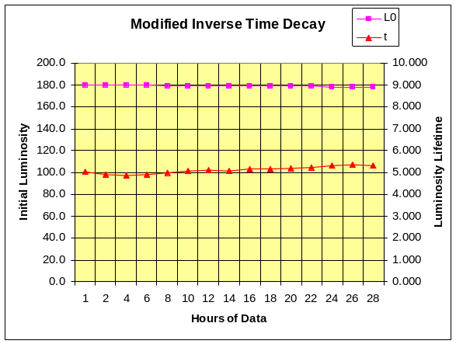 | 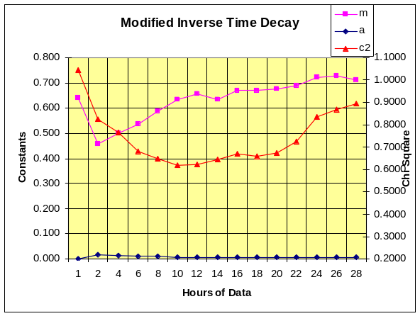
CDF Initial Luminosity and Lifetime | Constants and Chi Square
Figure 4-58

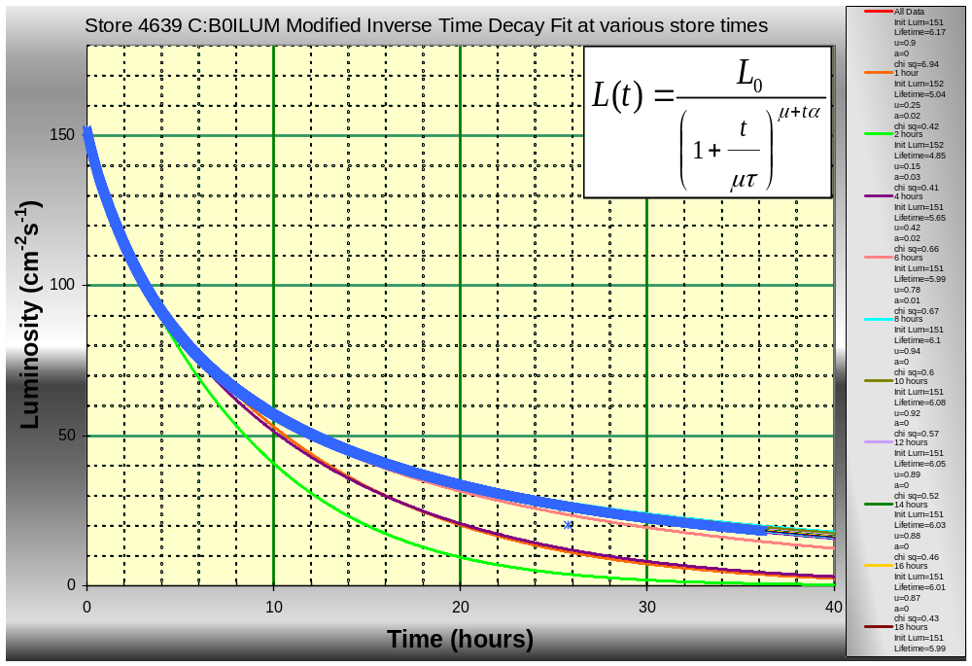
Figure 4-59

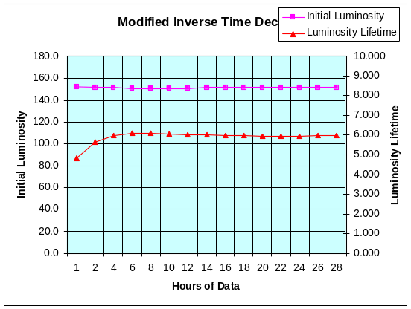 | 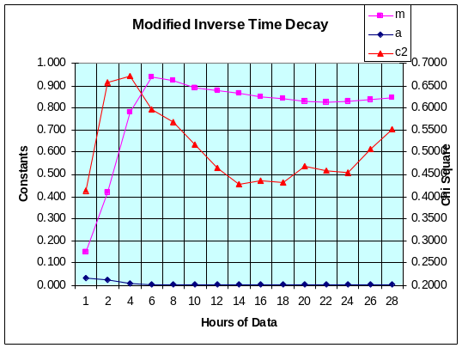
D0 Initial Luminosity and Lifetime | Constants and Chi Square

Beginning of Store

We have seen that our fit profiles change as we include more and more lumberjack data. We will again look at the data from Store 4639, but will zoom in to take a closer look at the match between the fits and our lumberjack data during the first two hours of the store.

Simple Exponential Fit (Equation 1)

The simple exponential fit proves to be a very poor predictor of the luminosity behavior. Figure aaa shows the CDF lumberjack data for the entire store (thick blue line) and each of the predicted luminosity curves.

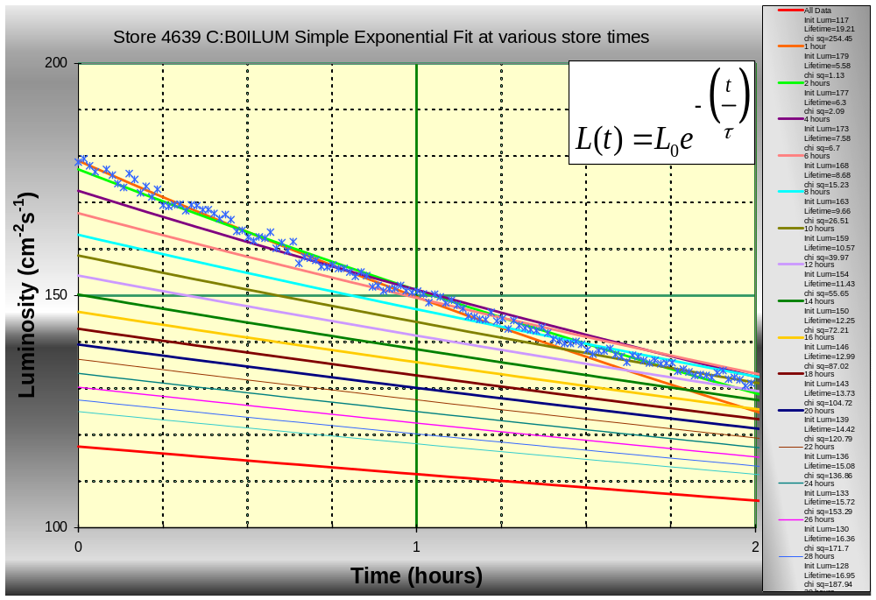
Figure 5-60

Modified Exponential Fit (Equation 2)

The modified exponential fit proves to be a very good predictor of the luminosity behavior. Figure aaa shows the CDF lumberjack data for the entire store (thick blue line) and each of the predicted luminosity curves.

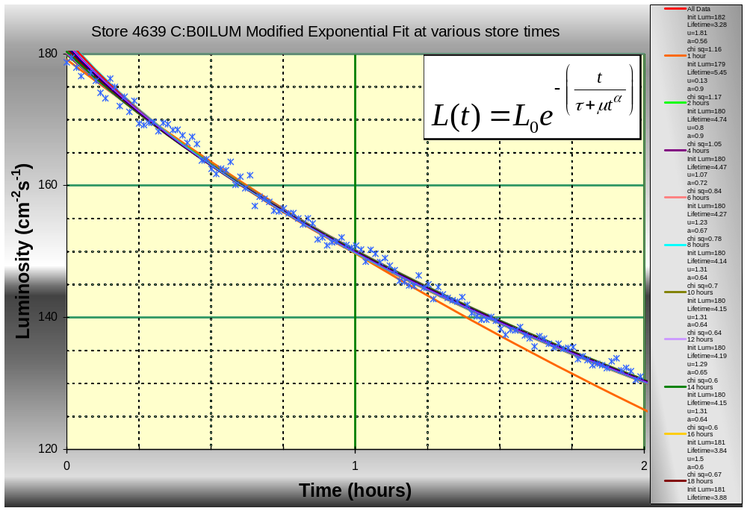
Figure 5-61

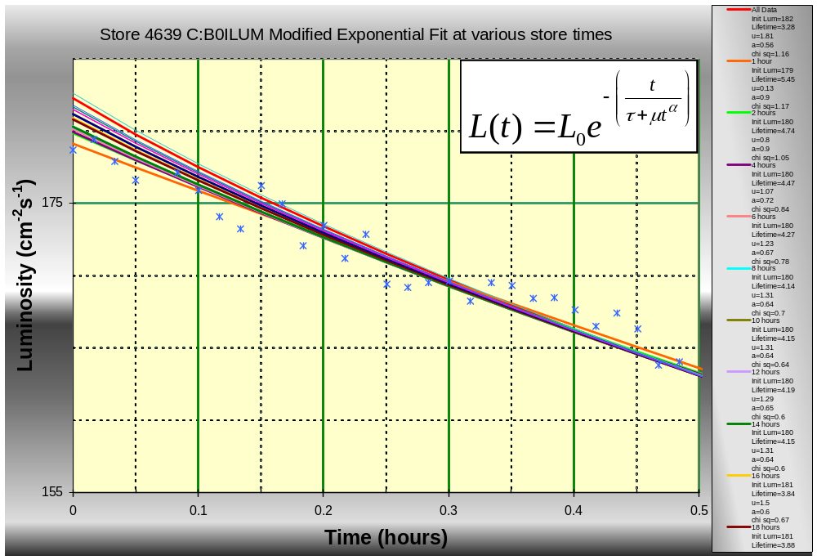

Inverse Time to Power Fit (Equation 3)

The inverse time to power fit proves to be a good predictor of the luminosity behavior. Figure aaa shows the CDF lumberjack data for the entire store (thick blue line) and each of the predicted luminosity curves.

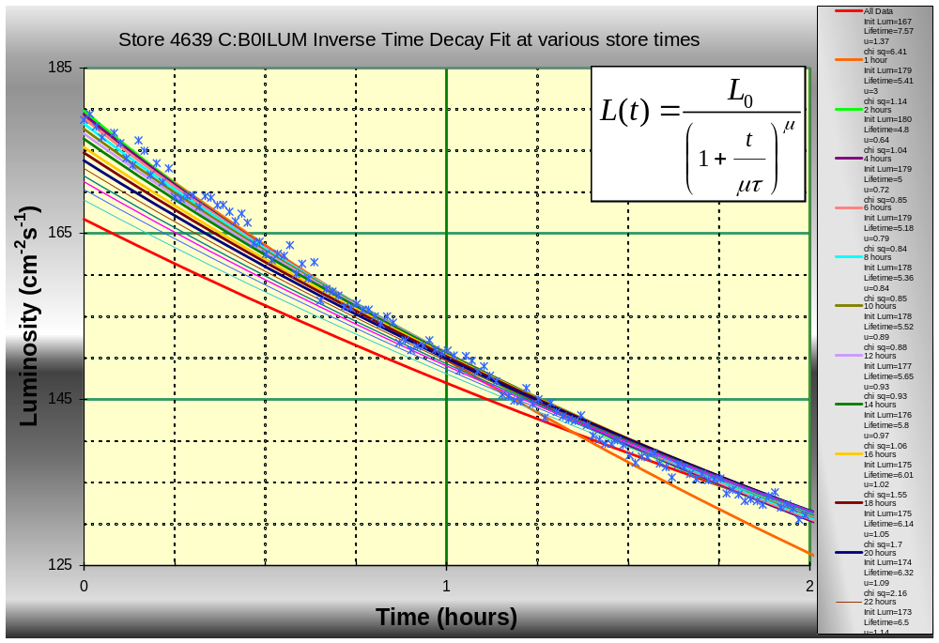
Figure 5-62

Modified Inverse Time to Power Fit (Equation 4)

The modified inverse time to power fit proves to be a good predictor of the luminosity behavior. Figure aaa shows the CDF lumberjack data for the entire store (thick blue line) and each of the predicted luminosity curves.

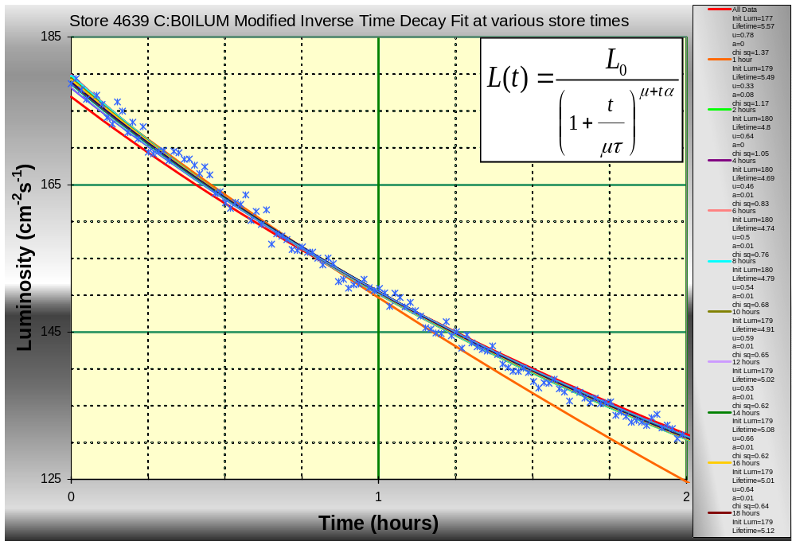
Figure 5-63

End of Store

The bottom line is we want to see how well our Luminosity models predict the end of store luminosity numbers given varying amounts of initial lumberjack data. This section examines the predictions for the last two hours of the store for each Tevatron model. Again, we use Store 4639.

Simple Exponential Fit (Equation 1)

The simple exponential fit proves to be a very poor predictor of the luminosity behavior. Figure aaa shows the CDF lumberjack data for the entire store (thick blue line) and each of the predicted luminosity curves.

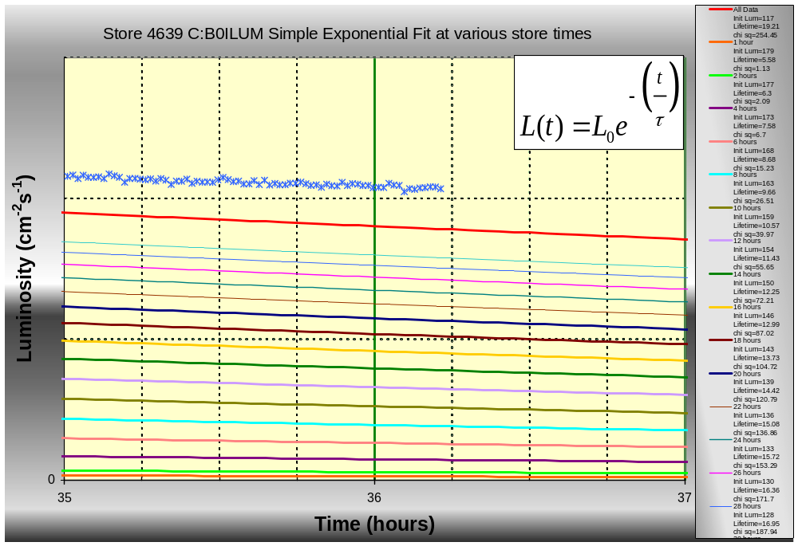
Figure 6-64

Modified Exponential Fit (Equation 2)

The modified exponential fit proves to be a very good predictor of the luminosity behavior. Figure aaa shows the CDF lumberjack data for the entire store (thick blue line) and each of the predicted luminosity curves.

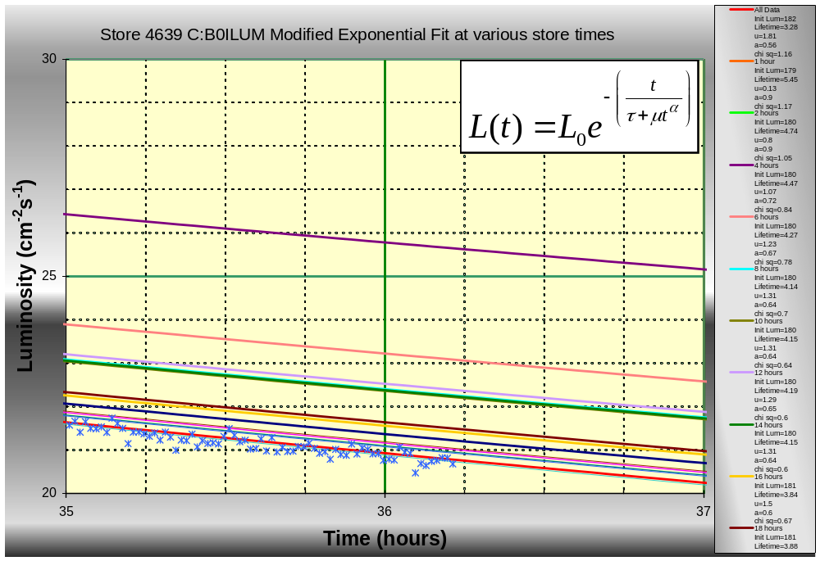
Figure 6-65

Inverse Time to Power Fit (Equation 3)

The inverse time to power fit proves to be a good predictor of the luminosity behavior. Figure aaa shows the CDF lumberjack data for the entire store (thick blue line) and each of the predicted luminosity curves.

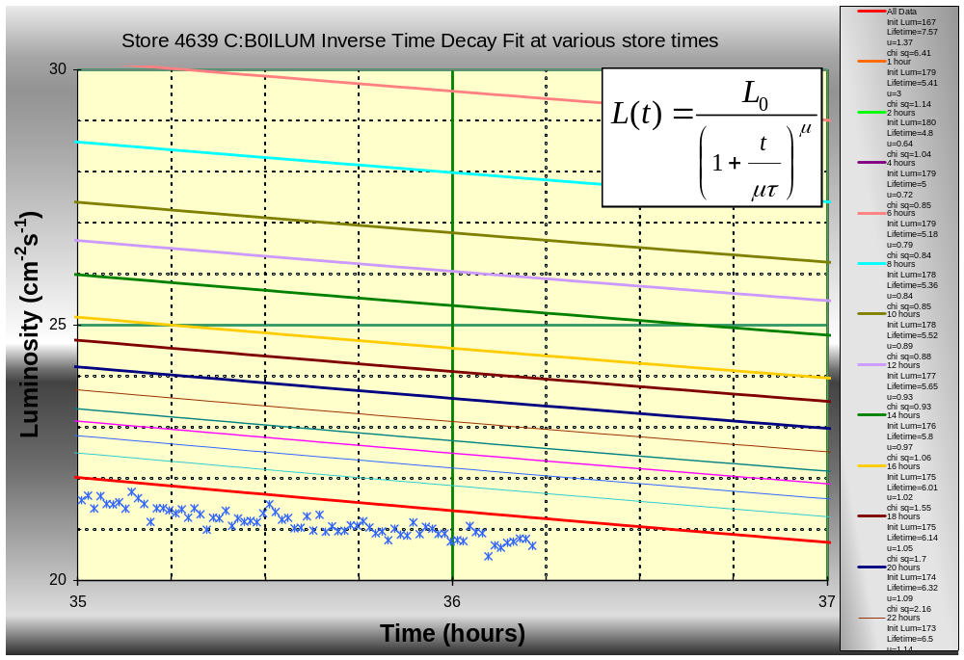
Figure 6-66

Modified Inverse Time to Power Fit (Equation 4)

The modified inverse time to power fit proves to be a good predictor of the luminosity behavior. Figure aaa shows the CDF lumberjack data for the entire store (thick blue line) and each of the predicted luminosity curves.

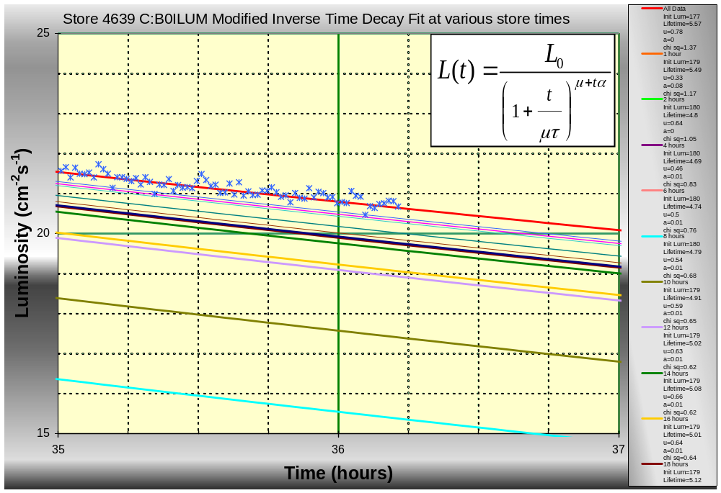
Figure 6-67

Comparing Fit Numbers for Top 5 Stores

Now that we have examined the data from Store 4639 in depth, it would be interesting to see how luminosity models change across multiple stores. For this section, plots of each of the model constants were constructed for the top 5 delivered luminosity stores (Store 4639, Store 4495, Store 4638, Store 4575, and Store 4581). In addition the complete set of fits was also run on the next five best delivered luminosity stores (Store 4574, Store 4573, Store 4473, Store 4477, and Store 4560).

Simple Exponential Fit (Equation 1)

The simple exponential fit proves to be a very poor predictor of the luminosity behavior. Figure aaa shows the CDF lumberjack data for the entire store (thick blue line) and each of the predicted luminosity curves.

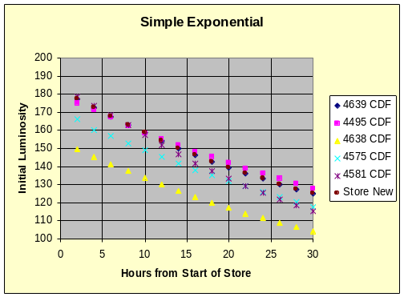 | 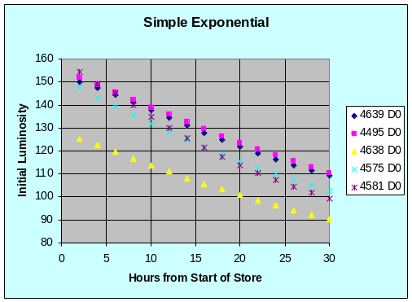
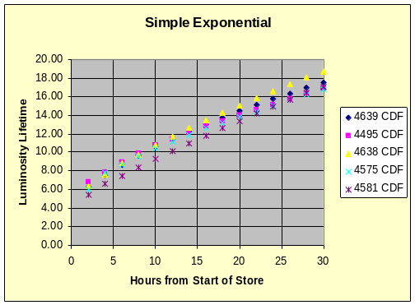 | 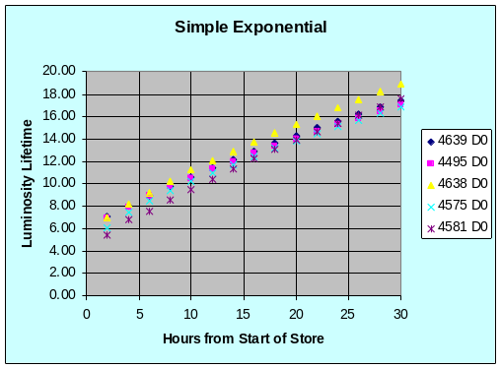
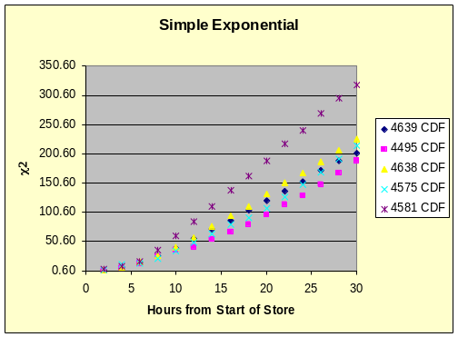 | 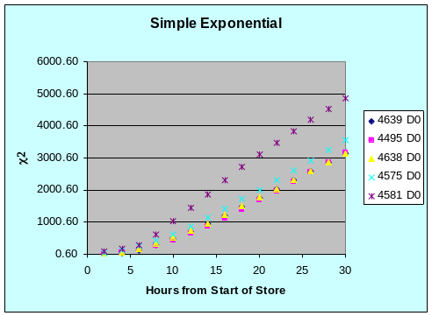
CDF | D0
Figure 7-68

Modified Exponential Fit (Equation 2)

The modified exponential fit proves to be a very good predictor of the luminosity behavior. Figure aaa shows the CDF lumberjack data for the entire store (thick blue line) and each of the predicted luminosity curves.

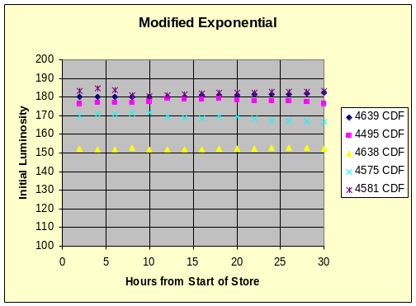 | 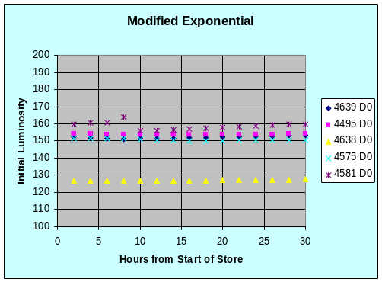
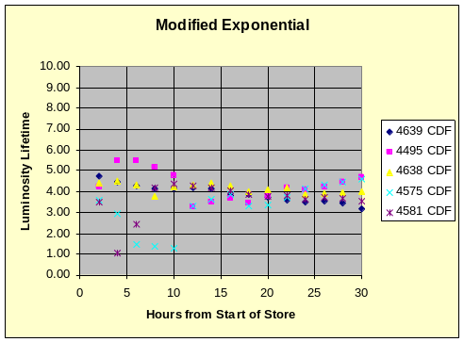 | 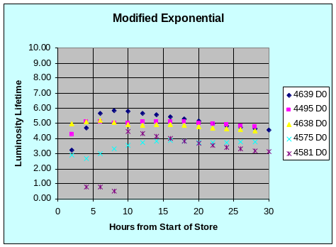
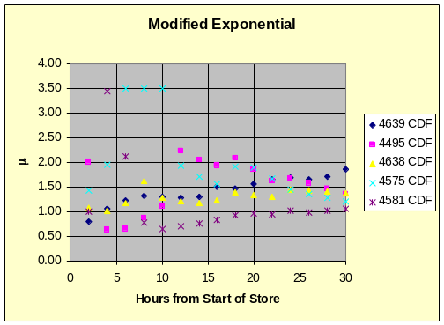 | 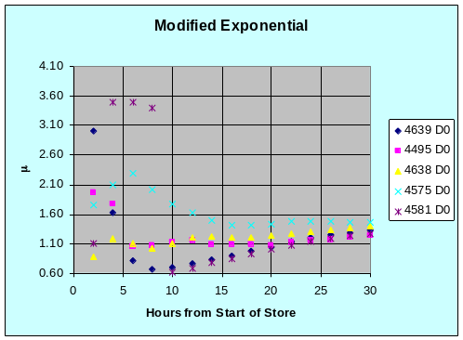
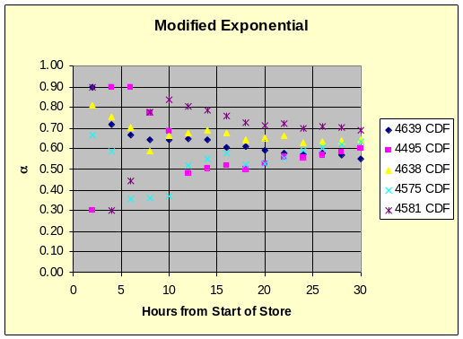 | 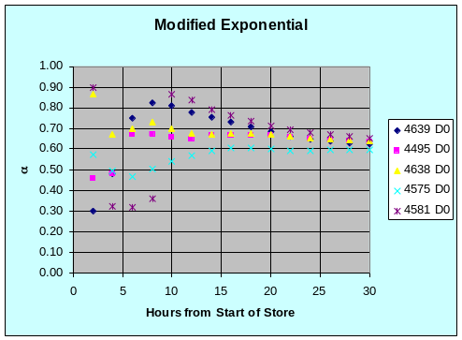
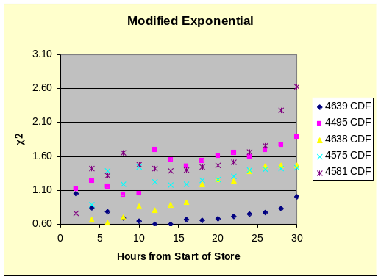 | 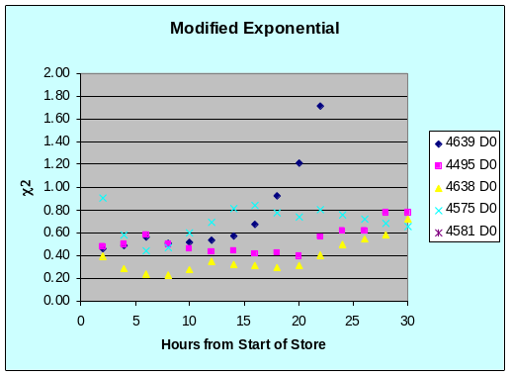
CDF | D0
Figure 7-69

Inverse Time to Power Fit (Equation 3)

The inverse time to power fit proves to be a good predictor of the luminosity behavior. Figure aaa shows the CDF lumberjack data for the entire store (thick blue line) and each of the predicted luminosity curves.

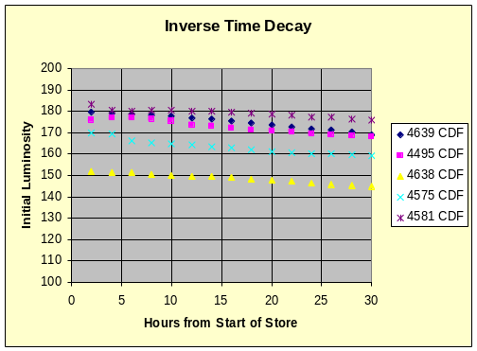 | 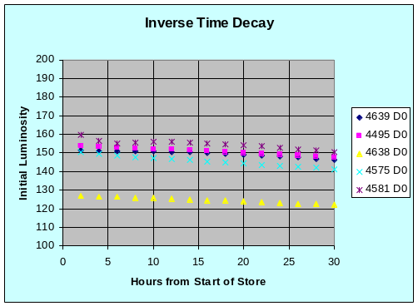
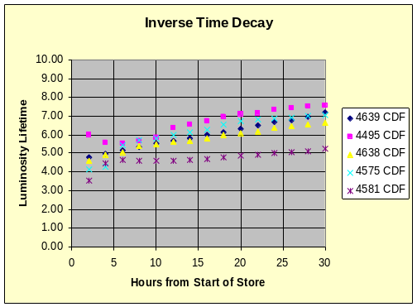 | 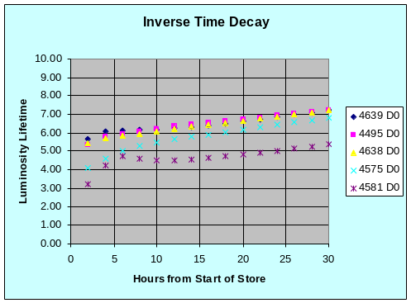
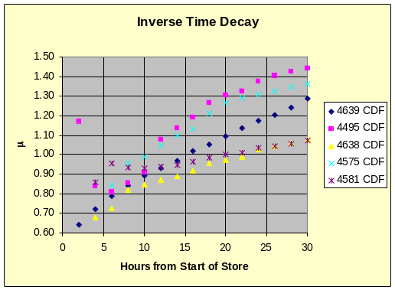 | 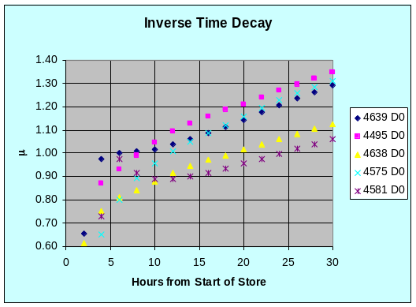
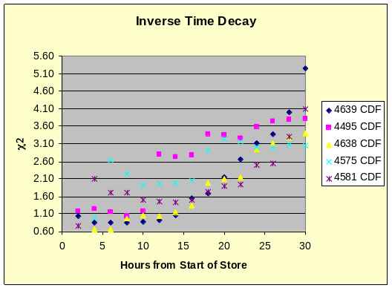 | 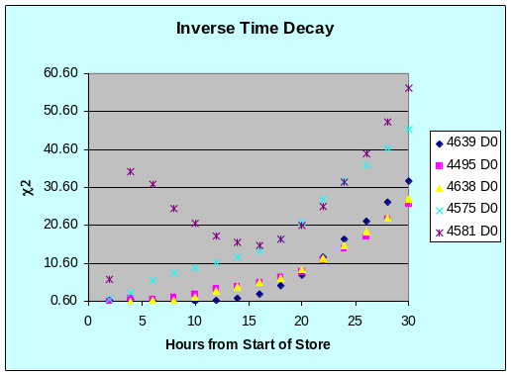
CDF | D0
Figure 7-70

Modified Inverse Time to Power Fit (Equation 4)

The modified inverse time to power fit proves to be a good predictor of the luminosity behavior. Figure aaa shows the CDF lumberjack data for the entire store (thick blue line) and each of the predicted luminosity curves.

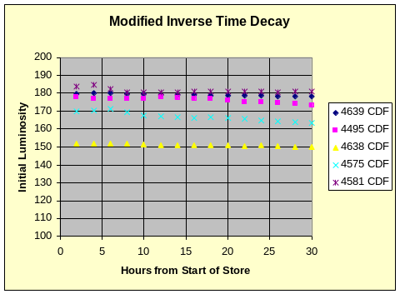 | 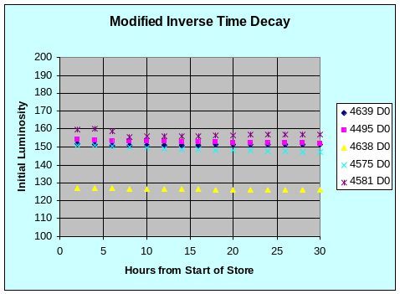
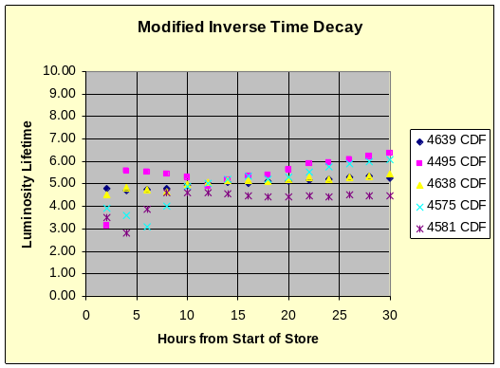 | 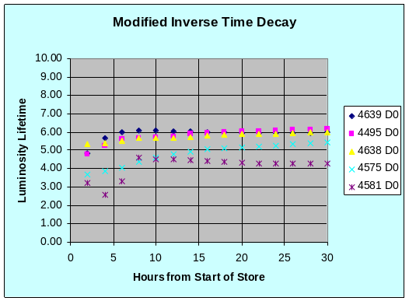
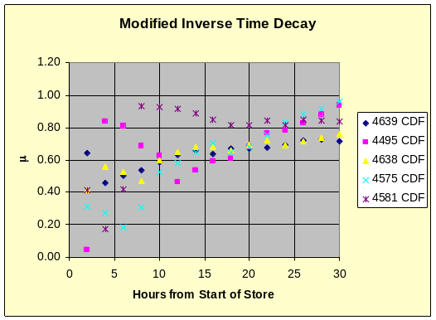 | 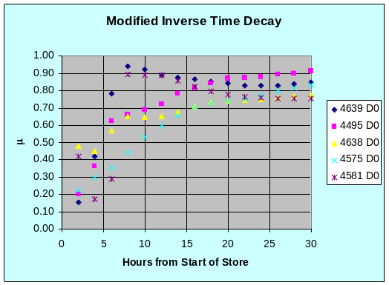
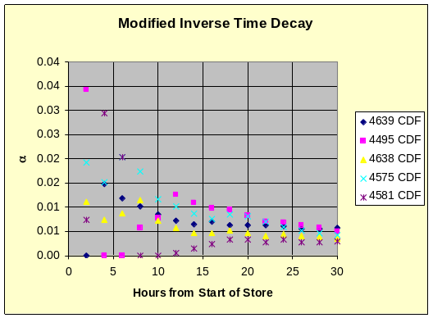 | 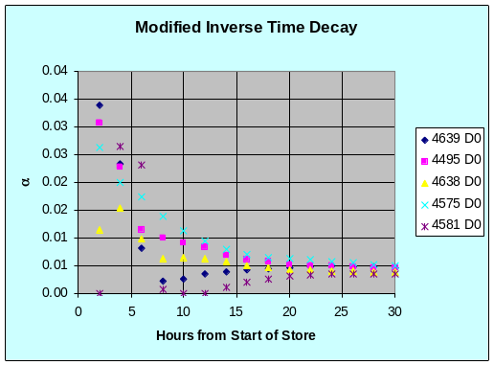
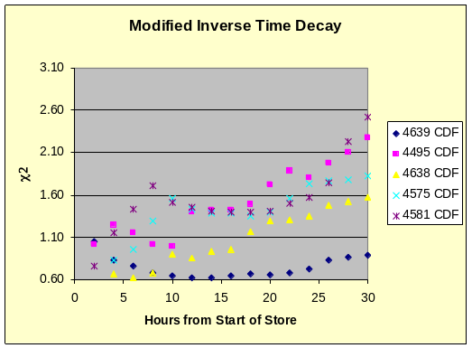 | 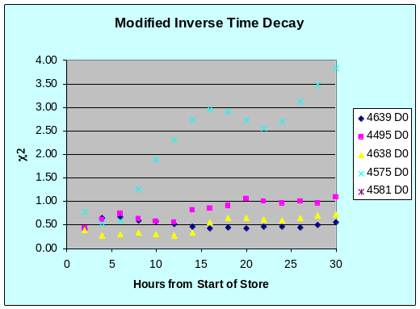
CDF | D0
Figure 7-71

Conclusions

What did we learn?

References and Useful Sources

  - McGinnis, Dave. Recycler-Only Operations Luminosity Projections. Beams Document Database #2022. <http://beamdocs.fnal.gov/cgi-bin/public/DocDB/ShowDocument?docid=2022>.
  - McCrory, Elliot. A Monte Carlo Model of the Tevatron, Beams Document Database #829. <https://beamdocs.fnal.gov/AD-private/DocDB/ShowDocument?docid=829>.
  - McCrory, Elliot. Tevatron Decay Fits. Home page. 2006. <http://mccrory.fnal.gov/tevatronDecayFits/key.html>.
  - McCrory, Elliot. Fitting the Luminosity Decay: Fits and Correlations. Beam Document Database #1305. < https://beamdocs.fnal.gov/AD-private/DocDB/ShowDocument?docid=1305>
  - Roman, Steven. Writing Excel Macros with VBA, Ed. Warren T. Reich. 4 vols. O’Reily Publishers, 2002.
  - Liengme, Bernard V. Microsoft Excel 2003 For Scientists and Engineers. Third Edition. Elsevier Butterworth Heinemann, 2004.
  - Walkenbach, John. Microsoft Excel 2000 Power Programming with VBA. Hungry Minds, Inc. 1999.

