MCP Cathode Electron Guns
V.Shiltsev, FNAL

Abstract: I propose to to use micro-channel plate (MCP) as a cathode for a electron guns. We suggest possible arrangement of MCP in the DC and RF guns and discuss possibilities of the method.

1. Introduction:

The essence of the idea is a suggestion to use MCP as a cathode of electron gun. Figure below
shows possible arrangement of the NCP for a DC and RF gun: MCP is mounted either in between usual Pierce electrodes (DC gun) or in the center of the wall of an RF gun. The cathode is illuminated from behind. Each photon hitting the MCP plate generates an avalanche of electrons resulting in about 1000 of them leaving the other surface of the cathode. Those electrons are accelerated by either DC electric field between cathode and anode and by RF electric field exited by RF generator inside 1 and a half cell RF cavity (a standard RF gun arrangement).

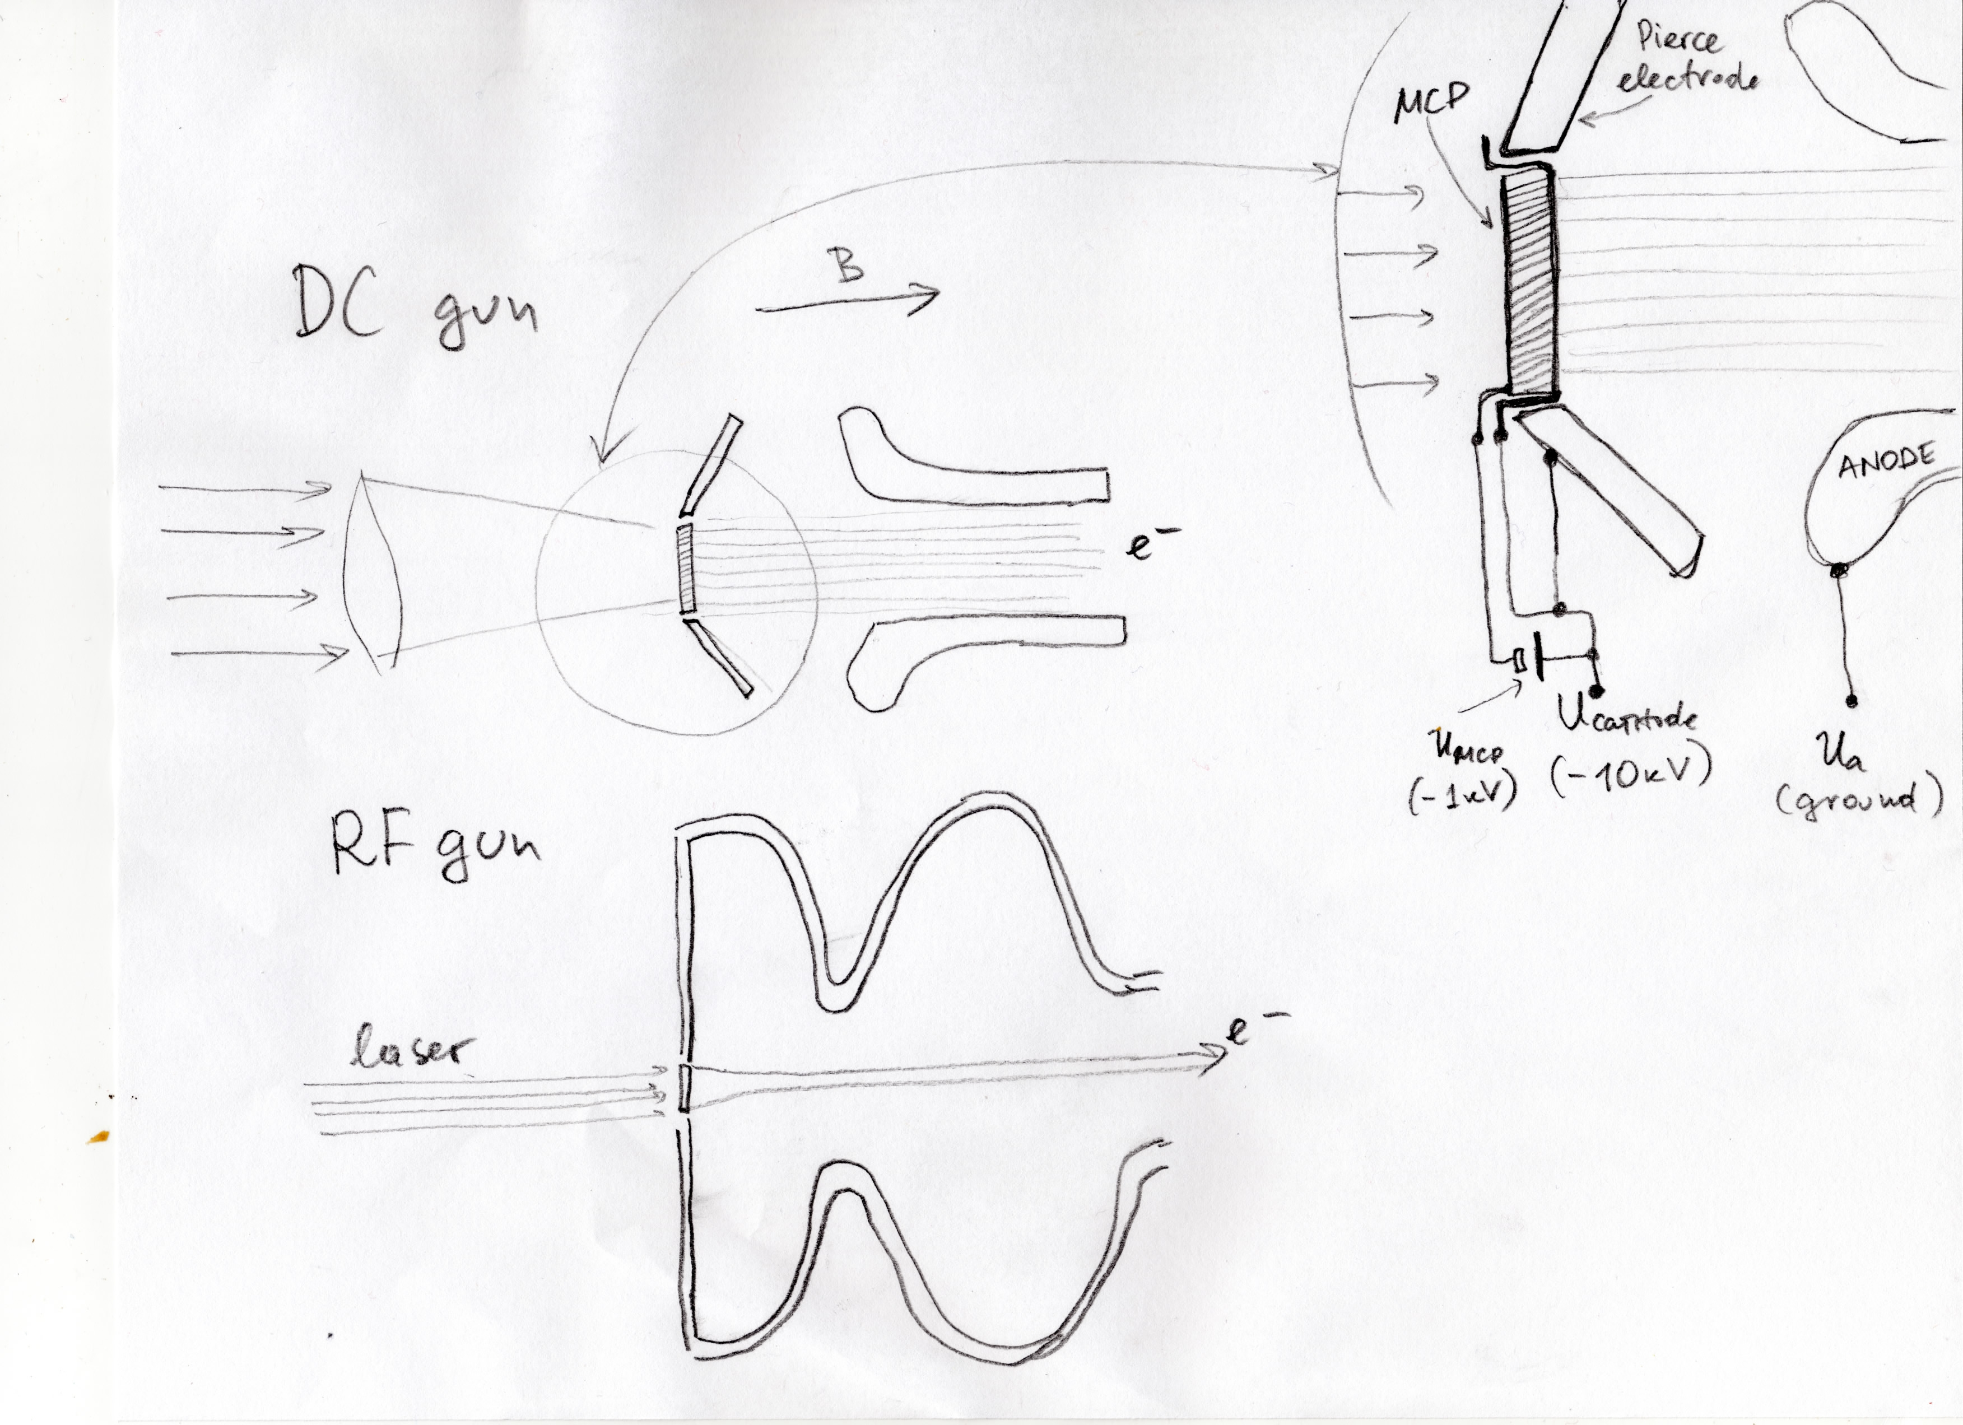

2. Advantages and issues to study:

There are a number of advantages of the MCR cathode guns in respect to commonly used ones :
- there is no need in heating filament and corresponding power supply (in DC guns)
- because of no heating, mechanical gun stability (e.g. distance from cathode to other electrodes) can be achieved much easier than in ordinary guns
- because of no heating, much better vacuum conditions should be expected in the MCP gun
- because of much lower cathode temperature, emittance of MCP gun e-beam is expected to be 4-5 times smaller than in ordinary electron guns
- short and very long pulse durations possible (for both DC and RF guns)
- quantum efficiency of MCP cathode is 10^5-10^7 times of those common type cathodes
used in RF guns (they have QE in the range from few e-4 to few %
- because of that, a ultra low (wrt to common scheme) laser power is required
- that opens possibilities to reduce laser pulse power amplitude stability (lower power pulse are though to be much easier to stabilize than high power ones)
- the feature of the MCP when the plate is illuminated from behind is extremely
attractive as it greatly simplifies optical system delivering light to the cathode (in ordinary schemes, the laser beam should inconveniently go thru the RF cell openings)
- it is believed that MCP guns can allow higher degree of polarization than ordinary ones (of coarse, MCP should be made of material like GaAs or like, and advantage is multiple interaction of electrons with microchannel plate surface).

I believe that an experimental study of the MCP cathode DC gun should be and could be started quickly to answer most intriguing questions like:
a) maximum charge and current MCP is capable to deliver (thought to be in the range from few nC to m.b. microC and more)
b) dilution of the laser pulse or front due to traveling of electrons thru the microchannels
c) MCP lifetime vs current/charge emitted
d) technological issues (mounting, laser windows, etc)

