fFermilab Doc Number: Beams-doc-2881
Version: 2
Type: Note

Main Injector Collimation System Hardware

Bruce C. Brown

Main Injector Department
Fermi National Accelerator Laboratory*
P.O. Box 500
Batavia, Illinois 60510
18 April 2008

*Operated by the Fermi Research Alliance under contract with the U.S. Department of Energy

Abstract
A collimation system for the Main Injector is described. It employs a primary-secondary collimation concept to localize the radiation induced by beam which fails to be captured and accelerated on Main Injector cycles which employ slip stacking. A primary collimator on the radial inside at MI230 imposes a momentum aperture which scatters beam which has not been sufficiently accelerated as the magnet ramp begins. A series of secondary collimators and masks localizes the beam loss and resulting radiation in order to reduce the activation of and radiation damage to accelerator components and to minimize residual radiation. The hardware system is described and references are provided to the design calculations.

I. Introduction
The Main Injector/Recycler installation employed almost all available straight sections so the requirement to place beam collimation systems in the existing tunnel has required compromises. A primary-secondary collimator system [1],[2] which is optimized for capturing the beam losses from slip-stacking injection/acceleration [3] and the associated secondary radiation has been designed [4], [5] and implemented. It employs a primary collimator to scatter lost beam, four 20-Ton secondary collimators (COL20T) in which most lost beam interacts, a polyethylene mask (PM) upstream of the collimator as a neutron absorber with nearby steel and concrete masks (STCM), steel and marble masks (STMM) upstream of the next accelerator components, a concrete wall upstream of Q305 to reduce neutron and other particle fluxes in the ECOOL area and marble or polyethylene/sand shielding bags to locally reduce radiation damage. The engineering aspects of the secondary collimators are described in [6].

II. Design Concepts

Primary Collimation

The uncaptured 8 GeV beam will not be accelerated, causing it to move on successively lower (relative) momenta orbits. It will reach the momentum aperture defined by the dispersion of about 1.7 m and the radial placement of the primary collimator which is located downstream of Q230. The beam which strikes this 0.25 mm (10 mil) W scattering foil will mostly be lost before the end of the MI300 straight section. If it is not lost there, it has a high probability of traversing several additional turns and again striking the primary collimator as it reaches a suitable betatron phase on a subsequent turn.

Secondary Collimation
At four locations in the MI300 straight section, collimation systems are constructed to capture the scattered 8 GeV beam and allow it to interact inside a massive steel shield. Each 20-Ton collimator has a 2" high by 4" wide aperture (nearly the size of other MI components) but can be precisely positioned off center to optimize the capture of scattered beam particles. The resulting hadronic shower will be mostly contained within the collimator but low energy neutrons are produced which propagate both upstream and downstream. A polyethylene mask (PM) placed upstream of the 20-Ton collimator substantially reduces the neutron flux in the coil of the upstream quadrupole.

Immediately downstream of the 20-Ton collimators are masks consisting of iron stacked adjacent to the beam pipe and surrounded by concrete. Particles which escape the 20-Ton collimator at forward angles may be captured in the STCM steel including outscattered beam particles or forward secondaries. This is most significant in the direction of the 20-Ton collimator motion where the aperture is more open than in a regular beam pipe. Forward neutron flux is attenuated by the surrounding concrete. STCM masks are installed for three of the secondary collimator locations (301, 303, 308).

The outscattered beam particles or forward secondaries at small angles which pass through the beam pipe at the STCM but are outside the aperture on the next trim dipole and quadrupole are sufficiently intense to be of concern. A steel mask outside of the beam pipe surrounded by marble to reduce residual radiation (STMM) will reduce both the radiation damage to magnet coils and improve the residual radiation patterns. It should be noted that the STMM masks were added as a result of the design calculations described in TM2391. They were not included in the system for which the calculations were carried out. As for the STCM masks, there is no STMM mask at 307.

Concrete Wall
The region from Q305 to downstream of Q306 contains the sensitive equipment required to implement electron cooling of the Recycler Ring beam (ECOOL). The collimation at 301 and 303 will result in a remaining neutron flux which would be detrimental to the ECOOL operation. A concrete wall which fills much of the tunnel cross section upstream of Q305 has been included in the design. The simulations indicate that the neutron flux is substantially attenuated despite the need to leave the aisle unobstructed. Of course, there will be other types of radiation which this system will intercept. The Main Injector beam aperture through the ECOOL region is sufficient to transmit nearly all of the remaining particles scraped by the primary collimator, leaving them to be captured in the downstream collimation systems. The calculations in TM-2391 document the expected reduction of radiation at ECOOL with respect to the remainder of the MI300 straight section.

Local Shielding
There will remain several regions which will require further consideration to limit radiation damage to components. Marble masks will be assembled for some of these, including regions upstream of the primary collimator. Bags filled with sand and/or polyethylene beads will be employed at locations where radiation is expected to be sufficient to raise concerns about coil damage.

III. Hardware Description

Collimation Device List

The following components comprise the devices which have been assembled for the collimation system.

- Primary Collimator Marble Mask (DS Q230)
- Primary Collimator PC01 (DS Q230)
- Shielding (DS PC01)
- Shielding (US V301)
- Polyethylene Mask PM 01 (DS Q301)
- Collimator COL20T01
- Steel-Concrete Mask STCM01
- Steel-Marble Mask STMM01 (US Q302)
- Polyethylene Mask PM 02 (DS Q303)
- Collimator COL20T02
- Steel-Concrete Mask STCM02
- Steel-Marble Mask STMM02
- Concrete Wall (US Q305)
- Polyethylene Mask PM 03 (DS Q307)
- Collimator COL20T03
- Polyethylene Mask PM 04
- Collimator COL20T04
- Steel-Concrete Mask STCM03
- Steel-Marble Mask STMM03
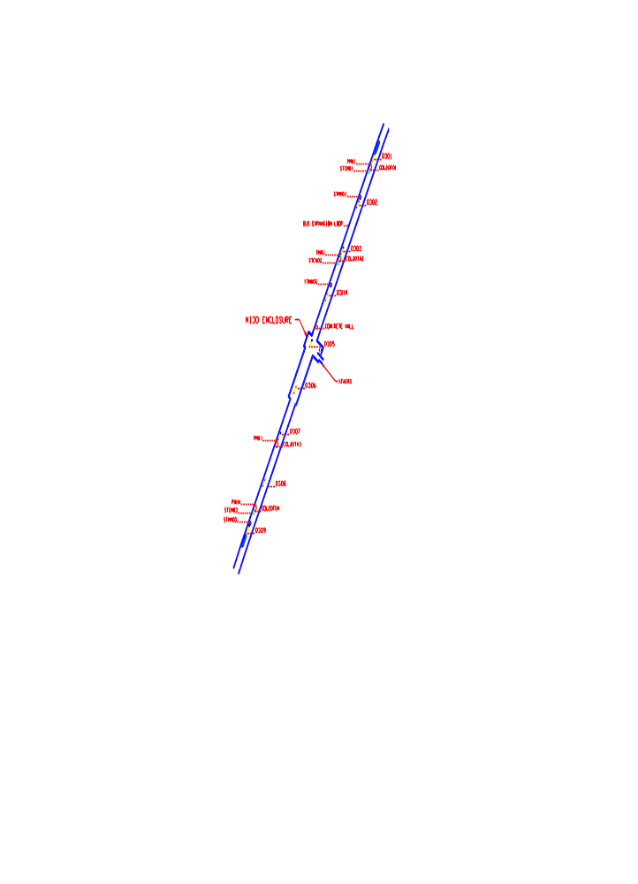Figure1. Main Injector Secondary Collimation System Layout.
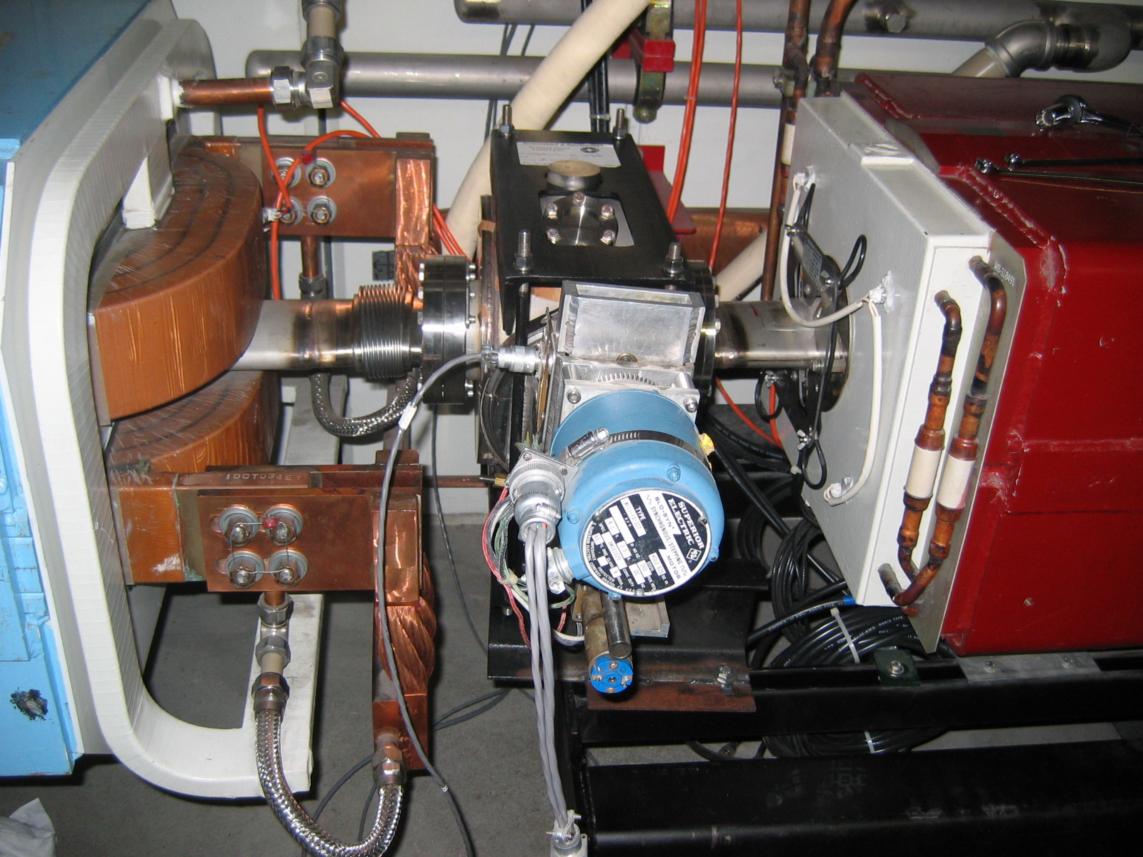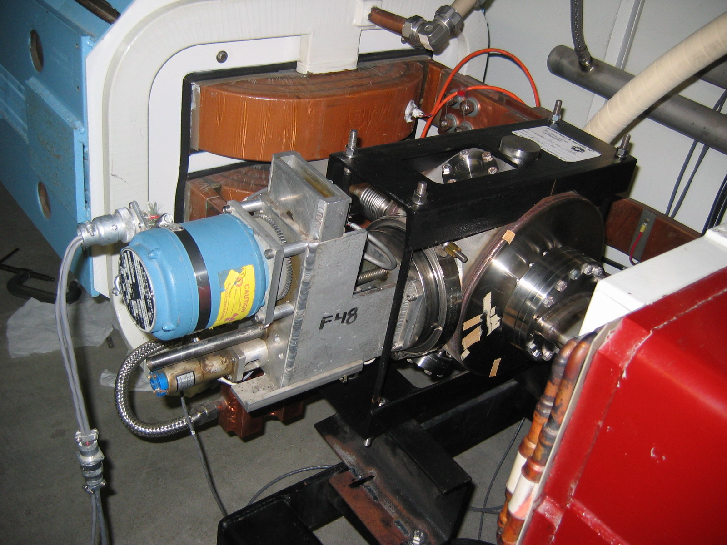
Figure 2. Primary Collimator Drive System shown before shielding installation

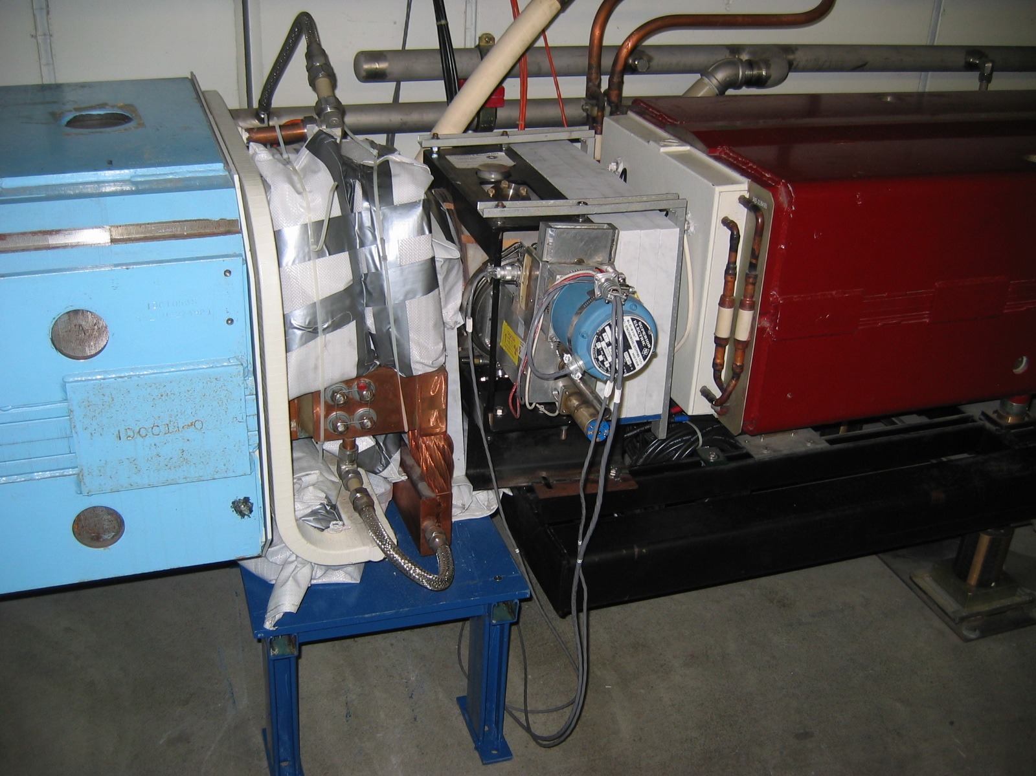

Figure 3 Primary Collimator Drive System shown after installation of marble shielding upstream of collimator and downstream shielding using bags of sand with polyethylene beads (10% by volume).

Primary Collimator System

The primary collimator consists of a 0.25 mm (0.010 inch) tungsten (W) foil mounted in a ‘C’ frame such that the open edge can approach the beam from the radial inside. The drive system shown in Figures 2, 3 is recovered from previous applications including a Main Injector diagnostic scanning wire system. The beam pipe and bellows upstream and downstream are surrounded by shielding to reduce the radiation damage to the nearby magnet coils.

The ACNET device is I:CPH230. The motor drive system has a range of 65.0875 mm (2.5625”). When fully inserted, the foil extends across the centerline to +9.73 mm (0.383”) (zero at beam centerline, radial outside is positive). Thus, when set to “out” or zero location the foil edge is 55.359 mm (2179 mils) from the beam centerline. Using a position reading of 600 mils places the foil edge at -1579.49 mils or -40.1 mm from the centerline. See [7] for reference information.
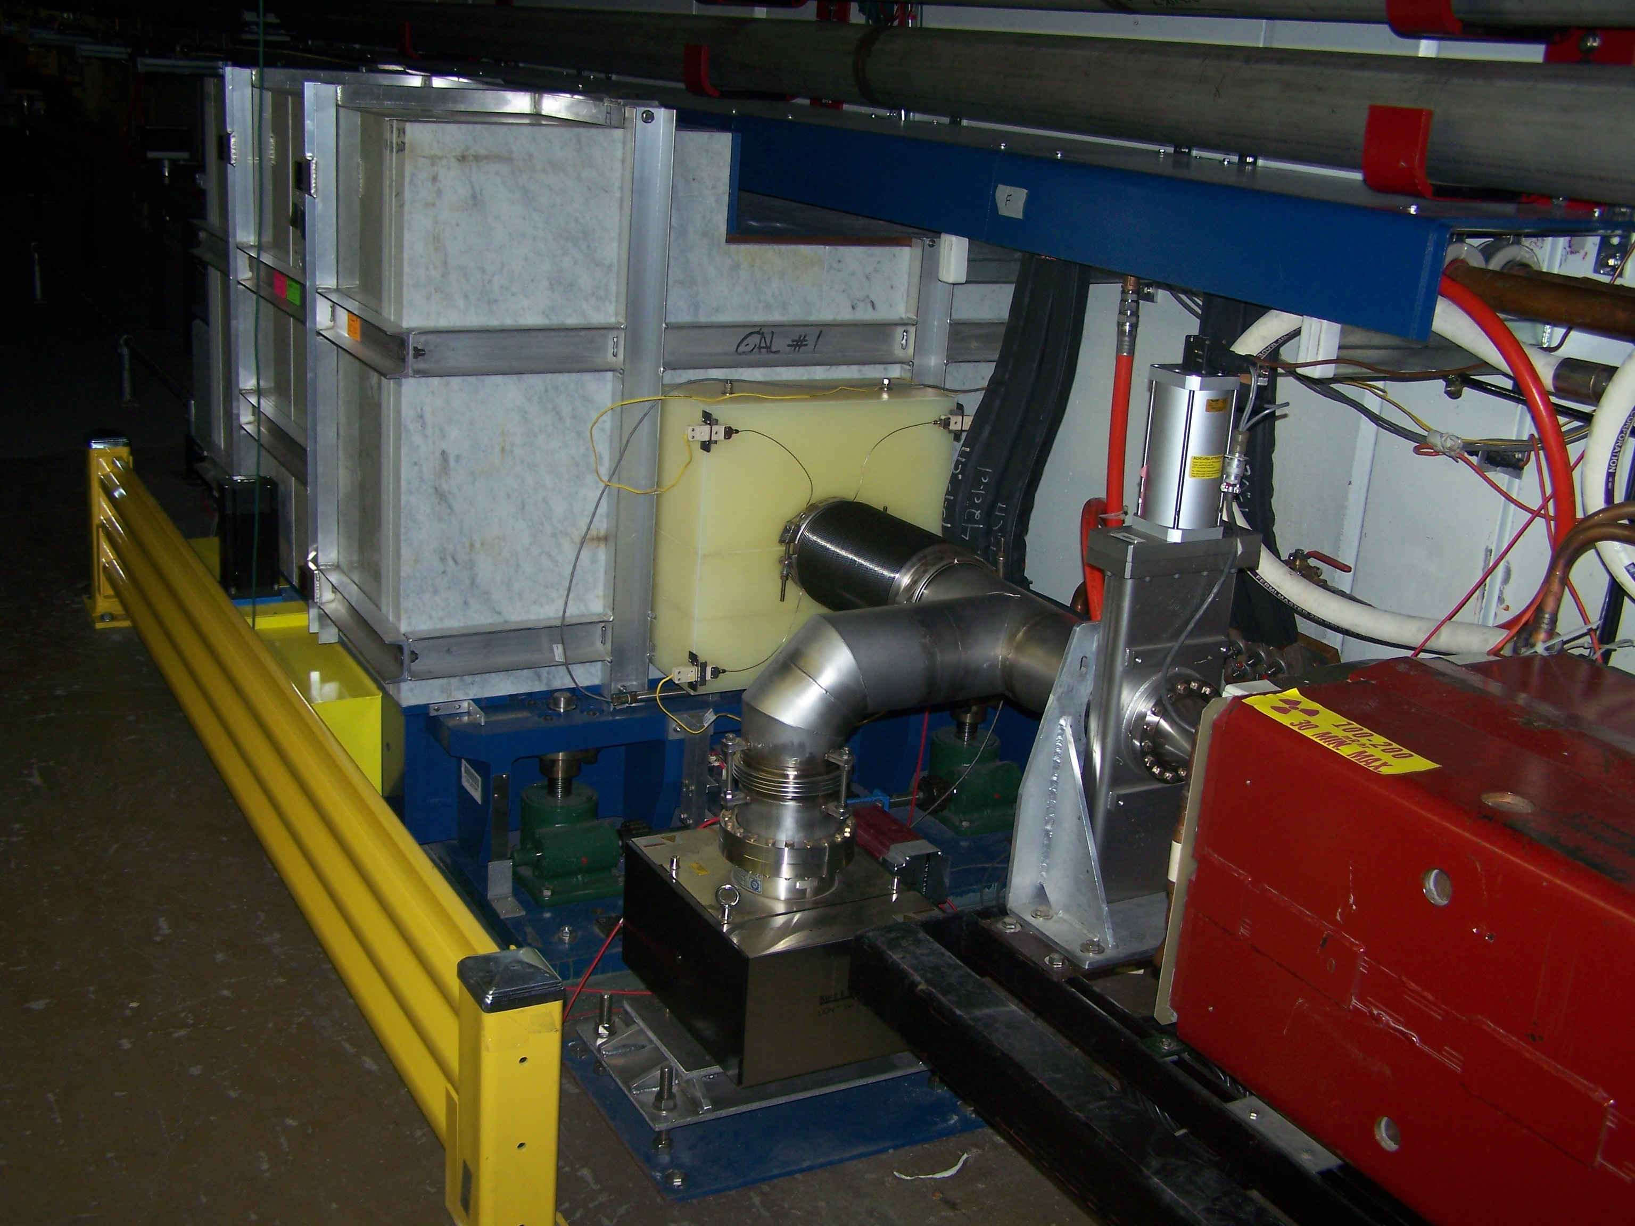

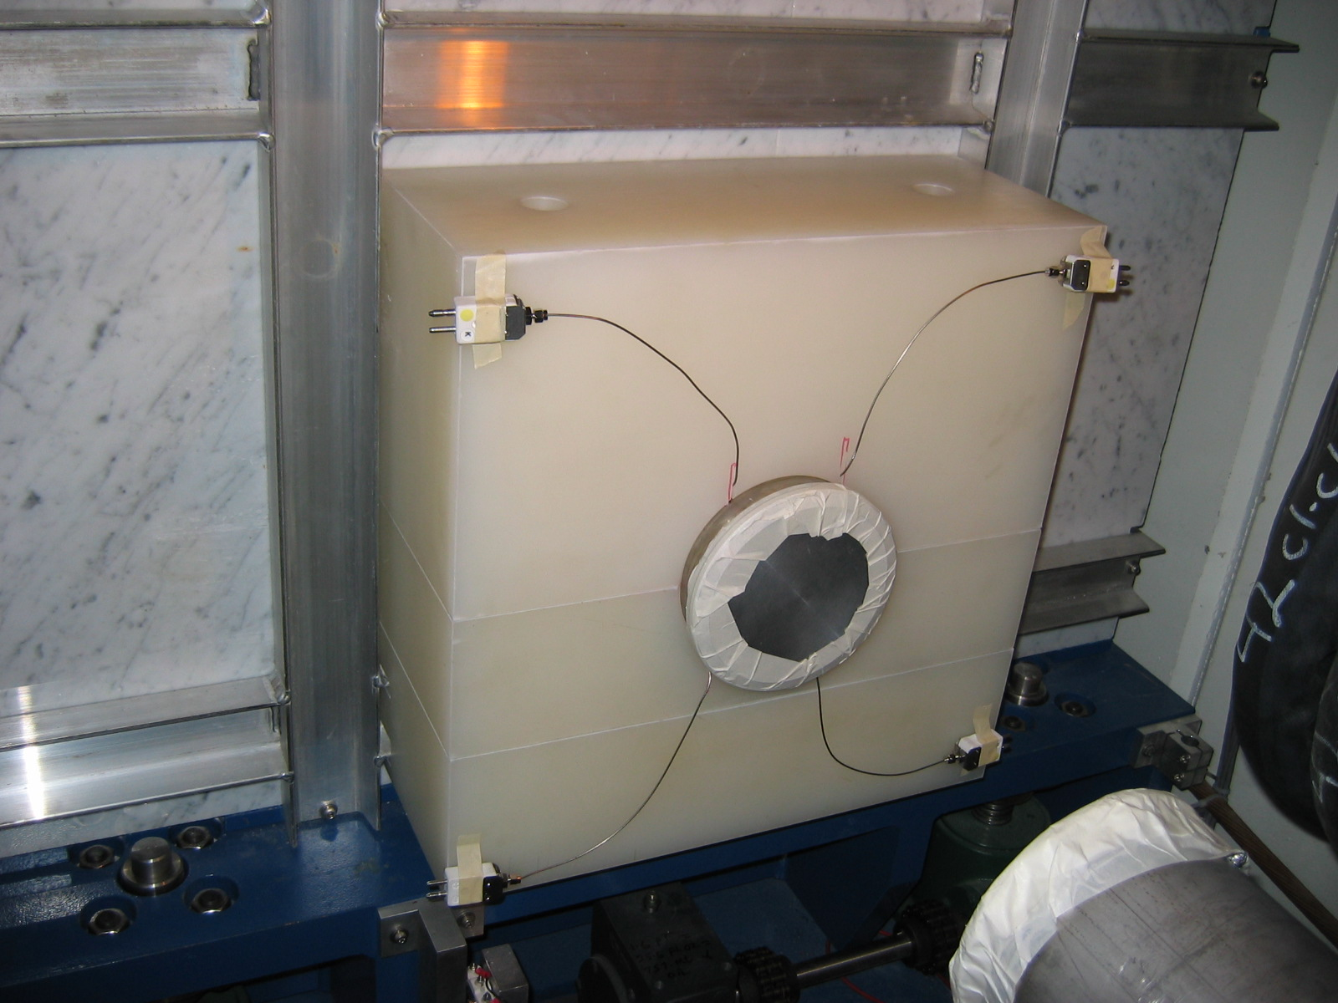

Figure 4. Upper: COL20T01 (C301) as viewed from upstream (10 April 2008). Lower: COL20T03 (C307) (11 Sep 2007). Polyethylene Mask PM 03 is installed on the upstream face. Four thermocouples are installed and routed to connection mounting blocks.

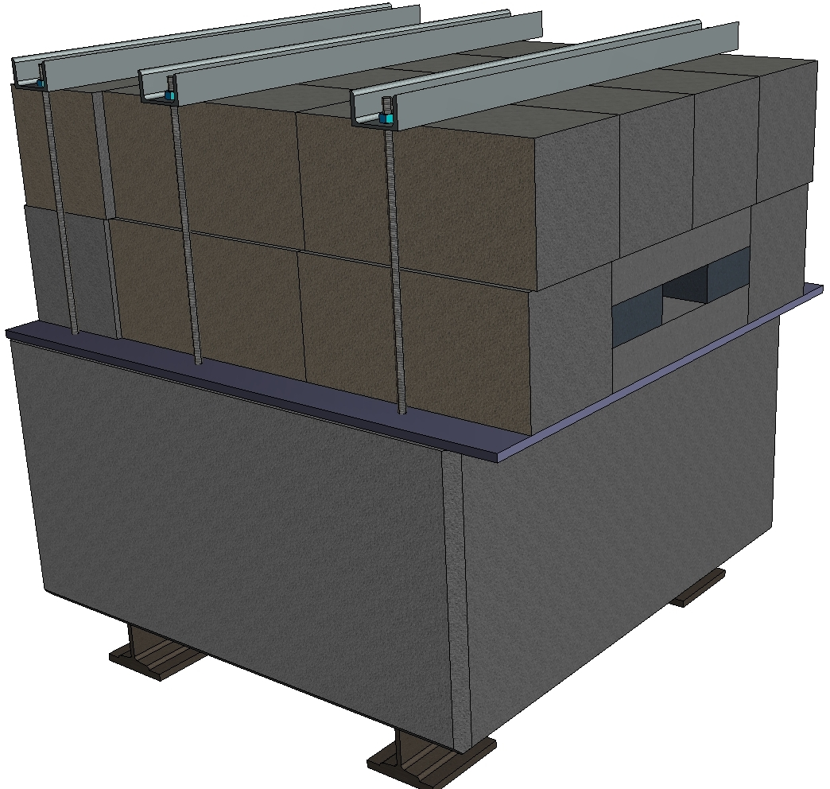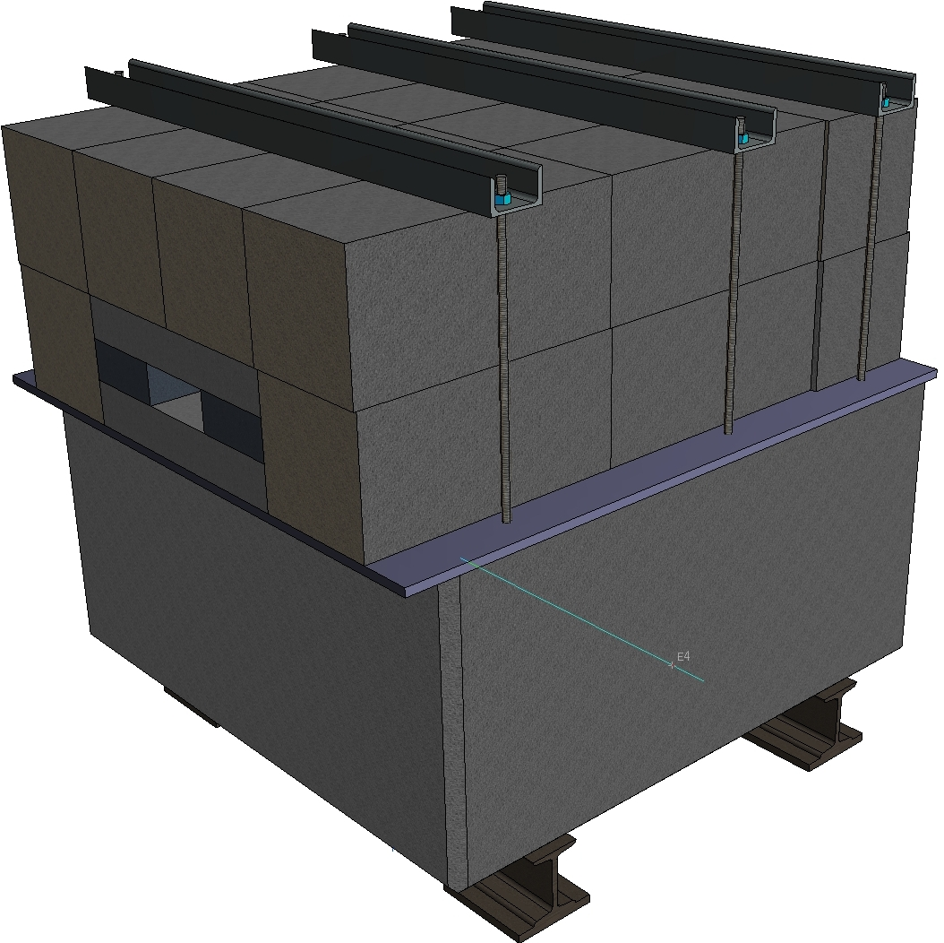
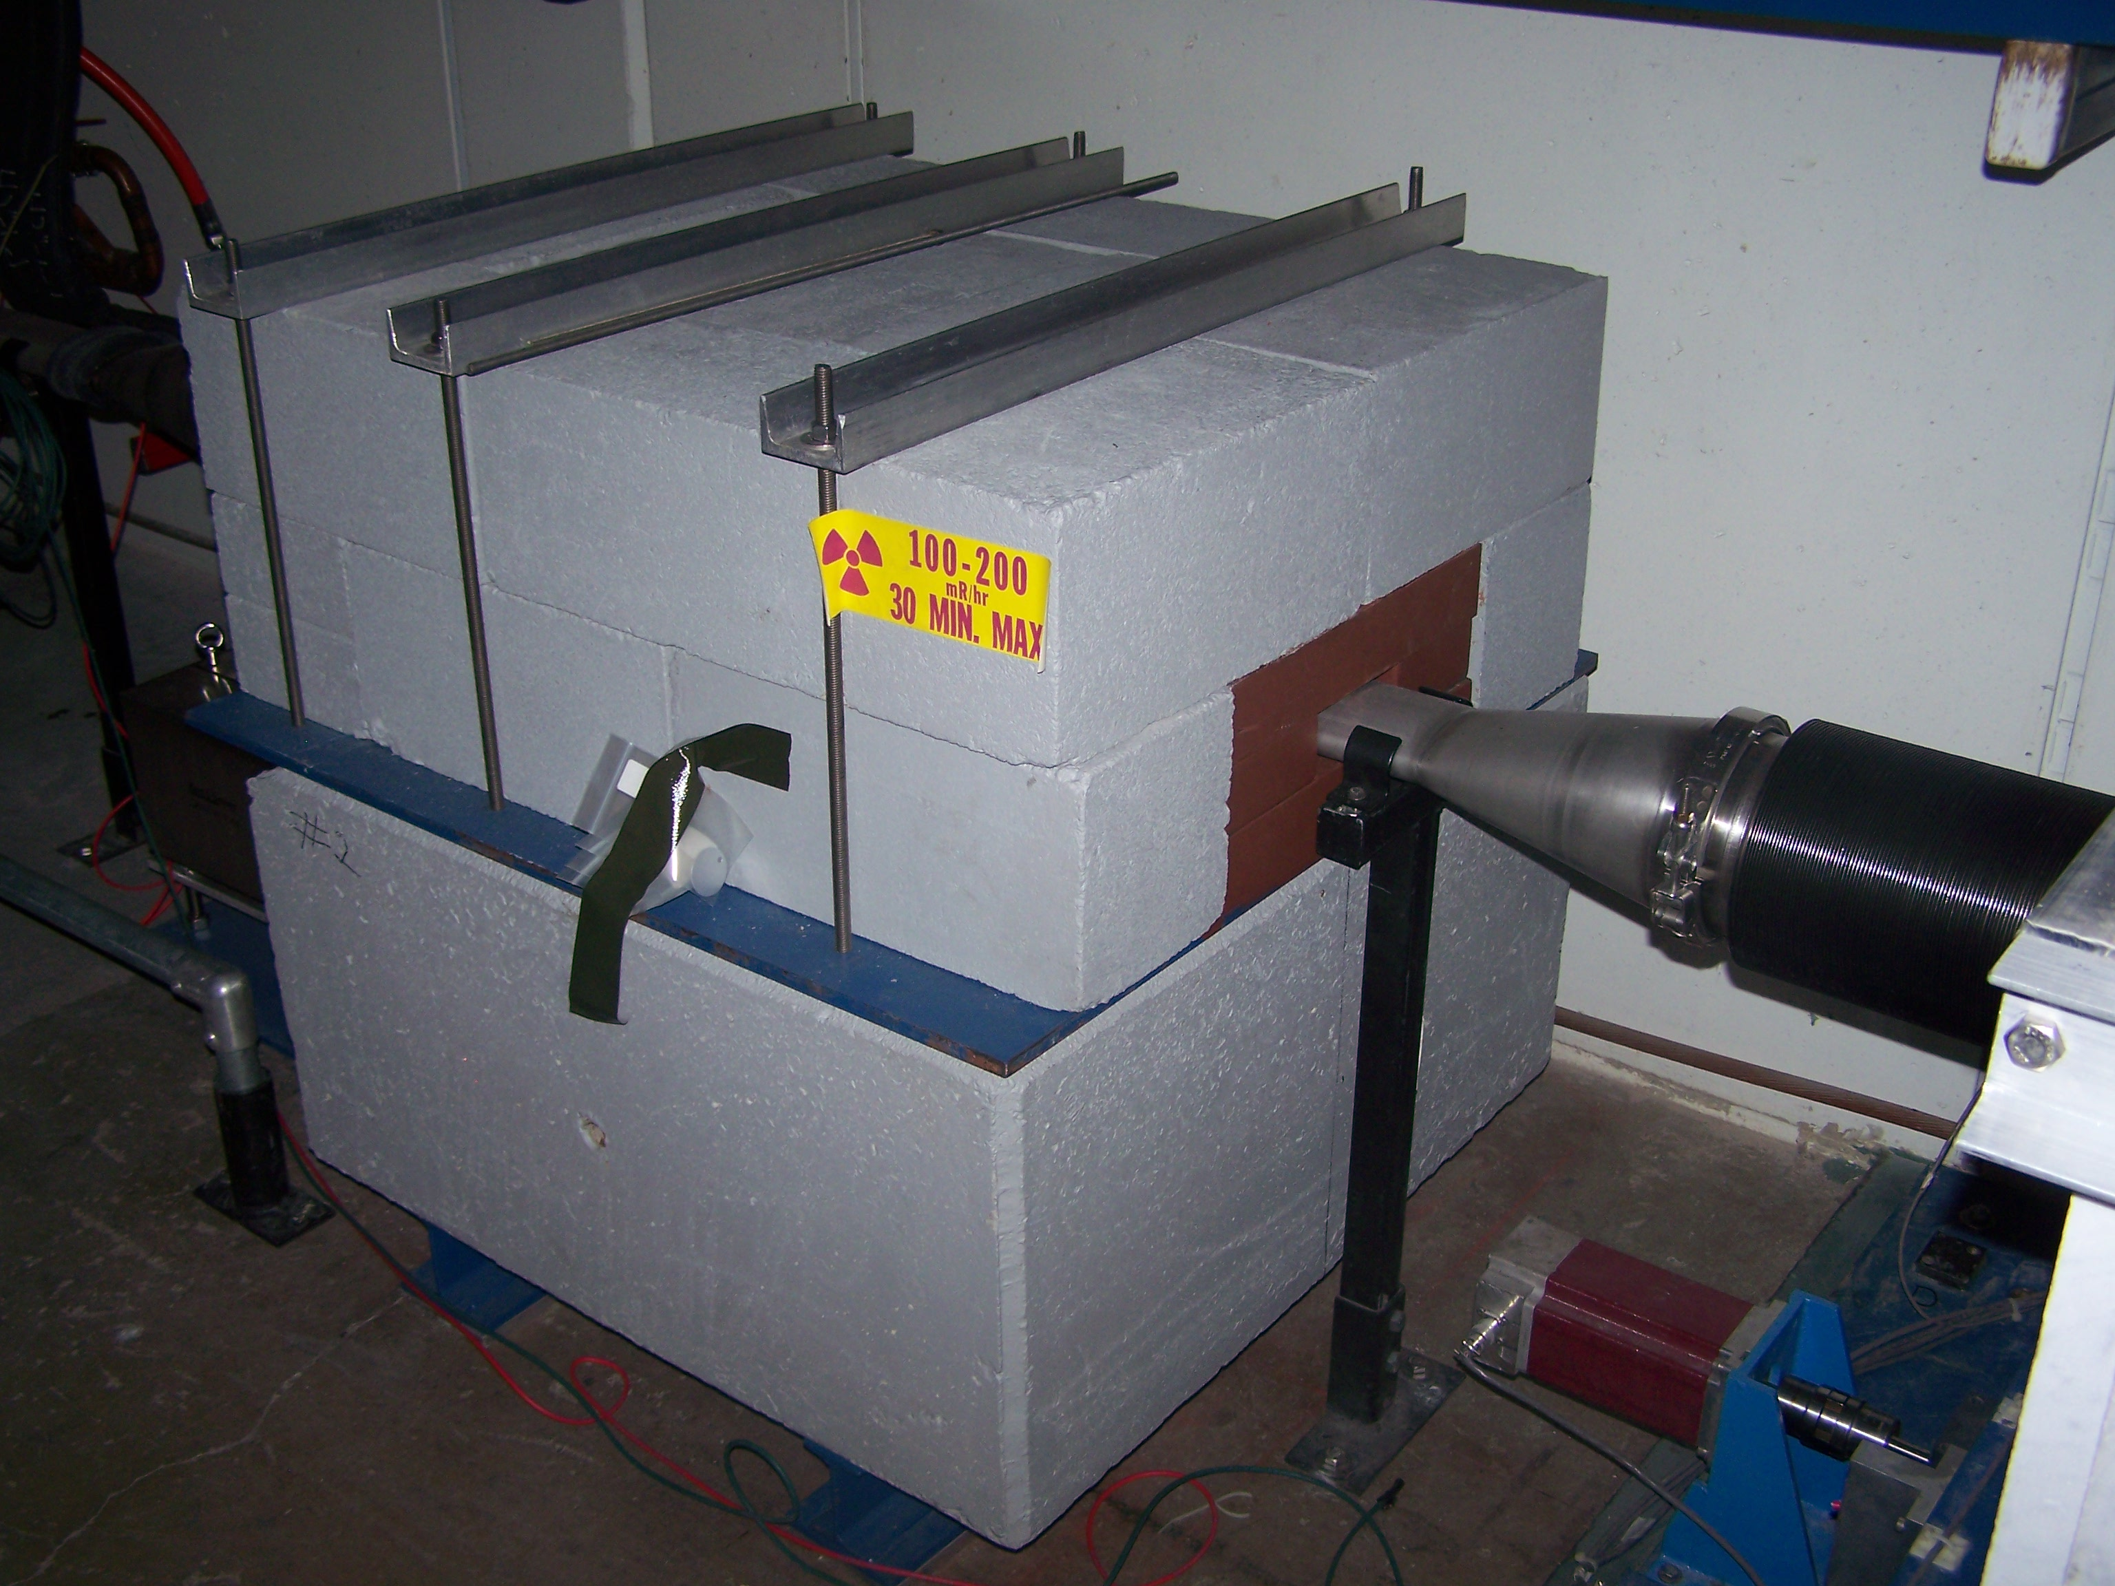

Figure 3. Upper: Two views of the design for Steel-Concrete Masks -- STCM
Lower: View of STCM01 downstream of C301 as viewed on 10 April 2008.

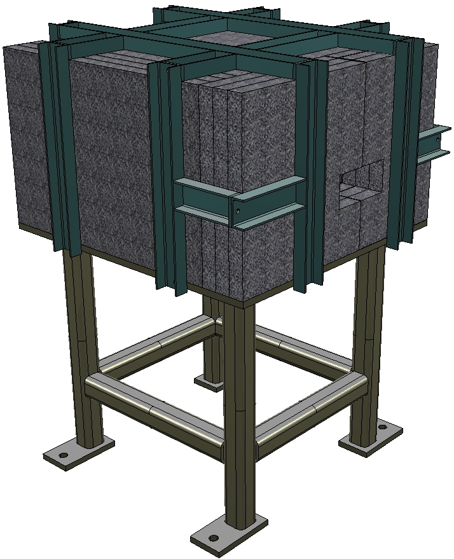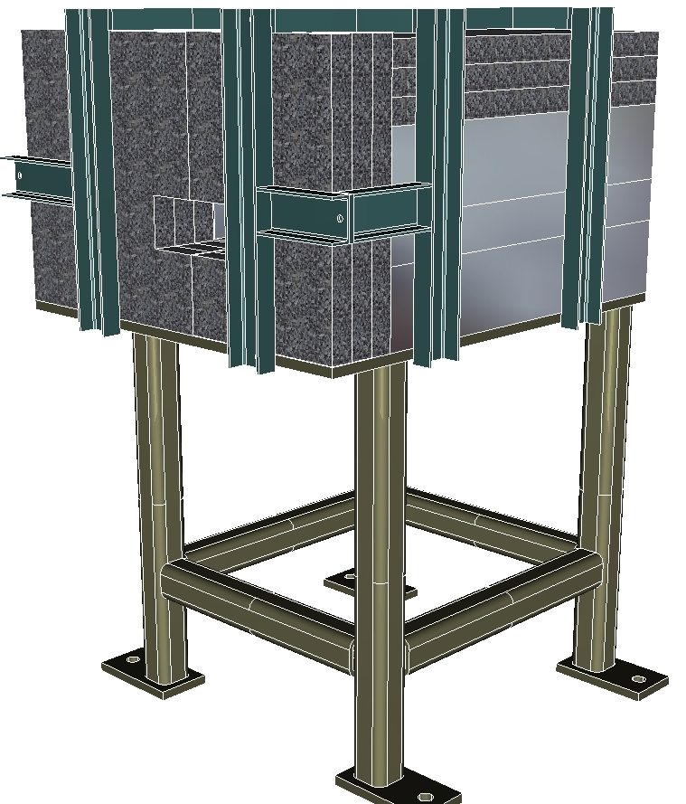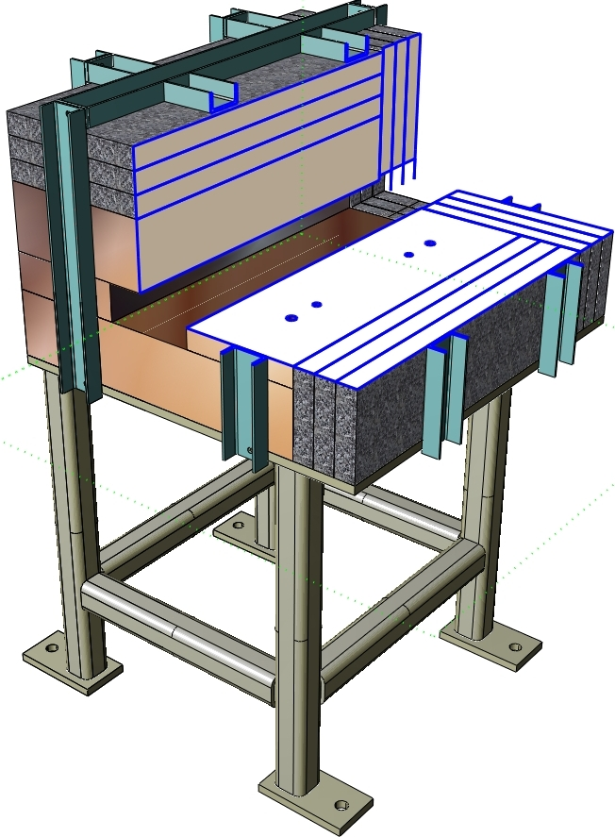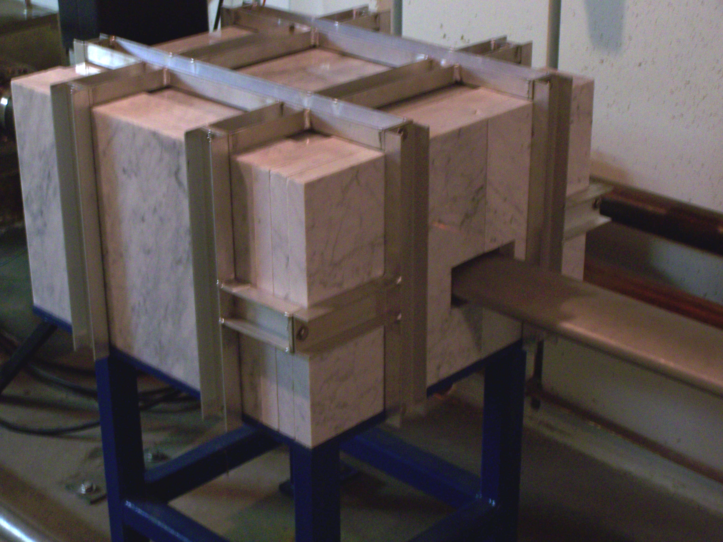
Figure 5. Design of Steel-Marble Mask (STMM)
Top Left is view from U.S. Aisle Side. Top Right is view from U.S Wall Side.
Bottom Left is D.S. View with quarter section removed to display Steel and Marble components. Bottom Right is photo of mask as installed.

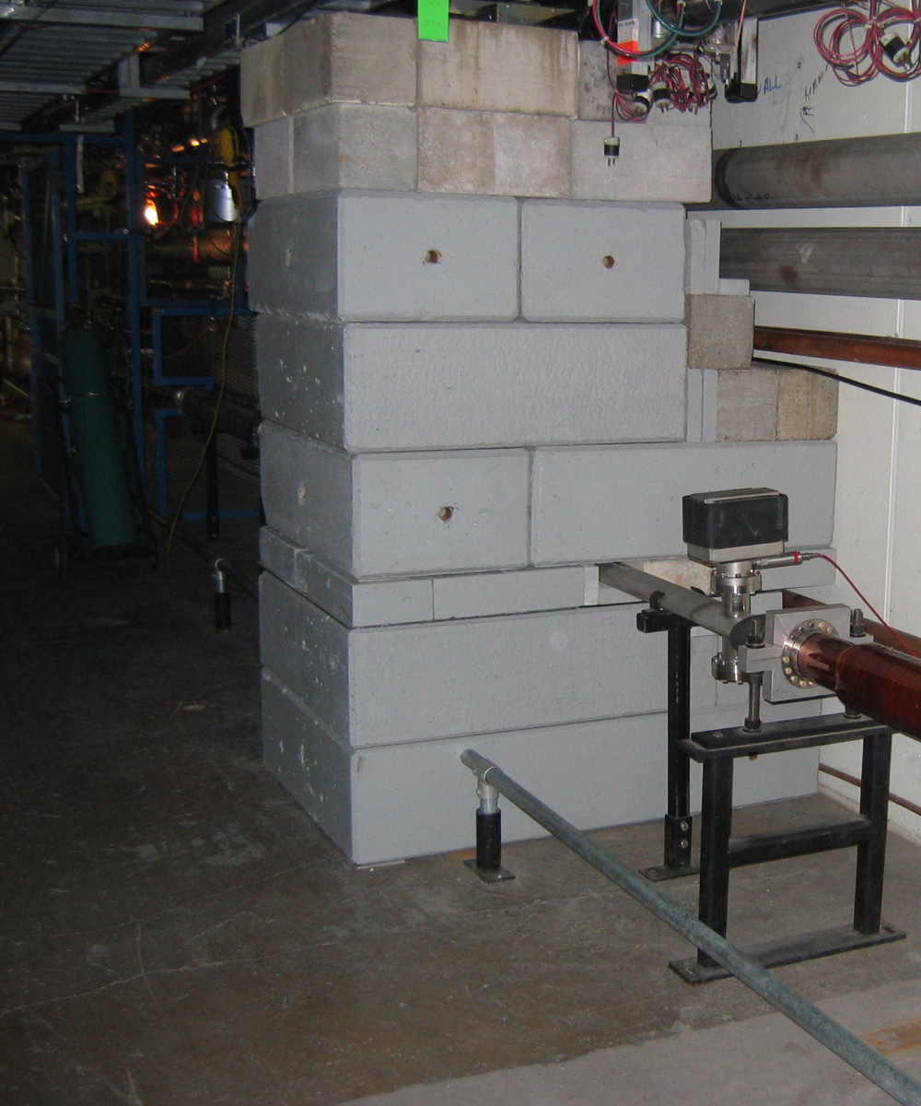

Figure 6. Concrete Wall upstream of Q305

Secondary Collimator - COL20T

The 20 Ton Secondary Collimators, COL20T, is comprised of a stainless steel vacuum liner with 1" thick walls surrounding a 2" x 4" vacuum aperture. This is surrounded by steel blocks to contain the radiation shower. On the aisle, upstream and downstream ends, and on the aisle side of the top, a marble shield surrounds the body of the collimator. This outer shell is minimally activated by the beam and absorbs low energy gamma rays from the activation of the iron to shield the aisle side from residual radiation. It is mounted on a precision motion system which can move ± 2" in the radial direction and ± 1" vertically. Motion control has a least count of 1 mil (0.001"). Readout noise is a few mils and the upstream vertical readout LVDT's experience an offset due to their proximity to the MI Dipole bus, giving them a modulation of 10 to 20 mils during the MI 120 GeV ramp. The horizontal motor drive is covered with metal plates to protect it from damage. Bumpers are installed in the aisle to protect the COL20T installation from passing carts or similar hazards. Figure 4 shows one of the four identical secondary collimators and the polyethylene mask in front of another.

Motor Devices:

Although not required for any collimation design feature, the mechanical design employs two motors for vertical motion. We intend to initially use them in tandem (locked mode) but the control permits separate operation. The following motor control devices are defined in the ACNET control system:

I:C301UV
I:C301DV
I:C301H
I:C303UV
I:C303DV
I:C303H
I:C307UV
I:C307DV
I:C307H
I:C308UV
I:C308DV
I:C308H

The upstream end of the vacuum aperture is tapered over a 14" length to a 2.5" x 4.5" opening such that the collimating surface presents a 17.86 milliradian incidence angle for collimated particles which were parallel to the collimator axis (and the beam under design conditions.) Since the most intense interactions will occur at the end of the taper, this design places that heat source more deeply in the collimator than was the case for the MI8 collimators and greatly mitigates the thermal issues by permitting the heat to be almost completely transferred to the surrounding iron. This is monitored by thermocouples placed in grooves which extend from the upstream end to a location just downstream of the end of the taper. The thermocouples are slid into place after assembly of the collimator and attached to the polyethylene mask (PM) which has been mounted on the upstream end of the collimator. Although 4 thermocouples are installed, only two are connected to readout electronics. At present, these are one top and one bottom on the aisle side of each collimator. ACNET devices for these thermocouples are as follows:

Thermocouples:

I:TC301T
I:TC301B
I:TC303T
I:TC303B
I:TC307T
I:TC307B
I:TC308T
I:TC308B

The thermocouples are Type ‘K’ with wires of chromega (Ni-Cr) and alomega (Ni-Al). The readout electronics is isolated so grounding near the junction is permitted.

Steel-Concrete Masks - STCM

Since the most intense interactions in the primary collimator occur on the face which has been displaced toward the beam centerline, the other edge of the (fixed aperture) collimator will be displaced away from the beam line. This exposes the beam pipe immediately downstream directly to the most intense secondary flux. In order to contain the radiation from the interaction of this secondary flux, a steel mask has been installed just downstream of COL20T01 (301), COL20T02 (303), and COL20T04 (308). This mask is mounted on concrete and surrounded by additional concrete. This mask design (STCM) is shown in Figure 3. The concrete portion of this mask serves to attenuate the flux of neutrons which
escapes from the COL20T collimators. These masks are included in the calculations reported in [5].

Steel-Marble Masks - STMM

The accelerator components downstream of each secondary collimator are exposed to the radiation flux which is outside of the beam pipe aperture. This flux consists of a small portion of the particles scattered by the primary collimator and the forward portion of the shower from the secondary (COL29T) and even the mask (STCM) which is outside of the beam pipe aperture. The calculations reported in [5] indicated that these radiation fluxes were sufficient to create both activation of the components and some radiation damage to magnet coils (trim dipole and quadrupole). By surrounding the beam pipe with a modest steel mask, this problem can be substantially reduced at very low cost. To minimize residual radiation exposure, these masks are constructed with marble to shield the aisle side of the STMM assemblies. STMM masks are installed at 301, 303, and 308. Note that the STMM were not included in the calculations in [5].

Concrete Wall

Since the ECOOL system is crucial to the current Tevatron operation and employs some equipment which may be more sensitive to radiation, we have taken steps to try to minimize the impact of this collimation system on the region from Q305 to Q307. The components were all placed outside of this region. To further minimize the radiation that impacts the ECOOL region, a concrete wall was constructed using standard radiation shielding blocks for the larger parts and standard commercial 80 lb (or smaller) concrete blocks. This 1-m long wall was included in the calculations [5]; however, it was constructed 312" (26 ft) from the downstream end of Q304 which is a little further upstream than was described for the calculation. In addition, we were able to stack two rows of block higher than the plan so the reduction in flux should be a little better than indicated by the calculation.

IV. Radiation Issues and Monitoring

The calculations reported in [5] are based on a tunnel model which was modified from previous work. The activation of materials below the floor of the tunnel can be a source of activity which can be pumped by sump pumps into the surface water. If there is gravel under the concrete, as shown in some tunnel cross sections used for the MI8 Collimator simulations, the activity in this material can be readily released to the drains and thereby to the sumps. The Main Injector was generally built by pouring the concrete directly on undisturbed soil, thereby limiting the migration of the water. This was noted and carefully documented in a Fermilab FESS note under Project # 6-6-7 (Tom Lackowski).

We also note that the MARS calculation [5], employs output from the STRUCT calculation [4]. The beam properties of lost particles are imported from all of the main loss points as input the MARS. However, for simplicity, about 12% of the lost particles reported from STRUCT are not included in the MARS calculation. We assume that other issues will be of comparable or greater significance in evaluating radiation issues for this project so we have be satisfied with this simplification.

Air Activation

The air activation calculation for full power operation of the Main Injector Collimation system was carried out by Kamran Viziri using the output of the MARS calculation. The assumed air flow was that created by the air fans operating at full capacity and the air input at 305 and outputs upstream and downstream. The results indicate that this source adds a modest fraction to the expected air activation at the Fermilab site boundary, keeping the site below regulatory limits.

Loss Monitors

The Main Injector is everywhere instrumented with loss monitors that are placed on the tunnel wall and a little above beam height at the downstream end of each main quadrupole. These provide good coverage of the collimation region. Two additional loss monitors are installed at ECOOL. For diagnostic purposes, we have installed a loss monitor adjacent to the beam pipe between the STCM and STMM at 301. It has been supplied with high voltage and a cable is connected to it which runs to the MI30 service building, however, initially there is no electronics connected to read out the loss measurement. Subsequently, it was connected to the previous version of BLM electronics and is available as I:LM30C1.

Activation Monitoring with Al Tags

Since sump water activation limits and concerns about radiation damage to coil insulation are both significant, we have placed activation monitoring tags (Al disks) at strategic points to permit an evaluation of the absorbed doses. Tags adjacent to the secondary collimators and masks should allow a comparison to the MARS calculation and thereby provide information on the sump water activation issues. Tags on the nearby quadrupoles will be employed to attempt to evaluation possible issues with coil insulation radiation damage.

Transferable Radiation Issues

Since significant residual radioactivity will be generated by the MI-300 collimation system, the construction was carried out with attention of minimization of transferable radiation. For this purpose, each iron piece was painted on the exposed sides. Similarly, the surfaces of the concrete blocks were painted for both the Fermilab shielding blocks and the commercial concrete blocks.

References

[1] N. V. Mokhov, "Beam Collimation at Hadron Colliders", AIP Conf. Proc. 693:14-019, 2004, available as Fermilab-CONF-03-220, August 2003.

[2] N. V. Mokhov et al., "Fermilab Booster beam collimation and shielding", presented at PAC03, available as Fermilab-CONF-03-087.

[3] K. Seiya et al., "Multi-batch slip stacking in the Main Injector at Fermilab, presented at PAC07, available as Fermilab-CONF-07-275-AD

[4] A. I. Drozhdin et al., "Collimation system design for beam loss localization with slipstacking Injection in the Fermilab Main Injector", PAC2007, available as Fermilab-CONF-070249-AD.

[5] I. Rakhno, "Radiation shielding for the Main Injector collimation system, Fermilab-TM-2391-AD, December 2007

[6] Vladimir Sidorov, "MI Secondary Collimator", Fermilab Accelerator Division, Mechanical Support Department, Engineering Note MDSN-ME-000071, 2007

[7] For the primary collimator position, one can measure the exposed length of the drive shaft to determine the holder location. 5.3125” is exposed when the holder is fully withdrawn and 2.75” is exposed when the foil is fully inserted. In the fully inserted location, the edge is 0.261” beyond the centerline of the beam pipe. The beam pipe is offset by 0.122” radially outside so when fully inserted, the foil is 0.383” beyond the beam centerline. Numbers per Alignment Report; Request 5424, Project 1802, T. Sager; 2, 3 Nov 2006.

