Program documentation

- Model Description

In experiment the detection of muon beam in muon cooling system is provided by Scintillating Fiber Detector, which consists of two parts: Scintillating Fiber Tracker (SFT) connected with Photo Multiplier Tube (PMT). It’s shown on Fig. 1.

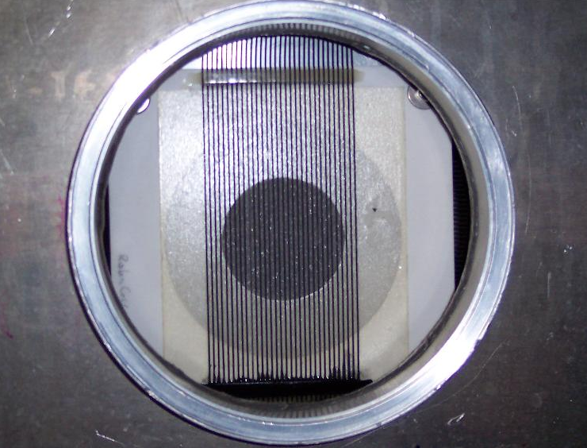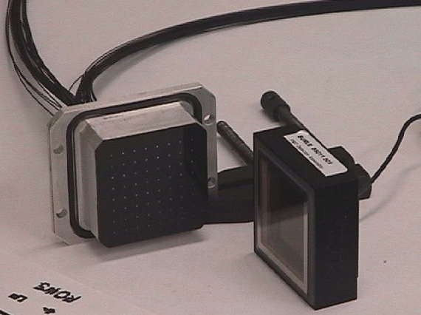
Figure 1. Scintillating Fiber Detector (SFD)

The SFT is stuck to beam line window as it’s demonstrated on this Figure; particles go through this tracker and produce photons which start to propagate inside the fibers toward PMT. Then the photons strike the PMT inlet window and produce electrons which are multiplied in PMT. Measuring the output signal (electric current) it’s easy make a histogram of muon beam space distribution along one of the coordinates (determined by fibers direction): each bin corresponds either to a fiber or a bundle (see Fig. 2).

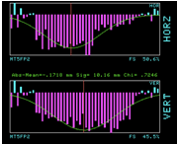
Figure 2. Beam space distribution histogram

2.1 User’s guide
Basically there are two different methods to run the program:
- run compiled executable file MAIN.EXE from Windows command line (cmd);
- compile executable file from sources and run it in Linux
In Windows ready for use executable file MAIN.EXE has to be put in the same folder with G4BL output file (G4BL.TXT), configuration files for all modeled detectors. After all MAIN.EXE has to be run n times (n –number of detectors) from command line with two arguments: first – the name of configuration file; second – the name of input data file; third – the name of output file (C:\MainFolder\main.exe config.txt g4bl.txt output.txt).
In Linux OS MAIN.CPP hast to be put in the same folder with DISTRIB.H, G4BL.TXT and configuration files. MAIN.CPP has to be compiled by gcc or g++ to make executable file, for example MAIN. After all MAIN has to be run n times (n – number of detectors) also with two arguments: first – the name of configuration file; second – the name of output file.
G4BL output file (G4BL.TXT) which contains the data collected from all the virtual detectors has its own standard 3 title lines and the data lines (1000 for each detector as a default) with 23 rows for different parameters. The program operates only with rows #7-#12 which contain muons coordinates: spatial – X, Y, Z and momentum – P_{x}, P_{y}, P_{z}.
The configuration (shown on Fig.3): file consists of the list of current detector parameters described below. This file has to be filled by user according the template: parameters have to be placed in right order (see below) and each one includes title (1 line), value (1 line) and the empty line to split one from other.

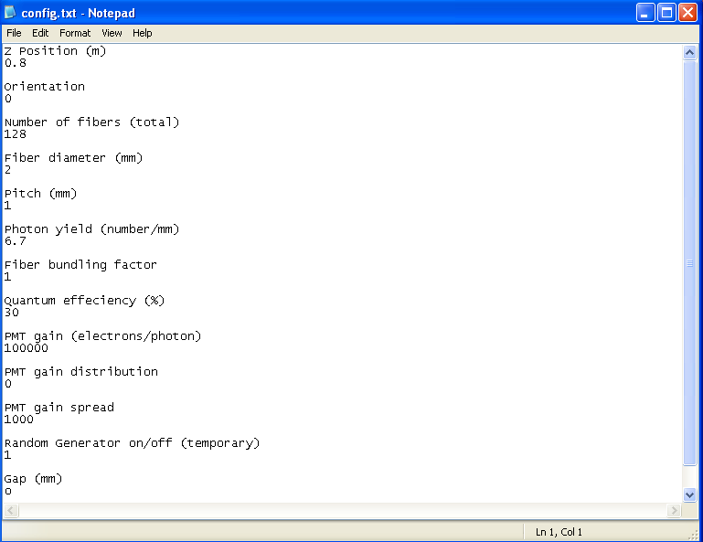
Figure 3. Example of configuration file

Z Position (m) – Z coordinate (along a beam line) of detector; is used by program to find the necessary detector in G4BL data file.
Orientation (degrees w. r. t. X axis) – the angle which determines the rotation of fibers with relative to X axis. F. e. Orientation = 90 means X turns to Y.
Number of fibers – number of fibers in current detector
Fiber diameter (mm) – diameter of fibers, parameter which determines a resolution
Pitch (mm) – the least distance between centers of nearest fibers (shown on Fig.4). If the Pitch >= Fiber Diameter it means detector has only one layer (Fig.4 a); from other side if Fiber Diameter/2<=Pitch<Fiber Diameter there is two-layer detector (Fig. 4 b) which provides to bundle the fibers in groups (see Fiber bundling factor)
Pitch=Radius
Pitch=
Diameter
a
b

Figure 4. a – one layer detector; b – two layers detector.

Photon Yield (number/mm) – the fiber constant which shows the average quantity of photons produced inside the fiber by 1 muon on the distance of 1 mm
Fiber bundling factor – can unite the fibers in groups varying this parameter (see Fig.). Minimum value is 1 – it means no bundling.
1
2
0
-1
1
1
0
1
0
0
1
1
0
1
0
0
0
1
Figure 5. Examples of bundling: left – no bundling; center – bundling by three; right – bundling by four.
Quantum efficiency (%) – shows which part of photons can be successful in electron production
PMT gain (electron/photon) – defines the average gain value of PMT
PMT Gain Distribution – has two states:
1) 0 means Exponential;
2) 1 means Gaussian (Normal)
PMT gain spread – the standard deviation (SIGMA) for Gaussian gain distribution
Random Generator (on/off) – Switch on/off the random generator; this parameter has two states: on – 1; off – 0; it is used for testing changes in the program.
Gap (mm) – distance between any secondary detector (z = Z_Position + Delta_Z), and primary detector which is determined in g4bl.txt and situated close to Y axis. It’s usually used when secondary detector is rotated on 90 degrees relatively to primary one to have the whole space picture of the beam.
After the program is finished, it produces the output file which contains the data in two rows: 1- number of the bin, 2- number of registered electrons. This data can be used by other applications to build a muon beam space histogram.
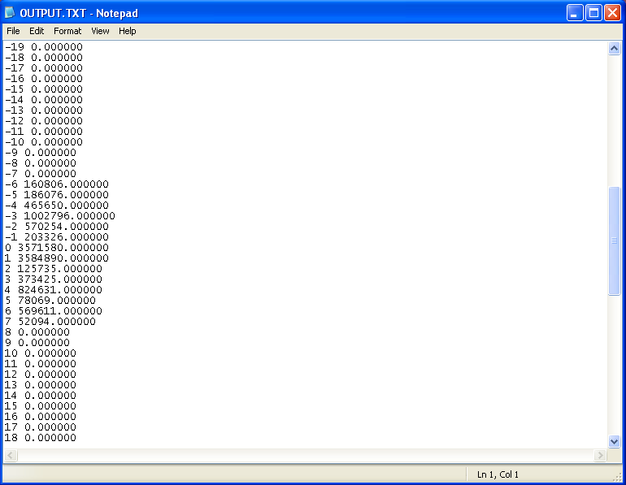
Figure 6. Example of output file

2.2 Developer’s Guide
The program is written with C++ by means of Borland 3.1 C++ compiler. In generally, the source of this program consists of two files: MAIN.CPP and header DISTRIB.H.
DISTRIB.H contains 1) very fast random number generator of period 2¹⁹⁹³⁷-1 found at [1] and described in the article [2]; 2) the initializations and realizations of different statistical distributions: Uniform, Poisson, Normal, Exponential.
All the distributions realized in DISTRIB.H are based on the same random number generator. Uniform distribution is simply formed from the random numbers of [0, 1] segment.
Poisson distribution with mean L is being realized by means of Poisson() function consisted of three sub functions: PoissonLow(), PoissonInver() and PoissonRatioUniforms(). Poisson() function uses inversion by chop-down method for L<17 (PoissonInver() sub function), and ratio-of-uniforms method for L >= 17 (PoissonRatioUniforms() sub function). For extremely low values L <10⁻⁶ numerical inaccuracy is avoided by direct calculation (PoissonLow() sub function). It is a simple calculation of the probabilities of x = 1 and x = 2, higher values are ignored.
The Normal distributed values are being obtained with Normal() function which operates with two arguments: mean m and standard deviation s. This function generates two normally distributed variables by Box-Muller transformation algorithm.
The ExpDist() function realizes the Exponential distribution using simple inversion method.
All computing methods and algorithms used in this program are described in Appendix.
In MAIN.CPP there are geometric calculations of muons moving through detector fibers and file input/output stuff. The program cycle is split on many single steps: one step – one function. Below there is a description of every step in the order of their appearance in the main () function.
InitialData() operates with configuration file (situated in MainFolder) which name is defined in command line, reads data from this file and puts it to corresponding external variables.
The g4bl.txt file contains a lot of data (simulations of many detectors), so SearchPosition() function is used to find the detector described in current configuration file. There are two steps:
1- to find the line which starts the necessary data;
2- to replace the pointer to this line.
First step is made by comparing Z_Position parameter from configuration file with the values from 9th row of g4bl.txt (Z coordinates). After this the pointer is replaced in the beginning of necessary line.
Then program begins to read data from each line, but it stores (in data[] array) only the space {X Y Z} and momentum coordinates {P_{x} P_{y} P_{z}} from rows ##7-12. The Orientation() function acts like rotation matrix does, it rotates fibers to make the determined angle between XZ plane and them, and new x and y values are calculated in coordinate system connected with fibers. Correction() and GetData() functions make geometric computations, run all the main processes (random generator, distributions) and put the final results in outputdata[] array. Below these functions are discussed with more detail. All this actions are included in while() cycle that goes on until the end of file or can be broken if the data for current detector (determined by Z_Position and obtained from g4bl.txt) is over.
The XYZ coordinate system used in the program is shown on Fig. 6. The fibers spread along X axis, muons move basically along Z axis, and Y axis spreads along the beam line window.

Z

Y

0
θ
Figure 6. Coordinate system and muon beam
Basically GetData() manages the intermediate operations: from getting the data from data[] array to obtaining the final results. Below all these steps are described:
- all the data from data[] is saved in declared variables;
- the angles θ and φ are calculated using simple formulas 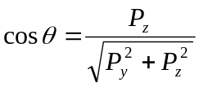, θ- angle between muon moving direction and XZ plane and 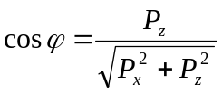, φ - angle between muon moving direction and YZ plane;
- number of bin (fiber or bundle) is calculated by HistNumber() or Bundling() function – it depends on FiberBundling parameter. HistNumber() function enumerates the fibers: the fiber crossed by Z axis has number 0, upper fiber have positive numbers 1, 2, 3 etc and lower fibers have negative ones -1, -2, -3 etc. In HistNumber() one fiber corresponds to one bin, in Bundling() one bundle of fibers corresponds to one bin, both these functions return the number of the bin current muon passed through;
- 4)GetX() and GetY() functions just return a new x and y coordinates of muons after simple calculations: 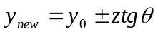 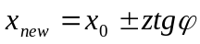, where x0, y0 are initial, z (is counted from 0) is a distance along Z axis and +/- depend on P_{x} and P_{x} signs accordingly
- Muon path length L (through fiber) is calculated with formula 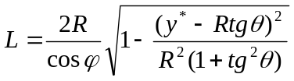, where R – fiber radius, y* - absolute value of fractional part of y respected to the fiber radius;
- then random number of photons is generated with Poisson(PhotonYeld*L) function;
- then uniformly distributed [0,1] random value is generated to select the photons that will successfully produce electrons in PMT – it means PhotonCounter is implemented only in case of random value < QuantumEfficiency/100;
- then gain distributions are realized: Exponential and Normal (configuration file defines which one is used). These distributions return a number of electrons detected after PMT for each muon. Results (bin number – number of electrons) are summed up and stored in outputdata[] array;
- finally average X and sigma are calculated with formulas 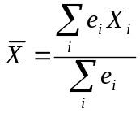 and 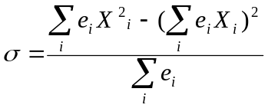, where X_{i} is any of coordinates (either x or y), e_{i} – number of electrons corresponded to muon number i.

Appendix: computing methods and algorithms

Inversion method
Assume that we want to generate a variable with the frequency function f(x). The distribution function is
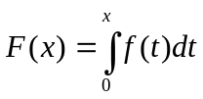 (1)
for a continuous distribution, or
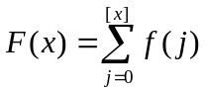 (2)

for a discrete distribution. If u is a variable with the uniform distribution u ~ uniform(0,1), then a variable with the desired distribution can be generated by applying the inverse distribution function to u:
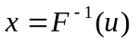 (3)
This method requires that F⁻¹ is easy to calculate.

Inversion by chop down search from 0
When f(x) is a discrete function (x integer) then (3) can be calculated by successively adding f(0) + f(1) + ... + f(x) until the sum exceeds u. Each f(x) is computed from the previous one according to a recursion formula, for example for Poisson it is:
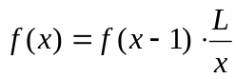 (4)
Since division is slow, this method can be speeded up by multiplying u with the denominator in the recursion formula instead of dividing f(x) with the denominator. We then have to check for overflow unless the parameters are limited to safe intervals. The computation time is proportional to the mean of x. Therefore this method is used only when the mean is low.

Chop down search from the mode
This is very similar to the method above. f(x) values are added consecutively until the sum exceeds u. The difference is that the x values are taken in a different order. Rather than starting at x = 0 we start at the mode M, and take f(M) + f(M-1) + f(M+1) + f(M-2) + f(M+2) + ... until the sum exceeds u. The advantage of this method is that the search is likely to end earlier when we take the most probable x-values first. The disadvantage is that the set-up time is higher.

Rejection method
The principle of the rejection method is that the frequency function f(x) is approximated by another distribution function h(x) which is easier to calculate, and then a correction is made by randomly accepting x values with a probability 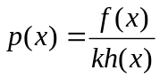, and rejecting x values with probability 1-p(x). The constant k is chosen so that k h(x) ≥ f(x) for all values of x. Whenever an x value is rejected, the procedure starts over again with a new x. The accepted x values have the distribution f(x) because the acceptance probability p(x) is proportional to f(x) / h(x). x values with distribution h(x) are generated by simple inversion from a random number u with uniform distribution: x = H⁻¹ (u), where H is the integral of h and H⁻¹ is the inverse of H. Acceptance/rejection is done on the basis of a second random number v with uniform distribution. x is accepted if v < p(x) and rejected if v ≥ p(x).
The rejection method can be improved by quick acceptance and quick rejection schemes. Quick acceptance is based on a minorizing function 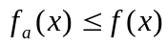 , and quick rejection is based on a majorizing function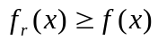. These can be simple linear functions or other functions that
are easy to calculate. The acceptance condition can be written as vkh(x) < f(x). The time-consuming calculation of f(x) is avoided by quick acceptance when vkh(x) < fa(x) and quick rejection when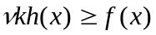. Only when vkh(x) is between these two values do we need to calculate f(x) in the final acceptance/rejection decision.
The advantage of the rejection method is that the calculation time does not grow with x. It is therefore used when the variance is so large that the chop-down search would be more time-consuming.
The disadvantage of the rejection method is that it is difficult to find a good hat function h(x) which is easy to calculate and at the same time approximates f(x) so good that the rejection rate will be low. A bad hat function will lead to a high rejection rate and hence a long execution time.
Various improvements of the rejection method are applied, as explained below.

Patchwork rejection method
(Stadlober & Zechner 1998). This variation of the rejection method uses a simple hat function, which has a large uniform section in the center and exponential tails. The area under the curve of the frequency function f(x) is cut into pieces which are rotated and rearranged geometrically like a jigsaw puzzle to fill as much of the area under the hat function as possible. A point under the curve of the hat function is generated on the basis of the two uniform random numbers u and v. It is then determined whether this point falls on a piece of our jigsaw puzzle or in the rejection area between the pieces. If the point falls on a rearranged piece then the transformations of the rearrangement are undone in order to find the corresponding x. Quick acceptance and quick rejection areas are used.
The advantage of this method is that the rejection rate is low. The disadvantage is that the setup time is quite high because it takes a lot of calculations to determine where the borders of each piece are. Hence, this method is only advantageous if the function is called many times with the same parameters.

Ratio-of-uniforms rejection method
(Stadlober 1989, 1990). Let u and v be two independent random numbers with uniform distribution in the intervals 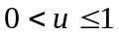, and 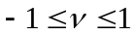. Do the transformation x= sv/u+a, y=u². The rectangle in the (u,v) plane is transformed into a hat function y = h(x) in the (x,y) plane. All (x,y) points will fall under the hat curve y = h(x) which is uniform in the center and falls like x⁻² in the tails. h(x) is a useful hat function for the rejection method. The acceptance condition is v < f(x)/k. s and a are chosen so that f(x) ≤ k h(x) for all x, where

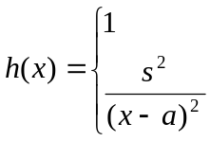 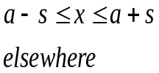 (5)
                              
The advantage of this method is that the calculations are simple and fast, and the rejection rate is reasonable. Quick acceptance and quick rejection areas can be applied. For discrete distributions, f(x) is replaced by f([x]) .
The following values are used for the hat parameters for the Poisson, binomial and
hypergeometric distributions
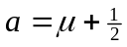 and
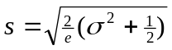+s₁, 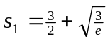
where μ  is the mean and σ² is the variance of the distribution (Ahrens & Dieter 1989). These values are reasonably close to the optimal values. It is possible to calculate the optimal values for a and s (Stadlober 1989, 1990), but this adds to the set-up time with only a marginal improvement in execution time. The optimal value of k is of course the maximum of f(x): k =f(M), where M is the mode.

Box-Muller transformation
A special transformation method is used for the normal distribution (Devroye 1986).
1. Generate two independent uniform variables u and v in the interval [-1,1]
2. Set z = u²+v²
3. If z ≥ 1 then reject and go to step 1
4. Set 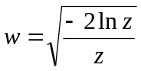
5. x₁ = uw and x₂= vw are independent variables with distribution normal(0,1)

- http://www.math.sci.hiroshima-u.ac.jp/~m-mat/MT/emt.html
- M. Matsumoto & T. Nishimura, in: ACM Transactions on Modeling and Computer Simulation, vol. 8, no. 1, 1998, pp. 3-30;

