Test of New Stripping Foils in the Booster

Jim Lackey and Weiren Chou (March 31, 2008)

The amorphous carbon foil made by Arizona Carbon Foil (ACF) has been used in the Booster for many years for charge-exchange injection, i.e. to convert H⁻ particles from the Linac to H⁺ particles circulating in the Booster. Recently, we received several new types of foils from TRIUMF and KEK, which were made by new technologies and of new materials.

TRIUMF provided us with two types of foils. One is multi-layer, which is 2.1 μm thick (approx. 400 μg/cm²) including 0.45 μm diamond-like-carbon (DLC) that is sandwiched between two layers of amorphous carbon (~0.8 μm each). (Figure 1) Another is DLC foil, which is also 2.1 μm thick and made of diamond-like-carbon deposited on a thin amorphous carbon film. Both types of foils have been installed in the Booster and tested.

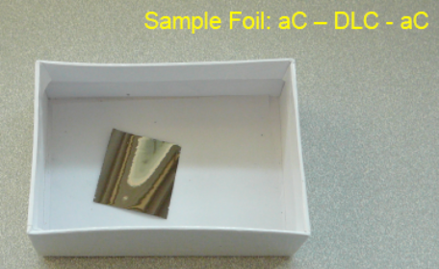

Figure 1: A multi-layer foil made by TRIUMF.

KEK provided us with several HBC (hybrid-boron-carbon) foils of various thicknesses. They have high durability and a lifetime of 1-2 orders of magnitude longer than amorphous carbon foils in a CW beam irradiation test at KEK. (Figure 2) We will install them in the Booster during next shutdown (or earlier) for pulsed beam testing.

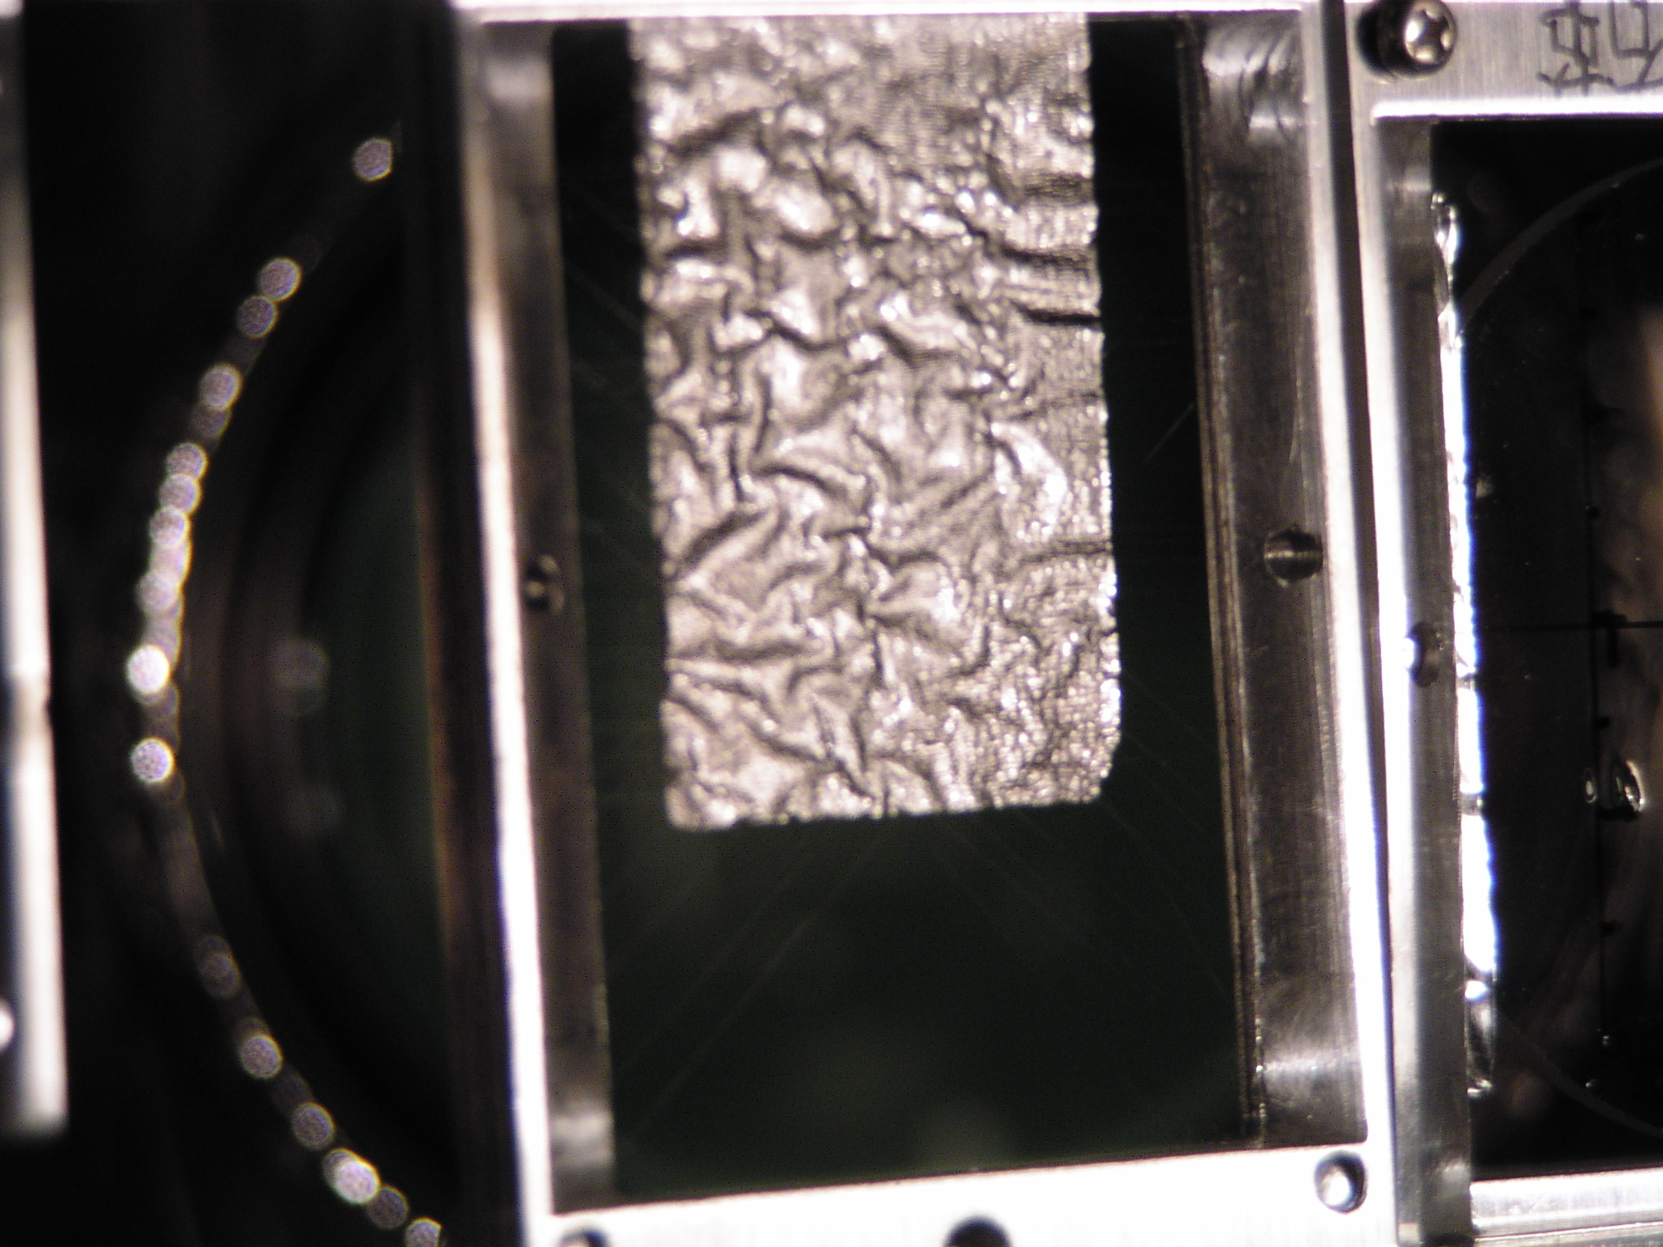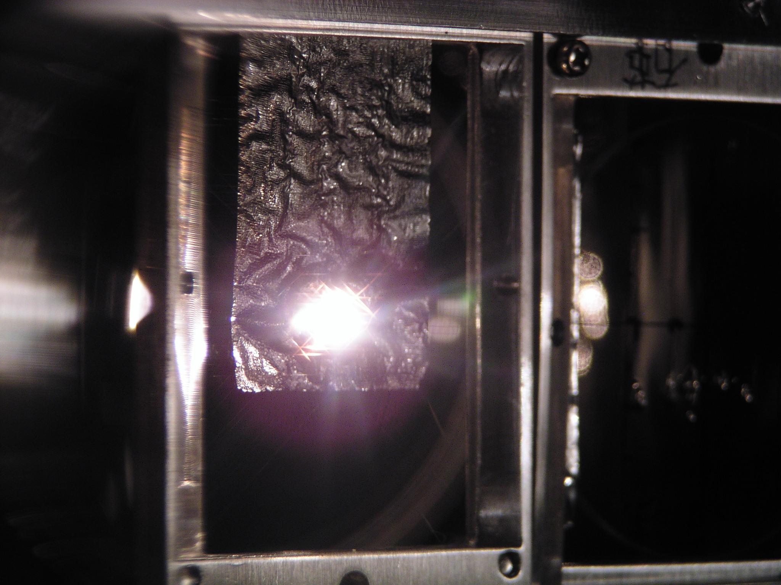

Figure 2: Left – HBC foil; right – HBC foil under irradiation of a continuous 750 keV H⁻ ion beam.
Figures 3 and 4 show a performance comparison between the TRIUMF foils and ACF foil. Four foils of the same thickness (2.1 μm) were compared. One is the ACF foil (Figure 3, left), one is the TRIUMF multi-layer foil (Figure 3, right), and two are the TRIUMF DLC foils (Figure 4). The yellow curves are the H⁰ losses during injection in the Booster. It is seen that, while the multi-layer foil gives similar H⁰ losses as the ACF foil (Figure 3), the DLC foils reduce the H⁰ losses by half. This could be attributed to better stripping efficiency of the DLC foil. The TRIUMF DLC foil is now used in normal Booster operation.

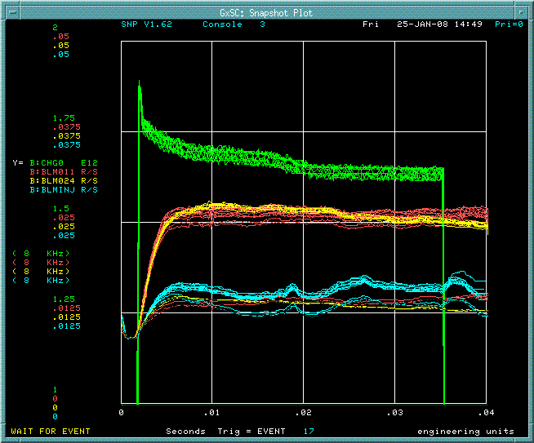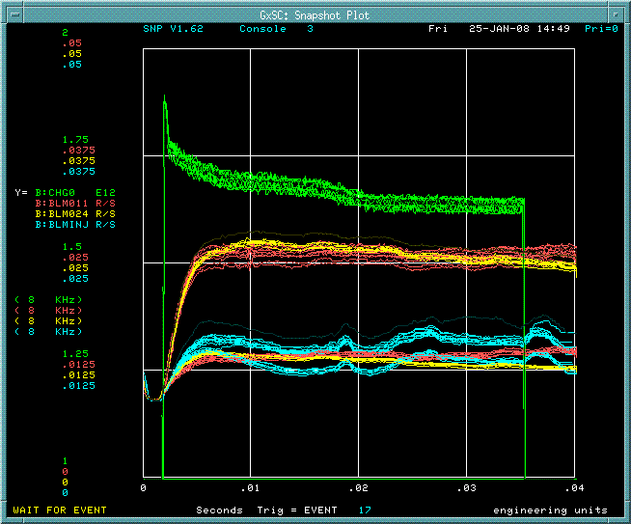

Figure 3: Yellow curves are the H⁰ losses. Left – ACF foil; right – TRIUMF multi-layer foil.

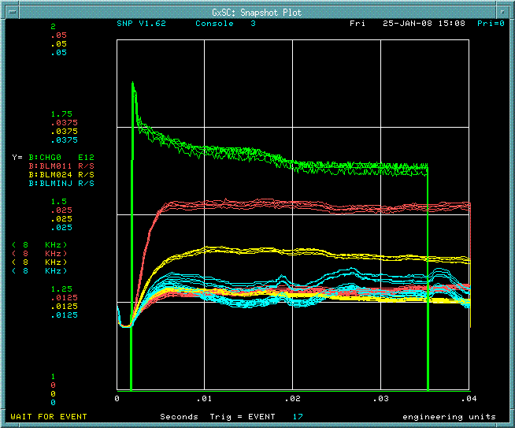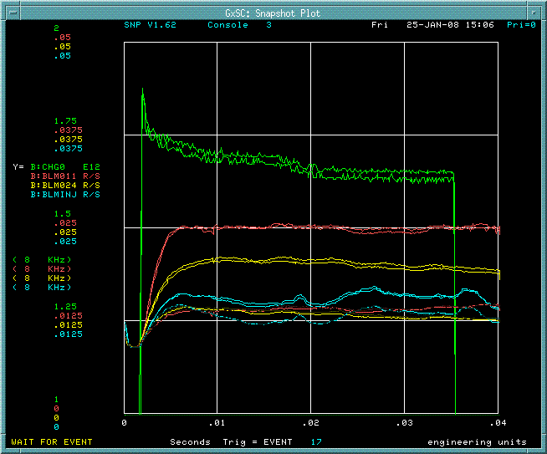

Figure 4: Yellow curves are the H⁰ losses. Left – TRIUMF DLC foil; right – another TRIUMF DLC foil. The H⁰ losses are about half of that in Figure 3.

These new foils from TRIUMF and KEK will be valuable for future beam intensity upgrade, including NOvA, SNuMI and Project X.

