Main Injector Department Note
January 21, 2007

The bunch length measurement with the wall current monitor in the Fermilab Main Injector
I. Kabardin, Novosibirsk State University
Supervisor: K. Seiya, Accelerator Division/Main Injector Department, FermiLab

Abstract

In this article a development of the data analysis algorithms to measure bunch lengths is described. There are two algorithms that we investigated: one is to fit Gaussian functions to wall current monitor outputs and the other is to
calculate the root-mean-square. Methods we used for the bunch length measurements in the 11-batch slip stacking at the Fermilab's Main Injector and for the examination how some RF cavities influence to the others.

Introduction
Fermilab Main Injector accelerates protons and extracts them to the antiproton production target for the Tevatron collider operation and Numi target for the MINOS neutrino experiment.
In order to increase proton intensity in the Main Injector, it was used a scheme called “slip stacking”. With slip stacking, the intensity of bunches can be doubled by injecting one bunch train at lightly lower energy, another train at lightly higher energy and bringing them together.
For slip stacking, we use three different RF systems and follow four steps, which can be examined in fig.1. The scheme of the Slip Stacking can be described in next 4 steps. Step 1: The first 5 bunch trains are injected from the Booster on the central orbit and captured by the first RF system. To make a room for the second bunch train, the trains are decelerated until it circulates on the inside of the central orbit. Step 2: Six bunch trains are injected on the central orbit and captured by the second RF system. Step 3: As the two groups of bunch trains have slightly different energies, they can move relative to each other. Step 4: When the two groups of trains coincide at the same longitudinal location, they are captured by the third RF system. The typical wall current monitor signal is illustrated in fig.2. The first 5 batches are injected on the central orbit (first 20 traces). To make a room for the second bunch train, they are then decelerated and other 5 batches are injected (next 26 traces). Finely both bunch trains are captured by third RF system(last 4 traces)
The goal of the data processing is to calculate the each bunch width and its central position.
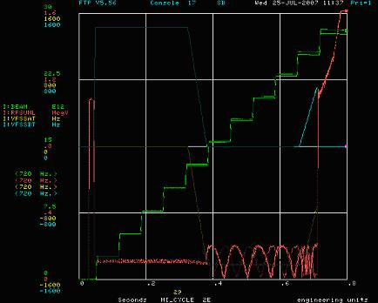 | 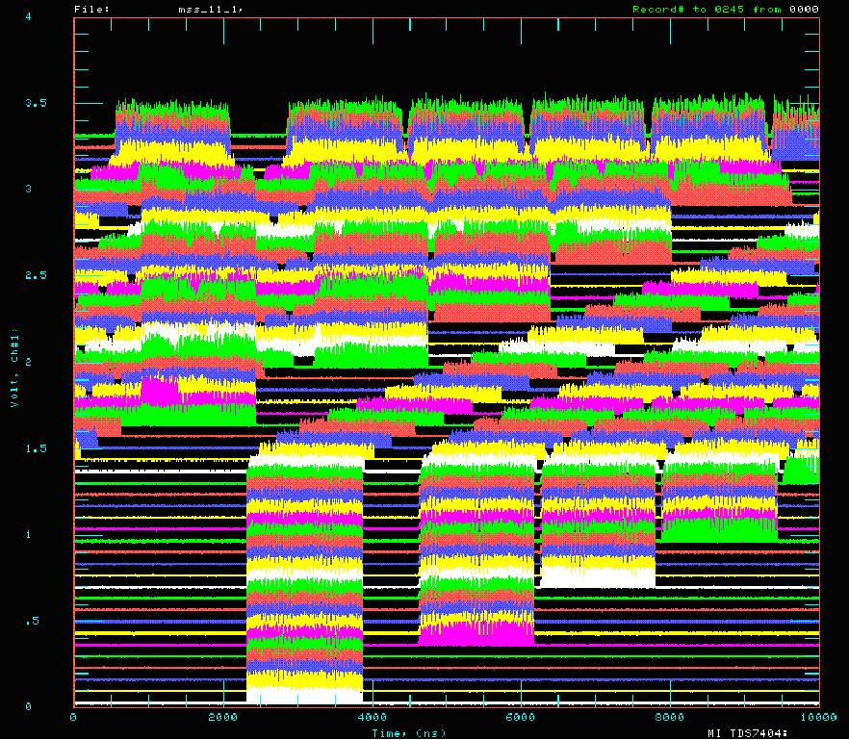
Fig. 1. The green line is intensity(x10¹² proton/pulse). The red line is RF Voltage (Mega Volts). The yellow line is frequency of RF system A (MHz). The cyan line is frequency of RF system B (MHz). | Fig. 2. The typical 11-batch slip stacking mountain range plot. The mountain range plot is a set of traces (250 items). Each trace is plotted on a graph in 10 micro sec.

Data processing
Gaussian fit
All the experimental data was taken from wall current monitor. There are 250 traces with number of 100000 points with 10 GHz sampling rate in each trace. The revolution in the Main Injector is ~11 micro sec. Figure 3 shows one of traces from the mountain range plot. The trace has same number of peaks with the number of bunches (fig. 4).
The data processing was done in the following way. A threshold was set for a trace and a peak in between the crossing points was searched (fig. 5). The data in one rf bucket, ~20 nsec, was fit to Gaussian using the peaks as input parameters (fig. 6).
The fitting results for all traces were shown in one graph, fig 7. The X-axis shows central position of the bunch. The Y-axis shows trace number which were taken every 256 revolution turns. And the color of the point means the bunch length. **
Data processing on the basis of fitting with Gaussian function gives error about 1%. The processing time was about 22 hours for one set of data. This program was unsuitable for real-time data processing for the operation.

Root mean square
In order to reduce time for a data processing, the root mean square value was calculated.
From statistic we know that for function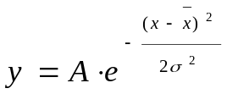, the mean values can be calculated by formula
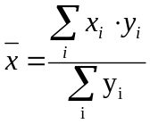 (1)
and the root mean square value can be calculated by formula
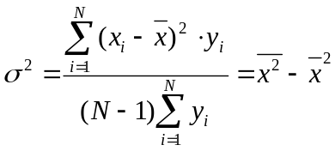 (2).
On the basis of the aforesaid the methodic can be illustrated in the following way. There was DC offset on the wall current monitor signals. It was changing with the total beam intensity in the ring and shown in figure 8 as a function of trace number. The offset was deducted from every trace. After the peak search, the mean value and the root mean square value were calculated and plotted in fig. 10. The execution of the algorithm on the basis of the root mean square calculation takes 10 seconds. The error is about 10%. These things make it proper for real time measurements.

The results of bunch length measurement on the basis of Gaussian function fitting are presented on fig. 9. The results of bunch length measurement on the basis of the root mean square calculation are presented on the fig. 10.

The bunch length also has been measured during acceleration. The bunch length at the transition energy tends to zero in a theory. The mesured of 95% half bunch length is shown on fig. 11. The length was minimum at 21.6·10¹⁰ eV/c which agreed with designed value of the momentum at transition at the Main Injector.

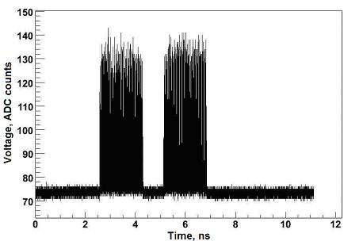 | 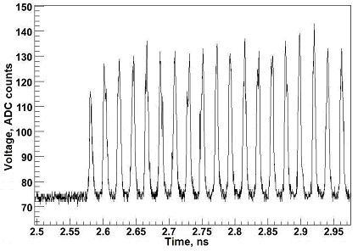
Fig. 3. The wall current monitor signals in one trace. | Fig. 4. The part of the first trace was expanded and shown in this figure.

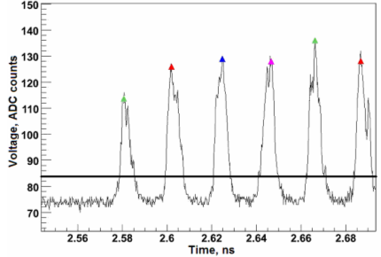 | 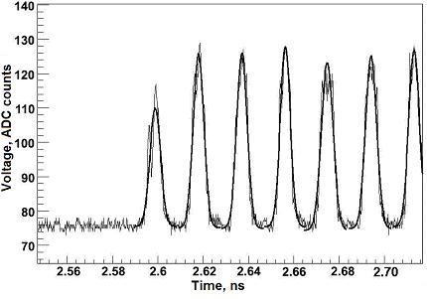
Fig. 5. The part of the trace with found maximums and threshold. | Fig. 6. The piece of the trace with added fitting Gaussian functions.

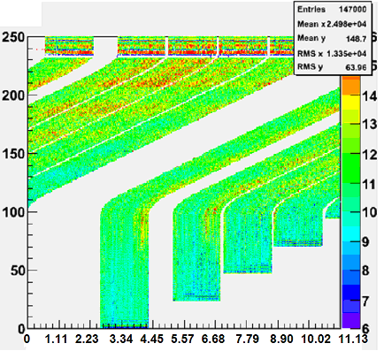 | 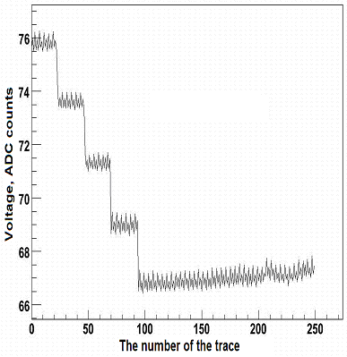
Fig. 7. The result of data processing with Gaussian functions. | Fig. 8. The dependence of the trace offset from number of the trace.

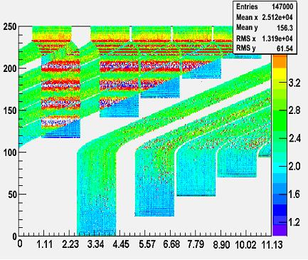 | 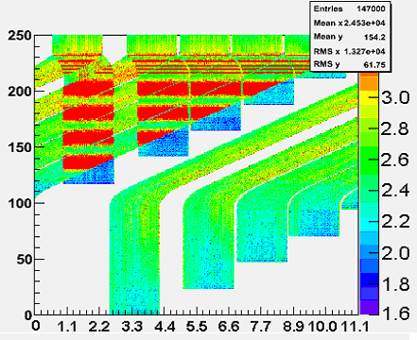
Fig. 9. Bunch length measurement with Gaussian function. | Fig. 10. The bunch length measurement on the root mean square calculations.

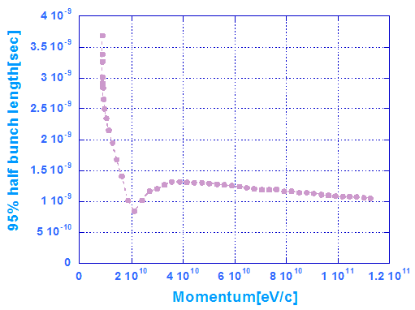
Fig. 11 The bunch length takes the minimum at speed corresponding to the transition gamma.

Experimental results
The slip-stacking scheme uses two RF systems. It is necessary to know how the RF system B influences on the RF system A. For this purpose there was made a following experiment. Five batches were injected on the central orbit. In the first case (fig.12) the RF system B is turned on and all five batches are captured by the RF system A. In the second case all the batches are captures by the RF system A, but the RF system B is turned off(fig.13). The results of the experiment are presented on fig.14, 15. The divergences of corresponding bunch length are less than 10% and so it was decided that RF system B do not influence on the RF system B.
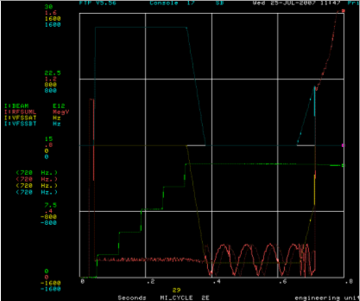 | 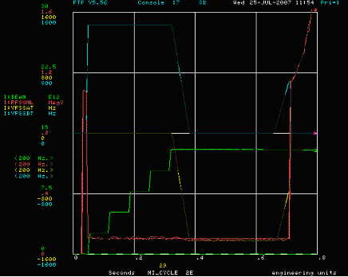
Fig. 12. Total rf voltage (red), frequency offset for RF system A(yellow) and RF system B(cyan) when RF system B is turned on. | Fig. 13. Total rf voltage (red), frequency offset for RF system A(yellow) and RF system B(cyan) when RF system B is turned off.

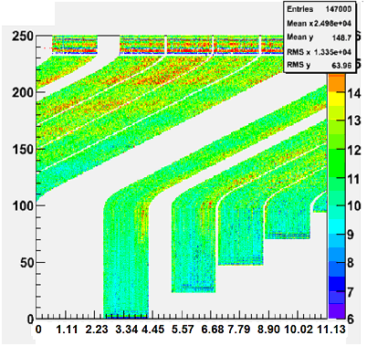 | 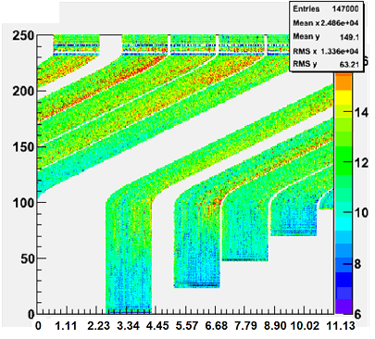
Fig.14 Bunch length measurement when RF system B was turned on. | Fig.15 Bunch length measurement when RF system B was turned off.

Conclusion
There were developed two data analysis algorithms for the bunch length measurement for the wall current monitor in the main injector at Fermilab. The first method is based on the fitting with Gaussian function. This algorithm gives error about 1% and takes 22 hours to process data for one experiment. The long time of execution makes it inappropriate for real time measurement. For real time measurements there was developed a method on the basis of the root mean square value calculation. This algorithm gives error about 10% and takes 12 seconds (24000 times faster than first!) to process the data. The algorithms were used in the 11-batch slip stacking measurements. The methods were used in the investigation of influence of the part of main injector's RF cavities on the others. The measurements show that one part of the RF cavities does not influence on the other.

Acknowledgements
I would like to acknowledge contributions of my supervisor K. Seiya for making the detailed drawing of the slip stacking procedure for me; I. Kourbanis for his advices about program writing; V. Nagaslaev for his help with studying programs to do data processing; D. Capista for help with software; A. Shemyakin for helping with reports. I am grateful to my supervisor K. Seiya for her explanations, target settings and advices; discussions with her were very useful for improving my knowledge.

References
- An introduction to the Physics of High Energy Accelerators, ed. D.A. Edwards, M.J. Syphers, SSC Laboratory, Dallas, Texas, 1993
- Handbook of accelerator physics and engineering, ed. A.W. Chao, M. Tigner,1999
- K. Seiya et al,, “Multi-batch slip stacking in the Main Injector at Fermilab”, PAC 07, Albuquerque, New Mexico, Jun 2007.

