Pingree Earth Quake Feb 10, 2010
J Volk, V Shiltsev
February 22, 2010

On February 10th 2010 a magnitude 3.8 earthquake (USGS reference US2010snay) occurred 3 km East north east of Virgil Illinois near Pingree Grove. While the magnitude was low the resultant ground motion caused beam loss in the Tevatron resulting in a quench of the superconducting magnets at E sector (1). There are two seismic stations at Fermilab. One station located on the surface at the B 48 kicker building the other in the MINOS near hall 100 meters below the surface. Figure 1 shows the Fermilab site with the locations of both seismic stations. Each station has two CMK3 Budker Institute of Nuclear Physics seismometers (2). One is for vertical motion the other is for horizontal motion. This is the analysis of the ground motion at the surface and 100 meters below the surface.
Figure 2 shows the time plot of both the horizontal and vertical seismometers for the B48 (surface) station. The maximum voltage produced by the seismometers is 10.2 volts. The horizontal seismometer was pegged for 7 seconds the vertical seismometer was pegged for 3 seconds. Figure 3 shows the Fast Fourier Transform (FFT) for both horizontal and vertical motion. The FFT was done with ORIGIN 8.0 software. The horizontal motion shows a peak at 0.38 hertz there is no well defined peak in the vertical motion, but a broad distribution around 0.25 hertz.
Figure 4 shows the time plot for the seismometer stations in the MINOS near hall. The seismometers sit on the floor at the junction of the Makokata shale and the Galena Platteville dolomite. The seismometers are not pegged during the earthquake. Figure 5 shows the FFT of the horizontal and vertical seismometers. There is a clear spike at 0.38 hertz in the vertical and no discernable peak in the vertical but 0.25 hertz will be used for calculation of motion.
Motion can be calculated using the formula;
Motion in micrometers = volts/0.52*frequency in hertz
Table 1 gives the calculated values of motion for all four measurements.
Station | Horizontal motion micrometers | Vertical motion micrometers
B48 | >100 | >100
MINOS | 50 | 31

There was more significant motion on the surface than at 100 meters below the surface. Since the Tevatron is less than 10 meters below grade on the glacial till the motion of the magnets can be estimated to be in excess of 100 micrometers. This is sufficient to cause large orbit distortions and loss of beam leading to the quench at E0.
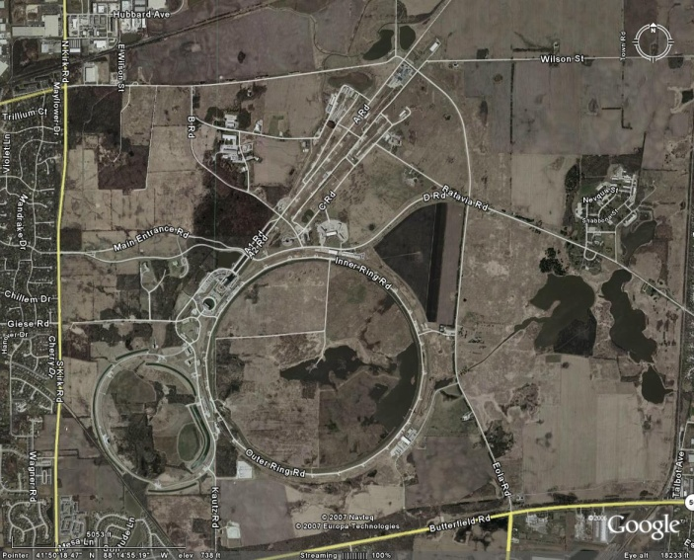
MINOS
B-48 kicker
building
Figure 1 location of seismometer stations at Fermilab
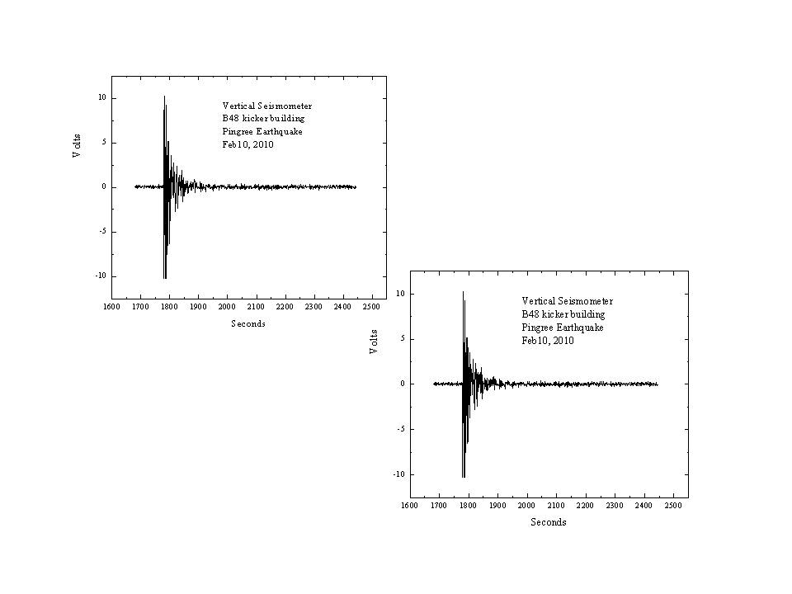
Figure 2 time plots of B-48 kicker building seismometers
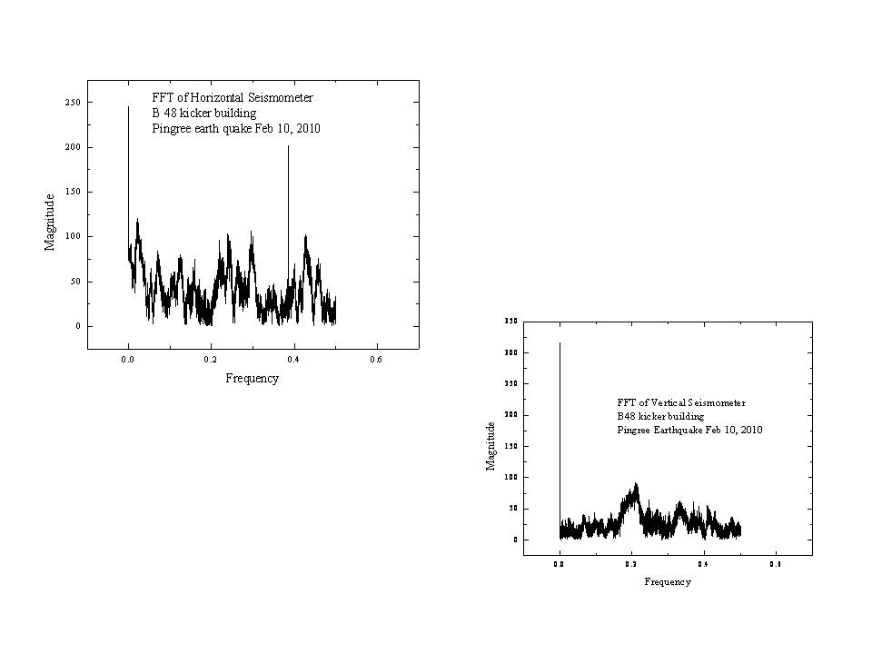
FFT of B-48 kicker building seismometers
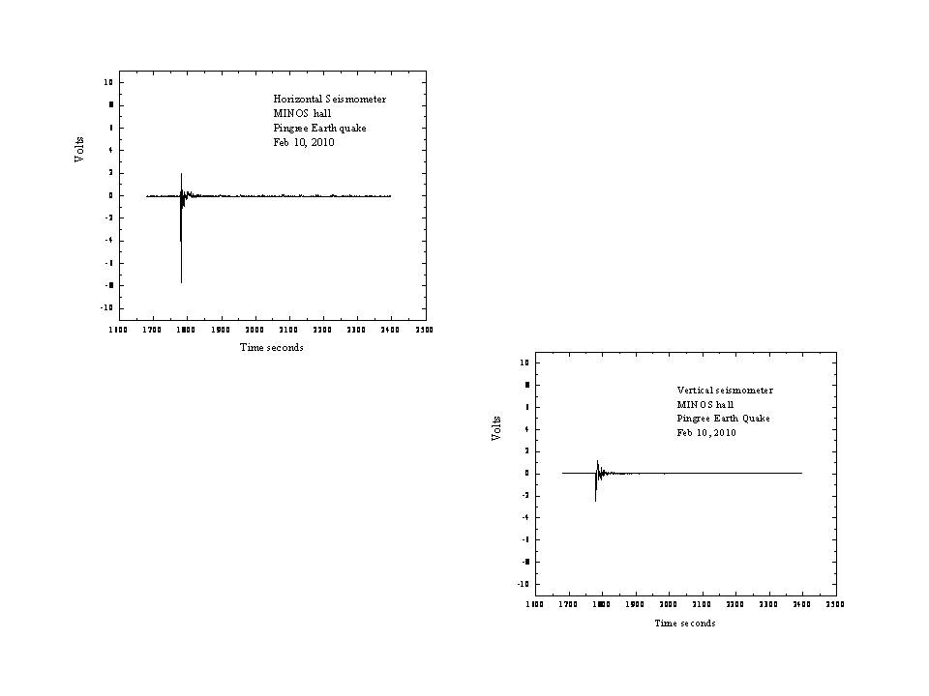
Figure 4 time plots of MINOS hall seismometers scales are the same as Figure 2
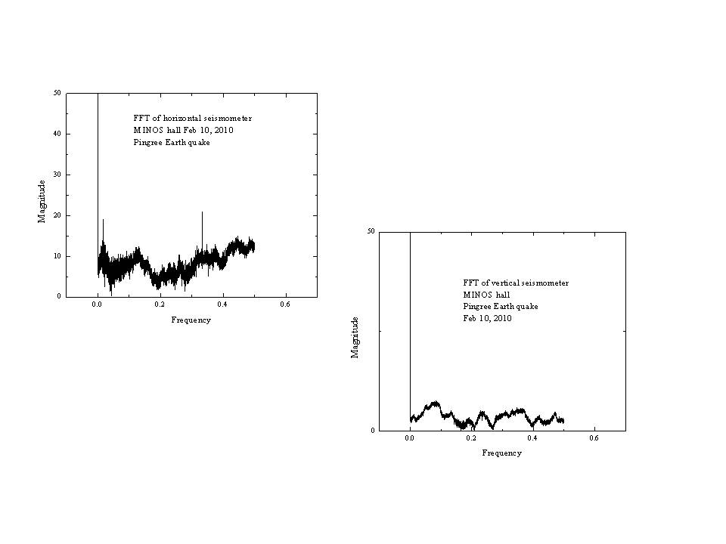
Figure 5 FFT of MINOS hall seismometers
- Main Control room log Feb 10
http://www-bd.fnal.gov/cgi-mcr/elog.pl?nb=2010&action=view&page=109&scroll=false
- Seismic Measurement at Fermilab for Future Colliders Projects, Budker Institute, Novosibirsk March 1997

