Radiation Shielding Tests for Laser Power Supply
Dave Johnson (APC)
Wayne Schmitt(AD ES&H)
March 18, 2010

The design of the Big Sky Ultra Nd:YAG laser system requires the power supply/water pump be within approximately 20 feet of the laser head. The design of the Booster system has the laser head installed in the launch box (black box pictured in Figure 1) with the power supply located in the back corner on the floor. The power supply (ICE) unit is connected to a control computer via RS232 communications port. A LabView program is utilized for control of the ICE power supply functions, data taking, and control of the scanning galvanometers. Within the first two weeks after the start up from the long shutdown the communications were interrupted between the ICE and the computer. It is unknown when within this period communications failed, however we know that the integrated charge in Booster during the period up to Sept 15 was about 8E17.
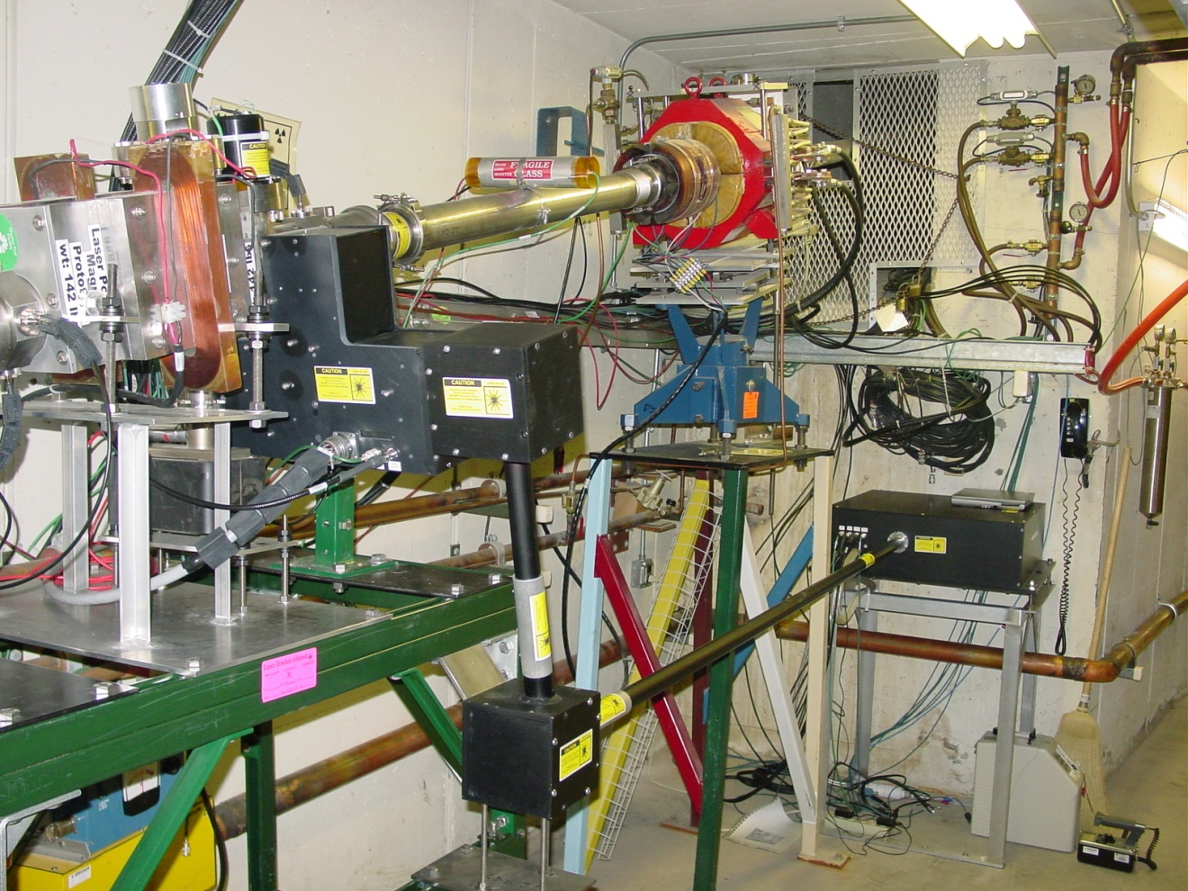

Figure 1: Lay out of the laser Profile Monitor Components in the Booster tunnel. The laser power supply is shown being removed. The installed position was back behind the launch box legs and the quad stand legs. The interlocked “Chipmunk” radiation detector (yellow/blue box) is in the lower left hand corner. The LPM optical system is contained in the black enclosures attached to the H- beam pipe.

The communications failure was ultimately traced to failed primary and control power supply components in the ICE supply (presumably due to interaction of the components with ionizing radiation).

The purpose of this study is to determine the type and magnitude of radiation fields at the location of the power supply and determine if a shielding enclosure could be constructed which would attenuate radiation to a “safe level” for re-installation of the ICE power supply (although this “safe level” has not yet been defined).

A temporary shielding enclosure was constructed out of poly/sand bags in the back corner below the 400 MeV Chute. At this location only two walls (and a top) were needed. The enclosure had an interior dimension of approximately 2 feet square and about 2 feet high. The walls were about 1 foot thick. Borated poly boards were installed against the back concrete walls to absorb any neutrons that might be reflected/scattered into the enclosure. A borated poly board was used for the top. It is assumed there would be little flux entering the shielded enclosure from the concrete. Figure 2 shows the location of the laser launch box and the location of the temporary shielding enclosure.
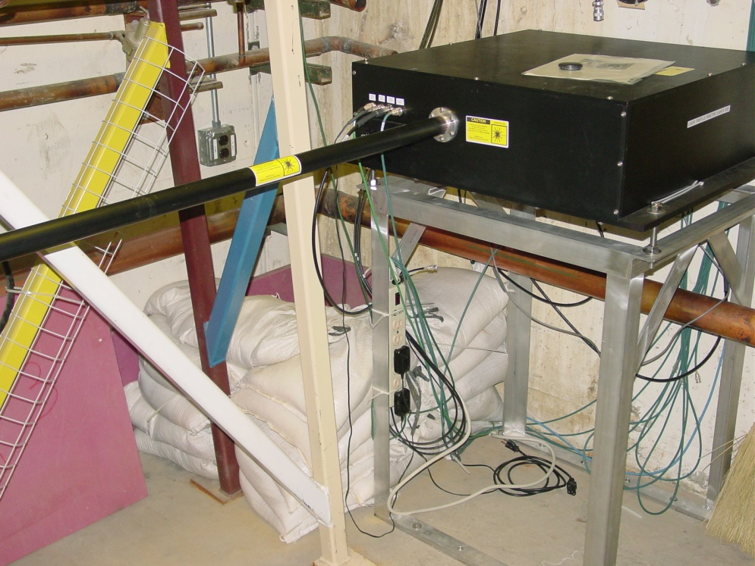

Figure 2: Shielding location for radiation testing. Note the (pink) borated poly boards on back walls. The poly board in the foreground is used as a top for the enclosure.

Detectors:

Standard Fermilab Area Monitor badges were used to measure types and levels of radiation present at the outside and inside surface of the poly bag shield wall. These badges are routinely used at Fermilab. These detectors have sensors for photons (x-ray and gamma ray), beta particles, and neutrons (both fast and thermal). Table 1 gives the energy range in which the badges are sensitive and the dose measurement range for the various types of radiation detected.

Table 1: Area Monitor Badge Measurement Specifications
Type | Energy Range | Dose Measurement Range
Photon | 5 keV to in excess of 40 MeV | 1 mrem – 1,000 mrem
Beta | 150 keV to in excess of 10 MeV | 10 mrem – 1,000 rem
Fast neutrons | 40 keV to 40 MeV | 20 mrem – 25 rem
Thermal/Intermediate neutrons | 0.25 eV to 40 keV | 10 mrem – 5 rem

Four detectors (badges) were installed, two outside the shielding and two inside the shielding, to measure the attenuation. These detectors were chosen to try to measure the ratio of fast to thermal neutrons as well as any gamma contribution. Figures 2 thru 5 show the location of the badges inside, outside, the retrieval system, and the badge numbering system. Initially, we were going to make a tunnel access after a few hours of beam to remove the badges however, to minimize the impact on operations and start up, an alternative scheme was used. This scheme attached the film badges to a thin poly ribbons which were draped over the top of the sand/poly bags. These were connected to a long rope which was run on the tunnel floor about 400 ft to outside the A0 tunnel access door. In this way, we could remove the badges while being outside the radiation area and not require a tunnel access.

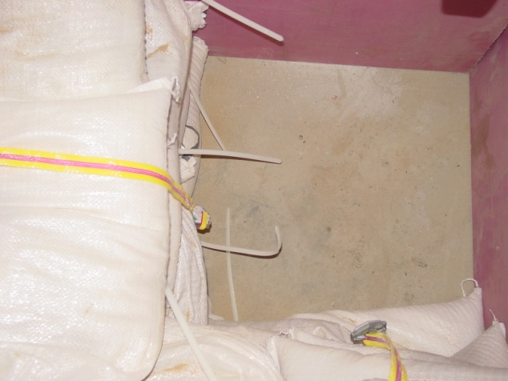

Figure 2: Badges inside shielding (with top of shielding removed)

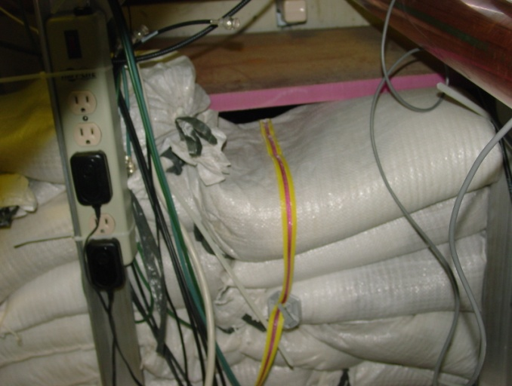

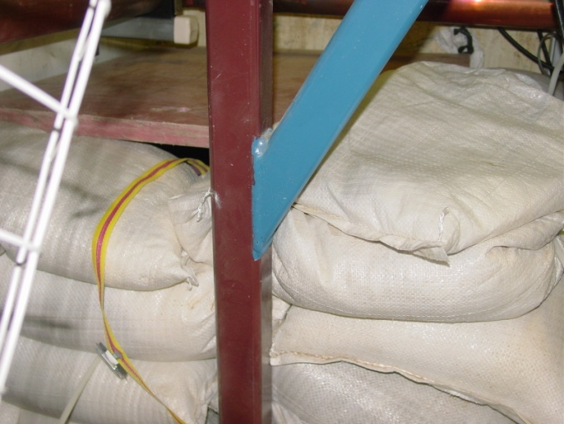

Figure 3: Location of the badges external to shielding. Note the gap between the poly bags and the ploy board. This was required to be able to remotely remove the interior badges.

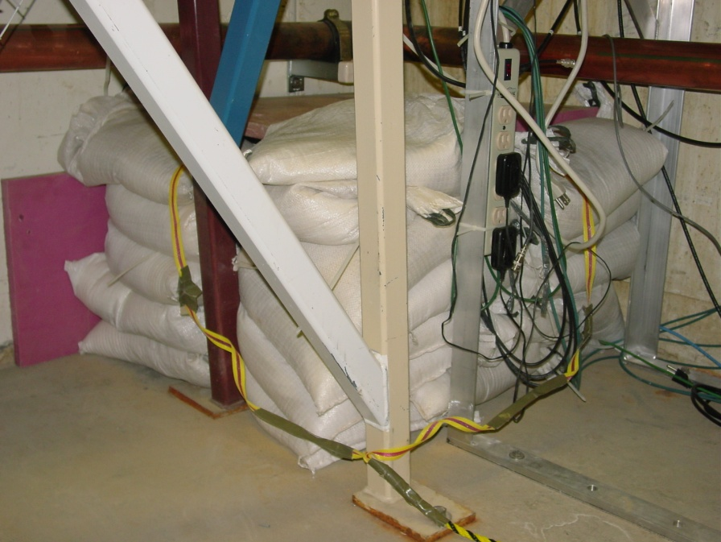

Figure 4: Badge retrieval system. Note the black and yellow rope attached to the magenta and yellow ribbons and badges. The rope was run on the floor of the Booster tunnel to outside the A0 access gate.

12
13
14
15
Quad stand legs
Laser launch box stand
Poly/sand bags
Linac Beam centerline
Linac Chute
Booster Beam line

Figure 5: Area monitor badge locations and numbering scheme as shown in figures 2 and 3.

The Experiment:

Four area monitor badges were installed at the locations discussed above. Booster beam was re-established after the access period averaging 3 to 5E12 per pulse. Figure 6 is a plot of accelerated charge each cycle (CHG1) and the integrated injection charge for the duration of the experiment from the data logger. During the test the integrated intensity was about 1.33E16 (averaging about 6.65E15/hr). After about 3 hours the beam was turned off and the badges were retrieved using the rope retrieval system. The rope and badges were checked for any contamination and were found to be clean. The badges were collected and sent off to Landauer, their manufacturer, for processing/reading along with their control badge.

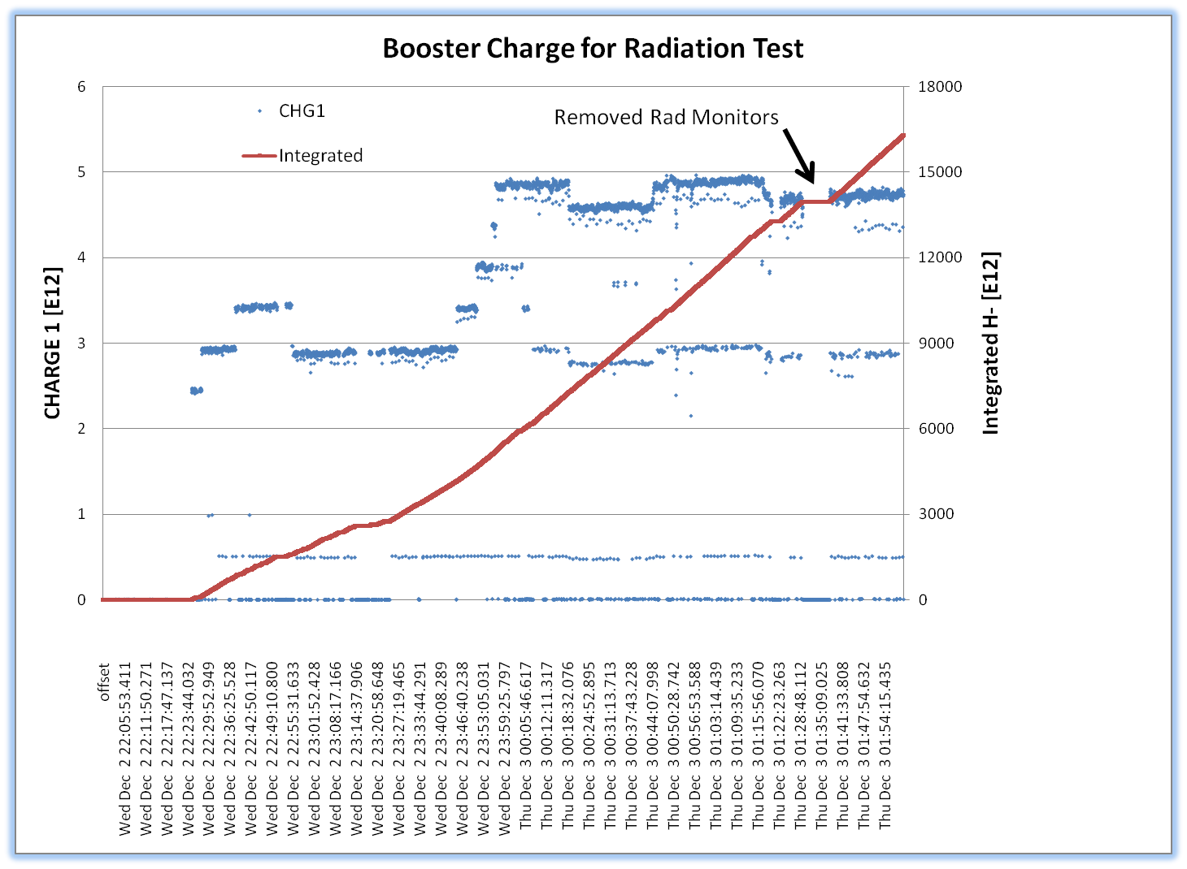

Figure 6: Booster pulse intensity (B:CHG1) and integrated intensity during the Radiation test. Data from the ACNET controls datalogger.

The results are shown in Table 2. The measured neutron dose outside the shielding was made up of 90% fast neutrons (40 keV to 40 MeV) and ~10% thermal/intermediate (called “slow” in the table) neutrons (0.25 eV up to 40 keV). The badge facing downstream (#12) along the beam line had a 50% larger accumulated dose that the badge on the side of the shielding (#14). Since the badges are generally shielded from direct showers from losses upstream of the chute area by the back wall of the chute (i.e. from

Table 2: Results of film badge readings in mrem.

Badge | Fast N | Slow N | Total
12(outside) | 350 | 40 | 390
13(inside) | 70 | 10 | 80
Ratio | 5 | 4 | 4.9
14(outside) | 230 | 30 | 260
15(inside) | 90 | 10 | 100
Ratio | 2.6 | 3 | 2.6

BRF23), the doses are likely from losses directly across from and downstream of the installation. Additionally, there was a reduction of the dose between outside and inside the ploy/sand bags of about 3 and 5. Both fast and “slow” neutrons saw approximately the same reduction. It should be noted that neither set of badges saw any gamma radiation above background. Investigating with Landauer, the badges were from 4/04 and the control badge had about 0.5 rem of gamma dose and each of the area monitor badges had < 0.4 rem. This result implies a null reading for gammas on the test badges.

The total neutron dose seen by badge #12 was 390 mrem. Assuming the dose rate was approximately constant over the three hour irradiation time this means that the dose rate seen by badge #12 (facing downstream) over the period was 130 mrem/hr (or 1.3 mSv/hr). This can be compared to the chipmunk located downstream on the wall which routinely pegged at 600 mrem/hr with beam on.

Depending on the energy spectrum, this rate can be used to approximate the neutron flux seen by the badges. Table 3 lists the neutron flux equivalent to a dose of 1 rem as a function of neutron energy. Since 90% of the dose to the badges was from “fast” neutrons in the 40 keV to 40 MeV energy range, we can estimate the flux seen by badge #12 by scaling the table values by 0.39 yielding between 5 and 50 X10⁶ neutrons/cm² at the badge location . Since we don’t know the real energy spectrum of the neutrons in the Booster tunnel, a conservative approach would be to use the higher energy value of 5x10⁶ neutrons/cm². If we assume a uniform accumulation rate, this flux gives a fluence of ~ 460 n/cm²/sec during the 3 hr irradiation time.

The neutron fluence at the test location is dependent on the location of the Booster loss and the relative magnitude of the loss. If we assume this test period is representative, then we should be able to scale these losses with the expected Booster intensity of a year period.

Table 3 gives the number of neutrons/cm² required for a dose of 1 rem as a function of energy. This data was taken from the Department of Army Tech memo 55-315.

Table 3:Neutron Flux Dose Equivalents
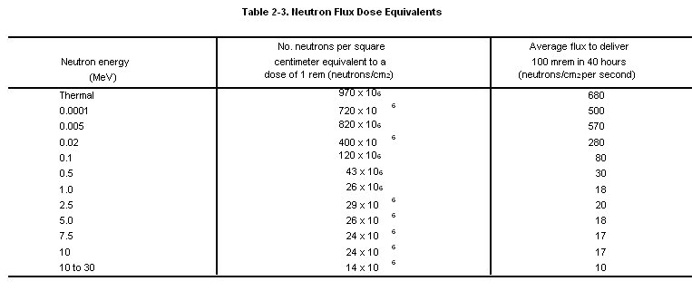

Shielding requirements

We are trying to shield the ICE power supply unit, which contain electronic components such as semiconductors. A table of radiation sensitivity of various component types, provided by Kamran Vazeri, shows that mild to moderate damage to semiconductor devices start around 10¹¹ neutrons/cm² for reactor neutrons with energies greater than 10 keV. The table indicates that incipient to mild damage occurs in the flux range of 10¹⁰ n/cm².

From this test, we see that the badge registered ~5x10⁶ n/cm² for 1.3x10¹⁶ protons, and we know that the ICE unit failed at an intensity of less than 8x10¹⁷ protons. Scaling with proton intensities says that the neutron flux should be less than 3x10⁸ n/cm² over a year period, significantly less than that predicted above. This includes some conservatism relating the dose to the energy spectrum since the dose equivalent for the highest energy neutrons was used.

The maximum yearly number of particles that Booster could expect to run can be estimated by assuming 4x10¹²/pulse at 15 Hz for 365 days/year or 1.9x10²¹/year. This clearly does not take into account for any down time. For integrated intensity projections a standard “Fermi year” is considered 5500 hours, taking into account downtime and shutdowns (0.6278 calendar year) which revises the estimate to 1.2x10²¹/year still at 15 Hz. Using a more realistic Booster rep. rate of 8 Hz brings the Booster intensity to 6.42x10²¹/year.

Using the maximum yearly number of particles, 6.4x10²⁰/year, we estimate the expected neutron flux of about 2.5x10¹¹ n/cm² over the course of a year outside the shielding. This implies that we will be looking for a factor of about 1000 in shielding effectiveness. The estimation for shielding is given in a separate document.

Summary

We have measured an accumulated dose in four radiation monitors (both shielded and non-shielded) in the approximate location of the laser power supply. We use this data to estimate an expected dose over a year running time with the goal of designing a neutron shield which will protect the power supply components. A summary of the measurements and calculated quantities follows.

- Booster integrated intensity (during test) 1.3x10¹⁶ protons in 3 hrs
- Maximum measured neutron dose (outside shield) 390 mrem
- Calculated neutron dose rate outside shield (1.3 mSv/hr)
- Calculated neutron flux outside shield 5x10⁶ neutrons/cm² , 10MeV<E_{n}<30MeV
- Calculated neutron fluence 460 n/cm²/sec
- Maximum measured neutron attenuation factor of 5 with test shield
- Estimated integrated Booster intensity 6.4X10²⁰/yr, nominal running
- Calculated expected maximum neutron flux outside shield 2.5X10¹¹ neutrons/cm² per year in energy range 10 MeV<E_{n}<30 MeV
- Calculated maximum expected dose 1.9x10⁴ rem accumulated in 5500 hrs (scaled from test data.
- Calculated maximum dose rate 3.5x10³ mrem/hr or 35 mSv/hr based on 5500 hrs
- Estimated flux at which ICE failed < 3x10⁸ n/cm²
- Estimated attenuation factor required, 1000.

