**Muon Collider Ring Lattice Design**

**Alexandr Netepenko**

**Supervisor: Yuri Alexahin**

**Fermi National Accelerator Laboratory**

**2010**

**Introduction**

Muon collider is a very promising and at the same time extremely challenging future project of accelerator and high energy physics community. Because of the difficulties of muons production and capturing, muons cooling, limited muons lifetime, there are several critical requirements for the muon collider ring design to achieve desired luminosity value.

First of all, with limited muons current and inability to achieve very small emittance, it is necessary to have tiny beta-functions at interaction point. With the requirement to have enough room for detector at IP, beta-functions on final focus quadrupoles become order of tens kilometers, which leads to drastic chromatic effects and appropriate correction scheme should be proposed.

Secondly, to maintain the short longitudinal beam size compared with the beta-star values to prevent the hourglass effect using modest RF systems we need to have very small compaction factor of the ring.

Furthermore, to accommodate as much incoming muons as possible one should have sufficient momentum acceptance, then, to utilize this muons we should have good dynamic aperture for this accommodated particles to survive at least one thousand turns, and it brings to play nonlinear detuning and resonance effects which should be addressed properly. After that all kinds of imperfections should be considered and studied deliberately to establish the feasibility of the muon collider ring construction and operation.

So it’s absolutely clear that muon collider ring design presents very sophisticated task and requires a lot of attention to its various aspects.

**Interaction Region design**

Let us start with a main part of collider ring – interaction region design issues. For the proposed beam energy of 750GeV, and beta function at interaction point of 10mm both in x and y planes and required room for detector of 6m we should provide IR optics design which keeps beta-functions on quads as small as possible. It’s also important not to forget about the maximum available quadrupole gradient and stay in feasible margin. The scheme with the final triplet quadrupoles having the parameters listed below was proposed. Magnetic rigidity for our energy is $Bρ=2500 Tm$

|  |  |  |  |  |
| --- | --- | --- | --- | --- |
|  | $$K1=\frac{1}{Bρ}\frac{dB_{z}}{dx}, m^{-2}$$ | $$L,m$$ | $$K1∙L,m^{-1}$$ | $$\frac{dB_{z}}{dx}, Tm^{-1}$$ |
| $$Q1$$ | $$-0.08$$ | $$2.6$$ | $$-0.208$$ | $$-200$$ |
| $$Q2$$ | $$0.052$$ | $$4.0$$ | $$0.208$$ | $$130$$ |
| $$Q3$$ | $$-0.05$$ | $$2.0$$ | $$-0.1$$ | $$-125$$ |
| $$Q4$$ | $$0.06$$ | $$1.0$$ | $$0.06$$ | $$150$$ |

Tab.1. Final focus quadrupole parameters

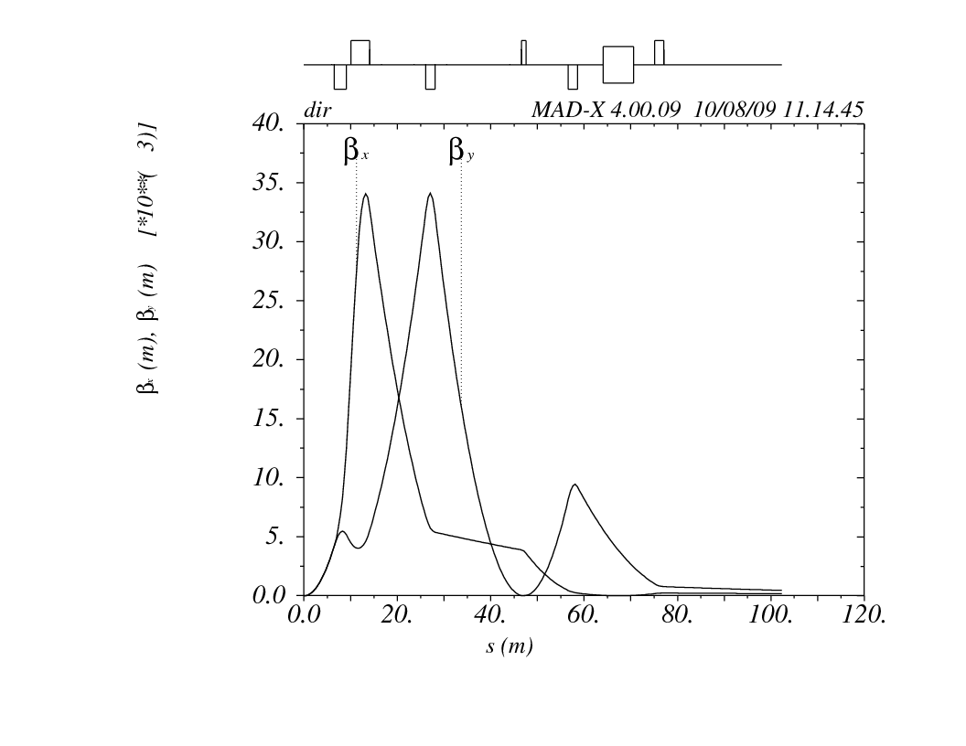

Pic.1. IR design and its beta functions

Anyway, it’s inevitable to have huge values of beta-functions order of 10s kilometers on strong quadrupoles that will produce large chromatic perturbations. To deal with it, let’s consider first beta functions chromatic perturbations theory.

**Chromatic beta function perturbation theory**

We are starting with putting to use two variables, where indices 1 and 2 in formulas correspond to beta function of design momentum particle and for particle with momentum deviation δ:

$$B=\frac{β_{2}-β_{1}}{\sqrt{β_{2}β_{1}}}=\frac{∆β}{β}$$

$$A=\frac{{α_{2}β}_{1}-{α_{1}β}_{2}}{\sqrt{β_{2}β_{1}}}$$

And defining

$$∆β=β_{2}-β_{1}, β=\sqrt{β_{2}β_{1}}$$

$$∆φ=φ_{2}-φ_{1}, φ={(φ}_{2}+φ_{1})/2$$

$$∆K=K_{2}-K_{1}$$

Using the known relations

$$\frac{dφ}{ds}=\frac{1}{β}, \frac{dβ}{ds}=-2α, \frac{dα}{ds}=Kβ-\frac{1+α^{2}}{β}$$

we can find

$$\frac{d(Δφ)}{ds}=\frac{d(φ_{2}-φ_{1})}{ds}=\frac{1}{β_{2}}-\frac{1}{β_{1}}=-\frac{∆β}{β^{2}}=-\frac{B}{β}$$

and

$$\frac{dB}{ds}=\frac{d}{ds}\left(\sqrt{\frac{β_{2}}{β_{1}}}-\sqrt{\frac{β_{1}}{β_{2}}}\right)=\frac{1}{2}\sqrt{\frac{β_{1}}{β_{2}}}\left(\frac{-2α_{2}}{β_{1}}+\frac{2α_{1}β_{2}}{β_{1}^{2}}\right)+…=\sqrt{\frac{β_{1}}{β_{2}}}\left(\frac{α_{1}β_{2}-α_{2}β_{1}}{β_{1}^{2}}\right)+…==-\left(\frac{α_{2}β_{1}-α_{1}β_{2}}{\sqrt{β_{2}β_{1}}}\right)\left(\frac{1}{β_{2}}-\frac{1}{β_{1}}\right)=-2A\frac{dφ}{ds}$$

$$\frac{dA}{ds}=βΔK+2B\frac{dφ}{ds}$$

These equations already show us, that in place of large beta and nonzero K, A function experiences strong kick proportional to δ, as far as $ΔK=\left(-K+S∙D_{x}\right)∙δ$ to the first order. One can also derive in small perturbation approximation the next equation for achromatic region:

$$\frac{d^{2}A}{{dφ}^{2}}+4A=0$$

It shows that the beta function perturbation propagates with twice the betatron frequency.

After the normalization to δ of above formulas we get

$$B=\lim_{δ→0}\left[\frac{1}{δ}\frac{β(δ)-β(0)}{\sqrt{β(δ)β(0)}}\right]$$

And the invariant for achromatic region represents an absolute measure of linear chromatic perturbations

$$W=\frac{1}{2}{(A^{2}+B^{2})}^{1/2}$$

On the next picture you can see the $W_{x},W_{y}$ chromatic functions of proposed interaction region without sextupole correction. More about the chromatic perturbation theory one can find in ref [1]

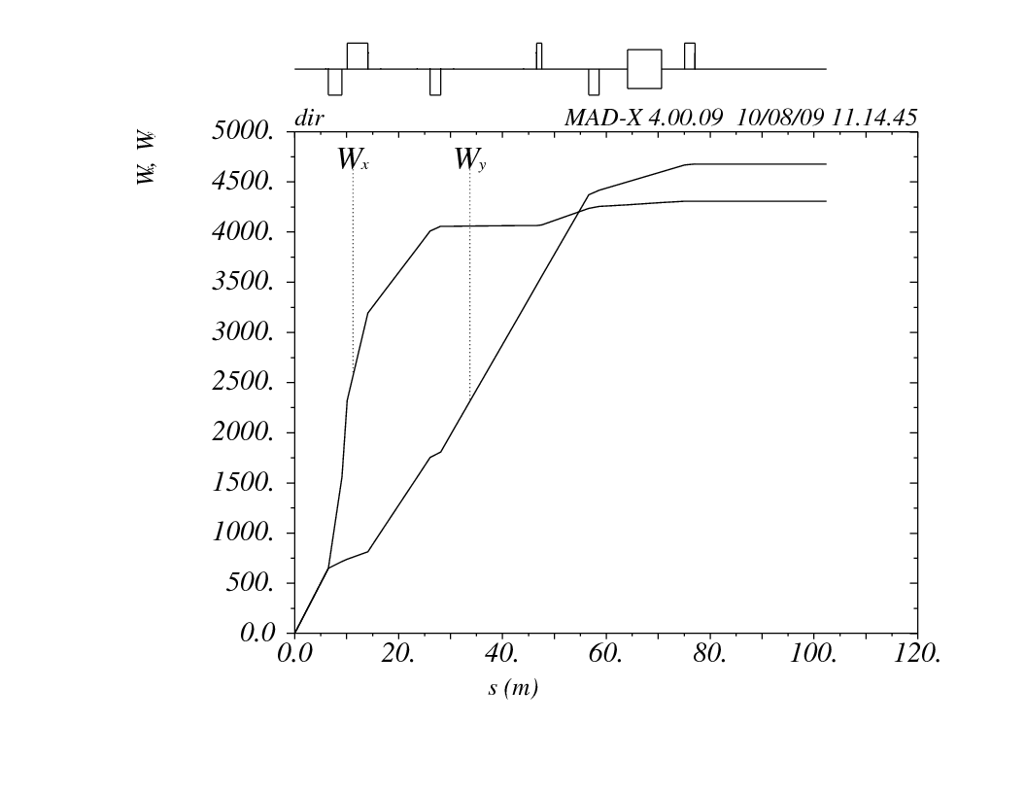

Pic.2. Chromatic functions of interaction region

In fact, in MAD program the chromatic beta perturbation functions are defined in different manner. The different set of variables is used, so the equations slightly different from mentioned above. But anyway, from the above plot we can see that for momentum deviation of ${10}^{-3}$ we will have $\frac{∆β}{β}$ of order 1, if we will allow this perturbation to propagate to the arcs and change its phase to bring the value from A term to B, because initially quadrupoles kick the A component. So it is strongly desirable to correct these perturbations locally.

**Chromatic perturbation correction**

For this correction it is necessary to have nonzero dispersion function in place of sextupoles near the final focus quads. One of the possible variants proposed was to have dispersion function crossing the IP at some angle, as shown on the next picture.

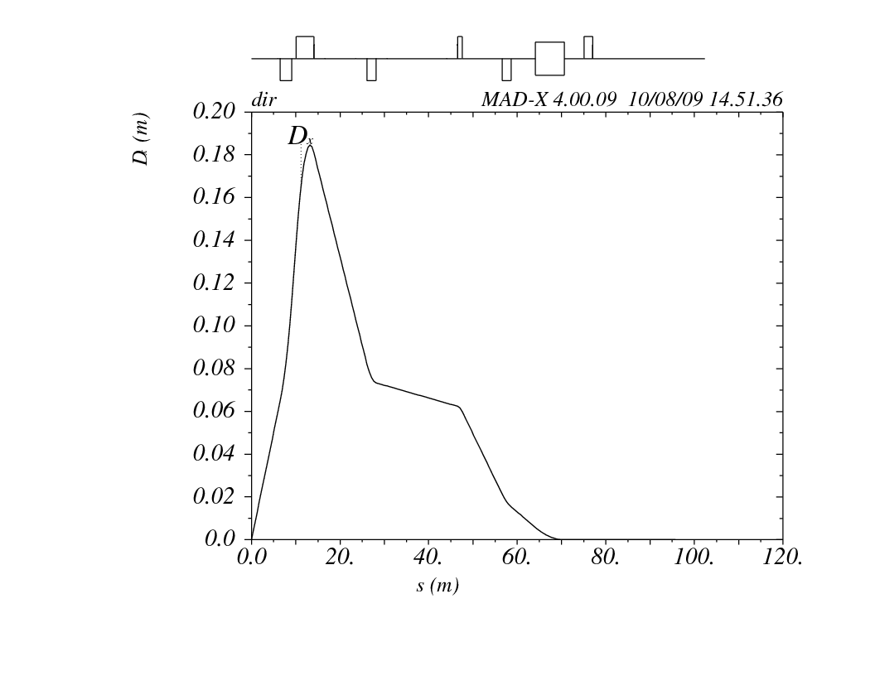

Pic.3. Dispersion function of IR

Having the dipoles bending in opposite directions from different sides of IP it is possible to bring dispersion to zero on sides and have anti-symmetric dispersion function.

Putting the sextupoles near each quadrupole we can correct chromatic perturbations. Basically you just compensate the focusing strength dependence with momentum deviation of the quads by sextupoles giving the effective quad gradient proportional to displacement which in its turn proportional to dispersion and momentum deviation.

$$\frac{dA}{ds}=βΔK+2B\frac{dφ}{ds}$$

$$ΔK=\left(-K+S∙D_{x}\right)∙δ$$

In such local chromaticity correction scheme we prevent the perturbation from the final focus quads to propagate to the ring lattice and cause the tunes and beta-functions dependence on the momentum offset. But, as will be shown below, with anti-symmetric dispersion function and opposite sign sextupoles on different sides from interaction point, the second order chromatic effects appeared to be drastic restriction for the stable motion momentum acceptance. In other words the local chromaticity correction cannot be done easily how it can be seemed at first glance.

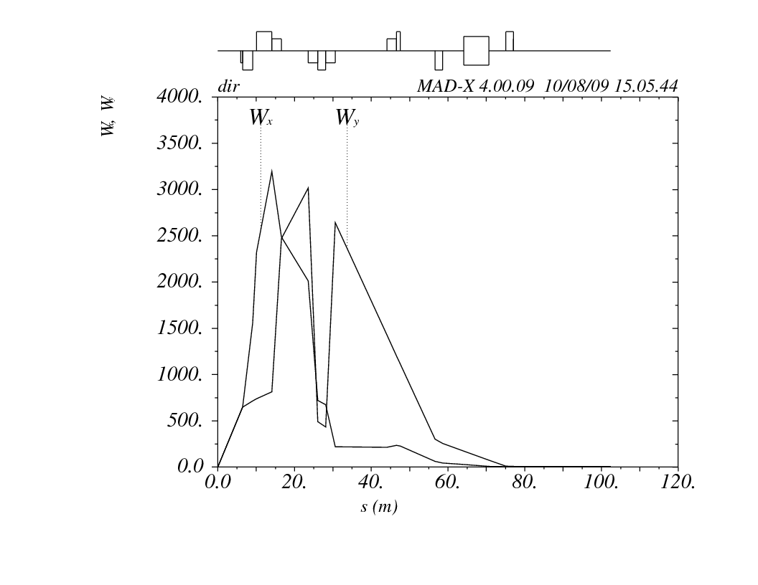

Pic.4. Corrected chromatic perturbation functions

For this design we have following sextupole parameters:

|  |  |  |  |  |
| --- | --- | --- | --- | --- |
|  | $$K2=\frac{1}{Bρ}\frac{d^{2}B_{z}}{{dx}^{2}}, m^{-3}$$ | $$L,m$$ | $$K2∙L,m^{-2}$$ | $$\frac{d^{2}B_{z}}{{dx}^{2}}, Tm^{-2}$$ |
| $$SX1$$ | $$-0.004948$$ | $$0.5$$ | $$-0.00247438$$ | $$-12$$ |
| $$SX2$$ | $$0.468864$$ | $$2.5$$ | $$1.17216$$ | $$1172$$ |
| $$SX3_1$$ | $$-0.560712$$ | $$2.5$$ | $$-1.40178$$ | $$-1401$$ |
| $$SX3_2$$ | $$-0.473618$$ | $$2.5$$ | $$-1.184045$$ | $$1184$$ |
| $$SX4$$ | $$0.034877$$ | $$2.5$$ | $$0.08719475$$ | $$87$$ |

Tab.2. Chromaticity correction sextupoles parameters

So the local chromaticity correction issue could seem to be easy and solved. But from the further investigation it will become clear that it’s delusion. But at this point it is essential to move to arc cell design issues to study then the whole closed ring optics periodic solutions.

**Arc design**

Designing the arcs we should remember about the compaction factor restriction. The expression for it is given by the next formula for the lowest order:

$$α_{0}=\frac{1}{C}\oint{ds\left[\frac{D_{x}(s)}{R(s)}-\frac{1}{{γ_{0}}^{2}}\right]}$$

As far as we have small positive contribution to the compaction factor from the IR, we need to have small negative arcs contribution. For this purpose so called FMC cell can be used. Its optic functions and dispersion are shown on the next picture.

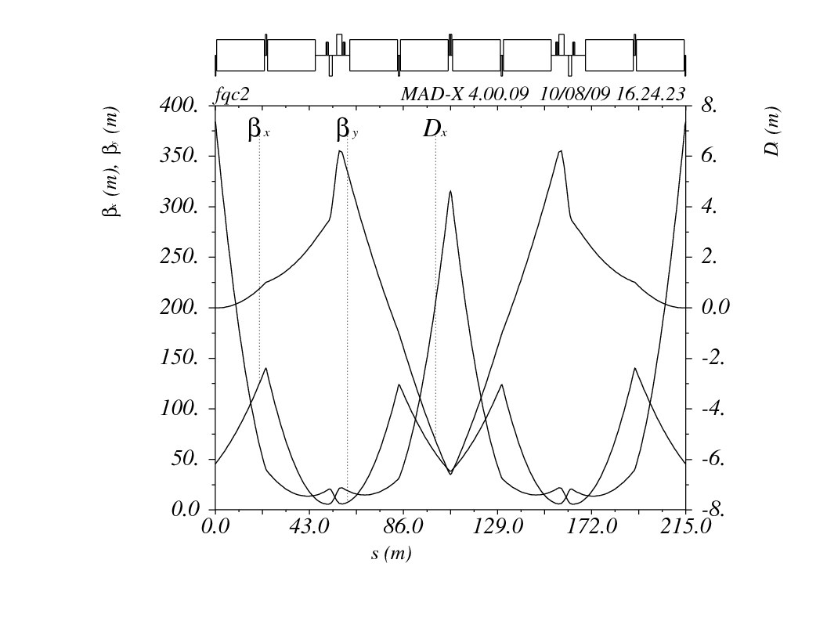

Pic.5. FMC cell dispersion and beta functions

For this cell compaction factor is $α_{0}=-9.5∙{10}^{-7}$ and in fact can be easily adjusted. The phase advance per one cell is equal to 1.25 for both planes. To close the ring we need to have nine such cells, because the bending angle of one magnet is $θ=π/36$ and we have eight of them in the cell, where the length of each magnet is $L=21.83m$, and the magnetic field magnitude is $B=10T$

**Second order chromaticity calculation**

Now, having the ring structure we can calculate the tunes and compaction factor momentum dependence. But before, it is better to correct natural chromaticity of the ring, which is initially $Q_{x}^{'}=-20.6, Q_{y}^{'}=-43.8$, by putting two sextupole families in the arc. Sextupole families planning is well described in ref [2]

After that we can obtain the next picture showing the fractional part tunes dependence of momentum deviation, where upper one is x tune.



Pic.6. Tunes momentum dependence

From this plot using fitting procedures we can find, that the second order chromaticity in our case has a value of $-1.88∙{10}^{6}$ for x and $-2.02∙{10}^{6}$ for y plane.

So we need to figure out why we do have so huge second order chromaticity. The first and the second order chromaticity are given by the next formulas:

$$ξ_{1}=\frac{1}{4π}\int_{0}^{C}{β_{0}(s)}\left[S_{0}\left(s\right)D_{0}\left(s\right)-K_{0}\left(s\right)\right]ds$$

$$ξ_{2}=\frac{1}{8π}\int_{0}^{C}{\left[S_{0}\left(s\right)D_{0}\left(s\right)-K_{0}\left(s\right)\right]}Δβ_{1}^{c}\left(s\right)ds+\frac{1}{4π}\int_{0}^{C}{β_{0}(s)S_{0}\left(s\right)ΔD_{1}^{c}\left(s\right)}ds-ξ_{1}$$

Since we have the sextupoles in places with large beta function, and if we will have nonzero chromatic dispersion derivative in these places, the second term of the second equation will contribute critically in second order chromaticity. On the next picture the second order dispersion is shown.

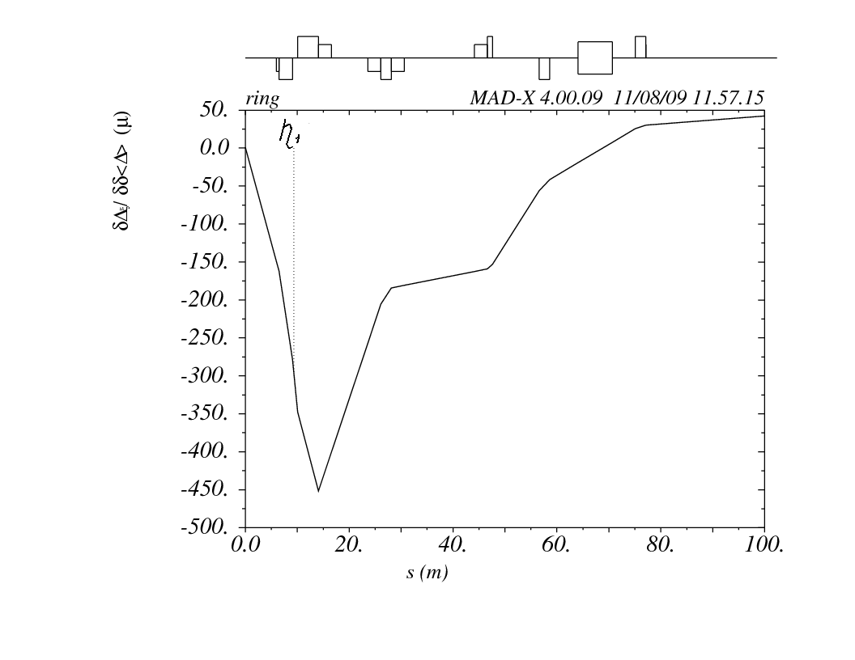

Pic.6. Second order dispersion function $η_{1}(ΔD_{1}^{c})$

As we can see, the value of chromatic dispersion is of order 2 on sextupoles of final focus, which multiplied by the values of beta functions of order 4 gives us second order chromaticity of order 6 which we have. Let us find out, where the second order dispersion comes from. The equation describing second order dispersion behavior is given below.

$$η_{1}^{''}+\left(\frac{1}{R^{2}}+g_{0}\right)η_{1}=g_{0}η_{0}-\frac{1}{2}λ_{0}{η_{0}}^{2}-\frac{1}{R}\left(1-\frac{1}{2}{η_{0}^{'}}^{2}\right)+\frac{2η_{0}}{R^{2}}-\frac{{η_{0}}^{2}}{R^{3}}$$

Where $g_{0}$ and $λ_{0}$ are strengths of quadrupole and sextupole respectively. Detailed derivation of this formula one can find in ref [3]. Since we have opposite sign dispersion from different sides of IP, we have the opposite signs sextupoles respectively, and as far as they $π$ apart, they excite the chromatic dispersion oscillations giving in phase kicks.

But in fact, the growth of chromatic dispersion caused by the IR is rather small. From the next picture you can see the second order dispersion with in case if we would have a zero slope at IP. It has the values of order 1 at the sextupoles, so the second order chromaticity will be lower by two orders. But when we get the periodic solution for whole ring, we have less pretty picture, because the arcs chromatic dispersion periodic functions is symmetric and the IR’s should be anti-symmetric as a first order dispersion, so we see the blow up near the IP and in arcs too. To get rid of it we need to bring the chromatic dispersion and its slope to zero at the edges of the IR and then match it to the arc periodic solution. It can be done by placing additional sextupoles in regions with nonzero dispersion to make kicks to chromatic dispersion.

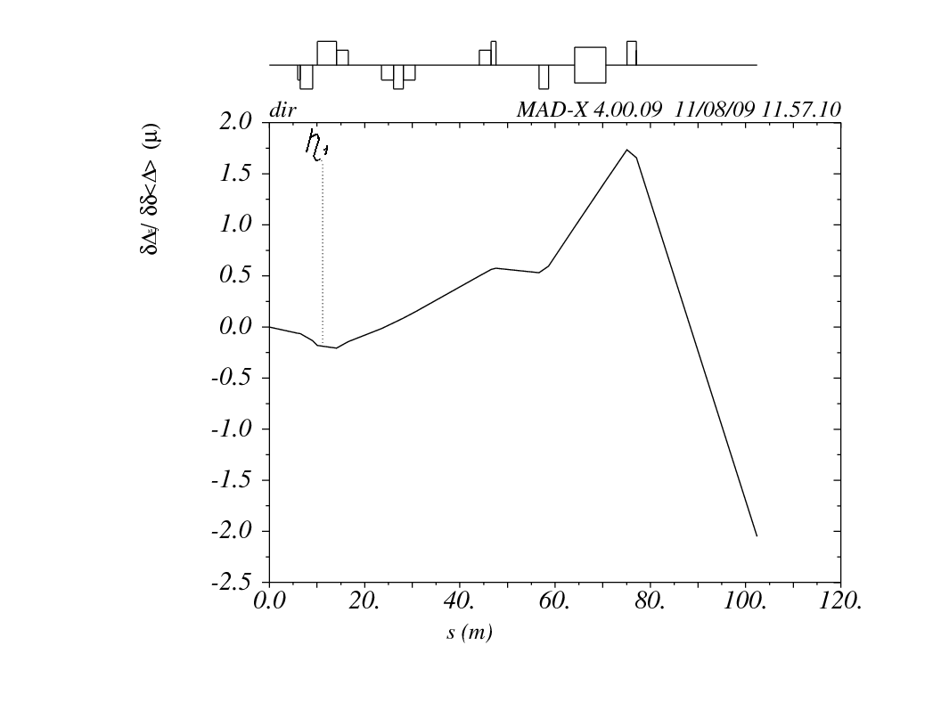

Pic.7. Chromatic dispersion with zero slope at IP

But at the same time we need not to forget about chromatic beta functions perturbations correction, first order chromaticity correction, and the compaction factor derivative minimization, that will be discussed further. So it’s really hard to do in such scheme.

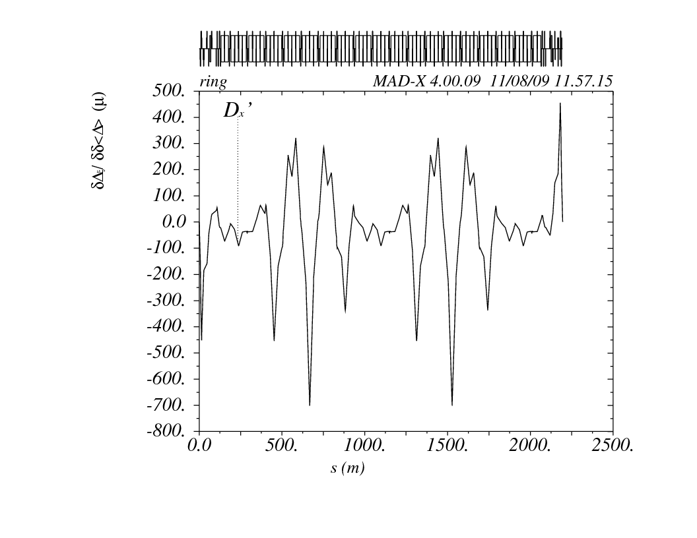

Pic.8. Chromatic dispersion of whole ring

**Momentum compaction factor chromatic derivative**

Momentum compaction factor to the second order is given by the next formula:

$$α_{1}=\frac{1}{C}\oint{ds\left[\frac{1}{R(s)}\left\{η_{1}(s)-\frac{1}{{γ_{0}}^{2}}η_{0}(s)\right\}+\frac{1}{2}{{η_{0}}^{'}}^{2}\left(s\right)+\frac{1}{{{2γ}_{0}}^{2}}\left(3-\frac{1}{{γ_{0}}^{2}}\right)\right]}$$

The main term here is

$$\oint{\frac{η_{1}(s)}{R}ds}$$

So additionally we need to manage the chromatic dispersion in such a way to minimize this integral. In this design, we have compaction factor momentum dependence as shown on the next picture.



Pic.8. Compaction factor momentum dependence

Fitting the graph, we obtain the value of compaction factor derivative equal to $-0.180$, which mean that for momentum deviation of order ${10}^{-3}$, compaction factor will grow from ${10}^{-6}$ to ${10}^{-4}$ what is very undesirable.

Actually, the second order chromaticity effects are much more crucial for proposed ring design, and it is clear that the scheme with anti-symmetric dispersion function does not work. It can be explained simply from the symmetry point of view, you have symmetric dispersion in arcs, and trying to combine it with anti-symmetric interaction region, which lead to very strong second order effects which could not be corrected just using the modest octupoles.

After a couple more ideas revision with opposite sign quadrupoles from different sides of IP etc. the decision was made to leave anti-symmetric dispersion scheme and try another variants.

**New IR design paradigm**

Finally after the long way towards the goal Eliana Gianfelice-Wendt came up with pretty consistent design and Yuri Alexahin formulated a new paradigm for muon collider ring interaction region design based on Eliana’s IR lattice. Its basic points given in the next list:

• Chromaticity of the larger β-function should be corrected first (before ϕ is allowed to change) and in one kick to reduce sensitivity to errors

• To avoid spherical aberrations it must be βy ⇒ then small βx will kill all detuning coefficients and RDTs (this will not happen if βy ↔ βx)

• Chromaticity of βx should be corrected with a pair of sextupoles separated by -I section to control DDx (smallness of βy is welcome but not sufficient)

• Placing sextupoles in the focal points of the other β-function separated from IP by ϕ = π×integer reduces sensitivity to the beam-beam interaction.

So it was understood that for minimizing the detuning coefficients problems we should allow vertical beta-function grow significantly large then horizontal despite the dipole aperture increase because of it. And the separate correction of chromaticity proposal firs for large beta, i.e. vertical plane, then for horizontal plane was also very important point. You can see the implication of this paradigm on the next picture showing IR optics, beta-functions and dispersion.

Pic.9. IR beta-functions and dispersion

Next picture shows implemented local chromaticity correction scheme which appeared to be working very well. Corrections sextupoles are shown in red.

Pic.9. IR chromatic functions after correction

In conjunction with new arc cell design by Yuri Alexahin, this IR layout gives really impressive results.

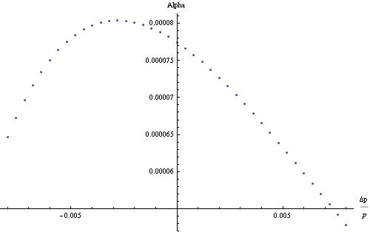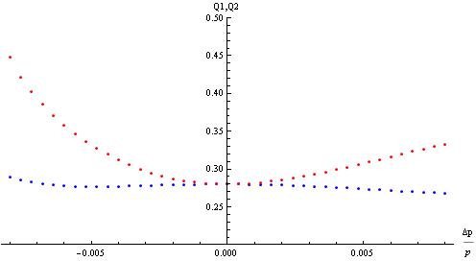

Pic.10. Tunes and compaction factor versus momentum deviation

We have very good momentum acceptance ±1%, and small and adjustable compaction factor. But what is more important, we have small detuning coefficient and as consequence good dynamic aperture.

For the dynamic aperture evaluation both MAD-X and MAD8 tracking routings were used. Next picture set shows dynamic aperture for constant momentum deviation. One can see that dynamic aperture stays sufficient enough for deviation of ±0.5%. The calculations were done using MAD8 4 dimensional lie4 method tracking for 1024 turns and beam-beam element included.



Pic.11. Dynamic aperture for different momentum deviations

If to plot the dynamic aperture diagonal versus momentum deviation we will get the next picture (left one). From the right 6D tracking for 1024 turns using MAD-X PTC tracking code results are shown.



Pic.12. Dynamic aperture diagonal and DA with synchrotron oscillations

**Beam-beam simulation**



As far as we have very large number of particles per bunch , the next very important aspect is beam-beam interaction influence on tunes and luminosity. The simulations were done using Mathematica to calculate this impact. Simple quasi-strong-strong model were used, where two upcoming bunches have Gaussian distribution and were sliced on 23 parts.

Pic.13. Upcoming sliced bunches

Then each slice from left bunch, let’s take one which is marked with red color, meats the slices from opposite bunch in places shown with green lines. It feels the focusing effect from each slice in both planes with the focusing strength given by



where sigmas are calculated according to the beta-function at the place of the interaction.

As far as the transfer matrix for the rest of the ring is known, we calculate new revolution matrix introducing the focusing effect of opposite beam slices for each slice at different points and find new beta-functions and tunes respectfully. Then we assign mirror reflected beta-functions to the opposite beam, and repeat the procedure until converged.

Finally, we get self consistent new beta-functions for each slice of the bunch, and after that, using the next formula



we are able to calculate new luminosity value which includes the beam-beam interaction effect. One can find more detailed information about beam-beam interaction in ref [4]

On the next pictures one can see the new values of beta-function for the first and middle slices of the bunch shown in black dots and the red dots is initial beta-function.

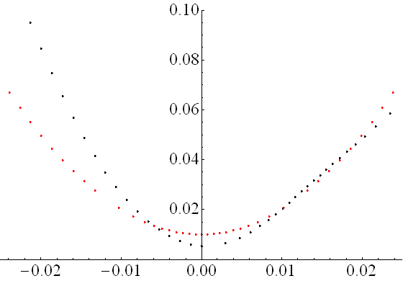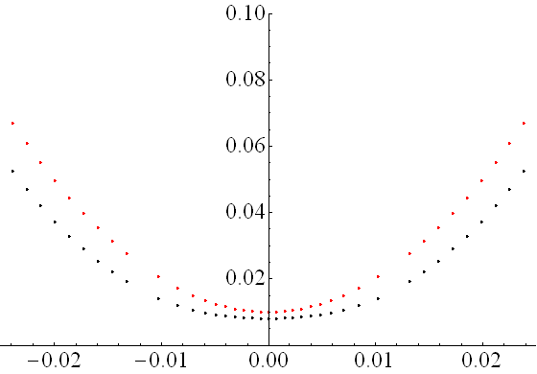

Pic.14. Beta-functions of first and middle slices

Also the tune shift for the different slices can be calculated and given on the next picture.

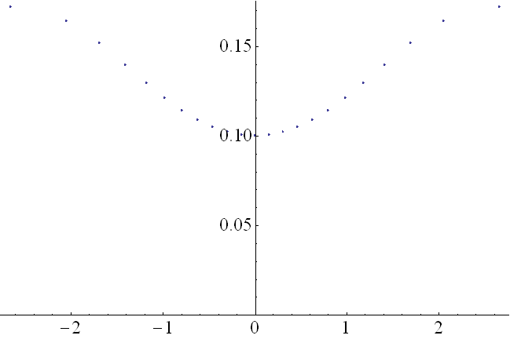

Pic.15. Tune shift for different slices of bunch

Calculations of the luminosity in its turn show us, that the beam-beam interaction brings back almost completely the luminosity loss because of hourglass effect. If the luminosity with hourglass effect is 75.8% of initial value, BB effect brings it back to 99.3%.



Pic.16. Dynamics snapshots of BB interaction

**Effect of IR dipole field nonlinearities on beam dynamics**

Because of huge vertical beta-function in interaction region, the vertical beam size requires large dipoles aperture.

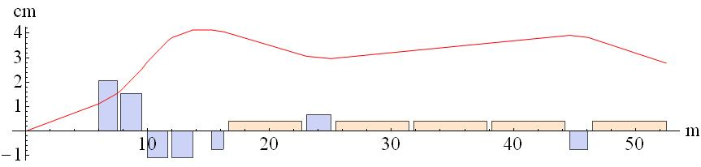

Pic.17. Vertical beam size

Together with the open mid-plane design proposed by V.Kashikhin it leads to high values of sextupole nonlinearities of the field and their effect on beam dynamics should be studied. For the standard multipole field expansion



multipole coefficient for the IR dipoles are given in the next table:

|  |
| --- |
| IR dipole: |
| Rref=40mm |
| b1=10000 |
| b3=-5.875 |
| b5=-18.320 |
| b7=-17.105 |

Tab.3. IR dipole field multipole coefficients

If to recalculate the sextupole gradient from the given coefficient and compare the integral strength with a first sextupole in lattice one can find, that is almost 10% value and it means that the influence of this field components will be significant.



After we introduced sextupole field components of BM, chromaticity correction is broken, but can be easily restored by slightly varying the strength of sextupoles.

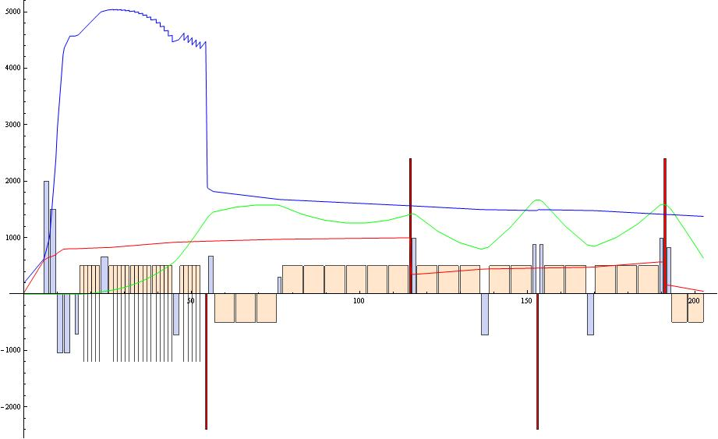

Pic.18. Broken chromaticity correction

What is more important, as far as vertical amplitude dependent tune shift is proportional to square of beta-function, it increases dramatically when we introduce sextupole component in BM field.



So this increase in detuning coefficients leads to significant dynamic aperture reduction.

Pic.19. Dynamic aperture and detuning coefficients

We can put correction sextupole where vertical beta-function is huge, but at the same time dispersion is zero so it will not affect the chromaticity and allow us to bring back the detuning coefficients.

Vertical amplitude dependent tune shift is given by the next formula



So, tune-shift dependence is parabolic in sextupole strength and by three points we can find the coefficients.



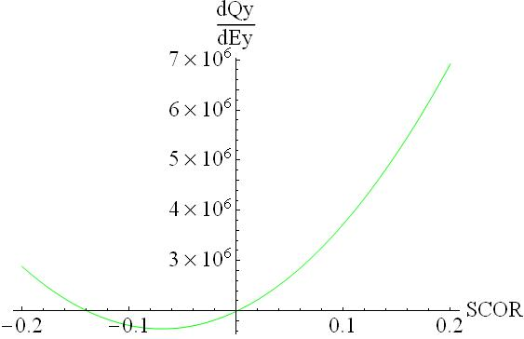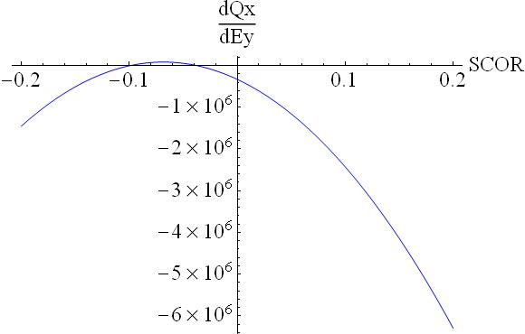

Pic.20. Amplitude dependent tune shifts versus correction sextupole strength

But it’s appeared that we can’t correct the vertical detuning using this correction sextupole placed close to IP. Ok, let us try to put octupoles in place of this correction sextupole. Octupole correction of detuning coefficient can be done easier as far as the detuning coefficients dependence is linear with octupoles strength, but will not affect the nonlinear terms coming from sextupole in terms of resonances excitation that is a disadvantage of octupoles correction.



Pic.21. Restored dynamic aperture

Additional detailed information about analytical calculation of smear and tune shit can be found in reference [5] So it’s clear that we can deal with BM filed sextupole nonlinearities using octupole correction, or combining both sextupole and octupole correctors.

**Instead of conclusion**

The list of issues to be addressed as a next step of muon collider ring lattice design is given below.

One can find that a lot of things still needed to be done to prove the muon collider ring feasibility, but the progress done in last year is very significant and allows us to hope for the proximate success.

**References**

[1] Chromatic effects and their first order correction

Bryan W. Montague, CERN, Geneva, Switzerland

[2] Planning sextupole families in circular collider

P.J. Bryant, CERN, Geneva, Switzerland

[3] Higher order formula for nonlinear dispersion

K. Soutome, M. Takao and H. Tanaka, SPring-8, Mikazuki, Sayo-gun, Hyogo 679-5198, Japan

[4] S.Y. Lee, Accelerator Physics, Second Edition

[5] J. Bengtsson, J. Irwin, Analytical calculations of smear and tune shift, SSC Laboratory, February 1990