Continued Monitoring of the Condi­tioning of the Fermilab Linac 805 MHz

Cavities*

E. McCrory, F. Garcia, T. Kroc, A. Moretti, M. Popovic, Fermilab, Batavia, IL 60510, USA

Abstract

We have reported previously on the conditioning of the high-gradient accelerating cavities in the Fermilab Linac [1, 2, 3, 4]. Automated measurements of the sparking rate have been recorded since 1994 and are reported here. The sparking rate and the fraction of beam pulses lost to RF faults continue to decline. X-ray data from the cavities suggest a slight worsening of the surfaces.

1. Introduction

Fermilab commissioned the seven, high-gradient 805 MHz RF accelerating modules in 1993, which gave this Linac the ability to send 400 MeV H-Minus ions to the Fermilab Booster. In order to achieve the desired acceleration, gradients of up to 8 MV/m were required, which led to maximum surface gradients of nearly 40 MV/m: 1.4 times the “Kilpatrick Limit”. These high fields caused some concern about RF breakdown leading to beam loss and to excessive X-ray exposure.

After seventeen years, the change in the rate of these breakdowns has stabilized at a level well below the original specifications.

2. The measurements

Automated measurements of the sparking rate of each of the seven 805 MHz RF cavities in the 400 MeV Fer­milab Linac have been collected since April 1, 1994. Also, we have automatically recorded the number of beam pulses lost each day, presumably due to RF break­down in one or more of the cavities, beginning in 1994.

*Table 1 Median number of sparks per cavity per day.*

We have measured the X-ray production rate as a function of the power levels in one cavity on several oc­casions over these years.

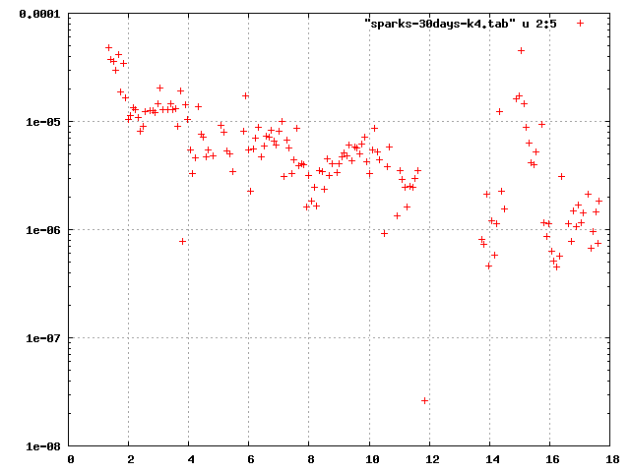2.1. Sparking Rate

The sparking rate is measured continually at the 15 Hz repetition rate of our RF system using an automated DAQ computer program. These data are recorded daily. We record the number of RF pulses for each of the seven 805 MHz cavities and the number of times an RF pulse at that cavity was ruined by an RF breakdown/spark. We have experimented with various ways of detecting sparks in the cavities, and have determined that watching for abnormal reverse power from the cavity is the most reliable.

*Figure 1Module 4 (of 7) sparking rate per 30-day interval, since 1993*

**2.1.1. The Overall Rate**

* Work supported by the US Department of Energy, contract # DE-AC02-76CH0-3000.

Table 1 shows the median number of sparks per day for each of the years we have been accumulating data. Usually, there are about 1.296x106 RF pulses in a day (24 hours at 15 Hz pulse repetition rate).

* Missing data. “0” indicates that more than half of the days had no sparks.

The “Days” column represents the number of days counted—a minimum number of 7E5 RF pulses in a day is applied. There is no indication that sparking is correlated among the cavities. Thus, one would expect that the sum of the values in each row represents the median num­ber of sparks in the entire Linac per day.

*Figure 1 Module 4 sparking rate as a function of years since 1993.*

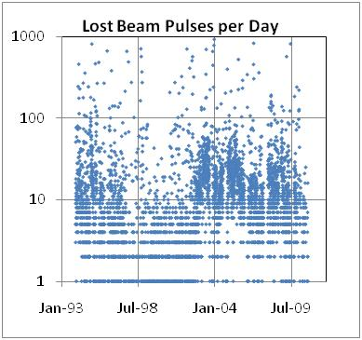**2.1.2. Rates per Cavity**

*Figure 2 Fraction of beam pulses lost per day*

*Figure 3 Count of lost beam pulses per day*

In the previous paper [4], it was reported that there is evidence the sparking rate was leveling off. This was from the analysis from Module 3’s sparking data. At this time we can say that the sparking rate of Module 3 has, indeed, stabilized at about 5x10-5 sparks per second (about 3 sparks per day). Modules 6 and 7 have also leveled at about 5x10-6 sparks per second.

The sparking rate of the other three modules continues to decrease. Modules 1 and 2 have a sparking rate of about 1x10-5 Hz, and Module 4 has reduced to 2x10-6 Hz, see Figure 1.

Since the beginning of 2010, we have had 4344 sparks in the Fermilab Linac. This datum represents 170 days when the Linac was running, or 2.2E8 RF pulses, thus an observed average sparking rate of about one spark per hour.

2.2. Lost Beam

We began counting the number of lost beam pulses per day in 1994, shown in Figure 2. The number of lost beam pulses per day reduced substantially to its lowest level at the time of the publication of the previous paper on this topic in 2000.

Since 2003 and the advent of the Fermilab high-intensity neutrino program, the Linac has delivered in excess of 500000 (5E5) 400 MeV beam pulses to the Booster. For much of 2010, almost half of the 15 Hz RF pulses in the Linac have contained beam. Prior to 2003, the typical number of beam pulses per day was about 30000.

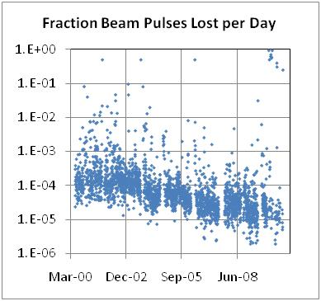In 2000, we started an automated count of the number of 400 MeV beam pulses in the Linac. To remove the effect of the varying number of beam pulses in a day, the fraction of the beam potential beam pulses that were lost is shown in the Figure 3.

A clear decrease in the fraction of beam pulses lost per day is seen.

2.3. X-Ray Measurements

The X-ray production of Module 5 has been measured four times over the last 18 years: 1992, 1996, 2000, and 2010. The measurements of the x-ray production are consistent with the assumption that it is produced by dark current emission from the high field areas of the cavity as described by the Fowler-Nordheim equation. The data are shown Figure 4.

The 1992 data were taken with a single detector placed approximately four feet transversely from the center of the module, between sections 2 and 3. The rest of the data were taken with four detectors placed approximately 1 foot transversely from the center of each of the four sec­tions of the module. The 1992 data have been multiplied by four (assuming a quasi-line source) to suggest the proper relationship to the other data that have not been transformed. The detectors used for the measurements have a time constant of 20-40 seconds. When taking the measurements in 2000, the cavities remained at each new power setting for 30 minutes before the data were recorded. In 2010, the power settings were held for only 2-3 minutes due to time constraints. Because this was not enough time for the detectors to settle at the new values, the data for each power setting were fit to an exponential and the asymptotic values were derived.

The source of the dark current is an emitting area that is assumed to be a microscopic protrusion or dielectric impurity. In either case a local enhancement in the electric field (Em) occurs that is related to the average field by β= Em/E0. We fit the data from each detector to the Fowler-Nord­heim equation for an RF field that describes enhanced field emission [4].



*Table 2 Fit results for field emission of Module 5*

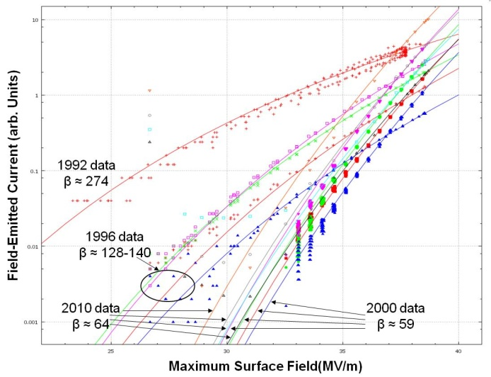where  is the work function in eV, E0 is the macroscopic surface field in V/m, and Ae is the area of the emitting site(s). We fit our data to this form using MINUIT [6] with the free parameters being  and a term propor­tional to Ae. These data are shown in the table on the next page.

In these data, see Table 2, we see relative stability in the X-Ray data from the last measurement, 10 years ago. The area terms have decreased by an order of magnitude, but the beta terms have increased by less than 10%. If the betas have truly increased, then this would indicate a slight degradation of the surfaces of the cavities. However, given the timescale over which this has occurred, we see no threat to their future performance,

3. Conclusion

Measurements suggest that the conditioning of the Fermilab Linac continues to improve or has stabilized, even after 18 years of operation. These measurements are:

*Figure 4 Field emission of Module 5 as a function of surface field*

* Automated detection of cavity sparks
  + The sparking rate in the Fermilab 805 MHz, 400 MeV Linac has reduced to approximately one cavity spark per hour of RF operation. This is a substantial reduction since 2000: one spark every 17 minutes.
* Fraction of beam pulses lost due to cavity sparks
  + Approximately 2 in 1E5 beam pulses is lost due to a cavity spark—far below the design criterion of 1 in 1000 and an order-of-magnitude decrease from 2001, the first full year of the automated counting of the beam pulses in the Linac.
* X-Ray emission
  + The size of the sites in Module 5 that are emitting x-rays has decreased by a factor of ten over the last decade, but the electric field enhancement factor has increased.

If this trend of infinitely improving conditions in the Fermilab Linac ever stops, we hope to be around to report on it at a future Linac conference.

4. REFERENCES

[1] Kroc, et al., Proceedings of LINAC90, (LA-12004-C, Los Alamos, 1991), pp 102-104.

[2] *Ibid*, Proceedings of LINAC92, (AECL-10728, Chalk River, Ontario, 1992), pp 187-189.

[3] *Ibid*, Proceedings of LINAC96, (ISBN 92-9083-098-0; ISSN 007-8328, Geneva, Switzerland, 1996), pp 338-340.

[4] *Ibid*, Proceedings of LINAC 2000, (SLAC-R-561, Monterey, CA, 2000), pp 1004-1006

[5] J.W. Wang, "RF Properties of Periodic Accelerating Structures for Linear Colliders", thesis, July, 1989, SLAC-Report-339.

[6] MUNUIT - Function Minimization and Error Analysis, CERN Program Library Entry D506, 1994-1998.