Installation, Timing and Gating Details for BPM’s In the Booster and 400 MeV Line
October 14,2010
Craig Drennan

Table of Contents
I. Beam Delivery from the Linac to the Booster 1
II. 200 MHz Beam Position Monitors 1
III. Injection BPM Position Gating and Sampling 3
IV. Booster BPM Basics 7
V. Booster BPM Turn by Turn Gating and Sampling 7
VI. BPM Cabling and Signal Distribution 9
Appendix A: Booster BPM Cable Listing 14
Appendix B: Booster BPM Electronics Listing 19

Table of Figures
Figure II.1 400 MeV beam line BPM’s 2
Figure II.2 Booster Injection BPM’s 3
Figure III.1 Block Diagram of the generation of the Chopper control and BPM gating signals 4
Figure III.2 Timing Diagram of the Chopper control and BPM gating signals 5
Figure V.1 Simplified block diagram of the Daughter Trigger Generator chassis. 9
Figure VI.1 Illustration of the routing of the Booster RF Reference signal. 11
Figure VI.2 Illustration of the BPM local oscillator distribution 12
Figure VI.3 Illustration of the Injection Sync trigger distribution 13

Beam Delivery from the Linac to the Booster
Beam accelerated in the Linac is switched into the 400 MeV line, on its way to the Booster by the combination of the 400 MeV Chopper and a Lambertson magnet. A Chopper is a pair of metallic plates, one on either side of the beam aperture, between which an electric field is created to bend the particle beam from its initial trajectory, towards the beam dump. The Lambertson magnet has two apertures. One aperture is simply a hole, the other contains a beam bending dipole field. Initially the Chopper plates are both energized to approximately 55 kV. The electric field is created when one of the plates is shorted to ground creating a sudden difference in potential between the pair. Beam is bent into the dipole aperture of the Lambertson which further direct the beam into the 400 MeV beam line. The signal which triggers the creation of the chopper’s electric field is “Chop On”. When the Booster has received as much beam from the Linac as it needs, beam is removed from the 400 MeV line by grounding the other plate of the Chopper, removing the difference in potential between the plates and removing the electric field. The signal that triggers this is “400 MeV Chop Off”.
There is also a similar chopper at the output of each of the Cockcroft-Walton Generators. These are referred to as the 750 keV Choppers. Another signal from the Booster, “750 keV Chop Off” is used terminate the flow of beam into the Linac just before “400 MeV Chop Off” triggers. This precludes the accelerator from accelerating beam it is not going to send to the Booster, beam that would be directed into the dump and into the metal separating the two apertures of the Lambertson magnet.
It is also worth noting that before the occurrence of Chop On, the first 2 microseconds of Linac beam is allowed to pass on to the dump giving the Linac RF servo loops time to settle to a more stable beam.

200 MHz Beam Position Monitors
Beam coming out of the Linac, through the 400 MeV beam line, into the Booster has a 200 MHz bunch structure. RF Module designed to operate with the 200 MHz BPM plate signals are used to derive the beam position voltages. Besides the BPM in the 400 MeV beam line there are 5 BPM’s (10 positions , horizontal and vertical) that are important for seeing the beam position as it is injected into the Booster at Booster period 1. Since these BPMs are used to measure beam position at both injection, when the beam has a 200 MHz structure, and during the Booster acceleration cycle when the structure of the beam sweeps in frequency from 37.9 MHz to 52.8 MHz, the detector signals are split and routed to both the 200 MHz RF Modules and the Booster RF Modules. The outputs of each type of RF module are digitized by separate digitizers. The 200 MHz RF Module position voltage outputs are digitized by 5 MHz sampling digitizers and the Booster RF Module positions are digitized by 2 MHz digitizers.
Figure II.1 shows the approximate location of the BPM’s in the 400 MeV beam line. Figure II.2 shows the approximate location of the Booster injection BPM’s. There are many more components such as magnets and vacuum pumps not included in the diagrams.
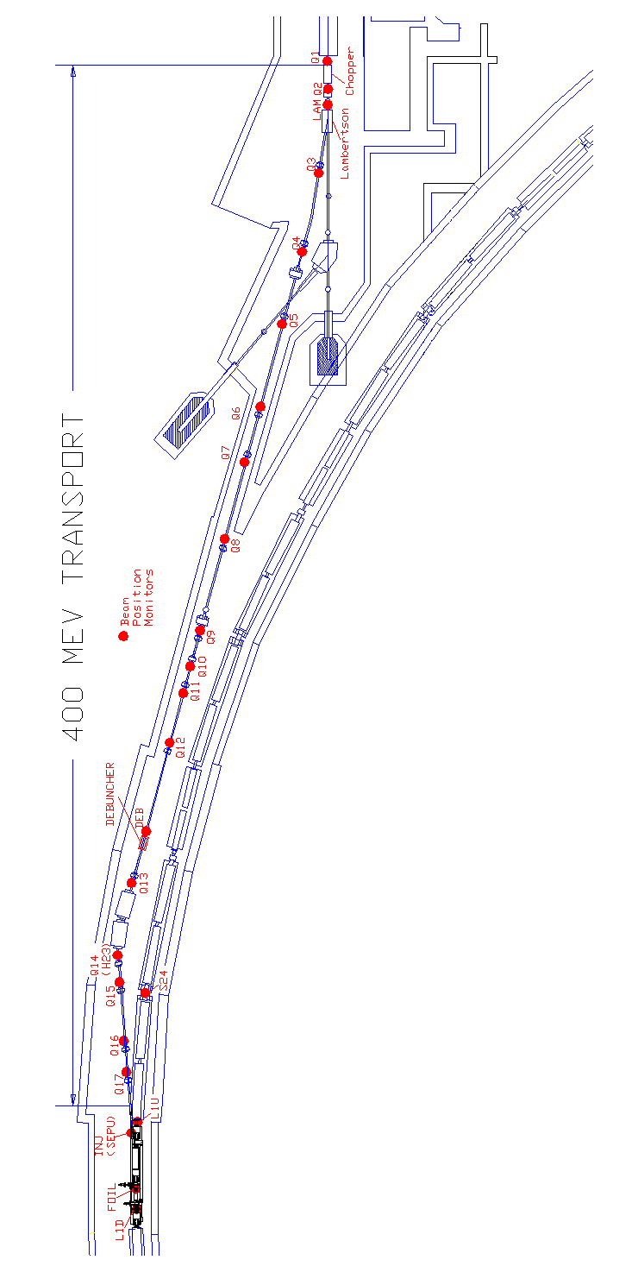
Figure II.1 400 MeV beam line BPM’s

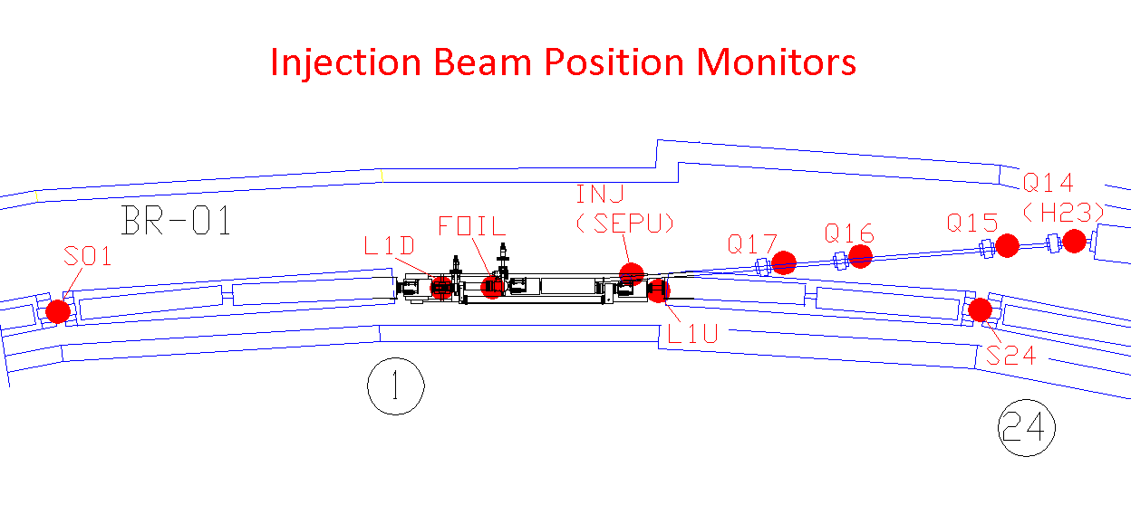
Figure II.2 Booster Injection BPM’s

Injection BPM Position Gating and Sampling
The objective in gating the BPM position voltage sampling is to capture beam positions when beam is actually present and ensure we are capturing valid position measurements. It will be shown that the 200 MHz BPM’s near the Booster Injection are gated only during the first Booster turn’s worth of beam. After this, the injected beam fills the booster and the following turns of beam from the Linac overlap onto the beam in the Booster and the 200 MHz structure is lost. Accurate position measurements can no longer be derived from these BPM’s until the Booster beam has been capture by the Booster RF in the next phase of the Booster acceleration cycle.
The 200 MHz BPM digitizer gate and sampling signals are generated by a set of modules in racks LG1-RR4-2 in the West Booster Gallery. There are four CAMAC modules that provide operator control of timing pulse inputs and delay variable settings. There is an FPGA programmable logic circuit housed in a NIM module that takes the CAMAC inputs and the Booster RF reference clock, and generates the chopper control signals and the BPM digitizer gates and sampling clock. Finally, there is a collection of TTL signal fan-out modules for distributing these outputs. Some of these fan-out modules are located down the West Gallery in racks G24-RR6 where a majority of the 200 MHz BPM signals is digitized.
The block diagram in Figure III.1 shows how the logic in the Chopper Controller is laid out. A timing diagram is given in Figure III.2.

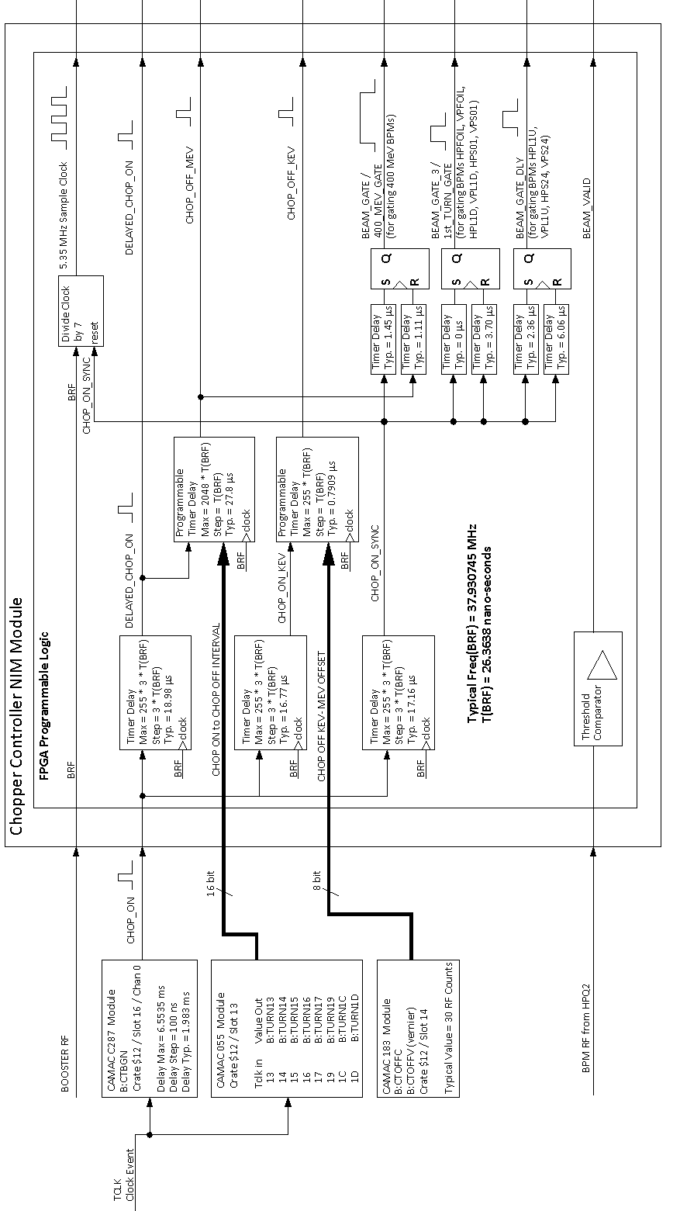
Figure III.1 Block Diagram of the generation of the Chopper control and BPM gating signals
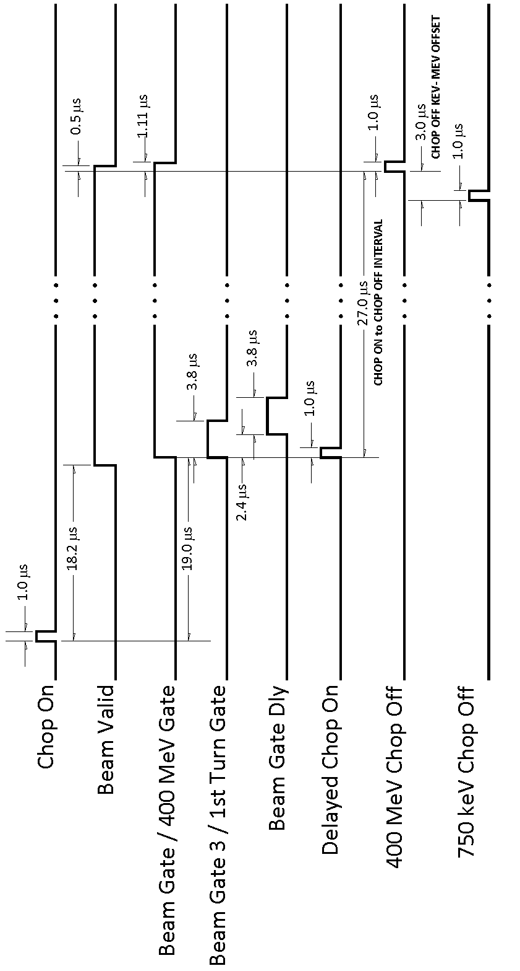
Figure III.2 Timing Diagram of the Chopper control and BPM gating signals

The Chop On input signal is synchronized to the Booster RF and then applied to 3 delay timers to produce 3 delayed chopper on signals.
- CHOP ON SYNC: This is the reference for deriving the BPM gates and sampling clock.
- DELAYED CHOP ON: This is the reference for deriving CHOP OFF MEV (400 MeV Chop Off).
- CHOP ON KEV: This is the reference for deriving CHOP OFF KEV (750 keV Chop Off).
The BPM sampling clock, labeled as 5.35 MHz, is actually the Booster RF divided by 7. The sampling clock is synchronized to the Booster RF and is reset by the CHOP ON SYNC pulse. That is, on the falling edge of the CHOP ON SYNC pulse the sampling clock will be low for 4 Booster RF cycles, then high for 3 Booster RF cycles and then repeat. In this way the first sample clock edge will have a fixed relationship to the occurrence of CHOP ON, at least to within a Booster RF cycle.
Additionally, the 400 MeV BPM digitizers are gated by one of three gates referenced to CHOP ON SYNC. These signals are actual outputs of the Chopper Controller module and distributed to the BPM VME Digitizer crates.
- 400 MEV GATE (BEAM GATE): This signal gates BPM position voltage sampling for the 400 MeV BPM’s. The gate is active just before beam is expected to be at the BPM’s through to a point just after beam is expected to be gone.
- 1ST TURN GATE (BEAM GATE 3): This signal gates BPM position voltage sampling for the first 6 BPM’s in the Booster ring that first see the beam as it enters the Booster from the 400 MeV line. These are horizontal and vertical positions measurements at the foil on the injection girder, period Long 1 (downstream) and period Short 1. The gate is active for a little more than the duration of one trip around the Booster, beginning just before the arrival of the beam. After one trip around the Booster, the beam wraps back on itself and its 200 MHz structure is lost.
- BEAM GATE DLY: This signal gates BPM position voltage sampling for BPM’s at period Short 24 and Long 1 (upstream). These BPM’s monitor the beam position as the beam returns to the point of injection. The gate is active just before the beam has made its first trip around the Booster for the duration of just a little more than one trip around the Booster.
The point of gating the BPM measurements just before the arrival of beam until just after is to be able to see the transition in the recorded data as a rough validation of the measurement and a check on our assumptions about the timing.
The output signal BEAM VALID is based on the presence of beam through the BPM at Q2, between the Chopper and the Lambertson. This signal latches active once beam is detected at Q2. The signal is cleared approximately 500 nanoseconds after CHOP OFF MEV pulses. The “falling” edge of this signal is detected by the 400 MeV BPM digitizer crate processors as a signal that valid BPM data has been acquired by the digitizer cards and that the data should be collected and processed.

Booster BPM Basics
The Booster is a 75 meter radius rapid cycling synchrotron which accelerates protons from 400 MeV to 8 GeV in approximately 33 ms. The machine lattice is divided into 24 identical periods consisting of an initial “long” straight section followed by the first pair of combined function magnets, a “short” straight section followed by a second pair of combined function magnets. At the upstream end of each pair of combined function magnets there is a Beam Position Monitor detector (BPM). Each BPM provides a measurement of both the horizontal and vertical position of the beam relative to the center of the detector. In summary, there is a horizontal and vertical position measurement at each long and short straight, at each of the 24 periods.
The Booster synchrotron is designed to accelerate the beam with the accelerating RF frequency sweeping from approximately 37.0 MHz to 52.8 MHz and a harmonic number, h = 84. This means a couple things for the BPM measurement. First, the harmonic number of 84 means that the revolution period will be 84 times the RF period throughout the cycle. This fact is used to time the digitizing of the BPM position voltages as explained in a later section.
Second, the RF demodulation of the signals from the BPM detector plates must be accomplished over the 37.0 MHz to 52.8 MHz range. This demodulation is accomplished by generating a frequency offset local oscillator signal along with the Booster RF signal generation. This local oscillator signal is used to mix down the BPM detector signals to a common IF, intermediate frequency used in the RF Modules that derive the position voltages from the BPM detector signals.
There are three signals that are distributed around the Booster gallery to the racks where the BPM positions are processed and digitized. These are the local oscillator signal (BPM LO), the Booster accelerating RF reference signal, and a trigger to begin position sampling, timed with respect to the arrival of the injection of beam into the Booster.

Booster BPM Turn by Turn Gating and Sampling
During the Booster acceleration cycle, beam position voltages are digitized by 4 channel VME modules. Digitization is controlled by a common external gate signal and sampling triggers (in groups of 4). There are several objectives in acquiring the BPM position measurements. First, it is desired to record a position from each vertical and horizontal BPM on each revolution of the beam, each turn. The second objective is for every BPM around the Booster to measure the position of the same portion of the circulating beam. These objectives are achieved with the management of the sampling triggers generated by the Daughter Trigger Generator chassis (DTG). The term “Daughter” refers back to a previous data acquisition system whose digitizing circuits were daughter boards that plug onto a larger module. A single DTG chassis can generate triggers for as many as 6 BPM horizontal and vertical position pairs. That is, one for every 12 BPM positions to be digitized.
The DTG chassis implements a counting function and three distinct trigger delay functions. The counting circuit counts the Booster RF cycles and initiates a sample trigger every 84. This trigger is delayed by a second set of counters that also counts RF cycles to compensate for the beam transit time between BPMs serviced in this location of the Booster gallery. Note that the transit time changes through the Booster cycle as the RF frequency changes. The number of RF cycles the sample triggers are delayed is set by switches in the DTG chassis and is settable between 0 and 7.
Additionally there is a jumper settable fixed delay that is meant to compensate for the differences in cable lengths between the RF Modulator electronics upstairs and each BPM detector in the tunnel. This delay is set according to the difference in cable delay for the particular BPM and the shortest cable delay in the group. This fixed delay is settable between 0 and 200 ns.
The third signal delay function in the DTG chassis is used to time the start of the 84 cycle count. This delay is settable between 200 and 3200 ns, in steps of 40 ns. This delay is used in conjunction with the delay of the cabling that distributes the beam injection sync pulse to the racks around the Booster gallery. It is the timing of this start trigger that anchors the other individual channel delays to accomplish the objective of having the position measurement of every BPM recorded for the same portion of the circulating beam.
The circuit schematic for the Daughter Trigger Generator is drawing number 0803-ED-21837 Rev. B, July 31, 1991. A simplified block diagram is given in Figure V.1.
Note at this point that the 4 channel VME digitizers have one external sample trigger input that controls the sampling of all 4 position voltage inputs. Hence only every other sample trigger output of the DTG chassis is employed.
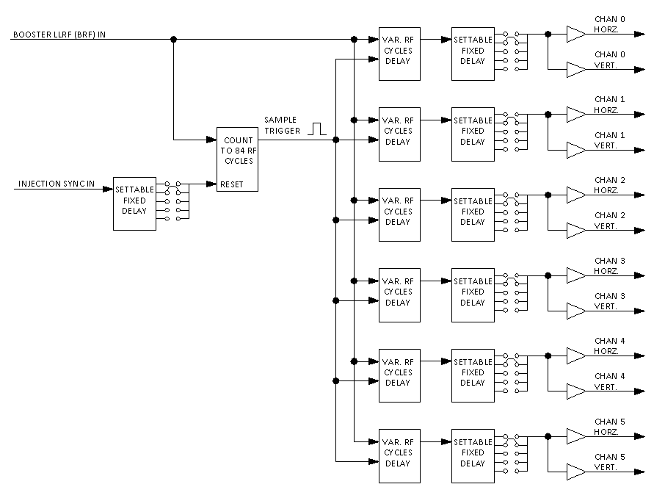
Figure V.1 Simplified block diagram of the Daughter Trigger Generator chassis.

BPM Cabling and Signal Distribution
As mentioned, there are three signals that are distributed around the Booster gallery to the racks where the BPM positions are processed and digitized. These are the local oscillator signal (BPM LO), the Booster accelerating RF reference signal, and a trigger to begin position sampling that is timed with respect to the arrival of the injection of beam into the Booster.
The Booster Low-Level RF reference and the frequency offset BPM local oscillator signal (BPM LO) are generated by the “Digital Frequency Source” VXI module in the Low Level RF room in the East Booster gallery. The naming of the RF reference signal has several aliases since the Booster has evolved over several decades. The names LLRF, BRF, VCO all refer to the Low Level RF reference and will be found on different cable labels, schematics and equipment inputs and outputs.
Figure VI.1 illustrates the routing of the Booster RF reference between the racks in the East and West Booster galleries. Since the RF frequency sweeps it is important to deliver the RF reference signals to each rack with equal phase delay. Loops of cable in each rack are sized to provide the same amount of cable delay for each signal. In the racks there are two functions that use the RF reference as an input. These are the Daughter Trigger Generators that count the RF cycles, and the BPM Test interface Modules used to periodically verifying the calibration of the RF Modules and the BPM Digitizers.
Figure VI.2 illustrates the routing of the BPM local oscillator signal used in the BPM detector signal demodulation in the RF Modules. As seen in the diagram, the BPM LO signals are amplified and then distributed to the RF Modules through special cabling withn the NIM crates and through the NIM module power connection.
Figure VI.3 illustrates the distribution of the Injection Sync signal. The Injection Sync signals are actually copies of the Delayed Chop On signal which switches beam from the LINAC, into the 400 MeV line and into the Booster. The Injection Sync signal is used by the Daughter Trigger Generators, as described earlier, to synchronize the turn by turn sampling of the position voltages. The Injection Sync signal is also used as the start pulse for the Booster Beam Present Gate signal that is applied to the front panel “Ext. Gate” input to the VME digitizer cards.
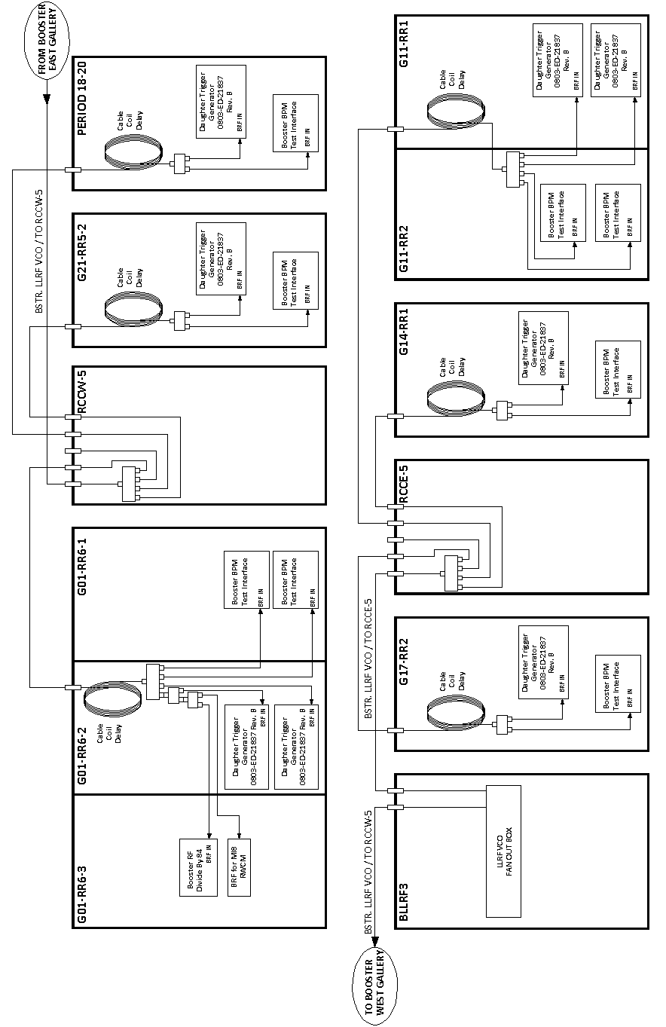
Figure VI.1 Illustration of the routing of the Booster RF Reference signal.
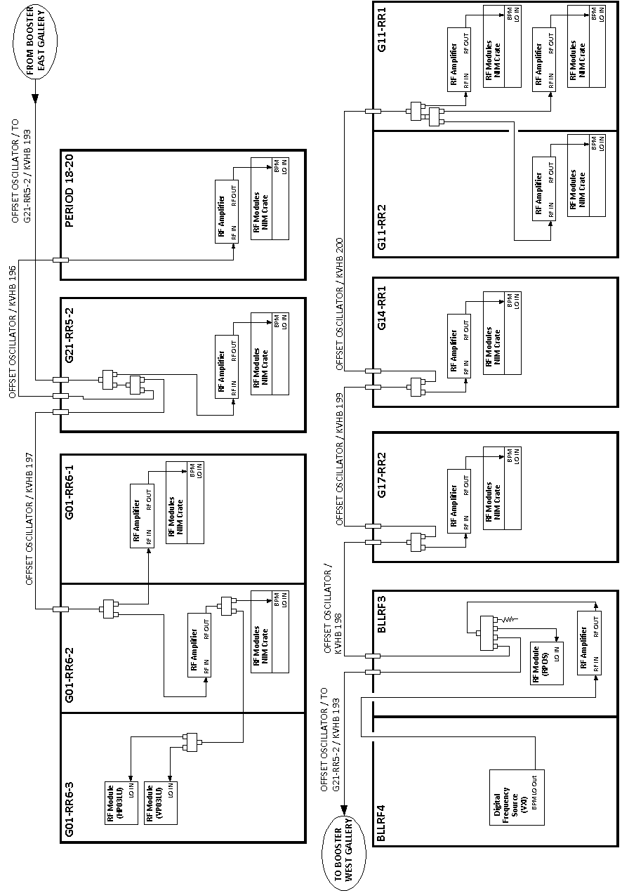
Figure VI.2 Illustration of the BPM local oscillator distribution
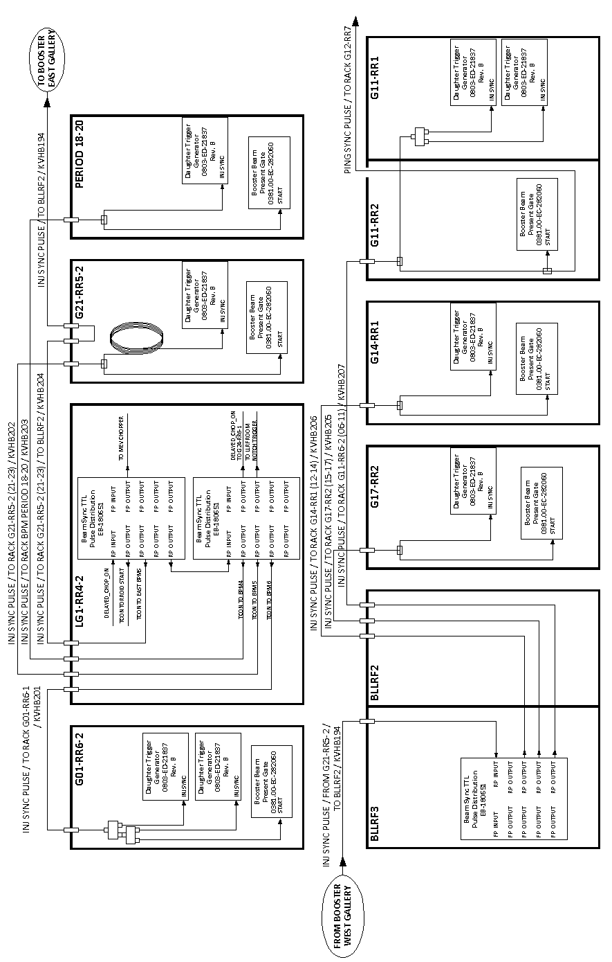
Figure VI.3 Illustration of the Injection Sync trigger distribution

Appendix A: Booster BPM Cable Listing
Table A.1 BPM Cable Listing
BPM | Plate | Channel | KVBH # | Location | Posted Cable Length, ns
H1 | IN | A | 185 | L24 | 271.1
H1 | OUT | B | 186 | L24
V1 | BOTTOM | A | 187 | L24 | 272.4
V1 | TOP | B | 188 | L24
H2 | IN | A | 189 | S24 | 241.5
H2 | OUT | B | 190 | S24
V2 | BOTTOM | A | 191 | S24 | 242.1
V2 | TOP | B | 192 | S24
H3 | IN | A | 001 | L1 | 210.7
H3 | OUT | B | 002 | L1
V3 | BOTTOM | A | 003 | L1 | 212.3
V3 | TOP | B | 004 | L1
H4 | IN | A | 005 | S1 | 164.8
H4 | OUT | B | 006 | S1
V4 | BOTTOM | A | 007 | S1 | 165.4
V4 | TOP | B | 008 | S1
H5 | IN | A | 009 | L2 | 109.5
H5 | OUT | B | 010 | L2
V5 | BOTTOM | A | 011 | L2 | 109.5
V5 | TOP | B | 012 | L2
H6 | IN | A | 013 | S2 | 80.2
H6 | OUT | B | 014 | S2
V6 | BOTTOM | A | 015 | S2 | 80.7
V6 | TOP | B | 016 | S2
H1 | IN | A | 017 | L03 | 115.9
H1 | OUT | B | 018 | L03
V1 | BOTTOM | A | 019 | L03 | 114.9
V1 | TOP | B | 020 | L03
H2 | IN | A | 021 | S03 | 146.9
H2 | OUT | B | 022 | S03
V2 | BOTTOM | A | 023 | S03 | 146.1
V2 | TOP | B | 024 | S03
H3 | IN | A | 025 | L04 | 197.9
H3 | OUT | B | 026 | L04
V3 | BOTTOM | A | 027 | L04 | 197.9
V3 | TOP | B | 028 | L04
H4 | IN | A | 029 | S04 | 224.4
H4 | OUT | B | 030 | S04
V4 | BOTTOM | A | 031 | S04 | 224.4
V4 | TOP | B | 032 | S04
H5 | IN | A | 033 | L05 | 273.9
H5 | OUT | B | 034 | L05
V5 | BOTTOM | A | 035 | L05 | 272.0
V5 | TOP | B | 036 | L05
H6 | IN | A | 037 | S05 | 303.5
H6 | OUT | B | 038 | S05
V6 | BOTTOM | A | 039 | S05 | 303.8
V6 | TOP | B | 040 | S05
H1 | IN | A | 041 | L06 | 493.2
H1 | OUT | B | 042 | L06
V1 | BOTTOM | A | 043 | L06 | 495.2
V1 | TOP | B | 044 | L06
H2 | IN | A | 045 | S06 | 462.7
H2 | OUT | B | 046 | S06
V2 | BOTTOM | A | 047 | S06 | 464.9
V2 | TOP | B | 048 | S06
H3 | IN | A | 049 | L07 | 415.2
H3 | OUT | B | 050 | L07
V3 | BOTTOM | A | 051 | L07 | 414.7
V3 | TOP | B | 052 | L07
H4 | IN | A | 053 | S07 | 382.2
H4 | OUT | B | 054 | S07
V4 | BOTTOM | A | 055 | S07 | 383.7
V4 | TOP | B | 056 | S07
H5 | IN | A | 057 | L08 | 330.9
H5 | OUT | B | 058 | L08
V5 | BOTTOM | A | 059 | L08 | 331.9
V5 | TOP | B | 060 | L08
H6 | IN | A | 061 | S08 | 301.7
H6 | OUT | B | 062 | S08
V6 | BOTTOM | A | 063 | S08 | 303.2
V6 | TOP | B | 064 | S08
H1 | IN | A | 065 | L09 | 255.7
H1 | OUT | B | 066 | L09
V1 | BOTTOM | A | 067 | L09 | 257.2
V1 | TOP | B | 068 | L09
H2 | IN | A | 069 | S09 | 227.2
H2 | OUT | B | 070 | S09
V2 | BOTTOM | A | 071 | S09 | 227.4
V2 | TOP | B | 072 | S09
H3 | IN | A | 073 | L10 | 176.4
H3 | OUT | B | 074 | L10
V3 | BOTTOM | A | 075 | L10 | 177.2
V3 | TOP | B | 076 | L10
H4 | IN | A | 077 | S10 | 145.9
H4 | OUT | B | 078 | S10
V4 | BOTTOM | A | 079 | S10 | 146.9
V4 | TOP | B | 080 | S10
H5 | IN | A | 081 | L11 | 115.7
H5 | OUT | B | 082 | L11
V5 | BOTTOM | A | 083 | L11 | 116.7
V5 | TOP | B | 084 | L11
H6 | IN | A | 085 | S11 | 145.2
H6 | OUT | B | 086 | S11
V6 | BOTTOM | A | 087 | S11 | 146.2
V6 | TOP | B | 088 | S11
H1 | IN | A | 089 | L12 | 215.0
H1 | OUT | B | 090 | L12
V1 | BOTTOM | A | 091 | L12 | 215.8
V1 | TOP | B | 092 | L12
H2 | IN | A | 093 | S12 | 186.7
H2 | OUT | B | 094 | S12
V2 | BOTTOM | A | 095 | S12 | 189.1
V2 | TOP | B | 096 | S12
H3 | IN | A | 097 | L13 | 136.0
H3 | OUT | B | 098 | L13
V3 | BOTTOM | A | 099 | L13 | 137.1
V3 | TOP | B | 100 | L13
H4 | IN | A | 101 | S13 | 106.4
H4 | OUT | B | 102 | S13
V4 | BOTTOM | A | 103 | S13 | 106.4
V4 | TOP | B | 104 | S13
H5 | IN | A | 105 | L14 | 58.4
H5 | OUT | B | 106 | L14
V5 | BOTTOM | A | 107 | L14 | 57.9
V5 | TOP | B | 108 | L14
H6 | IN | A | 109 | S14 | 79.7
H6 | OUT | B | 110 | S14
V6 | BOTTOM | A | 111 | S14 | 79.9
V6 | TOP | B | 112 | S14
H1 | IN | A | 113 | L15 | 187.0
H1 | OUT | B | 114 | L15
V1 | BOTTOM | A | 115 | L15 | 188.0
V1 | TOP | B | 116 | L15
H2 | IN | A | 117 | S15 | 155.8
H2 | OUT | B | 118 | S15
V2 | BOTTOM | A | 119 | S15 | 156.7
V2 | TOP | B | 120 | S15
H3 | IN | A | 121 | L16 | 107.1
H3 | OUT | B | 122 | L16
V3 | BOTTOM | A | 123 | L16 | 106.3
V3 | TOP | B | 124 | L16
H4 | IN | A | 125 | S16 | 76.9
H4 | OUT | B | 126 | S16
V4 | BOTTOM | A | 127 | S16 | 77.2
V4 | TOP | B | 128 | S16
H5 | IN | A | 129 | L17 | 78.5
H5 | OUT | B | 130 | L17
V5 | BOTTOM | A | 131 | L17 | 79.0
V5 | TOP | B | 132 | L17
H6 | IN | A | 133 | S17 | 107.9
H6 | OUT | B | 134 | S17
V6 | BOTTOM | A | 135 | S17 | 108.4
V6 | TOP | B | 136 | S17
H1 | IN | A | 137 | L18 | 256.3
H1 | OUT | B | 138 | L18
V1 | BOTTOM | A | 139 | L18 | 254.8
V1 | TOP | B | 140 | L18
H2 | IN | A | 141 | S18 | 225.5
H2 | OUT | B | 142 | S18
V2 | BOTTOM | A | 143 | S18 | 223.7
V2 | TOP | B | 144 | S18
H3 | IN | A | 145 | L19 | 174.9
H3 | OUT | B | 146 | L19
V3 | BOTTOM | A | 147 | L19 | 175.0
V3 | TOP | B | 148 | L19
H4 | IN | A | 149 | S19 | 144.0
H4 | OUT | B | 150 | S19
V4 | BOTTOM | A | 151 | S19 | 143.9
V4 | TOP | B | 152 | S19
H5 | IN | A | 153 | L20 | 92.2
H5 | OUT | B | 154 | L20
V5 | BOTTOM | A | 155 | L20 | 92.1
V5 | TOP | B | 156 | L20
H6 | IN | A | 157 | S20 | 73.7
H6 | OUT | B | 158 | S20
V6 | BOTTOM | A | 159 | S20 | 73.8
V6 | TOP | B | 160 | S20
H1 | IN | A | 161 | L21 | 106.3
H1 | OUT | B | 162 | L21
V1 | BOTTOM | A | 163 | L21 | 106.9
V1 | TOP | B | 164 | L21
H2 | IN | A | 165 | S21 | 77.7
H2 | OUT | B | 166 | S21
V2 | BOTTOM | A | 167 | S21 | 77.7
V2 | TOP | B | 168 | S21
H3 | IN | A | 169 | L22 | 77.8
H3 | OUT | B | 170 | L22
V3 | BOTTOM | A | 171 | L22 | 77.8
V3 | TOP | B | 172 | L22
H4 | IN | A | 173 | S22 | 108.3
H4 | OUT | B | 174 | S22
V4 | BOTTOM | A | 175 | S22 | 108.4
V4 | TOP | B | 176 | S22
H5 | IN | A | 177 | L23 | 158.4
H5 | OUT | B | 178 | L23
V5 | BOTTOM | A | 179 | L23 | 158.4
V5 | TOP | B | 180 | L23
H6 | IN | A | 181 | S23 | 188.5
H6 | OUT | B | 182 | S23
V6 | BOTTOM | A | 183 | S23 | 188.5
V6 | TOP | B | 184 | S23

Appendix B: Booster BPM Electronics Listing

VME Crate: BBPM24
Name | Period | Demod Rack # | VME alias | VME MOD | VME CHAN
HL24 | 24 | G01-RR6-1 | HP24L | 0 | 0
VL24 | 24 | G01-RR6-1 | VP24L | 0 | 1
HS24 | 24 | G01-RR6-1 | HP24S | 0 | 2
VS24 | 24 | G01-RR6-1 | VP24S | 0 | 3
HL1 | 1 | G01-RR6-1 | HP01L | 1 | 0
VL1 | 1 | G01-RR6-1 | VP01L | 1 | 1
HS1 | 1 | G01-RR6-1 | HP01S | 1 | 2
VS1 | 1 | G01-RR6-1 | VP01S | 1 | 3
HL2 | 2 | G01-RR6-1 | HP02L | 2 | 0
VL2 | 2 | G01-RR6-1 | VP02L | 2 | 1
HS2 | 2 | G01-RR6-1 | HP02S | 2 | 2
VS2 | 2 | G01-RR6-1 | VP02S | 2 | 3
HL3 | 3 | G01-RR6-2 | HP03L | 3 | 0
VL3 | 3 | G01-RR6-2 | VP03L | 3 | 1
HS3 | 3 | G01-RR6-2 | HP03S | 3 | 2
VS3 | 3 | G01-RR6-2 | VP03S | 3 | 3
HL4 | 4 | G01-RR6-2 | HP04L | 4 | 0
VL4 | 4 | G01-RR6-2 | VP04L | 4 | 1
HS4 | 4 | G01-RR6-2 | HP04S | 4 | 2
VS4 | 4 | G01-RR6-2 | VP04S | 4 | 3
HL5 | 5 | G01-RR6-2 | HP05L | 5 | 0
VL5 | 5 | G01-RR6-2 | VP05L | 5 | 1
HS5 | 5 | G01-RR6-2 | HP05S | 5 | 2
VS5 | 5 | G01-RR6-2 | VP05S | 5 | 3
HP03LU | 3 | G01-RR6-3 | HP03LU | 7 | 2
VP03LU | 3 | G01-RR6-3 | VP03LU | 7 | 3
 |  | G01-RR6-1
 |  | G01-RR6-1
 |  | G01-RR6-1
 |  | G01-RR6-1
 |  | G01-RR6-1
 |  | G01-RR6-1

VME Crate: BBPM21
Name | Period | Demod Rack # | VME alias | VME MOD | VME CHAN
HL21 | 21 | G21-RR5-2 | HP21L | 0 | 0
VL21 | 21 | G21-RR5-2 | VP21L | 0 | 1
HS21 | 21 | G21-RR5-2 | HP21S | 0 | 2
VS21 | 21 | G21-RR5-2 | VP21S | 0 | 3
HL22 | 21 | G21-RR5-2 | HP22L | 1 | 0
VL22 | 21 | G21-RR5-2 | VP22L | 1 | 1
HS22 | 21 | G21-RR5-2 | HP22S | 1 | 2
VS22 | 21 | G21-RR5-2 | VP22S | 1 | 3
HL23 | 21 | G21-RR5-2 | HP23L | 2 | 0
VL23 | 21 | G21-RR5-2 | VP23L | 2 | 1
HS23 | 21 | G21-RR5-2 | HP23S | 2 | 2
VS23 | 21 | G21-RR5-2 | VP23S | 2 | 3
VME Crate: BBPM18
Name | Period | Demod Rack # | VME alias | VME MOD | VME CHAN
HL18 | 18 | P. 18-20 (BGW-North) | HP18L | 0 | 0
VL18 | 18 | P. 18-20 (BGW-North) | VP18L | 0 | 1
HS18 | 18 | P. 18-20 (BGW-North) | HP18S | 0 | 2
VS18 | 18 | P. 18-20 (BGW-North) | VP18S | 0 | 3
HL19 | 18 | P. 18-20 (BGW-North) | HP19L | 1 | 0
VL19 | 18 | P. 18-20 (BGW-North) | VP19L | 1 | 1
HS19 | 18 | P. 18-20 (BGW-North) | HP19S | 1 | 2
VS19 | 18 | P. 18-20 (BGW-North) | VP19S | 1 | 3
HL20 | 18 | P. 18-20 (BGW-North) | HP20L | 2 | 0
VL20 | 18 | P. 18-20 (BGW-North) | VP20L | 2 | 1
HS20 | 18 | P. 18-20 (BGW-North) | HP20S | 2 | 2
VS20 | 18 | P. 18-20 (BGW-North) | VP20S | 2 | 3

VME Crate: BBPM15
Name | Period | Demod Rack # | VME alias | VME MOD | VME CHAN
HL15 | 17 | G17-RR2 | HP15L | 0 | 0
VL15 | 17 | G17-RR2 | VP15L | 0 | 1
HS15 | 17 | G17-RR2 | HP15S | 0 | 2
VS15 | 17 | G17-RR2 | VP15S | 0 | 3
HL16 | 17 | G17-RR2 | HP16L | 1 | 0
VL16 | 17 | G17-RR2 | VP16L | 1 | 1
HS16 | 17 | G17-RR2 | HP16S | 1 | 2
VS16 | 17 | G17-RR2 | VP16S | 1 | 3
HL17 | 17 | G17-RR2 | HP17L | 2 | 0
VL17 | 17 | G17-RR2 | VP17L | 2 | 1
HS17 | 17 | G17-RR2 | HP17S | 2 | 2
VS17 | 17 | G17-RR2 | VP17S | 2 | 3
VME Crate: BBPM12
Name | Period | Demod Rack # | VME alias | VME MOD | VME CHAN
HL12 | 14 | G14-RR1 | HP12L | 0 | 0
VL12 | 14 | G14-RR1 | VP12L | 0 | 1
HS12 | 14 | G14-RR1 | HP12S | 0 | 2
VS12 | 14 | G14-RR1 | VP12S | 0 | 3
HL13 | 14 | G14-RR1 | HP13L | 1 | 0
VL13 | 14 | G14-RR1 | VP13L | 1 | 1
HS13 | 14 | G14-RR1 | HP13S | 1 | 2
VS13 | 14 | G14-RR1 | VP13S | 1 | 3
HL14 | 14 | G14-RR1 | HP14L | 2 | 0
VL14 | 14 | G14-RR1 | VP14L | 2 | 1
HS14 | 14 | G14-RR1 | HP14S | 2 | 2
VS14 | 14 | G14-RR1 | VP14S | 2 | 3

VME Crate: BBPM06
Name | Period | Demod Rack # | VME alias | VME MOD | VME CHAN
HL6 | 11 | G11-RR6-2 | HP06L | 0 |  | 0
VL6 | 11 | G11-RR6-2 | VP06L | 0 |  | 1
HS6 | 11 | G11-RR6-2 | HP06S | 0 |  | 2
VS6 | 11 | G11-RR6-2 | VP06S | 0 |  | 3
HL7 | 11 | G11-RR6-2 | HP07L | 1 |  | 0
VL7 | 11 | G11-RR6-2 | VP07L | 1 |  | 1
HS7 | 11 | G11-RR6-2 | HP07S | 1 |  | 2
VS7 | 11 | G11-RR6-2 | VP07S | 1 |  | 3
HL8 | 11 | G11-RR6-2 | HP08L | 2 |  | 0
VL8 | 11 | G11-RR6-2 | VP08L | 2 |  | 1
HS8 | 11 | G11-RR6-2 | HP08S | 2 |  | 2
VS8 | 11 | G11-RR6-2 | VP08S | 2 |  | 3
HL9 | 11 | G11-RR6-1 | HP09L | 3 |  | 0
VL9 | 11 | G11-RR6-1 | VP09L | 3 |  | 1
HS9 | 11 | G11-RR6-1 | HP09S | 3 |  | 2
VS9 | 11 | G11-RR6-1 | VP09S | 3 |  | 3
HL10 | 11 | G11-RR6-1 | HP10L | 4 |  | 0
VL10 | 11 | G11-RR6-1 | VP10L | 4 |  | 1
HS10 | 11 | G11-RR6-1 | HP10S | 4 |  | 2
VS10 | 11 | G11-RR6-1 | VP10S | 4 |  | 3
HL11 | 11 | G11-RR6-1 | HP11L | 5 |  | 0
VL11 | 11 | G11-RR6-1 | VP11L | 5 |  | 1
HS11 | 11 | G11-RR6-1 | HP11S | 5 |  | 2
VS11 | 11 | G11-RR6-1 | VP11S | 5 |  | 3
HUL6 | 11 | G11-RR6-3 | HP06LU | 7 |  | 0
VUL6 | 11 | G11-RR6-3 | VP06LU | 7 |  | 1
HUL7 | 11 | G11-RR6-3 | HP07LU | 7 |  | 2
VUL7 | 11 | G11-RR6-3 | VP07LU | 7 |  | 3

