fFermilab
Doc Number: Beams-doc-3717
Version: 1.0
Type: Note

Comparison of Short Term Cooldown Data for MI Collimator C307

Near Beam and Beside Marble Shielding

Amir Jaehoon Safavi

Illinois Math and Science Academy
and
Fermi National Accelerator Laboratory*
P.O. Box 500
Batavia, Illinois 60510

17 Nov 2010

*Operated by the Fermi Research Alliance under contract with the U.S. Department of Energy

Comparison of Short Term Cooldown Data

for MI Collimator C307

Near Beam and Beside Marble Shielding

At

Fermilab
Introduction
Radiation around the main Injector is a serious concern and in order to mitigate the effects of the radiation it is important to understand it. In this study, the radiation will be mathematically modeled and compared in order to better understand the effect of the marble shielding.

Data Collection
Data was collected at the Main Injector Collimator C307 by placing one sensor with a 10 R range directly above the pipe that the proton beam runs through and the other with a 2 R range on the side of a block of layered marble surrounding the Collimator. See diagram 1 for additional details. The unshielded radiation received radiation directly from inside the Collimator while the shielded radiation was shielded from the Collimator by several layers of marble and steel.

Diagram 1

Source of Shielded radiation data

Source of “down stream” unshielded radiation data

Picture 1: The 2R sensor that collected the shielded radiation data.

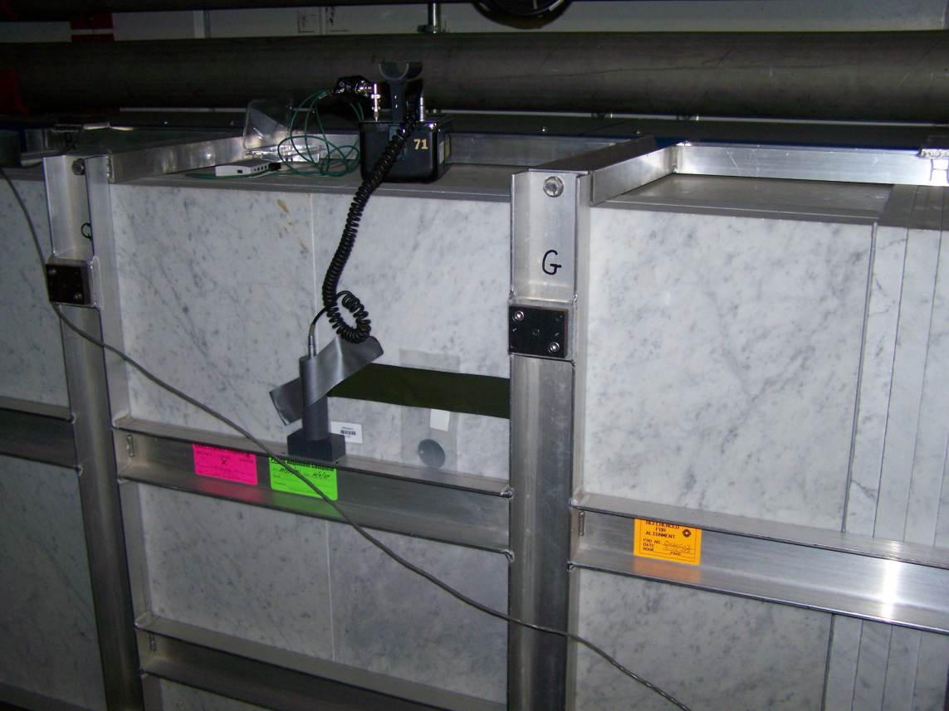

Picture 2: The 10R sensor that collected the unshielded radiation data. Note that the 2R sensor can be seen on the aisle side of the collimator.

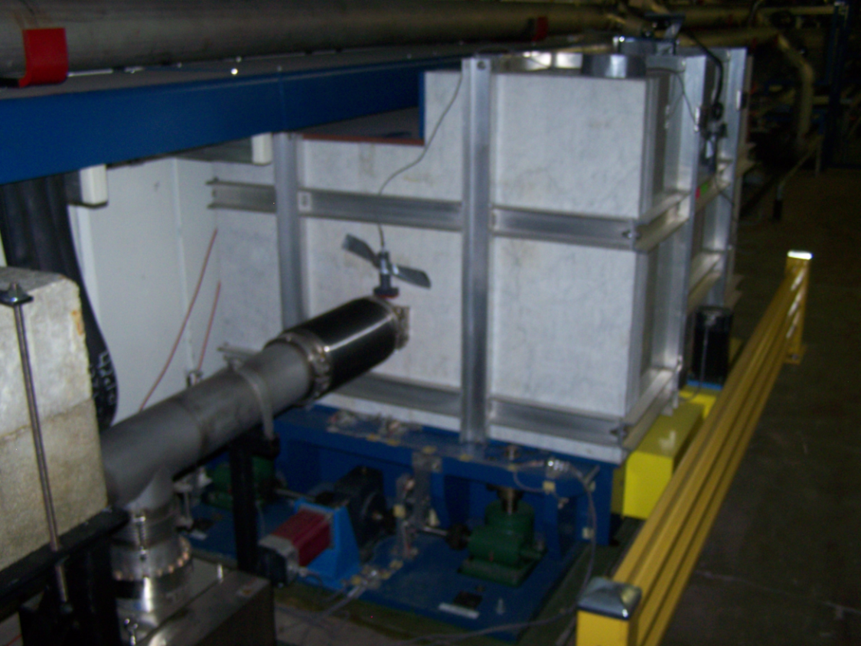

Graphs and Data tables

Figure 1 shows the ratio of the Unshielded radiation levels divided by the shielded levels of radiation. The ratio increase indicates that the unshielded radiation level is cooling down at a slower rate than the shielded radiation. The ratio increase is about 20 percent which is very significant and indicated that further research had to be done on this topic.

Next, each data set was fit to the assumption that three Mn isotopes are responsible for the observed radiation. The analysis procedure is described in the appendix. Table 1 shows fitted results, figures 2 and 3 show the measurements and the curve described by the fit.
Figure 1

⁵⁶Mn half life = 312 days, ⁵⁴Mn half life = 5.59 days ⁵²Mn, half life = 2.58 hours
A1 is initial radiation from ⁵⁶Mn, A2 ⁵⁴Mn, and A3, ⁵²Mn

Table (initial radiation levels and ratios)
 | Unshielded | Shielded | Ratio
A1(⁵⁶Mn) | 716.9 mr/hr | 1.4635 mr/hr | 489.85
A2 (⁵⁴Mn) | 2936 mr/hr | 13.907 mr/hr | 211.11
A3 (⁵²Mn) | 883.0 mr/hr | 11.683 mr/hr | 75.58
A1/A3 | 0.811 | 0.125
A2/A3 | 3.325 | 1.19036
Initial Radiation | 4554 mr/hr | 23.6 mr/hr | 192.97

Figure 2

Figure 2 shows the raw data and a fit collected from down-stream source for the MI Collimator C307.

Figure 3

Figure 3 shows the raw data and a fit collected from a sensor next to the marble shielding around the Collimator.

Conclusion

The marble shielding not only reduces the radiation, but also changes the observed ratio of the isotopes to one another. Because the ratio of the unshielded to shielded increases, the unshielded radiation source decreases slower than the shielded radiation source. This indicates that the radiation at the shielded location is comprised mostly of elements with shorter half lives. The conclusion of the ratio is backed up by the fitted data of the initial radiation values of each isotope.

Appendix: Methods

The three isotopes of manganese that will be used for the model will be Mn⁵⁶,Mn⁵⁴, and Mn⁵². These isotopes will last long enough to produce radiation over a period of time such as days, but will unstable enough to produce significant amounts of radiation.
The equations will be as follows:
$$M=A_{1}*2^{\frac{t}{λ}}+A_{2}*2^{\frac{t}{λ}}+A_{3}*2^{\frac{t}{λ}}$$
Where as:
$$M=total radiation in millirads$$
$$A1,A2,andA3=initial millirads ofMn56,Mn54, and Mn52 respecitvely$$
$$λ=half life in seconds$$
$$t=time in seconds$$
To optimize the function, Excel was used compare the fitted prediction for radiation to the experimental measurements. The differences were squared and summed up to create a final difference sum. The method used is known as the least squares method. The solver tool was then used to optimize A1,A2, and A3 (the initial radiation amounts) so that the difference sum was as low as possible. The solver tool in Excel can be accessed by:
- Clicking the office button (the one at the top left hand corner).
- Clicking “Excel options” which is at the bottom of the drop-down menu.
- Clicking “Add-ins” in the left pane of the Excel options menu
- Selecting “Excel add-ins” where it says Manage: and clicking “Go…”.
- Placing a check in the box next to “Solver add-in” and clicking ok
- The solver will be in the data section.
Note: this only works for Excel 2007.

After several manual iterations, the values for the initial radiations seemed to yield a reasonable difference squared sum. However, some things can be done to improve the accuracy. For example, more isotopes could be compared, such as several other isotopes of manganese or iron. In addition more data over a longer period of time would yield more accurate results about the long term radiation.

