Booster Beam Loss Monitor

Commissioning Guide
Draft Sent Out for Comment
January 14, 2013
Craig Drennan

Table of Contents
I. Introduction 1
I.1 Draft General Procedure for Installation and Commissioning 1
I.2 Draft Procedure for Commissioning 1
I.3 ACNET Device Names 2
Appendix A: New BLM Front-End and Integrator / Digitizer Assignments 4
Appendix B: BLM Channel Calibration Coefficients, Alarm Limits and Scale Factor Predictions Between Old and New Read Back Electronics. 7

Introduction
This note is written to provide details and procedures for commissioning into service the new Booster Beam Loss Monitor readout electronics. Refer to the document “Booster Beam Loss Monitor Data Acquisition and Presentation Specification”, Beams-doc-3723-v8, for additional details not provided in this document.

Draft General Procedure for Installation and Commissioning
General considerations for tests made using operational BLM’s
- Operational BLM’s have limits set to signal the Booster to shut down if losses become excessive in the vicinity of the BLM. When disconnecting the BLM from its normal read back electronics the Booster should be monitored from the control room and should be disconnected for as brief an interval as possible.
- If artificial calibration signals are to be injected into the normal read-back electronics, it may be necessary to disable the abort alarm limit for the effected BLM channel.
- All BLMs’ 1 ms Sums are logged for each type of Booster cycle. An electronic logbook entry should be made indicating when each normal BLM read back was disconnected from its BLM. If an artificial calibration signal is injected the BLM chassis output voltage to the IRM should be disconnected. The IRM computes the 1 ms Sums, the 100 sec Sums and the forever Sum and we should avoid corrupting the sums with the injected signal. The BLM’s snapshot plot is made using the output voltage to the MADC channels.

Draft Procedure for Commissioning
- The new electronics are installed into the racks at Periods 1, 11, 17, and 20 in the Booster Gallery.
- Integrator / Digitizer inputs are cabled to their respective connections on the output of the Signal Filter / Feed-through boxes. Appendix A lists the Old/New front-end assignments and the Integrator/Digitizer channel assignments for the effected BLM’s.
- Make online comparison of old versus new readouts for each BLM with actual losses.
  - Test (temporary) ACNET devices will be assigned to the new readout channels in the Booster Gallery period being tested. These Test devices will be reassigned when moving the testing to another period.
  - We will also need test devices that assume the role of 1 ms Sum and 100 second Sum.
  - Under stable Booster acceleration conditions the normal system readings for a particular BLM will be noted, and then the signal cable from the BLM will be disconnected from the normal system and connected into the new read back electronics.
  - The BLM readings produced by the new read back system will be recorded and compared to those of the normal system.
  - A scale factor will be computed between the two sets of readings and compared to the predicted scale factors given in the tables in Appendix B.
  - The BLM will be disconnected from the normal system for as little amount of time as possible. The considerations listed above should be applied.
- What kind of signal can we inject to test the alarm limits
  - I have a precise current source that can source a consistent Nano-amp current.
  - The source could be used to find the trip setting for a particular BLM and then that level could be applied to the new readout channel.
  - We would also lower the source setting to ensure the new readout channel would not trip under these conditions.
  - Perhaps a more realistic test current would be a pulse we could adjust the amplitude of.
- Data from all the test will be considered together to ensure consistency in the conversion between the old and new readouts.
- Operator evaluation of the new readouts and the plotting and logging functions can be carried out for a period of days to ensure the new front ends are working reliably.
- Once the scaling and alarm settings are understood for the new readouts the Controls Group will make the ACNET database changes to establish the new readouts as the operational devices.
- The Test ACNET device names will be move to the next BLM rack location to be upgraded.

ACNET Device Names
Charge measured from each BLM is integrated or summed using 4 different time scales. An ACNET device is assigned to each of the 4 different sums, for each of the Booster BLM’s.

ACNET Name Format | Type of Sum | Description
Not yet available | 80 μs Integration Samples | These are the values read from the Integrator/Digitizer Modules. These can be used in the future to observe small losses hard to see in the longer time scale representations
B:BLMxxx | Full Cycle Sampled Accumulations | This data is what is delivered to ACNET for snapshot plots and parameter pages. These are running sums of the 80 μs samples over a single Booster cycle
B:BLxxx0 | 100 Second Moving Sums | These are used for control room bar graph displays and abort alarms. These devices contain sums of the total losses recorded on all beam resets (event 10's) during the last 100 seconds and update every 17 seconds
B:BLxxx1 | 1 ms Integrated Samples, Event $11 sums only | These are used for data logging for historical and Booster studies purposes
B:BLxxx2 | 1 ms Integrated Samples, Event $12 sums only
B:BLxxx3 | 1 ms Integrated Samples, Event $13 sums only
B:BLxxx4 | 1 ms Integrated Samples, Event $14 sums only
B:BLxxx5 | 1 ms Integrated Samples, Event $15 sums only
B:BLxxx6 | 1 ms Integrated Samples, Event $16 sums only
B:BLxxx7 | 1 ms Integrated Samples, Event $17 sums only
B:BLxxx9 | 1 ms Integrated Samples, Event $19 sums only
B:BLxxxC | 1 ms Integrated Samples, Event $1C sums only
B:BLxxxD | 1 ms Integrated Samples, Event $1D sums only

Appendix A: New BLM Front-End and Integrator / Digitizer Assignments

Booster Gallery Rack -- G01-RR6
FE Old/New | BLMW1 |  | BLMW1P
 | Channel |  | ACNET Name | Board-Chan.
 | :0200 | IRMS05 | B:BLMS05 | BD0-0
 | :0201 | IRML05 | B:BLML05 | BD0-1
 | :0202 | IRMS04 | B:BLMS04 | BD0-2
 | :0203 | IRML04 | B:BLML04 | BD0-3
 | :0204 | IRMS03 | B:BLMS03 | BD1-0
 | :0205 | IRML03 | B:BLML03 | BD1-1
 | :0206 | IRMS02 | B:BLMS02 | BD1-2
 | :0207 | IRML02 | B:BLML02 | BD1-3
 | :0208 | IRMS01 | B:BLMS01 | BD2-0
 | :0209 | IRML01 | B:BLML01 | BD2-1
 | :020A | IRMS24 | B:BLMS24 | BD2-2
 | :020B | IRML24 | B:BLML24 | BD2-3
FE Old/New | BLML3 |  | BLMW1P
 | :0200 | IRM021 | B:BLM021 | BD3-0
 | :0201 | IRM011 | B:BLM011 | BD3-1
 | :0202 | IRM023 | B:BLM023 | BD3-2
 | :0203 | IRM024 | B:BLM024 | BD3-3
 | :0204 | IRM025 | B:BLM025 | BD4-0
 | :0205 | IRM026 | B:BLM026 | BD4-1
 | :0206 | IRMCHG | B:BLM051 | BD4-2
 | :0207 | BLML47 | B:BLM052 | BD4-3
 | :0208 | IRM051 | B:BLM061 | BD5-0
 | :0209 | IRM052 | B:BLM062 | BD5-1
 | :020A | IRM061 | B:BLM063 | BD5-2
 | :020B | IRM062 | B:BLM071 | BD5-3
 | :020C | IRM071
 | :020D | IRM072

Booster Gallery Rack – G11-RR6
FE Old/New | BLME1 |  | BLME1P
 | Channel |  | ACNET Name | Board-Chan.
 | :0200 | IRMS11 | B:BLMS11 | BD0-0
 | :0201 | IRML11 | B:BLML11 | BD0-1
 | :0202 | IRMS10 | B:BLMS10 | BD0-2
 | :0203 | IRML10 | B:BLML10 | BD0-3
 | :0204 | IRMS09 | B:BLMS09 | BD1-0
 | :0205 | IRML09 | B:BLML09 | BD1-1
 | :0206 | IRMS08 | B:BLMS08 | BD1-2
 | :0207 | IRML08 | B:BLML08 | BD1-3
 | :0208 | IRMS07 | B:BLMS07 | BD2-0
 | :0209 | IRML07 | B:BLML07 | BD2-1
 | :020A | IRMS06 | B:BLMS06 | BD2-2
 | :020B | IRML06 | B:BLML06 | BD2-3

Booster Gallery Rack – G17-RR2
FE Old/New | BLME2 |  | BLME2P
 | Channel |  | ACNET Name | Board-Chan.
 | :0200 | IRMS17 | B:BLMS17 | BD0-0
 | :0201 | IRML17 | B:BLML17 | BD0-1
 | :0202 | IRMS16 | B:BLMS16 | BD0-2
 | :0203 | IRML16 | B:BLML16 | BD0-3
 | :0204 | IRMS15 | B:BLMS15 | BD1-0
 | :0205 | IRML15 | B:BLML15 | BD1-1
 | :0206 | IRMS14 | B:BLMS14 | BD1-2
 | :0207 | IRML14 | B:BLML14 | BD1-3
 | :0208 | IRMS13 | B:BLMS13 | BD2-0
 | :0209 | IRML13 | B:BLM13 | BD2-1
 | :020A | IRMS12 | B:BLMS12 | BD2-2
 | :020B | IRML12 | B:BLML12 | BD2-3

Booster Gallery Rack – G20-RR1
FE Old/New | BLME2 |  | BLME2P
 | Channel |  | ACNET Name | Board-Chan.
 | :0200 | IRMS23 | B:BLMS23 | BD0-0
 | :0201 | IRML23 | B:BLML23 | BD0-1
 | :0202 | IRMS22 | B:BLMS22 | BD0-2
 | :0203 | IRML22 | B:BLML22 | BD0-3
 | :0204 | IRMS21 | B:BLMS21 | BD1-0
 | :0205 | IRML21 | B:BLML21 | BD1-1
 | :0206 | IRMS20 | B:BLMS20 | BD1-2
 | :0207 | IRML20 | B:BLML20 | BD1-3
 | :0208 | IRMS19 | B:BLMS19 | BD2-0
 | :0209 | IRML19 | B:BLML19 | BD2-1
 | :020A | IRMS18 | B:BLMS18 | BD2-2
 | :020B | IRML18 | B:BLML18 | BD2-3

Appendix B: BLM Channel Calibration Coefficients, Alarm Limits and Scale Factor Predictions between Old and New Read Back Electronics.
The coefficients C1 and C2 were determined through calibration test performed on the legacy BLM Log Amp Integrators. The Rad/Sec Max Limits were taken from the ACNET parameter page B11. Computation of the scale factor between the old and new readouts can be found in the file “BLMScaling 130114.xlsx” in the DocDB database at Beams-doc-3723.
Channel | C1 | C2 | M, Linear fit Scale Factor. | 100 Sec Sum Rad/Sec Max Limit | Expected Rad Max Limit
L01 | 1.058726 | 23.138925 | 4.026557 | 25 | 6.209
L02 | 1.079847 | 23.613476 | 4.868800 | 28 | 5.751
L03 | 1.066126 | 23.280417 | 4.192278 | 150 | 35.780
L04 | 1.085368 | 23.813356 | 5.544046 | 50 | 9.019
L05 | 1.085209 | 23.694054 | 4.898254 | 50 | 10.208
L06 | 1.066535 | 21.702730 | 0.785346 | 600 | 763.995
L07 | 1.059226 | 22.162795 | 1.423333 | 280 | 196.721
L08 | 1.056286 | 22.245239 | 1.621982 | 100 | 61.653
L09 | 1.073892 | 22.862261 | 2.401757 | 40 | 16.654
L10 | 1.072113 | 22.896017 | 2.555346 | 100 | 39.134
L11 | 1.067870 | 22.694835 | 2.199140 | 28 | 12.732
L12 | 1.049345 | 22.790893 | 3.200770 | 26 | 8.123
L13 | 1.071808 | 23.106934 | 3.208474 | 500 | 155.837
L14 | 1.097026 | 23.695018 | 4.118009 | 55 | 13.356
L15 | 1.110667 | 23.879618 | 4.092676 | 40 | 9.774
L16 | 1.024595 | 22.345971 | 2.882238 | 50 | 17.348
L17 | 1.055373 | 22.956385 | 3.488143 | 25 | 7.167
L18 | 1.040472 | 23.073156 | 4.918920 | 42 | 8.538
L19 | 1.061679 | 23.379040 | 4.969242 | 95 | 19.118
L20 | 1.048828 | 23.145449 | 4.692994 | 75 | 15.981
L21 | 1.042727 | 23.079758 | 4.791032 | 50 | 10.436
L22 | 1.072445 | 23.848534 | 6.964521 | 43 | 6.174
L23 | 1.062033 | 23.405727 | 5.084851 | 50 | 9.833
L24 | 1.050297 | 23.093264 | 4.345596 | 38 | 8.744
S01 | 1.056624 | 22.998315 | 3.579550 | 340 | 94.984
S02 | 1.075080 | 23.454829 | 4.416965 | 1300 | 294.320
S03 | 1.101798 | 24.161697 | 6.287340 | 163 | 25.925
S04 | 1.088620 | 23.827456 | 5.363447 | 100 | 18.645
S05 | 1.096000 | 23.783848 | 4.592772 | 300 | 65.320
S06 | 1.055089 | 22.360708 | 1.865400 | 1800 | 964.940
S07 | 1.066470 | 22.106592 | 1.205052 | 200 | 165.968
S08 | 1.056672 | 22.340495 | 1.783726 | 120 | 67.275
S09 | 1.094737 | 23.356804 | 2.978504 | 100 | 33.574
S10 | 1.089401 | 22.973435 | 2.148376 | 100 | 46.547
S11 | 1.068449 | 22.581719 | 1.934524 | 85 | 43.938
S12 | 1.101710 | 23.825023 | 4.409288 | 100 | 22.679
S13 | 1.089368 | 23.399598 | 3.373609 | 500 | 148.209
S14 | 1.103289 | 23.739831 | 3.936461 | 118 | 29.976
S15 | 1.105098 | 23.767950 | 3.948408 | 190 | 48.121
S16 | 1.084828 | 23.635577 | 4.630436 | 120 | 25.915
S17 | 1.071826 | 23.250011 | 3.731732 | 120 | 32.157
S18 | 1.051381 | 23.191091 | 4.742779 | 288 | 60.724
S19 | 1.103661 | 24.389953 | 7.787109 | 300 | 38.525
S20 | 1.111293 | 24.403921 | 7.060733 | 100 | 14.163
S21 | 1.080141 | 23.756021 | 5.636621 | 225 | 39.918
S22 | 1.102112 | 24.285618 | 7.134779 | 225 | 31.536
S23 | 1.110512 | 24.296315 | 6.374198 | 135 | 21.179
S24 | 0.953993 | 20.742134 | 1.501187 | 225 | 149.881
21 | 1.051732 | 22.157015 | 1.580308 | 55 | 34.803
23 | 1.074219 | 22.391647 | 1.452909 | 100 | 68.827
24 | 1.052937 | 22.577092 | 2.420949 | 50 | 20.653
25 | 1.056401 | 22.805972 | 2.930219 | 85 | 29.008
26 | 1.043974 | 22.727813 | 3.241510 | 525 | 161.962
61 | 1.090309 | 24.170073 | 7.516283 | 500 | 66.522
62 | 1.085402 | 23.865600 | 5.856105 | 1600 | 273.219
71 | 1.137023 | 24.852544 | 7.761957 | 280 | 36.073
72 | 1.118057 | 24.430559 | 6.572250 | 280 | 42.603

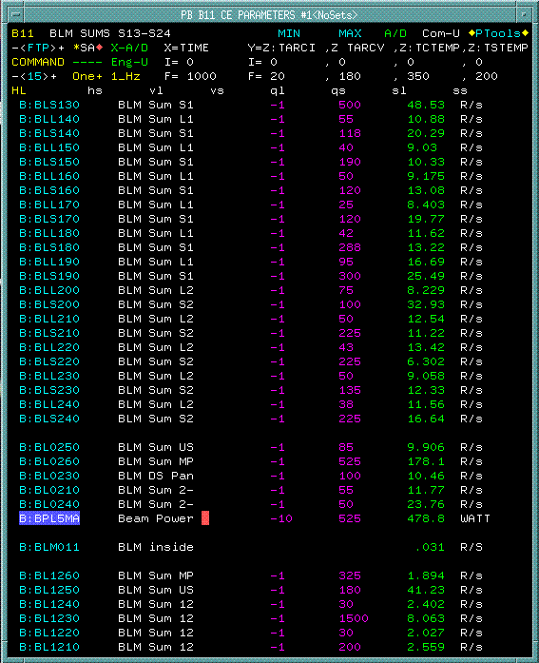
Alarm Thresholds (Rads/Sec) before upgrade
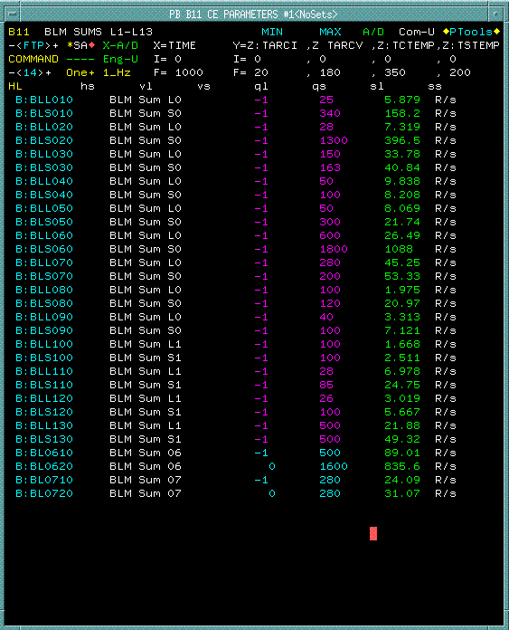
Alarm Thresholds (Rads/Sec) before upgrade

