Beam Position Monitor Requirements in the Linac and 400 MeV Line
  - September 12, 2011
  - Fernanda Garcia, Craig Drennan

Scope of the Project
The scope of the BPM upgrade includes the processing of the RF BPM pickup signals to determine beam position through the duration of the Linac beam pulse. The data acquisition electronics will also be required to compute position averages and deliver all of the position data to the ACNET control system every 66 ms (15HZ). A limited number of BPM’s in the Linac and 400 MeV line will be required to deliver all of the position data samples to applications running in ACNET at the 15 Hz rate. The majority of these BPM systems will return a single position to ACNET each beam pulse.
This project does not involve changing the BPM detectors or the cabling that comes up from the Linac enclosure.

Linac BPM Specifications

Parameter | Minimum | Typical | Maximum
Beam Intensity Range | 5 mA | 34 mA +/- 1 mA | 60 mA
Beam Pulse Duration | 2 usec | 25 usec | 60 usec
BPM Signal Frequency (Note 1) |  | 402.48 MHz
BPM Signal Amplitude Range
Position Measurement Range |  | +/- 25 mm
Position Rise Time (within 2%) |  |  | 200 nsec
Position Modulation BW | 3 MHz
Sample Rate |  | 10 MHz
Position Resolution (Note 2) | 0.25 mm
Position Accuracy (Note 3)
Long Term Position Stability |  | 0.25 mm
Beam Phase w.r.t. RF Resolution | 0.1 deg
Beam Phase Modulation BW

Note 1: 402.48 MHz is the second harmonic of the beam structure.
Note 2: Pin cushion error for 70% of beam positions should be good to 0.25 mm resolution.
Note 3: Involves mechanical alignment and individual measurement calibration.

See Appendix B for a list of Linac BPM’s.
Linac BPM applications to be supported:
- Beam Steering (see Appendix A)
- Long Term Logging
- Momentum and momentum spread measurements

400 MeV Line BPM Specifications

3.1 Specification Summary
Parameter | Minimum | Nominal | Maximum
Beam Intensity | 5 mA | 34 mA +/- 1 mA | 60 mA
BPM Signal Amplitude
BPM Signal Frequency |  | 201.24 MHz
Position Meas. Range |  | +/- 50 mm
Position Rise Time |  |  | 200 ns
Position Modulation BW | 3 MHz
Beam Pulse Duration | 2.2 us | 25 us | 45 us
Sample Rate |  | 5 MHz
Position Resolution |  | 0.1 mm
Position Accuracy
Long Term Position Stability |  | 0.25 mm

See Appendix C for a list of 400 MeV and Booster Injection BPM’s.
400 MeV Line BPM applications to be supported:
- Beam Steering
- Long Term Logging
- Momentum and momentum spread measurements

3.2 BPM Detector Variations
There are 4 different BPM detector variations in the 400 MeV and Booster Injection. Each type has its own position sensitivity value. The sensitivity value, ‘s’, is required to determine the position of the beam given the amplitude of the RF signals from Plate A and Plate B of the BPM.
$$s∙X_{0}=20 Log10\left({V_{A}}/{V_{B}}\right)$$
Where $X_{0}$ is the deviation of the beam position from the center of the BPM. The sensitivity value has units of ${dB}/{mm}$. Table 3.2.1 lists the different BPM detectors.

BPM Detector Type | BPM Sensitivity, dB/mm | Inside Diameter, Inches | Pickup Electrode Length, Inches | Pickup Electrode Radius, Inches | Pickup Electrode Angle, Degrees | Detector Drawing Numbers
LINAC | 1.800 | 1.50 | 3.671 | 0.7300 | 28
Lambertson | 0.479 | 6.13 | 5.375 | 3.0625 | 60 | 0390.025-MD-299762
Injection Foil | 0.436 | 6.13 | 5.375 | 3.0625 | 60 | 0390.025-MD-299593
400 MeV | 0.476 | 4.63 | 6.000 | 2.3125 | 60 | 0314-MD-299021
Short Inject. | 0.679 | 4.56 | 8.000 | 1.6875 | 60 | 0320.000-MD-137240
Booster | 0.500 | 4.62 | 13.313 | 2.3120 | 70 | 0320.090-MD-394546

BPM Detector Type | Description
LINAC | These are the standard 1.5 inch BPM’s in the High Energy Linac.
Lambertson | This BPM is just upstream of the 400 MeV Lambertson
Injection Foil | This BPM is just downstream of the Foil Changer on the Booster Injection Girder.
400 MeV | This is the BPM used in the majority of the locations in the 400 MeV line. It is the same style as the old Booster BPM’s before the corrector upgrade in 2007. In some locations the plate termination was modified to make the BPM bidirectional. Some detectors had to be rotated in order to fit them mechanically into the beam line.
Short Inject. | This is a short version of the Booster corrector BPM made to fit in the upstream end of the Booster Injection Girder.
Booster | This is the standard Booster corrector style BPM. These BPM in the vicinity of the Injection Girder have splitters in the tunnel for the plate signal cables. One set of signals is routed to the standard Booster readout electronics, and the second set is routed to the 200 MHz RF Modules for looking at beam as it comes out of the 400 MeV line

3.3 400 MeV Line BPM Data Acquisition and Sampling Control
The 400 MeV Line BPM’s see a portion of the Linac beam controlled by the electrostatic chopper device at the end of the High Energy Linac. There is a fixed delay between the firing of this chopper and the appearance of beam in the BPM’s. The timing logic that determines when to fire the chopper also triggers the start of position sampling so that the first and subsequent points in the position data record have a fixed relationship to the arrival of beam. This relationship is then the same from cycle to cycle, from pulse to pulse. Additionally, position sampling begins a fixed number of samples before the arrival of beam. The arrival of beam can be seen in the data record as a slewing from some “no beam” value to a realistic beam position value. This helps the operator doing a study of the beam line with verification that the data record they are observing is properly timed. Note that though we use the term “fixed” that there is some jitter in all this on the order of one sample period or less.
In addition to the BPM’s in the 400 MeV Line there are BPM’s in and on either end of the Booster Injection girder that we need to see the 400 MeV beam with. The chopper timing logic also provides gating of position sampling for these BPM’s. A detailed document for all of this chopper / BPM timing is provided in Beams-doc-3696-v1 in the Accelerator Division docDB document database.
Note that the sampling clock used to sample the BPM position voltage at the digitizers is synchronized to the chopper trigger and is provided by the chopper timing logic. Future implementations of 400 MeV BPM electronics need to support this arrangement.

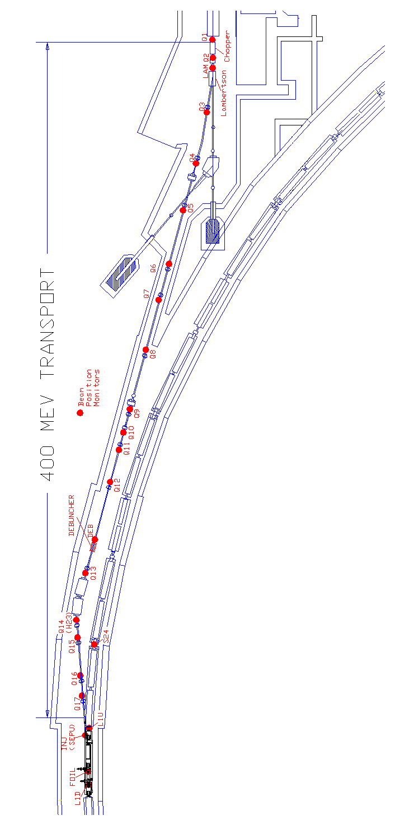
Figure 3.1 Illustrations of the 400MeV BPM Locations
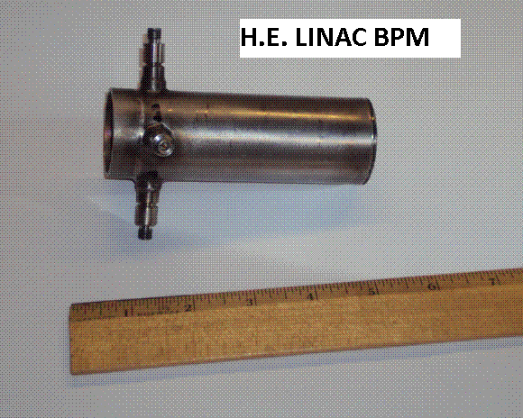
Figure 3.2 Photo of a High Energy Linac BPM.

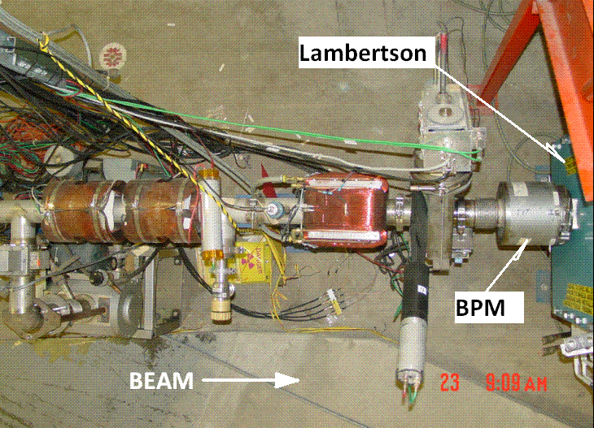
Figure 3.3 Photo of the Lambertson BPM.

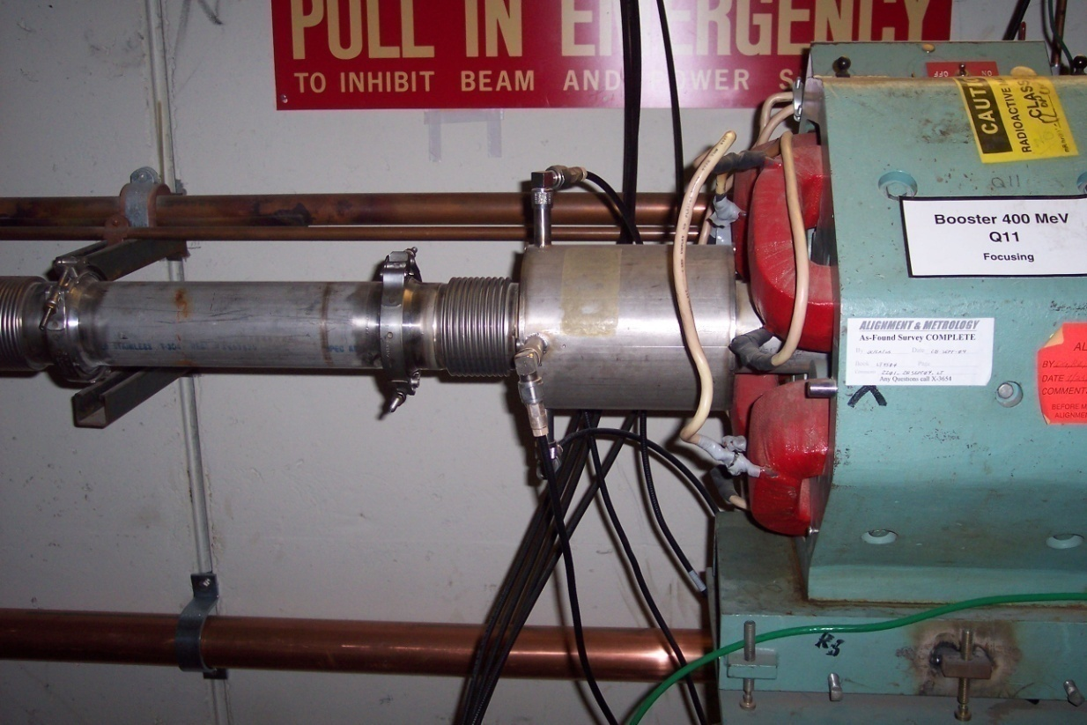
Figure 3.4 Photo of the standard 400 MeV BPM.

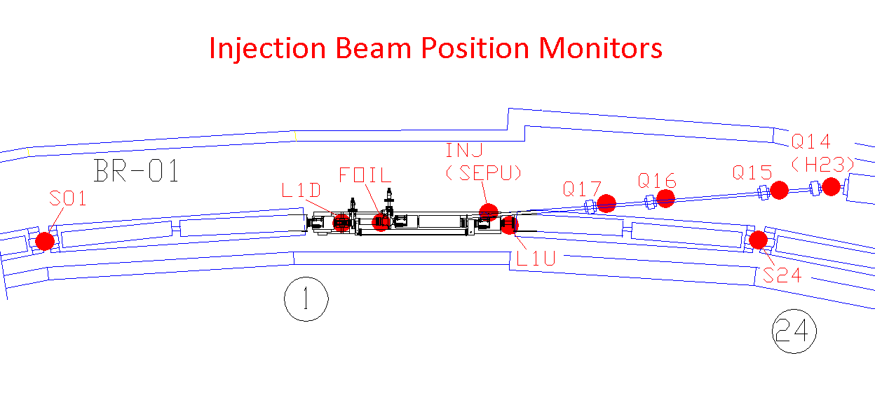
Figure 3.5 Illustration of the BPM locations near the Booster Injection Girder.

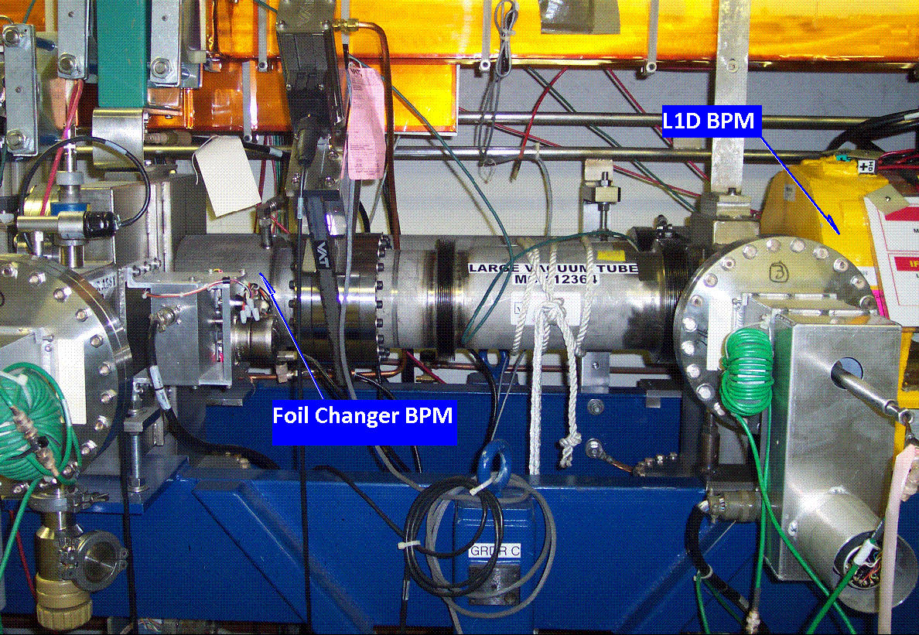
Figure 3.6 Photo of the BPM downstream of the Injection Girder Foil Changer.

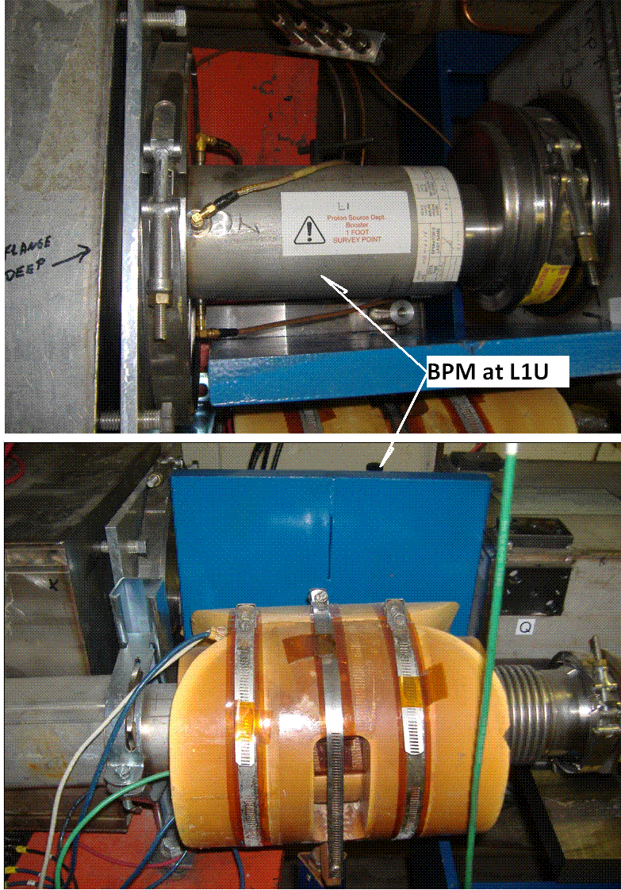
Figure 3.7 Photo of the BPM at L1U near the Booster Injection Girder.

Appendix A: Linac Steering Application
This text is taken from the “Linac Rookie Book”, v2.1, October 1, 2004.

Linac Steering and Momentum Analysis (page 135)
Proper operation of the 400 MeV transport line assumes a specific beam position and angle at the entrance to the line. To this end the alignment of scanning wires W1 and W2 is such that the nominal beam position is at the center of the wires. Conducting a Linac steer will adjust the beam’s center position using BPM positions (chapter three’s Linac Tuning Guide).
Linac steering should be done before any 400 MeV line tuning, before any 750 keV line tuning, and once per shift just for the heck of it. Momentum analysis is simply a matter of running wire W5 (horizontal) across the beam and observing the beam profile. A change in the peak width will correspond to a momentum spread change assuming no other focusing changes.

L32: Linac Steering (page 172)
The Linac steering page provides automatic measurement of beam positions at the beginning of the 400 MeV transport line, as well as calculating corrections to the steering trim magnets that will center the beam.
The program has the option of operating under Novice or Expert Level. The program starts up in the Novice Level with the options available on the screen used most frequently. Clicking on the Novice Level will switch to the Expert Level. The Expert Level is not user friendly and (as far as I know) has no restore function. So, if you use it proceed with caution—better yet, leave this to the experts. However, you have two options at this level:
♦ Enter Calib:
This allows you to enter calibration values by hand and save them to file.
♦ Redefine 0's:
This sets the desired positions to steer to.
In the novice level there are five options you can initiate:
♦ Restore Dipoles:
This will set all of the dipoles to the original values that existed before you entered the page.
♦ Read BPMs:
This reads the horizontal and vertical beam positions at Q74 (L:D74BPH and L:D74BPV) and at Q2 after the chopper (B:HPQ2 and B:VPQ2). Use trim magnets L:D72TMH, L:D72TMV, and L:D74TMV to position the beam properly on the Lambertson.

♦ Pulses to Avg=6:
This is where the user can input the number of pulses to take before displaying data. The current and suggested default is 6. This means the BPMs will average data for 6 STUDIES pulses. Set the 15 Hz box, or use the 15 Hz beam switch by each console, to 3 or 5 Hz and then turn on. Remember to turn it off when you are finished.
♦ Calculate New Dipole Settings:
This command takes the collected BPM data and calculates trim values which you have the choice of sending or not. The offset value is the amount of the error (the desired position has been subtracted from the BPM reading). Under the heading CHANGE are the amounts in amps that the program wants to change the dipole settings. Under the heading SET is the value of the new dipole setting. The Send New Settings command will send out these settings. If no changes are to be made then the command won't even appear on the screen. The code will automatically change the nominal of the trims so beam is not inhibited. The program will warn the user if the trim setting(s) is/are out of tolerance.
♦ Check Calibration:
Calibration numbers are the measured response at a particular BPM due to changing the current at a dipole. In essence, if you plot the BPM reading versus dipole setting and take the slope of this line (usually pretty linear) then you have the calibration number. This needs to be checked if the lattice has been changed in the region where steering is being done. Most likely this would be a change in the quadrupole values Q72, Q73, Q74, or B:Q2.

It should be noted that the trim supplies are small. D/A values of 10 or greater will probably not have the desired effect on the beam positions. If the program cannot center beam without turning a trim on that hard, the 750 keV line should probably be re-tuned.
Steering should be checked before and after any 750 keV line tuning, before any 400 MeV or Booster tuning, before any momentum scans, and once per shift. You should tune once per shift to forestall the natural tendencies of positions drifting.

Appendix B: List of Linac Beam Position Monitors

Linac Beam Position Monitors |  |  | Current ACNET Conversion Volts to mm
 |  |  | Xpos = (C1*Xvolts / C2) + C3
Location | ACNET Name | CONTROLS  NAME | C1 | C2 | C3 | Accelerator  Beta | MeV
LE Linac | L:BPH2OT | BPH2OT | 39.459 | 10 | 1.000 | 0.275 | 37.5
 | L:BPV2OT | BPV2OT | 39.430 | 10 | 0.700 | 0.275 | 37.5
 | L:BPHNTF |  | 41.430 | 10 | 0.000 | 0.275 | 37.5
 | L:BPH3IN | BPH3IN | 41.490 | 10 | 1.500 | 0.275 | 37.5
 | L:BPV3IN | BPV3IN | 42.090 | 10 | 0.500 | 0.275 | 37.5
 | L:BPH3OT | BPH3OT | 38.490 | 10 | -0.500 | 0.375 | 66.2
 | L:BPV3OT | BPV3OT | 38.688 | 10 | 3.000 | 0.375 | 66.2
 | L:BPH4IN | BPH4IN | 41.430 | 10 | 4.000 | 0.375 | 66.2
 | L:BPV4IN | BPV4IN | 42.060 | 10 | 2.500 | 0.375 | 66.2
 | L:UPHNTF |  | new |  |  | 0.375 | 66.2
 | L:UPVNTF |  | new |  |  | 0.375 | 66.2
 | L:BPH5IN | BPH5IN | 41.000 | 10 | -2.500 | 0.414 | 92.6
 | L:BPV5IN | BPV5IN | 41.000 | 10 | -1.000 | 0.414 | 92.6
 | L:BPH5OT | BPH5OT | 38.000 | 10 | 2.000 | 0.457 | 116.5
 | L:BPV5OT | BPV5OT | 38.000 | 10 | 1.000 | 0.457 | 116.5
Transition | L:D02BPH | 0-1 H | 120.000 | 10 | -32.290 | 0.457 | 116.5
 | L:D02BPV | 0-1 V | 120.000 | 10 | -30.290 | 0.457 | 116.5
 | L:D03BPH | 0-2 H | 120.000 | 10 | -32.020 | 0.457 | 116.5
 | L:D03BPV | 0-2 V | 120.000 | 10 | -29.080 | 0.457 | 116.5
 | L:D04BPH | 0-3 H | 120.000 | 10 | -29.780 | 0.457 | 116.5
 | L:D04BPV | 0-3 V | 120.000 | 10 | -29.520 | 0.457 | 116.5
Module 1 | L:D11BPH | M1-1 H | 120.000 | 10 | -32.540 | 0.471 | 125.1
 | L:D11BPV | M1-1 V | 120.000 | 10 | -30.980 | 0.471 | 125.1
 | L:D12BPH | M1-2 H | 120.000 | 10 | -31.790 | 0.483 | 133.8
 | L:D12BPV | M1-2 V | 120.000 | 10 | -30.010 | 0.483 | 133.8
 | L:D13BPH | M1-3 H | 120.000 | 10 | -29.260 | 0.496 | 142.8
 | L:D13BPV | M1-3 V | 120.000 | 10 | -31.450 | 0.496 | 142.8
Module 2 | L:D21BPH | M2-1 H | 120.000 | 10 | -28.520 | 0.521 | 161.2
 | L:D21BPV | M2-1 V | 60.000 | 10 | -30.860 | 0.521 | 161.2
 | L:D22BPV | M2-2 V | 120.000 | 10 | -31.550 | 0.532 | 170.6
 | L:D22BPH | M2-2 H | 60.000 | 10 | -28.730 | 0.532 | 170.6
 | L:D23BPV | M2-3 V | 60.000 | 10 | -30.370 | 0.544 | 180.2
 | L:D23BPH | M2-3 H | 120.000 | 10 | -32.540 | 0.544 | 180.2
Module 3 | L:D31BPH | M3-1 H | 120.000 | 10 | -30.940 | 0.565 | 199.7
 | L:D31BPV | M3-1 V | 60.000 | 10 | -30.790 | 0.565 | 199.7
 | L:D32BPV | M3-2 V | 120.000 | 10 | -28.000 | 0.575 | 209.5
 | L:D32BPH | M3-2 H | 60.000 | 10 | -29.570 | 0.575 | 209.5
 | L:D33BPH | M3-3 H | 120.000 | 10 | -29.000 | 0.585 | 219.6
 | L:D33BPV | M3-3 V | 60.000 | 10 | -30.480 | 0.585 | 219.6
 | L:D34BPH | M3-4 H | 60.000 | 10 | -30.000 | 0.595 | 229.8
 | L:D34BPV | M3-4 V | 120.000 | 10 | -29.700 | 0.595 | 229.8
Module 4 | L:D41BPH | M4-1 H | 120.000 | 10 | -32.250 | 0.604 | 239.9
 | L:D41BPV | M4-1 V | 60.000 | 10 | -29.790 | 0.604 | 239.9
 | L:D42BPV | M4-2 V | 120.000 | 10 | -31.270 | 0.614 | 250.1
 | L:D42BPH | M4-2 H | 60.000 | 10 | -29.670 | 0.614 | 250.1
 | L:D43BPH | M4-3 H | 120.000 | 10 | -32.480 | 0.622 | 260.1
 | L:D43BPV | M4-3 V | 60.000 | 10 | -30.410 | 0.622 | 260.1
 | L:D44BPH | M4-4 H | 60.000 | 10 | -30.180 | 0.631 | 271.1
 | L:D44BPV | M4-4 V | 120.000 | 10 | -32.000 | 0.631 | 271.1
Module 5 | L:D51BPH | M5-1 H | 120.000 | 10 | -27.500 | 0.639 | 281.5
 | L:D51BPV | M5-1 V | 60.000 | 10 | -29.790 | 0.639 | 281.5
 | L:D52BPV | M5-2 V | 120.000 | 10 | -28.410 | 0.647 | 292.1
 | L:D52BPH | M5-2 H | 60.000 | 10 | -29.570 | 0.647 | 292.1
 | L:D53BPH | M5-3 H | 120.000 | 10 | -28.000 | 0.654 | 302.8
 | L:D53BPV | M5-3 V | 60.000 | 10 | -30.180 | 0.654 | 302.8
 | L:D54BPH | M5-4 H | 60.000 | 10 | -29.620 | 0.662 | 313.6
 | L:D54BPV | M5-4 V | 120.000 | 10 | -30.330 | 0.662 | 313.6
Module 6 | L:D61BPH | M6-1 H | 120.000 | 10 | -32.500 | 0.669 | 324.4
 | L:D61BPV | M6-1 V | 60.000 | 10 | -29.620 | 0.669 | 324.4
 | L:D62BPV | M6-2 V | 120.000 | 10 | -32.096 | 0.676 | 335.2
 | L:D62BPH | M6-2 H | 60.000 | 10 | -29.120 | 0.676 | 335.2
 | L:D63BPV | M6-3 V | 60.000 | 10 | -30.230 | 0.683 | 346.1
 | L:D63BPH | M6-3 H | 120.000 | 10 | -29.824 | 0.683 | 346.1
 | L:D64BPH | M6-4 H | 60.000 | 10 | -29.540 | 0.689 | 357.1
 | L:D64BPV | M6-4 V | 120.000 | 10 | -30.066 | 0.689 | 357.1
Module 7 | L:D71BPH | M7-1 H | 120.000 | 10 | -29.802 | 0.696 | 368.1
 | L:D71BPV | M7-1 V | 120.000 | 10 | -29.802 | 0.696 | 368.1
 | L:D72BPH | M7-2 H | 120.000 | 10 | -29.934 | 0.702 | 379.1
 | L:D72BPV | M7-2 V | 120.000 | 10 | -30.190 | 0.702 | 379.1
 | L:D73BPH | M7-3 H | 120.000 | 10 | -29.904 | 0.708 | 390.2
 | L:D73BPV | M7-3 V | 120.000 | 10 | -30.016 | 0.708 | 390.2
 | L:D74BPH | M7-4 H | 120.000 | 10 | -30.116 | 0.714 | 401.5
 | L:D74BPV | M7-4 V | 120.000 | 10 | -30.040 | 0.714 | 401.5
 | L:D75BPH | M7-5 H | 152.000 | 10 | -45.200 | 0.714 | 401.5
 | L:D75BPV | M7-5 V | 152.000 | 10 | -45.200 | 0.714 | 401.5
400MeV-Dump Area | L:BPH201 | BPH201 | 75.264 | 10 | 0.000 | 0.714 | 401.5
 | L:BPH202 | BPH202 | 74.959 | 10 | 0.000 | 0.714 | 401.5
 | L:BPH203 | BPH203 | 76.667 | 10 | 0.000 | 0.714 | 401.5
 | L:BPH204 | BPH204 | 75.000 | 10 | 0.000 | 0.714 | 401.5
 | L:BPV201 | BPV201 | 75.625 | 10 | -3.000 | 0.714 | 401.5
 | L:BPV202 | BPV202 | 75.050 | 10 | 0.000 | 0.714 | 401.5
 | L:BPV203 | BPV203 | 77.120 | 10 | 0.000 | 0.714 | 401.5
 | L:BPV204 | BPV204 | 75.000 | 10 | 0.000 | 0.714 | 401.5

Appendix C: List of 400 MeV and Booster Injection Beam Position Monitors

400 MeV and Booster Injection BPM’s
ACNET Name | Controls  Name | BPM Sensitivity, dB/mm | Inside Diameter (inches) | Pickup Electrode Length, Inches | Pickup Electrode Radius, Inches | Pickup Electrode Angle, Degrees | Accelerator  Beta | Detector Drawing Numbers
B:HPQ1 | HP-Q1 | 1.800 | 1.50 | 3.671 | 0.7300 | 28 | 0.714 | 0230-MB-61354
B:VPQ1 | VP-Q1 | 1.800 | 1.50 | 3.671 | 0.7300 | 28 | 0.714 | 0230-MB-61354 (Linac Style)
B:HPQ2 | HP-Q2 | 0.476 | 4.63 | 6.000 | 2.3125 | 60 | 0.714 | 0314-MD-299021
B:VPQ2 | VP-Q2 | 0.476 | 4.63 | 6.000 | 2.3125 | 60 | 0.714 | 0314-MD-299021
B:HPLAM | HP-LAM | 0.479 | 6.13 | 5.375 | 3.0625 | 60 | 0.714 | 0390.025-MD-299762
B:VPLAM | VP-LAM | 0.479 | 6.13 | 5.375 | 3.0625 | 60 | 0.714 | 0390.025-MD-299762
B:HPQ3 | HP-Q3 | 0.476 | 4.63 | 6.000 | 2.3125 | 60 | 0.714 | 0314-MD-299021
B:VPQ3 | VP-Q3 | 0.476 | 4.63 | 6.000 | 2.3125 | 60 | 0.714 | 0314-MD-299021
B:HPQ4 | HP-Q4 | 0.476 | 4.63 | 6.000 | 2.3125 | 60 | 0.714 | 0314-MD-299021
B:VPQ4 | VP-Q4 | 0.476 | 4.63 | 6.000 | 2.3125 | 60 | 0.714 | 0314-MD-299021
B:HPQ5 | HP-Q5 | 0.476 | 4.63 | 6.000 | 2.3125 | 60 | 0.714 | 0314-MD-299021
B:VPQ5 | VP-Q5 | 0.476 | 4.63 | 6.000 | 2.3125 | 60 | 0.714 | 0314-MD-299021
B:HPQ6 | HP-Q6 | 0.476 | 4.63 | 6.000 | 2.3125 | 60 | 0.714 | 0314-MD-299021
B:VPQ6 | VP-Q6 | 0.476 | 4.63 | 6.000 | 2.3125 | 60 | 0.714 | 0314-MD-299021
B:HPQ7 | HP-Q7 | 0.476 | 4.63 | 6.000 | 2.3125 | 60 | 0.714 | 0314-MD-299021
B:VPQ7 | VP-Q7 | 0.476 | 4.63 | 6.000 | 2.3125 | 60 | 0.714 | 0314-MD-299021
B:HPQ8 | HP-Q8 | 0.476 | 4.63 | 6.000 | 2.3125 | 60 | 0.714 | 0314-MD-299021
B:VPQ8 | VP-Q8 | 0.476 | 4.63 | 6.000 | 2.3125 | 60 | 0.714 | 0314-MD-299021
B:HPQ9 | HP-Q9 | 0.476 | 4.63 | 6.000 | 2.3125 | 60 | 0.714 | 0314-MD-299021
B:VPQ9 | VP-Q9 | 0.476 | 4.63 | 6.000 | 2.3125 | 60 | 0.714 | 0314-MD-299021
B:HPQ10 | HP-Q10 | 0.476 | 4.63 | 6.000 | 2.3125 | 60 | 0.714 | 0314-MD-299021
B:VPQ10 | VP-Q10 | 0.476 | 4.63 | 6.000 | 2.3125 | 60 | 0.714 | 0314-MD-299021
B:VPQ11 | VP-Q11 | 0.476 | 4.63 | 6.000 | 2.3125 | 60 | 0.714 | 0314-MD-299021
B:HPQ12 | HP-Q12 | 0.476 | 4.63 | 6.000 | 2.3125 | 60 | 0.714 | 0314-MD-299021
B:VPQ12 | VP-Q12 | 0.476 | 4.63 | 6.000 | 2.3125 | 60 | 0.714 | 0314-MD-299021
B:HPDEB | HP-DEB | 0.476 | 4.63 | 6.000 | 2.3125 | 60 | 0.714 | 0314-MD-299021
B:VPDEB | VP-DEB | 0.476 | 4.63 | 6.000 | 2.3125 | 60 | 0.714 | 0314-MD-299021
B:HPQ13 | HP-Q13 | 0.476 | 4.63 | 6.000 | 2.3125 | 60 | 0.714 | 0314-MD-299021
B:VPQ13 | VP-Q13 | 0.476 | 4.63 | 6.000 | 2.3125 | 60 | 0.714 | 0314-MD-299021
B:HPQ15 | HP-Q15 | 0.476 | 4.63 | 6.000 | 2.3125 | 60 | 0.714 | 0314-MD-299021
B:VPQ15 | VP-Q15 | 0.476 | 4.63 | 6.000 | 2.3125 | 60 | 0.714 | 0314-MD-299021
B:HPQ16 | HP-Q16 | 0.476 | 4.63 | 6.000 | 2.3125 | 60 | 0.714 | 0314-MD-299021
B:VPQ16 | VP-Q16 | 0.476 | 4.63 | 6.000 | 2.3125 | 60 | 0.714 | 0314-MD-299021
B:HPQ17 | HP-Q17 | 0.476 | 4.63 | 6.000 | 2.3125 | 60 | 0.714 | 0314-MD-299021
B:VPQ17 | VP-Q17 | 0.476 | 4.63 | 6.000 | 2.3125 | 60 | 0.714 | 0314-MD-299021
B:HPINJ | HP-INJ | 0.476 | 4.63 | 6.000 | 2.3125 | 60 | 0.714 | 0314-MD-299021
B:VPINJ | VP-INJ | 0.476 | 4.63 | 6.000 | 2.3125 | 60 | 0.714 | 0314-MD-299021
B:HPFOIL | HP-FOIL | 0.436 | 6.13 | 5.375 | 3.0625 | 60 | 0.714 | 0390.025-MD-299593
B:VPFOIL | VP-FOIL | 0.436 | 6.13 | 5.375 | 3.0625 | 60 | 0.714 | 0390.025-MD-299593
B:HPH23 | HP-H23 | 0.476 | 4.63 | 6.000 | 2.3125 | 60 | 0.714 | 0314-MD-299021
B:VPH23 | VP-H23 | 0.476 | 4.63 | 6.000 | 2.3125 | 60 | 0.714 | 0314-MD-299021
B:HPL1D | HP-L1D | 0.500 | 4.62 | 13.313 | 2.3120 | 70 | 0.714 | 0320.090-MD-394546
B:VPL1D | VP-L1D | 0.500 | 4.62 | 13.313 | 2.3120 | 70 | 0.714 | 0320.090-MD-394546
B:HPS01 | HP-S01 | 0.500 | 4.62 | 13.313 | 2.3120 | 70 | 0.714 | 0320.090-MD-394546
B:VPS01 | VP-S01 | 0.500 | 4.62 | 13.313 | 2.3120 | 70 | 0.714 | 0320.090-MD-394546
B:HPL1U | HP-L1U | 0.679 | 4.56 | 8.000 | 1.6875 | 60 | 0.714 | 0320.000-MD-137240
B:VPL1U | VP-L1U | 0.679 | 4.56 | 8.000 | 1.6875 | 60 | 0.714 | 0320.000-MD-137240
B:HPS24 | HP-S24 | 0.500 | 4.62 | 13.313 | 2.3120 | 70 | 0.714 | 0320.090-MD-394546
B:VPS24 | VP-S24 | 0.500 | 4.62 | 13.313 | 2.3120 | 70 | 0.714 | 0320.090-MD-394546

