1.3 GHz Phase Averaging Reference Line for Fermilab’s NML
Brian Chase, Ed Cullerton
A 1.3 GHz phase averaging reference line is being developed for Fermilab’s NML accelerator. The reference line is composed of directional couplers and 7/8” heliax cable. The reference line is shorted at one end of the line to provide reflected signals that are summed and phase averaged with the forward signals at each directional coupler. The phase drifts of the 7/8” heliax are compensated for by the phase averaging at each coupler. A method is also outlined to minimize phase deviation caused by impedance mismatches and directivity of the directional couplers. Simulations results of the reference line are presented along with results of a scaled version of the reference line built in the lab.
1. Overview
The concept of the NML reference line design is to send an RF signal down a length of coaxial cable with a short circuit at the end of the line. Using dual directional couplers, the forward and reflected signals are coupled out of the coaxial line, and then summed together to realize an averaged phase that is not sensitive to variations in cable. This statement is only true when ideal components are used, and a procedure is outlined in this paper to minimize the phase deviation caused by non-ideal components. To increase phase accuracy, phase feedback is used to hold the phase constant at the short circuited end of the line. The concept described above is similar to a scheme presented in [1].
The source for the phase stable 1.3 GHz signal is the master oscillator[2], which will be located in a temperature controlled room at the front end of the accelerator. A ten watt amplifier, located in the same rack as the master oscillator, will amplify the 1.3 GHz signal and send it down the reference line. The reference line is looped back to the master oscillator and feedback is used to maintain an absolute phase reference point. A diagram of the NML reference line is shown in figure 1. The reference line will provide a phase stable signal to the following systems: laser source, electron gun, CC1, CC2, CM1, CM2, CM3, and two points along the reference line will provide for instrumentation.

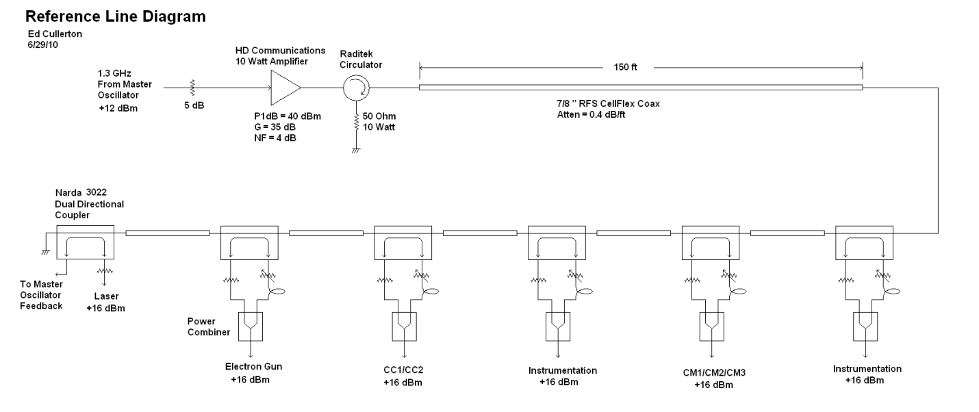
Figure 1. Diagram of the 1.3 GHz NML reference line.
2. Components of the Reference Line
The components of the reference line have been carefully selected to minimized added phase noise and minimize phase deviation. The 10 Watt amplifier is specified with a low noise figure and a low ripple power supply to minimize added phase noise to the signal. A plot of the residual phase noise of the amplifier is shown in figure 2. There is a calibration factor of -62 dB that is added to the numbers seen in the plot, and the worst case is –139.8 dBc/sqrt(Hz) at 852 Hz. The very low frequency data (<100 Hz) is unreliable due to power supply ground loops that cause error in the measurement.
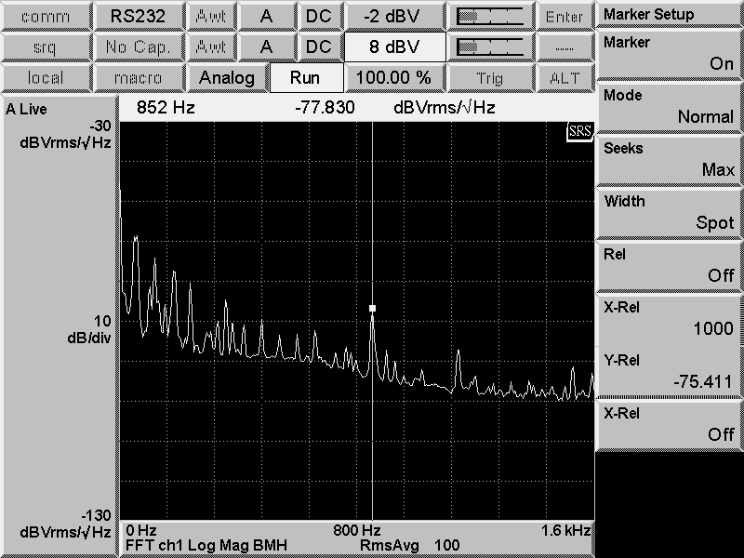
Figure 2. Residual phase noise of the 10 Watt amplifier.
The phase accuracy of the reference line is dependent on reflections within the reference line, the directivity of the couplers, the phase stability of the coaxial cable between couplers, and the phase stability of the cables used to sum the signals together.
Reflections within the line from impedance mismatches between the couplers and the 7/8” coaxial cable will causes phase deviations as temperature varies. The larger the impedance mismatch, the greater the phase deviation The Narda 3022 20dB directional coupler was chosen because it has good VSWR (<1.05) and good directivity(>35 dB). The return loss of a typical Narda 3022 directional coupler return loss is shown in figure 3. RFS CellFlex 7/8”coaxial cable was chosen for the cable between the couplers because of its excellent temperature stability, and a plot of its temperature characteristics is shown in figure 4. Times Microwave Phasetack 210 cable was chosen for the summing cables because it also has excellent temperature stability, and a plot of its temperature characteristics are shown in figure 5.
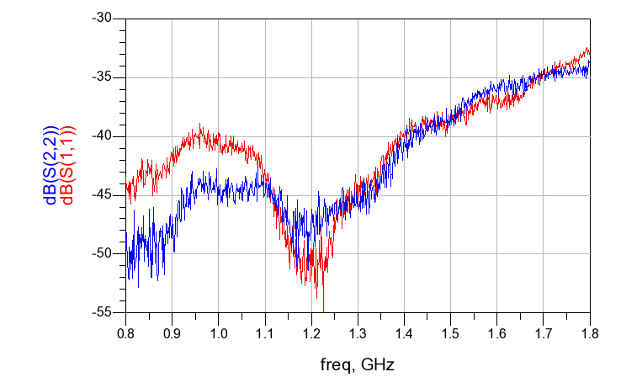
Figure 3. Narda 3022 20dB Coupler typical return loss.
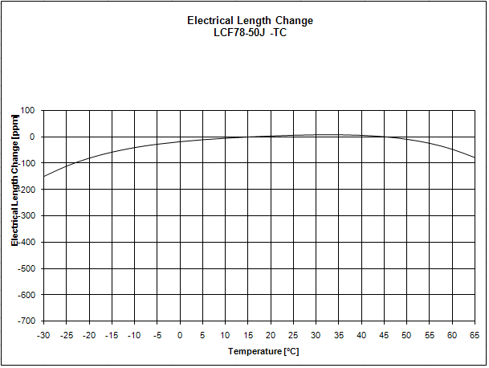
Figure 4. RFS 7/8” cable electrical length vs temperature.
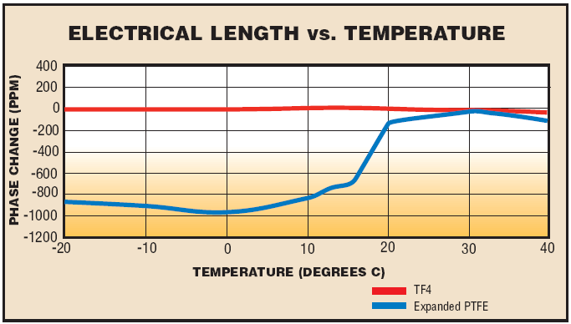
Figure 5. Phasetrack-210 cable electrical length vs temperature.
3. Reference Line Simulation and Design
Simulations have been performed to verify a procedure for building the reference line. The goal of the procedure is to minimize phase deviation vs change in temperature. A change in temperature leads to changes in cable length, so we can say that we are designing the reference for minimum phase deviation vs change in cable length. Internal reflections in the reference line, due to impedance mismatches between the coupler and 7/8” cable, cause phase deviations when the electrical length of the 7/8” cable is changed. If the directional couplers and the 7/8” cable were perfectly matched, changes in cable length would not affect the phase, because of the nature of the phase averaging scheme. The design procedure outlined in this paper looks at the phase ripple caused by internal reflections along the reference line, and adjusts cable length between the couplers so that the change in averaged forward and reflected signals is minimized. This is done by adjusting the length of 7/8” cable so that the averaged phase is on a peak of this phase ripple. This will minimize the phase deviation due to changes in the 7/8” cable length caused by temperature change.
The Narda 3022 directional couplers have been measured using a 4 port network analyzer and the s-parameter data is used in the simulations. A model for the RFS cable has also been developed for simulation. The simulations were done using Agilent ADS. The design procedure starts at coupler 2 nearest the shorted end of the reference line, and is used to determine the optimum cable length between couplers 1 and 2. The circuit model used to simulate this first section of the reference line is shown in figure 6. The simulation calculates S21 and S31, which correspond to the forward and reflected signals at the output of the second coupler. Starting with an arbitrary length of 30 meters for the 7/8” cable, the results of the simulation are shown in figure 7. The phase is plotted over a broad frequency sweep so that the phase may be flattened using electrical delay. Once the electrical delay is adjusted to flatten the phase, the circuit is again simulated with a more narrow frequency sweep so that the peak phase can be seen more clearly, which is shown in figure 8.
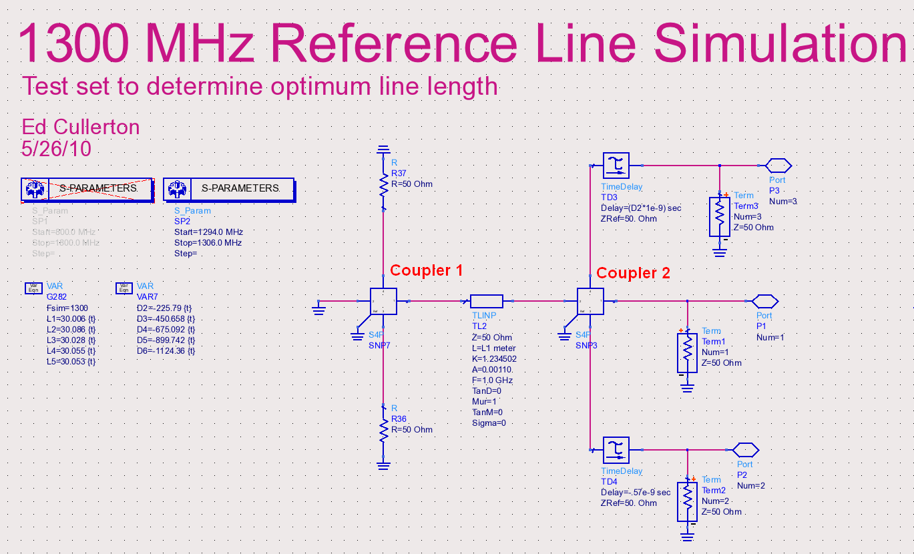
Figure 6. Simulation to find the optimum cable length between coupler 1 and coupler 2.
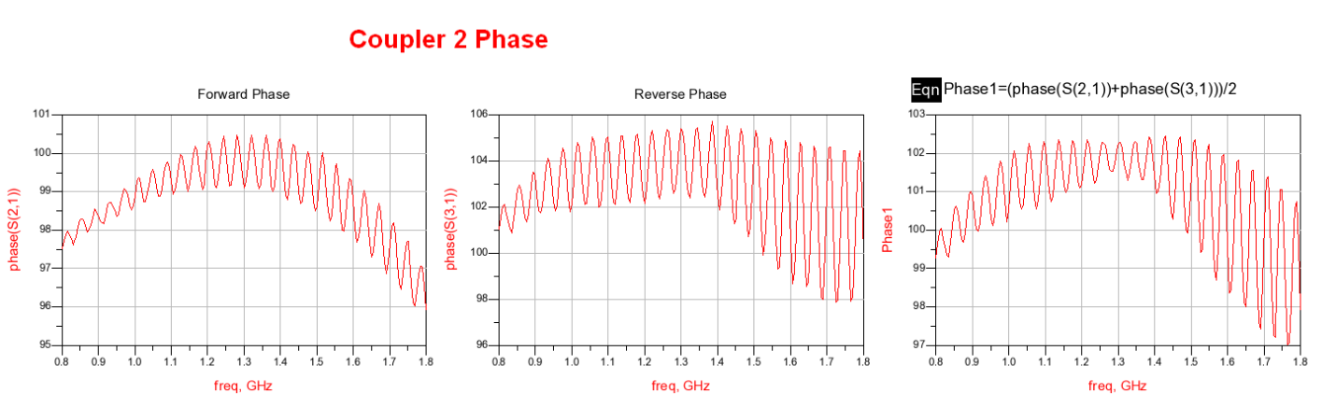
Figure 7. Broad frequency sweep of the forward, reflected, and averaged phase and coupler 2.
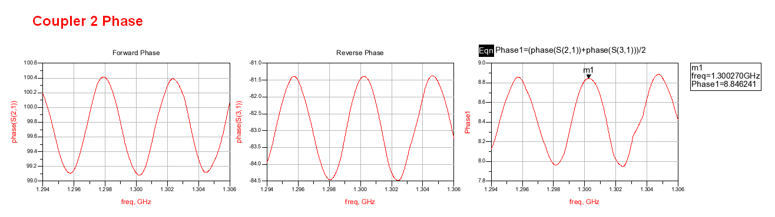
Figure 8. Forward, reflected, and averaged phase at coupler 2 before cable length adjustment.
It is seen from figure 8 that the average phase has a peak at 1.30027 GHz. The procedure calls for the cable length to be adjusted so that the peak is at exactly 1.3 GHz. This will satisfy the condition of minimum phase change versus change in cable length. The final adjustment to the cable was made and a plot of the simulation results is shown in figure 9. It is seen that the average phase is at a peak exactly at 1.3 GHz.
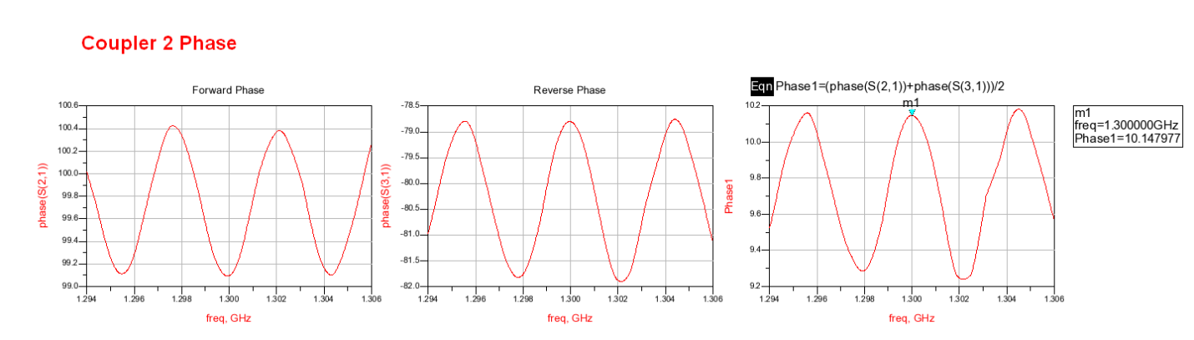
Figure 9. Forward, reflected, and averaged phase from coupler 2.
The procedure continues with the next coupler down the line. The simulation schematic for coupler 3 is shown in figure 10. As seen in figure 11, the s21 and S31 phase measurements show more ripple due to the additional reflections caused by adding another coupler in the line. It is also seen that the ripples are more narrow in frequency, which leads to increased phase error due to changes in cable length. This characteristic will limit the amount of couplers that can be added to the line given a specified phase deviation for the line. The procedure was repeated for a total of 6 couplers, and the cable lengths for each section of the reference line have been determined. The final simulation results for all the couplers, after adjusting cable lengths, is shown in figure 12.
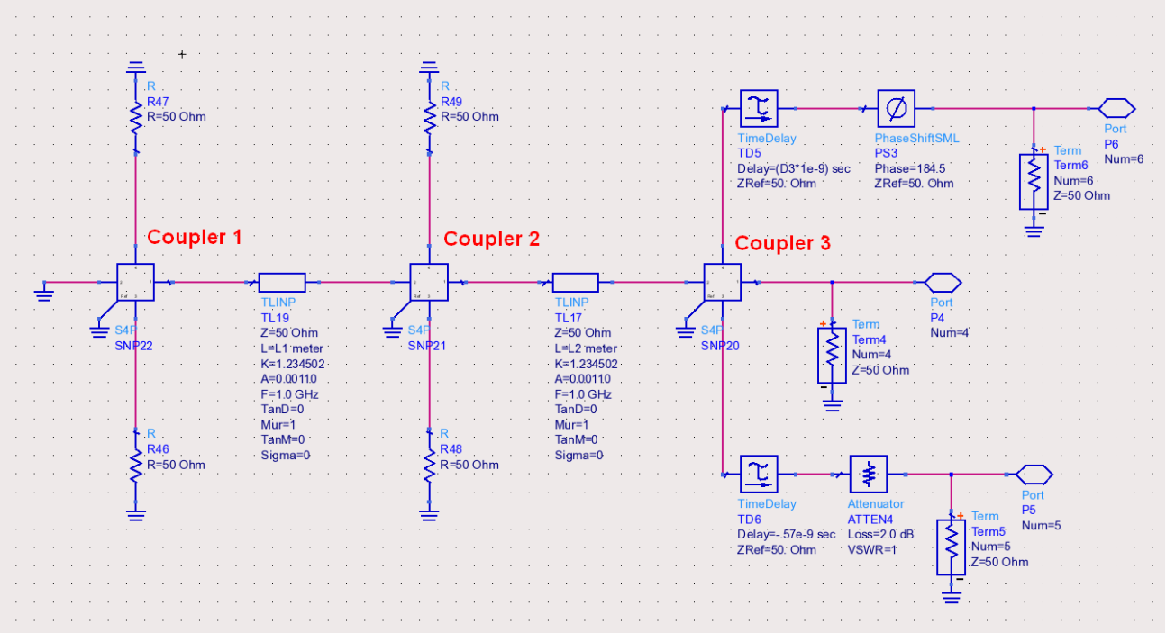
Figure 10. Simulation to find optimum cable length between coupler 2 and coupler 3.
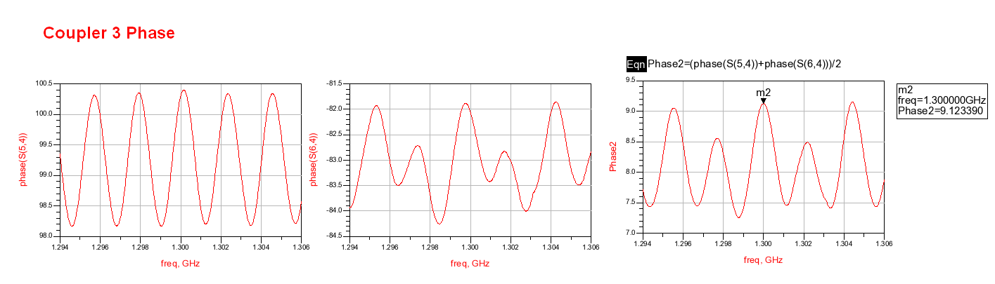
Figure 11. Forward, reflected, and averaged phase from coupler 3 after cable adjustment.
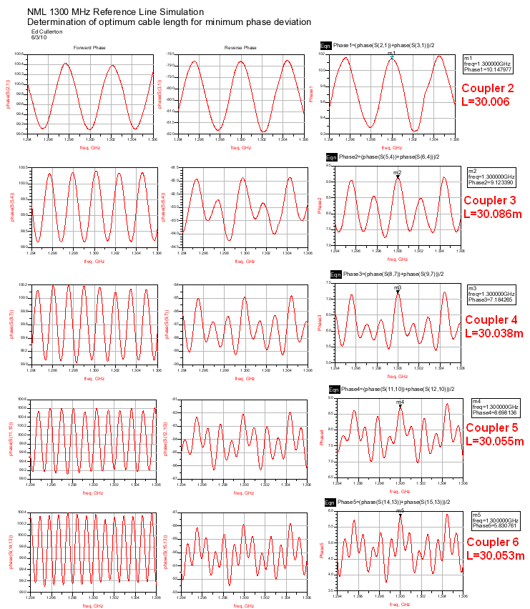
Figure 12. Final simulation results for all cable length adjustments.
The adjusted cable lengths were then entered into the complete reference line simulation schematic, shown in figure 13, and simulated 250 times. Each simulation varies each cable between the couplers randomly with a gaussian distribution that represents a +/- 20 degree C temperature change. The standard deviation of the error between station 1 and all other stations is plotted in figure 14. The phase deviation is less than 9 millidegrees for any 1 station.

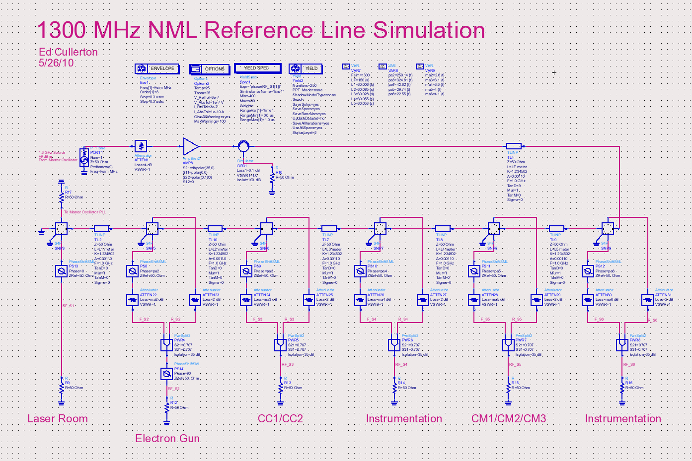
Figure 13. Complete reference line simulation.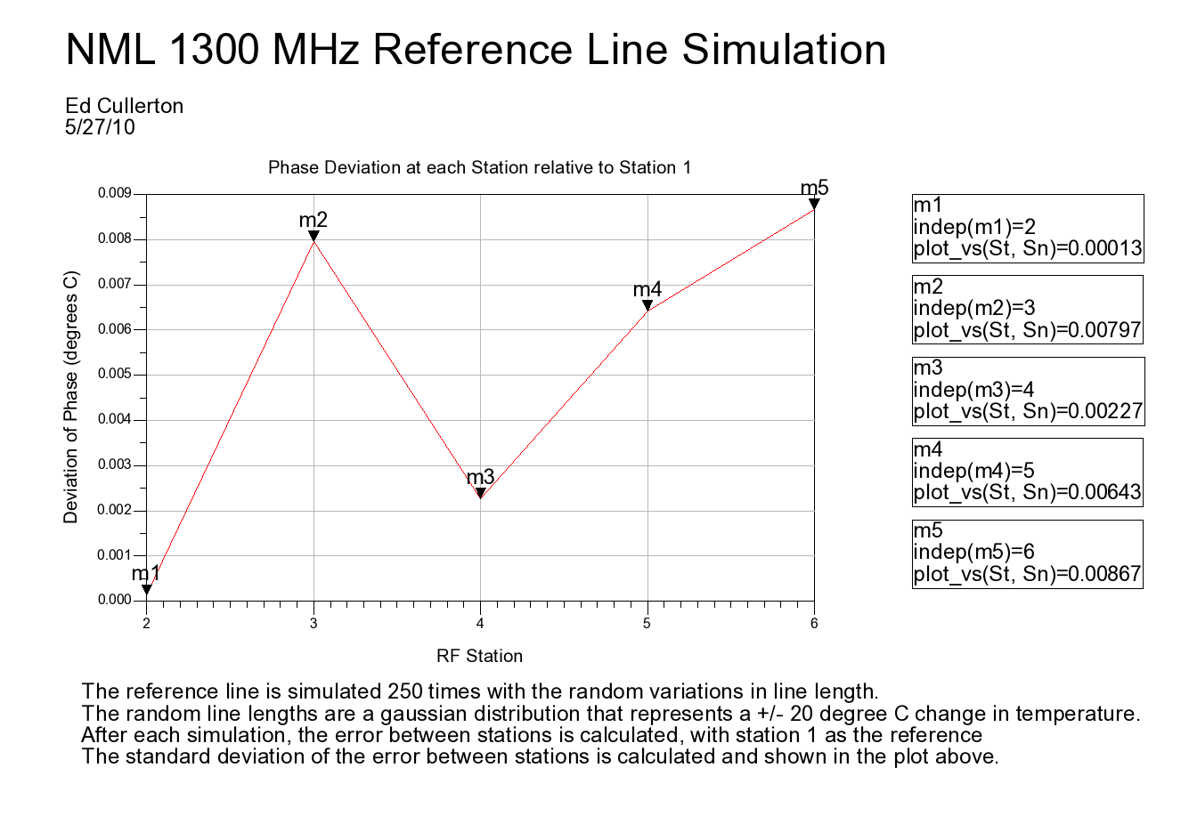
Fig. 14. Simulation results showing the phase errors of the complete reference line.
4. Scaled lab version
A scaled version of the reference line has been assembled in the lab to verify simulation data. To scale the reference line to a controllable size, the 30 meter sections of RFS 7/8” cable have been replaced by 1 meter sections of Belden 0.141” conformable cable. The temperature characteristics of the Belden cable are similar to that of the PTFE characteristics shown in figure 5. Coincidentally, the phase change over temperature change for a 1 meter section of the Belden cable approximates a 30 meter section of RFS cable fairly well. A computer model of the Belden cable was made and the reference line was designed and simulated using the same procedure described earlier. The results of the simulation are shown in figure 15. Because the phase change over temperature change are similar for the 1 meter Belden cable and the 30 meter RFS cable, the results are similar to the results seen in figure 14.
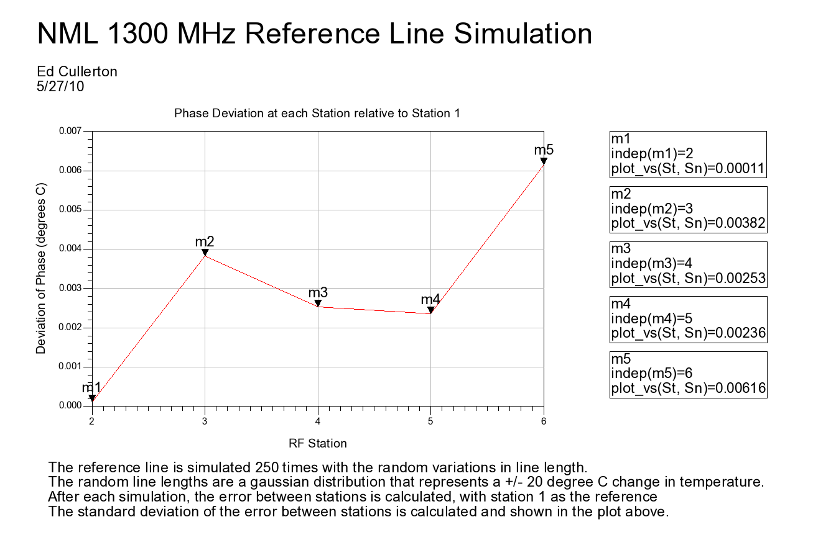
Figure 15. Simulation results showing phase errors of the scaled reference line.

The scaled version of the reference line was assembled in the lab using the procedure described above. Each step of the procedure is documented using a network analyzer configured as shown in figure 16. Figures 17-21 show actual network analyzer plots of s21 phase, S31 phase, and averaged phase for each section of the reference line. The top two traces of the figure are S21 phase and S31 phase, and the bottom trace is the average of the two. It is seen that the average phase ripple is at a maximum at 1.3 GHz for each coupler, corresponding to the minimum phase deviation described earlier. It is also seen that the ripple patterns exhibit similar characteristics as seen in the simulations.
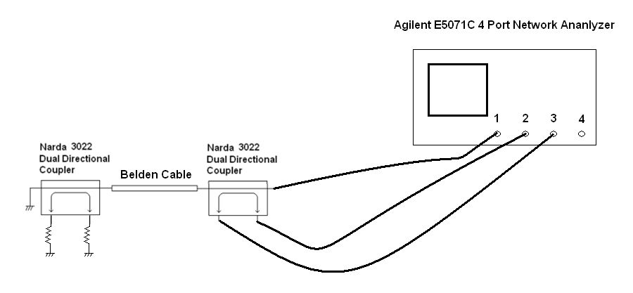
Figure 16. Network analyzer setup for building and measuring the scaled reference line.

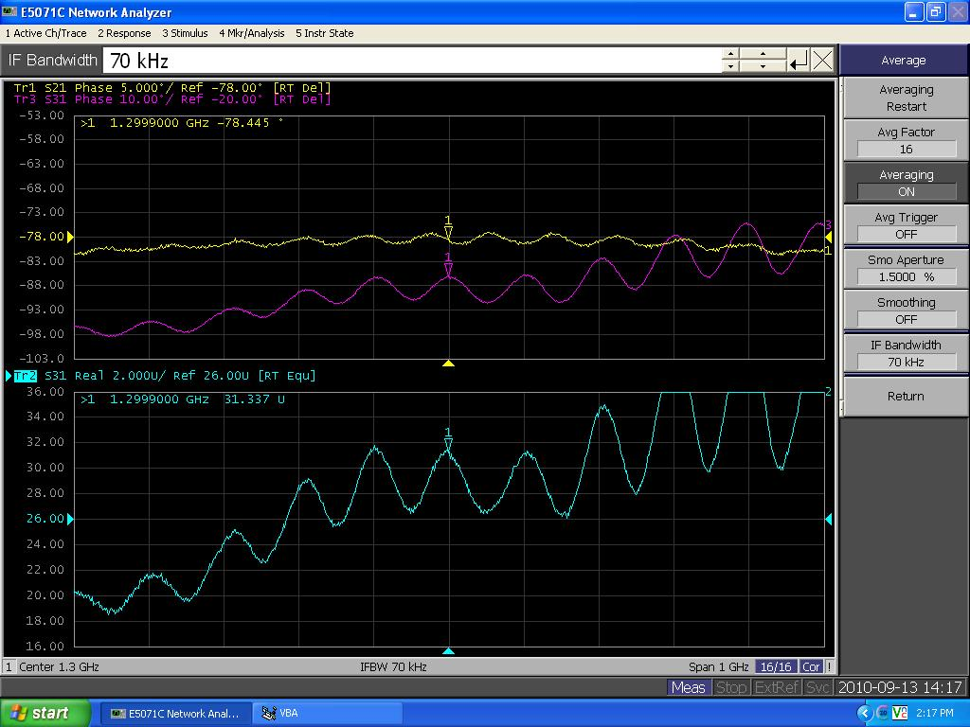
Figure 17. S21 phase, S31 phase, and averaged phase of the forward and reverse ports of coupler number 2.
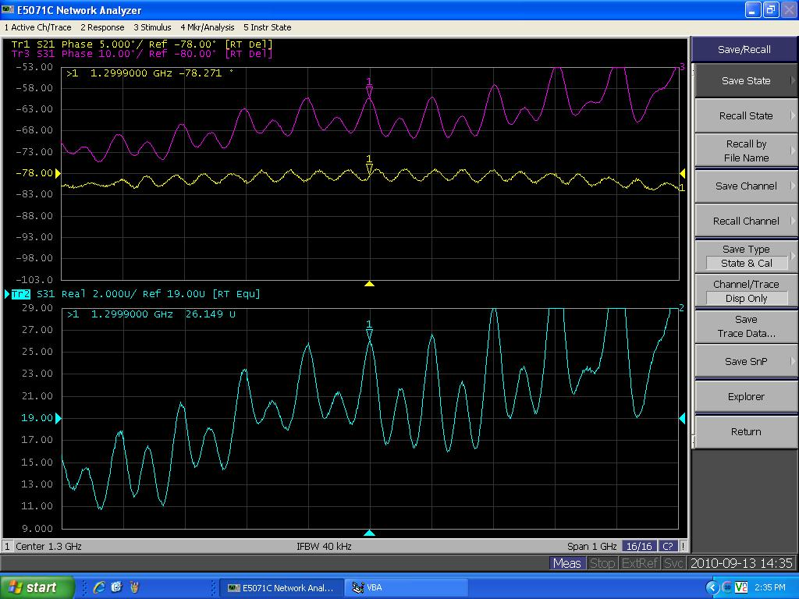
Figure 18. S21 phase, S31 phase, and averaged phase of the forward and reverse ports of coupler number 3.

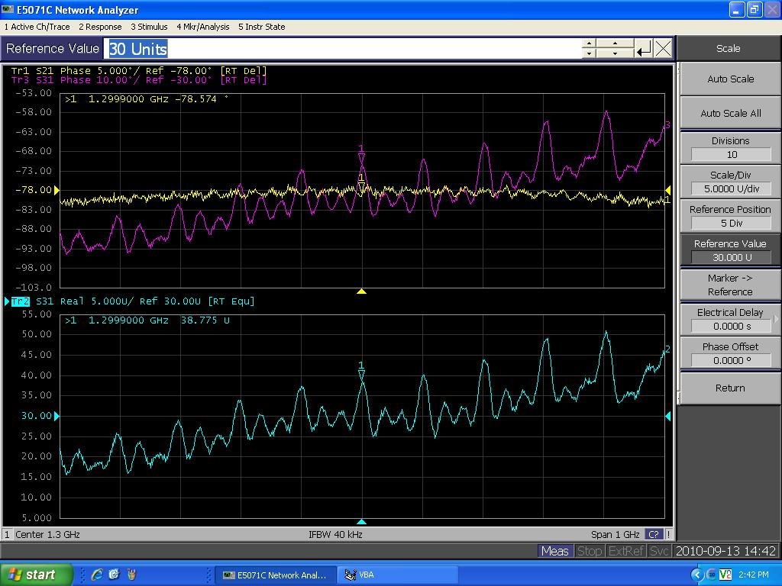
Figure 19. S21 phase, S31 phase, and averaged phase of the forward and reverse ports of coupler number 4.
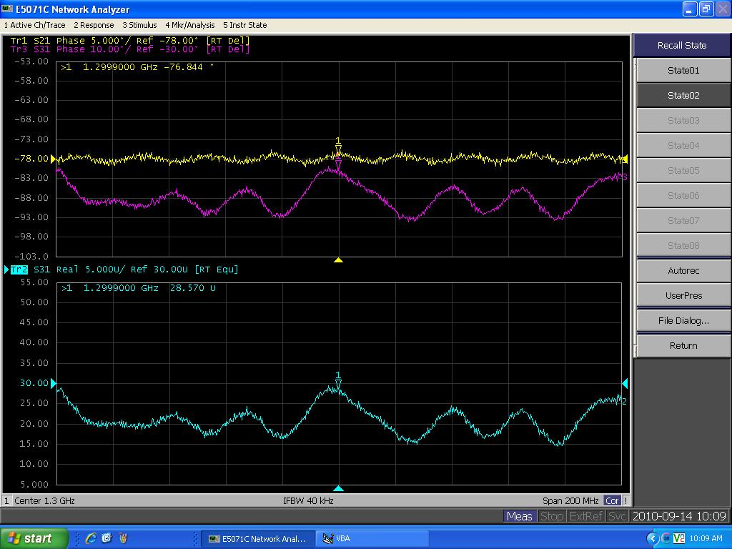
Figure 20. S21 phase, S31 phase, and averaged phase of the forward and reverse ports of coupler number 5.
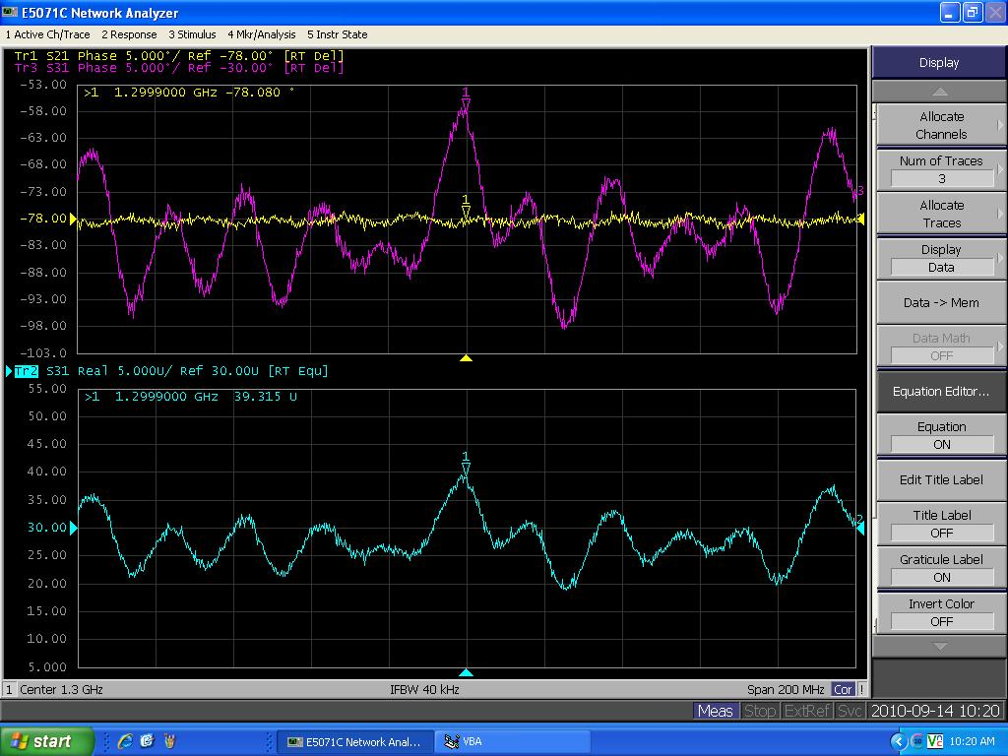
Figure 21. S21 phase, S31 phase, and averaged phase of the forward and reverse ports of coupler number 6.
The entire reference line was placed inside a temperature controlled enclosure and measurements were made for 40 degree temperature swing. A diagram of the test setup is shown in figure 22. The results of the test are shown in figure 23.
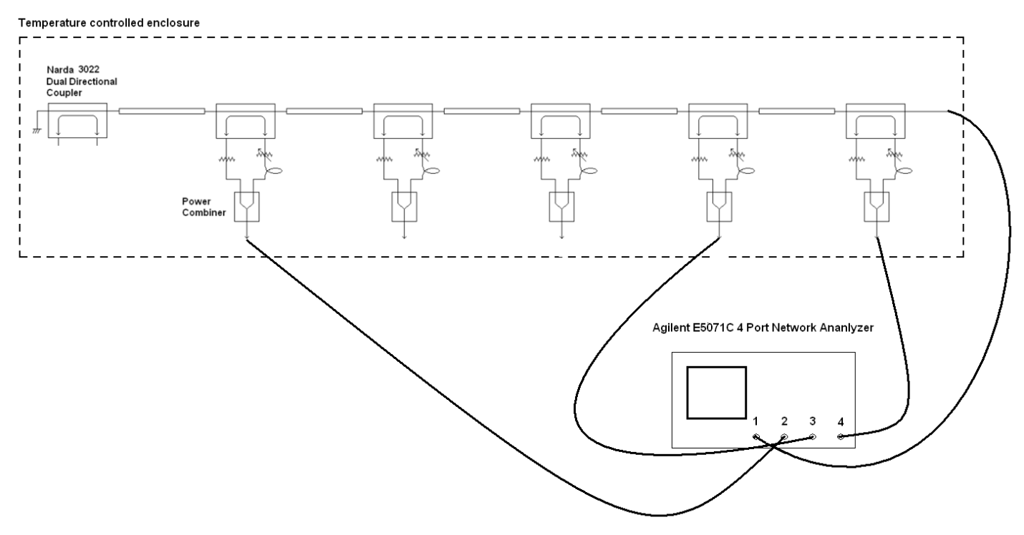
Figure 22. Test setup used to measure phase versus temperature.

Figure 23. Lab results.

Combiner circuit: 0.005 degree difference between port 1 and 2 over 20 degrees F (+.005 on port 1)

References
[1] Josef Frisch, David Brown, Eugene Cisneros, “ The NLC RF Phase and Timing Distribution System”, May 17, 2000
[2] Julien Branlard, “NML Master Oscillator”, Fermilab docDB, Accelerator Division, 3674-v1.

