Booster VME-DDS Module Assembly Modifications

November 20, 2017
Craig Drennan

- Replaced all AD8066 op amps with AD8034. The AD8034 have lower, but sufficient bandwidth and run cooler, less power.

- Replace the IO_UPD series termination, at the AD9910 DDS chips, with shorts.

- Do not install ADC Differential Amp capacitors;
(C450, C474), (C531, C563), (C512, C528), (C479, C502)

- Change DPOT resistors to 162 ohms; R326, R341, R356, R371

- Change ADC input capacitors to 120 pF; (C457, C464), (C543, C550), (C511, C519), (C486, C494)

- Do not install DAC filter capacitors; C568, C583, C611, C629

- Change voltage regulator enable pull-down resistors to 1960 ohms;
R68, R85, R102, R119, R366, R351, R336, R315

- Change DAC Gain resistors to 422 ohms; R131, R152, R171, R191

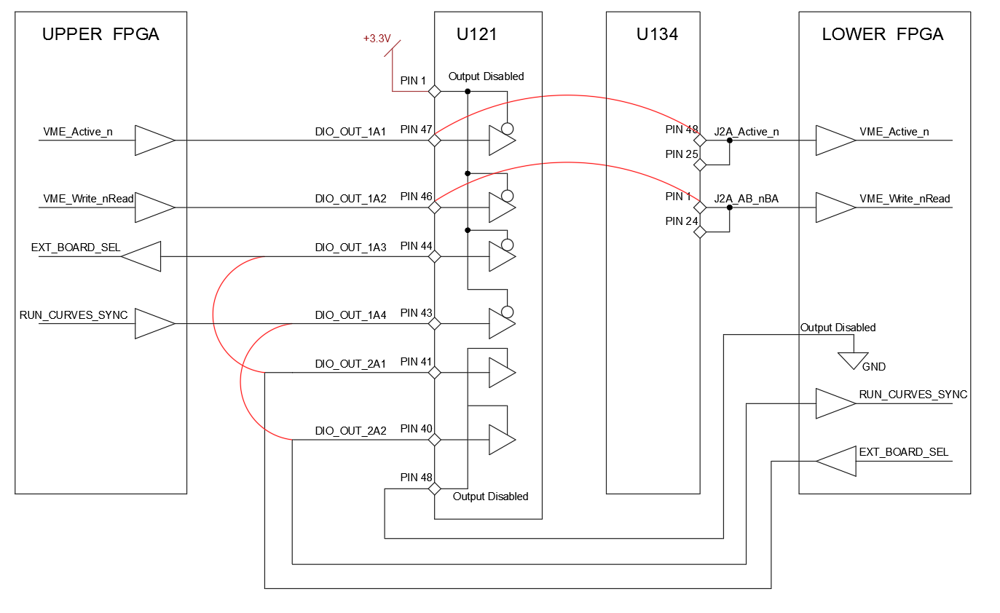
Figure 1 U121 modification diagram
Refer to Figure 1 above for the following modifications.
- Lift pin U121-1 and isolate it from the pad with a small piece of Kapton tape. Connect to +3.3V at the via shown in Figure 2.

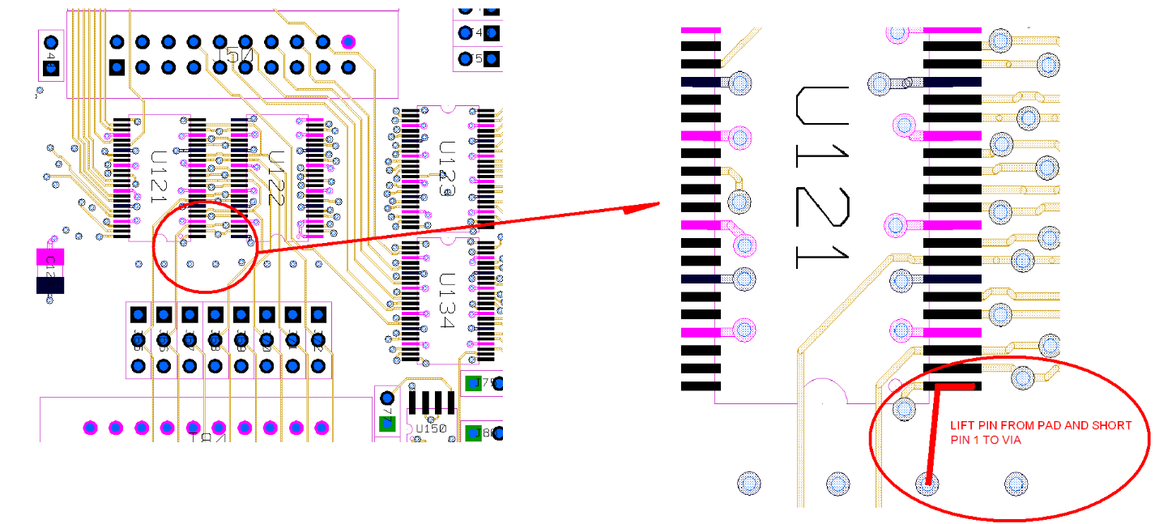
Figure 2 U121 pin 1 modification.
- Add the jumpers shown in Figure 3.

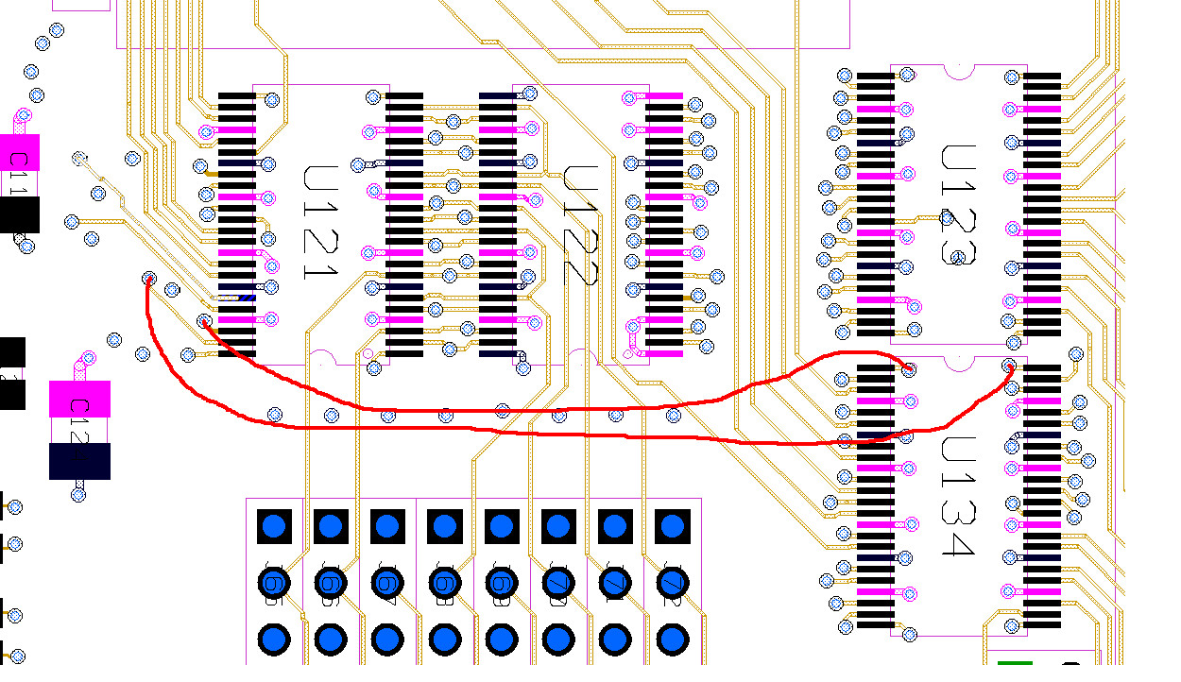
Figure 3 Jumper for transceiver signals

- Add the jumpers shown in Figure 4.
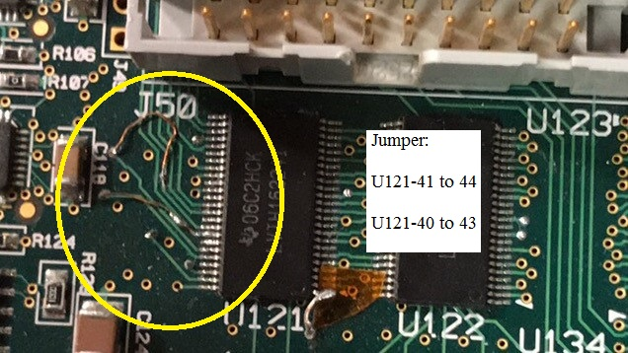
Figure 4 Photo of jumpers, pins 41 to 44 and 40 to 43
- The four low pass filters in the DDS RF Output Section have been changed to part # Minicircuits SCLF-135+.

- The 0 Ohm series resistors for the RF-TEST connection are not installed. R9, R18, R37, R44.

- The 49.9 Ohm resistors between the RF low pass filters and the RF amplifiers are not installed. R43, R31, R15, R3.

- The inductor pullups on the output of the RF amplifiers are not installed and jumped across. L1, L2, L3, L4.

- The RF amplifiers have been changed to Minicircuits RAM-4+. U5, U21, U34, U51.

- RF amplifier output pullup resistors have changed to 133 Ohm ¾ Watt. R41, R25, R12, R1.

- The RF power splitters are not installed and the top row of pads, on each, are shorted together. PS1, PS2, PS3, PS4.

- The following right-angle SMA RF output connectors are not installed: J4, J11, J16, J26.

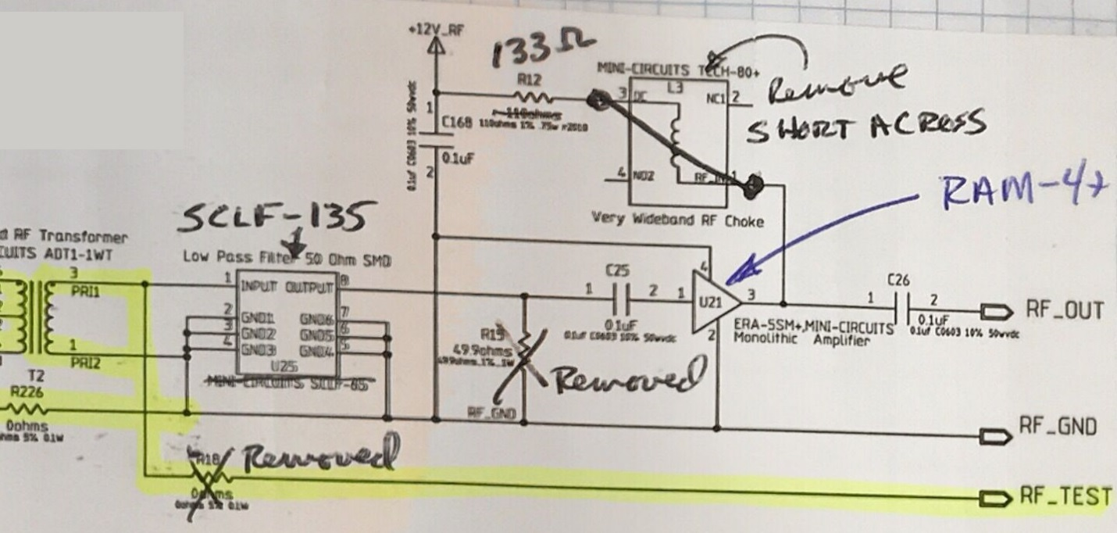
Figure 5 RF output modifications (Schematic)
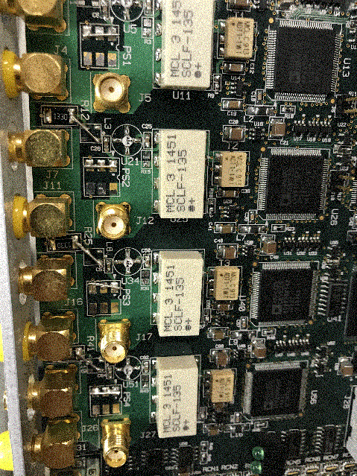
Figure 6 RF output modifications (PCB)

