Notes on Linac Toroid Beam Current Measurement

Linac Toroid Beam Current Measurement
Aisha Ibrahim
November 1, 2011

Introduction
Ions are accelerated down the Linac in bunches of charge, modulated at a frequency of 201 MHz. The total charge, $Q_{Total}$ , is the sum of the charge of all the bunches.
$$Q_{Total}=\sum_{n=0}^{M}{q_{n}}$$
Where M is the number of bunches in a Linac beam pulse.
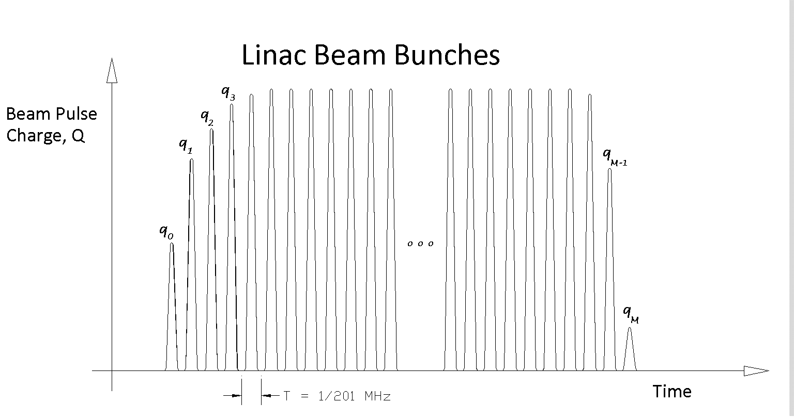
The average current, $I$, over an interval T = 1/RF Frequency is defined for the charge pulses passing through a particular cross section of the Linac beam pipe, as
$$I_{n}=\frac{q_{n}}{T}$$

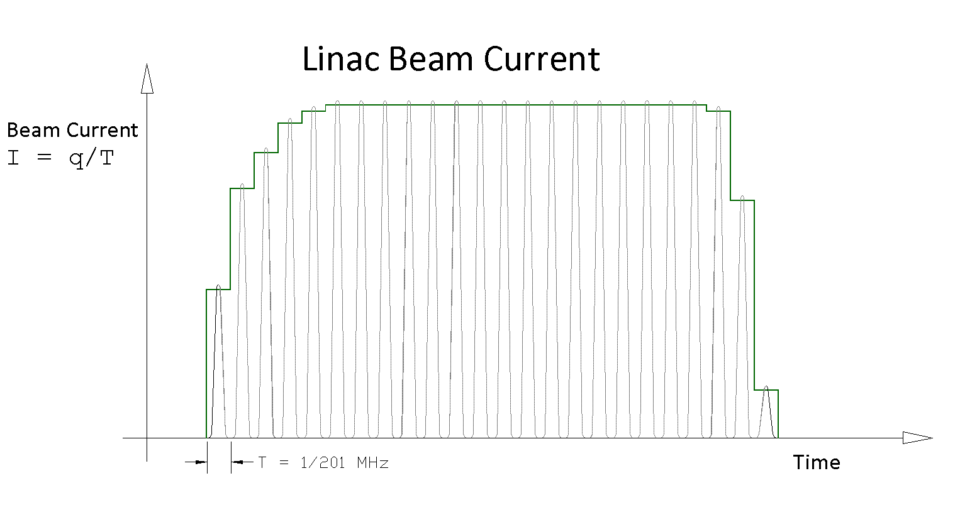
The toroid current monitor produces a voltage that is proportional to the beam current. Due to the bandwidth limits of the device, the bunch-by bunch information is lost. The output of the toroid is an envelope of the Linac beam pulse.
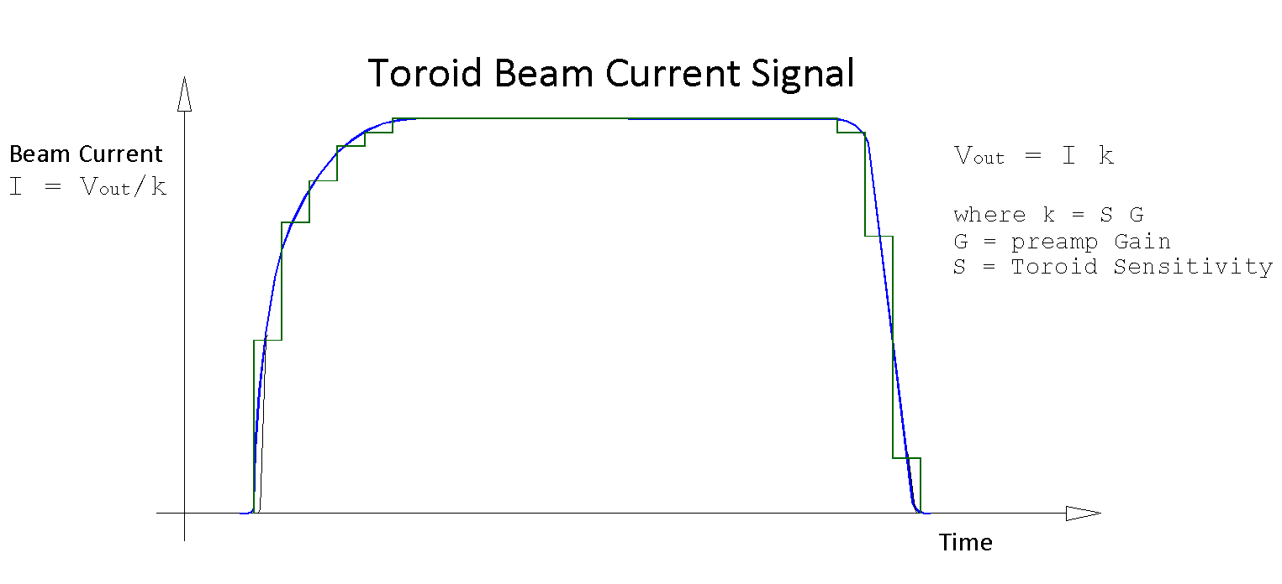
The relationship between the beam current and the voltage out is shown in the figure above. The preamp gain, G, is chosen such that the dynamic range of the expected beam current, and hence the voltage out of the toroid, provides the best bit resolution out of the digitizer’s ADC.

Total Charge
The total charge of a Linac beam pulse can be determined from the toroid beam current signal. We have that $Q_{Total}=\int{I}dt$, where $dt={T=1}/{Sampling Frequency}$. Using the digitized signal
$${Total Intensity=Q}_{Total}=\sum_{n=0}^{M}{I_{n}∙T}=\frac{T}{k}∙\sum_{n=0}^{M}{v_{n}}$$
Where $v_{n}$ is the nth digitized sample of the toroid signal.
The integration window must include both leading and trailing edges of the Linac beam pulse to include contributions of all bunches even runts, as well as additional effects of cable dispersion.
The digitizer for the Linac toroid system is set to sample at 80 MHz and collect N=8192 samples per Linac beam pulse, a $102μs$ sampling interval. This accommodates operational parameters which will vary in pulse width between $1μs$ and $100μs$. However it is not apparent at this point if the extra 2$μs$ is enough time to allow tails of longer pulses to settle.

Total Intensity
Total beam intensity can be calculated from $Q_{Total}$ by dividing by the charge per particle, $e_{charge}$.
$$Total Intensity=\frac{Q_{Total}}{e_{charge}}=\frac{T}{k∙e_{charge}}∙\sum_{n=0}^{M}{v_{n}}$$
It will be necessary to have an external TTL pulse synchronized to the beam event. This pulse would have a delay set during initial commissioning such that the pulse precedes the start of the Linac beam pulse and is also preceded itself by $102μs$ of no beam. Samples taken before the TTL pulse, during the no beam period, would be used to calculate the baseline value which is later used to correct the beam signal before integration. After the delay is set, the trigger should “track” the leading edge of the Linac beam pulse.
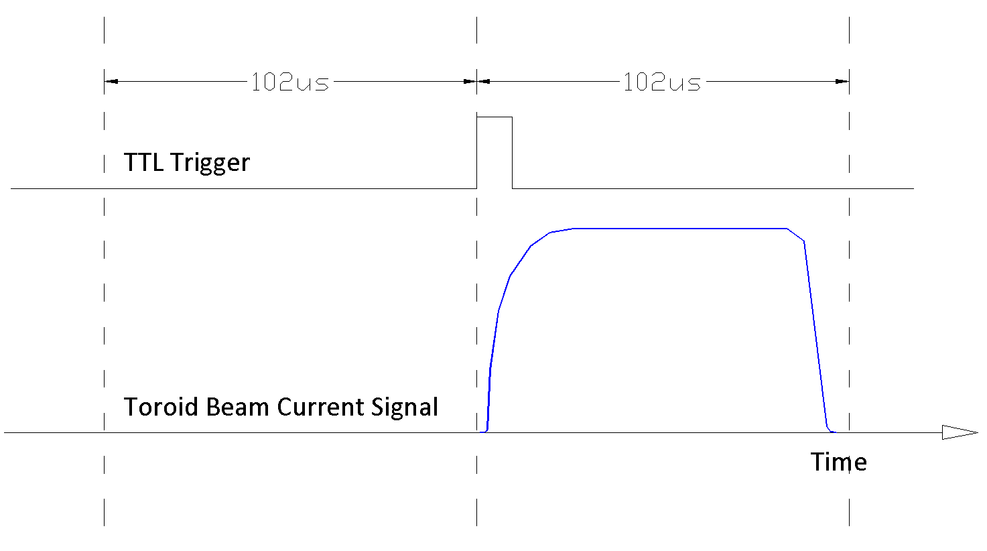

Average Current
Average current of the Linac beam pulse can be computed as
$$Average Current, I_{AVG}=\frac{Q_{Total}}{PW}=\frac{T}{k}∙\frac{1}{PW}∙\sum_{n=0}^{M}{v_{n}}$$
where PW is the pulse width of the measured beam pulse.
Note that $I_{AVG}$ is dependent on the determination of the Linac beam pulse width. The Linac beam pulse width varies during normal operation. There are a couple options for determining the pulse width.
Option 1: If we use the same trigger as used for the total intensity, we can use the calculated baseline value as a threshold to define the pulse width. As a result, the definition of pulse width here would be closer to the full base width. This algorithm however can suffer if RMS noise is too high or too many spurious noise elements exist. In such cases, additional processing would be needed.
Option 2: If given another trigger, pulse width can be independently calculated. This trigger would have to be able to track the trailing edge of the Linac beam pulse automatically, regardless of pulse width. The firmware can then measure the time between the trigger for the total intensity and this 2nd trigger. The delay of the trigger should be set during commissioning to account for the propagation delay and cable lengths as well as to “identically” place the trigger w.r.t beam at each location.
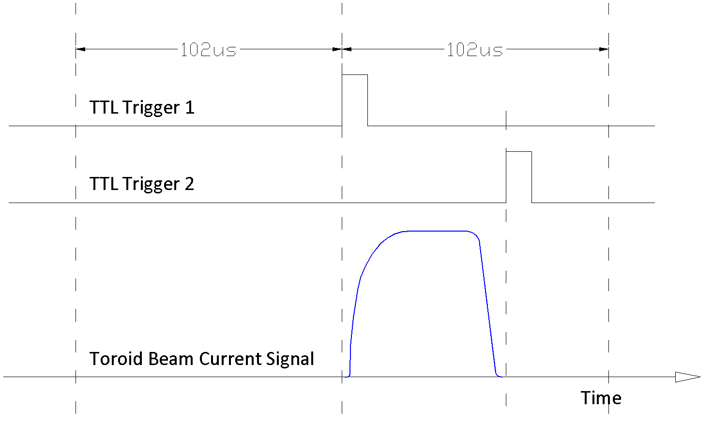

Beam Budget Monitor, BBM
Because of the nature of the toroid, it is a question whether total intensity or average current is a better representation of what was delivered down the Linac. It is recommended that both be available to be used for transfer efficiency plots/analysis or BBM reporting. The toroid system should provide the host BBM program 2 each 16 bit data registers which will be read at approximately 1 Hz. The registers are
- A running sum of reported total intensity for every received trigger, in 2’s complement format.
- A count of the total number of triggers received.

Steady State Current
Because the macro Linac beam pulse will never be perfectly square, a measure of the steady state current would be an overestimation of the current delivered to the toroid. However, large differences between $I_{SS}$, the steady state current, and $I_{AVG}$, the average current, might be an indication of abnormal events. From this perspective, $I_{SS}$ might be useful.
Trigger 2, the end of beam, would be synchronized to the trailing edge of the Linac beam pulse. Some number of samples prior to the trigger event, X, would be buffered and used in the computation of $I_{SS}$ as described below.
$$Steady State Current, I_{SS}=\frac{1}{X}∙\sum_{n=0}^{X}{v_{n}}$$
The signal to noise ratio, SNR, of the measurement would improve by $\sqrt{X}$
But the X samples should not include the leading or trailing edge of the beam pulse. Although X can be set to dynamically change depending on the pulse width calculation, it is recommended to keep X a fixed number. Making X fixed would help keep $I_{SS}$ immune to errors in the pulse width calculation. Also it provides a better premise to compare $I_{SS}$ of different pulse widths.
Note that regardless of X, $I_{SS}$ will be affected by any droop rate errors. For the 3100 model, approximately 4% droop error is expected for a $100μs$ pulse width. It may be necessary to implement a droop correction algorithm to get a better $I_{SS}$ value.

===========================================================================

Linac Toroid Beam Current Measurement

Average Current vs. Steady State Current
Craig Drennan
November 2, 2011

During the last Linac Toroid Upgrade meeting we had a brief discussion about whether the rise time of the Linac source would contribute to a discrepancy between the measurement of the steady state beam current and a measure of the average current over the whole pulse. After looking into the situation and asking some questions, I would say that the average beam current measurement proposed by Aisha Ibrahim would be fine.
Figure 1 is an oscilloscope display of the current out of the Linac Source, ITOR1, and the portion of the beam allowed to be accelerated in the Linac for the HEP program, IHTOR2. That is beam bound for the Linac and beyond. This beam is purposely taken from the flat, steady state portion of the beam out of the source. There is no rise time to be concerned with in the calculation for this case. Note that the scope traces in Figure 1 shows the intentional variation of beam on and beam off times.

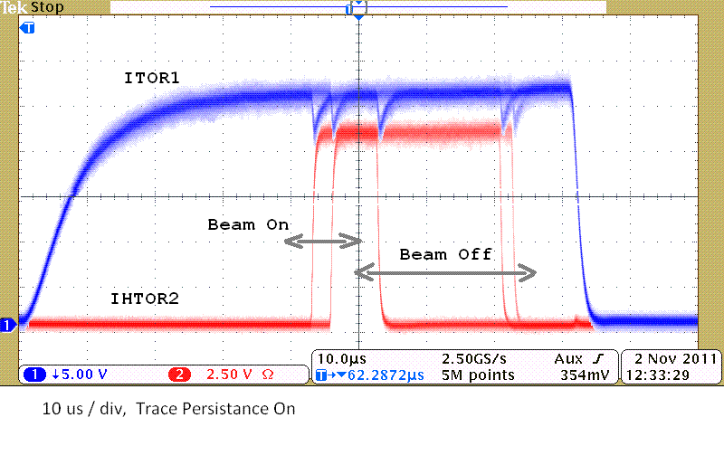
Figure 1.

The rise time of the source is seen when beam is bound for the NTF treatment facility. Figure 2 is a “photo-shopped” artist’s rendition of what this looks like. The start of the beam begins during the rise of the source in order to get a wide pulse of beam, approximately 62 us, to send to NTF. Since the only time the rising current is included is when the pulse is the widest, minimizing the contribution of this portion in the computed current average. Additionally, I spoke with NTF’s engineer and doctor and was told that they are not so concerned with the current value, but only the integrated total of protons delivered to them.

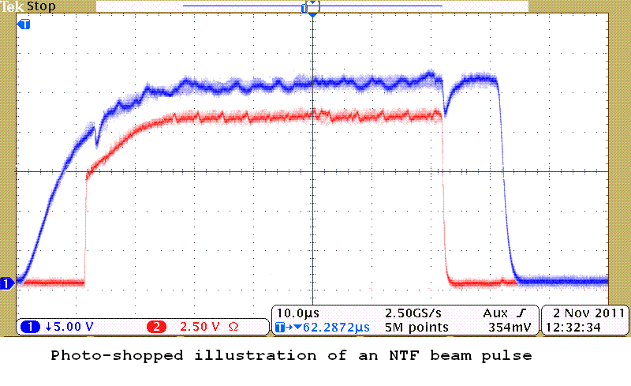
Figure 2.

