Booster Laser Notcher Options

Dave Johnson

August 29, 2011

Introduction:

Utilization of lasers to strip or neutralize moving H- ions has been discussed for many years. The process being described here is the removal of the outer, weakly bound, electron, thus forming H0 ions. Some of the proposals and applications of photo-neutralization include H- beam diagnostics, measuring transverse and longitudinal profiles, emittance carving, removing selected bunches from a bunched beam (chopping), and the neutralization of periodic longitudinal sections of a long H- linac pulse (notching).

The Proton Improvement Plan is tasked with Booster upgrades which will increase the Booster throughput required for future operations while maintaining acceptable losses. The current goal is 2.2x1017 protons/hr extracted @ 15 Hz by 2016. Assuming a 90% Booster cycle efficiency, the Linac must provide protons at a rate of 2.42x1017 ions/hr. This corresponds to ~4.5x1012 protons/pulse (Booster cycle) assuming 100% duty factor. Assuming this intensity corresponds to 10 or 11 turns (a 22 to 24.2 us linac pulse length), the linac 200 MHz bunch intensity is on the order of 109 ions/bunch.

Extraction from the Booster at 8 GeV requires a “notch” in the beam of approximately three 53 MHz bunches or approximately 50 to 60 ns to allow for the rise time of the extraction kicker. This corresponds to ten to twelve 200 MHz linac bunches or 2.2 to 2.7% of the injected intensity. The current “notcher” removes this beam into the Booster magnets and is responsible for approximately 30% of the beam power loss. Moving the notching outside of the ring and providing a well shielded absorber for the notched beam should eliminate or significantly reduce the loss in the Booster associated with notching. This note will explore several options for utilizing lasers to create the notches.

Previous Booster Notching Proposals and Experiments

There have been discussions on using lasers to create notches in the Linac beam for some time. In TM-1957 (1995) Ray Tomlin considered the stripping of H- ions with lasers where he estimated laser power requirements and suggested some applications for implementation, from laser diagnostics, to notching the beam for extracting, to emittance carving. In 2001, Tomlin reported the results of an experiment performed in the 740 keV line which utilized a laser at a nearly head-on interaction angle (approx 3 to 5 degrees) to create a ~25 ns notch in the DC 750 keV beam which was seen on a BPM pick up after Linac Tank 2 (at 30 MeV). Here, he used a 200 mJ, 5 ns laser pulse to create the notch.

In 2005, Xi Yang and C. Ankenbrandt published two papers, FN-0765-AD (April 2005) and FN-0767-AD (May 2005) discussing a proposal to mitigate Booster extraction losses by laser notching the Linac beam at the Booster Injection RF frequency and Booster Injection Revolution frequency, respectively. In these papers they discuss laser requirements and propose the location of the interaction region at the entrance to the existing 90-deg. bend dipole in the 750 keV line. Their design the suggestion of using a laser with 15 Hz repetition rate and a storage cavity

Notcher Timing Requirements

Ultimately, the beam at extraction needs to have a 50 to 60 ns notch to allow for the extraction kicker rise time to cleanly extract the beam to the 8 GeV line. Figure 1 shows the beam structure at injection for Booster. The MACRO beam structure represents the 15 Hz Booster cycle. The MINI structure represents a single 24.2 s injection into Booster made up of 11 turns. Shown within this Linac pulse are 50 to 60 ns “notches” at the Booster revolution frequency of approximately 450 kHz. These notches are separated by the revolution period of ~2.2 s. The third line in the Figure 1, labeled MICRO, represents the 400 MeV 200 MHz bunch structure of the Linac beam being injected. The bunch spacing is 5 ns and the bunch length is estimated to be 500 to 600 ps ( ~+/-20 deg in 200 MHz bucket). The red “bunches” represent those that are neutralized within the 200 MHz bunch train.

Figure 1: 400 MeV Bunch structure

Laser interaction with a moving H- ion

The photodetachment cross section of H- by incident photons with energy E, is given by []



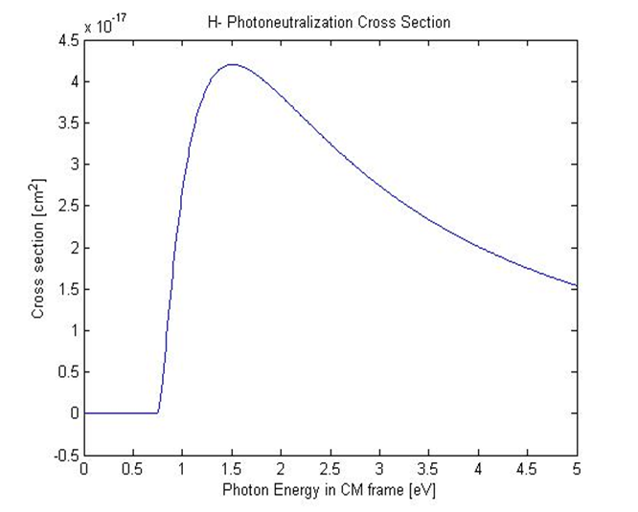Where MAX = 4.2E-17 cm2 for photons of approximately 1.5 eV and E0, the binding energy of the 2nd electron is given as 0.7543 eV. Figure 1 shows the cross section as a function of the photon energy in the electrons CM frame.

Figure 2. Photodetachment cross section as a function of center-of-mass photon energy.

The choice of the lab frame laser energy (wavelength) is dependent on the H- energy and the interaction angle through,



Where  and  are the usual relativistic parameters and  = 180o is head-on. Here, for an interaction angle between the H- and photons of 90o, we see that the cm photon energy is just gamma times the lab frame laser energy. There are three potential locations for a laser notcher: before the RFQ at 35 keV, after the RFQ but before tank 1 at 750 keV, and after the linac but before injection at 400 MeV. The gammas for 35 and 750 keV are ~ 1 while the gamma for 400 MeV is ~ 1.4 . Figure 3 shows the photon energy from a 1 micron laser in the center of mass frame of the moving H- ion for both 750 keV and 400 MeV ions and the 400 MeV cross section as a function of crossing angle. From these two plots it is clear that for a 1 micron laser the optimal interaction angle is close to 90 degrees for the 400 MeV case. Due to the lower velocity at 750 keV, the cross section is almost independent of interaction angle.

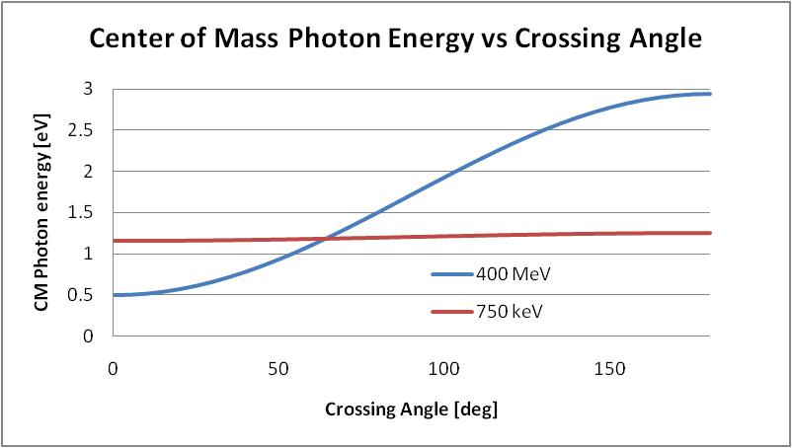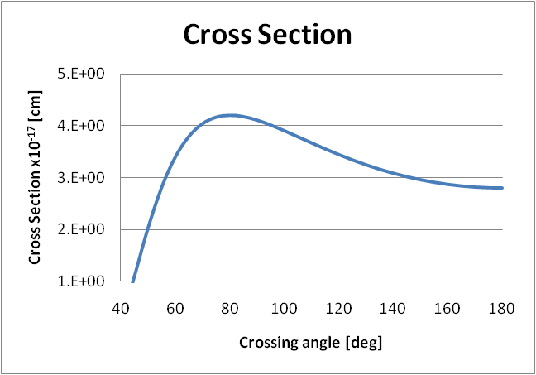

Figure 3: (left) Photon energy of a 1 micron laser in the center of mass frame of a moving H- ion as a function of crossing angle and (right) the cross section for photodetachment from a 1 micron lab frame laser and a function of crossing angle.

Photodetachment

“In the case when the probability of interaction is high, but for which the interaction mechanism is not intensity dependent,” [9] the fraction of the electrons that are detached from the moving H- ions is given by [10]

$$F_{neut}=N/{N_{0}}=(1-e^{-fσ(E)τ})$$

Where N and N0 are the number of ions neutralized and initial number of ions, *f* is the flux of photons at the interaction point in [photons/cm2/sec],  is the photodetachment cross section [cm2], and  is the interaction time [sec]. We see that for a given cross section in the limit of large photon flux or long interaction times, the fraction neutralized saturates 100%. The photon flux can be written as

$$f=\frac{E_{laser}L}{πr^{2}hcτ_{laser}}$$ where

Linac Beam Properties

Before RFQ

After RFQ



400 MeV line

References:

[1] R. Connolly et. al., “Laser Beam Profile Monitor Development at BNL for SNS,” proceedings of the 2002 Beam Instrumentation Workshop, Upton, NY, USA, 6-9 may 2002.

[2] S. Assadi, et. al., “The SNS laser Profile Monitor Design and Implementation”, proceedings of the 2003 Particle Accelerator Conference, page 2706.

[3] C. J. Johnstone, “Method and apparatus for laser-controlled proton beam radiology”, US Patent 5760395, June 2, 1998.

[4] R. Tomlin, “Laser Stripping of Relativistic H- Inos with Pratical Considerations”, Fermilab TM-1957 (December 1995).

[5] R. Tomlin, “Ion Beam Notcher Using a Laser”, proceedings of the 2001 Particle Accelerator Conference, page 3912.

[6] Xi Yang and C. Ankenbrandt, “Design Report of the Laser System for Notching H- Beams at Booster Injection RF Frequency in the 750 keV Linac”, Fermilab FN-0765-AD (April 2005).

[7] Xi Yang and C. Ankenbrandt, “Reducing the Extraction Loss via Laser Notching the H- Beam at the Booster Injection revolution Frequency”, Fermilab FN-0767-AD (May 2005)

[8] R. Shafer , “Laser Diagnostic for High Current H- beams”, LA-UR98-2634 (May, 1998)

[10] R.C. Connolly, et.al., “A transverse Phase Space Space measurement Technique for High Brightness H- Beams”, Nucl. Inst. Methods A312, 1992, pp 415-419.

[9] H.C. Bryant and E.P. MacKerrow, “Accelerator-Based Atomic Physics Techniques and Applications”, ed. S.M. Shafroth, J.C. Austin, (1997) chapter 6, page 183.