BOOSTER NOTCH ABSORBER ASSEMBLY.
Vladimir Sidorov 09/19/2012
The BOOSTER Absorber will be installed in the Long 13.
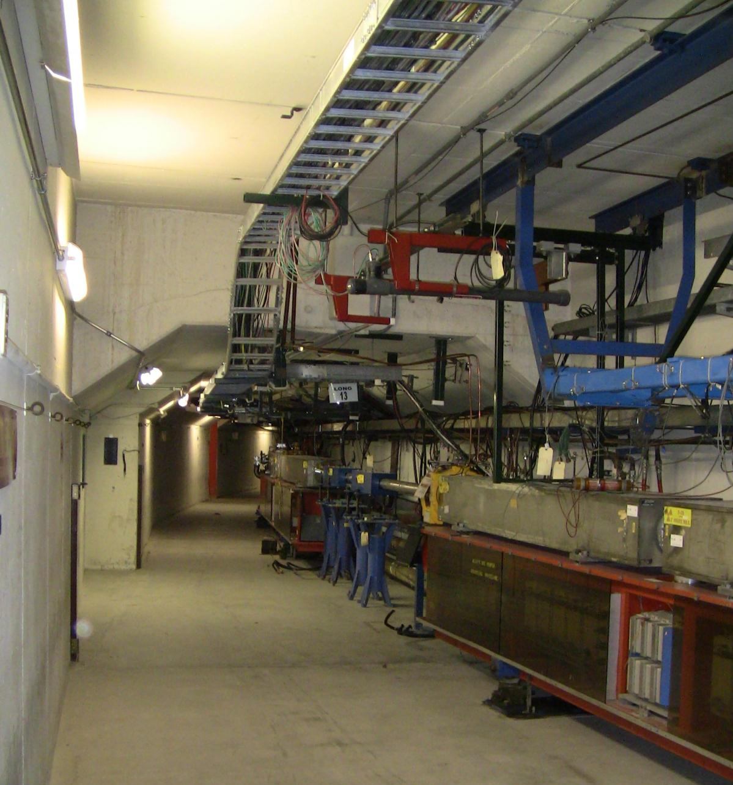

Space issues : cable trays, shelves, water tubes, conduits.
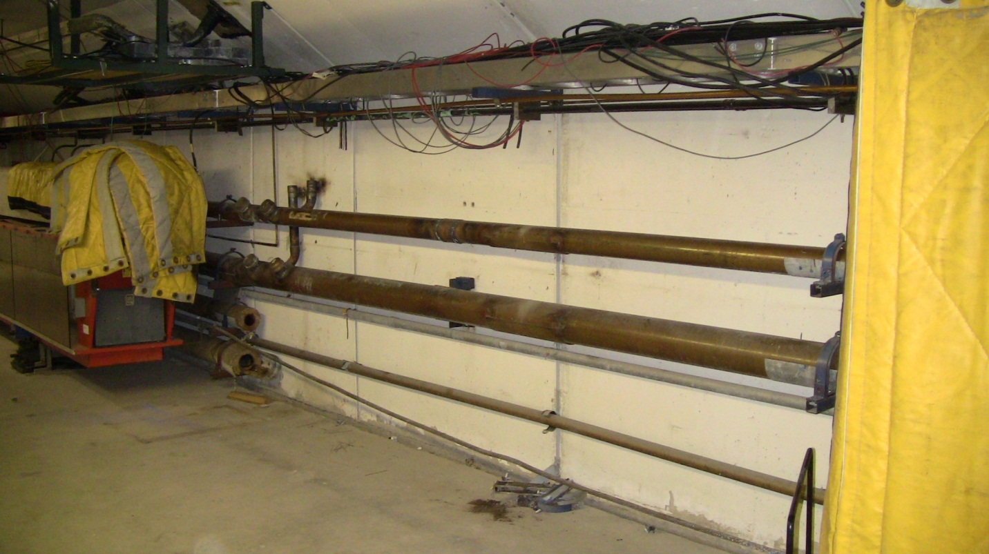
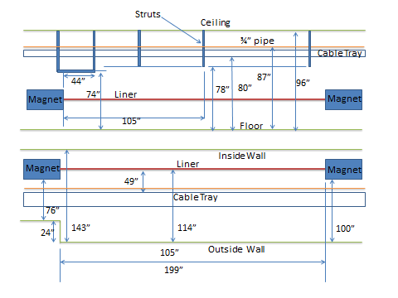

Equipment and tools are used for the absorber installation.
Hydraulic table, Fork lift with boom, gantry crane, four hydraulic cylinders, screw jacks, round tubes, crow bars, wood wedges, creeping, brackets, pallet.
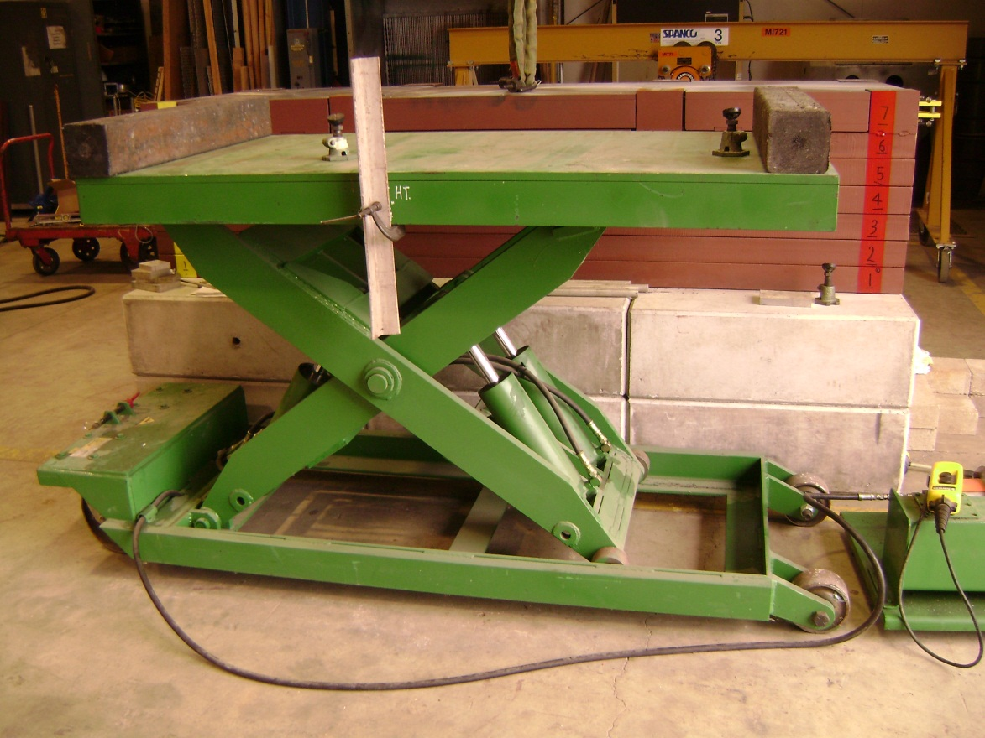
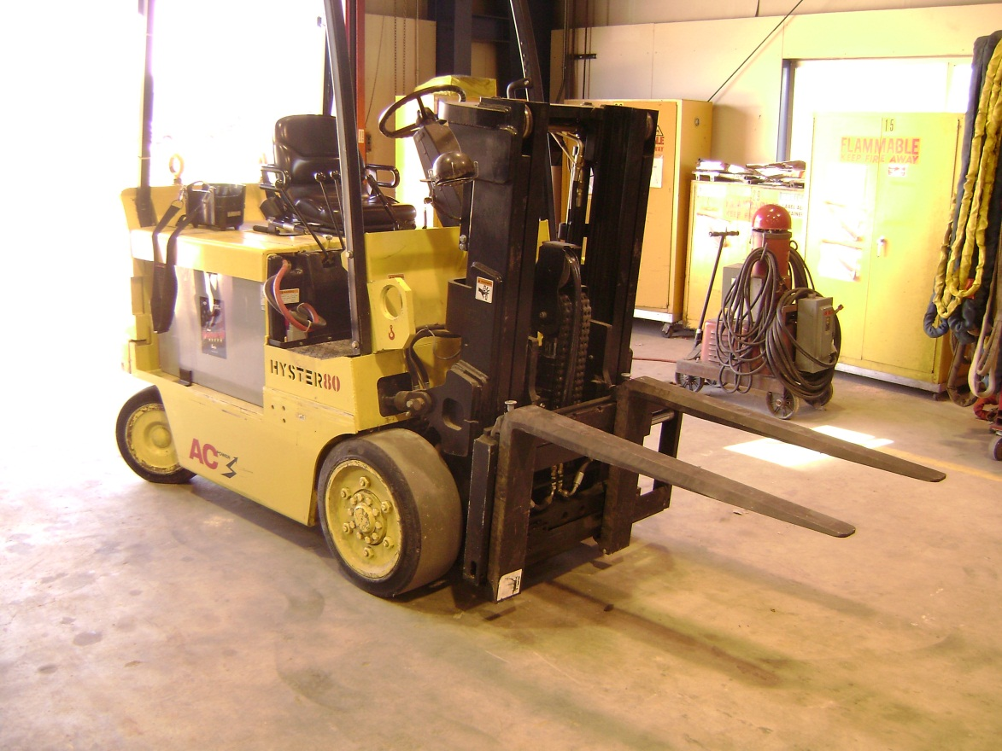
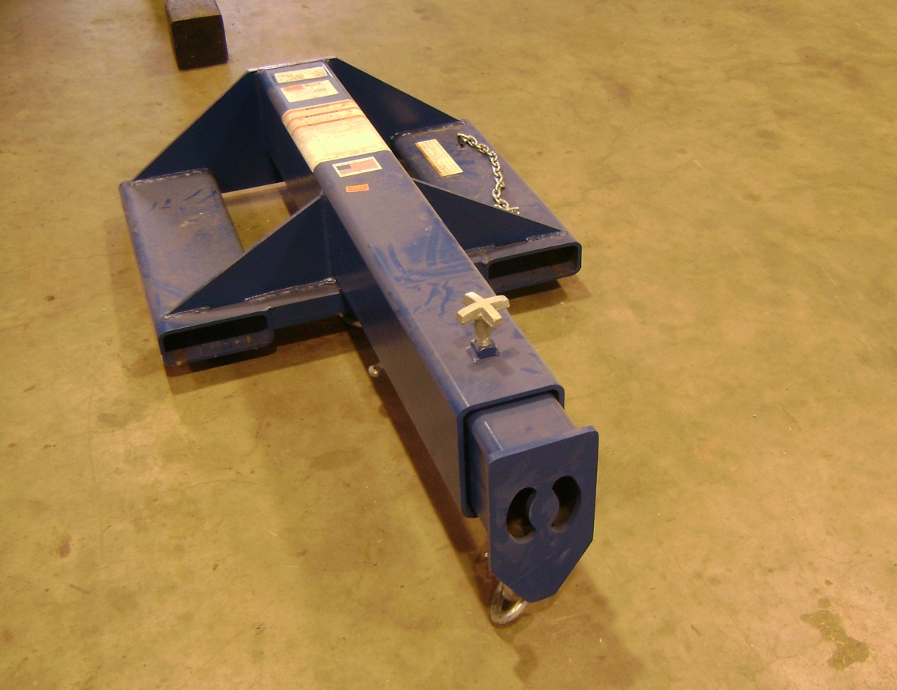

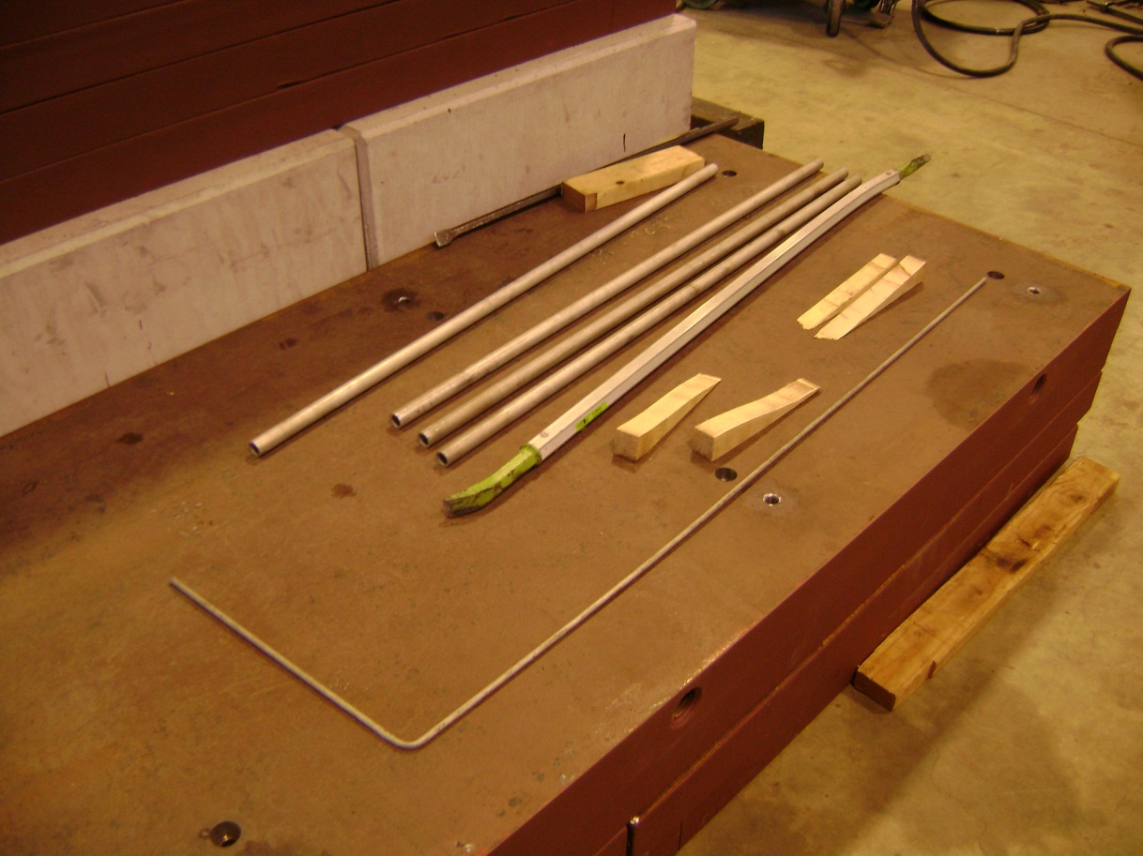
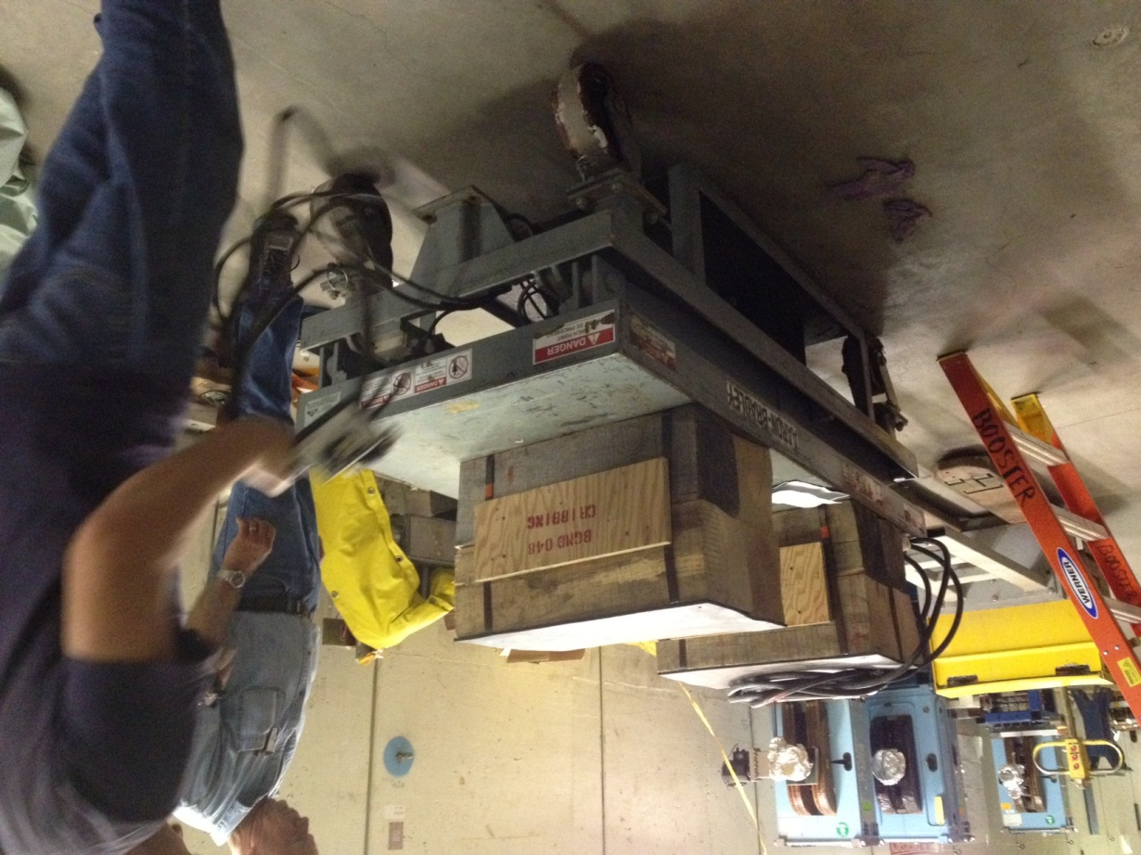
The pallet attached to the lifting table will be used for absorber parts transportation from the hatch to the Long 13.
- Concrete shelves installation.
Three welded shelves are installed and stacked with concrete bricks close to the wall over the water pipes and conduits.
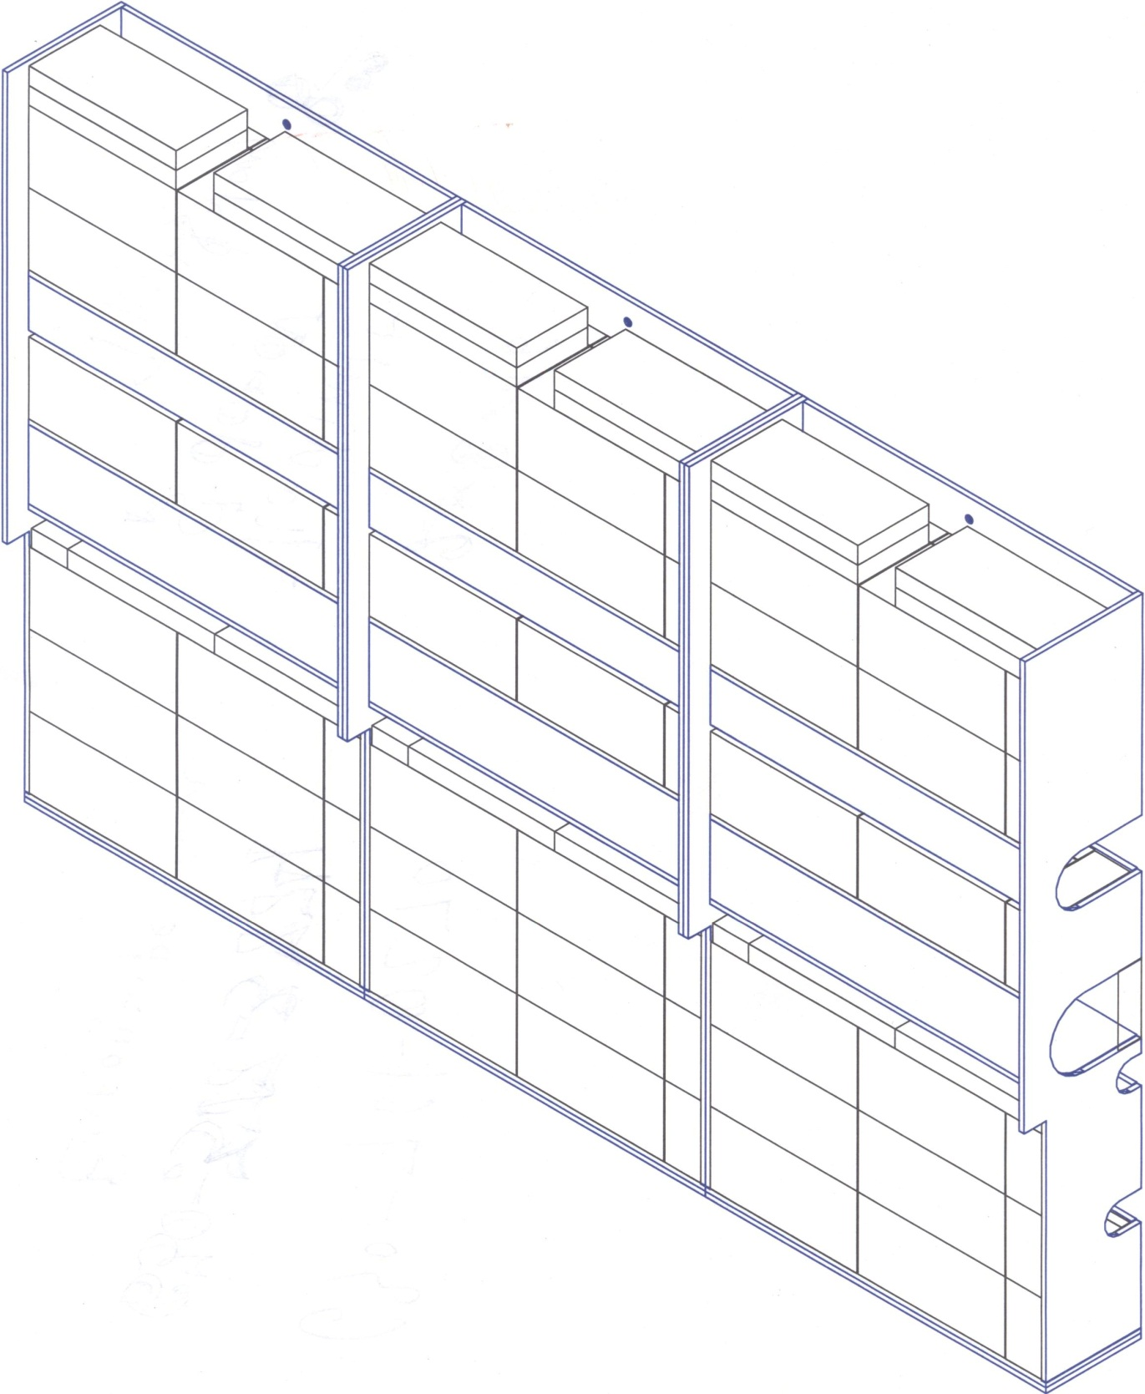

- Concrete blocks installation.
Six concrete blocks K-type and six concrete blocks L-type are installed in the front of the shelves and used as a base for the absorber steel plates installation. Concrete blocks can be moved and installed with the gantry crane or the fork lift.
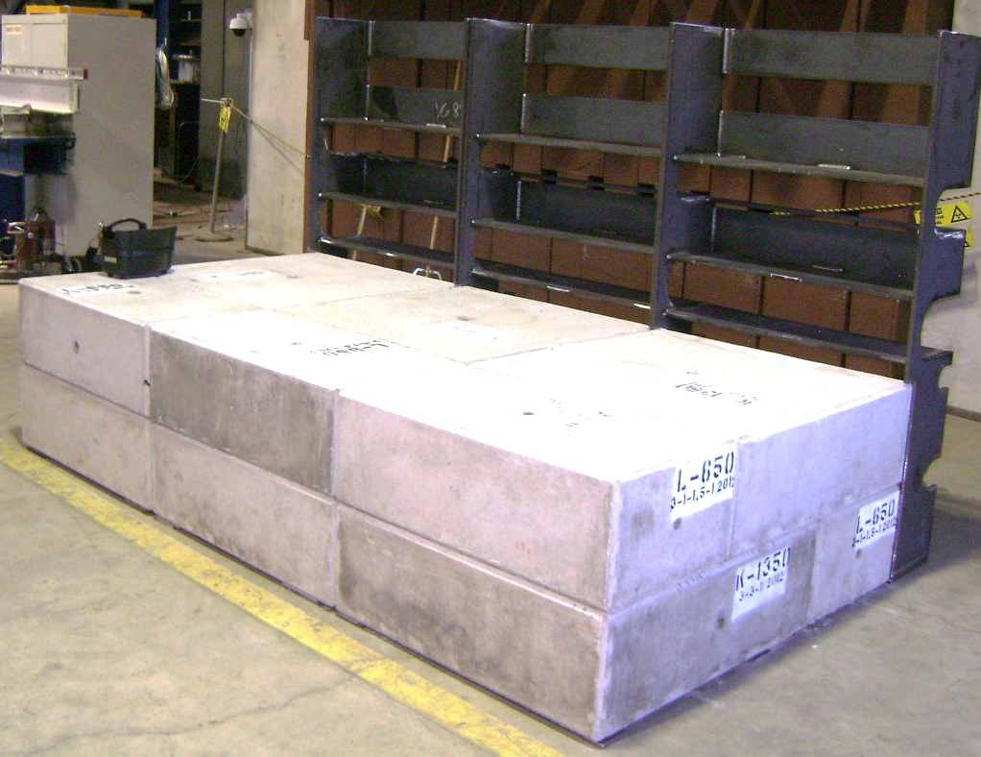
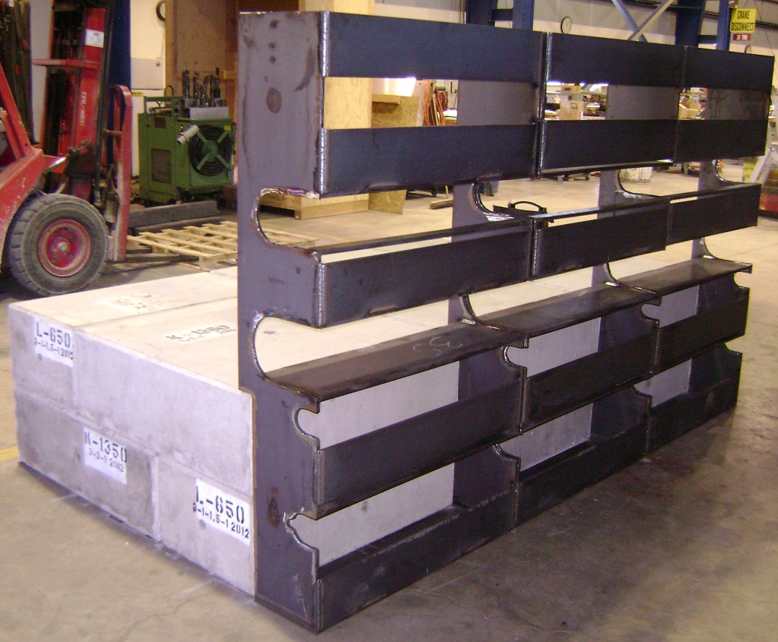

- Bottom steel plates installation.
First steel plates are installed with the gantry crane or hydraulic lifting table.

- Moving block base plate installation.
The base plate is installed on the bottom plates with the hydraulic table and special tool ( see top plates installation below).

- Moving block installation.
The moving block is the most difficult part for the installation.
The moving block is delivered to the absorber on the lifting table and leveled with the base plate. Two 8” channel placed on the top of the base plate stands. The block is lifted 2”up with screw jacks and round tubes are inserted between the block and table plate. The moving block rolled on the top of the 8’ channels. Two brackets are bolted to the moving block and supported with hydraulic cylinders. The block is lifted up and 8” channels are removed. The block slowly lowered down and placed on the flat rollers.
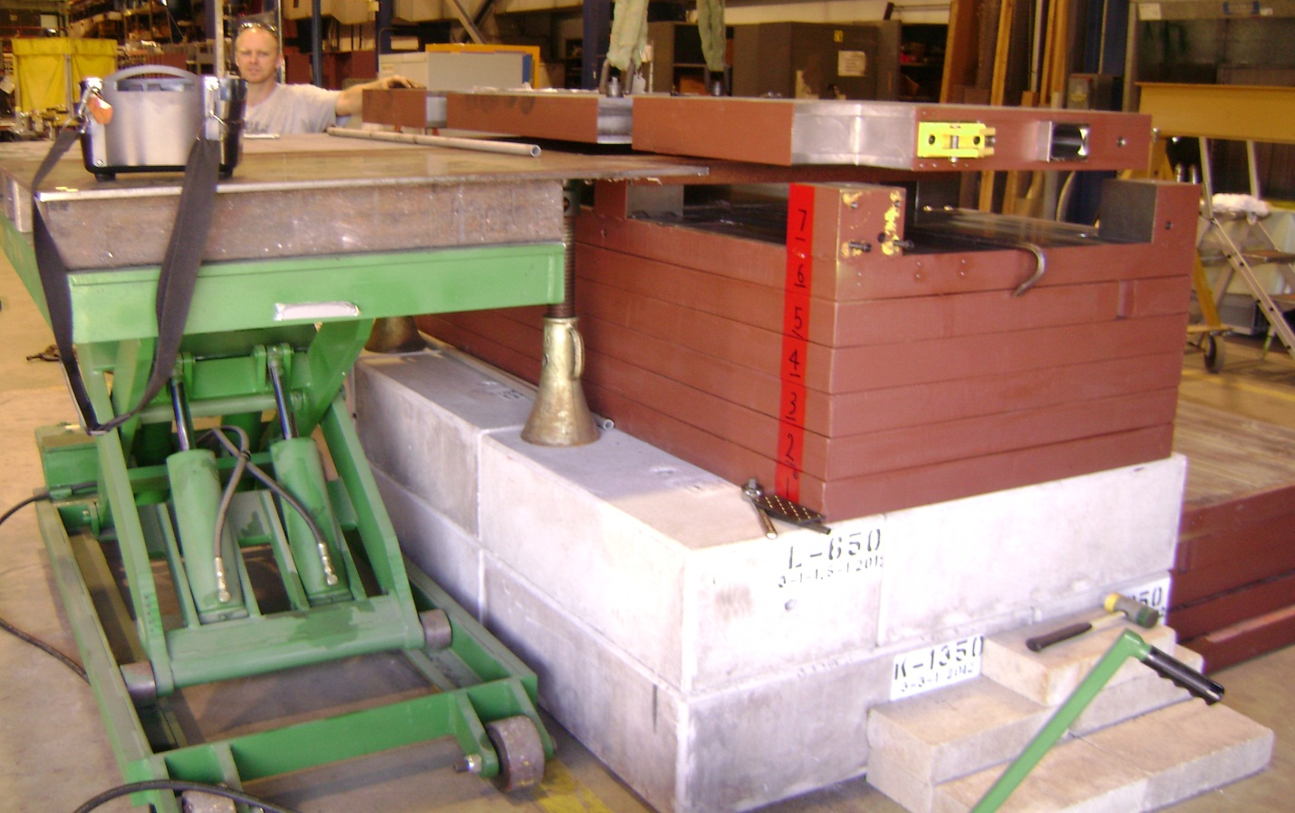
Moving block
Round tube
Bracket
Table plate
8” channel
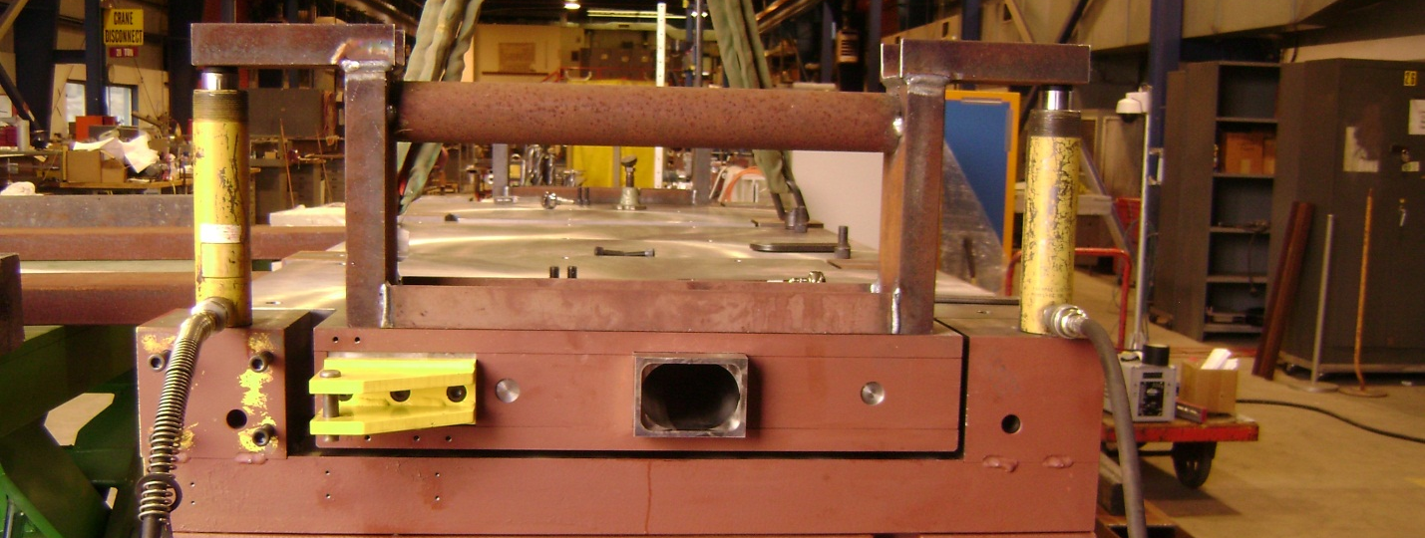
8” channel
Cylinder
Fig. 7 Moving block installation.
- Top plates installation.
The plate delivered to the absorber on the table .
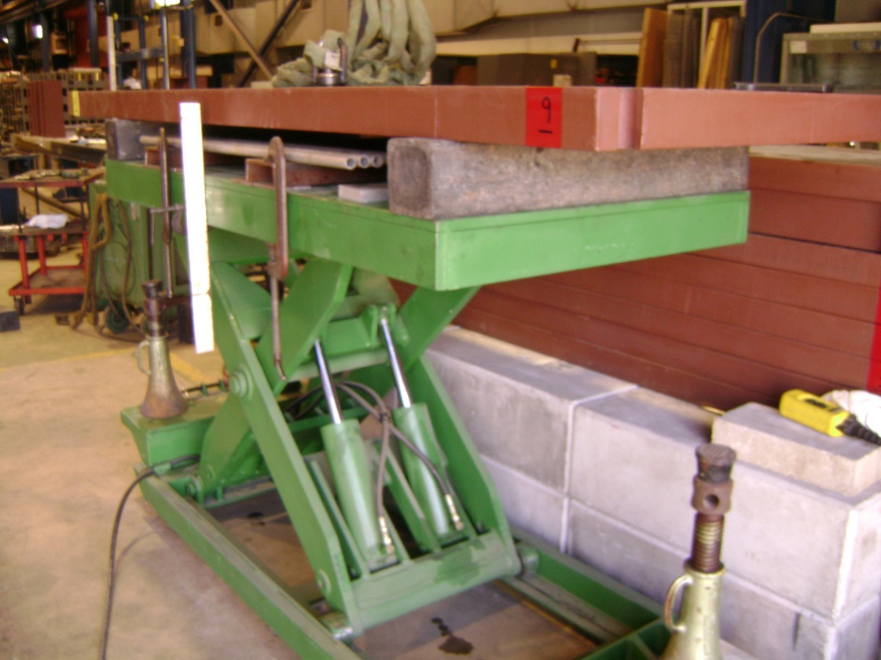
Round tubes are inserted under the plate.
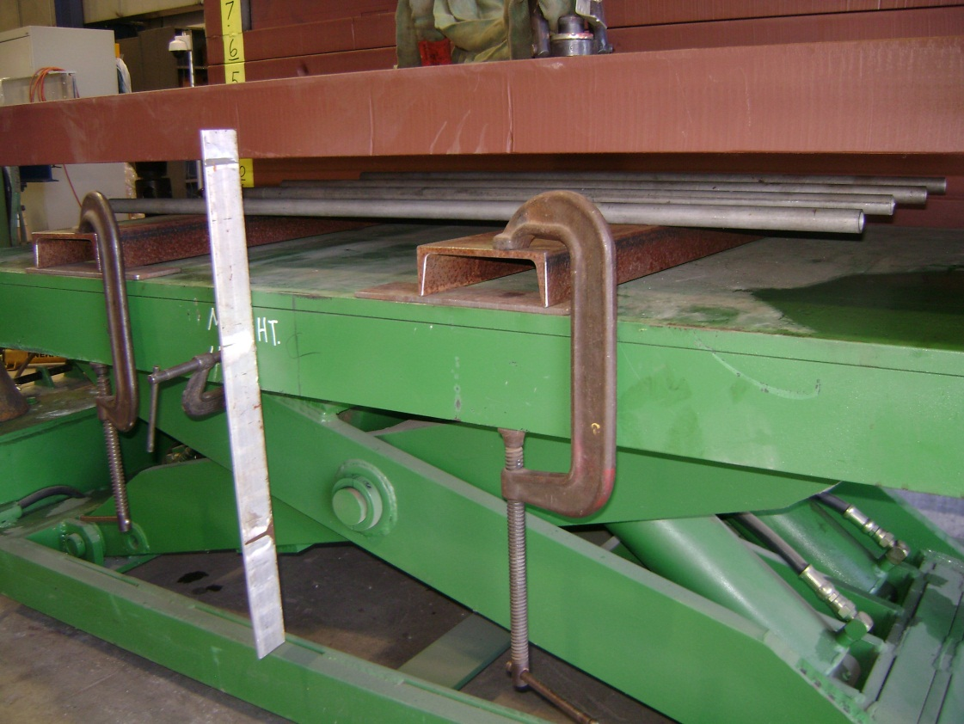

The pate lifted up and creeping is removed.
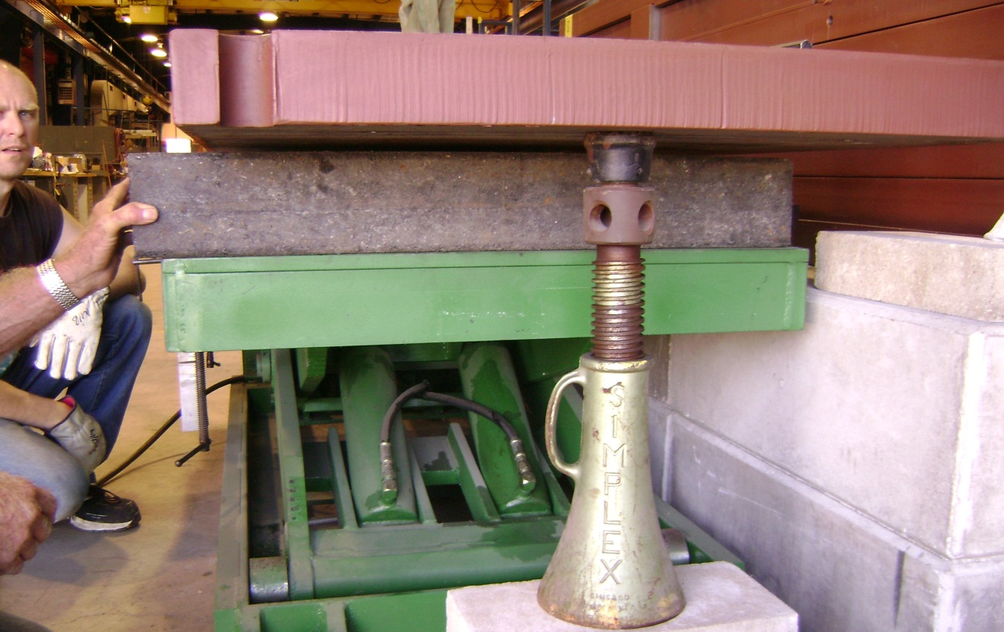
The plate is lowered down on the round tubes.
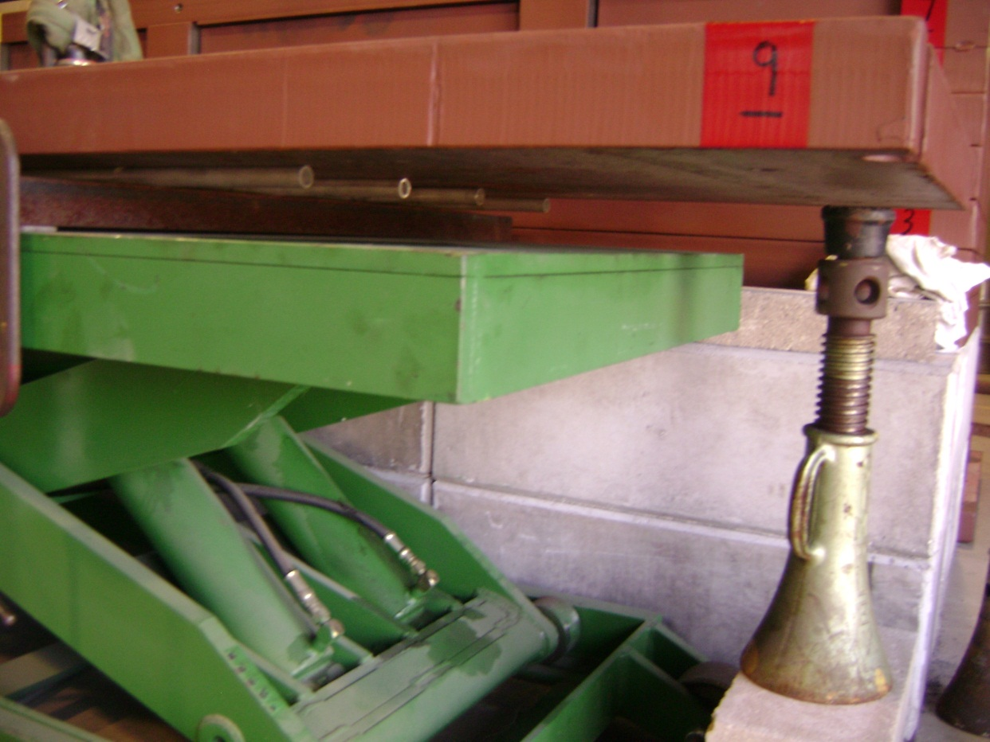
Others round are placed on the top of the installed plate of the absorber.
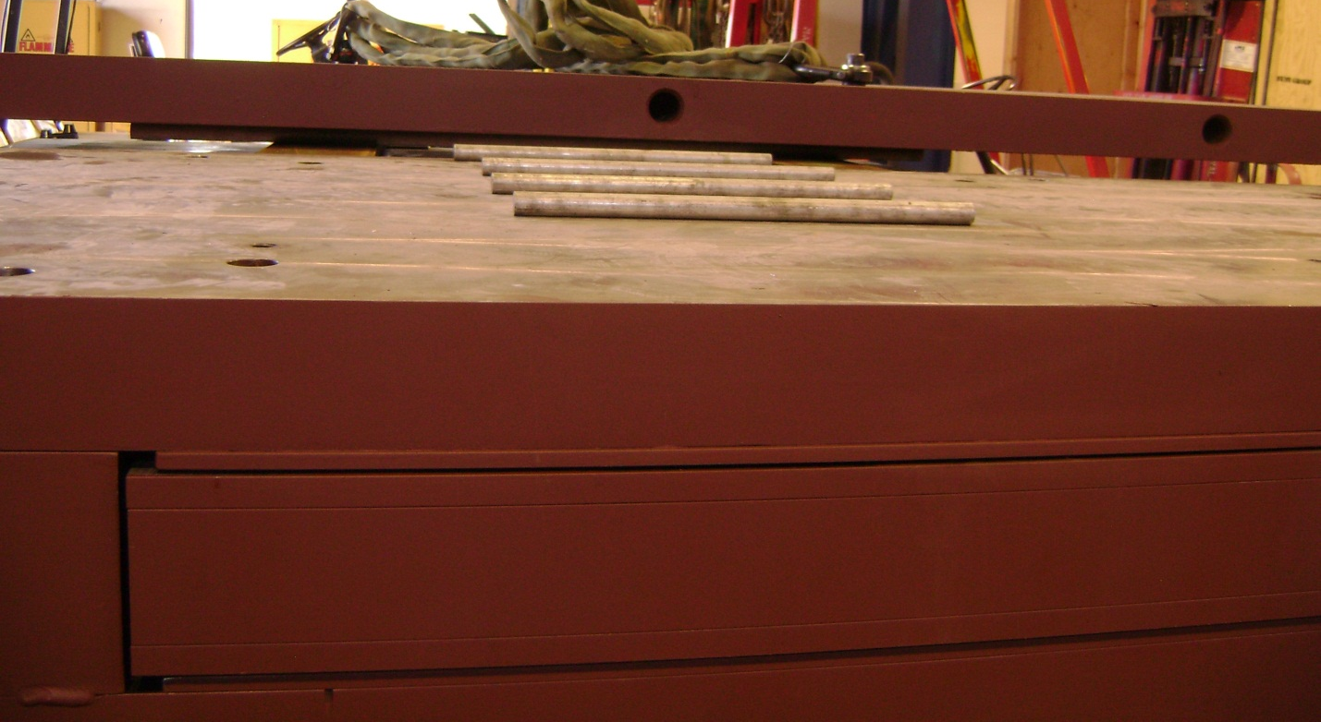
The plate is rolled on the absorber and stopped in the end.
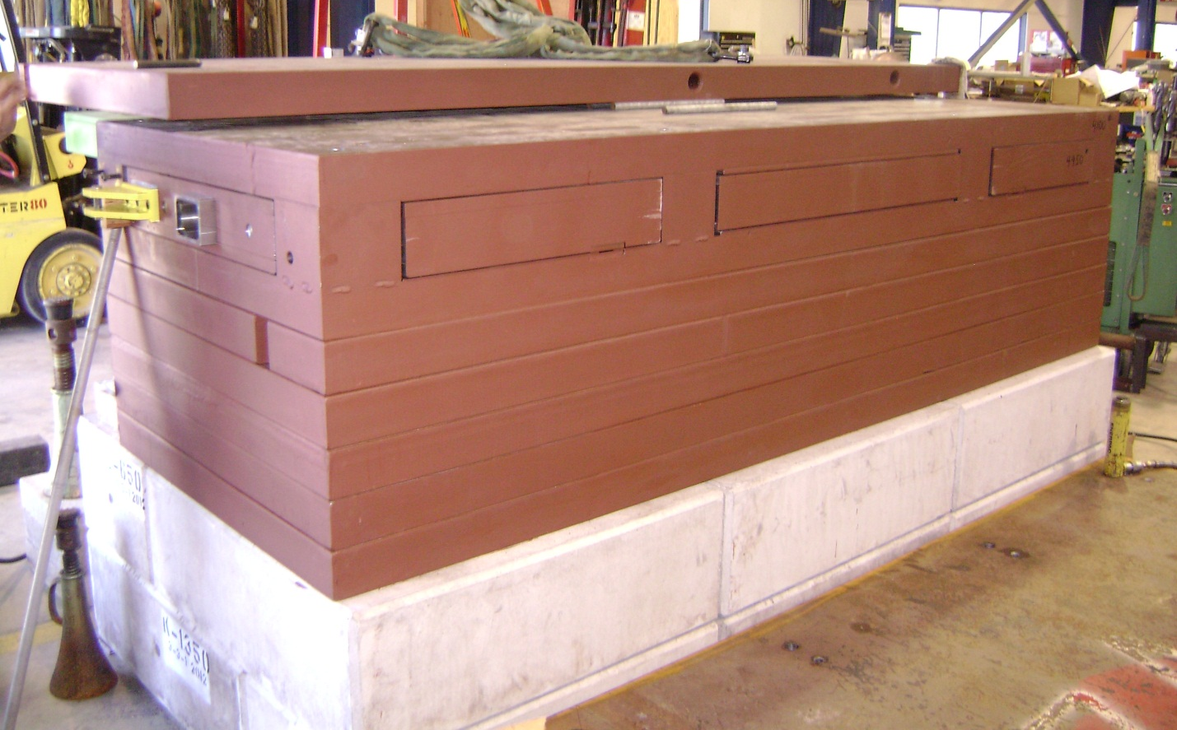
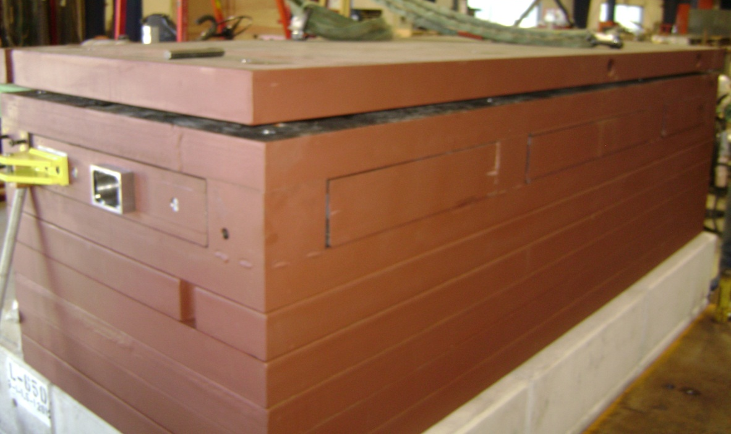
The plate is lifted up by crow bar and wood edges are inserted between plate and absorber to remove rounds.

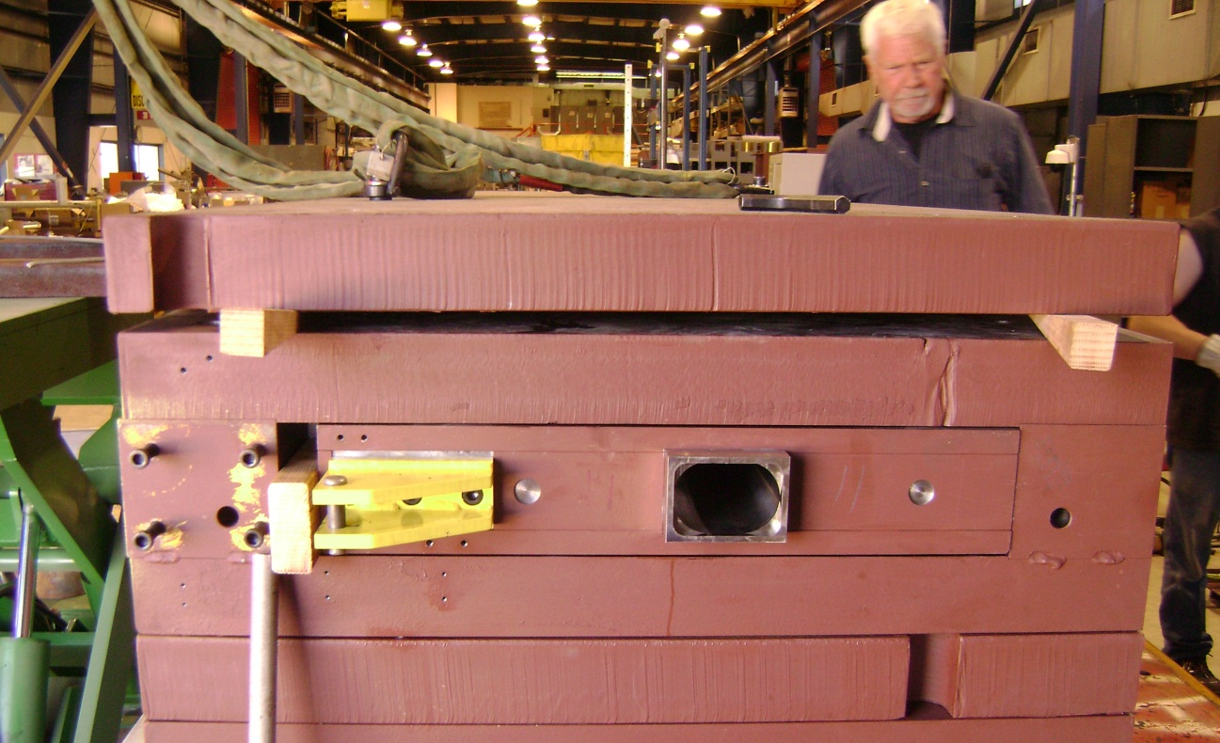

Round are removed with the long hook.
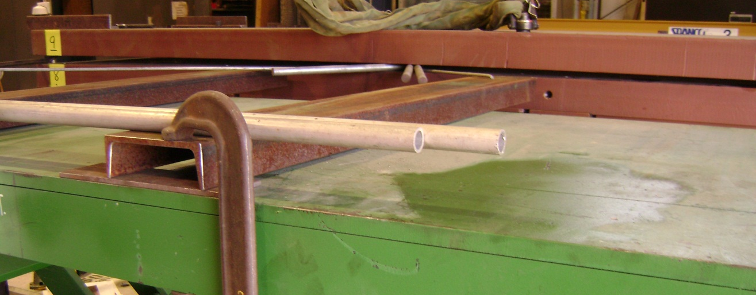
The plate is moved by crow bar to get the screws alignment.

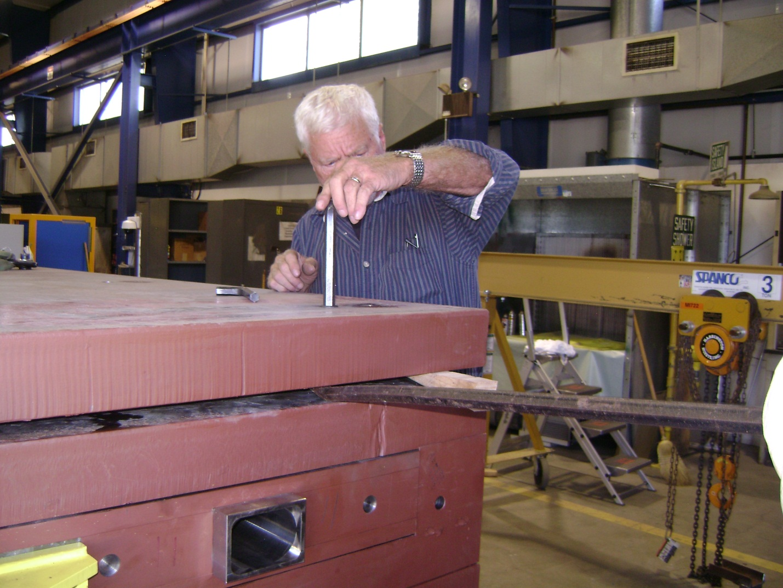

All screws are started and wood wedges removed.
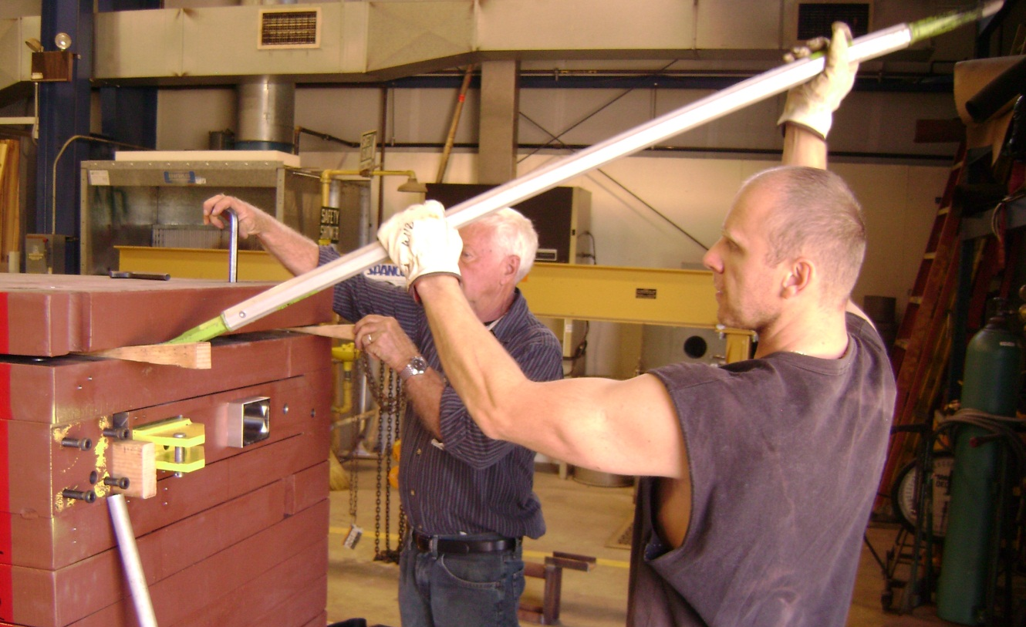
All screws are tightened.
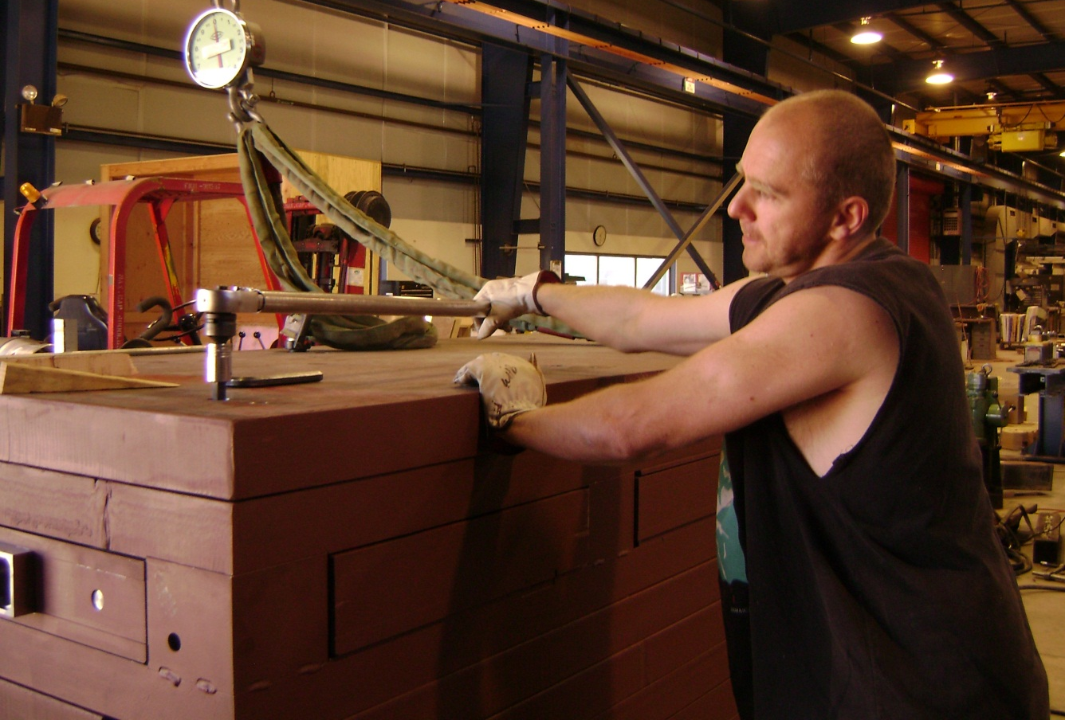
All top plates are installed with the same procedure.
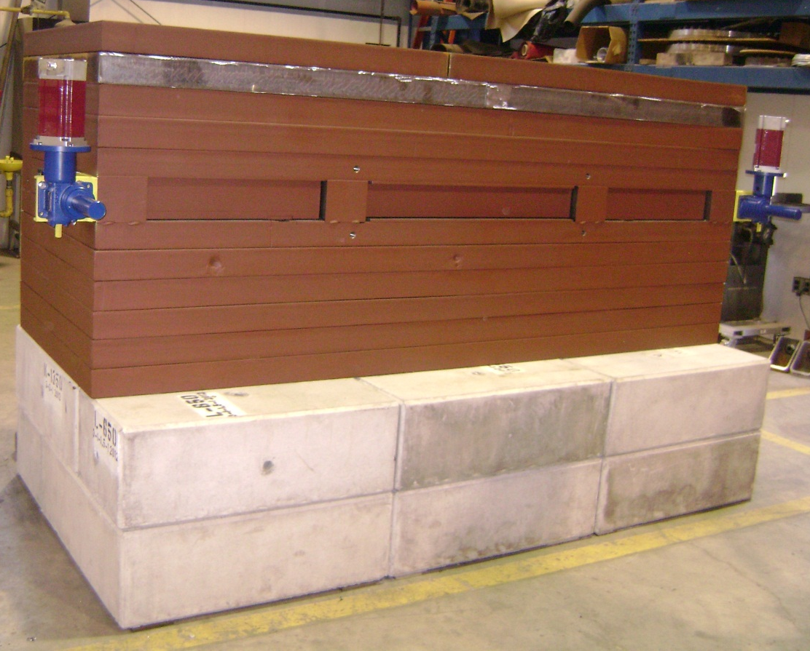
- Polyethylene installation.
Two layers of the polyethylene 4” thick are installed on both ends of the absorber.
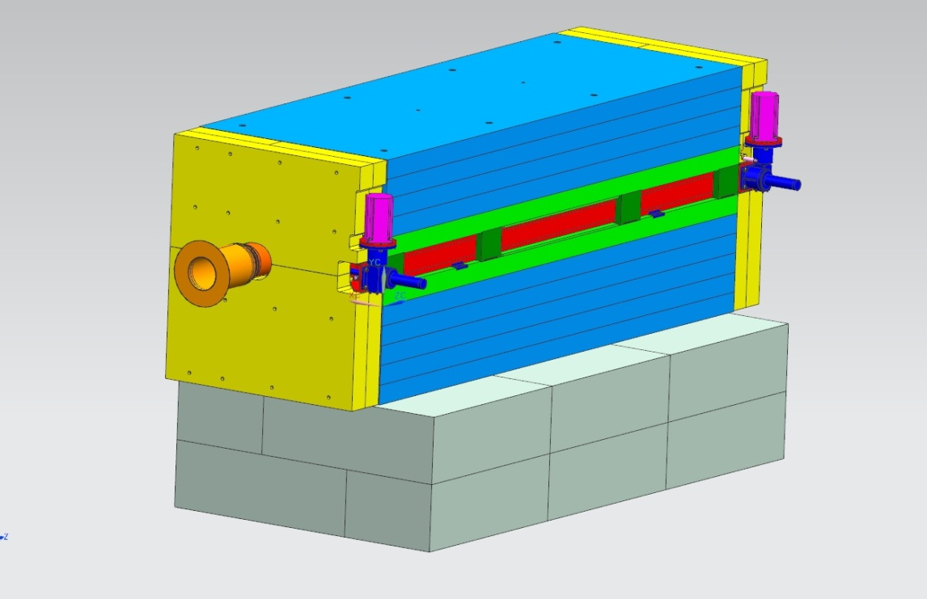

- Concrete bricks and marble installation.
Concrete bricks stacked on the aisle side and top of the absorber.
Four layers marble ( 4” thickness) are installed on the aisle side of the absorber and secured with frame that is bolted to the angle on the top and concrete blocks on the bottom.
