Booster Notching Absorber Assembly
Vladimir Sidorov
01/09/2013

The conceptual design of the Booster Notching Absorber is based on Primary beam loss calculations at notching prepared by Sasha Drozhdin and Energy deposition simulations with MARS prepared by Igor Tropin. The New Booster Notching Absorber is located in the Long 13 of the Booster Ring.
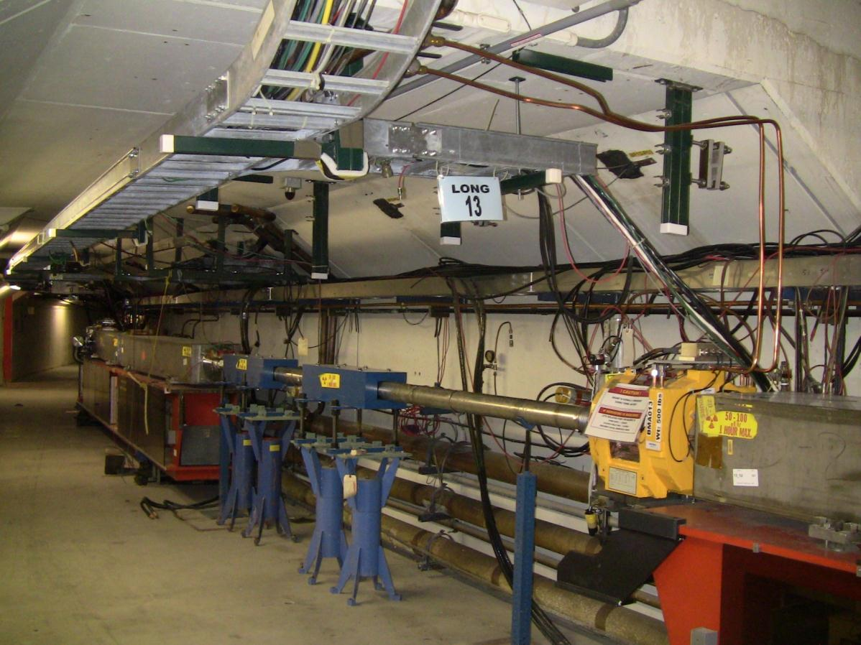

Fig.1 Long 13 before the Notch Absorber Installation.

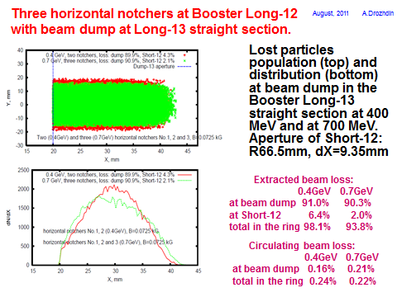
Fig.2 Vacuum Liner, neutral position. Fig.3 Vacuum Liner, working position.

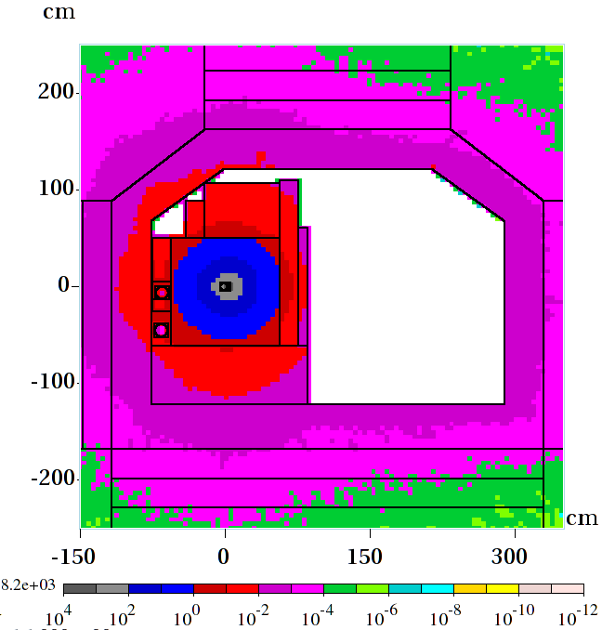

Fig.4 Energy deposition, MARS Calculations (residual dose).

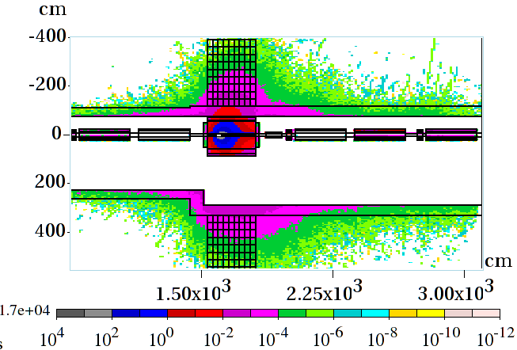
Fig.5 Energy deposition, MARS Calculations, plan view (residual dose).
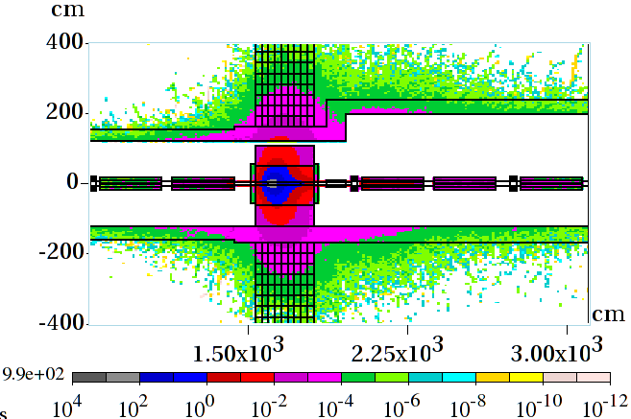
Fig.6 Energy deposition, MARS Calculations, vertical view (residual dose).
Booster Notching Absorber Components.
The vacuum liner (item 1) is surrounded with steel absorber (item 2) and concrete (item 3) blocks. Polyethylene masks (item 4) are mounted around the vacuum liner tube extension in the upstream and downstream ends of the absorber. The driving system (item 5) provides 1.00” movement of the vacuum liner inserted into the moving block (item 6) . Two bellows (item7) are connected to the vacuum liner and to the Booster beam pipe. The marble plates ( item 8 and 9), are installed on the aisle side and downstream end of the absorber. The steel –marble mask ( item 10) is installed on the downstream end of the absorber. Three steel frames (item11) are holding marble and concrete blocks in the place.
5
4
3
11
2
7
10
9
1
8
6
Fig.7 Booster Notch Absorber.
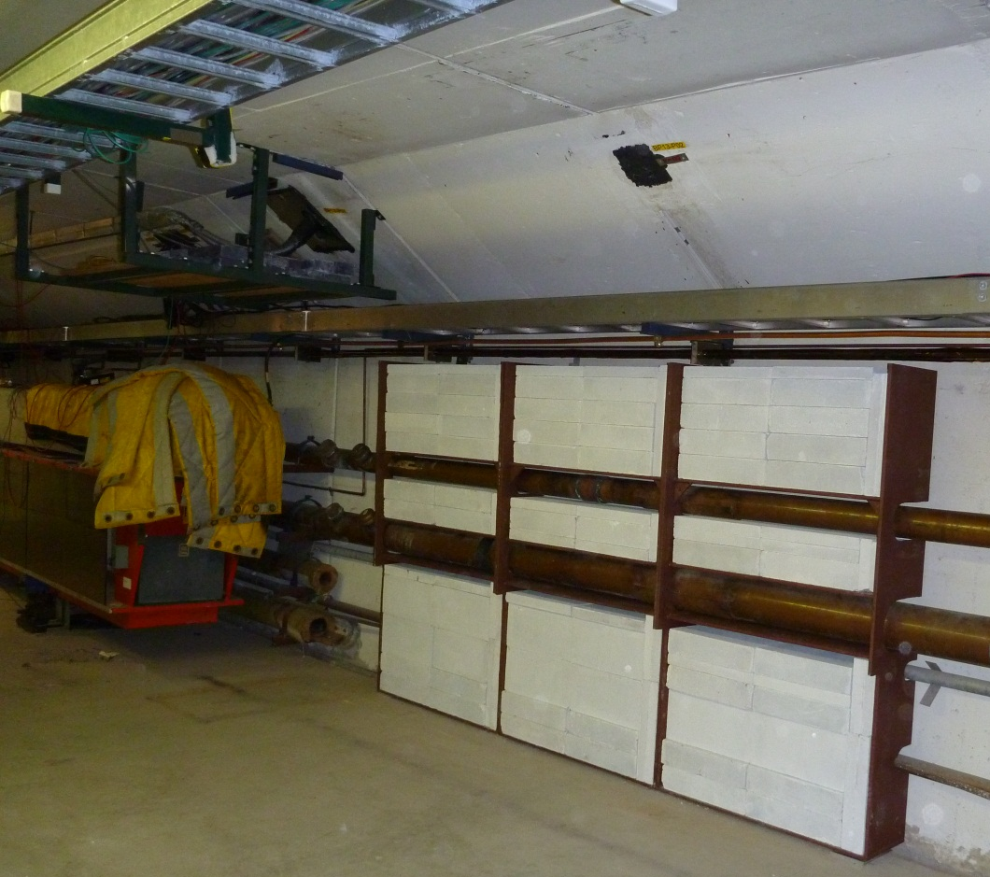
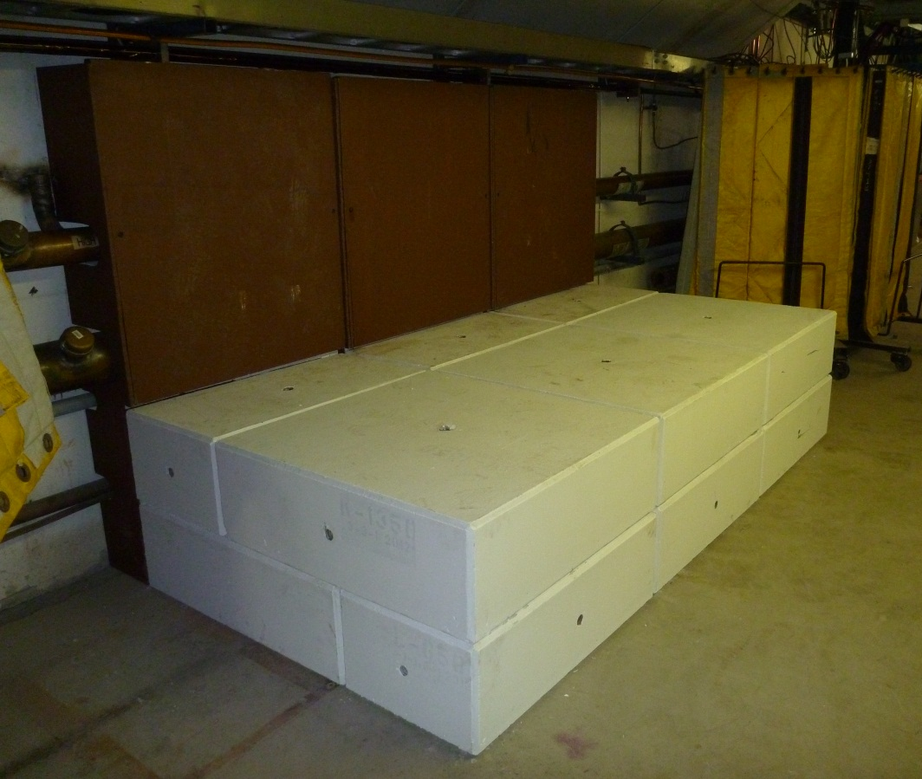
Fig. 8 Wall shielding and base concrete blocks installation.
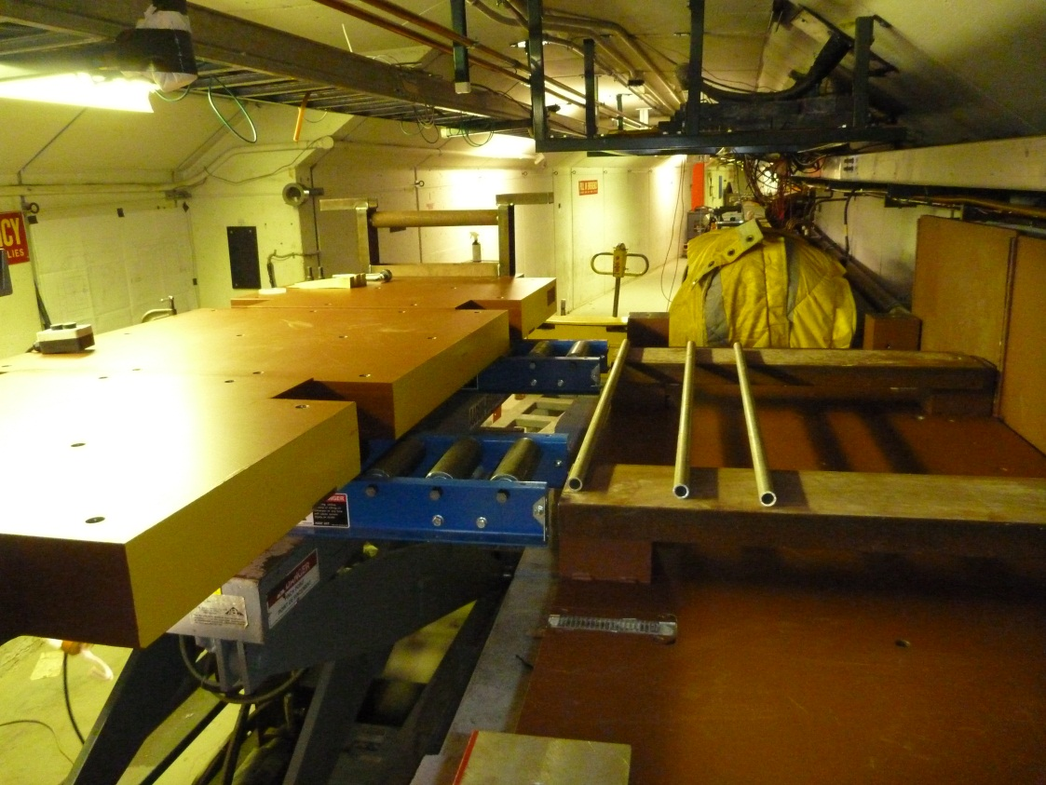
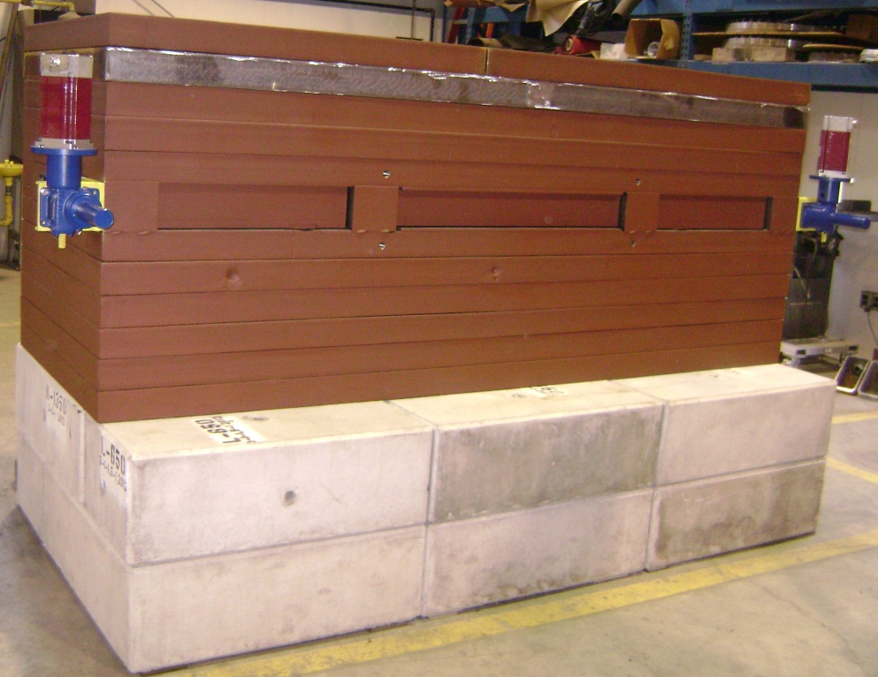

Fig. 9 Notch Absorber steel blocks assembly.

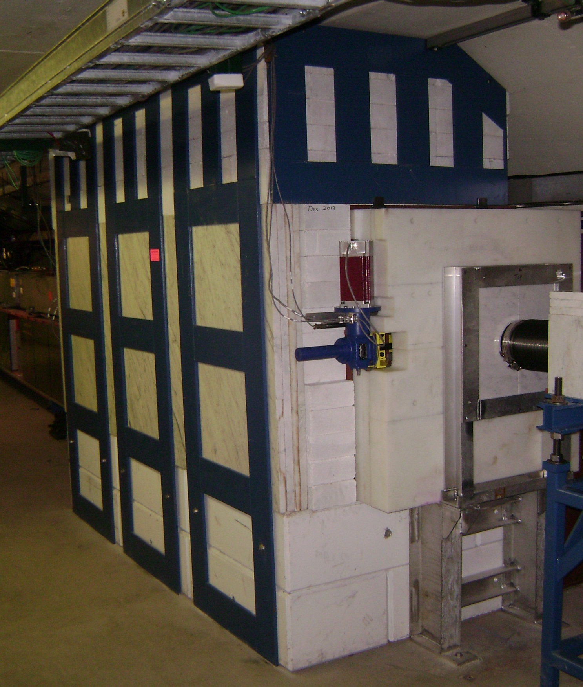
Fig. 10 Downstream end of the Absorber.
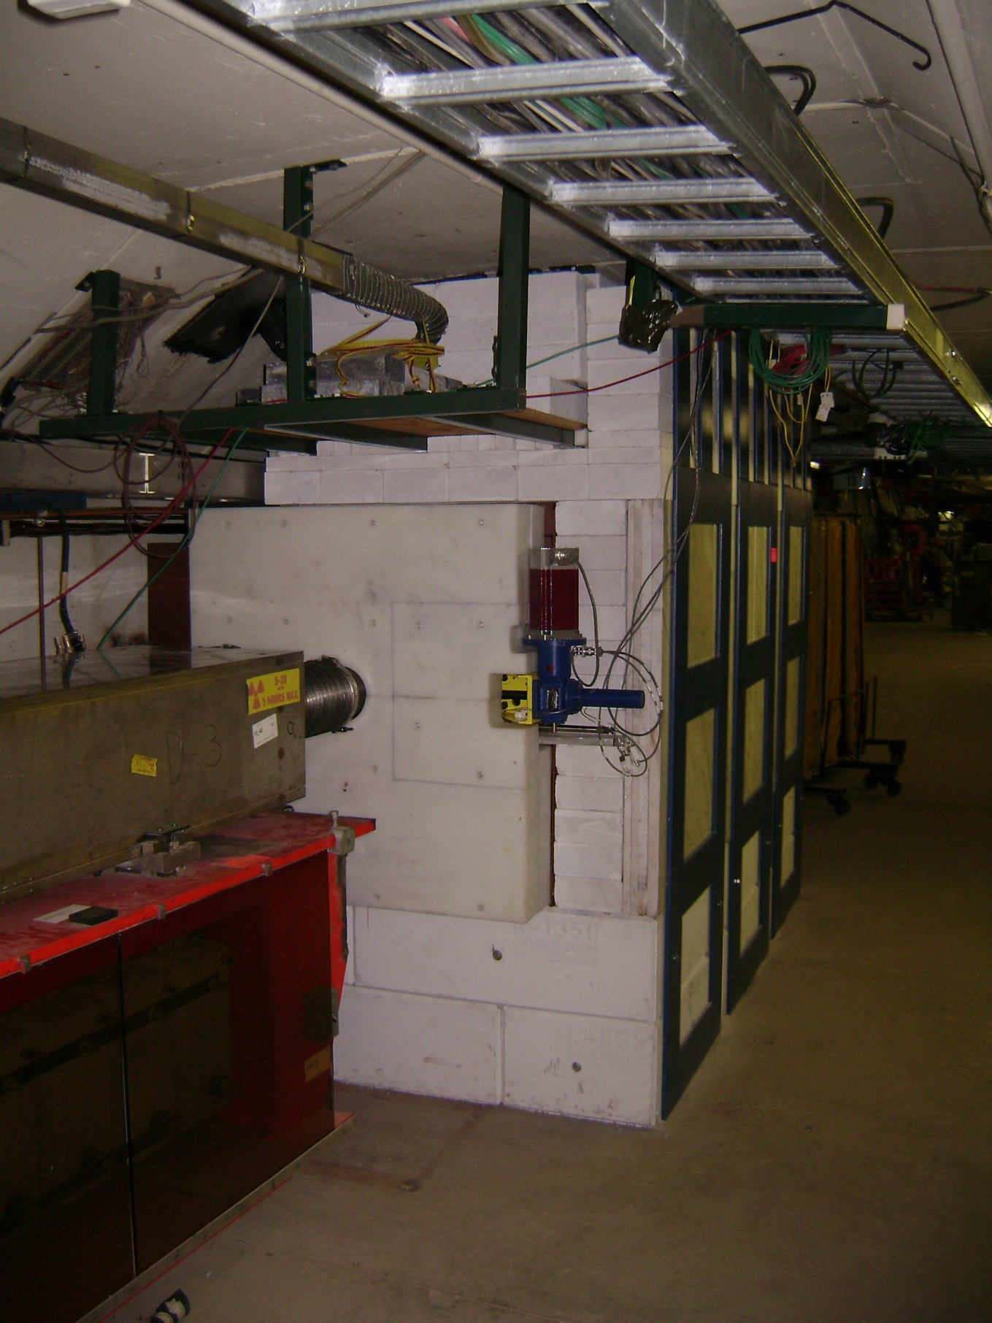
Fig. 11 Upstream end of the Absorber.
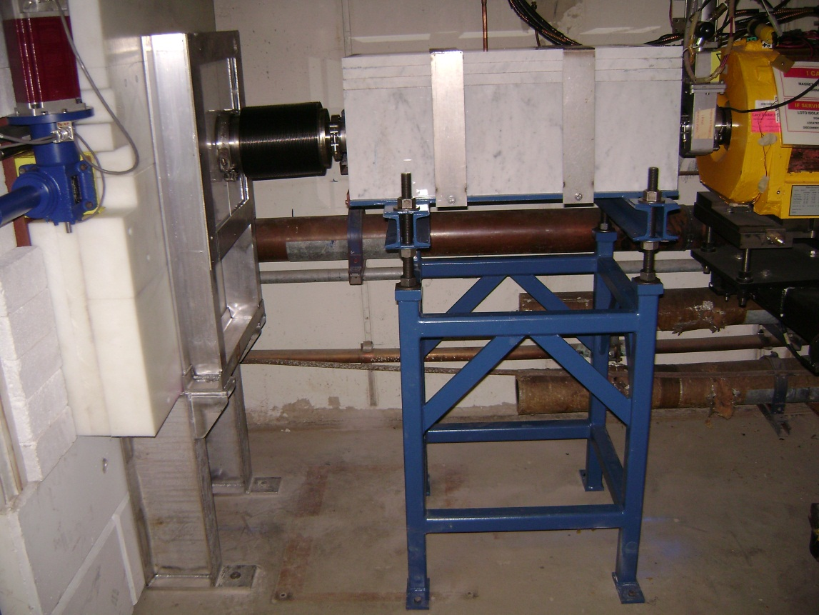
Fig.12 Downstream end bellows and Steel-Marble mask .
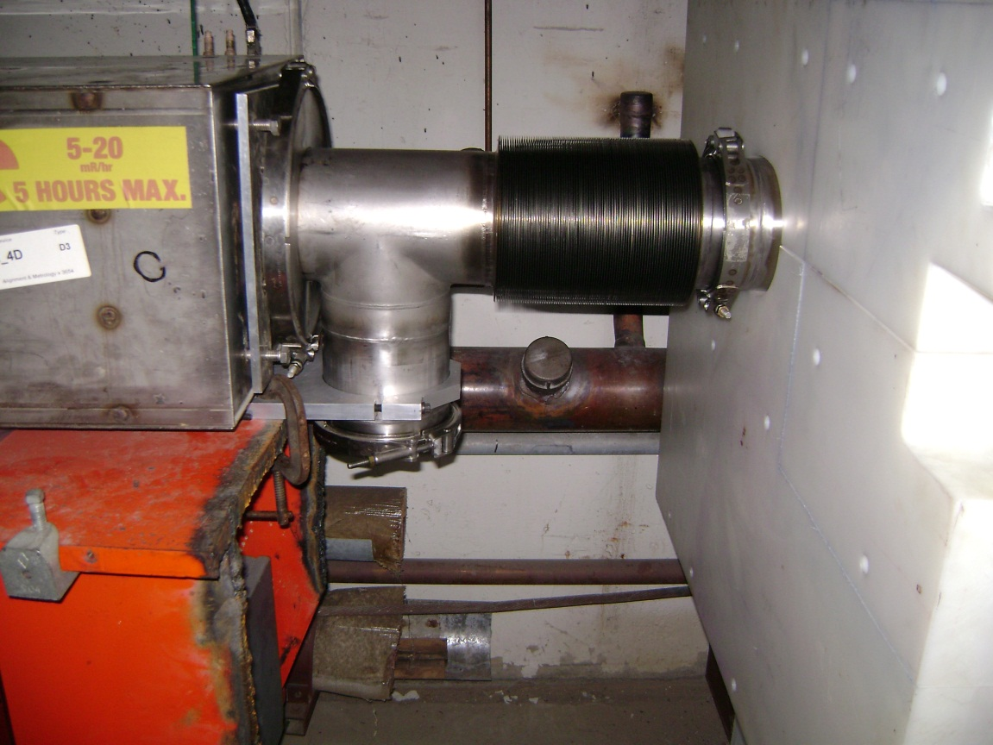
Fig. 13 Upstream end bellows and Ion pump port.
Alignment measurement data
BASELINE2
Measurements::NOTCH Export Field.txt1
Point Name |  | X | Y | Z
NOTCH_UP |  | -0.005 | 35.300 | 0.018
NOTCH_CT |  | -0.006 | 89.527 | 0.021 | ADJUSTED BY JERRY JUDD TO ZERO THE UPST END
NOTCH_DN |  | -0.008 | 143.755 | 0.024

Point Name |  | X | Y | Z
NOTCH_UP |  | -0.617 | 35.299 | 0.002
NOTCH_CT |  | -0.619 | 89.526 | 0.020 | MOVED RADIALLY IN 23500 COUNTS
NOTCH_DN |  | -0.621 | 143.753 | 0.038

Point Name |  | X | Y | Z
NOTCH_UP |  | -0.780 | 35.298 | 0.002 | MOVED RADIALLY IN 7000 COUNTS . UPST LIMIT LIT
NOTCH_CT |  | -0.782 | 89.526 | 0.020 | DNST LIMIT UNLIT
NOTCH_DN |  | -0.785 | 143.753 | 0.039

NOTCH_UP |  | 0.327 | 35.299 | 0.018
NOTCH_CT |  | 0.324 | 89.527 | 0.020 | MOVED RADIALLY OUT 2500 COUNTS
NOTCH_DN |  | 0.321 | 143.754 | 0.023

Summary:
- The Notch Absorber is successfully and safely assembled in the BOOSTER Long 13.
- The Notch Absorber is assembled with acceptable vacuum liner moving parameters: from 0 position toward beam center 0.79” ( 20mm), from 0 toward aisle side 0.277”
( 7mm).

