Distortion in

Resistive Wall Current Monitor

Signal Transmission Lines

Duncan Scott
f
Fermi National Accelerator Lab
August 2013
Abstract
The new tomographic reconstruction program tardis being implemented in the Main Injector and Recycler requires accurate longitudinal charge profiles measured by resistive wall current monitors (RWCM). A basic theory of signal attenuation due to skin effect resistances in coaxial transmission lines is presented to explain signal distortion from the RWCMs. The theory is used to generate a finite impulse response function that can be convoluted with a distorted signal to reproduce the original signal. Knowledge of the exact cable properties, (lengths, attenuation) in the line is essential and should be checked for the Main Injector and Recycler.

Introduction
tardis, a longitudinal phase space tomographic reconstruction programme, requires longitudinal charge profiles of the beam. These are measured using a resistive wall current monitor (RWCM) in the beam pipe, the signal is then digitized by a scope []. The RWCM signal is transmitted along a coaxial line to the scope and during this transmission is distorted. Higher frequency signals propagate more quickly down real transmission lines than low-frequency signals and are attenuated more quickly. This separation and attenuation of different frequencies by a transmission line causes signal distortion. Longer transmission lines and/or higher frequency signals distort more.
The single biggest source of distortion is the skin effect causing an increase in the effective resistance of the conductors as frequency increases. Sometimes the rounding off of a sharp step in a cable is called dispersion, but dispersion is distortion caused by different frequencies moving at different speeds. Most cable distortion, for practical cables, is caused by attenuation of higher frequencies, not by dispersion, and what dispersion there is works to slow down the low-frequency signals, not the high-frequency signals.
A method that includes cable dispersion would be carried out in the following way: the signal would be Fourier transformed to find its frequency content, a Hilbert transform is then required to handle the negative frequency components and preserve causality, then each frequency component can be propagated along the line for the particular cable properties and propagation mode, then the inverse transforms calculated to retrieve the propagated signal in the time domain. This analysis is not done here as it is assumed dispersion is not a significant factor compared to skin effect losses.
Skin Effect Distortion
Skin-effect distortion is a well-known effect and can be corrected for with some knowledge of the line. Previous work [, , ] has used the following formula for the integrated charge, $I_{c}$, obtained from a delta-function input to the line [] :
$$I_{c}\left(t\right)= 1-erf\left(\frac{1.45×10^{-8} Al}{\sqrt{2t}}\right), \left(1\right)$$
where $l$ is the cable length and $A$ is the attenuation per 100 unit lengths (feet in [5]) at 1GHz in dB. The derivative of (1) is taken to find the delta function response, which can then be convoluted with initial signal to find the distorted signal. Alternatively, the distorted signal can be convoluted with the inverse response to recover the original signal. However, in deriving (1) (see Appendix) the delta function response, $g\left(t\right)$, is arrived at and can be used from the start:
$$g\left(t\right)=\frac{lα}{2\sqrt{f}πt^{3/2}}ⅇ^{\frac{l^{2}α^{2}}{4fπt} },$$
where $α$ is the attenuation constant for a particular frequency $f$. These formula assume negligible dielectric losses in the line and the attenuation varies as $\sqrt{f}$ giving universal curves which can be scaled by a particular cable’s parameters. For the Heliax LDF5-50A cables used for the RWCM with parameters given in Table 1 this is a good approximation.
Parameter | Symbol | Unit | Value
Inductance | $$L$$ | $$μH m^{-1}$$ | 0.2
Inner Conductor radius | $$r$$ | mm | 4.55
Inner Conductor Material |  |  | Copper Tube
Attenuation (VSWR @ 1GHz) | $$A$$ | dB 100 $m^{-1}$ | 4.115
Table 1: Relevant Parameters for LDF5-50A Heliax Cable [].
The value for $α$ is calculated from the manufacturer’s attenuation in dB in the following way:
$$A= 20 \log_{10}\left(e^{-lα}\right)$$
$$-4.115 dB= 20 \log_{10}\left(e^{-100α}\right)$$
$α=\frac{\log_{e}\left({10}^{\frac{4.115}{20}}\right)}{100}=0.0047375 \left[m^{-1}\right]$
Example Delta Function Response
For the Main Injector it will be assumed the line comprises of two coaxial cables described in Table 2 [], giving the impulse response as in Figure 1.
Cable Type | Length  (m) | Attenuation  (dB m⁻¹ VSWR @ 1GHz)
LDF5-50A | 39.32 | 0.004115
RG58 | 2.44 | 0.705
Table 2: Assumed cable properties for MI RWCM transmission line.
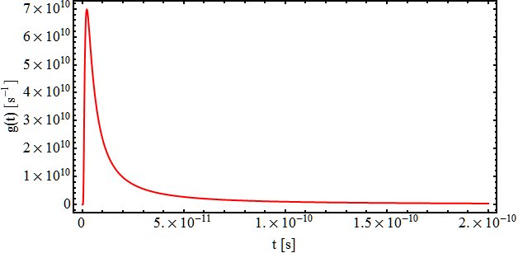
Figure 1: Impulse response of cabling described in Table 2.
Inverse Response
An initial signal convoluted with the impulse response gives the distorted signal. To recover the original signal from the distorted signal it must be convoluted with the inverse response. This is done by creating a lower triangular convolution matrix from the impulse response and finding it’s inverse. For example the convolution of a discrete signal, $S=\{S_{1},{ S}_{2},{ S}_{3},{ S}_{4}\}$ with $f=\{a,b,c,d\}$ is simply:
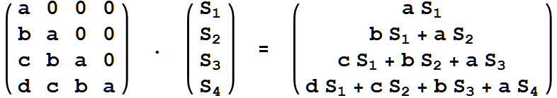
There are simple methods for finding the inverse of a lower triangular matrix like the one in the left hand side of the above expression. An example finite impulse response (FIR) is shown in Figure 2. Most of the interesting features happen on very short time scales. The actual form of the response depends on the time step considered.
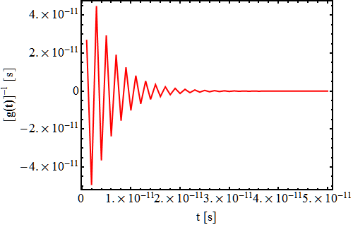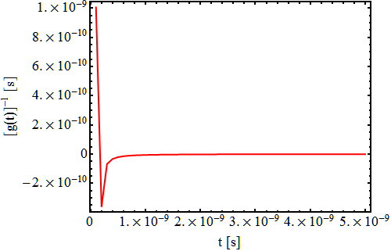
Figure 2: FIR of the MI RWCM Signal Transmission Line using a ps (left) and 100 ps (right) time step.
A distorted signal can now be recovered by convolution with the FIR. If just the distortion of the signal is required (and not the absolute amount of attenuation) the integrated response may be normalised to 1 ensuring the initial and final signals have the same integrated charge. An example distorted signal from the MI RWCM and after correction is shown in Figure 3, the trailing edges are reduced and the peak intensity is raised.
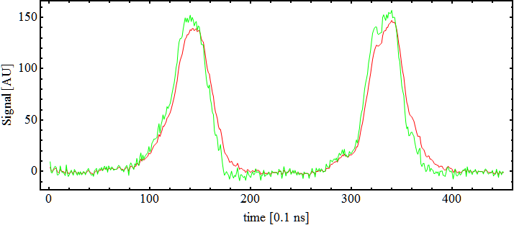
Figure 3: RWCM signal from MI scope (red) and after cable distortion correction (green).
Conclusion
A simple transmission line theory has been used to explain signal distortion due skin effect attenuation in coaxial lines. These attenuations are assumed to be proportional to the square root of the signal frequency allowing for universal curves to be calculated that define the impulse response. The inverse impulse response can be found, giving a FIR filter that can be used to recover the undistorted signal. The exact attenuation for the MI and Recycler RWCM should be checked. This procedure should be incorporated in to the pre-processing modules of tardis to give more realistic input profiles for tomographic reconstruction.
Appendix Derivation of Equation 1
A coaxial cable can be represented by a network of four basic components, shown in Figure 4. The distributed resistance of the conductors is represented by a series resistor, $R$, $L$ is a series inductor representing the distributed inductance. The capacitance between the two conductors is represented by a shunt capacitor $C$. The conductance $G$ of the dielectric material separating the two conductors is represented by a shunt resistor between the signal wire and the return wire.
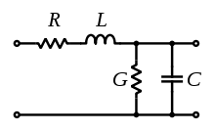
Figure 4: Schematic layout of coaxial line.
From the well-known solution to this system, (known as the telegraph equations) the transfer function for an input signal voltage $V_{1}$ and output signal voltage $V_{2}$ along a cable of length $l$terminated in its characteristic impedance is:
$$\frac{V_{2}}{V_{1}} ={ e}^{-lγ} = { e}^{-l\left(α+i β\right)}$$
where $γ$ is the propagation constant. The value of $γ$ is derived from properties of the cable and can be expressed in terms of the attenuation, $α$, and phase shift, $β$, coefficients that are functions of the angular frequency, $ω,$ of the signal:
$$γ=\sqrt{\left(R+iωL\right)\left(G+iωC\right)}=α\left(ω\right)+i β\left(ω\right)$$
With skin effect losses and zero dielectric loss, $G=0$, $γ$ is:
$$γ={\left(p^{2}LC+p^{\frac{3}{2}}CK\right)}^{\frac{1}{2}},$$
where $p=iω$ and $K$ depends on the conductor radius, $r$, conductivity, $σ$ and permeablility $μ$, as:
$$K=\frac{1}{2πr}\sqrt{\frac{μ}{σ}}.$$
The inverse Laplace Transform of the transfer function is the impulse response of the line. One method to calculate this is to series expand the square root term in the propagation constant:
$${ \left(p^{2}LC+p^{\frac{3}{2}}CK\right)}^{\frac{1}{2}}= p\sqrt{LC}{\left(1+\frac{K}{L\sqrt{p}}\right)}^{\frac{1}{2}}$$
$$≈p\sqrt{LC} + \frac{1}{2}K\sqrt{p}\sqrt{\frac{C}{L}} - \frac{1}{8}\frac{K^{2}}{L}\sqrt{\frac{C}{L}} + \frac{1}{16}\frac{K^{3}}{L^{2}\sqrt{p}}\sqrt{\frac{C}{L}} - \frac{5}{128}\frac{K^{4}}{L^{3}p}\sqrt{\frac{C}{L}}+⋯-⋯$$
The first term is the delay term and the rest describe the signal distortion. As the third order term is independent of $p$ it can be used to estimate the validity of taking only the first two terms by considering the ratio:
$$\left|\frac{\frac{1}{8}\frac{K^{2}}{L}\sqrt{\frac{C}{L}}}{ \frac{1}{2}K\sqrt{p}\sqrt{\frac{C}{L}}}\right| = \left|\frac{K}{4L\sqrt{p}}\right| = \frac{K}{4L\sqrt{2πf}},$$
in specific examples. For example, using the parameters from Table 1 gives this ratio to be of the order $8×10^{-5}$ m⁻¹ at a GHz, indicating the first two terms are an acceptable approximation, the transfer function is now:
$$\frac{V_{2}}{V_{1}}=e^{-l\left(pT+\frac{K}{2R_{0}}p^{\frac{1}{2}}\right)},$$
with $T=\sqrt{LC}$ and $R_{0}=\sqrt{L/C}$. The inverse Laplace Transform of the $e^{-lpT}$ term is a delta function delaying the signal by $l-Tl$, the transform of the other term is a standard one that can be looked up giving the impulse response as:
$$g\left(t\right)=\frac{Kl}{4\sqrt{π}R_{0}t^{3/2}}ⅇ^{-{\left(\frac{Kl}{4R}\right)}^{2}\frac{1}{t}} for lT≥t,$$
$$g\left(t\right)=0 for lT<t.$$
By collecting real and imaginary parts for the propagation constant the real part $α$ can be used to substitute for $K$ (with $ω=2πf$):
$$γ=\frac{K}{2R_{0}}\sqrt{\frac{ω}{2}}+ⅈ\left(ωT+\frac{K}{2R_{0}}\sqrt{\frac{ω}{2}}\right),$$
$$α=\frac{K\sqrt{πf}}{2R_{0}},$$
$$g\left(t\right)=\frac{lα}{2\sqrt{f}πt^{3/2}}ⅇ^{\frac{l^{2}α^{2}}{4fπt}}.$$
As well as the impulse response the step response, $h\left(t\right)$, can be found by taking the inverse transform of $p^{-1}$ times the transfer function (now the ${\frac{1}{p}e}^{-lpT}$ term gives a unit step function):
$$h\left(t\right)=1-erf\left(\frac{αl}{2\sqrt{πft}}\right) for t≥0$$
$$h\left(t\right)=0 for t<0$$
As a check differentiating $h\left(t\right)$ with respect to t should give $g\left(t\right)$, which it does. To get Equation (1) assume the ratio of $α$ to $\sqrt{f}$ is a constant, which is a good approximation for many coaxial cables, choose $f=1$GHz, convert to dB using a factor of 8.69588 and leave in a factor of $\sqrt{2}$:
$$h\left(t\right)=1-erf\left(\frac{1.4524×10^{-8}αl}{\sqrt{2\left(t-T_{l}\right)}}\right) ,$$
where $T_{l}$ is the transit time of the cable and $α$ is expressed in dB per 100 unit lengths, feet in[5].
References

We are tacitly assuming all the attenuation is contained in $α$, i.e. just considering frequency response distortion.
These numbers should be checked as the reference is over ten years old
Voltage Standing Wave Ratio
[] B. Fellenz & J. Crisp, “An Improved Resistive Wall Monitor’ 8th Beam Instrumentation Workshop, SLAC, 1998
[] A. Tollestrup & R.Flora, “Calibration of the SBD using T:IBEAM as a reference” Fermilab-Beams-doc-722, 2003
[] R. Thurman-Keup, “Tevatron and Main Injector Sampled Bunch Displays” Fermilab- Beams-doc-3043, 2008
[] M. Backfish, “MiniBooNE Resistive Wall Current Monitor” FERMILAB-TM-2556-A D
[] Q. kerns et al. “Counting Note: Pulse Response of Coaxial Cables” LBL-CC-2-1B, 1964
[] Andrews Data Sheet, http://www.repeater-builder.com/andrew/andrew-ldf5-50a-spec-sheet.pdf
[] J. Crips nad B. Fellenz, “Calibration of the Resistive wall Monitor for the SBD and FBI Systems” Fermilab-TM-2208

