Ultra High Input Impedance Electrometer/Pulse Train Converter

For the Measurement of Beam Losses

Daniel Schoo
Version AD650.4
July 2013

DESIGN OVERVIEW
The intended purpose of this project is to design a new circuit to measure beam losses in the NuMI, G-2 and Mu2e beamlines using traditional Andrew® Heliax® type HJ5-50 air dielectric cable based loss monitor detectors and report those values to the existing Radiation Safety System. Additionally the circuit may also be useful as a replacement for the obsolescent front end electronics in the Fermi “Chipmunk” radiation detector. This constrains the circuit to match the requirements of the existing system for measuring and reporting losses.

Typically beam losses for radiation safety purposes are measured by collecting the electrical charge induced in a gas filled ion chamber exposed to the loss flux. The charge collected is directly proportional to the amount of beam loss. The value of the charge is then converted to a pulse train for reporting back to the Radiation Safety System.

Because of the way that the Radiation Safety System evaluates the incoming data, the pulse train must possess two important characteristics. First, the peak frequency is proportional to the peak value of the collected charge. Second, the total number of pulses is proportional to the total integrated value of the charge. The pulse frequency immediately indicates the severity of the loss before the pulse count has completed in order to enable a rapid response to large losses. The pulse count reports the actual loss value. This is reported over a period of time limited by the rate that the Radiation Safety “MUX” data collection system can accept, which could be many seconds in duration for large losses. “The relatively instantaneous release of TTL pulses from a relatively large beam loss could be detected by the RSS and would safely initiate a RSS interlock trip. However the accurate recording of such an event by the MUX system could be missed due to the 70 Hz bandwidth limitation. The Chipmunk ion chamber electrometer output has an associated 20 second time constant which has worked well for the MUX system.”¹

The pulse amplitude must conform to standard TTL levels. The peak frequency of the pulses must be limited to the maximum rate that the existing radiation safety MUX data collecting system can accept, which is about 70 hertz. One other constraint is that the measurement must be continuous and unbroken without dead times or pauses in order to ensure that all of the losses are accounted for and reported.

To that end I developed the following circuit in Figure 1 for the conversion of continuous/pulse charge integration to a pulse train:

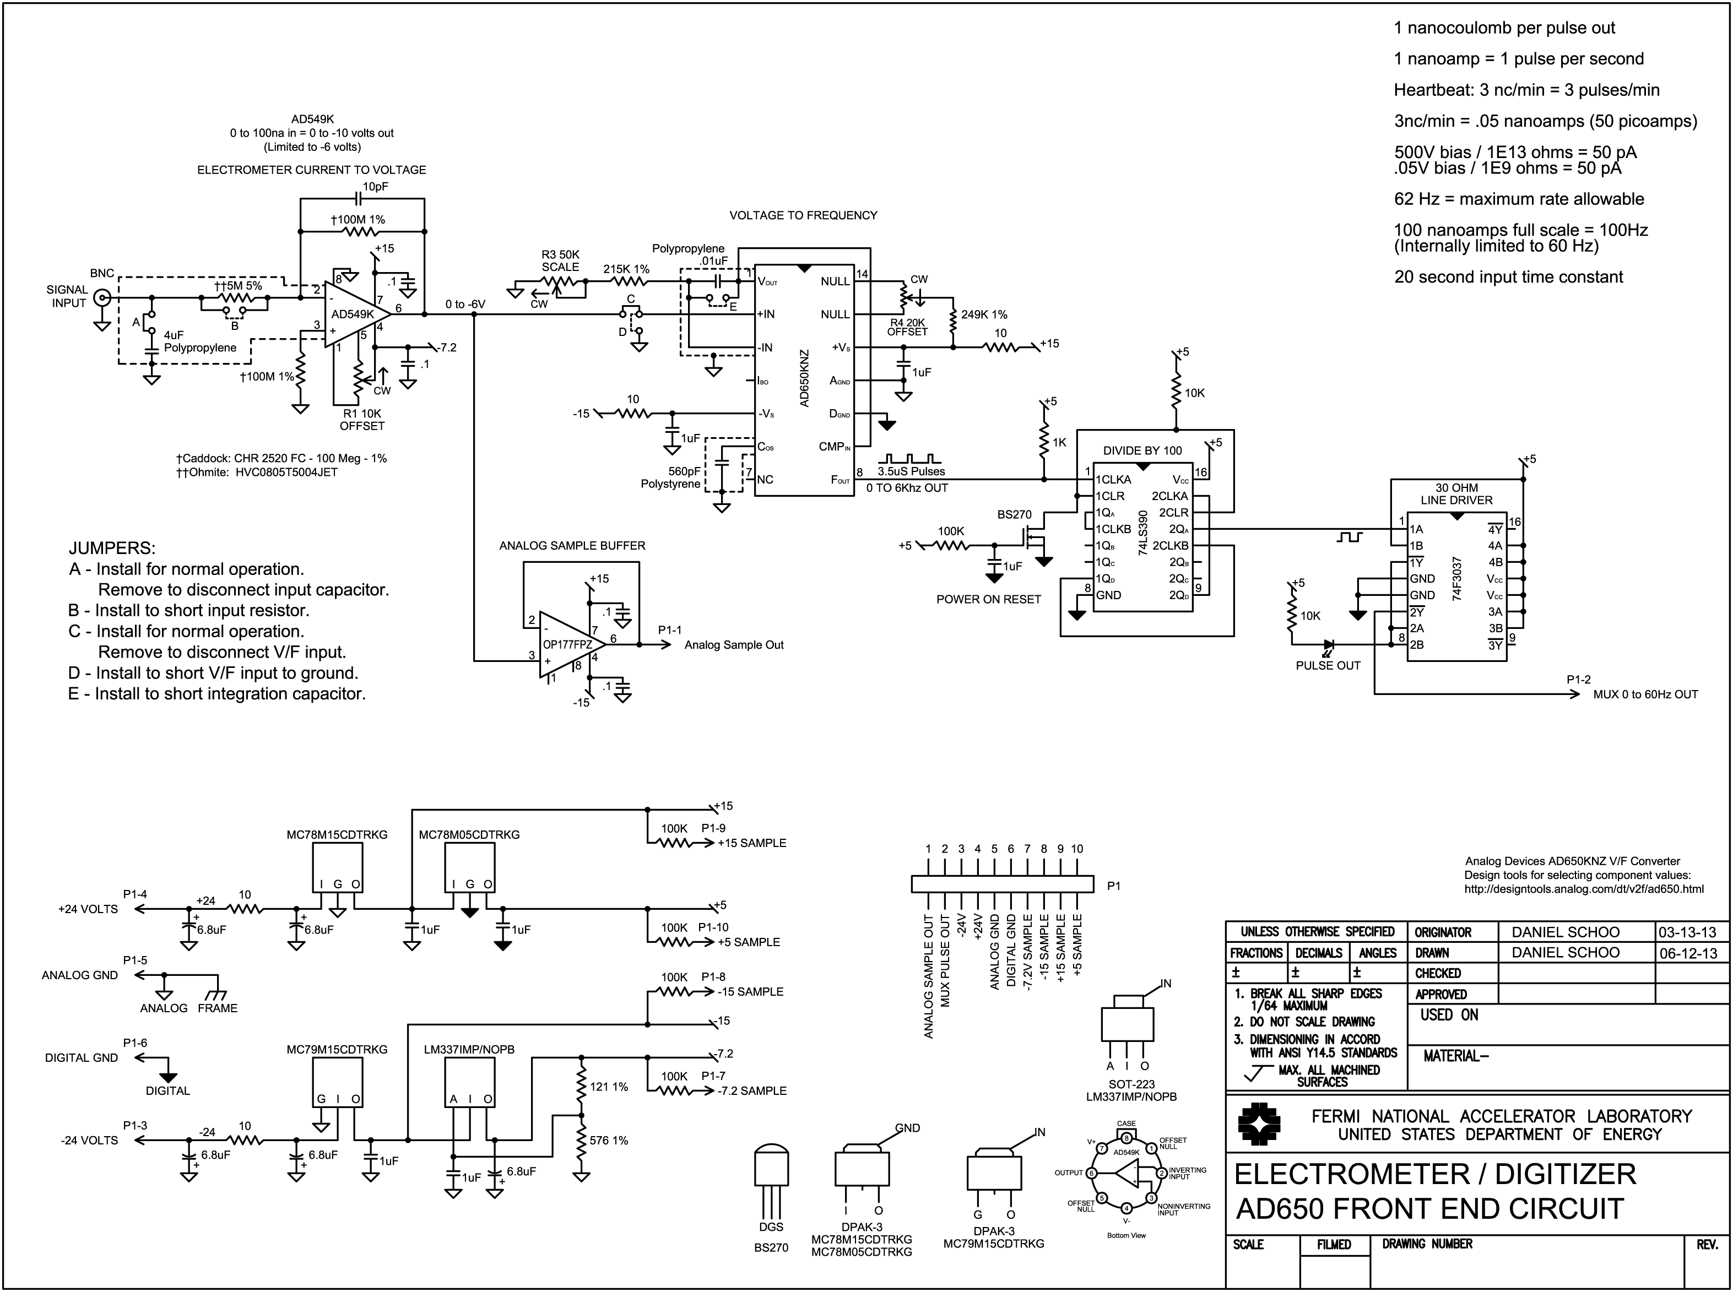
FIGURE 1

CIRCUIT OVERVIEW:
The electrometer circuit in Figure 1 accumulates the charge from a loss monitor ion chamber detector and converts the value of that charge to a pulse train having a peak frequency and number of pulses directly proportional to the amount of charge. There are three parts to the circuit, the input operational amplifier, the voltage to frequency converter and the divide by one hundred scaler. The input opamp reads the charge from the ion chamber that is deposited in a capacitor. The charge on the capacitor is drawn down and converted to a voltage. The voltage is then converted to a pulse train by the voltage to frequency converter. The output from the voltage to frequency converter is scaled by a factor of one hundred to bring the frequency range into compliance with the RS MUX system requirements.

CIRCUIT FUNCTION:

Detector
The detector consists of a length of 7/8 inch diameter Andrew Heliax® cable. The cable is of the “air filled” type with a spiral polyethylene spacer between the outer copper sleeve and inner conductor. The two ends are terminated with caps that have two electrical connectors, a BNC connected to the inner conductor for signal and an SHV high voltage connector connected to the outer sleeve for bias. A gas connection port is also supplied to allow filling the empty space inside the cable with argon or an argon / carbon dioxide mix. As ionizing radiation from beam losses passes through the gas fill in the detector it ionizes some of the gas molecules. A constant positive bias of 500 volts is applied to the outer sleeve. This sets up an internal electrostatic field to allow the collection of radiation induced positive ionic current on the center conductor. As such the detector forms an essentially infinite impedance current source that delivers a charge directly proportional to the amount of ionizing radiation that passes through the space inside the cable.

Current to Voltage Amplifier
The input amplifier is an Analog Devices AD549 monolithic integrated circuit Ultra Low Input Bias Current Operational Amplifier. The AD549 has an input bias of typically 75 femtoamps to maintain negligible contribution of the bias to the measured signal and is packaged in a grounded metal can to minimize electromagnetic interference.²

The capacitor on the signal input absorbs and stores the charge developed in the detector. The resulting voltage on the capacitor (V) is equal to the charge in coulombs (Q) divided by the value of the capacitance in farads (C).
$$V=\frac{Q}{C}$$

For the normal range of operational losses this voltage is expected to be in the range of zero to tens of millivolts. For a catastrophic failure it could be several orders of magnitude higher. The operational amplifier draws the deposited charge from the capacitor through the input resistor into a virtual ground point at the inverting input. The virtual ground is normally maintained at zero volts by a current provided through the feedback resistor equal to the input current but opposite in polarity such that the sum of currents at the virtual ground is zero.

The input capacitor performs several functions. First, it absorbs and holds the charge from the ion chamber allowing the input opamp to draw it down over time and report all of the charge at a rate that is within the limit of the MUX to accept. Second, along with the input resistor, it provides the required 20 second time constant. Third, it provides a low impedance AC path to ground for noise and hum. The input capacitor must be a type with minimal dielectric absorption such as polypropylene or Teflon™ in order to minimize retention of part of the charge.

The value of the input capacitor must be chosen taking into account several factors. A smaller value capacitor reaches a higher voltage with a given value of charge, especially for high beam losses. The disadvantage is higher voltages encourage higher leakage currents inside and around the capacitor and cause the operational amplifier to saturate at lower loss values when the output voltage of the amplifier reaches its maximum limit. For very large charges the voltage could become excessively large possibly overscaling or damaging the input opamp. A small value of capacitance also requires a high value of input resistor to provide the 20 second time constant. A larger value of capacitor lowers the voltage developed with a given charge promoting lower leakage and a better margin of safety for gross overscales. This necessitates a lower value of input resistor to maintain the desired time constant. Very large capacitance keeps the input voltages very low but requires a very small value of input resistor increasing the voltage gain of the opamp and inviting noise problems. Large value capacitors are also physically large and are difficult to place.

As charge is deposited to the input capacitor the opamp draws it out and converts the value of charge to a voltage. The output voltage of the opamp is directly proportional to the remaining charge on the capacitor and thus follows a decaying exponential conforming to the 20 second time constant. Because you are measuring total charge and not voltage, the value of the input capacitor has no effect whatsoever on the charge to pulse output conversion.

Since a loss monitor ion chamber is essentially an infinite impedance current source, and you are measuring charge flowing into a virtual ground and not voltage, the value of the input resistor is not a factor in the ultimate charge to voltage conversion gain from the detector. The primary effect that the value of the input resistance has is to govern the rate at which the charge is removed from the input capacitor and reported. This is exactly what is desired for the 20 second time constant. Secondarily it sets the voltage gain of the input operational amplifier. If the gain is very high this can become a problem because the input becomes susceptible to noise pickup and oscillation. The value of the resistor was chosen in conjunction with the value of the input capacitor to provide the 20 second time constant at a gain that does not promote noise pickup.

The input current-to-voltage conversion gain is determined by the 100 Meg feedback resistor. The voltage drop developed across this resistor is .1 volts per nanoamp. This translates to a conversion factor of 10 volts out for 100 nanoamps of current into the virtual ground node at the inverting input. The 10 picofarad capacitor shunting the feedback resistor rolls off the high frequency gain to suppress noise pickup and promote stability. There is a matching 100 Meg resistor from the non-inverting input to ground. This is to reference the non-inverting input to ground potential and balance the bias current voltage drops to minimize offset.

These two resistors are very sensitive to vibration due to charge induced by changes in capacitance to ground and internal stresses. For my breadboard test circuit I used Caddock TF series ultra-precision film resistors that are manufactured on a flat ceramic substrate. They are excellent resistors but because of their large flat physical configuration they are highly prone to capacitance to ground changes with vibration. Covering them with copper tape and grounding the tape helped to minimize but not eliminate this problem. The Caddock CHR surface mount resistor is specifically designed for electrometer service with ion chambers and other charge amplifier applications. I used these in the NIM module test and they were considerably less sensitive to vibration. These effects should be taken into account in the final assembly by careful shielding and vibration damping of the sensitive input circuit components.

One very important function of the electrometer is to limit the rate at which the loss is reported to the MUX. The MUX system is limited to an input pulse rate of about 70Hz maximum. In the Chipmunk detectors the 20 second time constant provides this function.¹

I limited the reporting rate of this circuit to 60 Hz. In order to do this, the negative supply voltage for the input opamp is such that the amplifier’s output voltage saturates at about -6 volts representing a 60 pulse per second rate. This limits the current that the opamp can provide into the virtual ground point through the feedback resistor slowing the rate at which the charge is depleted from the capacitor. While the reporting rate is limited it does not cause any loss of data. Any charge that would cause a rate above the maximum value remains in the input capacitor and is reported out at the limited rate. As the charge is depleted it eventually goes below the 60 Hz limit and the pulse frequency resumes the normal rate following the value of the remaining charge until all of the charge has been converted and reported.

This limit must be imposed inside the opamp feedback loop on the rate at which the charge is drawn from the capacitor. If the limit were placed at any other part of the circuit, for example at the voltage to frequency conversion, the charge would continue to be drawn from the capacitor at a rate higher than is being reported causing the excess charge to be unreported. A voltage limiting circuit could be imposed on the output of the opamp inside the feedback loop but this would add complication and additional parts count to the design. By limiting the negative supply voltage the opamp is necessarily limited to the maximum rate with no additional components and only moderate effects to the performance until gross overloads are encountered.

Voltage to Frequency Converter
The voltage to frequency converter follows the input amplifier. I selected an Analog Devices AD650KNZ precision monolithic “Voltage-to-Frequency and Frequency-to-Voltage Converter”. I had used an AD537KD in an earlier version of the circuit due to prior experience and I had several samples on hand for immediate evaluation. The AD537 was adequate and worked well but the AD650 is easier to calibrate, has better sensitivity, better linearity and is about $70 less expensive than the roughly $90 AD537. The AD650 also does not have a rather annoying habit of the AD537 to sputter spurious output pulses at close to zero signal input levels³. Unlike the AD570, which is based on the Current Steering V/F circuit, the AD650 is a Charge Balance circuit⁴.

The AD650 datasheet claims a useful dynamic range of six decades representing an input voltage range of 10 microvolts to 10 volts. For the loss monitor application a four decade range of 1 millivolt to 10 volts will suffice but the extra headroom helps to ensure better accuracy on the lowest signal levels. For future use the AD650 would be much more appropriate for the Chipmunk upgrade.

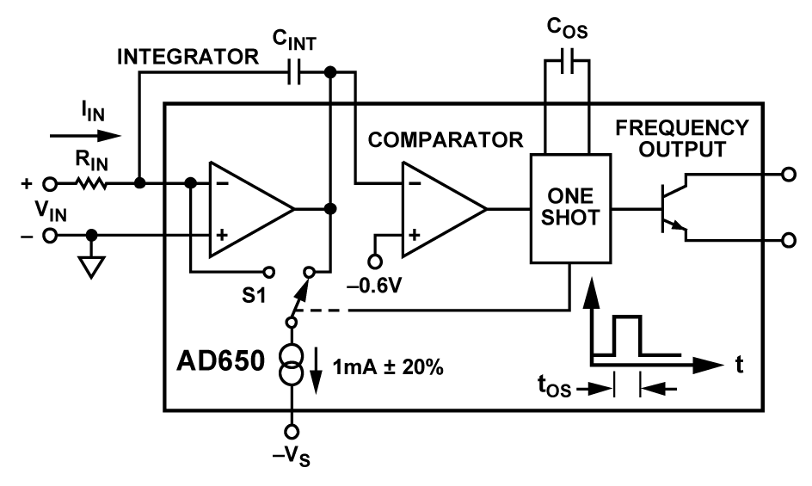
FIGURE 2

Figure 2 illustrates the internal block diagram of the AD650. It consists of three major parts: an operational amplifier, a voltage comparator and a fixed duration one-shot multivibrator. The operational amplifier is configured as an integrator with a capacitor (C_{INT}) from the inverting input to the output. The output of the operational amplifier is connected to a comparator which fires the one-shot. The integrator integrates the input current and when the output voltage reaches the threshold voltage of the comparator, the comparator changes state firing the one shot. The one-shot operates a switch on a constant current sink that removes a precise amount of charge from the integrator reducing the voltage back below the comparator threshold and the cycle starts over⁵.

The input current continues to be integrated even as the precision charge is subtracted out providing a continuous uninterrupted collection of the measured charge. The more current that is applied to the V/F circuit the more quickly the integrator voltage reaches the comparator threshold and the more rapid is the cycle time. This circuit is functionally the same as the front end of the Chipmunk radiation detector, integrated into a monolithic integrated circuit.

Functionally the circuit works like a rain barrel and a bucket. The rain barrel is supplied with a continuous inflow of water representing the input current. The rising water level in the barrel represents the integrator storing up the charge causing the output voltage to rise. When the water level reaches the top of the barrel representing the point where the comparator trips the one-shot, the bucket dips into the barrel and removes a single bucketful of water representing the one-shot switching a precise amount of discharge current out of the integrator. The faster the water pours into the barrel the more often the bucket must dip it out in order to prevent the barrel from overflowing. More dips per minute represents a higher frequency output from the V/F with more current in.

Calculation of the associated component values for this circuit is somewhat more complicated than for the AD537. The value of the capacitor controlling the one-shot time duration (C_{OS}), the input resistance to the integrator (R_{IN}) and the integration capacitor (C_{INT}) are all interdependent. Analog Devices provides a web based component selection calculator for the AD650⁶. The user defined values for maximum input voltage, maximum frequency and one-shot timing capacitor are entered and the other two values for the input resistance and integration capacitor are returned. Guidance for the selection of the one-shot timing capacitor is given in the AD650 datasheet and is constrained to the limits of 50pF to 1000pF.⁵ I chose a value of 560pF for best linearity. Both the integration capacitor and the one-shot timing capacitor must be a type with minimal dielectric absorption such as polystyrene, polypropylene or Teflon™. They do not have to be high precision values but should be as stable as possible with temperature and other conditions. The only other component value to be selected is the pullup resistor for the open collector Frequency Output to match whatever load the output is driving.

The output pulses of the V/F are fixed duration of 3.5 microseconds and variable repetition rate from less than one pulse per minute to 10,000 pulses per second. The pulse output is an open collector NPN transistor driver capable of sinking up to 8 milliamps at a maximum of 36 volts referenced to digital ground. I have it pulled up to +5 volts with an external 1K resistor for typical TTL levels.

Divide by 100 Scaler
The AD650 is not capable of operating down to the necessary frequency range of zero to 100Hz directly as the AD537 is. The lowest practical range is zero to 10 KHz. This is easily remedied by adding a TTL divider to scale the output frequency down by a factor of 100. The disadvantage is that it adds complication to the circuit however the other advantages of sensitivity, accuracy and the lack of near zero input signal instability over the AD537 are more than outweighed by the addition of one TTL chip.

Immediately following the pulse output of the V/F is a 74LS390 TTL dual bi-quinary divide by 100 scaler. The scaler translates the zero to 10 KHz V/F range to zero to 100 Hz for the Rad Safety MUX. The scaler also changes the narrow V/F output pulses to a 50% duty cycle square wave that is easier to transmit reliably over a long cable. The scaler is cleared to zero on powerup with a startup reset circuit. The output of the scaler is buffered by a SN74F3037 TTL quad two input NAND gate 30 ohm line driver. Two of the gates in the package are daisy chained, one following the other, in order to maintain the high true logic level of the scaler output. The first gate also switches the pulse output status led.

Analog Sample Buffer
The sample buffer is a unity gain non-inverting amplifier included for testing purposes. It is often beneficial to be able to sample the analog signal to evaluate noise problems or for troubleshooting and calibration without disturbing or loading the internal signal path. It was included in the final production version for diagnostic signal sampling purposes.

CALIBRATION OVERVIEW
The electrometer circuit is calibrated in steady state using the setup shown in Figure 1. A precision voltage reference with a 1000 Meg resistor in series simulates the current source characteristics of a typical gas filled ion chamber at a value of 1 nanoamp per volt. Various voltages are applied and the frequency output of the V/F is adjusted to a specified frequency output of 1 Hz per nanoamp over the useable range of input current, which corresponds to 1 nanocoulomb per pulse per second. For jumper locations refer to the schematic diagram.

SETUP
Verify that shunt blocks are installed in the following locations:
A and C.

Verify that no shunt blocks are installed in the following locations:
B, D and E.

Trimming the Internal Offset Voltages:
Power up the electrometer board.
Temporarily short the input of the electrometer to ground at the BNC connector.
Install a shield cap on the BNC connector and allow one hour for the electrometer to stabilize.
Measure the voltage at pin 2 of the AD650 V/F chip and adjust R1, the AD597 OFFSET control, for a null reading ±50 microvolts. Make the measurement using an Agilent model 34410A digital multimeter in the average mode and read the average voltage.
Temporarily install and remove a jumper at ‘E’ to zero the V/F integrator before the next adjustment.
Using a 1X probe connect an oscilloscope to pin 1 of the AD650 and observe the trace.
Adjust R4, the OFFSET control, on the AD650 to minimize any up or down drift on the scope trace around zero volts using the 20 millivolt per division range of the scope. You may have to install and remove the jumper at ‘E’ periodically to re-zero the V/F integrator until you get the rate of drift close to optimal. This measurement is to a very fine scale and will not remain stable for any length of time. Achieve the best stability around zero volts and go to the next step.

Range Calibration:
Set up the following test circuit to do the range calibration procedure:
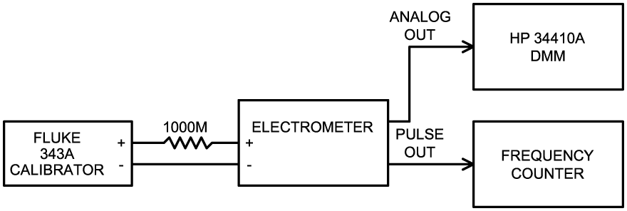
FIGURE 1

Connect the electrometer to a Fluke model 343A calibrator through a precision 1000 Meg .1% resistor or use a precision current source adjusted for 50 nanoamps.
Connect the pulse output to a frequency counter.
Set the calibrator to 50.25 volts or set the precision current source to 50 nanoamps.
Allow five minutes for the frequency to settle to the final value.
Adjust R3, the SCALE control, on the V/F converter for an output frequency of 50.00 Hz.
The calibration at this point is complete. The following steps may be done to validate the accuracy at ultra-low input currents.

Set up the test circuit in Figure 2 to do the ultra-low range validation:
FIGURE 2
Connect the pulse out from the electrometer to the AM Modulation input of the function generator. Set up the function generator for a 2 KHz sinewave output at 1 VRMS output level. Enable AM modulation on the function generator to gate the 2 KHz signal on and off with the electrometer pulse high/low periods.
Set the counter to pulse totalize mode and the triggering such that it counts only when the function generator output is at the higher level from the modulation.
Set the calibrator to .01005 volts or the precision current source to .01 nanoamps.
Short the input capacitor of the electrometer for 30 seconds.
Remove the short and allow the frequency to settle for five minutes.
Reset the counter to zero counts during a non-counting period.
Allow the counter to collect a sample burst of 2 KHz signal.
Observe that the counter accumulates 100,000 counts +-15,000 representing about a 100,000 millisecond (100 second) repetition rate.

TESTING and VERIFICATION of ACCURACY
The first test is for gross overload of the input circuit.
Input Tolerance for Damage and Inaccuracy
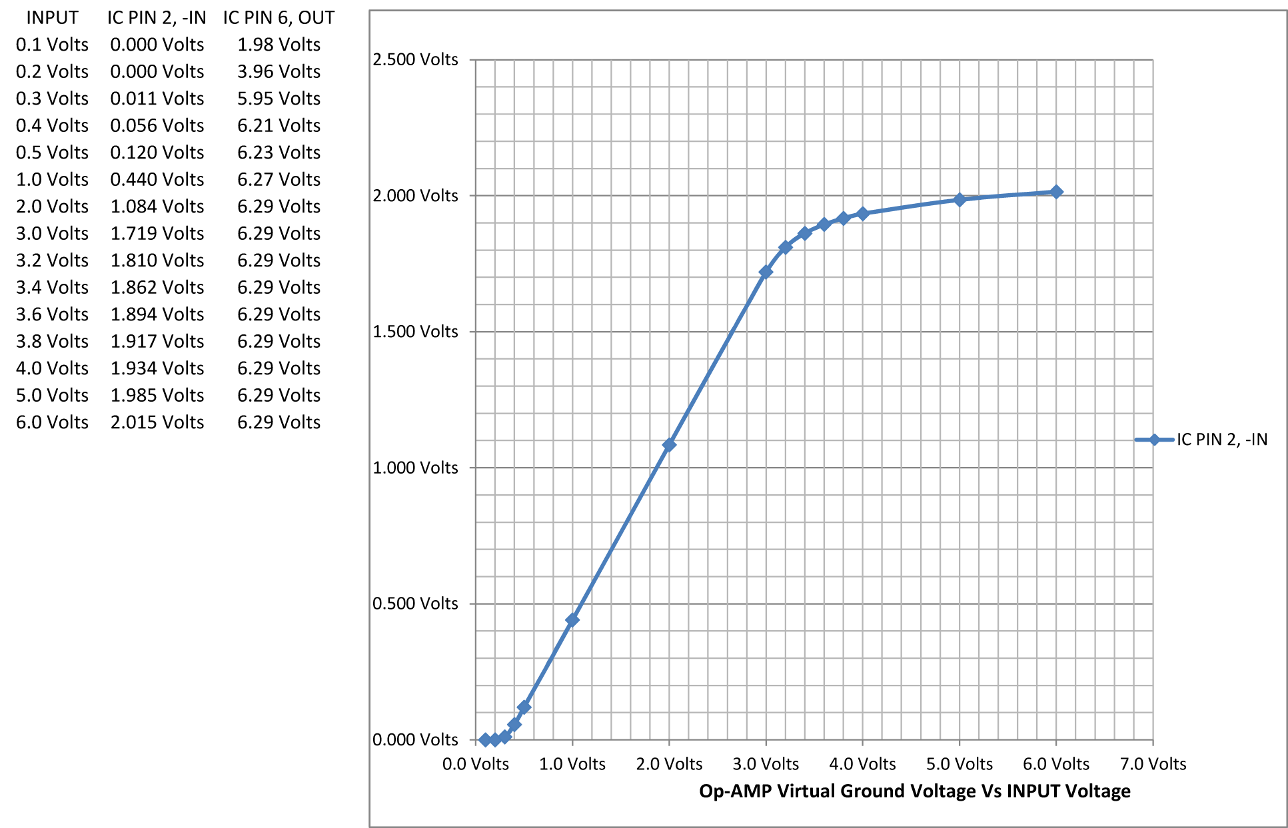
FIGURE 4

This test is performed with a precision voltage reference connected directly to the input connector of the electrometer with no external series resistor. The input voltages are set up in ascending order according to the chart and the voltages at the virtual ground (pin 2) and the output of the opamp (pin 6) are measured to assess the overload characteristics. The amplifier output voltage on pin 6 is limited to about 6 volts in order to prevent overscaling the Rad Safety MUX system. With the electrometer having a voltage gain of 20 from the combination of the 100 meg feedback resistor and the 5 meg input resistor, that point is reached with an input voltage of .3 volts. This corresponds to a charge of 1200 nanocoulombs using a 4 microfarad input capacitor. Above that voltage the amplifier output is in saturation and no longer able to maintain the virtual ground node on pin 2 at ground potential. It does however maintain a linear relationship between the input voltage and the virtual ground node until the input voltage reaches about 3.0 volts corresponding to about 12,000 nanocoulombs of charge. At this point the curve breaks rapidly downward indicating that the charge current is beginning to be diverted elsewhere other than through the feedback resistor. As a practical matter the error reaches about 1% at the 2500 nanocoulomb level and anything above that is problematic.

OVERALL RESPONSE TO LARGE INPUT, PULSE CHARGES
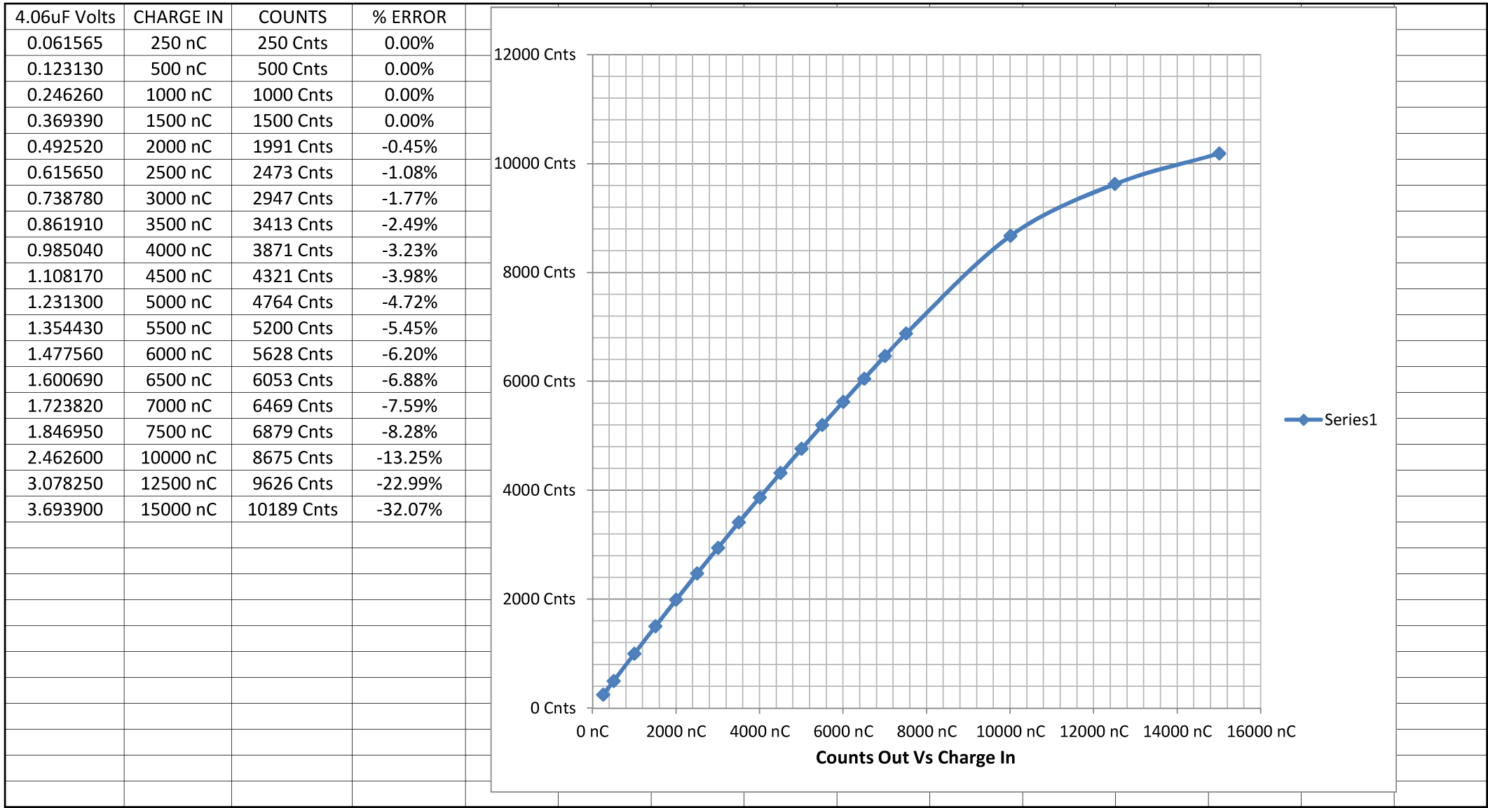
FIGURE 5

Figure 5 data was collected using the following circuit:

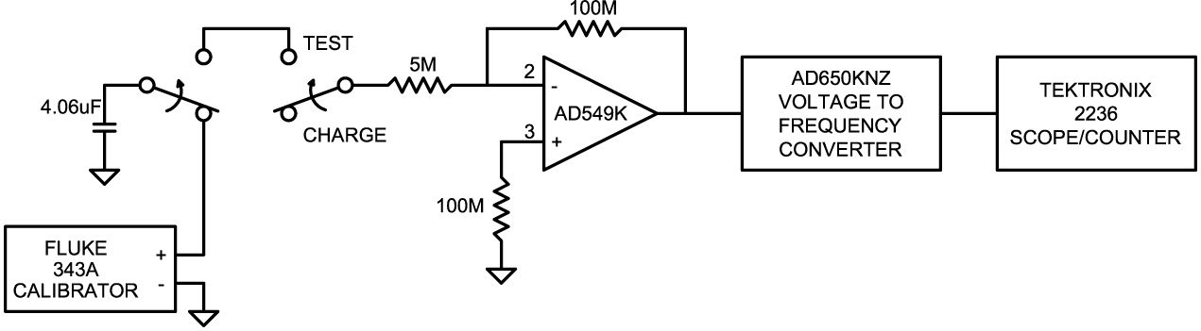
FIGURE 6

To assess the accuracy of the circuit for converting a fixed amount of stored charge into a digital value the circuit in Figure 6 is used. A 4.06 microfarad polypropylene capacitor is connected to a Fluke model 343A DC Voltage Calibrator and allowed to charge. A known amount of charge is stored in the capacitor using the formula:
$$Q=C*V$$
Where Q is the charge in Coulombs, C is the capacity in Farads and V is the voltage in volts. The input of the electrometer is open while the capacitor charges. To perform the measurement the capacitor is switched off of the reference supply and the electrometer input is switched to the charged capacitor. The charge stored in the capacitor is removed by the electrometer and counted out by the voltage to frequency converter. The pulse count is totaled as the capacitor discharges. When the capacitor voltage reaches zero the total counts are recorded and the test is repeated with a new value of charge.
As you can see from the chart, the curve has a slight downward slope over much of the test range above about 2000 nanocoulombs becoming worse with increasing charge. When the charge input reaches about 10,000 nanocoulombs there is a pronounced breakpoint where the slope drops. This is approaching the point where the virtual ground point voltage begins to droop with increasing input voltage as demonstrated in Figure 4. For this reason the circuit cannot be expected to report correct values of charge at these values unless the value of input capacitor value is increased in order to lower the voltage.
OVERALL RESPONSE TO NORMAL RANGE INPUT, PULSE CHARGES
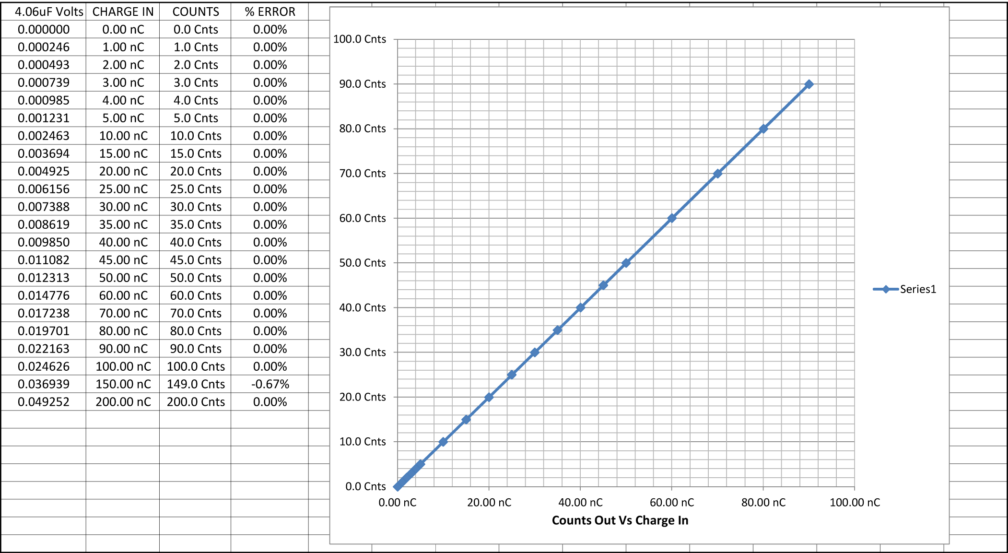
FIGURE 7
The chart in Figure 7 shows the pulse charge readings using the Figure 6 test circuit from 200 nanocoulombs down to the lowest pulse measurement level of 1 nanocoulomb. There is little to comment about the performance except that it is ruler flat and accurate. There is one point at 150 nanocoulombs that is one count low. Repeated tests at this level repeatedly show 149 counts. In the span of values ten times higher and more than ten times lower there is no deviation from calculated values and the reason for the deviation at one point is unknown.

OVERALL RESPONSE TO NORMAL RANGE INPUT, CONTINUOUS CHARGES

VERY LOW RANGE
Because the circuit is designed to produce only one pulse per nanocoulomb, the pulse charge test is only applicable down to the 1 nanocoulomb level. To measure the response of the circuit to charges of less than 1 nanocoulomb, it is necessary to apply a continuous current of 1 nanoamp or less over a period of time in order to build up enough charge to get a pulse response. To assess the accuracy of the circuit for converting a sub nanocoulomb charge into a continuous pulse train the circuit in Figure 8 is used.

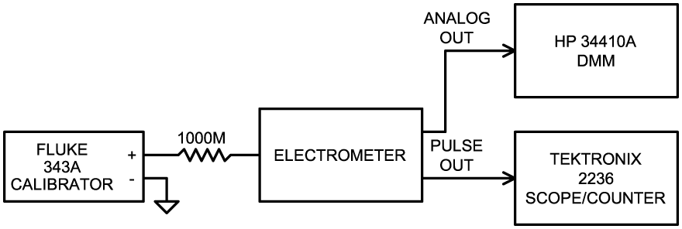
FIGURE 8

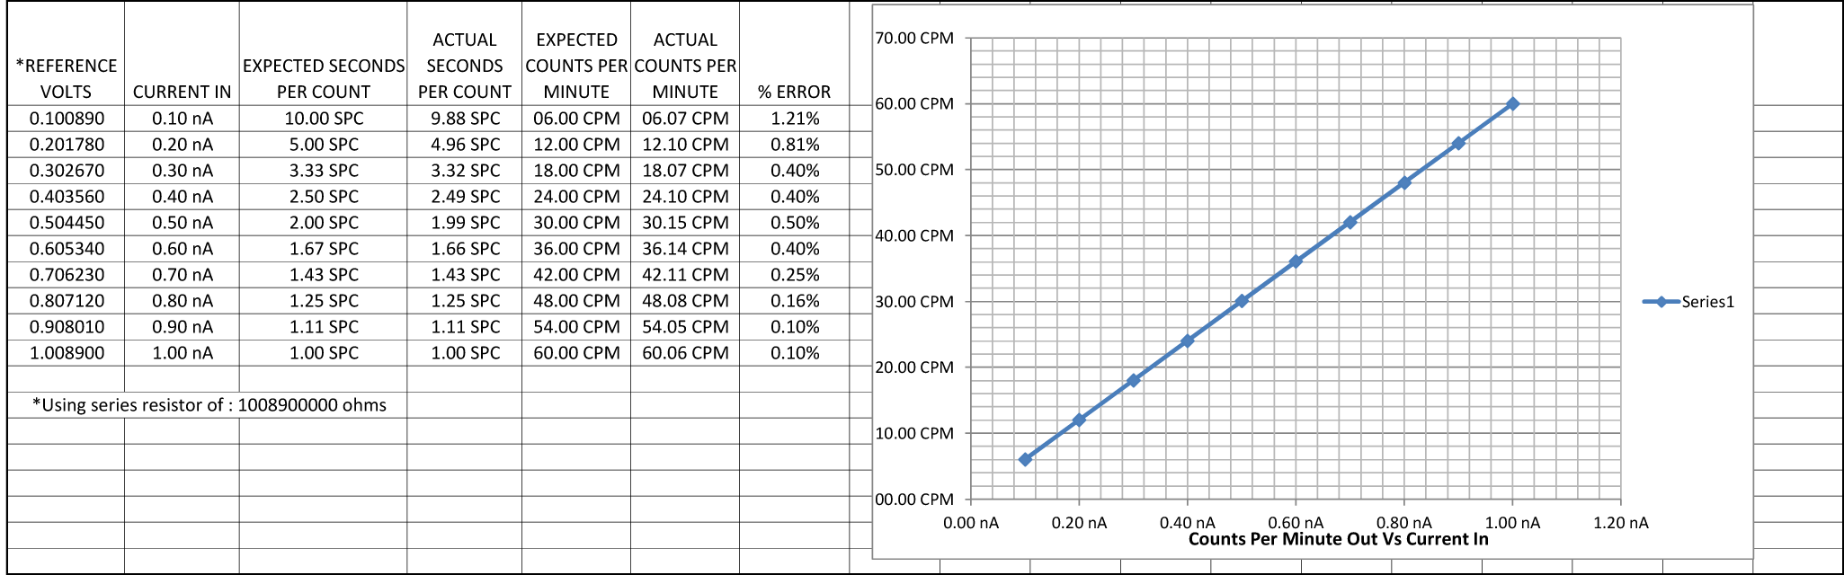
FIGURE 9
In Figure 9 we see the performance in the very low range from 1 nanoamp and lower. Because of the very low repetition rate the counter is set up in the Pulse Width mode to read the number of seconds per count rather than the number of counts per second. Even at this low level the percentage of error from the ideal is small.

ULTRA LOW RANGE
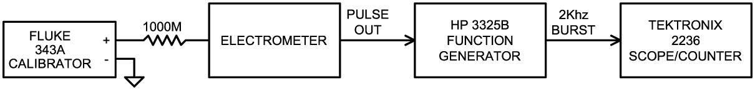
FIGURE 10
Finally we get to the Ultra Low Range where we are scraping the bottom of the charge barrel. Like the Very Low Range measurement we must measure seconds per pulse rather than pulses per second. Because of the very long delay times involved, my Tek scope / counter was unable to wait that long between pulses to display the width time. In order to make the ultra long time measurements I used the test setup shown in Figure 10. The internal 5 meg input resistor in the electrometer is taken into account in calculating the voltages required for the correct input currents.
The pulse output of the electrometer is used to gate the output of a Hewlett-Packard model 3325B digital function generator set up to provide 2000 Hz sine waves. The 2000 Hz output is gated on and off by the positive pulse output from the electrometer. The number of 2000 Hz cycles in the resulting gated burst is directly proportional to the amount of time that the pulse output is positive in milliseconds. Because the gate is positive for exactly half of the total repetition rate, a 2000 Hz signal is used to multiply the positive gate time by two. To measure the repetition rate in milliseconds the total number of 2000 Hz cycles for one positive excursion of the pulse output is counted on the Tektronix model 2236 scope / timer in the totalize mode and the number is recorded.

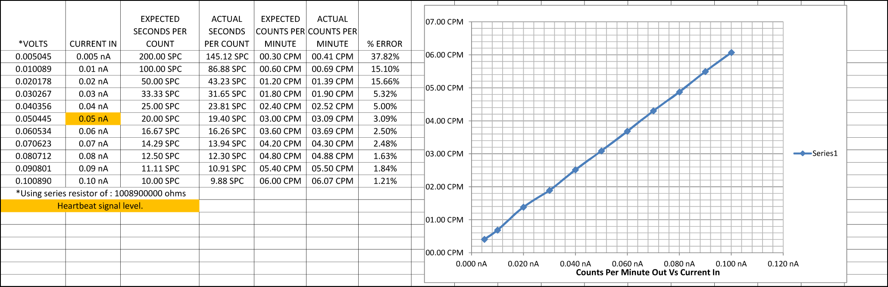
FIGURE 11
The Figure 11 chart shows a mild rise in the readings below the .1 nanoamp level. By the time the .02 level is reached the error is more than 15%. At this point the V/F converter is reading voltages below 1 millivolt and subject to noise, thermoelectric and drift effects, kluge card leakage and other factors in the entire chain. The accuracy would no doubt benefit from a carefully laid out circuit board and better shielding. At the .05 nanoamp level of the heartbeat, the error is not excessive and the circuit is able to report that and much lower amounts of charge reliably. Further tests and study will be necessary in the field to assess the actual performance in a real world detector situation.

References:
1. “Preliminary Test Results, Dynamic Range Requirements, and TLM Electrometer Requirements for Total Loss Monitor (TLM) Systems at Fermilab” A. Leveling, J. Anderson, P. Czarapata, October 5, 2012
http://www-muon.fnal.gov/Personnel/Leveling/TLMs.htm

2. Datasheet “Analog Devices Ultralow Input Bias Current Operational Amplifier AD549” Revision H, 2008

3. Datasheet “Analog Devices Integrated Circuit Voltage to Frequency Converter AD537”, Revision C, undated

4. Analog Devices MT-028 Tutorial, “Voltage-to-Frequency Converters” Walt Kester, James Bryant, 2009
http://www.analog.com/static/imported-files/tutorials/MT-028.pdf

5. Datasheet “Analog Devices Voltage to Frequency and Frequency to Voltage Converter AD650”, Revision E, 2013

6. AD650 Component Selection Calculator: http://designtools.analog.com/dt/v2f/ad650.html

7. Calibration Procedure for the LLM Electrometer Charge to Pulse Train Converter Circuit, Daniel Schoo, March 2013

