**Tomography And Related Diagnostics In Synchrotrons:**

**An Introduction**

Duncan Scott

Abstract

Tomography and Related Diagnostics in Synchrotrons, tardis[1], is an application that uses tomography to reconstruct the longitudinal phase space distribution from longitudinal charge profiles of the beam. The programme has many customizable features and is designed to run as a standalone application, in a batch mode, and an online mode, in which live data is taken and analysed. This note will give a brief introduction to using tardis in “*online mode*” through acnet, concentrating on the day to day monitoring of the beam.

1. **Introduction**

A qualitative introduction to the tomography algorithm used in tardis can be found here.[2] In the Main Injector (MI) and Recycler (RR) resistive wall current monitors (RWCM) detect the longitudinal charge profile of the beam. This signal can be digitized and recorded on a scope, located in MI60. The scope is triggered by a ‘*Trigger Box’* or ‘*Mountain Range Box*’ connected to the RF and situated by the scopes in MI60. Once digitized the signal is sent to tardis for analysis. tardis can also talk to the scope and trigger box to set their parameters, Figure 1 shows a schematic layout of the system.



RWCM

in tunnel

Digitizer

Trigger Box

RF

TARDIS

Figure : schematic of tomography set-up.

1. **tardis start-up and loading a default set-up**

tardis can be started through acnet from page i122. After loading the main window or front page, shown in Figure 2, is displayed: the layout of the plots is configurable so may change, but the menu, button and status bars and tabbed canvases are fixed.

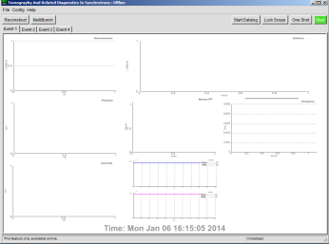

Menu Bar

Tabbed Canvases

Status Bar

Plot Canvas

(Configurable)

Button Bar

Figure : TARDIS Front Page on Startup.

To load a default (canned) setup choose File → Load / Save Current Setup, initializing a pop-up window. From this window most of the parameters used by tardis can be set (from values in the entry boxes). Current values are read and displayed in the text boxes with black background (pressing “READ” will re-read current parameters and update the text boxes).

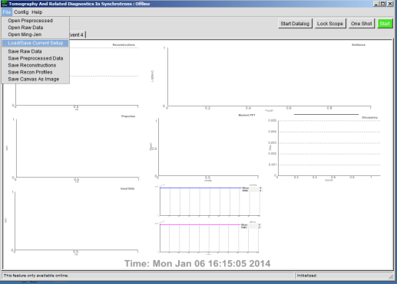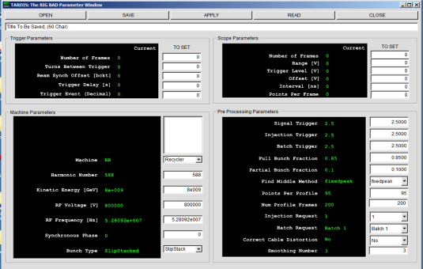

Figure : Figure : TARDIS load/save default set-up window.

After opening a file the entry boxes are updated to the values in the file[3], clicking APPLY will send the entry box values for tardis to try and apply. The top two group boxes, “*Trigger Parameters*” and “*Scope Parameters*” are for hardware and so may not get set correctly. The “*Machine Parameters*” and “*Pre-Processing Parameters*” are software parameters and should always set correct. After tardis tries to apply the set-up it re-reads the current state and updates the text boxes, any parameters that do not match the entry box will now be displayed red, correctly set parameters will be green. For well used set-ups this should be all the configuring that is required and the window can be closed. The parameter most likely to need changing is the RF voltage, it can be checked with I:RFSUM, note the value at the “Trigger Delay [s]” time should be used.

1. **Taking data and reconstructing**

Once back on the main page a “One Shot” can be tried to test if everything is working. This runs through a complete cycle:

* Data acquisition
* Pre-processing raw data
* Tomography
* Displaying results to the front page
* Data logging (if selected).

For a single batch at injection a cycle should take between 20 and 30 seconds. A typical result for Batch 1 at Injection for $23 event is shown in Figure 5. If the front page does not update then something failed during that cycle, following the status messages in the lower left hand corner may help diagnose the issue. If the results seem reasonable the “Start Datalog” button can be pressed and then the green “Start” button to enter continuous looping.

Fraction of Bunch Within Energy Contours

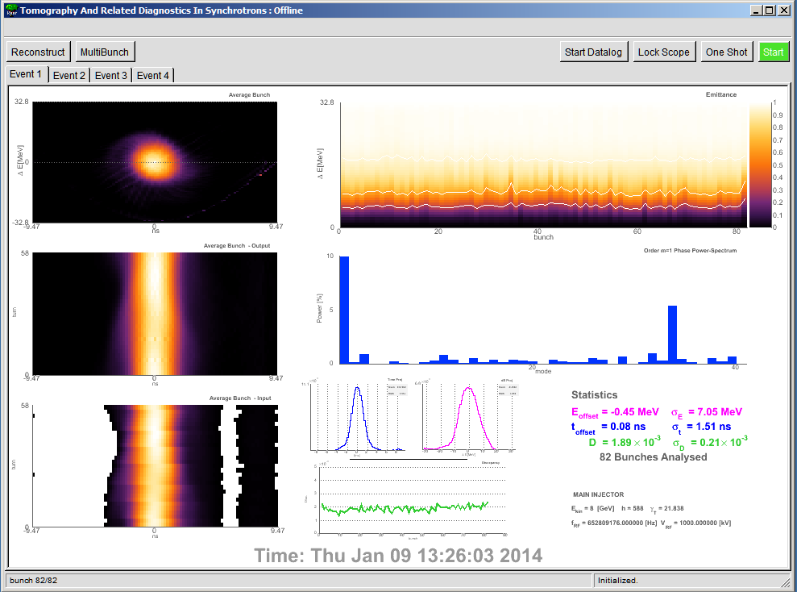

Average Bunch and Discrepancy Stats, Machine parameters

Coupled Bunch Mode Power Spectrum (Dipole Mode)

Tomography Discrepancy

Energy and Time Projection of Average bunch

Average Bunch Profiles (reconstructed data)

Average Bunch Profiles (input data)

Average bunch reconstruction

Figure : Example TARDIS results.

1. **Continuous looping**

Once looping tardis keeps repeating its cycle. There are 4 event tabs on the front page and these each hold different data sets. It is possible to save and re-analyse any of the current datasets. After the four tabs have data the programme cycles back to the first tab and that dataset is overwritten. If you want to change parameters, unlock the scope, look at some interesting data in a tab, stop continuous acquisition etc. click “Stop” and wait. Due to the different phases of the algorithm tardis does not stop instantly. When out of loop the red “Stop” button while turn green and display “Start.”

1. **Common Issues**

The interaction between the CERN Root libraries, acnet, and console operating system windows manager can sometimes be fragile, too many rapid button clicks, especially during window initialization, updates and resizing can cause crashes.

Many of the parameters can be set in multiple pop-up windows so be careful to avoid cross-talk.

**Scope-Lock**

Only one acnet application can have control of the scope. If tardis has the scope the front page button changes color and text. Locks are based on an honor system and can be viewed in D60:LockPeeker.



**Failed During Data Acquisition**

Was there any beam? tardis does not know a priori if there was beam present, it makes this decision during the pre-processing phase. Whilst looping if there is no beam tardis will keep blindly asking the scope for new data and try and process it, this is the standard behavior and expected. If you know there was beam and tardis still failed during data acquisition then some setting up of the DAQ will be required. For well used set-ups that normally work there are two likely things to check:

* **Has the beam intensity significantly changed?** If so then the scope range, offsets and pre-processing triggers may need to be optimised to avoid signal clipping, improve signal to noise and enable tardis to find the requested batch from the raw data.
* **Beam Synchronization Offset Jitter.** The Trigger Box triggers the scope based on the beam synch offset signal, jitters have been observed somewhere in this system (probably in the trigger box hardware). It may be necessary to change the Trigger Box Beam Synchronization Offset so the scope records data for the requested batch over the correct time period.

**Tomography Discrepancy is Too High**

The discrepancy measures the difference between the raw data and the reconstruction. The mean value ‘*D*’ is shown in the stats box, the graph shows D for each bunch. Values below 0.002 with little spread are desired, however the transition from good to bad is a judgment call. It is very possible to have reasonable looking reconstructions with incorrect input parameters that give low(ish) D. Setting known parameters to correct values, such as RF voltage etc. is important and should help mitigate this.

1. **Conclusions**

This is a very simple introduction to getting the application running with default parameters. See the advanced guide for more information on how the programme works and how to make changes. Even if an instance of TARDIS is running with the scope locked other versions can be opened to look at saved data, other machines and general learning.

1. Following the naming tradition of i121: Flash Gordon
2. D. J. Scott “Introduction to Longitudinal Phase Space Tomography” Beams-doc-4503
3. The entry boxes values can also be manually changed.