From: Dave Capista (AD/MI)
Date: April 17, 2014
MI Pond F Temperatures

Attached is a plot (Figure 1) of the pond water temperature at the inlet to the heat exchanger at MI10, which is fed from pond F. Also included are the solar input power and the MI magnet power so that one can see when the machine was on and off. Some of the temperature readings at the end of the plot look a bit strange; I believe we had the pond pump off during this time and the sensor was just reading the building temperature as a result.
The set point for MI LCW supply temperature is 90degF. There is about a 7deg dT between the pond temperature and the LCW supply temperature, thus pond temps above 83degF will cause the system to be out of regulation.
The original design temperature for this system was 95degF. We lowered the temperature to 90degF to save power, but understand that we cannot maintain this temperature during the summer.
I usually get concerned when the supply temperature goes over 100degF. The problem with hot water is the aging of the power supplies. Magnets are OK. I do not really know where the reliability of the supplies will suffer. EE support will talk about it but probably cannot give a good answer either. We have used the 100F as a safe value, however, I am concerned that if we continue to run power supplies at higher temperatures, it will be globally to the entire ring, thus eventually creating a large-scale problem.
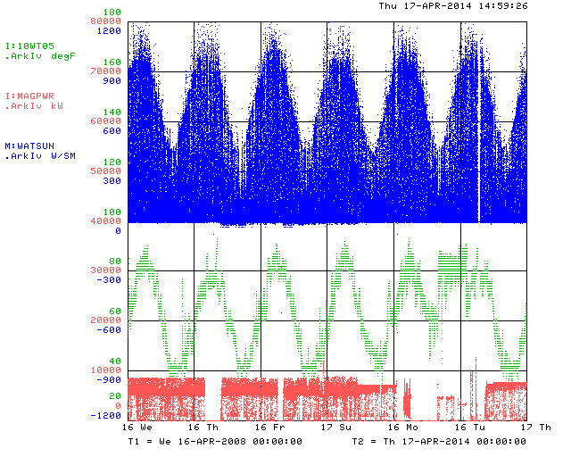
Figure 1: The MI Pond F water temperature (green, degF), the MI magnet power (red, kW), and the average solar power input (blue, W/sq.m) as a function of time (1 year/div).

