

**Fermilab**

**February 11, 2013**

***Rev 1 October 24, 2013***

**To: Bill Pellico and Dan Wolff**

**From: George Krafczyk**

**Subject: Booster Gradient Magnet/Choke Measurements**

Measurements were performed on both a Booster gradient magnet and a Booster choke with the intent to compare the **15 Hz** losses with the **20 Hz** losses for a proposed Booster upgrade.

This analysis suggests that running the booster at **20 Hz** with a current equal to the present **15 Hz Booster** will require about **3.9%** more power. Capacitor voltage will increase by about **32%** and the resonant capacitor at each **“Girder”** must decrease from **~8.33 mF** to **~4.69 mF.** This also carries the implication that the **RMS current per µF** will also **increase** as well.

If further consideration of the frequency increase is anticipated, it is recommended to put together a representative **“Girder”** and drive it at Booster operational currents and make a definitive loss measurement.

**Inductor AC Loss Measurement:**

The test setup used for this measurement is given in **Figure 1** on **Page 2**. The capacitor bank is driven from a variable frequency voltage source. The source is tuned in frequency until the current from the power source is in phase with the capacitor bank voltage. The power loss at the resonant frequency is then the power delivered from the power source.

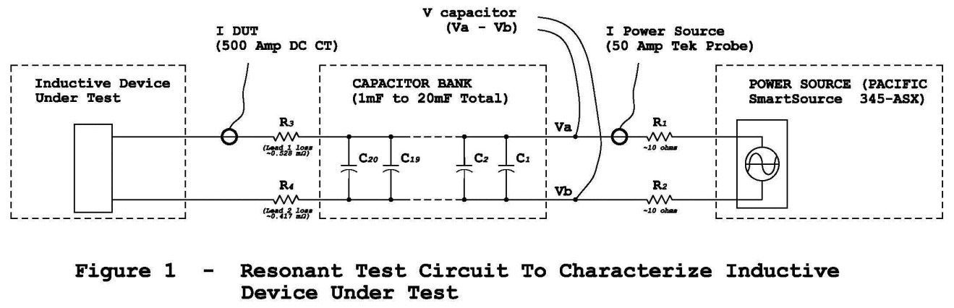

**Gradient Magnet AC Loss Measurement:**

For the gradient magnet five points were taken with **1, 2, 4, 6** and **10** capacitors *(generally about 1µF per capacitor)*. This data is presented in **Figure 2** below.

|  |
| --- |
|  |
| **Figure 2** |

The measurements indicate that the losses at **75 Amps_rms** will increase from **~119 watts @ 15 Hz** to **~138.4 watts @ 20 Hz**. The measurement has a combination of core losses and copper losses. A skin depth calculation **(See Appendix A, Page 8)** indicates that the copper loss increase from **15 Hz** to **20 Hz** will be minimal.

This measurement is used to produce a **SPICE** model that will be used in the **“Girder”** simulations. The **SPICE** model is given in **Figure 3** below. A spice run was taken at **75 Amps_RMS** for each of the frequencies and is also ploted in **Figure 2**.

|  |
| --- |
|  |

Looking at these model parameters the DC resistance of the magnet is **13.85 mohms** which indicates that there is another **4.5 mohms** of loss associated with **I_rms** (series current). At least **1 mohm** is associated with the wiring from capacitor bank to the device under test. I will consider this a parasitic and not remove it from my **“Girder”** simulation.

An earlier **15 Hz** simulation shown in **Appendix C,** **Page 10** predicts **~120 watts** dissipation at **15 Hz & 75 Amps_rms** when driving **1 gradient magnet**. This compares favorably with the measurements made (**Figure 2**) and the above **SPICE** model (**Figure 3**).

Matching measurements at higher frequency required a larger resistance across the inductor (lower core loss) and a larger series resistance (higher copper loss). These changes are reflected in the **SPICE** model of **Figure 3**.

**Choke Loss:**

For the choke, three points were taken with **1, 1.5** and **2.5** capacitors. This data is presented at **30 Amps_rms** in **Figure 4**. The reduced current set of measurements is the result of the larger inductance of the choke. The inductance is about twice that of the Booster gradient magnet.

The choke measurements predict that the losses will increase from **~55.5 watts @ 15 Hz** to **~70.2 watts @ 20 Hz**.

|  |
| --- |
|  |
| **Figure 4** |

|  |
| --- |
|  |

The end result is given in **Figure 5,** for a **SPICE** model of the choke. This model will be used in **“Girder”** simulations at **15 Hz, 20 Hz** and **25 Hz**.

The DC resistance of the choke is **26.1 mohms.** Again, this is about **10 mohms** less than the best fit for the model series resistance.

As with the gradient magnet model, the choke model requires a bit more series losses and a smaller parallel loss to match **15 Hz, 20 Hz** and **25 Hz** loss measurements.

**“Girder” Simulation:**

The **“Girder” SPICE Model** is given below in **Figure 6**. This model was driven with the Booster current. **C_Resonant** was varied such that the resonant frequency was **15, 20** and **25 Hz** in the simulation**.**

|  |
| --- |
|  |

**Table 1** on the next page has various parameters listed. In going from **15 Hz** operation to **20 Hz** operation the model predicts an increase in power dissipation for the **“Girder”** of **3.9%**. The **“Girder”** drive voltage has increased by about **9.2 Volts_pk-pk**. *(from* ***50.2 Volts_pk-pk*** *to* ***59.4 Volts_pk-pk****)*

Capacitor voltage has increased by about **32%** to **+1135/-1096 volts. RMS** current in the **magnets, choke** and **capacitors** is unchanged.

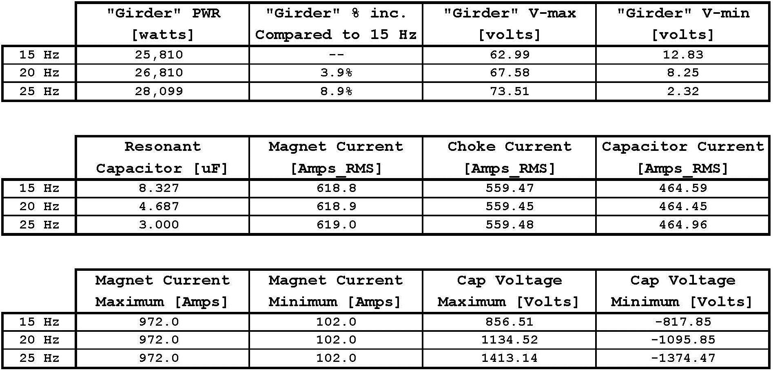

**Table 1 – Assorted “Girder” Data from Spice Model**

**Booster Power Supply #1 Measurement:**

In an attempt to validate this **SPICE** simulation with the existing **Booster Power Supplies**, **Voltage to Ground** data was supplied for **Booster Power Supply #1**. An equation was fit to both the positive terminal to ground voltage and the negative terminal to ground voltage. The data is given in **Figure 7** on the next page. The signals are taken from the magnet side of the power supply filter . A difference voltage was produced from this fit data.

Assuming the booster current is in phase with this voltage data, the energy out of the supply was calculated. Since each power supply drives **12 “Girders”** the power per girder was determined to be **26,600 Watts**. This compares well to the model loss of **25,810 Watts** at **15 Hz**.

|  |
| --- |
|  |
| **Figure 7** |

**Appendix A**

**Copper Skin Depth Calculation:**

The skin depth as a function of frequency is given by the equation:



For copper:

**Meter**

So, at **15 Hz,  cm, 0.67 inch,**

at **20 Hz,  cm, 0.58 inch and,**

at **25 Hz,  cm, 0.52 inch.**

The magnet is constructed with square copper wire **0.45 in** on a side and a **0.25 in** hole for water cooling. Since the skin depths at **15 Hz** and **20 Hz** are both greater than the copper bus, the increase in eddy current losses should be minimal.

**Appendix B**

**Booster RMS Current Calculation:**

|  |
| --- |
|  |
| **Figure 8** |

RMS current of an offset sine wave as displayed in **Figure 8** at the right is:

**I_rms = sqrt{A*A + B*B/2}**

Where: A = I_dc

B = I_pk

Maximum current is ***I_dc + I_pk*** and minimum current is ***I_dc – I_pk***.

The present booster has an **I_dc of 537 Amps** and a **I pk-pk of 870 Amps**. (**A = 537 Amps and B = 870/2 = 435 Amps**)

With these parameters **I_rms = 619 Amps_rms, I_max = 972 Amps** and **I_min = 102 Amps**.

**Appendix C**

|  |
| --- |
|  |
| **Figure 9** |