1.3 GHz 8 Channel Receiver with Single Channel Transmitter for Fermilab’s NML Test Facility
Brian Chase, Ed Cullerton, Uros Mavric
This paper describes the 1.3 GHz receiver used at Fermilab’s NML accelerator facility. The unit has 8 channels of down conversion and a single transmitter. The down-converted IF output frequency is 13 MHz, and the LO frequency is 1.313 GHz. The unit has an RF to IF conversion gain of- 4 dB, with a 1 dB compression point at the RF input of +12.5 dBm. The channel to channel isolation is better than 70 dB for any adjacent channels and better than 80 dB for all other channels. The transmitter uses modulated I and Q inputs at 13 MHz to generate a modulated RF output at the 1.3 GHz. The transmitter is capable of an RF output level of +15 dBm, and there is a TTL RF switch on the output of the transmitter. The power requirements of the unit is +6V@1.7 A and -6V@100 mA. The unit is housed in a 1U rackmount chassis.
Figure 1 is a functional diagram of the 8 channel receiver and transmitter. The LO input, LO monitor, IF I and Q inputs, and the RF gate are front panel SMA connectors. The IF outputs and IF monitors are a Harting gang of 8 coaxial connectors on the front panel. The RF inputs and the transmitter RF Output are rear panel type-N connectors, and the RF input monitors and the transmitter RF Output monitors are rear panel SMA connectors. Pictures of the rackmount unit are shown in figures 2 and 3.
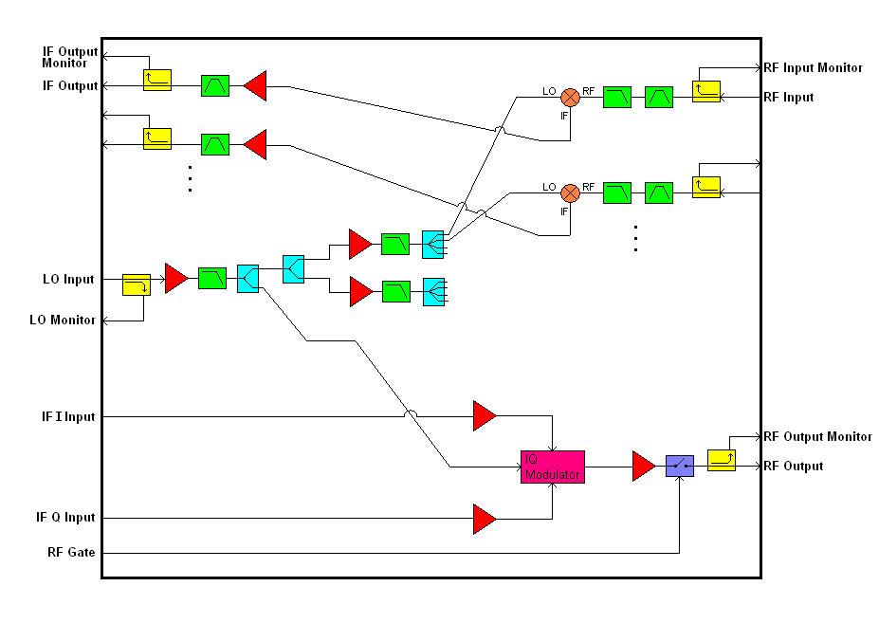
Figure 1. Block diagram of the 8 channel receiver.
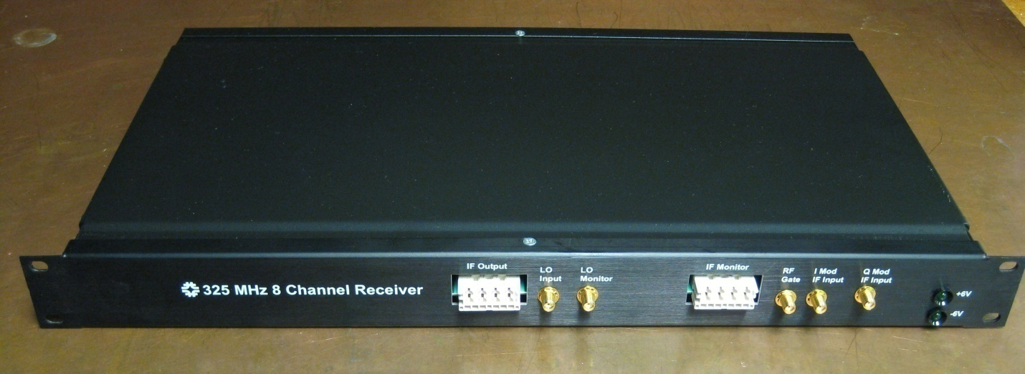
Figure 2. Picture of the front side of the receiver.

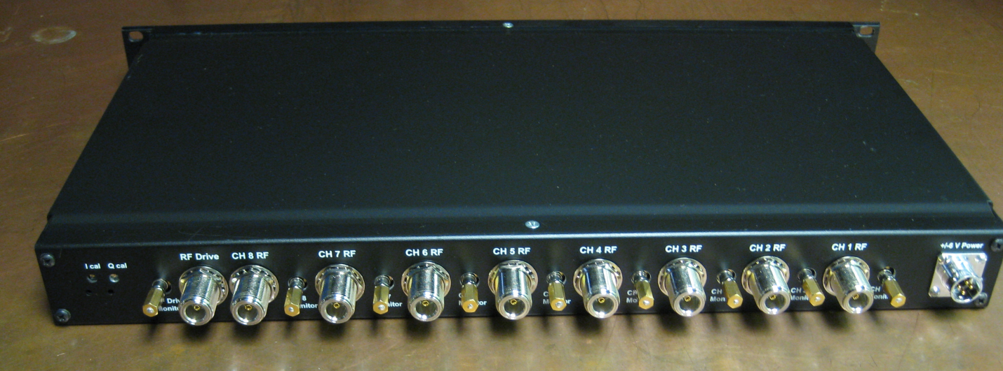
Figure 3. Picture of the backside of the receiver.
Downconverter Conversion Gain Measurements
The conversion gain of the receivers is about -4 dB. A plot of the conversion gain for the receiver is shown in figure 4. As seen in figure 4, the receiver was designed to have a maximum RF input of +10 dBm, for a maximum IF output of +6 dBm. Also seen is the 1 dB compression point of about +12.5 dBm. The channel to channel variation is less than 0.5 dB

Figure 4. 1.3GHz receiver conversion gain measurements.

Downconverter Noise Figure
The noise figure of the downconverter is calculated to be 21.3 dB, and was verified using the “gain“ method of measuring noise figure. A diagram of the signal path is shown in figure 5, and a diagram of the measurement setup is shown in figure 6. The measurement uses a spectrum analyzer to measure the noise figure at the output of the downconverter with a 50 Ohm load on the input. An amplifier was added at the output to increase the gain so that the signal could be measured by the spectrum analyzer. The additional amplifier (mini-circuits ZFL-500) increases the noise figure by 0.5 dB, and this can be calibrated out of the measurement. The requirement of the downconverter is that the noise output be less than the noise floor of the analog to digital converters, which is -147 dBm. The noise floor of the cavity signal is -174 dBm, and with a noise figure of 21.3 dB, the IF output noise floor of -152.7 dBm. This exceeds the requirement of -147 dBm by 5.7 dB.
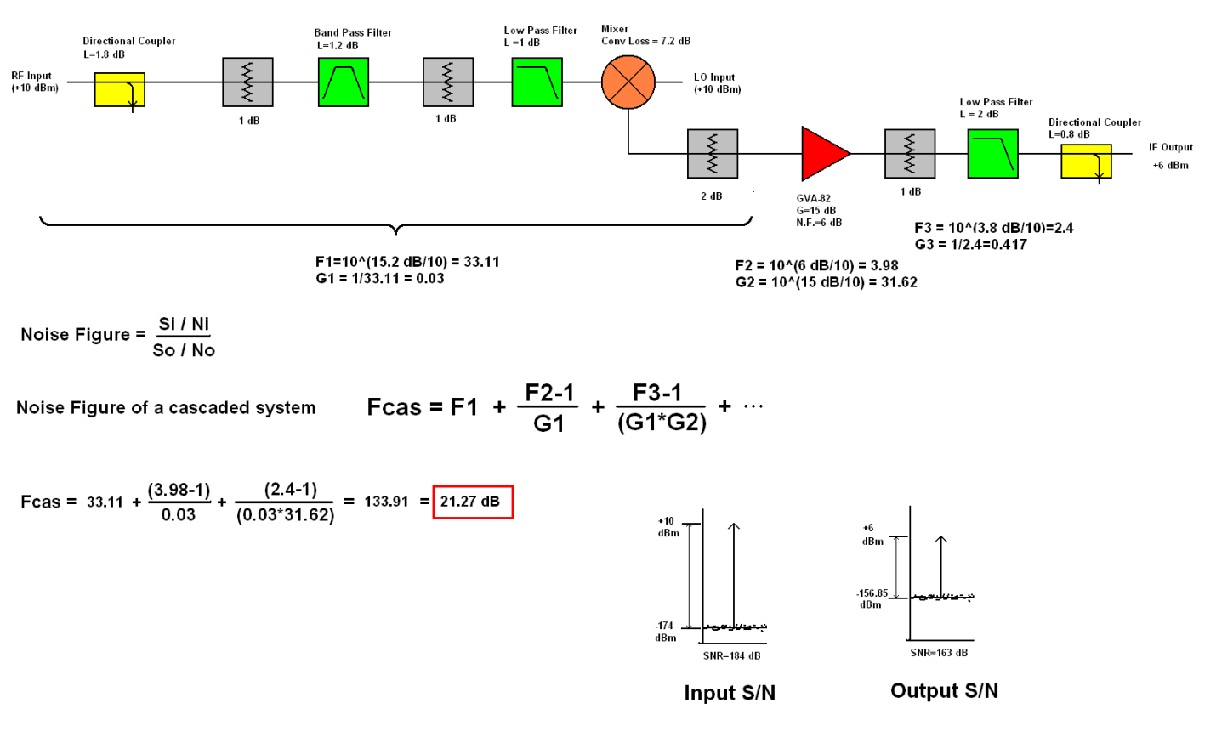
Figure 5. Down converter noise figure calculation.

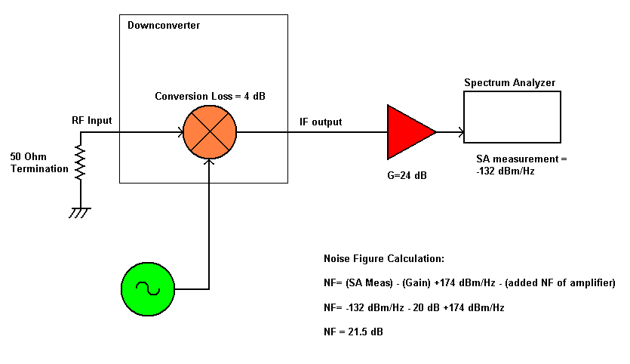
Figure 6. Noise figure measurement.

Transmitter Conversion Gain Measurements
A plot of the transmitter RF output vs. IF input is show in figure 7. The IF input is 13MHz I and Q signals. There are two potentiometer adjustments on the rear panel for adjusting carrier suppression. Stable carrier suppression is typically better than 50 dB. Figure 8 shows a spectrum analyzer plot for the 1.3 GHz RF output.

Figure 7. 1.3GHz Transmitter Conversion Gain Measurement.
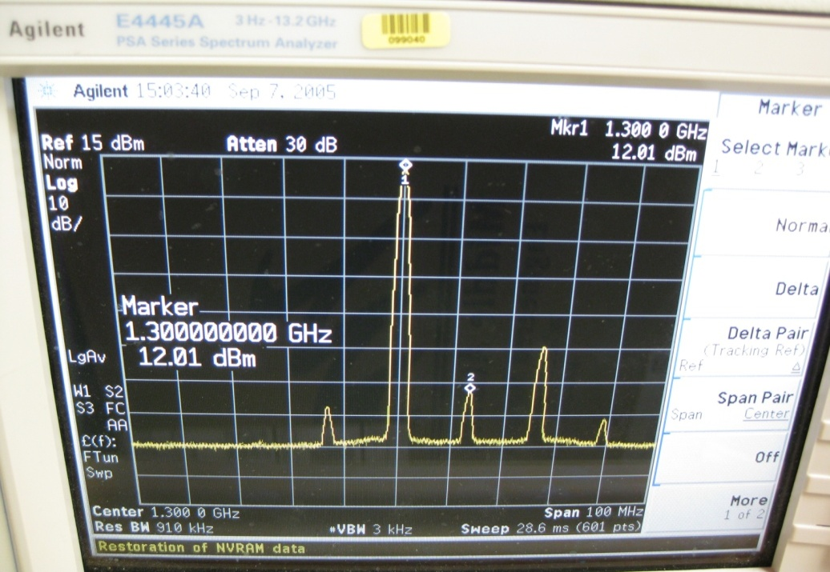
Figure 8. RF Output of the 1.3 GHZ Transmitter.
Transmitter Output Noise Power
The transmitter output noise power can be calculated from the components data sheets. A block diagram of the transmitter section is shown in figure 9 with associated gains and noise figures. As seen in the figure, the calculated noise power at the output is -137.5 dBm/sqrt(Hz). The measured noise power at the output is -138 dBm/Hz and is shown in figure 10.
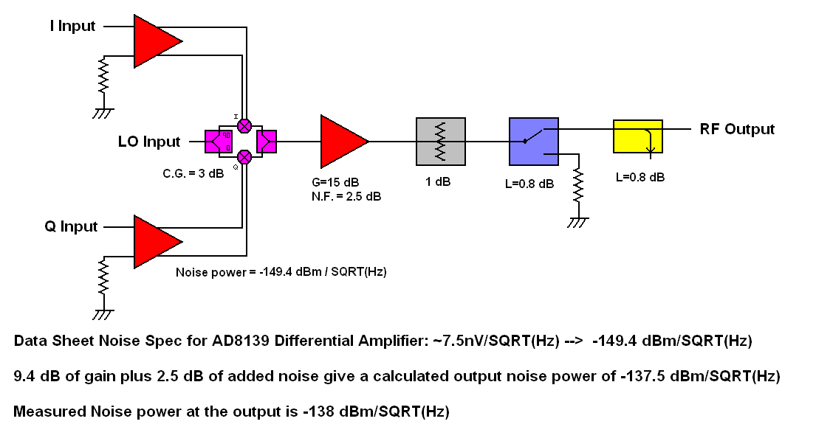
Figure 9. Calculated noise power at the output of the transmitter.

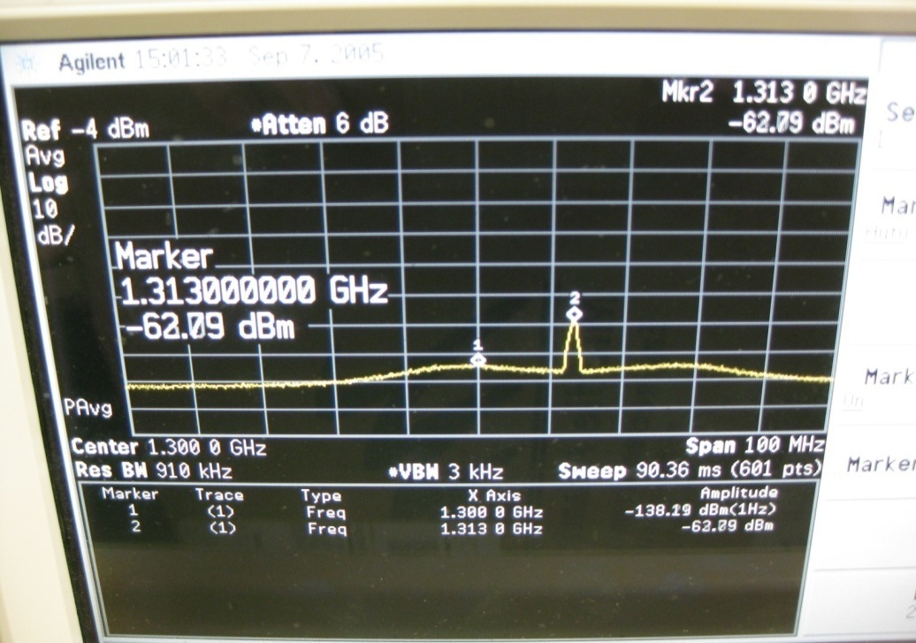
Figure 10. Noise output of the 1.3GHz Transmitter (-138 dBm @ 1.3GHz).

Upper sideband suppression can be improved with adjustment to the I and Q phase if desired. Figure 11 shows the upper sideband suppression after tweaking the I and Q phase.

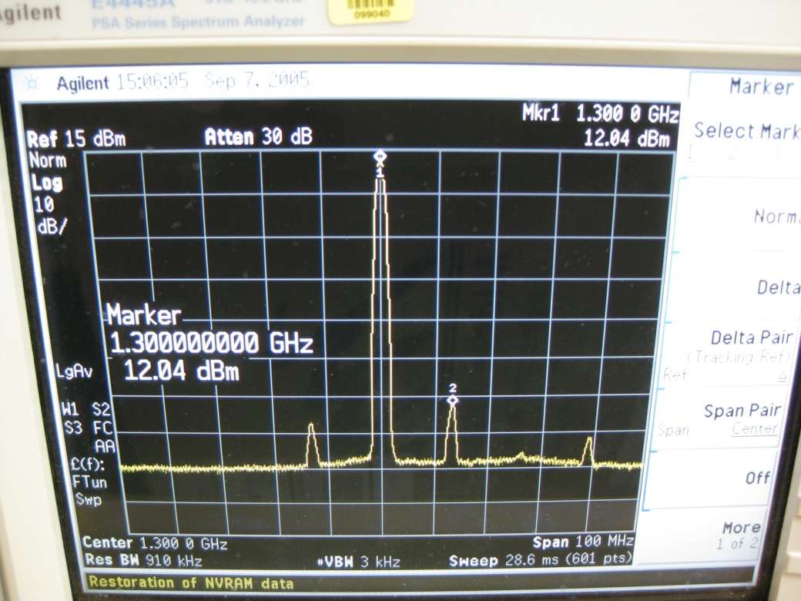
Figure 11. Upper sideband suppression of the 1.3GHz Transmitter.

Signal Monitors
The RF Input signal monitors are SMA connectors on the rear panel. The monitor signal comes from a 10 dB coupler on the RF input. The measured coupling is about 11.7 dB down from the RF input. The IF monitors are the 8-gang coaxial Harting connector on the front panel. The measured coupling is about 9.8 dB from the IF Output. The LO signal monitor is a SMA connector of the front panel. The signal level is about -11.1 dB from the LO input. The RF Drive signal monitor is a SMA connector of the rear panel. The signal level is about -10.5 dB from the RF drive for the 1.3 GHz Unit. These numbers may vary +/- 1 dB from unit to unit, so individual data sheets should be referred to for exact numbers.

Temperature Stability
Temperature stability measurements have been made for the downconverter and transmitter. The downconverter test setup is shown is figure 12, and the transmitter test setup is shown in figure 13. At room temperature, and with the unit powered up, the temperature of the unit is about 90 degrees F. The temperature of the oven was ramped up to 105 degrees F, and the downconverter phase drift was about +1 degrees, and the amplitude drift was about -0.12 dB. That is a phase stability of about 0.07 degrees/ degree F, and an amplitude stability of about 0.008 dB/ degree F. The same test was done with the transmitter. The phase drift was about 0.9 degrees, and the amplitude drift was about 0.05 dB. That is a phase stability of about 0.06 degrees/ degree F, and an amplitude stability of about 0.003 dB/ degree F.
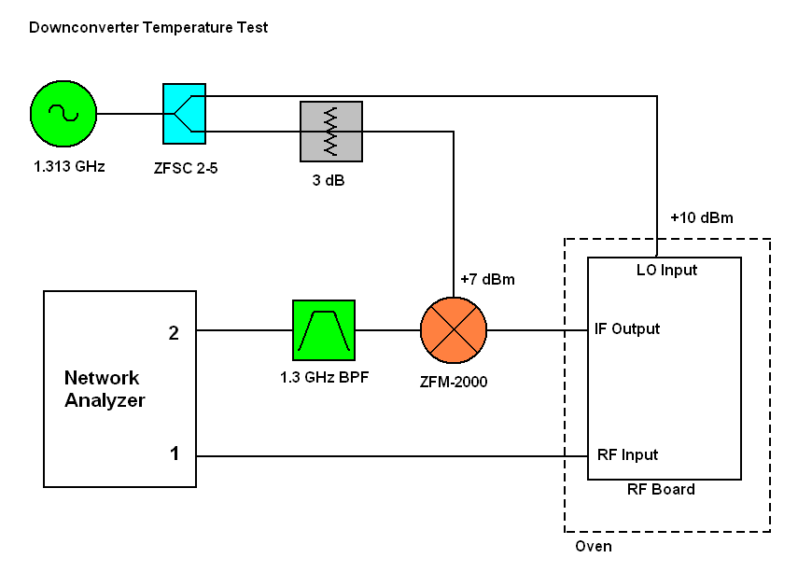

Figure 12. Downconverter temperature stability test set-up.

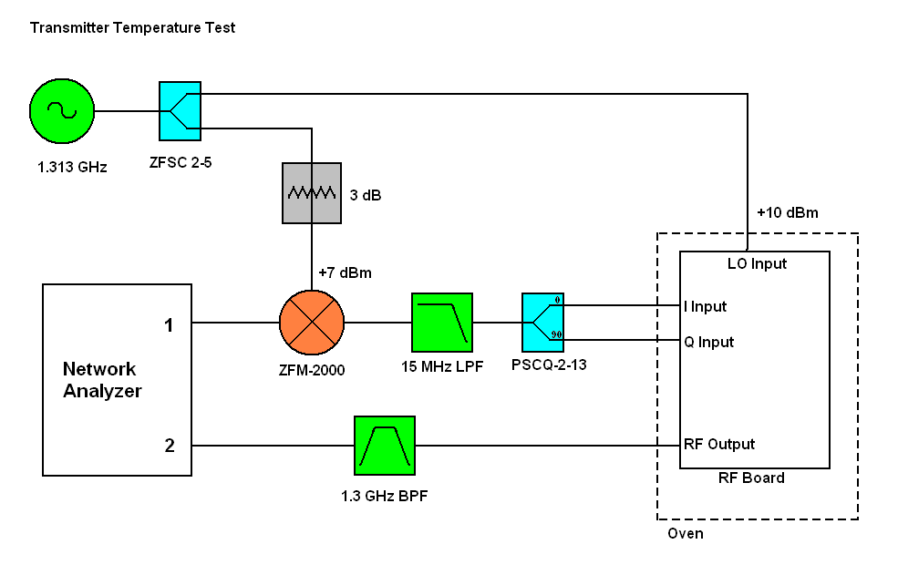
Figure 13. Transmitter temperature stability test set up.
Channel to Channel Isolation
Below in figure 14, the channel to channel isolation matrix for a typical receiver is shown. The RF input power for each measurement is +4 dBm. As seen in the figure, the worst case is the adjacent channels, with 72 dB the worst case.
RF Input Channel | ----------------------------------IF OUTPUT (dBm)---------------------------------
(+4 dBm) | ch1 | ch2 | ch3 | ch4 | ch5 | ch6 | ch7 | ch8
ch1 | 0.4 | -80 | -84 | -85 | -90 | -87 | -89 | -84
ch2 | -82 | 0.14 | -84 | -86 | -89 | -85 | -98 | -94
ch3 | -83 | -85 | 0.46 | -79 | -94 | -98 | -87 | -85
ch4 | -84 | -76 | -79 | 0.77 | -93 | -89 | -83 | -90
ch5 | -87 | -82 | -85 | -72 | 0.23 | -80 | -79 | -83
ch6 | -82 | -84 | -91 | -91 | -89 | 0.07 | -88 | -96
ch7 | -88 | -97 | -93 | -82 | -88 | -82 | -0.24 | -86
ch8 | -90 | -84 | -91 | -96 | -83 | -78 | -78 | -0.18

Figure 14. Channel to channel isolation matrix.

