Superconducting Cavity Model and Simulation for Fermilab’s NML Test Facility
Ed Cullerton, Brian Chase, Julien Branlard
Fermilab Accelerator Division/Low Level RF
A model has been developed for the superconducting cavities at Fermilab’s NML test facility. The model was developed using Agilent’s ADS simulation software. The model includes Lorentz force detuning, beam loading, directional coupler directivity, and non-ideal RF effects of the waveguide distribution components. The progression of the this paper will start with a simple RLC cavity model, then continue on to add more features to better model the real world system.
- Cavity Model
A simple circuit model of the cavity is shown in figure 1. The model uses a parallel RLC circuit with a transformer to couple power into the cavity. The model shown in figure 1 is generated using Agilent’s ADS, and can simulate S11 of the cavity. The equations for the cavity parameters are:
$R_{cav}=\frac{1}{2}\frac{R}{Q}Q_{0}$ ( 1 )
$L_{cav}=\frac{1}{2}\frac{R}{Q}\frac{1}{w_{0}}$ ( 2 )
$C_{cav}=\frac{1}{\frac{1}{2}\frac{R}{Q}w_{0}}$ ( 3 )
$T_{cav}= \sqrt{\frac{R_{cav}}{Z_{0}β}}$ ( 4 )
where,
$\frac{R}{Q}=1036 Ω$
$w_{0}=2*π*1.3e^{9}$
$Q_{0}=2e^{10}$
$β=\frac{Q_{0}}{Q_{L}}-1$
$Z_{0}=50 Ω$
$Q_{L}=3e^{6}$
Simulation results for S11 of the cavity are shown in figure 2. Figure 2 also shows the calculated cavity parameters values. The resonant frequency of the cavity is clear from the simulation results, and the large over-coupling is also clear from the results.
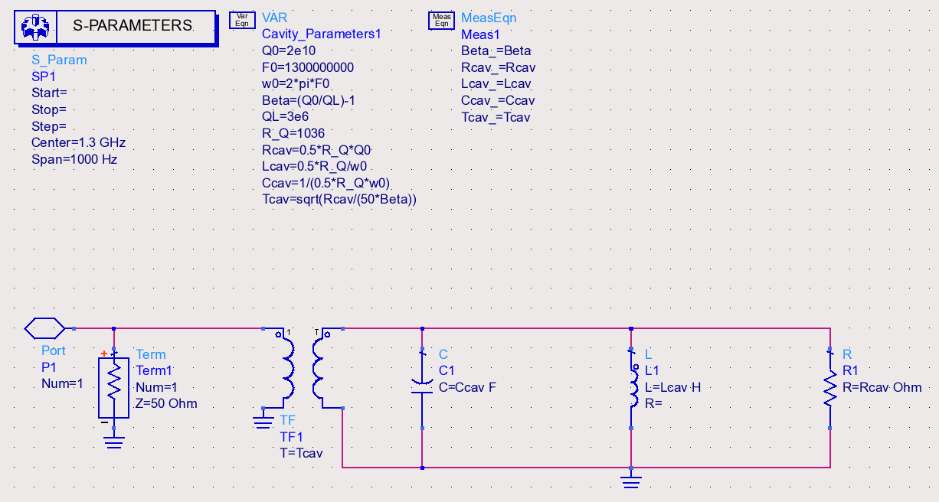
Figure 1. Simple RLC cavity model.
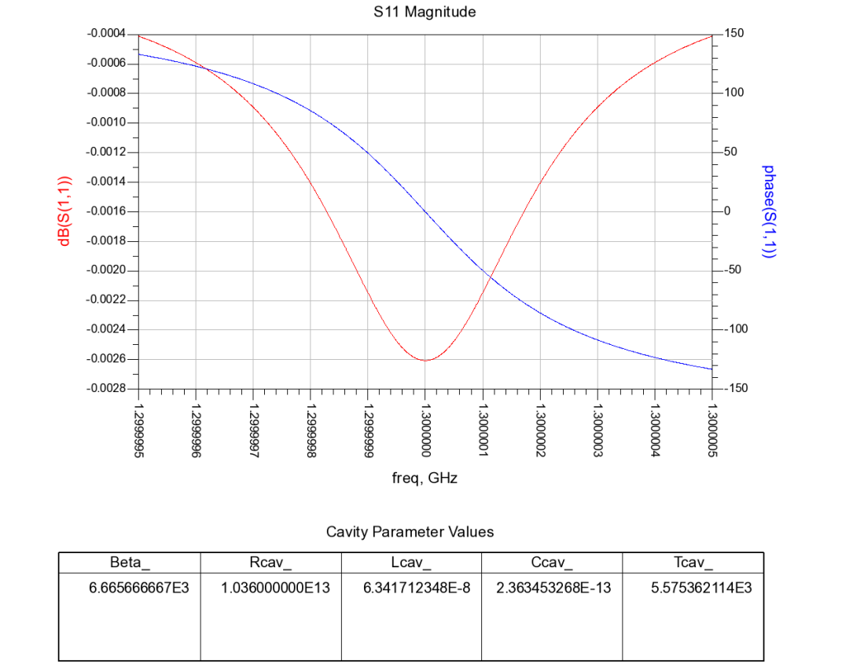
Figure 2. S11 simulation of the cavity with cavity parameter values.
- Time Domain Simulation of the Cavity
The model will now be simulated in the time domain using the ‘Envelope’ simulation of ADS. For this simulation, a carrier frequency is defined, and the time domain envelope of the carrier is displayed. The circuit model for this simulation is shown in figure 3. The model includes an ideal directional coupler so the forward and reverse power signals can be observed. The cavity is driven with a 300 kW, 800 us pulse, and the results of the simulation are shown in figure 4.
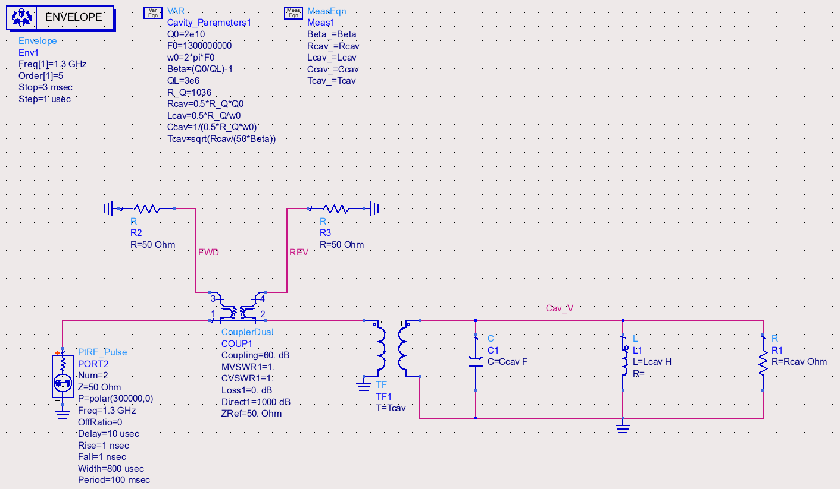
Figure 3. Time domain simulation schematic of the cavity model.
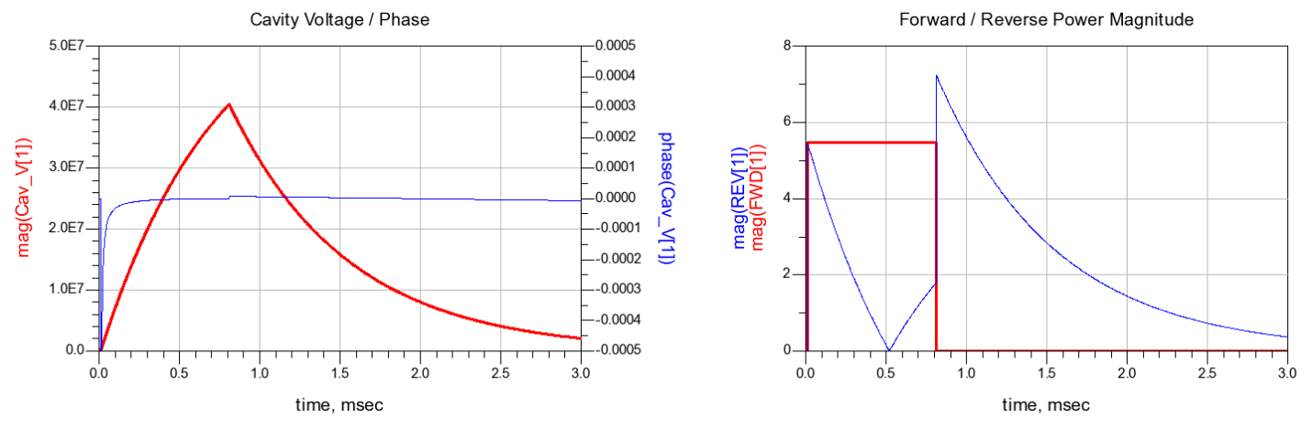Figure 4. Time domain simulation results.
- Beam Loading of the Cavity
The next addition to the model is beam loading. Beam loading is be added to the model by driving a current into the RLC circuit. The circuit model used to accomplish this is shown in figure 5. A network of switches and sources are used to turn the beam current on at the end of the cavity fill time. For this simulation, the cavity is filled to the point when the reflected power from the cavity is minimum. This point can be seen clearly in figure 4, when the reverse power is zero around 510 us. A new RF drive source has been added to the model that can provide a power step at the end of fill time. A power step is used to lower the RF drive when 9 mA of beam current is injected into the cavity to maintain a flat gradient during the beam pulse.
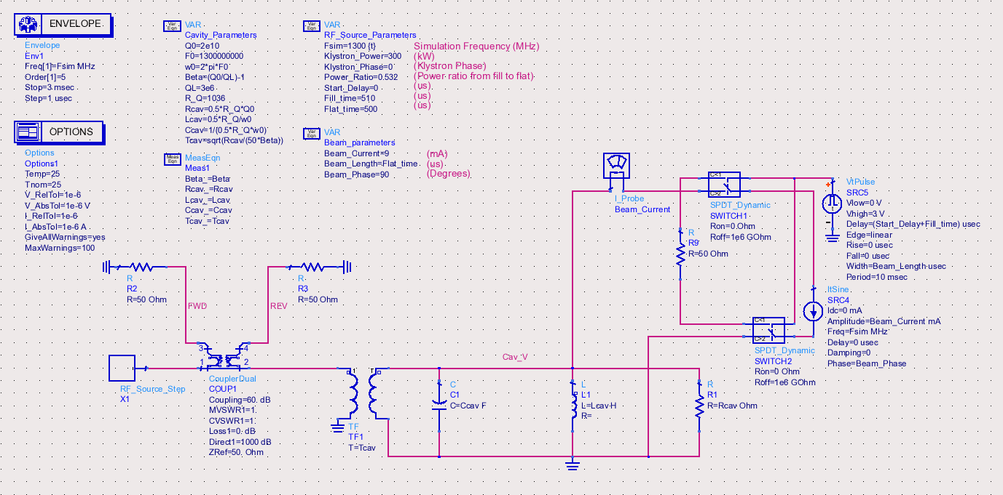
Figure 5. Cavity model with beam loading.
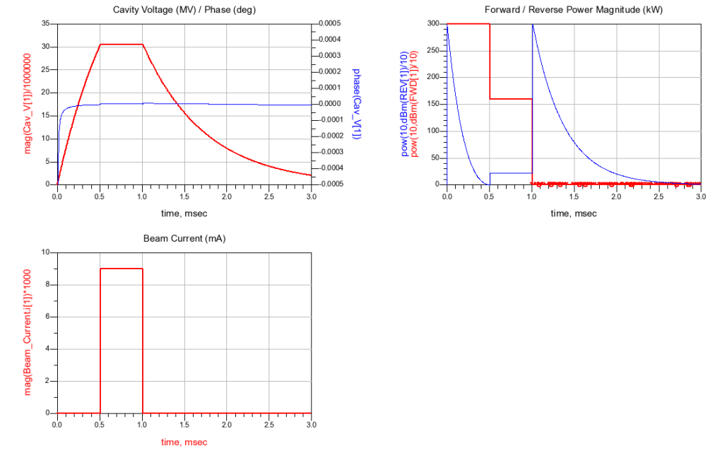
Figure 6. Results of beam loading simulation
- Lorentz Force Detuning
The next addition to the model is Lorentz force detuning. A picture of the ADS cavity model is shown in figure 7. The Lorentz force detuning includes three mechanical modes based on second order differential equations as function of cavity voltage. The second order differential equation [1] for the resonant frequency change, for each mechanical mode is:
$Δω_{0}=2π∙K_{m}∙V_{cav}^{2}+\frac{\frac{∂∆ω}{∂t}}{(Q_{m}∙ω_{m})}+\frac{∂^{2}∆ω}{∂^{2}t}∙ω_{m}^{2} (radians)$ ( 5 )
Where,
$m=mechanical mode number$
$K_{m}=mechanical mode constant$
$ω_{m}=mechanical mode resonant frequency in radians$
$Q_{m}=mechanical mode quality factor$
The Lorentz force detuning is calculated in the component item called ‘Lorentz_detuning’, as seen in figure 7. The input to the component is the cavity voltage, and the output of the component is a current equal to the detuning, in radians. The detuning, in radians, is then used to change the resonant frequency of the cavity by changing the values of $L_{cav}$ and $C_{cav}$. A detailed explanation of how the detuning value is derived is shown in appendix A. The details of how to change the values of $L_{cav}$ and $C_{cav}$ are also included in the appendix. The model includes a parameter to allow for pre-detuning of the cavity. An output transformer and length of cable have been added to circuit to model the pickup probe. The complete cavity model is used as a component, with input and output ports, in the following simulations to simplify the main circuit schematic. The main circuit schematic is shown in figure 8, with the cavity model in the component labeled ‘NML_Cavity’.
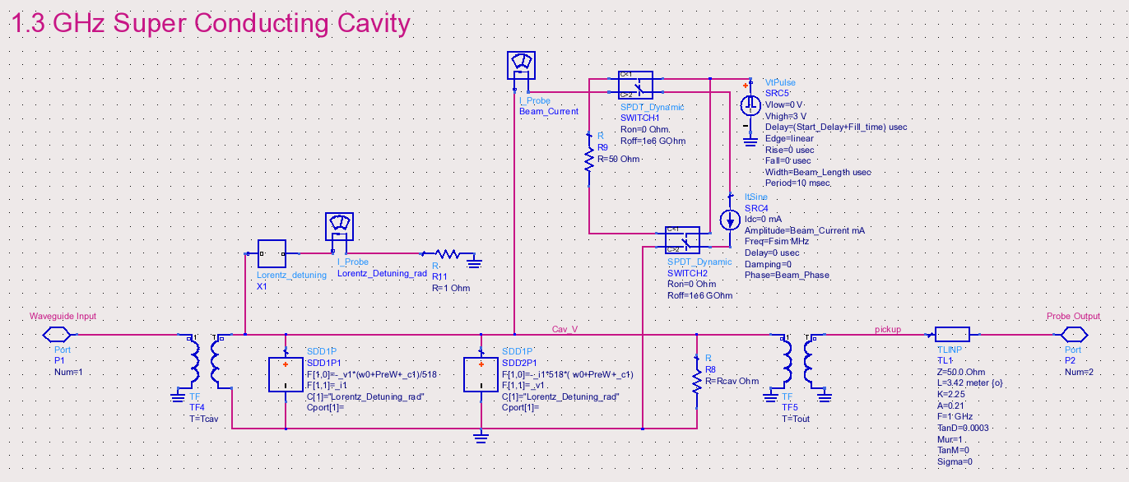
Figure 7. Cavity model with Lorentz force detuning.
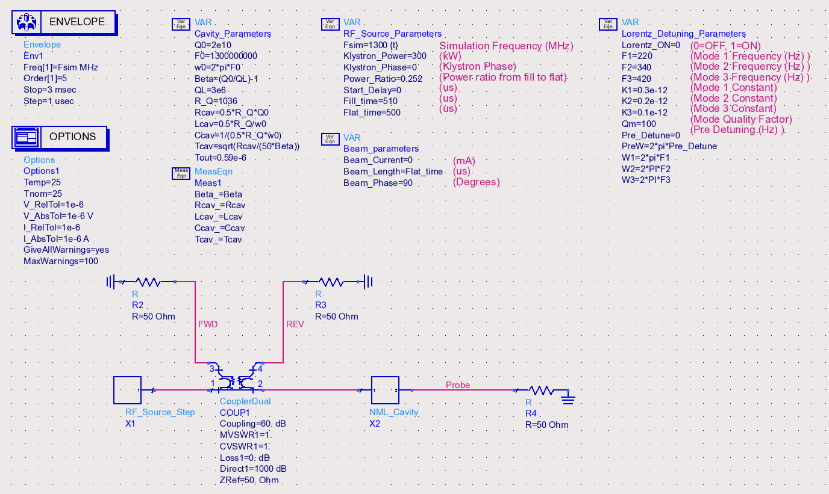
Figure 8. Simulation schematic with Lorentz force detuning.
For the first simulation of the circuit shown in figure 8, the beam current is turned off, the Lorentz force detuning is turned off, and the power ratio of the input drive is adjusted so that the cavity gradient is flat after fill. The flat top length is increased to 2 ms. The results of this simulation is shown in figure 9.
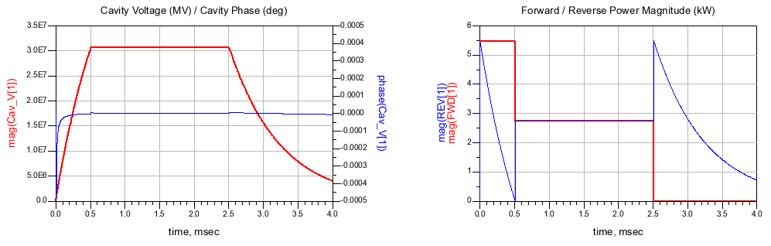
Figure 9. Simulation results with beam loading and Lorentz force detuning turn off.
For the next simulation of the circuit, the Lorentz force detuning is turned on, and the results of the simulation are shown in figure 10. The parameters used for the Lorentz force detuning are:
$f_{1}=220 Hz, f_{2}=340 Hz, f_{3}=420 Hz$ (mechanical mode frequencies)
$K_{1}=0.3e^{-12}, K_{2}=0.2e^{-12}, K_{3}=0.1e^{-12}$ (mechanical mode constants)
$Q_{1}=Q_{2}=Q_{3}=100$ (mechanical mode Q)
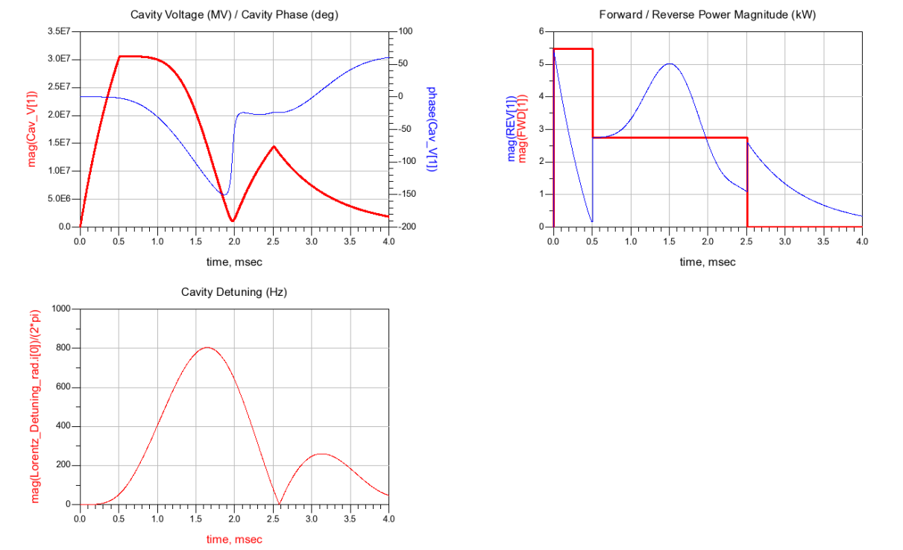
Figure 10. Cavity simulation with Lorentz force detuning.
- Non-ideal RF Components
The next step for the circuit model is to add non-ideal components to the RF drive system. The components include a waveguide isolator, waveguide directional coupler, and sections of waveguide between the components. The circuit model is shown in figure 11.
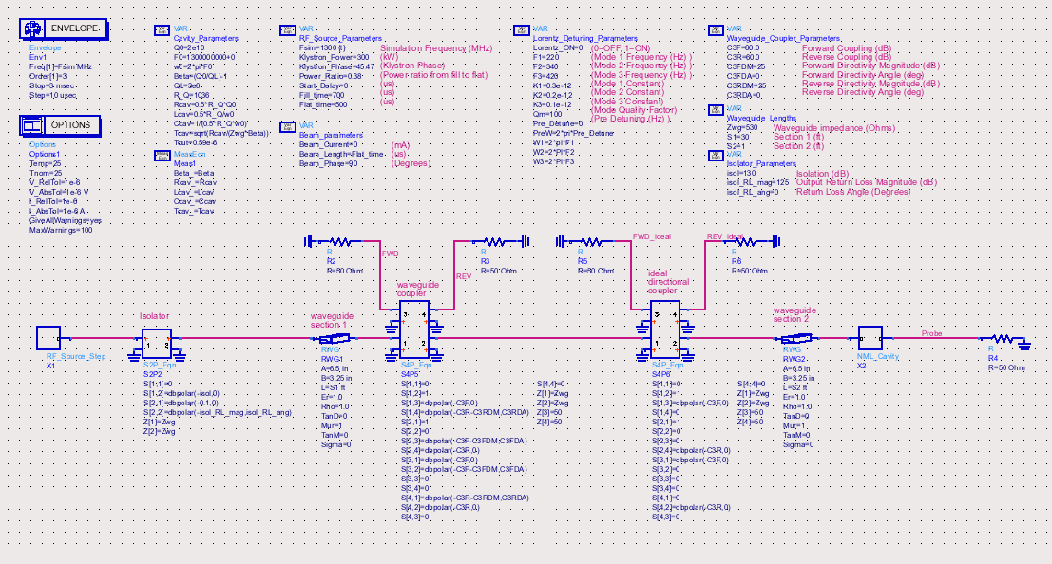
Figure 11. Circuit model with non-ideal RF components.
For the simulations of this circuit, beam loading and Lorentz force detuning will be turned off. The circuit includes two directional couplers. One coupler is ideal, and the other coupler includes the effects of directivity. The ideal directional coupler is placed next to the non-ideal coupler in order to observe the actual forward and reflected signals. Both couplers have 60 dB of coupling, and the non-ideal coupler has 25 dB of directivity, with an angle of 0. These numbers are worse than actual components used in the system, but for this initial simulation, the parameters are made worse so that the effects can be seen more clearly. The circuit model also includes waveguide components, of an arbitrary length, in the RF drive path. An ideal isolator is also added to the model at the front end of the RF drive path for this simulation. A non-ideal isolator will be used in the model for the next simulation. The results of this simulation are shown in figure 12. The power ration of the RF drive was tuned to achieve a flat gradient. The first thing to notice in the simulation is the detuning of the system from the waveguide components. This is seen by the non-flat phase of the cavity phase. The second thing to notice is the effects of directivity on the forward and reflected signals. The blue traces are the actual forward and reflected signals from the ideal coupler, while the red traces are from the non-ideal coupler.
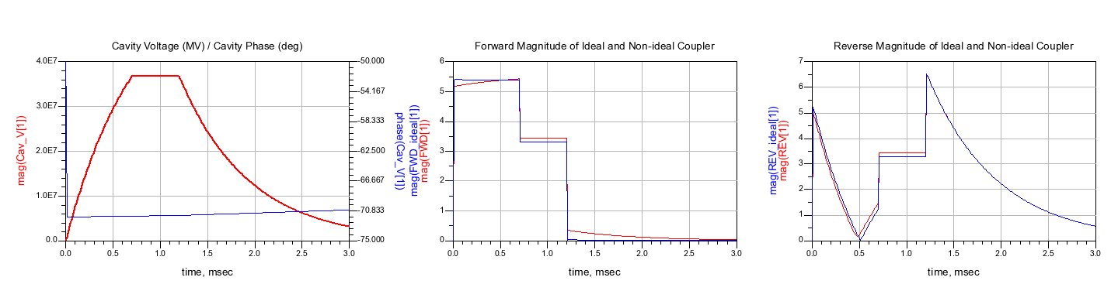
Figure 12. Simulation results with a non-ideal directional coupler and waveguide components.
The next simulation includes a non-ideal isolator. The isolator is given 30 dB of isolation, and an output return loss of 25 dB. Again, these numbers are worse than actual components used in the real system. All other parameters are kept the same as the previous simulation. The results of the simulation are shown in figure 13. As seen by the cavity phase, the system in further detuned. It is also seen that the actual forward and reflected signal are distorted by the addition of the isolator output impedance mismatch.

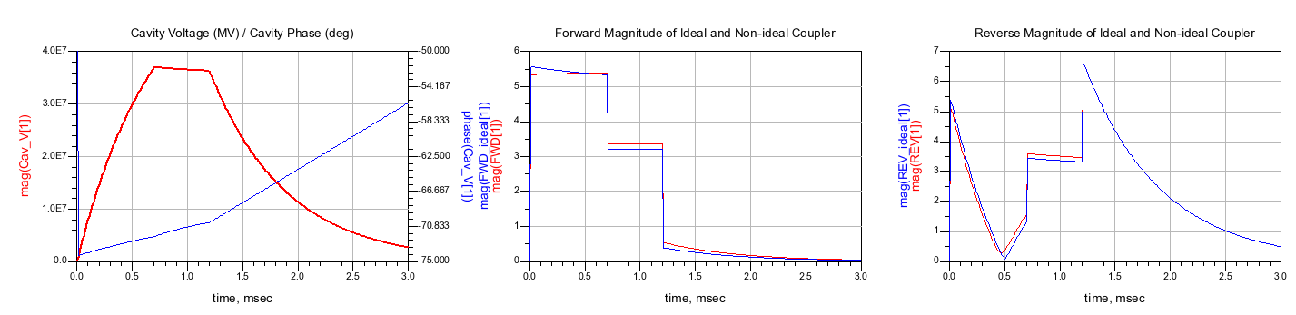
Figure 13. Simulation results with non-ideal isolator.

- Discussion
The model presented in this paper gives insight into the effects that the RF components will have on RF system. With careful measurement of each component of the RF drive and distribution, an accurate model can be developed that represents a real world system. It is also possible to use this model to develop calibration procedures, tuning procedures, and to examine hardware requirements.

Appendix
The Lorentz force detuning includes three mechanical modes based on second order differential equations as function of cavity voltage. The second order differential equation[1] for the resonant frequency change, for each mechanical mode is:
$Δω_{0}=2π∙K_{m}∙V_{cav}^{2}+\frac{\frac{∂∆ω}{∂t}}{(Q_{m}∙ω_{m})}+\frac{∂^{2}∆ω}{∂^{2}t}∙ω_{m}^{2} (radians)$ ( a1 )
Where,
$m=mechanical mode number$
$K_{m}=mechanical mode constant$
$ω_{m}=mechanical mode resonant frequency in radians$
$Q_{m}=mechanical mode quality factor$

In order to solve this equation in an ADS circuit model, a component called a symbolically defined device is used. The solution to the 2nd order differential equation is achieved using this device is shown in figure A1.
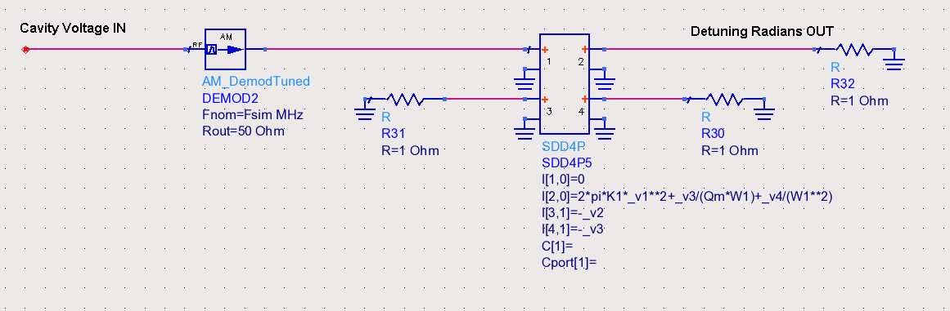
Figure A1.
The input to the circuit model shown in figure A1 is from the cavity, and it is the 1.3 GHz carrier. The symbolically defined device requires that the input signal to the device be baseband, so the AM demodulation component is used to provide the baseband envelope of the cavity voltage to the component. The output current of each port ( I[x,y] ) is defined in the symbolically defined device (SDD4P), where X is the port number, and Y is a weighting function. For the device shown in figure A1, the current in port 1 is defined as I[1,0]=0. This states that there is no current flowing out of port 1, and there is no weighting function. A weighting function of 1 defines the current output at the port is the first derivative of the value you define. For example, port 3 is defined as I[3,1]=-_v2. This defines the current flowing out of port 3 as the first derivative of the voltage at port 2. Port 4 also has a weighting function of 1, and the current is defined as the first derivative of the voltage at port 3. Since the current flowing out of port 2 is defined to be equal to the change in radians ($∆ω)$ due to the Lorentz force detuning, the current flowing out of port 3 is the first derivative of that change ($\frac{∂∆ω}{∂t}$ ), and the current flowing out of port 4 is the 2nd derivative of that ($\frac{∂^{2}∆ω}{∂^{2}t}$). As seen in the figure, port 2 is defined using voltages at port 3 and port 4 to define the first and 2nd derivative. This leads to the current defined for port 2 to be the second order differential equation defined in equation (a1).
The complete circuit model for Lorentz for detuning is shown in figure A2. The circuit model sums three 2nd order differential equations, and the circuit model also provides a switch to turn on or off the Lorentz force detuning. The output current of this circuit model is equal to the total detuning of the cavity and will be used to change the resonant frequency of the cavity.
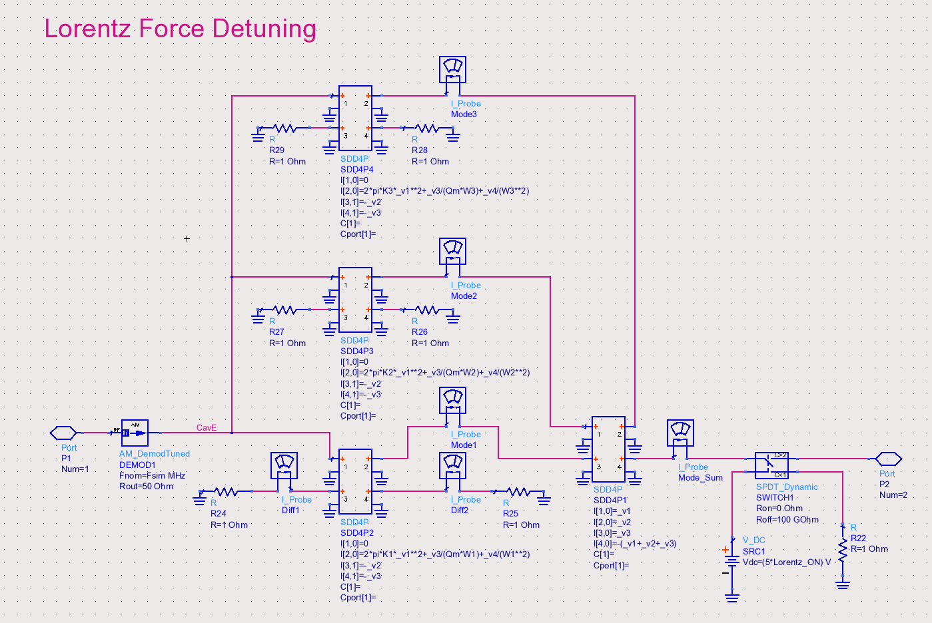
Figure A2. Lorentz force detuning.
The inductance and capacitance of the cavity is also modeled using the ADS symbolically defined device. The reason for using this device is so that the value of the inductance/capacitance can be dynamically change during the simulation to account for the detuning of the cavity from Lorentz forces. Figure A3 shows how the symbolically defined devices are used to model the inductor and capacitor. The complete cavity model can be seen in figure 7.
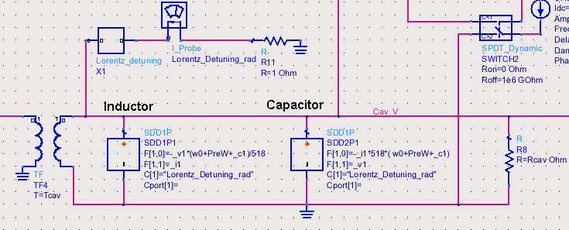
Figure A3.
The current is defined slightly different with these symbolically defined devices. The output current of the port is the defined by the equation:
F[x,y] + F[x,y] + … = 0 ( a2 )
Where X is the port number of the voltage or current defined, and Y is the weighting function. The weighting function operates the same way as the previous implementation, where a weight of 1 is the first derivative. In order to use this device to model an inductor, the device must conform to the equation of an inductor, which is:
$V=L\frac{∂i}{∂t}$ ( a3 )
If the terms are rearranged, the form the equation fits the form of the symbolically defined device:
$F\left[x,y\right]+F\left[x,y\right]=\frac{V}{L}-\frac{∂i}{∂t}=0$ ( a4 )
The symbolically defined device can now be defined by:
F[1,0] = -_v1 / L
F[1,1]= _i1
Where _v1 is the voltage at port 1, and _i1 is the current at port 1. Notice that a weight of 1 is applied to the current, which implies the first derivative of the current. The value of L is defined by equation (2), which is:
$$L_{cav}=\frac{1}{2}\frac{R}{Q}\frac{1}{w_{0}}$$
Which simplifies to L= 518 / w0 using the values defined previously. The symbolically defined device can now be defined by:
F[1,0]= -_v1*w0/518
F[1,1]= _i1
One more important feature of the symbolically defined device is that a controlling current can be used within the equations. As seen in figure A3, the parameter C[1]=”Lorentz_Detuning_rad” is used in the inductor model. This is a reference to the current probe that monitors that current coming out of our Lorentz force detuning component. Once the current reference is defined using C[1], the variable _c1 can be used in the equations. For our circuit model, _c1 is equal to the detuning of the cavity in radians. Now the value of our inductance can be changed in accordance with the change in resonant frequency defined by the Lorentz force detuning ( _c1 ). The symbolically defined device can now be defined by:
F[1,0]= -_v1*(w0+_c1)/518
F[1,1]= _i1
One more additional parameter is added to the equation to allow pre-detuning of the cavity. The final form for the equations of the inductor model is:
F[1,0]= -_v1*(w0+PreW+_c1)/518
F[1,1]= _i1
This now gives us an inductor model that can be dynamically changed during the simulation, while adhering to our basic cavity equations. The capacitor model is developed using the same method.

References
[1] Schilcher, Thomas, “Vector Sum Control of Pulsed Accelerating Fields in Lorentz Force Detuned Superconducting Cavities”, PhD Thesis, 1998.

Appendix B
A picture of the RF source sub-circuit is shown in figure 5. The RF signal is generated by the ADS component P_1_Tone, located in the upper right-hand side of the figure labeled ‘PORT2’. The power source is then modulated by an IQ modulator labeled ‘MOD1’. Signals ‘I_Mod’ and ‘Q_Mod’ that feed the IQ modulator are generated by voltage supplies which mimic a feed forward table. A setpoint table is also generated in the same way and is used to calculate error signals for proportional feedback (I_error and Q_error). As seen in the figure, the component SDD6P1 is used to sum the error signals with the feed forward signal when feedback is turned on by the variable ‘FB_ON’. The probe signal, which comes from the cavity pickup, is fed into port 1 (P1) of the sub-circuit. As seen in figure 4, the probe signal includes the cable losses, downconversion loss, and electrical delays of the downconverter. A knob for the fanback phase and amplitude is included in the model for calibrating the feedback system (PS1 and AMP1). After the fanback phase and amplitude components, an IQ demodulator (DEMOD2) is used to generate I and Q components of the detected probe signal. These signals are then used to generate detected amplitude and phase signals with the component SDD4P1. The detected I and Q signals are also used to calculate the I_error and Q_error signal using the component SDD6P2.
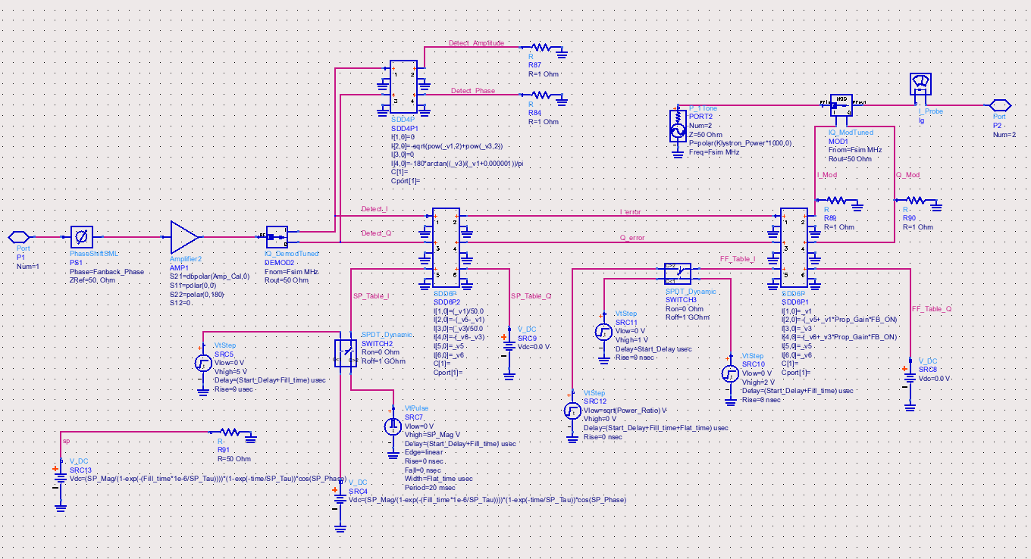
Figure 5. RF source sub-circuit with feed forward and feedback.

