Field Tables RGF and RGD Recycler mangets

J Volk

Feb 14, 2014

POISSON produces a table of magnetic field parameters as part of the output the lmin ltop kmin ktop cards set the limits the region that is included in the tables. For the RGF and RGD decks the the kmin and ktop are not included so the default is the minimum and maximum is taken the lmin =1 ltop=101 sets the maximum values.

The dimensions are inches and the spacing is 0.1 inch or a 2.54mm grid spacing. It can’t be made smaller the mesh does not work at a 5mm spacing. Values given in the tables are;



K and L are the mesh values, X and Y (in inches) are the dimensions in inches, Bx By |B| are the magnetic field values, Az is the vector potential then the derivatives of the fields are given. Units are Gauss.

Figure 1 shows the mesh on top of the RGD the mesh goes outside of the steel dimensions. The exact values can be found in the RGD-1.am file.

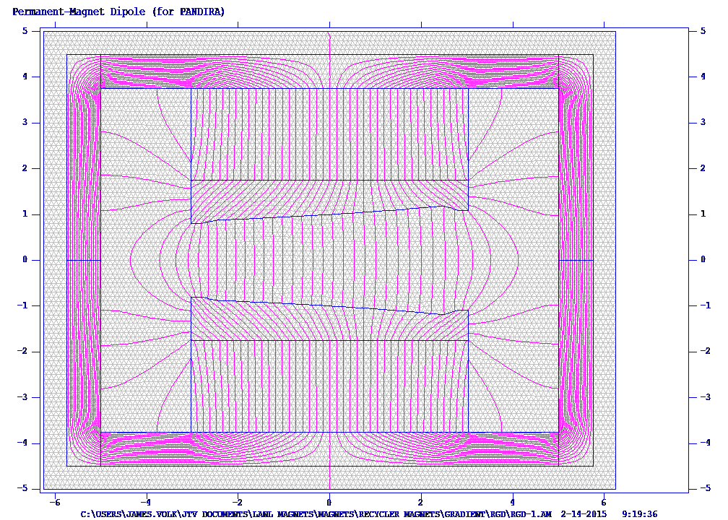

Figure 2 shows the RGF mesh

