Dan Johnson (Reviewed by: Duane Newhart, Stan Johnson)

I have tried to identify the major topics of interest when building or designing a control room. Some to the control room design will spill over into other areas such as meeting and food preparation areas.

- Size
  - Must meet the needs of the equipment and number of workstations needed to support operations. The Main Control Room at Fermilab has 10 full stations (6 monitors each) and 3 reduced stations (2 monitors each). There are 4 Operators scheduled for shift, but day shifts are flooded with experts. We also have 3 – 52” monitors for key displays on the wall. More would be nice, but we don’t have space available. Try to make it large enough to support current and the future mission of the lab.
  - Large monitors are standard control room equipment these days.
  - Try to maintain some open space, avoiding temptations to fill space with consoles, table, chairs or cabinets. You will undoubtedly need space a couple years down the road.
  - The MCR is approximately 50’ x 41’ in size.
- Location
  - The control room should be in close proximity to the area/machine it is servicing. Remote control rooms are nice until you need to go in the field and fix something.
- Break Area
  - There should be a break and meeting areas near the control room.
    - We have a kitchen with an oven, refrigerator, sink, coffee, tea, water, microwave, etc. just outside the control room. This allows for Operators to leave to get food or drink. The kitchen outside the MCR is approximately 11’x9’.
    - We have a meeting room outside the control room for between shift briefings or if a problem occurs and needs expert collaboration. The room is named the Dungeon and is approximately 21’x12’.
    - Small meetings in the control room can work, but they can also become distracting.
- Meeting Area
  - There should be a small meeting location in the control room large enough to lay out drawings and get a small group together to solve a problem.
  - A meeting room outside the control room is also beneficial for collecting a larger number of people and discussing problems.
- Lighting
  - Natural Light
    - It is good to have access to natural light if possible. Blinds and other mechanisms can be used to darken the room if needed.
  - Direct vs Indirect
    - Direct light tends to cause a glare on the monitors where indirect tends to work better. Monitors also come with different filters to reduce reflections.
  - Fluorescent vs LED
    - We had dimmable LED lighting installed in the control room. It is very nice. It is very bright if needed, but is dimmed most of the time.
- Temperature - HVAC
  - Need to have some control over temperature. The Operators on the midnight shift will want it a little warmer than the day crews. The thermostat should be programmable but allow for temporary changes.
  - There has been more concern about disease and illness since many people are in the same room using the same equipment.
    - A good ventilation system with HEPA filtering for the area would be nice.
    - Hand sanitizer and console/keyboard wipes are very effective
- Control Room Consoles/Furniture
  - This area is wide open and depends on how much money you want to spend. We purchased off the shelf consoles for the main control room. The computers can be hidden away behind doors or in a pullout drawer. Labs like DESY had the consoles specifically built to their specifications. The ROC West at Fermilab also went with special consoles, but that added cooling complications.
  - Every console in the MCR can control any system. We do not like having specialized consoles in the MCR and try to avoid them.
  - The consoles and chairs need to meet ergonomic criteria since they will be used 24 hours a day.
  - The consoles and chairs need to be durable since they will take a beating.
  - The carpet or flooring needs to be durable and able to withstand dirt and high traffic.
  - We would like to add a standing workstation in the control room. Studies have shown that sitting for extended periods is not good for Operators.
- Layout
  - Various layouts exist. The main control room at Fermilab has the Crew Chief located in the middle of the room so he/she can keep an eye on all activities and promote communication.
  - Communication
    - Control Room Discussions
      - The room needs to be laid out to allow all parties to communicate freely and yet maintain a reasonable level of individual conversations.
    - Phone Systems
      - Should be able to have multiple people listening on the same line. The VoIP (Voice over Internet Protocol) systems don’t seem to support this feature.
  - Auxiliary Systems
    - Cable TV access
    - Scopes
    - Power outlets
      - Many people bring in laptop or USB powered equipment. Having connections at a console is a plus
    - Rack mounted equipment
    - Electrical and Radiation Safety Equipment
    - Key distribution
    - Lock Out Tag Out areas
    - Access equipment
- Cable Management
  - It is important to know what cables you have, where they go and what they are needed for. Years after the control room is in service, you will want to change systems or remove cables and the headaches begin.
- Noise Reduction
  - Printers
    - Isolate behind a wall or in another part of the room.
  - Computer Fans
    - The drone of a fan gets to people after awhile
  - Other Sources
    - We do not have speakers at individual computers but use a centralized system broadcast though the entire control room. When we have an audio notification, everybody in the control room hears the same thing.
- Sound System
  - We have a centralized system with speakers in the ceiling. All the audio whether it is music or audio alert notifications go through the same system.
- Other Ideas
  - Try to think outside the box with new equipment. There are many ideas for interactive screens either on the wall or table top. They are becoming less expensive and more realistic.
- Visitor Experience
  - The Main Control Room at Fermilab has a glass window and the visitors stay on the outside of the room. Special visitors are permitted in the control room, but the Crew Chief must be notified. Operators will leave the control room to answer questions and talk with visitors. The main control room at Fermilab is a controlled area and you must have a laboratory identification badge to enter.
  - The Remote Operations Center (ROC) West at Fermilab does allow guided tours to enter the control room.
  - The Remote Operations Center (ROC) East at Fermilab used for remote CMS operation is secure but has visitor information projected on the glass wall.

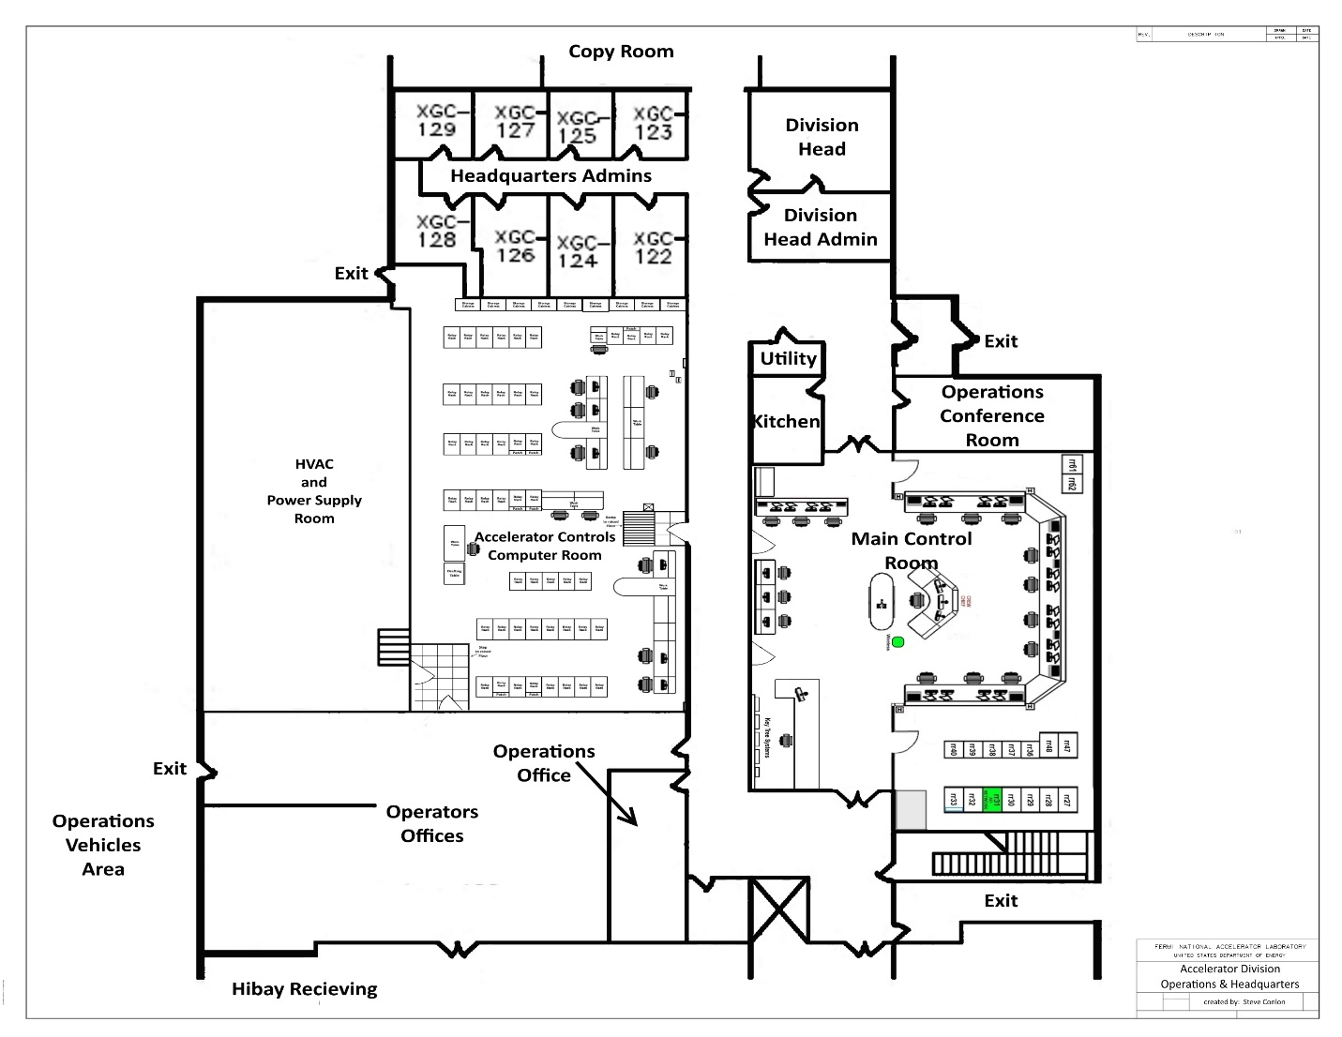
Main Control Room and Surrounding Area Layout Drawing by Steve Conlon

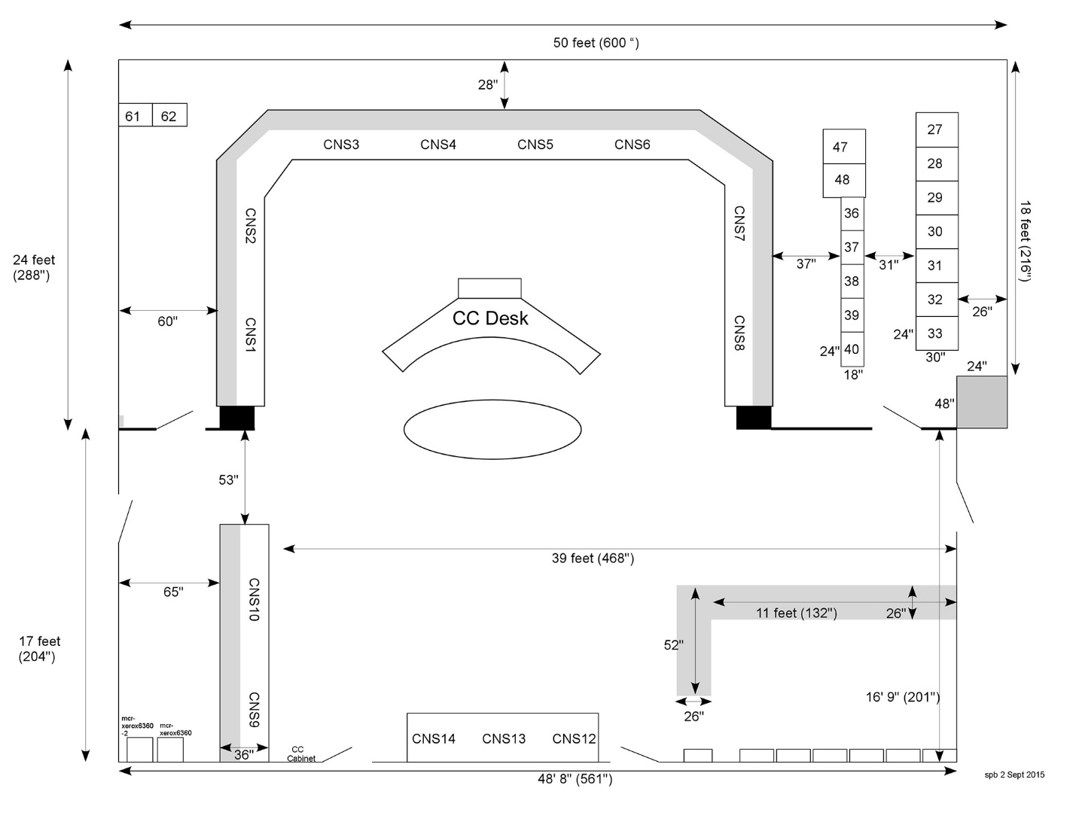
Main Control Room Layout Drawing by Steve Baginski

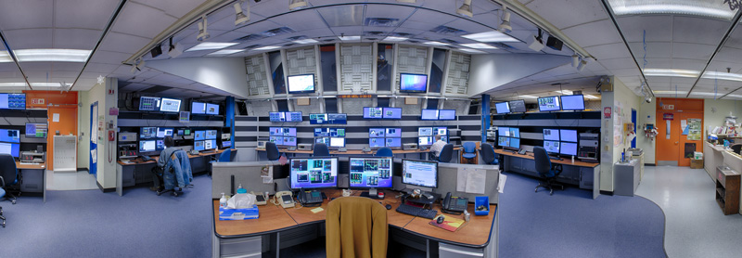
Main Control Room photo by Visual Media Services (VMS)

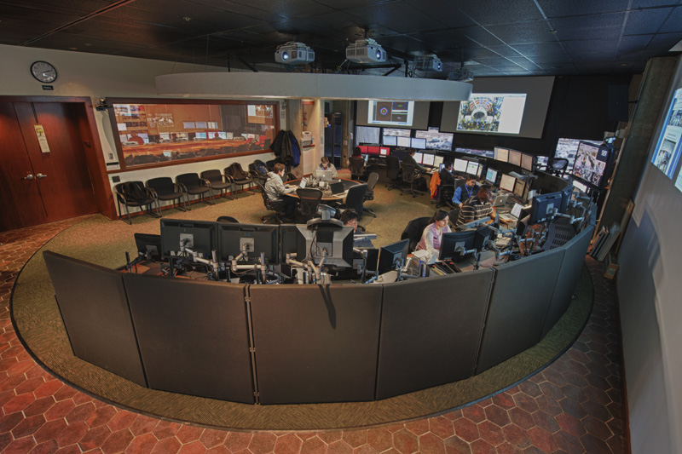
Remote Operations Center (ROC) East photo by Visual Media Services (VMS)

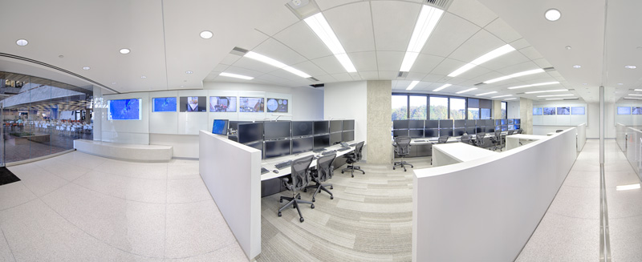
Remote Operations Center (ROC) West photo by Visual Media Services (VMS)

