ACCELERATOR DIVISION ADMINISTRATIVE PROCEDURE
ADAP-11-0001
BEAM PERMITS, RUNNING CONDITIONS, and STARTUP

RESPONSIBLE DEPARTMENT: ESH&Q RPO

Prepared By: _____________________________________ Date: _____________
ESH&Q Radiation Physics Operations Department Head

Reviewed By: _____________________________________ Date: _____________
AD Operations Department Head

Approved By: _____________________________________ Date: _____________
AD Division Head

REVISION NO. 8 REVISION ISSUE DATE

Table of Contents
1.0 Purpose and Scope 2
1.1 Policy 2
2.0 Responsibilities 2
2.1 ESH&Q Radiation Physics Operations (RPO) Department Head 2
2.2 AD Department Heads 2
2.3 AD Division Head 2
2.4 Assigned Radiation Safety Officer (RSO) 3
3.0 Startup Procedure 3
3.1 Beam Permits and Running Conditions 3
3.2 Operating Notes 4
3.3 System Start-Up Sign-Off Sheet 4
3.4 System Turn-On 5
4.0 Documentation 5
5.0 Distribution 5
6.0 Attachment 1 - Example Beam Permit 6
7.0 Attachment 2 - Example Running Condition 7
8.0 Attachment 3 - Example System Sign-Off 11
9.0 Attachment 4 - Example Operating Note 12

Purpose and Scope
The purpose of this procedure is to describe how the Accelerator Division (AD) complex is turned back on after extended shutdowns or after extensive maintenance or improvement work has taken place. An extended shutdown is defined as a shutdown that is typically greater than a month long. This procedure is also used as a driver to generate Beam Permits and Running Conditions that define operational parameters. This procedure can be executed whenever it is deemed necessary to formally review a given startup or operational change. This procedure does not address the shorter, controlled shutdowns that occur during the course of a run for maintenance and repair of specific components, or improvements to a few specific subsystems.

Policy
It is the Accelerator Division Policy that beam will not be introduced into any accelerator or beamline enclosure until:
a. equipment and components are configured in a manner to safely allow beam transport;
b. operational beam limits have been established consistent with the requirements of the Accelerator Safety Envelope (ASE) contained in the current applicable Safety Assessment Document (SAD), the appropriate SAD Chapter, and the appropriate Shielding Assessment (SA) for the area.

Responsibilities

ESH&Q Radiation Physics Operations (RPO) Department Head
The ESH&Q RPO Department Head is responsible for ensuring this document is prepared and updated on an as-needed basis.

AD Department Heads
All Department Heads are responsible for ensuring that the provisions relevant to their departments are carried out. In the event of a change in departmental procedure that affects startup, the AD Department Heads are responsible for ensuring that the AD Division Head or designee is informed. In addition, the AD Department Heads (or their designees) are required to sign off on the relevant System Start-Up Sign-Off sheets.

AD Division Head
The AD Division Head is responsible for overseeing that the provisions of this procedure are carried out. The AD Division Head is responsible for approving the System Start-Up Sign-Off, Beam Permit and Running Condition documents, and for sending the appropriate memos to the Operations Department Head to allow for the start or restart of the various accelerator systems.

The AD Division Head is responsible for designating a major shutdown or initiating this procedure. Such a designation is accomplished by a memo to the AD Operations Department Head rescinding authorization to introduce, accelerate, or transport beam until re-authorized in writing as described in this procedure.

Assigned Radiation Safety Officer (RSO)
The Assigned Radiation Safety Officer (RSO) will prepare and review the Beam Permit, Running Condition and the System Start-Up Sign-Off documents for compliance with the Accelerator Safety Envelope (ASE) contained in the current applicable Safety Assessment Document (SAD), the appropriate SAD Chapter, and the appropriate Shielding Assessment (SA) for the area. (See Attachments 1, 2, and 3, respectively).

Startup Procedure

Beam Permits and Running Conditions
Prior to the start of any accelerator beamline or experimental area, a Beam Permit and Running Condition shall be generated and placed in the Main Control Room (MCR) (Attachments 1 and 2). The Beam Permit and Running Condition identify ASE and Operating Limits allowed for the appropriate system within the current ASE and SA and/or SAD, and define necessary actions for the Main Control Room (MCR) operations crew to follow for off-normal occurrences.
Beam Permits are prepared by the Assigned Radiation Safety Officer to ensure compliance with the current appropriate system ASE and Operating Limits. Beam Permits are reviewed by the AD Operations Department Head, the AD Systems Department Head, the assigned RSO, and the ESH&Q RPO Department Head. Beam Permits are then approved by the AD Division Head.
Running Conditions provide the AD Operations Department with the allowed or required safety related beamline parameters, configurations, and any additional safety related restrictions on operating the beam. Running Conditions typically include:
- The Date Issued
- A Mode Identifier (some systems have multiple Running Conditions)
- The ASE intensity limit
- The Operating Intensity Limit
- Beam intensity monitoring devices
- The designated Critical Devices and enclosures protected
- Any Interlocked Radiation Detectors and monitoring channels (MUX)
- Any required special interlocks or setting types
- Devices or systems that must be disabled to allow access
- Associated Gates, Fences, or Passive Shielding Requirements
- Operational Comments such as what toroid monitors beam intensity
- Any special concerns that require approval before re-enabling the system
- Items that require documenting in the MCR electronic logs (E-Log)
Running Conditions are prepared by the Assigned Radiation Safety Officer and signed by the AD Systems Department Head, Assigned Radiation Safety Officer, AD Operations Department Head, and AD Division Head. Only the MUX channels of interlocked detectors and Operational Comments can be altered by the Assigned RSO using initials on existing documents. Any other modification to an existing Running Condition is covered by an Operating Note.

Operating Notes
Operating Notes may be issued by the Assigned RSO to the AD Operations Department that temporarily modifies an existing Running Condition to allow for special operating conditions that do not contradict shielding assessments. Typically, Operating Notes require intensities lower than the Running Condition allows. Operating Notes may include, but are not limited to: reduced intensities for commissioning beam, reduced intensities for temporary conditions that result in special concerns of a radiological nature, or special runs for beam studies. Operating Notes allow for an equivalent or more conservative modification to beam operations or intensities than the existing Running Condition. Operating Notes are in effect until they are rescinded by the Assigned RSO.

System Start-Up Sign-Off Sheet
The Assigned RSO is responsible for providing the System Start-Up Sign-Off Sheet to each System Department Head with the appropriate “System Being Signed Off” designated and the appropriate Shielding Assessment noted on the form.
Each System Department Head is then responsible for ensuring that support Departments that have performed work on the system sign the System Start-Up Sign-Off Sheet, otherwise indicate “N/A” for support Departments that did not perform work.
Support Department(s) Signatures indicate that, unless noted in the comments section, their relevant systems are ready for the restart of beam operation. If there is any remaining work on their relevant systems that would affect the restart of beam operations, descriptions of the remaining work should be made in the comments section.
Department Head Signatures indicate that all work is completed in the relevant support Departments and that to their knowledge the system is ready to accept beam, or that any remaining work indicated in the comments section has been acknowledged and will be evaluated to ensure safe restart of beam operations. In addition, the signature also indicates that the radiation shielding for the system is configured as described in the current shielding assessment.
The Assigned Radiation Safety Officer signature indicates concurrence that the radiation shielding and that the Radiation Safety Interlocks are configured as described in the current shielding assessment, and that all items in the relevant system’s configuration control log have been closed out.
The AD Division Head signature acknowledges their review of the system readiness for safe restart of beam operations.

System Turn-On
A valid Beam Permit, Running Condition and System Start-Up Sign-Off (see Attachments 1, 2, 3) are required to be completed before a given beamline system may accept and/or accelerate beam.
System operation is initiated by a memo that is sent by the AD Division Head to the AD Operations Department Head indicating that a system is ready for beam transport.

Documentation
Copies of all Beam Permits, Running Conditions, and System Start-Up Sign-Off forms will be retained by AD Headquarters. Active Beam Permits, Running Conditions, and Operating Notes (if applicable) for all accelerator systems will be viewable in the Main Control Room.

Distribution
An electronic controlled copy of this procedure is maintained on the Beams DocDB: http://beamdocs.fnal.gov/AD-public/DocDB//ShowDocument?docid=4975

Attachment 1 - Example Beam Permit
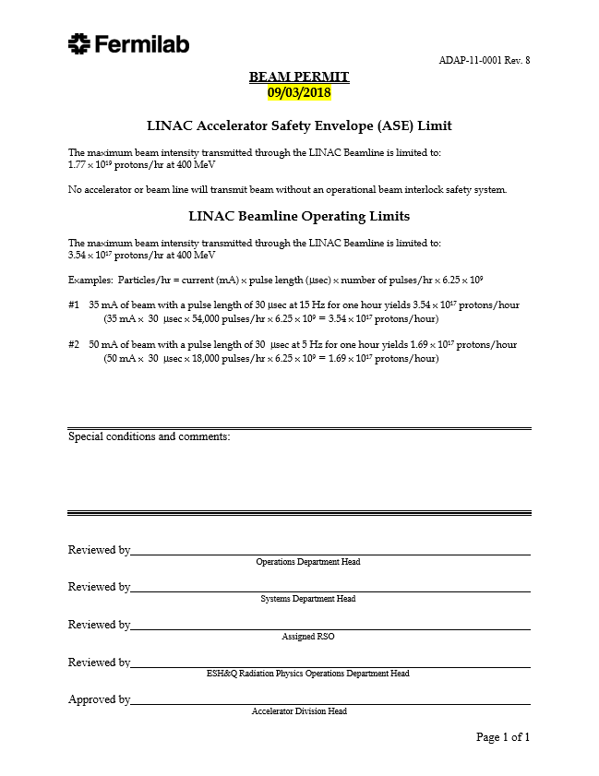

Attachment 2 - Example Running Condition
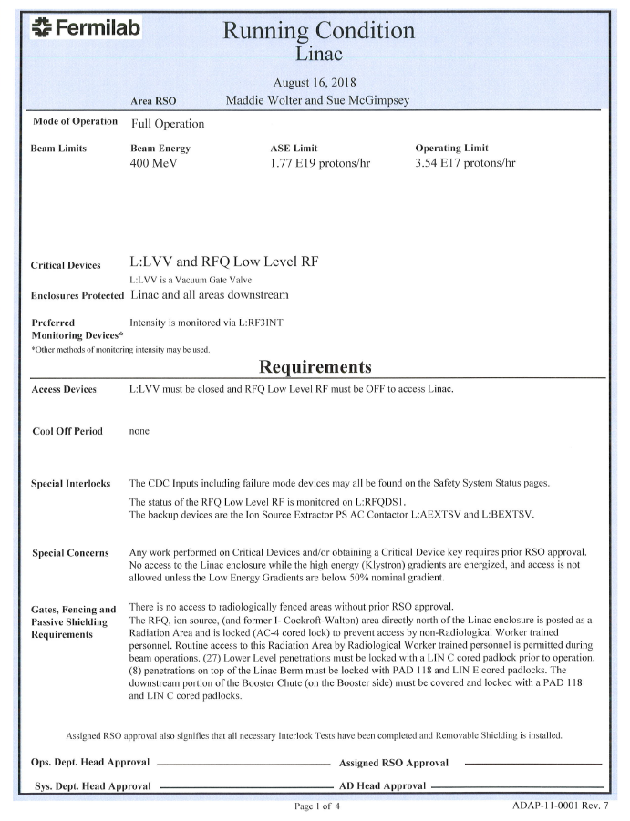
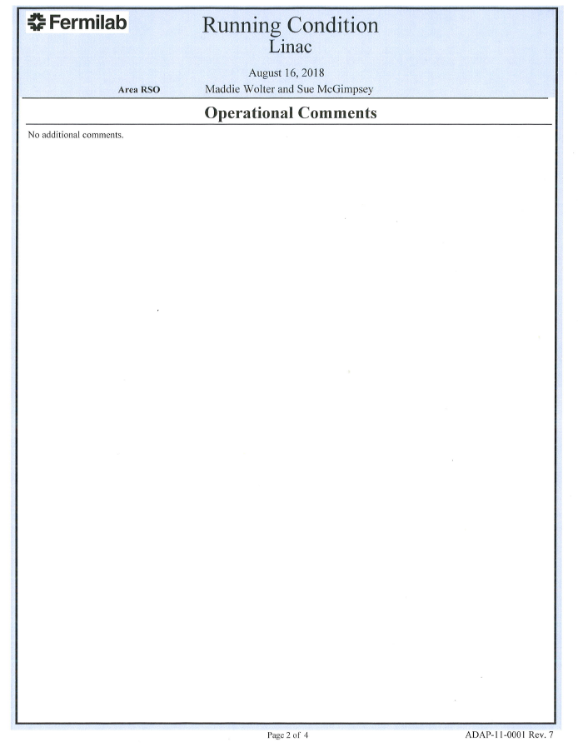
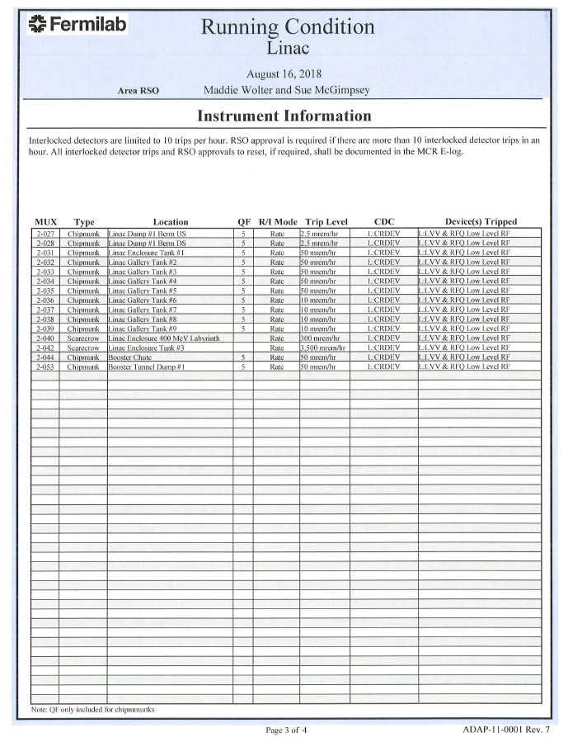

Attachment 3 - Example System Sign-Off
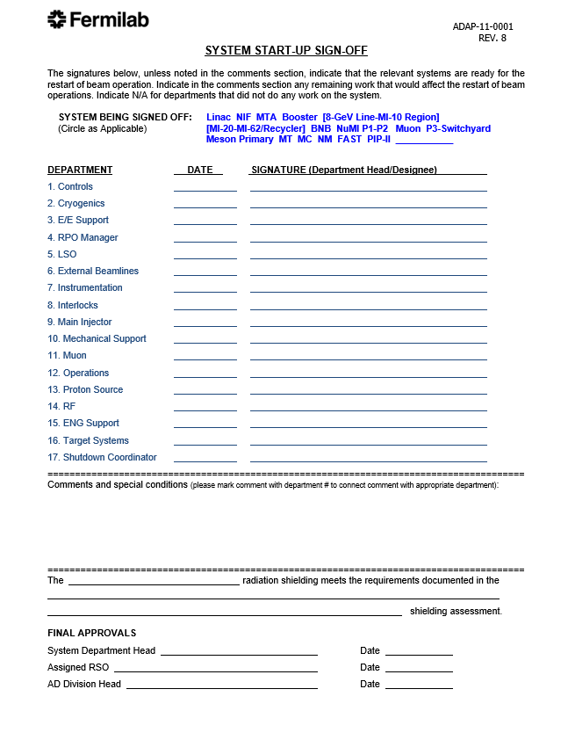

Attachment 4 - Example Operating Note

