A Historical Look at Booster Radiation Activation Surveys

For the past 15 years the Booster group has been performing regular radiation activation surveys. The purpose of these surveys has been two-fold:
- Locate loss points and
- Set acceptable beam loss levels as measured by the beam loss monitors (BLMs) [1].
This program of performing radiation activation surveys began with the start of the Booster Neutrino Beam Line (BNB). The Booster increase of the proton flux, about 200% since the start of the survey program, has been an extremely critical part of our operations and planning. Data from these surveys have been used to guide beam physics, shutdowns’ work (ALARA) and upgrades. Data were initially taken at both on contact and at one foot. However, it was determined that the one foot measurements were sufficient to ascertain the information needed.
The data for all surveys are entered into an online database which is accessible via the web [2]. The web page allows one to plot data for a survey, a set of surveys, and compare surveys for the entire ring or for individual locations.
The data show that the activation has not increased at the same rate as the proton flux. Keeping the activation consistent allows for enclosure work to be done. Areas such as RF cavities at 10 long straight section have seen reduced activation and have resulted in lower exposure rates to workers.

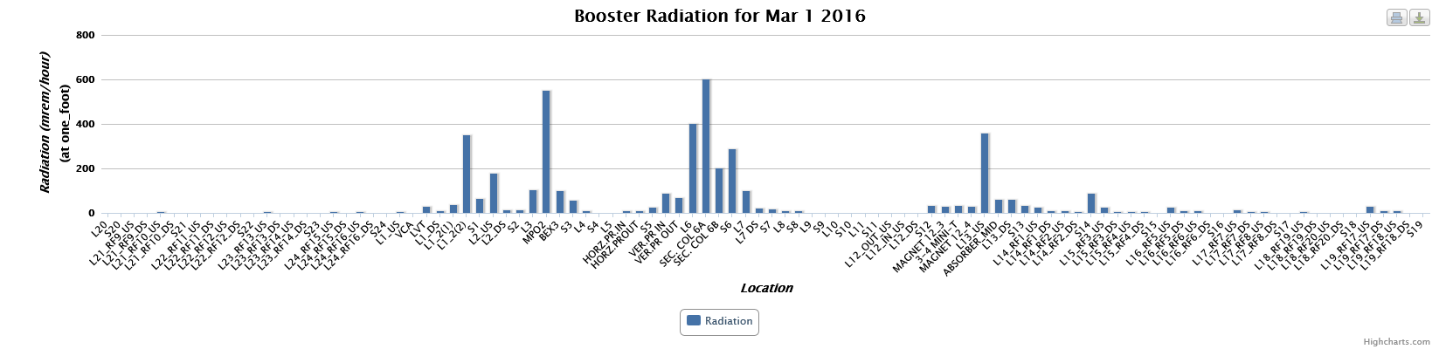
Figure 1: Booster radiation survey performed March 1, 2016.
Figure 1 shows data from a recent radiation activation survey taken one hour after beam off. The week prior to the survey, the Booster ran at 1.8E17 pph. The levels are reasonable and correlate to BLMs readings seen during beam operations.
Figure 2 below provides a difference plot between two radiation surveys taken over ten years apart. The November 2006 data are from a survey taken one hour after beam off; the proton flux during operations had been 0.8 E17 pph. The plot shows that for nearly every location the activation has decreased. In most cases, the activation reduction has been significant.

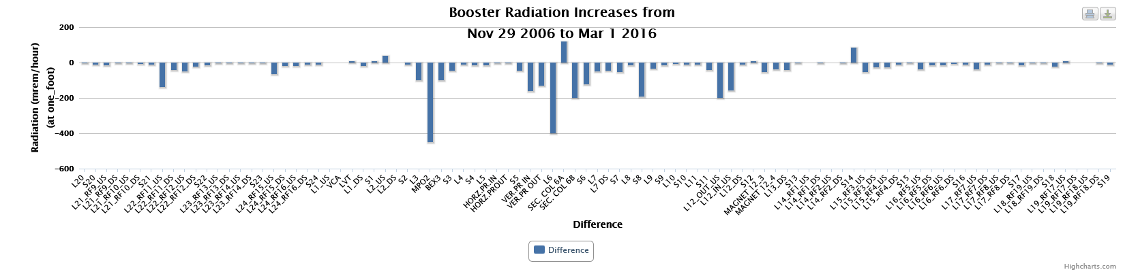
Figure 2: Radiation activation survey - difference plot.
The decrease of activation is due to the reduction of beam losses coming from work performed by the Proton Source and upgrades from the Proton Plan and the Proton Improvement Plan (PIP). The current plan is the completion of the PIP which will make the Booster capable of 2.7E17 pph. Work will continue to keep the activation at the same level or less.
[1] http://www-bd.fnal.gov/proton/booster/blms/
[2] http://www-bd.fnal.gov/cgi-booster/rad_survey.pl

