Business trip: March 28&29, 2016

National Magnetics Group, Inc
NMG. TCI Ceramics

1210 Win Drive
Bethlehem, PA 18017-7061, USA

Phone: +1-610-867-6003 (x138) Fax: +1-610-867-0200
E-mail: goutam@magneticsgroup.com
Web: www.magneticsgroup.com

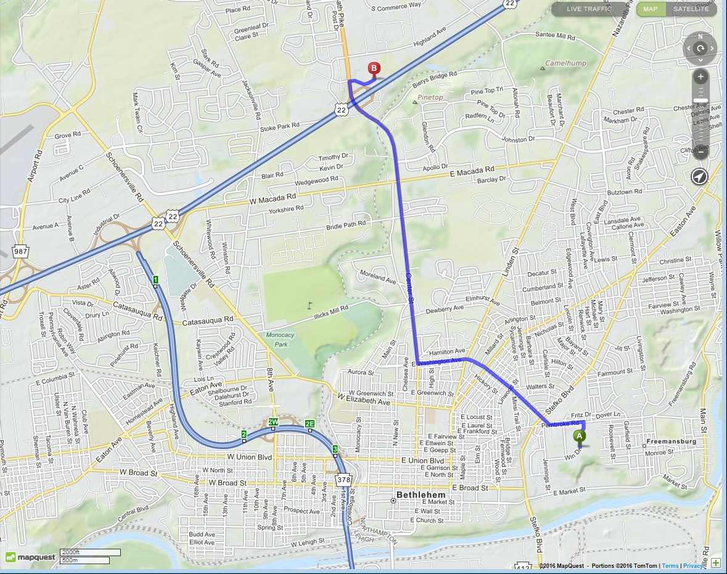

To see & to ask:
- How mixes are made? How stoichiometry is controlled? How the uniformity of the mix is controlled?
- Preparation for heat processing? What is the time of firing?
- What is the furnace size and what is the temperature uniformity in the furnace?
- What is the surface quality after thing are taken from the furnace?
- How the uniformity of the properties is tested after firing? (if tested)
- What machinery and tools are used for mechanical work? What is surface quality after machining?
- What glue is used to make big assemblies? Is there any non-glue (e.g. paste) solution to use during assembly (e.g. for heat removal purpose)?
- What are major factors that define parameters of the garnet?
- What properties of the material are measured and how?

Meeting March 29, 2016
Paul Oberbeck – the owner (president)
Ph: 610 867-7600
pbo@magneticsgroup.com

Goutam Das – plant manager
Phone: +1-610-867-6003 (x138) Fax: +1-610-867-0200
E-mail: goutam@magneticsgroup.com

Ashim Samanta – Process Engineer
Ph: 610 867-7600
ashim@magneticsgroup.com

Also presented several people that were responsible for different processes.

Talked with Ashim Samanta - overview of the processes at NMG. He promised to send his presentation file, but what I’ve got is just the titles.
Production line:
- Raw materials
- Milling
- Mixing
- Why the doping material are needed – to reduce the Ms and to change the Curie temperature.
- Drying
- Carbonizing
- Pressing and firing
- Critical steps to achieve needed properties (includes permeability, saturation magnetization, Curie temperature, thermal coefficients of permeability)
- Different processes to get the final shape (spherical powder)
- Hydrostatic pressure
- High temperature kilns
- Pressurized kiln is too small to process all the sectors for one garnet block.
- One layer layout for our work
- Mechanical shaping – very knowledgeable/enthusiastic manager
- Possible issues with the proposed way of handling the assembly Suggestion to make it simpler – to glue in the shop.
- Inspection of the line width of a resonance (ΔH) at 9.4 GHz
- Setup to measure the dielectric properties: ε and tg(δ) (in a cavity)
- Setup to measure hysteresis curves of the ferrite materials
- agreement to measure magnetization curve of the garnet.
- Trans-Tech flyer about the measurements of the permeability tensor.

Take a closer look:
- Nickel ferrites: NF 5000 NF5200 (4πMs = 5000 Oe 5200 Oe)
- Magnesium ferrites may provide some advantages
- M-20 material μ = 2000 and stable with T
- M3F (20) – tuner of the 10st harmonics cavity
- Alternatives for the Al garnet that reduce ΔH
- Dielectrics with different permittivity and temperature compensation !!

