Ferrite Ordering and Test Summary, 2013-2016

This report summarizes the key aspects involved in ordering and testing the ferrites necessary to build additional ferrite tuners for the Booster RF Cavities. The original ferrites (early 1970’s) were made by Stackpole Carbon (low Mu version) and Toshiba (High Mu version), both of these companies are now out of business. Bids went out to six companies in 2012, only two responded. We have very detailed specifications (see Engineering Specification No. O334.05-ES-63078 and 0334.05-ES-182403) and require a fairly large (8 inch) ferrites that few companies have the ability to manufacture. Fermilab received sample lots from both National Magnetics and Ceramic Magnetics. Ultimately, after several iterations, only National Magnetics was able to produce ferrites that met our specifications.

The last of our orders was filled by National Magnetics in Oct 2016. The total ferrites we have received in the last three years is: 260 high mu and 375 low mu. Each tuner requires 10 high mu and 18 low mu ferrites and we ended up building 19 new tuners. We now have 76 high mu and 33 low mu ferrites as spares.

All ferrites were measured and weighed to verify they were mechanically within specification. Next, they were all put in the low power test fixture and electrically measured with a vector impedance meter (HP 4193A) to find the resonant frequency and Q. Since high power testing was very time consuming (one hour per ferrite), approximately 10% of the total were tested in this mode.

Sample of physical measurements and low power test results:

|  |  |  |  |  |  |  |
| --- | --- | --- | --- | --- | --- | --- |
| Core # | data sheet mu | measured mu | Out Diam cm | In Diam cm | Thickness cm | mass grams |
| M4-2016-425 | 12 | 11.04 | 20.325 | 12.715 | 2.547 | 2103 |
|  |  |  |  |  |  |  |
|  |  |  |  |  |  |  |
| volume cm^3 | density gm/cm^3 | Qo | fo MHz | f low | f high | Inductance |
| 502.97 | 4.18 | 271 | 43.560 | 43.480 | 43.641 | 2.59E-08 |

Sample of high power test results:

|  |  |  |  |  |  |  |
| --- | --- | --- | --- | --- | --- | --- |
| **M4-2015-425 (after biasing)** | | |  |  |  |  |
| **Bias Current (A)** | **Setting (dBm)** | **Res. Freq. (MHz)** | **Forward Power (V)** | **Reverse Power (V)** | **Cav. V before HLE** | **Cav. V after HLE** |
|  |  |  |  |  |  |  |
| 3000 | 7.0 | 42.278 | 1.24 | 0.31 | 9.45 | NO HLE |
| 5000 | 7.0 | 42.553 | 1.23 | 0.27 | 10.52 | NO HLE |
| 10000 | 7.0 | 42.850 | 1.22 | 0.31 | 11.25 | NO HLE |

|  |  |  |  |  |  |
| --- | --- | --- | --- | --- | --- |
| **Q measurement** |  |  |  |  |  |
| **Bias Current (A)** | 0, before* | 3000 | 5000 | 10000 | 0, after* |
| **SG setting (dBm)** | NA | 7.0 | 7.0 | 7.0 | NA |
| **Max Cavity Voltage (V)** | NA | 9.45 | 10.52 | 11.25 | NA |
| **Resonant frequency (MHz)** | 43.560 | 42.278 | 42.553 | 42.850 | 45.272 |
| **f1** | 43.480 | 42.232 | 42.518 | 42.818 | 45.198 |
| **f2** | 43.641 | 42.321 | 42.587 | 42.883 | 45.350 |
| **Q** | **270.6** | **475.0** | **616.7** | **659.2** | **297.8** |
| * with low power fixture |  |  |  |  |  |
|  |  |  |  |  |  |

Tuner stacking sample:

|  |  |  |  |  |  |  |  |  |  |  |  |  |
| --- | --- | --- | --- | --- | --- | --- | --- | --- | --- | --- | --- | --- |
|  | Tuner 10 | |  |  |  |  |  |  |  |  |  |  |
|  | **Core #** | **mu** | **mass** | **density** | **fo MHz** |  |  | **Core #** | **mu** | **mass** | **density** | **fo MHz** |
|  |  |  |  |  |  |  |  |  |  |  |  |  |
| 1L | M4-343 | 10.2 | 2033 | 4.04 | 44.34 |  | 1R | M4-259 | 11.0 | 2033 | 4.04 | 43.60 |
| 2L | M4-216 | 10.9 | 2052 | 4.08 | 43.71 |  | 2R | M4-230 | 11.0 | 2052 | 4.09 | 43.58 |
| 3L | M4-347 | 10.4 | 2077 | 4.13 | 44.13 |  | 3R | M4-188 | 11.1 | 2079 | 4.15 | 43.69 |
| 4L | M4-359 | 10.5 | 2099 | 4.17 | 44.02 |  | 4R | M4-354 | 10.7 | 2101 | 4.18 | 43.84 |
| 5L | M4-351 | 10.6 | 2107 | 4.19 | 43.95 |  | 5R | M4-330 | 10.9 | 2107 | 4.19 | 43.72 |
| 6L | M4-368 | 10.9 | 2133 | 4.23 | 43.66 |  | 6R | M4-291 | 11.7 | 2126 | 4.23 | 43.02 |
| 7L | M4-285 | 11.9 | 2137 | 4.26 | 42.81 |  | 7R | M4-289 | 11.7 | 2137 | 4.26 | 42.96 |
| 8L | M4-108 | 11.6 | 2166 | 4.31 | 43.23 |  | 8R | M4-224 | 11.8 | 2168 | 4.31 | 42.88 |
| 9L | M4-155 | 12.1 | 2205 | 4.39 | 42.82 |  | 9R | M4-127 | 12.2 | 2203 | 4.39 | 42.68 |
| 10L | M3-134 | 19.3 | 1918 | 3.82 | 37.67 |  | 10R | M3-153 | 19.5 | 1924 | 3.83 | 37.53 |
| 11L | M3-233 | 23.1 | 2065 | 4.11 | 35.67 |  | 11R | M3-261 | 23.0 | 2070 | 4.11 | 35.70 |
| 12L | M3-175 | 23.5 | 2089 | 4.16 | 35.48 |  | 12R | M3-284 | 23.8 | 2097 | 4.16 | 35.35 |
| 13L | M3-240 | 23.8 | 2108 | 4.19 | 35.34 |  | 13R | M3-223 | 23.7 | 2102 | 4.19 | 35.40 |
| 14L | M3-289 | 24.2 | 2114 | 4.21 | 35.16 |  | 14R | M3-244 | 24.2 | 2118 | 4.21 | 35.16 |
|  |  |  |  |  |  |  |  |  |  |  |  |  |
| |  | | --- | |  | |  |  |  |  |  |  |  |  |  |  |  |  |
|  |  |  |  |  |  |  |  |  |  |  |  |  |
|  |  |  |  |  |  |  |  |  |  |  |  |  |
|  |  |  |  |  |  |  |  |  |  |  |  |  |
|  |  |  |  |  |  |  |  |  |  |  |  |  |
|  |  |  |  |  |  |  |  |  |  |  |  |  |
|  |  |  |  |  |  |  |  |  |  |  |  |  |
|  |  |  |  |  |  |  |  |  |  |  |  |  |

Figure 1 is a block diagram of the equipment used for the high power test.

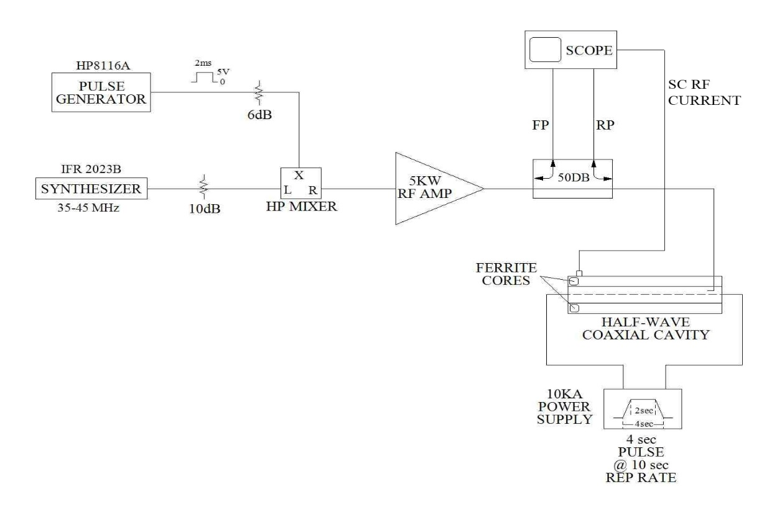

Figure 1

Figure 2 shows the coaxial cavity and associated equipment used for the high power test.

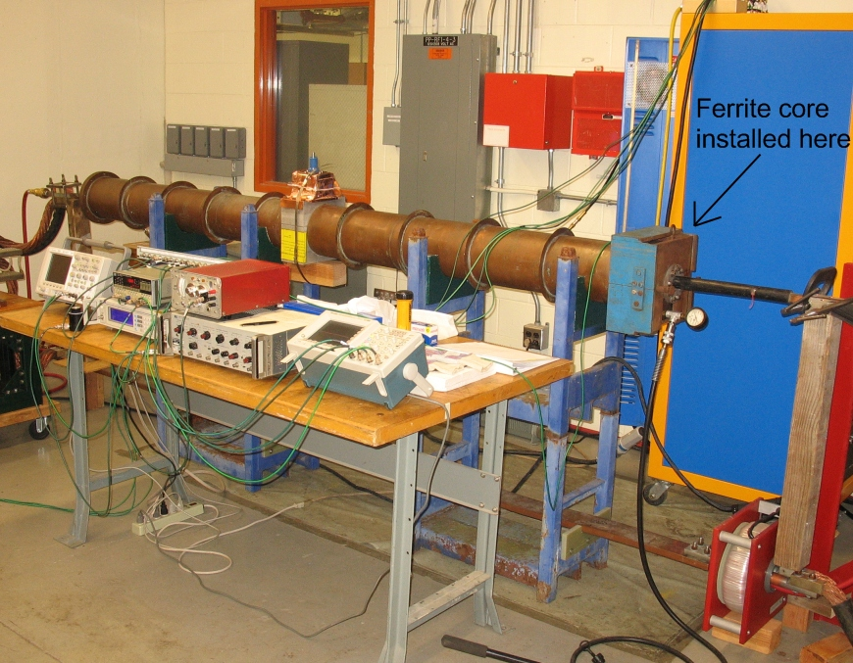

Figure 2

After the first hundred or so ferrites were received and tested, the very long high power test procedure was fine tuned in order to speed up the testing. For the high current pulse supply, the original 4 second pulse @ 10 second rep rate was reduced to a 400ms pulse @ 4s rep rate. This was the shortest pulse possible while still reaching the 10KA level with a reasonable flat top, and the lower duty cycle kept the equipment running much cooler and with fewer trips. The full test was then as follows:

1. Place the ferrite core being tested inside the fixture.
2. Adjust High Power tune knob to approximately 1/2 inch position:
3. Turn on the high current power supply (HCPS).
4. Increase the flattop current (in 1,000 A increments per pulse) all the way up to 10,000 A. Bring the current back down to 0 A.
5. With the HCPS set to 3000 A:
   1. Turn on the 5 kW RF Amp and set to full power.
   2. Increase the RF signal gen to 0dBm and tune the generator to the frequency that provides the greatest gap voltage, then tune test fixture knob for a minimal amount of reverse power and max gap voltage.
   3. Increase power to 7dBm, retune signal generator for minimum reverse power/ max gap voltage. Record the resonant frequency, Reverse power, Forward power, and gap voltage.
   4. Verify whether or not the high loss effect is occurring.
   5. If it is not occurring, increase and decrease signal generator frequency to reach .707 of max gap voltage and record these frequencies in order to calculate Q.
6. Adjust High Power tune knob to zero position (no further adjustment needed) and repeat step 5 with the following bias current levels:
   1. 5,000 A
   2. 10,000 A
7. Turn off the HCPS and the RF amplifier and start this procedure over with a new core.

Due to our strict specifications, it took National Magnetics over a year to perfect their manufacturing process and produced consistent ferrites. Then it often took over two months for National to produce a batch of ferrites for us, whether it was a test batch of five or a full batch of 50. It is the likely scenario that should we need more of these ferrites years down the road, the longer the time line is, the longer the time it will take National to “re-learn” how to produce these ferrites. On a side note, Ceramic Magnets, Inc. is now a division of National Magnetics Group, and therefore makes National the only company in the U.S. that can produce these ferrites.

Relevant documents:

High Power RF Testing of Ferrite Cores, 8/29/2012

Report on High Mu National Magnetics Sample Ferrite Toroids, RF Department Technical Note # 95, August 2013

Ferrite Toroid (Ui = l2.5) Engineering Specification, 0334.05-ES-63078

Ferrite Toroid (Ui = 20) Engineering Specification, 0334.05-ES-182403

All documents and test data located here:

\\beamssrv1\ Projects\HLRF\New Ferrites_Booster RF Cavities