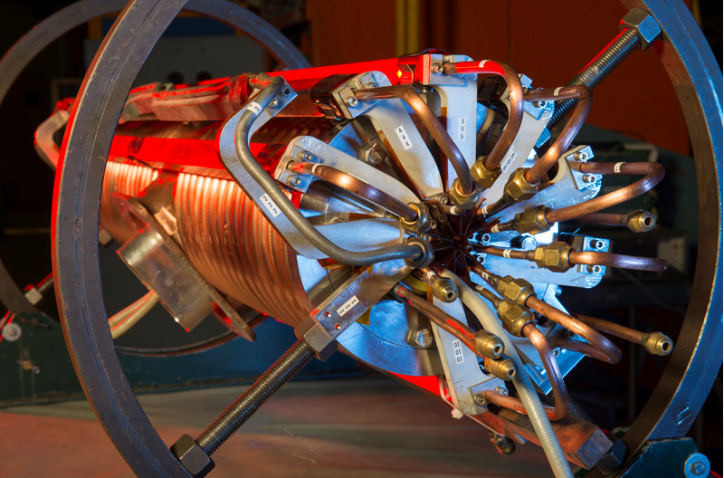
New Booster RF Cavity Tuner Photo credit: Reidar Hahn

Overview and Timeline
In 2012 design and procurement began for new Booster RF cavity tuners, as part of the Proton Improvement Plan (PIP). These tuners were largely based on the existing design with a couple of changes. Production began in Technical Division at IB2 by technicians Steve Sorenson and Chuck Pribyl. TD engineering support was provided by Bill Robotham, inventory control/procurement was under the direction of John Zweibohmer. A prototype was completed in May of 2014, and the first full production tuner assembly was completed in March of 2015. 19 tuner assemblies were built by August of 2016. In 2012 planning called for building a total of 60 new tuners, or enough to completely replace the original tuners. However, initial data appeared to show refurbished tuners were adequately reliable. Consequently, the new tuner production was descaled to only the first phase, or about 20 tuners.

Design
Two major components of new tuner design differ from the original, as well as a couple minor changes. The two different components are the outer buss conductors, and the mating connecting buss/fingers. The original buss was simply a copper bar with 3/8in copper tubing brazed to the top surface. These were prone to mechanical damage and therefore often replaced. A new design was proposed by Mike May, consisting of an extruded buss bar with an integral cooling channel. This was adopted, and 3/8in copper tube was brazed into the ends of the bar. The connecting finger also had to be redesigned with a notch in between the bolt holes to allow for the water channel.
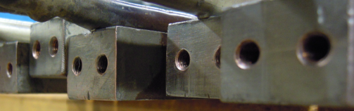  Outer buss | 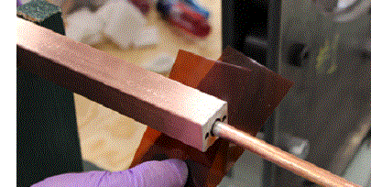  New design, outer buss
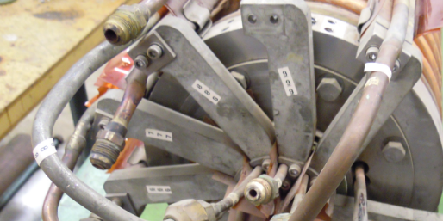  Outer buss and fingers, original | 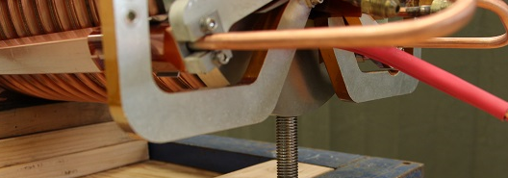  Outer buss and fingers, new design

There are also components made with different processes or materials, but are functionally equivalent to the original. These include the outer shell assemblies (machined instead of brazed), and the cooling cone assemblies (cast aluminum with imbedded cooling instead of copper casting with brazing copper cooling lines). The aluminum cooling cones were also implemented in refurbishment process of the original tuners. Lastly, the stainless end flanges of the later tuners produced by TD have a slightly different mounting bracket, designed to accept 3/8in hoist rings for easier rigging. These are sometimes removed from the tuner and replaced with the original bracket before installing on an RF cavity.
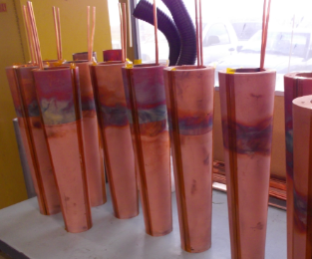  Original copper cones | 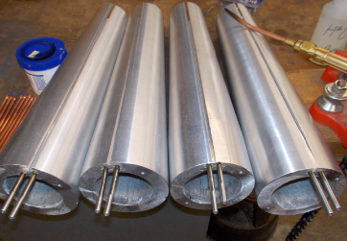  New aluminum cones

Production
New tuner production was a combination of effort between TD and AD labor. Nearly all the components were stocked at Industrial Building 4 (IB4) as controlled inventory. All assembly work was controlled and documented with travelers issued by TD engineering. Final assembly of the tuner took place at IB2. However, most of the inner buss package sub-assemblies (F00496030), and cooling cone assemblies (F00496031) were assembled and produced at MI60 by AD Mechanical Techs. Ferrites were supplied directly by the RF Department, along with the specific stacking order (recipe) for each tuner assembly.

Testing
Initial acceptance testing (hipot) of the final assembly was performed at IB2, final testing was completed by the RF Department after the assembly was shipped to MI60. In addition to final testing at MI60, the generic new tuners were configured for either front, bottom, or back installation locations on the cavity. This included high voltage or flex cooling lines pulled through the tuner, stem installation, and two specific outer conductor buss bars. All later tuners were fitted with thermocouples epoxied to the inside of the stem, with the cable run out through the center of the tuner.

Personnel

Management/Engineering
Bill Pellico (L1 PIP mgr), Keith Gollwitzer (L2 PIP mgr), John Reid (L3 PIP mgr and RF Dept head), Matt Slabaugh (L4 PIP mgr AD/MSD Mech engineer), Pat Sheahan (RF Dept engineer), Bill Robotham (TD Mech engineer)

Mechanical Technicians
Steve Sorenson (IB2), Chuck Pribyl (IB2), Jeff Duncan (AD), Mike Piekarski (AD), Ryan Montiel (AD), Paul Schilds (AD), Ken Klotz (AD), Gerik Wysocki (AD), Sathapat Sukkert (AD)

RF Technicians
John Holm (AD RF)

Appendices
- New Tuner Parts List
- TD Parts inventory October 2016
- Sample Travelers
- Sample final test sheet
- Copy of assembly drawing
- Risk Assessment

