PROTON IMPROVEMENT PLAN
BOOSTER UPGRADE STATIONS 21 AND 22
10 JAN 2017

- UTILITIES:

- ELECTRICAL – BWG-124 is completely wired except for the 480 VAC which comes from Linac Breaker Panel DHP-L4-1.

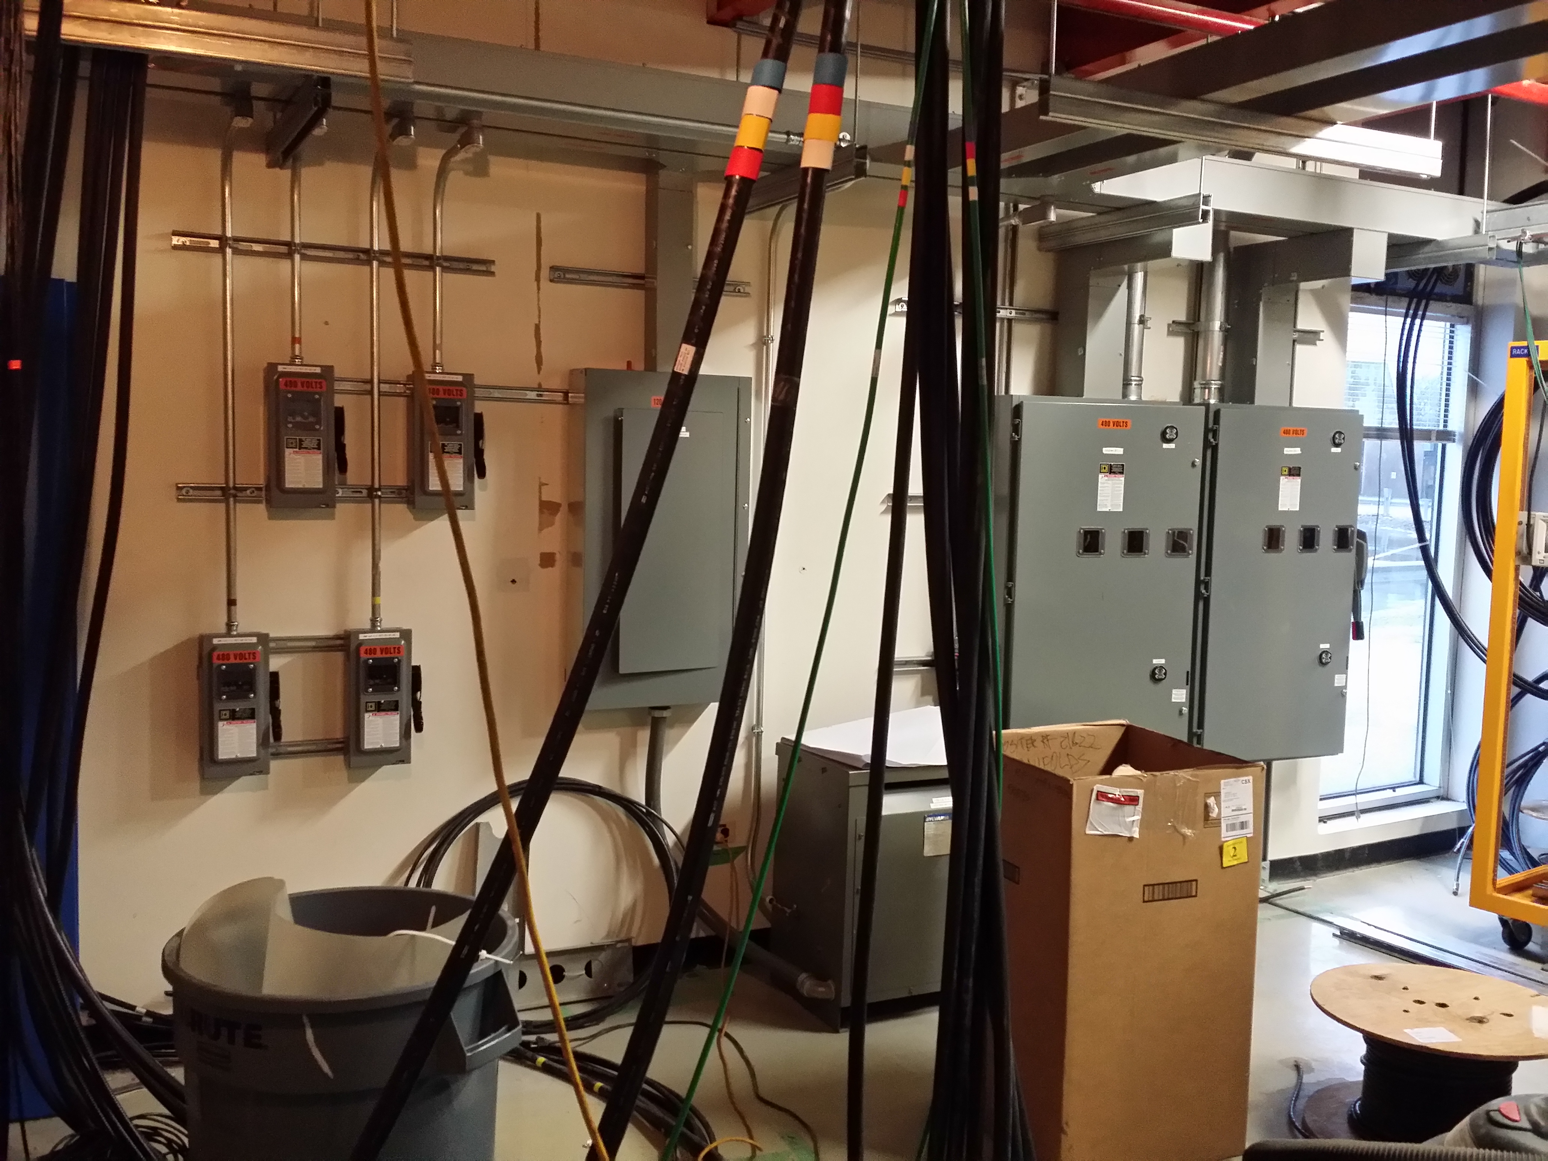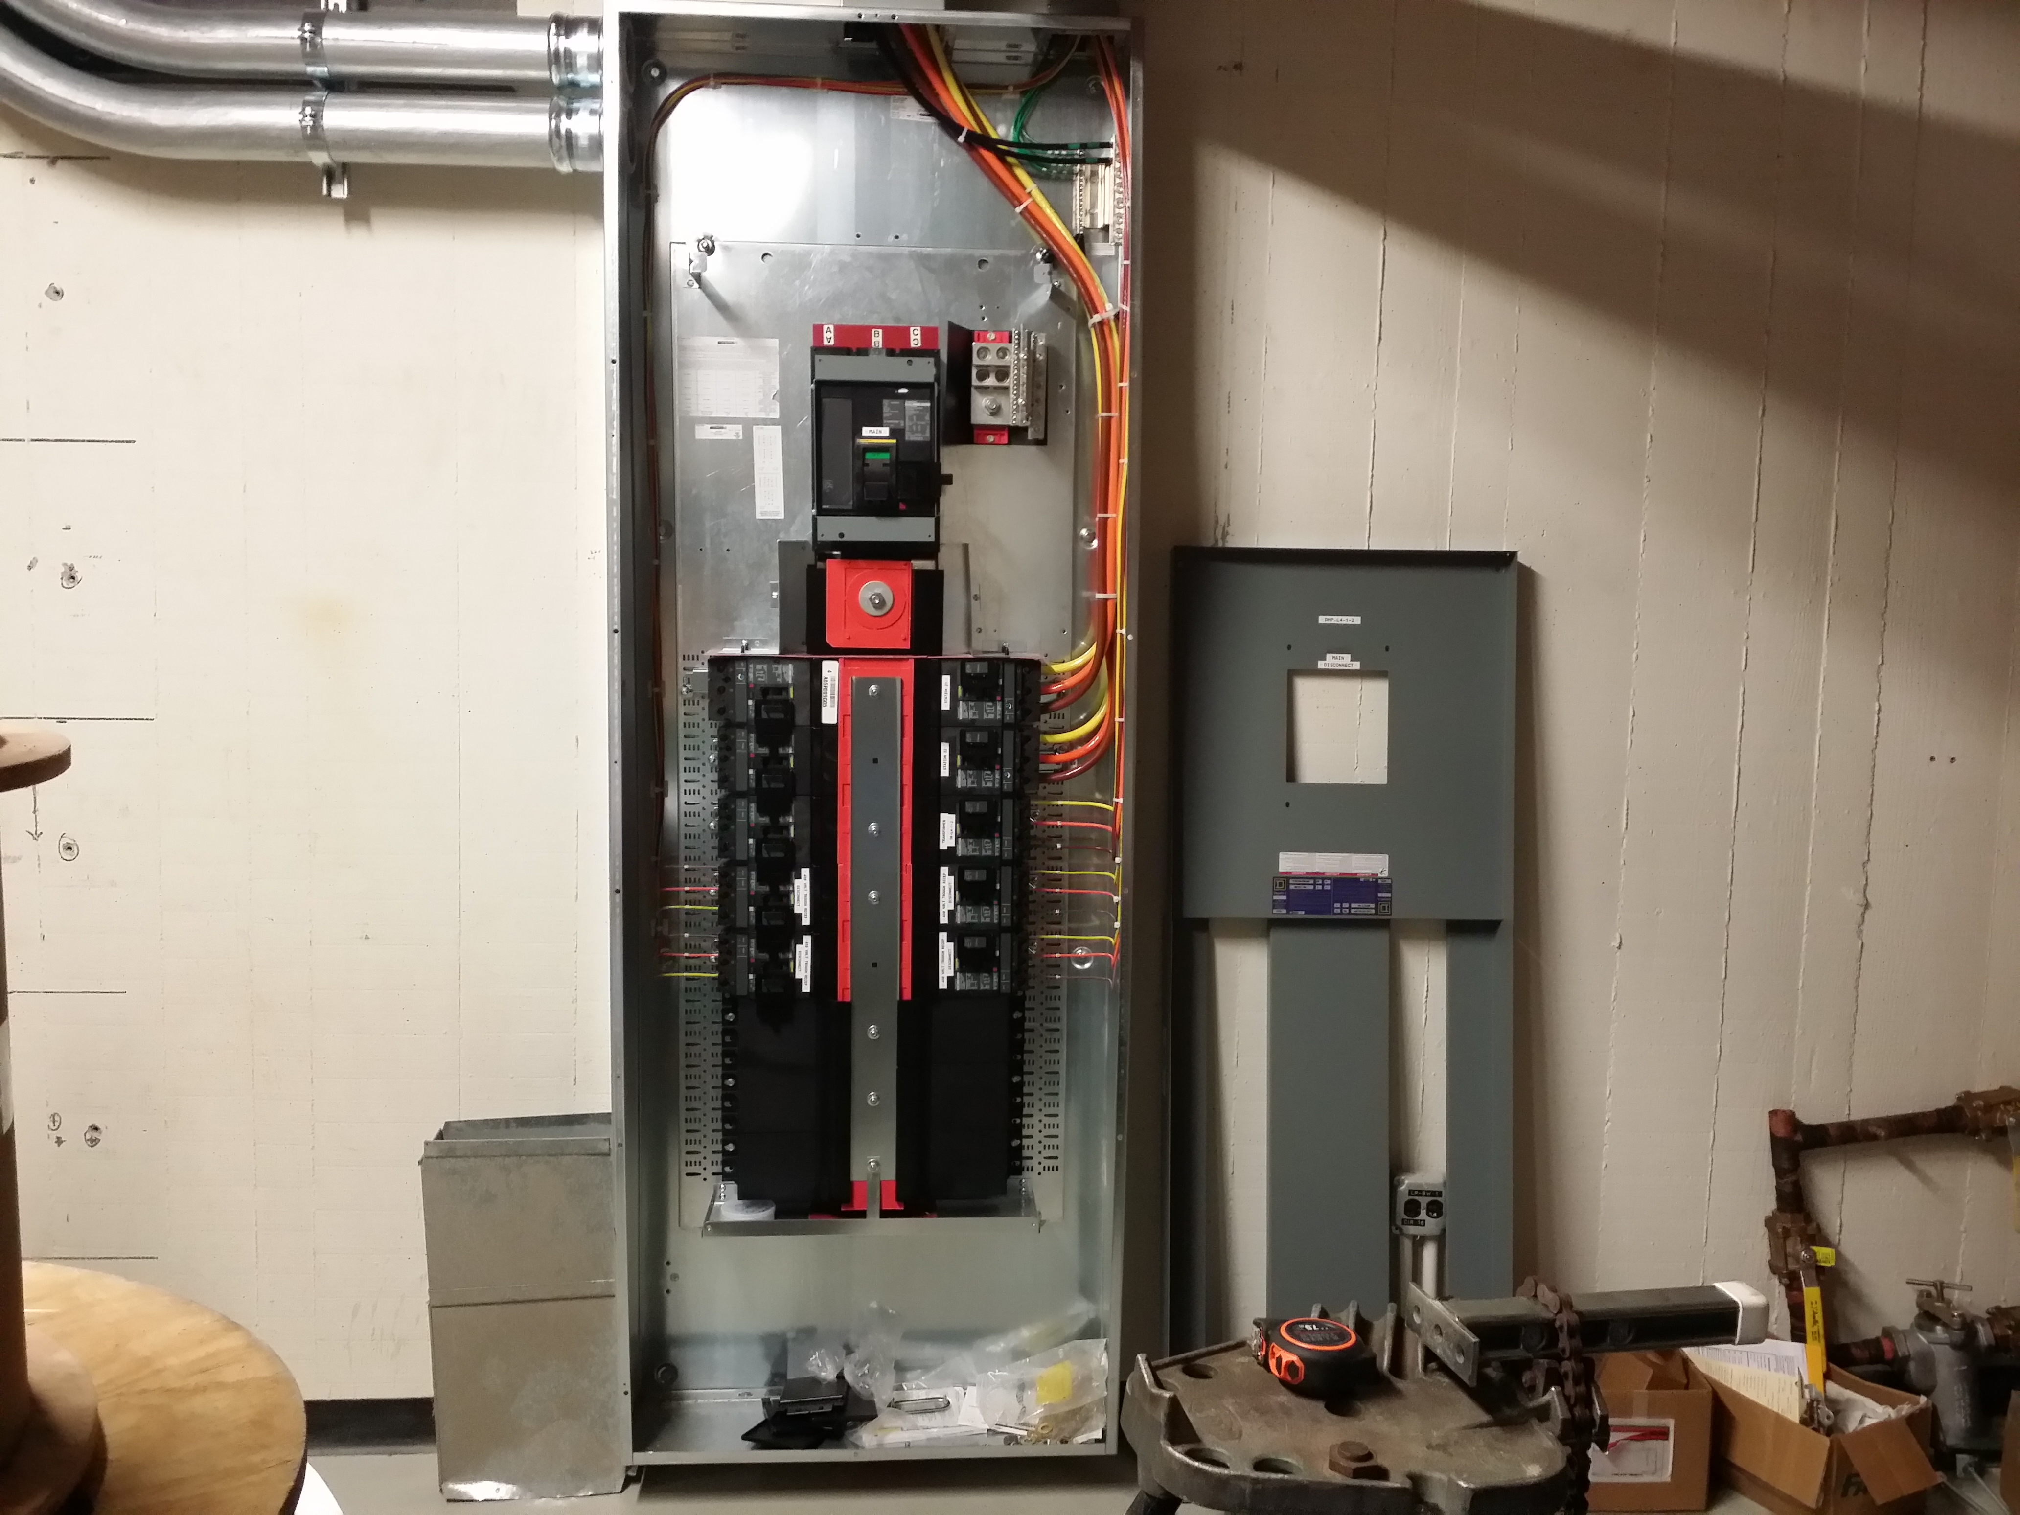

- LCW – Manifolds are partially fabricated. Techs are going to mount the manifolds and bring copper pipes out of room BWG-124 to West Gallery. David Hixson wants to have a meeting to discuss best solution to connect LCW from Gallery to the room.

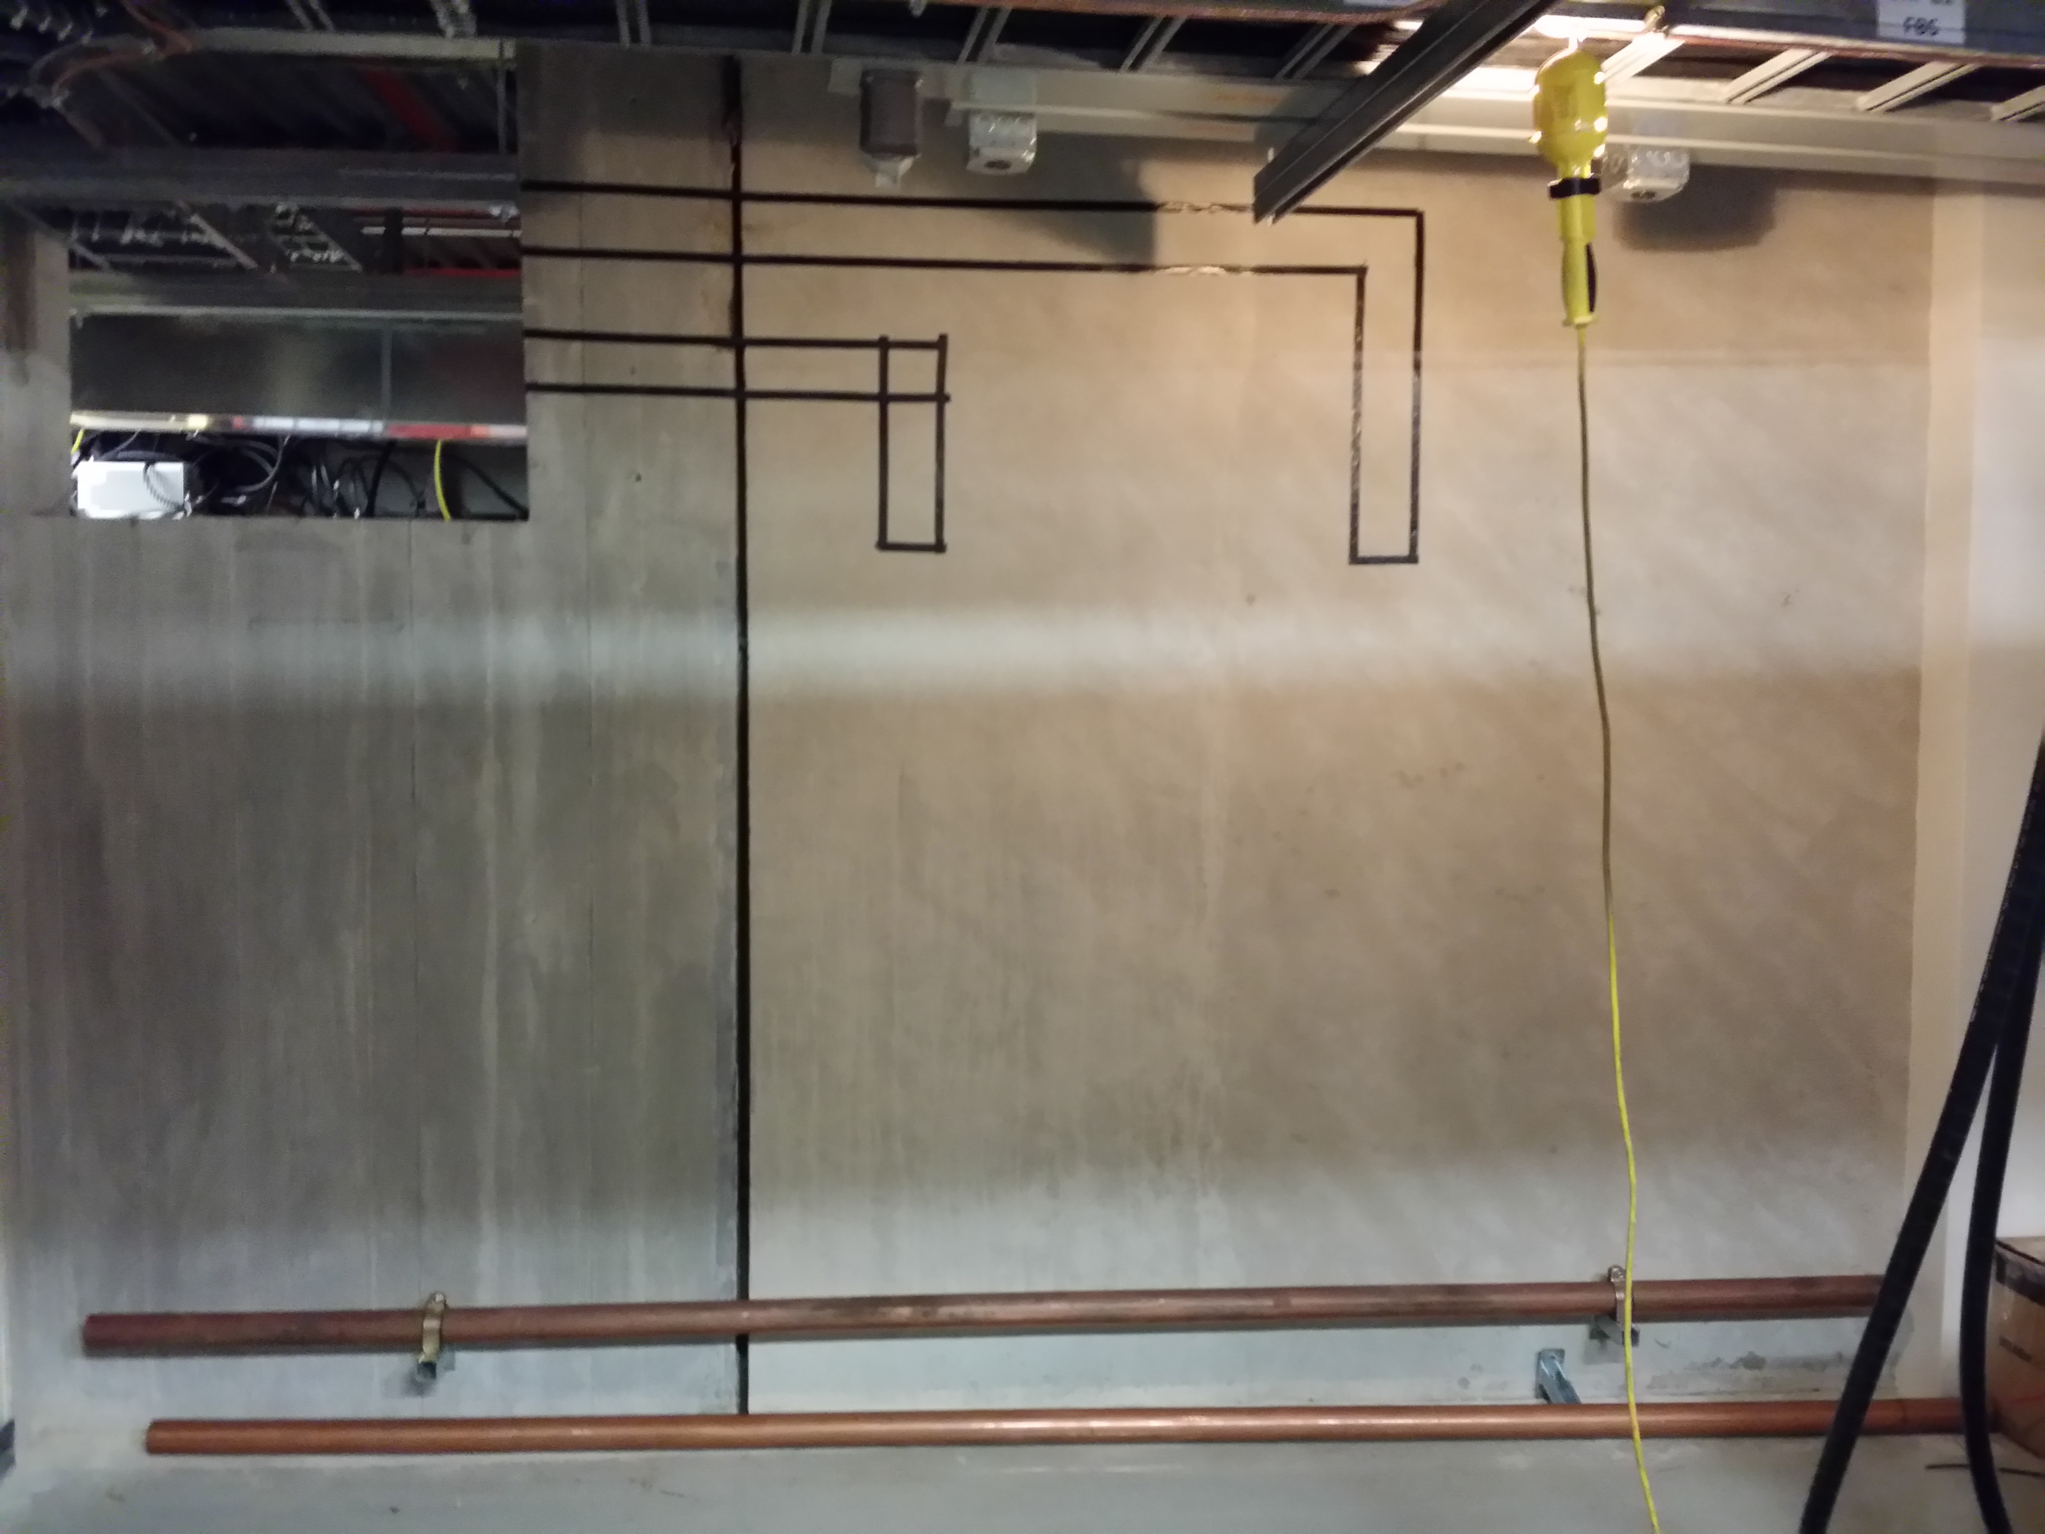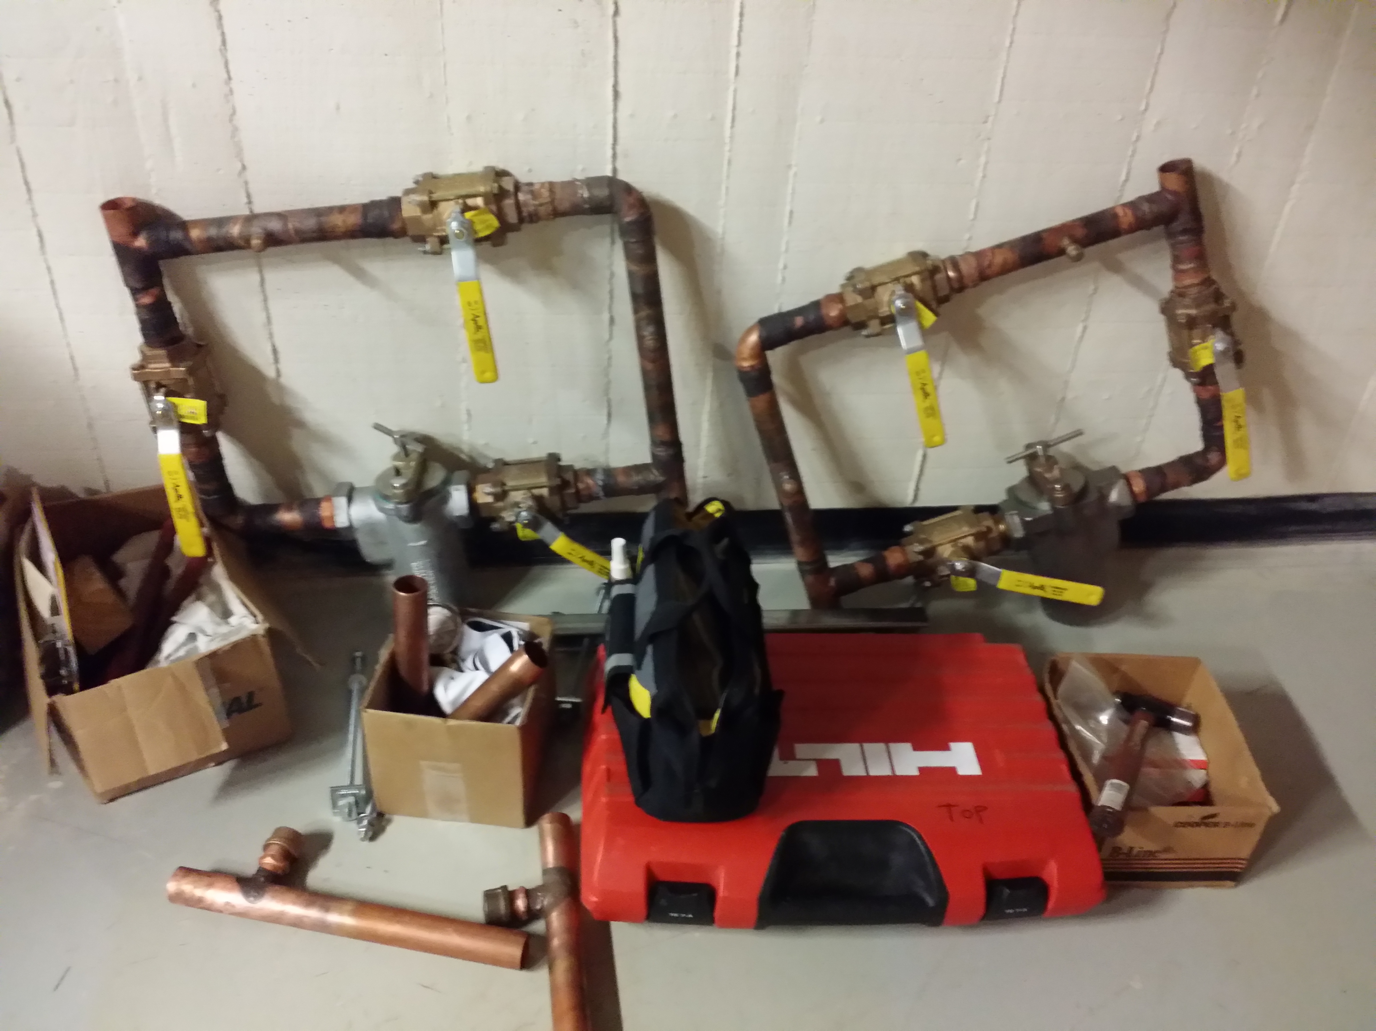

- HVAC – No status report on cooling system for the room yet. Need to contact FESS and see if they came up with a cooling unit for the room and when it can be installed.

- Bus Bars – Drawings have been generated for the Bus Bars, which go from the penetration into the room BWG-124.

- Solid State Driver Racks – The SSD racks are in place. Need to make the delay line, terminate and phase match cables and order LCW strainers.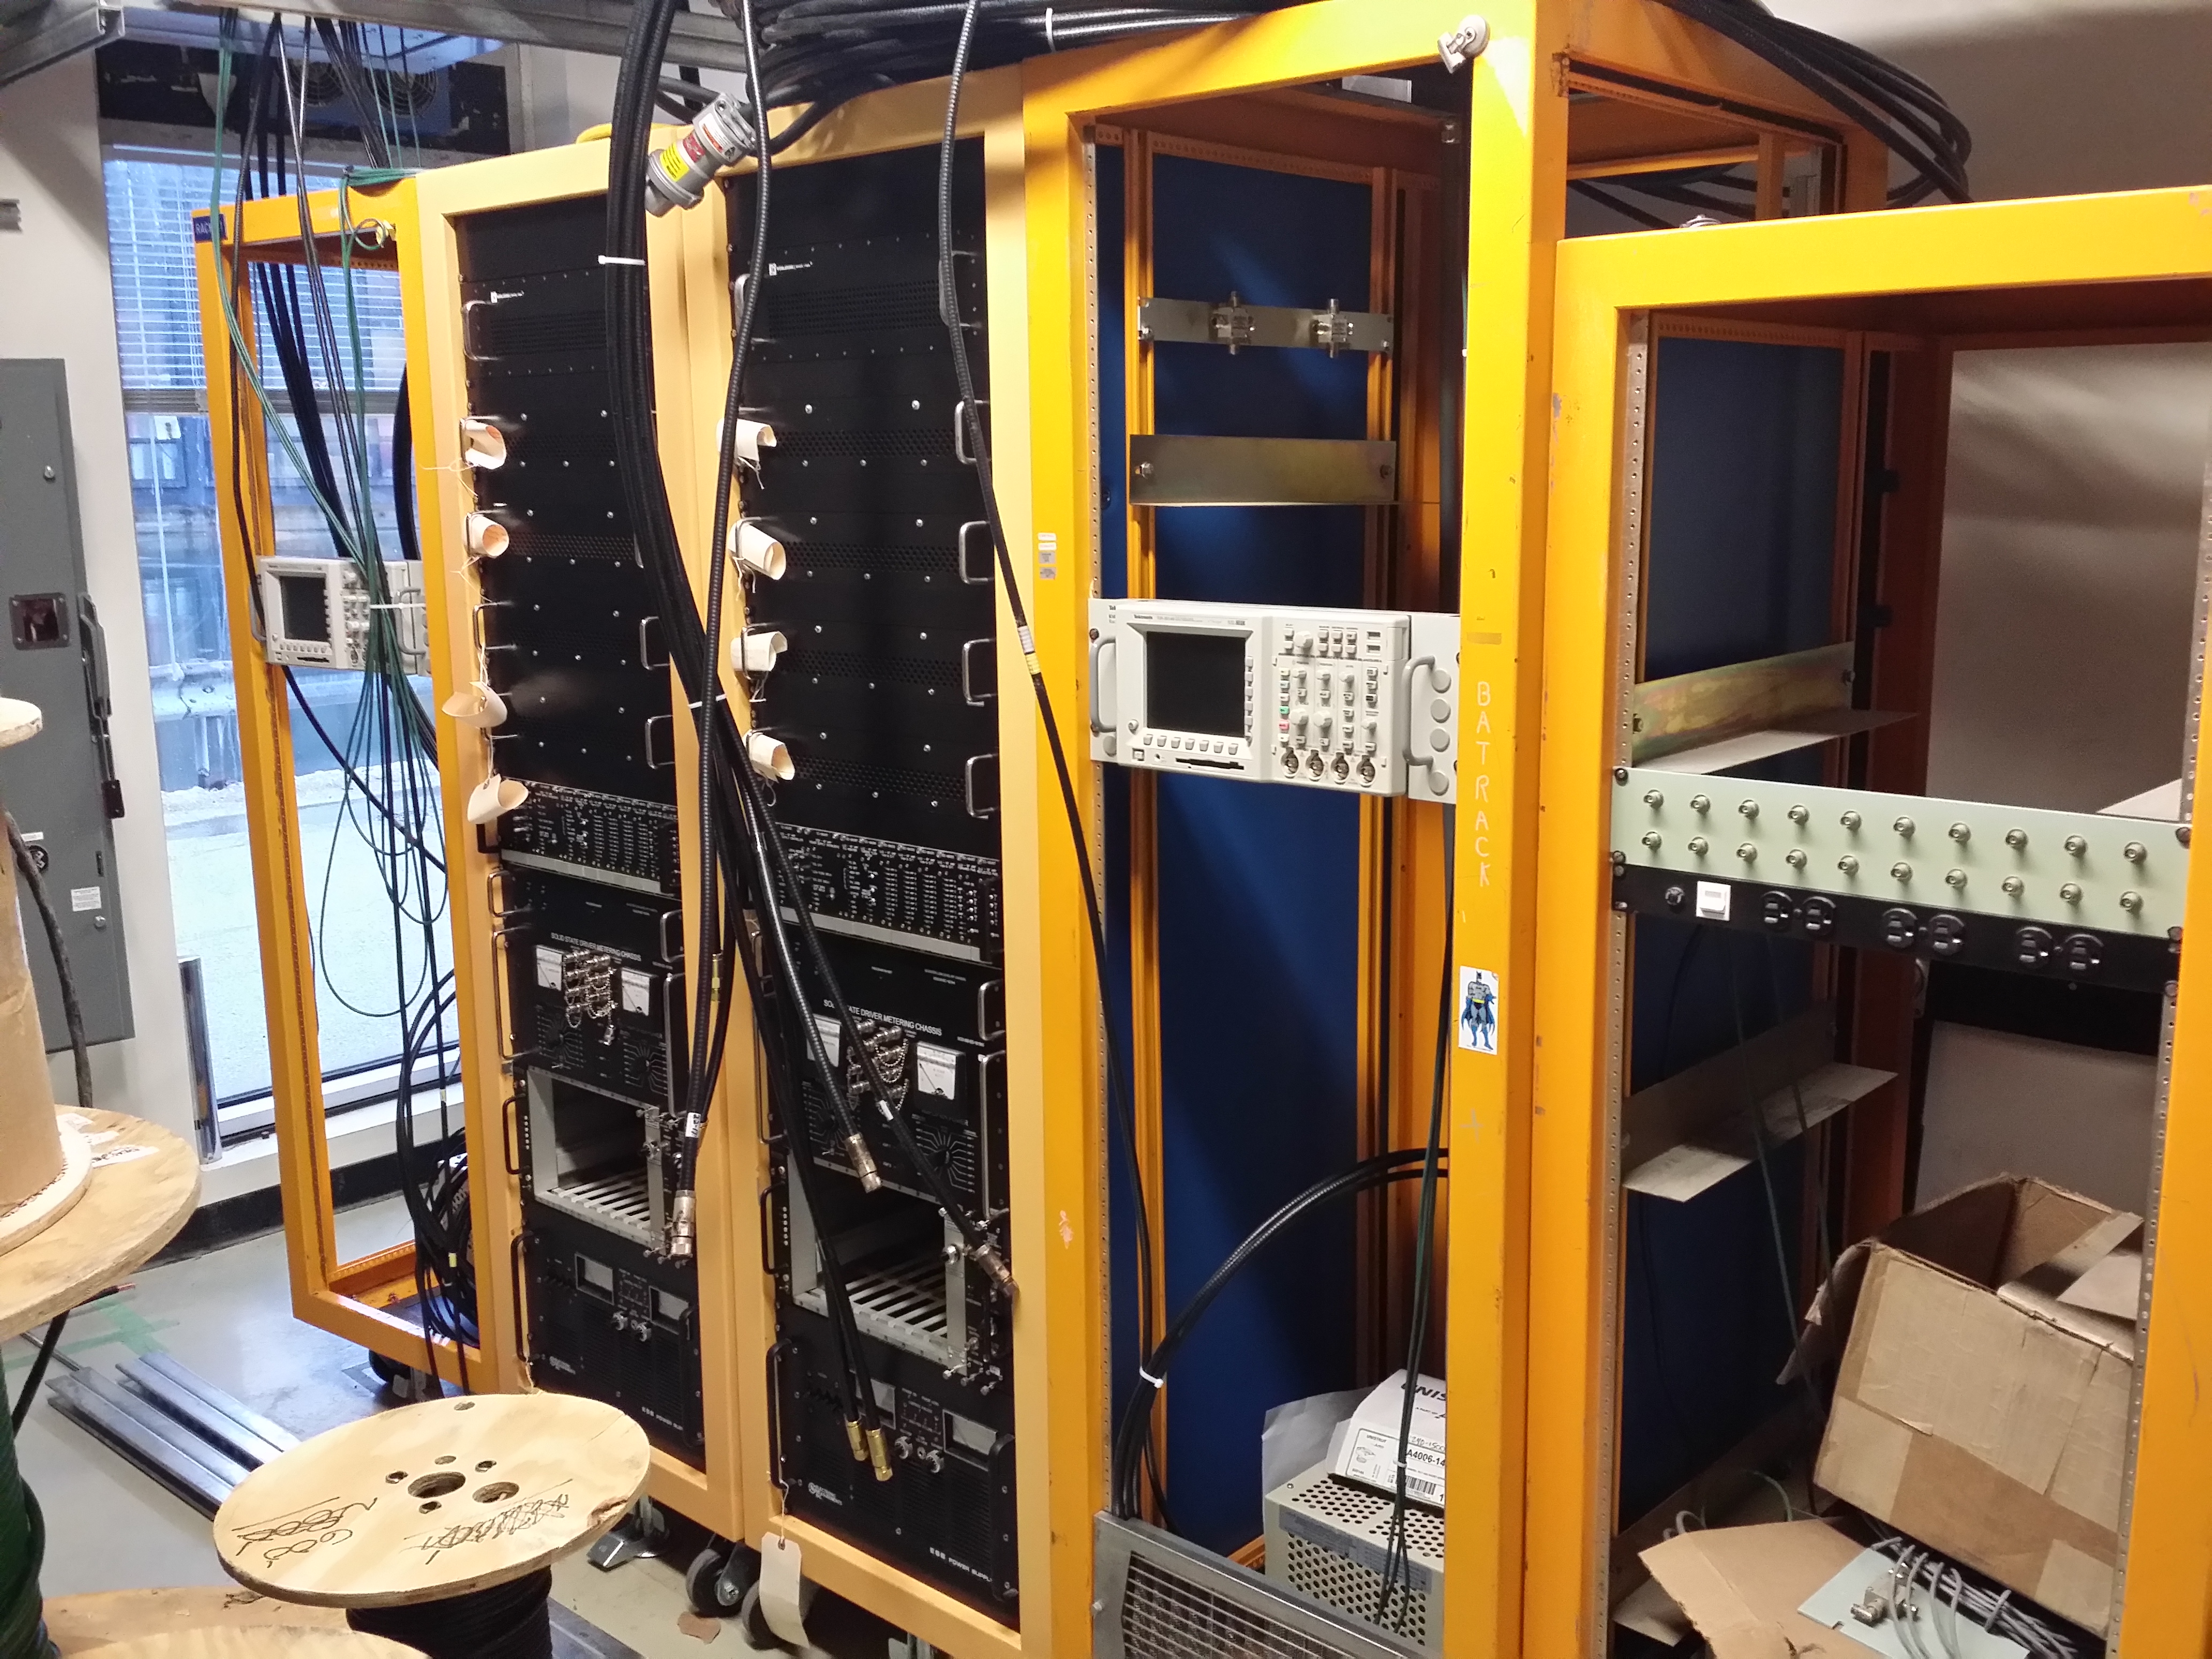

- RMU Racks – The racks are in place but only have a scope mounted. Schematics, Mechanical drawings and parts are being bought and gathered to build the following:

- Phase Detector
- Digital Cross Connects
- MEIU’s
- A to D box
- Misc. Cables

- Modulator - 2 Modulators out at MI-60

- Bias Supply – Need more info.

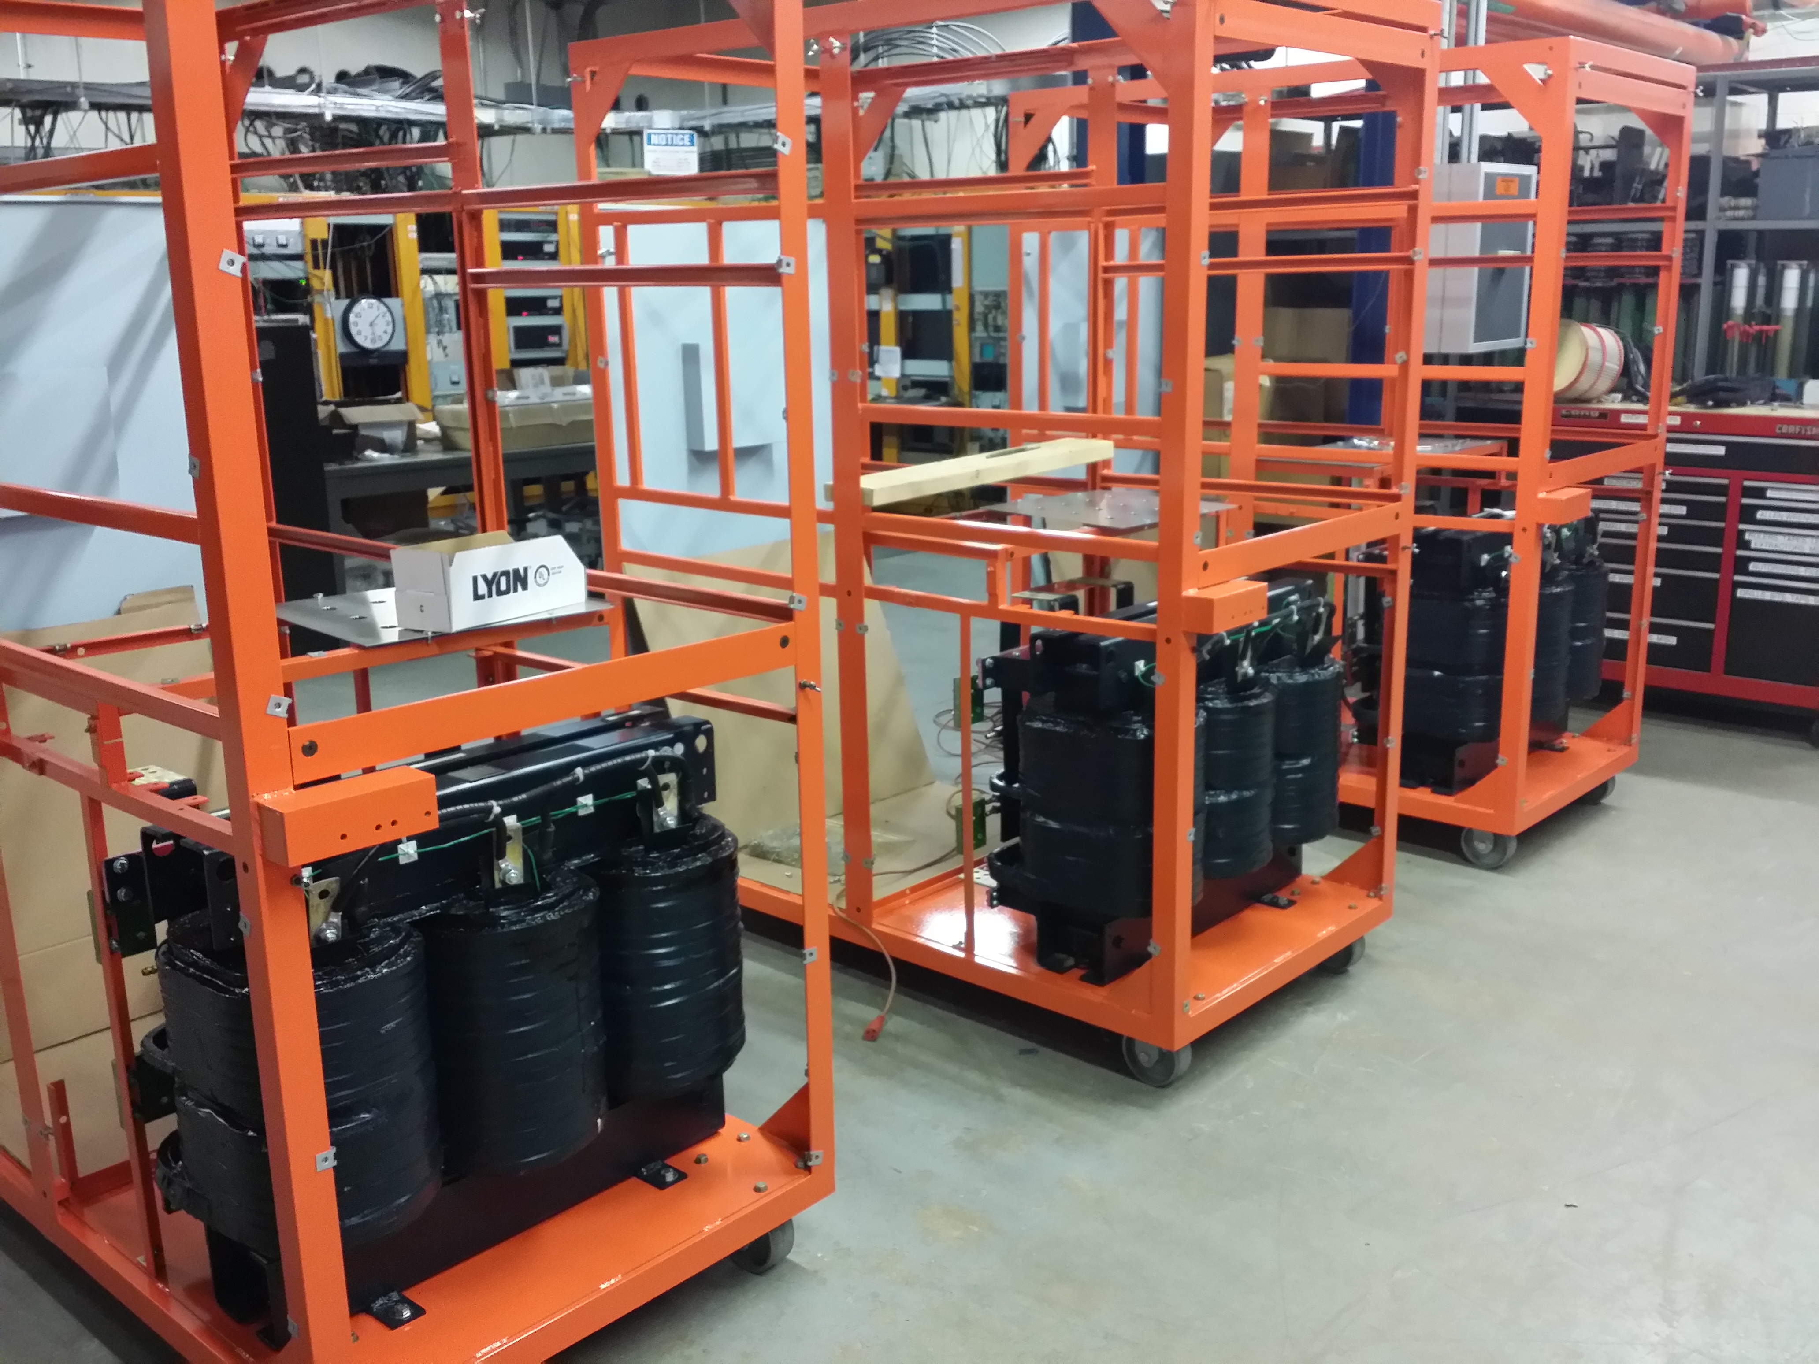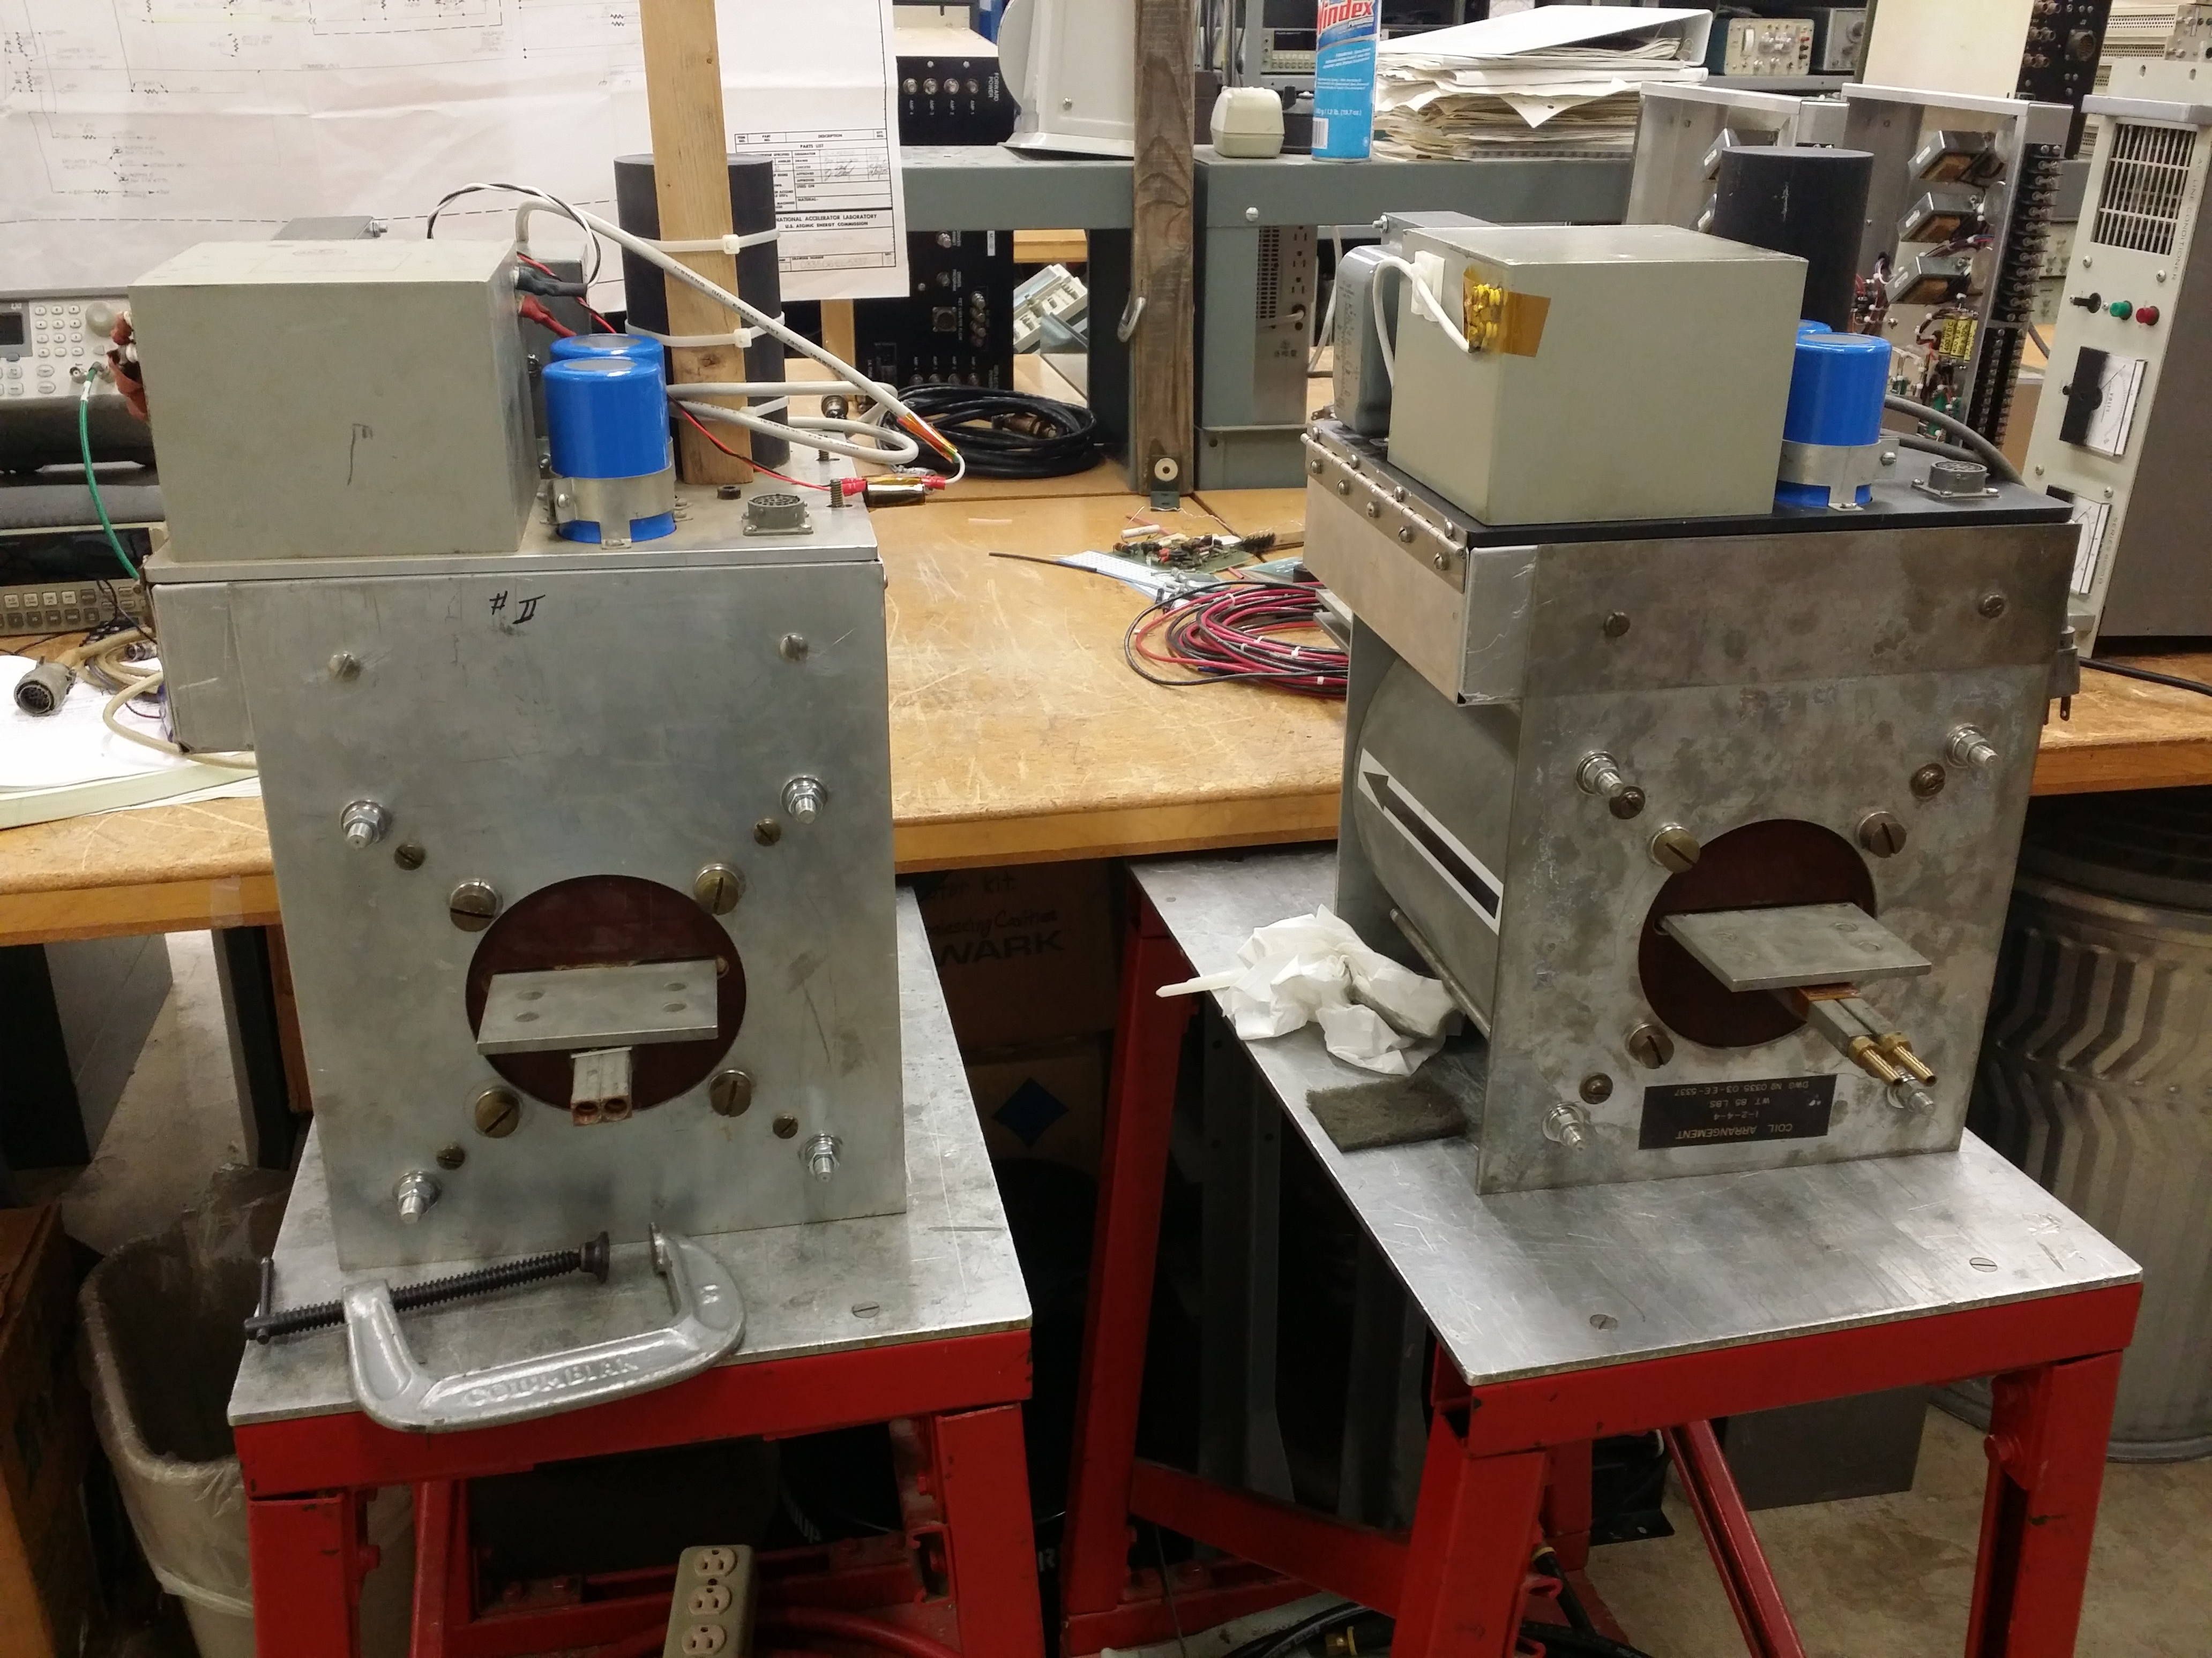

- Program Boxes:

- Run 4 program cables from station #17 to BWG-124
- Run water leak daisy chain
- Run scope trigger
- Run Trig1 and Trig2

- RCC Rack:

- Cables need termination
- Spark Detector Cable
- Anode Inhibit pulled and terminated
- RF Gate installed at RCC Rack.

