**Eddy Currents in the RF Shell of the Tunable Cavity**

1. **Introduction.**

In summer 2016, a 2D analysis was made on possible impact of eddy currents in the shell of the tunable 2-nd harmonic cavity of FNAL Booster, which is in the development stage at FNAL. This analysis was built based on the proposed in [1] conceptual design of the magnetic system of the cavity. Fig. 1 shows a sketch of the cavity tuner with the magnetic system consisting of the solenoidal coil and a flux return and with the RF shell (in bold).

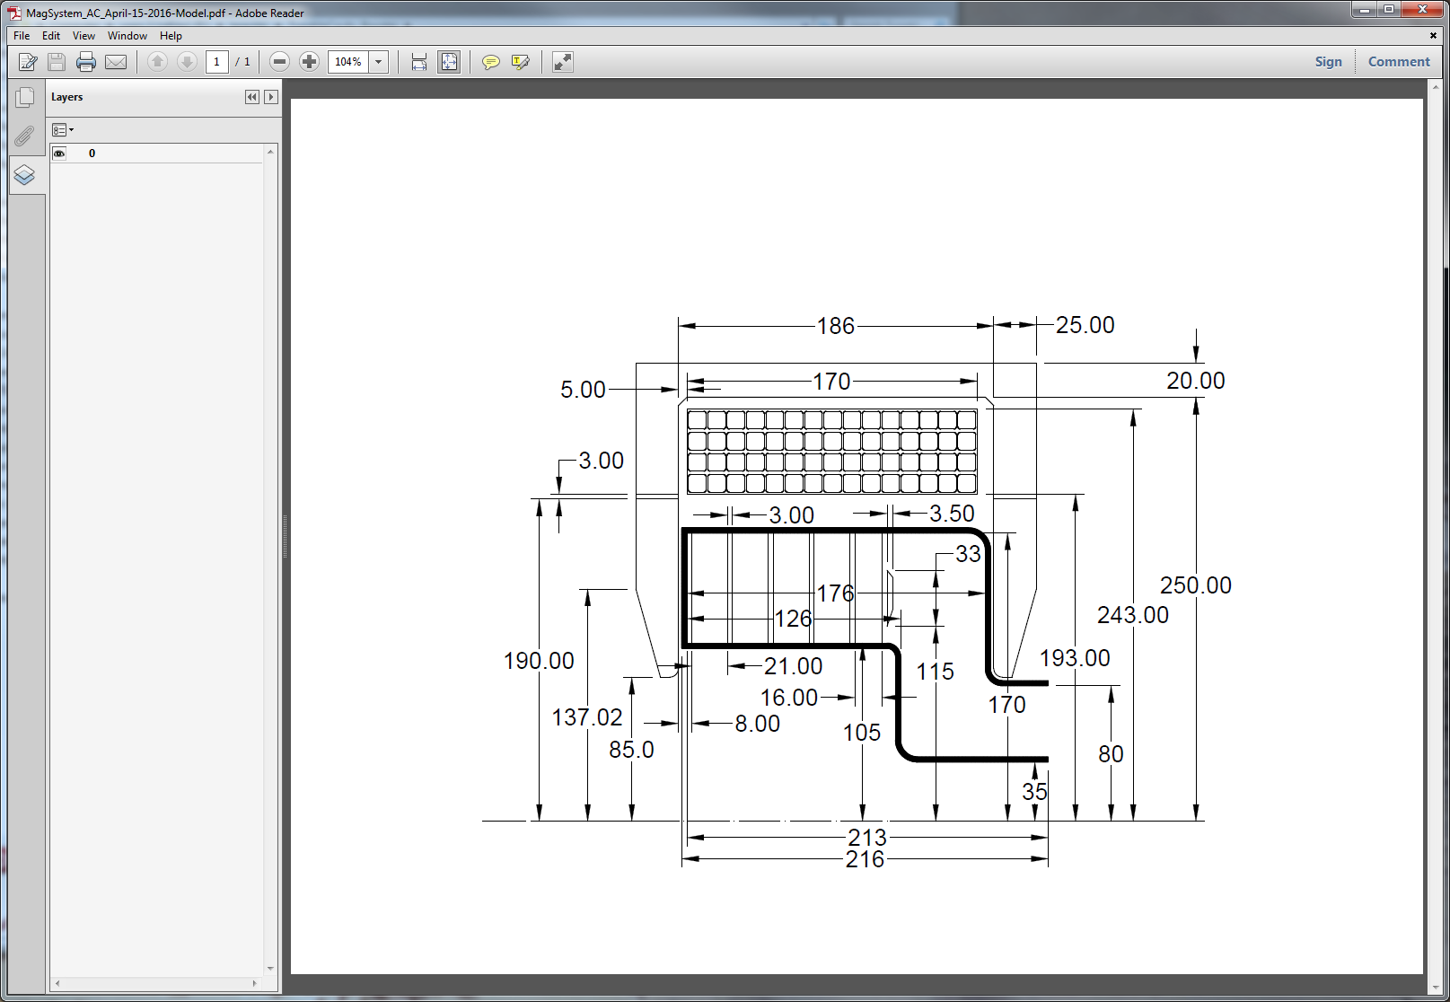

Fig. 1. Geometry accepted during the 2D eddy current study

To meet the cavity frequency ramp requirement [2], a very specific current ramp in the bias magnet must be supported. Inevitably, this ramp results in eddy currents in all structural elements of the cavity tuner. To evaluate the impact of the eddy currents, a simplified current pulse shape was accepted in [1]; it is shown in Fig. 2 for the number of turns N = 50 in the bias coil. The current ramp rate (in terms of Ampere-Turns) reaches 3000 A/ms. For the initial (setting) ramp, this rate was ~1000 A/ms. The total length of the pulse was ~50 ms, which is consistent with the required 15 Hz operational repetition rate.

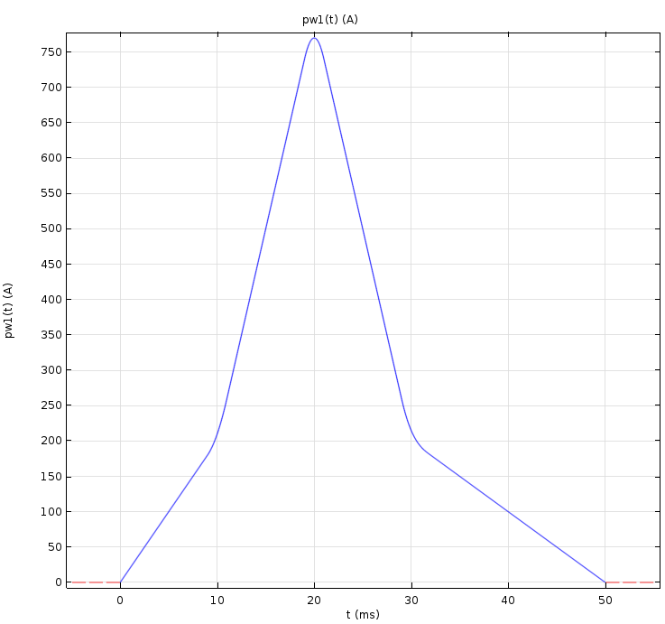

Fig. 2. Simplified current ramp used for the 2D eddy current impact study; N = 50.

For three millimeter thick stainless steel shell with 20 µm copper coating, the shell seemed sufficiently magnetically transparent. Maximum eddy current generated in the shell was 1200 A, which is ~10% of the total current at the injection stage. More problematic was expected heat deposition in the shell due to this current: ~900 W in the outer part of the shell and ~300 W in the inner part. Fig. 3 shows the induced current density in the shell at the moment t = 22 ms.

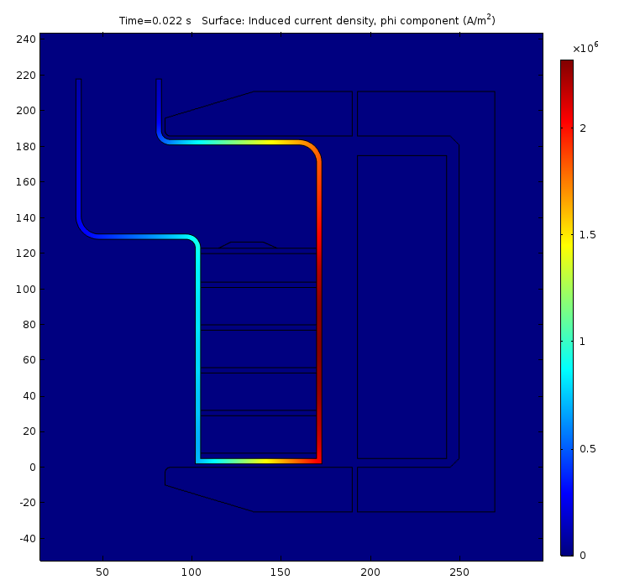

Fig. 3. Induced current density in the RF shell of the tuner

Adding to the already significant RF power loss that must be evacuated from the walls of the RF tuner (1600 W for the outer part of the shell and 1400 W for the inner part), this additional thermal load complicates the cooling of the shell. Eliminating the circular pattern of the eddy current by using longitudinal slots in the shell seems a natural way to increase the transparency for the magnetic field and cutting the power loss. Analysis of this arrangement requires using a 3D model; in this note, a summary of this study is presented.

1. **Settings for the 3D study**

It was shown in [3] that from the point of view of keeping the anomalous RF power loss in the garnet material of the tuner under control, the most challenging part of the accelerating cycle is injection, where the magnetic field is the closest to the gyromagnetic resonance condition. So, only this part of the cycle will be studied here. As the current rise rate at this stage reaches its maximum value for the active part of the cycle, results can be applied to the whole cycle. At the injection, the current rise is described by the following expression (N = 50):

**I(t) [A] = 167.855 + 3.36∙t2 [ms]** /1/

Fig. 4 shows the correspondence between the current found using expression /1/ and the current values at certain time moments found by combining the conceptual bias system DC performance data in [1] and tables for the frequency ramp [2]. Depending on the type of a power supply, the time dependence of the excitation current can be quite different. If a wide frequency range power source is used that is capable of the DC operation, the current can just start with the initial value I0 ≈ 168 A. If a pulsed mode power supply is used, the setting period is needed, and the current pulse will be similar to shown in Fig. 5.

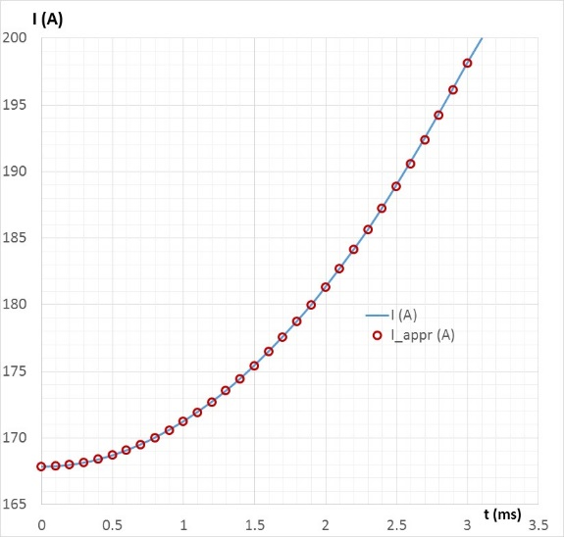

Fig. 4. Bias coil current rise during the injection period

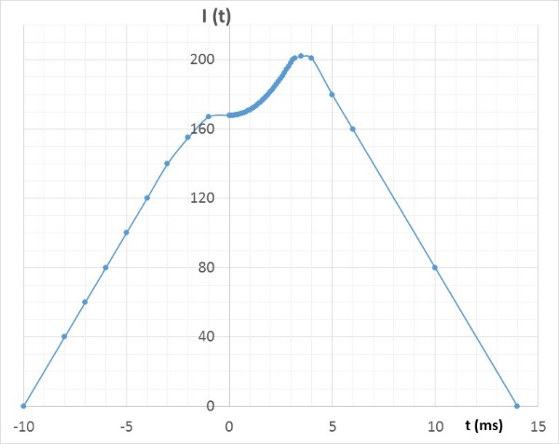

Fig. 5. Current rise during the injection period if a pulsed mode of operation is used.

Current rise during the setting part of the pulse makes its impact of the magnetic field in the tuner due to eddy currents it generates in the shell. The initial current rise rate of the power supply (from the beginning of the cycle at t = -10 ms in Fig. 5 to the beginning of the injection period at t = 0) must be chosen to make this impact tolerable. In Fig. 2 and Fig. 5 we see the maximum current rise rate during the setting time d(Iw)/dt = 1000 A/ms (N = 50). The initial proposal for the power supply [5] assumes the setting current rise rate of ~4000 A/ms or even higher. Corresponding current and voltage tracers are shown in Fig. 6.

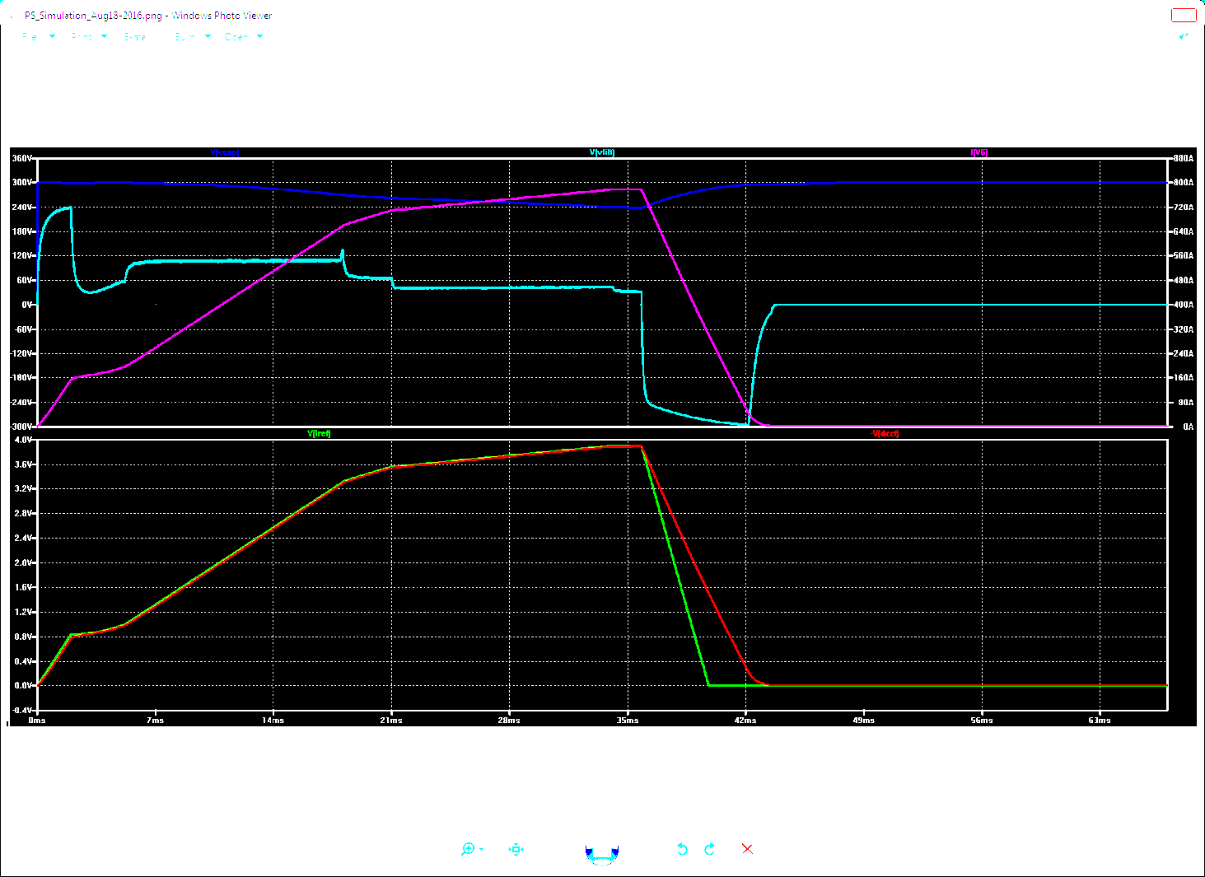

Fig. 6. Pulsed power supply proposal: voltage (cyan) and current (magenta)

To understand the range of our freedom in the tuner design, the impact of the setting current rise rate must be investigated, as well as miscellaneous design features such as the wall thickness, copper coating impact, the number of sectors the shell is assembled of, etc. The geometry of the tuner’s RF shell, which is currently analyzed, is shown in Fig. 7; it is similar to that shown in Fig. 1, but incorporates flanges (currently assumed in the design) and have slightly simplified shape. The simplifications are not going to affect the qualitative results of the study as only the eddy currents, not the RF performance, is being studied.

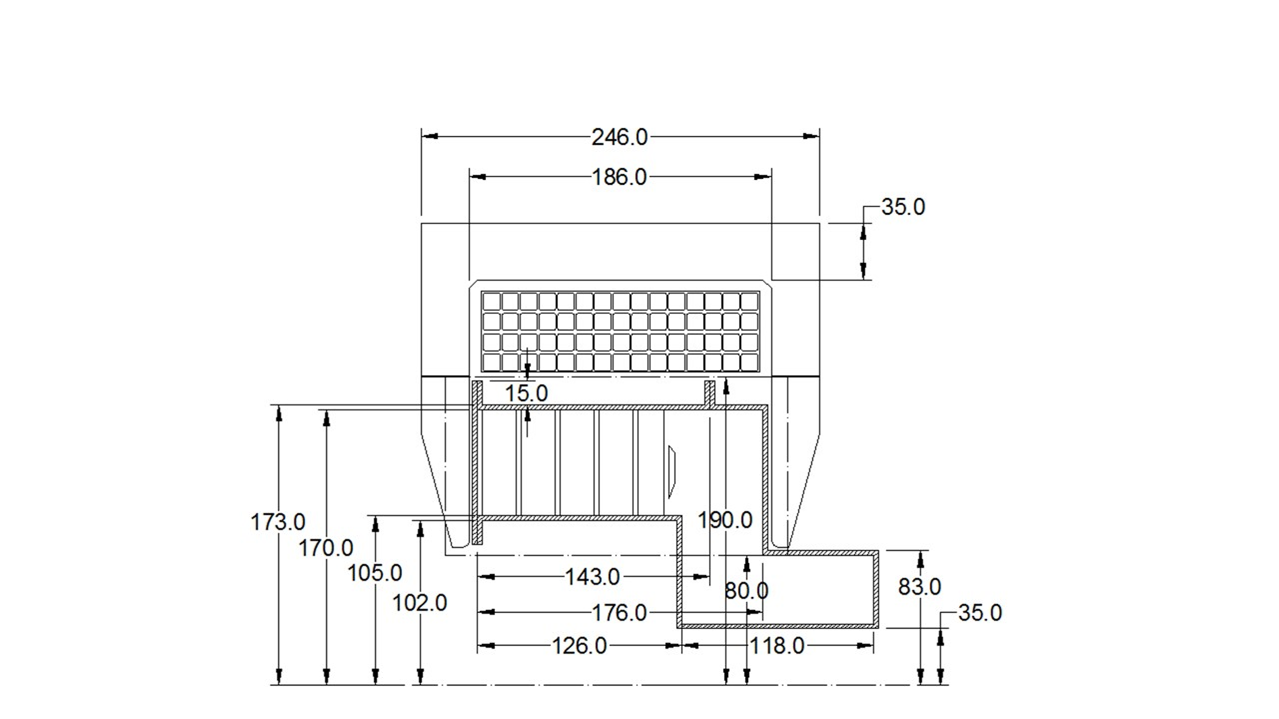

Fig. 7. Geometry of the tuner and the magnetic system accepted during 3D study.

To compare results of 3D study with those obtained using 2D geometry, let’s first consider **axially symmetric system**. While the injection part of the bias current pulse is not a changeable one and must follow expression /1/, the setting part can vary. We will start with the bias current pulse shown in Fig. 8.

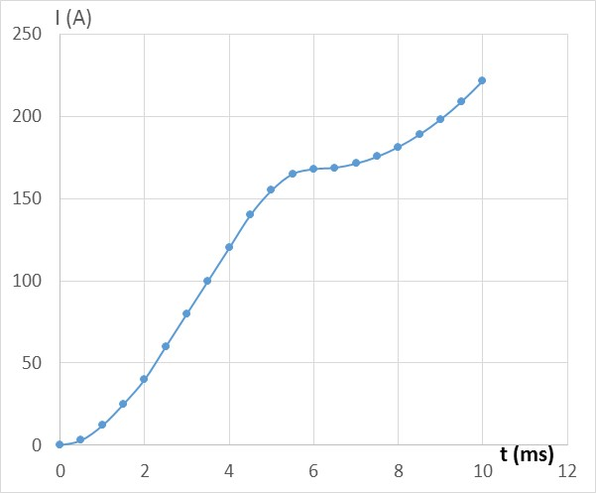

Fig. 8. Current pulse shape; injection starts at the moment t = 6 ms

The maximum setting current rise rate in this case is ~2000 A/ms, which is a bit higher than it was accepted during the 2D study (1000 A/ms).

To set a starting point for the study, let’s first check the ideal case when the conductivity of the shell material is low to the extent that we can entirely neglect it. With the current shape as in Fig. 8, Fig. 9 shows the magnetic field at four points located at the border between neighboring sectors as following:

Point #1 X = 8 mm, R = 110 mm

Point #2 X = 8 mm, R = 165 mm

Point #3 X = 120 mm, R = 110 mm

Point #4 X = 120 mm, R = 165 mm

Here the X = 0 coordinate is placed at the inner surface of the left side flux return in Fig. 7. Point X = 8 mm corresponds to the surface of the first garnet block; point X = 120 mm is in the surface of the last block. Permeability of the garnet blocks µ = 5 was accepted here and further in this study.

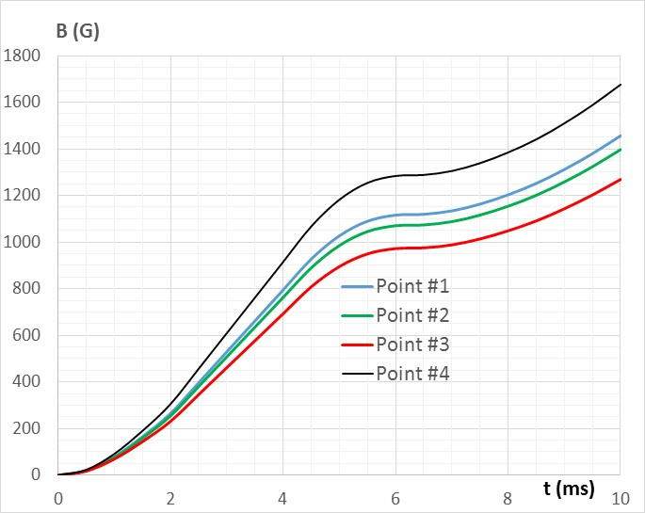

Fig. 9. Magnetic field at the chosen locations in the case with low-conductivity shell.

To obtain a quantitative judgement on how eddy currents affect magnetic field, a transfer function graphs for each point of interest will be used. For the case we just studied, which used low conductivity material to build the shell, these graphs are shown in Fig. 10.

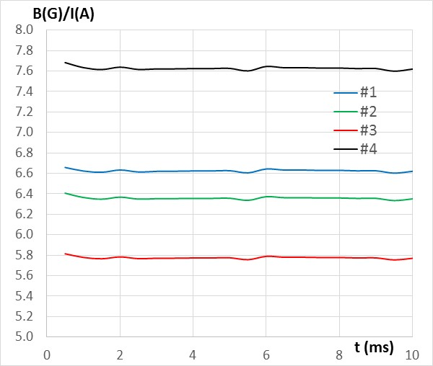

Fig. 10. Transfer function behavior for the chosen points 1 – 4.

As expected, the transfer function does not change in time in this case.

The situation changes dramatically when the shell is made of 3-mm thick stainless steel (conductivity σ = 1.37·106 S/m). Corresponding curves of the magnetic field and the transfer functions at the chosen points are shown in Fig. 11.

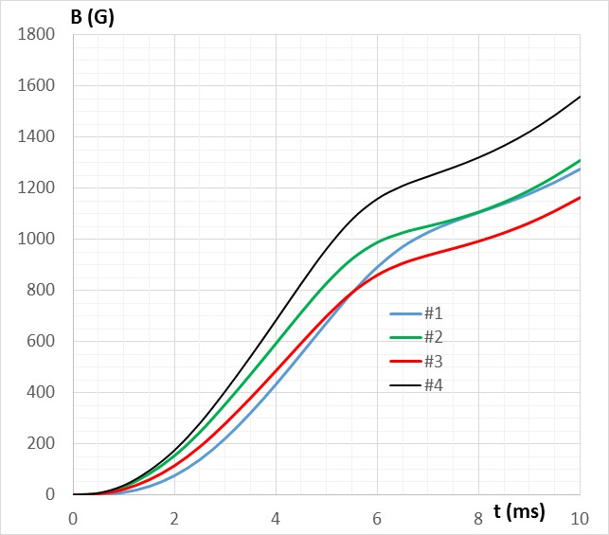 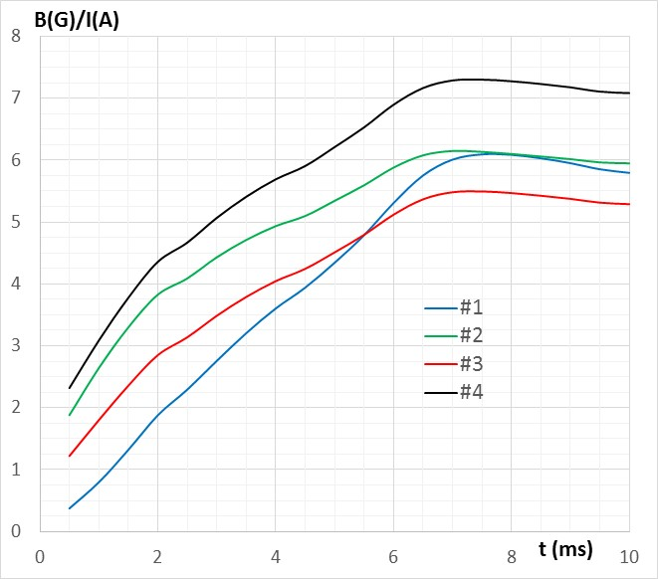

Fig. 11. Magnetic field and transfer functions for the axially symmetric case with 3 mm thick shell and σ = 1.37·106 S/m.

Comparing graphs in Fig. 11 with those in Fig. 9 and Fig. 10, we see that at the injection start (t = 6 ms), the field at all locations is significantly lower than in the ideal case, and the shape of the magnetic field pulse does not correspond to what is desired as the eddy currents decay time is well comparable with the excitation current timing parameters.

At 6 ms, the lowest magnetic field for the case with low conductivity shell is 972.5 G. At the same moment, for the azimuthally symmetric case made of 3 mm stainless steel it is 860 G; the difference is ~12%, consistent with the results of the 2D study and also with the value of the eddy current flowing in the shell. Fig. 12 shows the current induced in this shell. It reaches ~2000 A at t = 4 ms, when the bias current Iw = 6000 A.

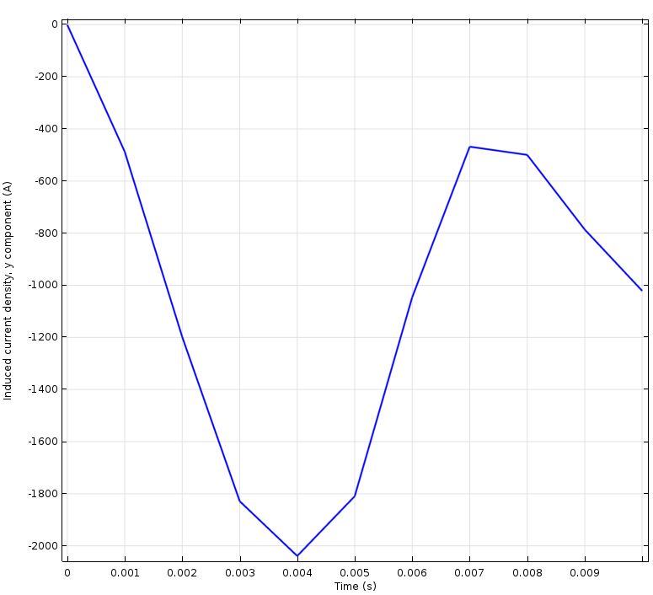 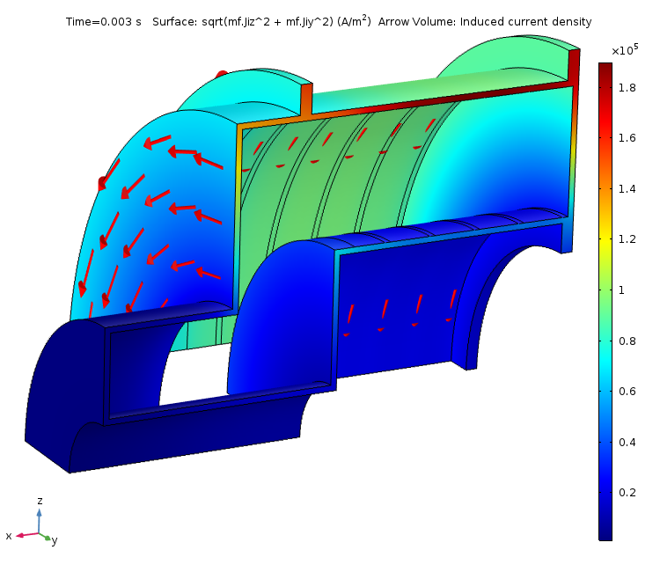

Fig. 12. Azimuthal current induced in the stainless steel shell

To mitigate the impact of the eddy current, we must break the axial symmetry by using longitudinal cuts that prevent azimuthal currents from flowing in the shell.

1. **Tuner’s shell made of four insulated sectors without and with additional slots**

Fig. 13 shows the model geometry with the tuner’s RF shell consisting of four insulated quarters. As seen in the picture, the beam pipe is not cut.

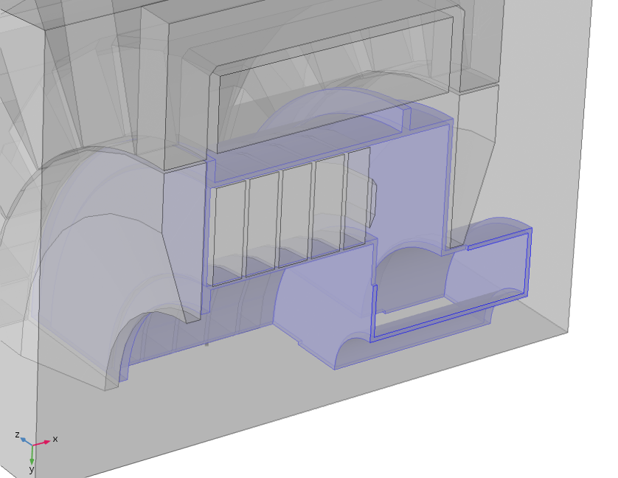

Fig. 13. Geometry of the 3D eddy current study

In Fig. 14 one can see the pattern of the eddy currents in this case. There are no uninterrupted azimuthal currents any more. Instead we see closed current contours in each sector of the shell.

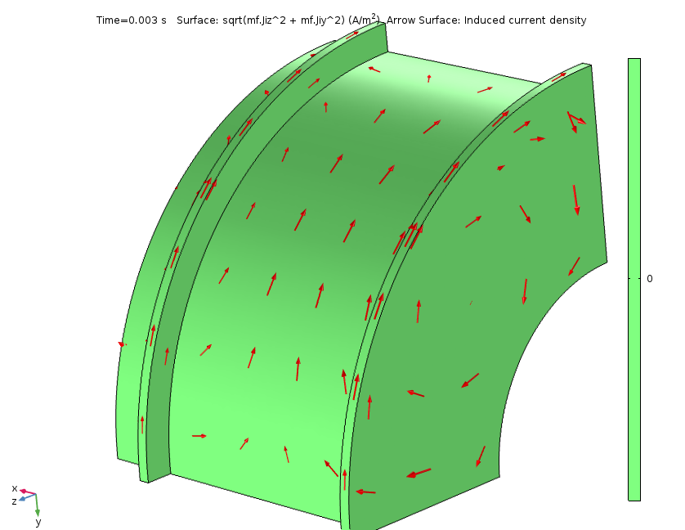

Fig. 14. Eddy current pattern in an insulated shell sector.

Results of this particular study are summarized in Fig. 15 where the field and the transfer functions for the field at several points are plotted. Because we expect some variations of the field at the same radius but different azimuths, the number of point is increased; four points used in the previous stage still remain. Updated list of points coordinates is listed below:

#1 ̶ Z = 8 mm R = 110 mm @ 0⁰

#2 ̶ Z = 8 mm R = 165 mm @ 0⁰

#3 ̶ Z = 120 mm R = 110 mm @ 0⁰

#4 ̶ Z = 120 mm R = 165 mm @ 0⁰

#5 – Z = 8 mm R = 110 mm @ 45⁰

#6 – Z = 8 mm R = 140 mm @ 45⁰

#7 – Z = 8 mm R = 165 mm @ 45⁰

#8 – Z = 120 mm R = 110 mm @ 45⁰

#9 – Z = 120 mm R = 140 mm @ 45⁰

#10 – Z = 120 mm R = 165 mm @ 45⁰

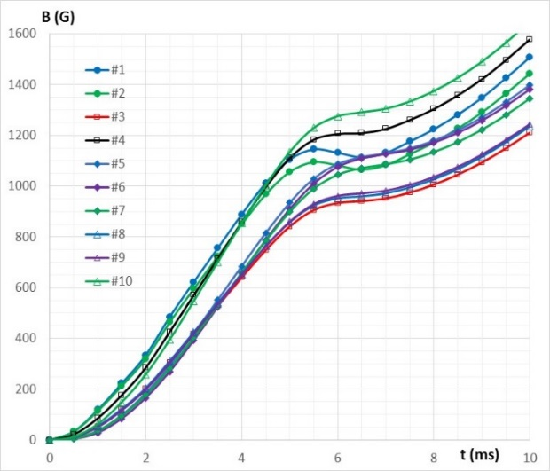 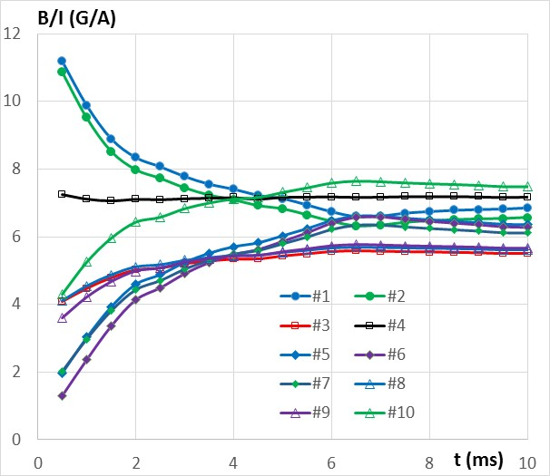

Fig. 15. Magnetic field and transfer functions for the case using insulted sectors of the shell made of 3 mm thick stainless steel (σ = 1.37·106 S/m).

As only important is to follow transfer function during the injection period, graphs in Fig. 16, which are derived from corresponding graphs in Fig. 15 show the transfer function curves starting 1 ms before the injection time (that is starting at t = 5 ms in this case).

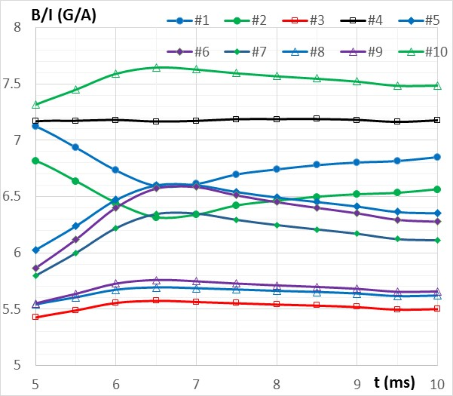

Fig. 16. Transfer functions as in Fig. 15 for t > 5 ms

Comparing these graphs with those in Fig. 11 at the time period from 5 to 7 ms, we clearly see the impact of eddy currents for the points #1 and #2. There is some amplification of the field in the gaps between the segments due to eddy currents during the current rise (points 5 ÷ 7). As the current rise rate becomes smaller at t ≈ 6 ms, delay in the eddy currents decay results in a sag or bulging in the magnetic field profile.

For the points at Z = 120 mm his effect is not so pronounced as the point is far from the end wall.

Transfer functions in the area of interest (t ≥ 6 ms), although smoother than in Fig. 11, still not completely flat, as desired. Some improvements can be made by making additional slots in the middle of the each sector to further restrict the freedom for the eddy currents. One of the restrictions for using this approach is the need to simultaneously provide water cooling solution for both the inner and the outer parts of the RF shell. Fig. 17 provides one of possible ways to place water cooling piping on the sectors of the shell without crossing the slots.

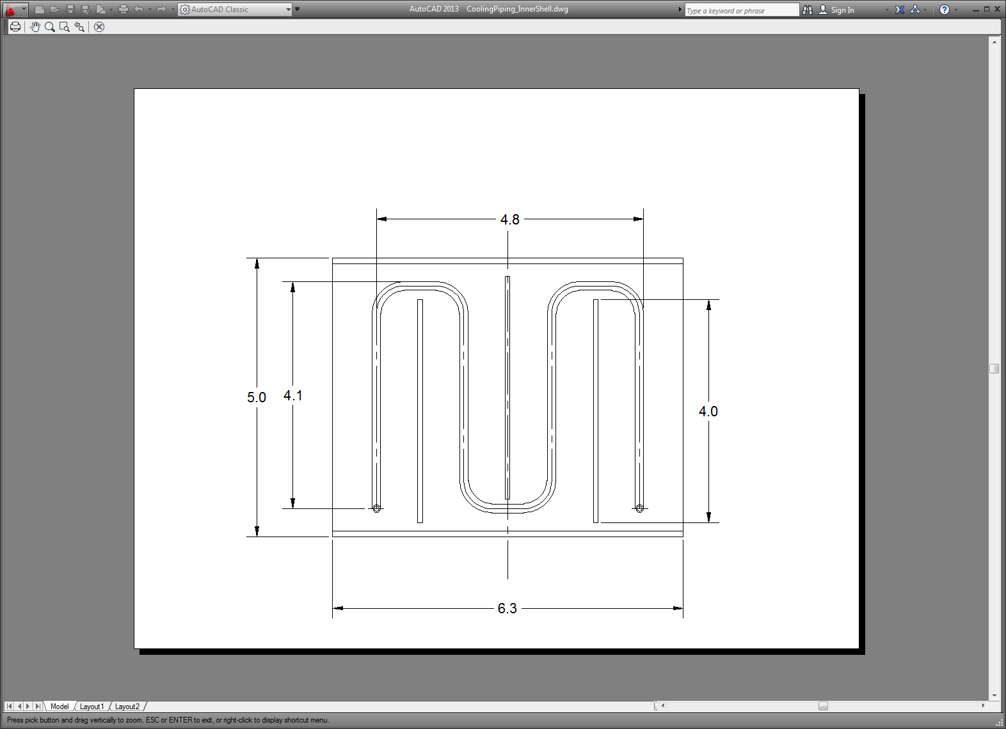

Fig. 17. Concept of a water cooling pipe placement on the inner shell.

5/32” OD stainless steel pipe with 20 mil wall thickness laid out on the surface of the shell as shown in the picture provides enough cooling capacity both for the inner (1.4 kW) and the outer (1.6 kW) surface of the shell. This layout allows making three additional slots in the surfaces that should help in restricting eddy currents. Fig. 18 shows the modeling geometry and in Fig. 19 the eddy current pattern for the outer surface is investigated. This eddy current pattern, although different from what shown in Fig. 14, qualitatively is quite close, so we should not expect here a perfect cure for its effects.

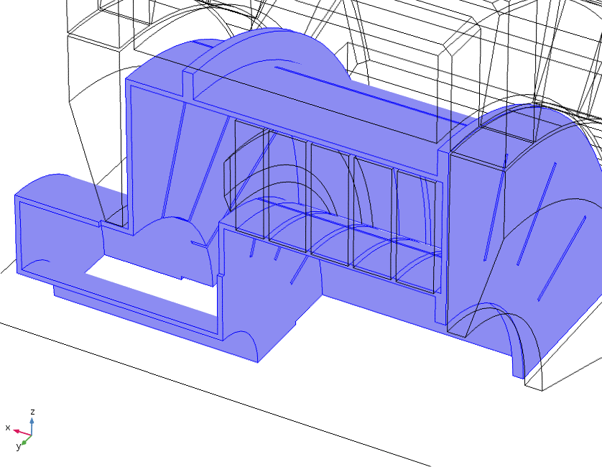

Fig. 18. Geometry of the TF shell with additional slots.

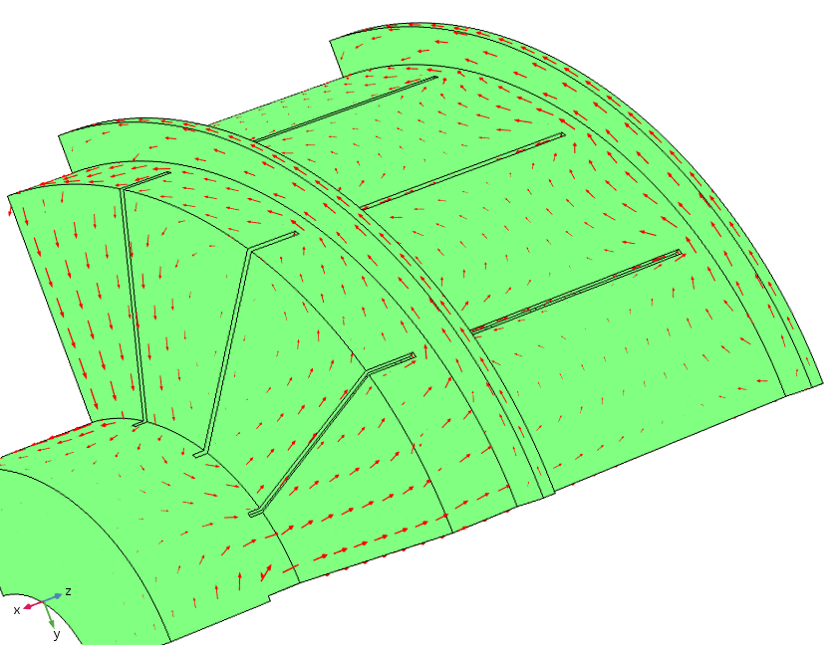 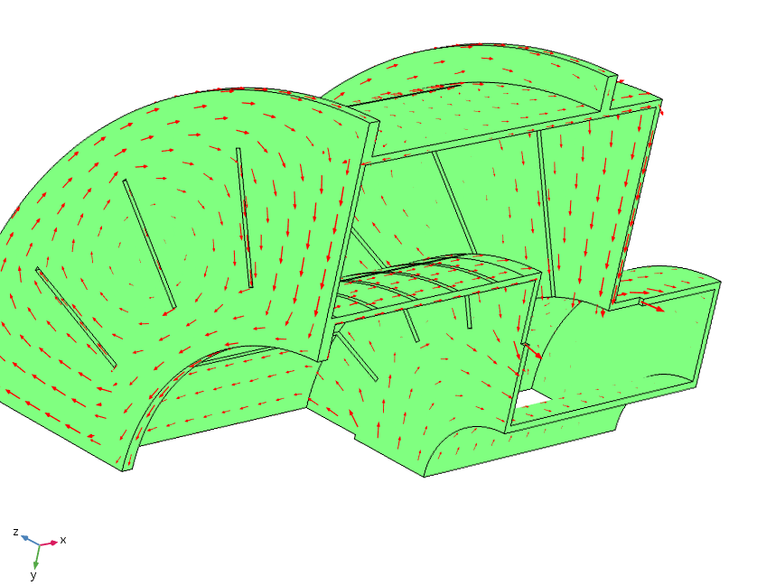

Fig. 19. Eddy current pattern in the shell with additional slots

Corresponding graphs of magnetic field and the transfer factors are shown in Fig. 20, which must be compared with curves in Fig. 16. There are some changes visible on the curves, especially for the points #7 and #10, which are close to the outer shell (R = 165 mm) on both sides of the tuner (Z = 8 mm and Z= 120 mm) and in the middle of the sector (45⁰) where we have a slot in the vicinity. Nevertheless, the changes are not game changing. Still a significant sag in the magnetic field in the beginning of the injection cycle (t = 6 ms) is visible for the magnetic field at the points #1 and #2.

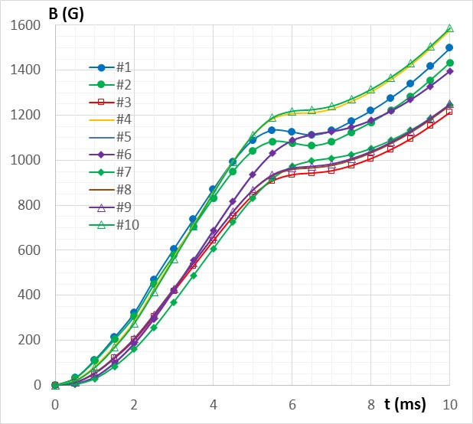 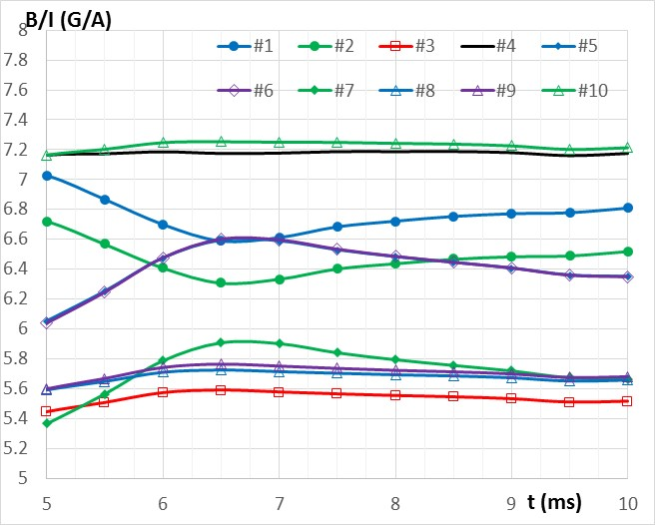

Fig. 20. Magnetic field and transfer functions for the case with insulted sectors of the shell and with additional slots (σ = 1.37·106 S/m).

The most noticeable deviation from the constant transfer function are observed for the points #1, 2, 5, 6 and 7, all of which are in close vicinity to the shale at X = 8 mm. Eddy currents induced during the setting stage (d(Iw)/dt|max = 2000 A/ms) have their post-action that results in some increase or decrease of the local magnetic field.

1. **Effect of the setting current rise rate**

One of ways way to mitigate this post-action is to reduce the setting current rise rate, which. Let’s try making this current rise rate not exceeding the maximum current rise rate at the injection stage: d(Iw)/dt|max = 1000 A/ms. Fig. 21 shows updated pulse current shape with the maximum current rise rate of 1000 A/ms. The injection stage starts at t = 11 ms; the current rise during this stage is defined by /1/.

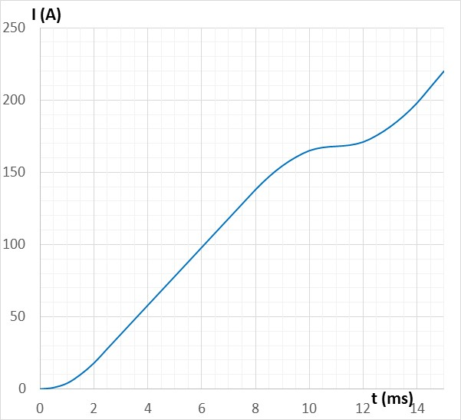

Fig. 21. Updated current rise curve of a pulsed power supply.

In Fig. 22, the magnetic field rise is shown for the study point during the whole cycle and only at the injection phase.

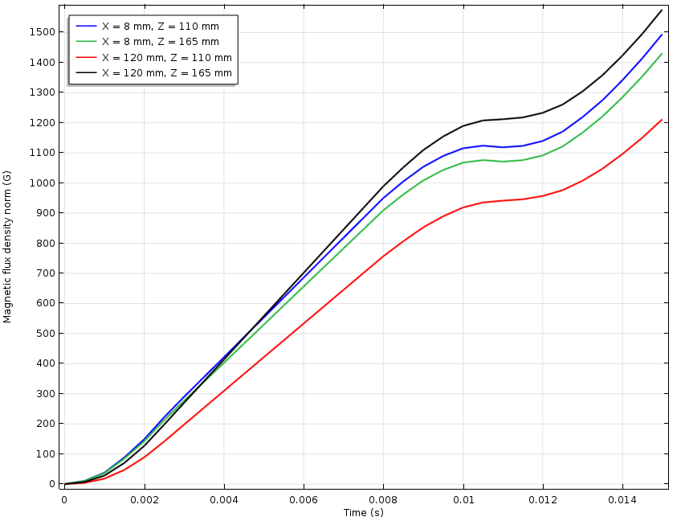 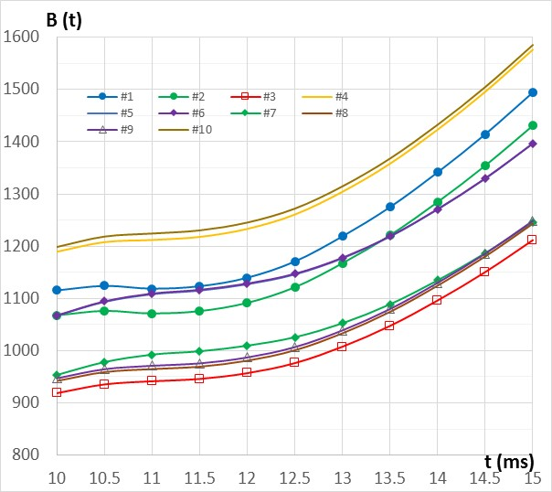

Fig. 22. Magnetic field in the case of the slower setting current rise.

The sags that we saw in the curves #1 and #2 in the beginning of the cycle are much more modest now. Comparing the field values at the start of injection with those seen in Fig. 10 for the ideal case, we see ~2% increase of the field for points #1 and #2 (X = 8 mm) and ~5% decrease of the field for the points #3 and #4 (X = 120 mm).

Fig. 23 shows the transfer functions for the injection stage compared with what was found in the ideal case (Fig. 11).

 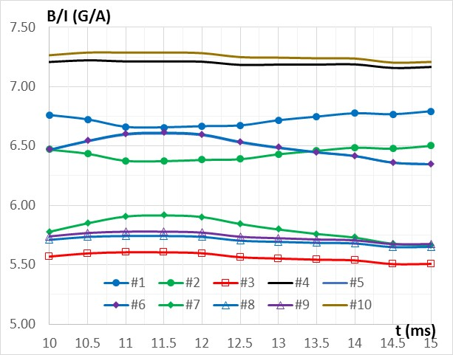

Fig. 23. Transfer function for the ideal case and for the case with updated current rise curve.

In the beginning of the injection cycle at t = 11 ms, the values of the transfer functions compare with the ideal case as follows:

Ideal Case Last Case

Point #1 6.63 6.66

Point #2 6.38 6.38

Point #3 5.78 5.6

Point #4 7.6 7.21

Even better approximation of the ideal case can be made if to make additional slots not only in the cylindrical and the end surfaces, but also though the flanges, that stay uncut till now. A decision to make these cuts can come only after structural studies of the cavity design.

1. **Impact of copper coating**

At the time this study is conducted, there is no finished design of the tuner yet, and no choice is made of the RF shell wall thickness. To understand the impact of this thickness, let’s first understand what copper coating adds to the eddy current problem.

At 75 MHz, skin layer in copper is δ [µm] = 66.2/sqrt(f [MHz]) ≈ 7.7µm. To avoid significant drop of the quality factor due to resistivity of the stainless steel the shell is made of, at least 3δ thickness. We will assume ~25 µm of copper coating added on the surface of stainless steel. Surface resistance of this coating is ~0.68 mΩ. Surface resistance of 1 mm thick layer of stainless steel (σ = 1.37·106 S/m) is 0.73 mΩ. From the point of view of eddy current impact, the addition of 25 µm thick layer of copper coating is equivalent to adding 1 mm to the stainless steel shell thickness.

The cases that were investigated so far were dealing with 3 mm thick shell. As we have just seen, this is equivalent to having a 2 mm thick shell with 25 µm copper coating. As this 2 mm thick shell can prove unsound structurally, some understanding is needed on what impact can be expected if the thickness of the shell is increased by 1 mm. This problem is addressed within the frame of the used models by modifying the conductivity of the shell material in the model so that effective surface conductivity changes accordingly. The possibility of using the effective conductivity of material come from the fact that the expected skin layer of the eddy currents of significantly larger that the thicknesses of all materials. Expected effective frequency of eddy currents even in the worst case (Fig. 6) does not exceed 100 Hz. For copper at 100 Hz the skin layer δ ≈ 6.7 mm; for stainless steel at this frequency δ ≈ 40 mm.

Surface conductivity of a 3 mm layer of stainless steel is 3/(0.73·10-3) = 4110 S. For a 25 µm layer of copper it is 1470 S. Combined surface conductivity is 5580 S, which is achieved in a 3 mm thick layer of material with conductivity σ = 1.86·106 S/m. The curves of the transfer function with this surface conductivity are shown in Fig. 24.

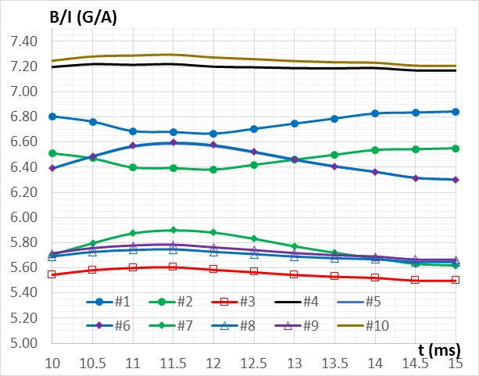

Fig. 24. Transfer functions for the 3 mm thick slotted shell with 25 µm copper coating

Points that are in the gap location at X = 8 mm (#1 - #3) see slight increase (~1%) of the field as the wall shields out more field now. The points in the middle of the quarter (#5 - #7) see less field for the same reason.

Adding copper coating for the four-segment design of the shell does not impact the eddy-current performance of the tuner.

1. **Aggressive approach to making slots**

The next questions that needs an answer is whether aggressive cutting of the shell, including the flanges, can help further improving the impact of the eddy currents. Geometry of the last case (3 mm thick shell with 25 µm copper coating) was modified to make cuts though the flanges as shown in Fig. 25 below. This way of restricting eddy currents does not eliminate entirely the big loop, which contributes the most to the deformation of the transfer function, but as the loop length becomes significantly longer, the effect of this measure should be visible. Corresponding arrow field that shows the pattern of the eddy current in this case is shown in Fig. 26. This pattern should be compared with that in Fig. 19.

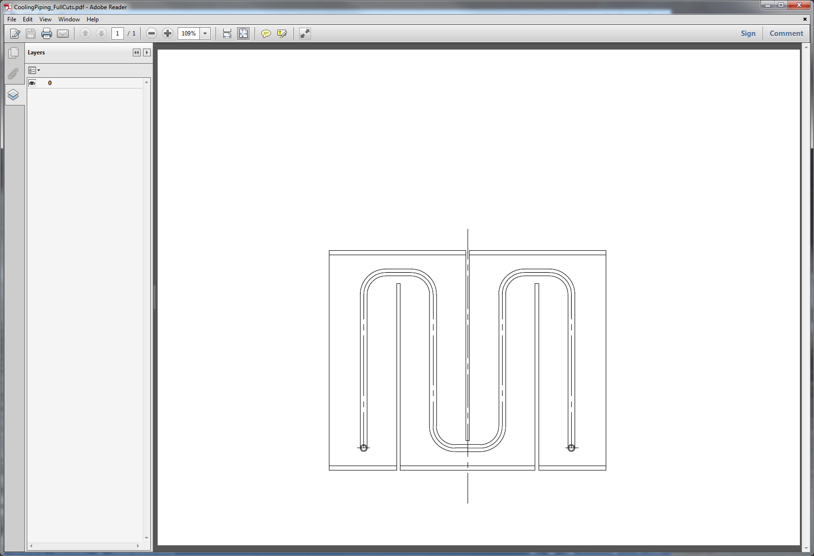

Fig. 25. Another approach to making slots in the shell

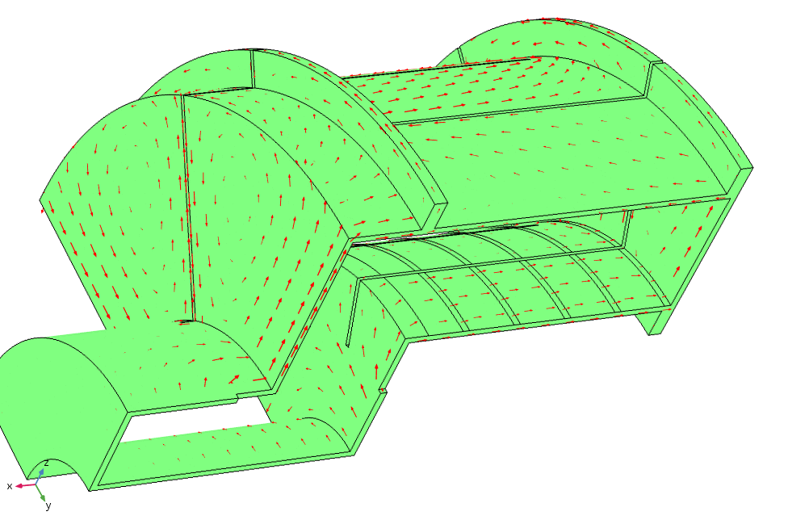 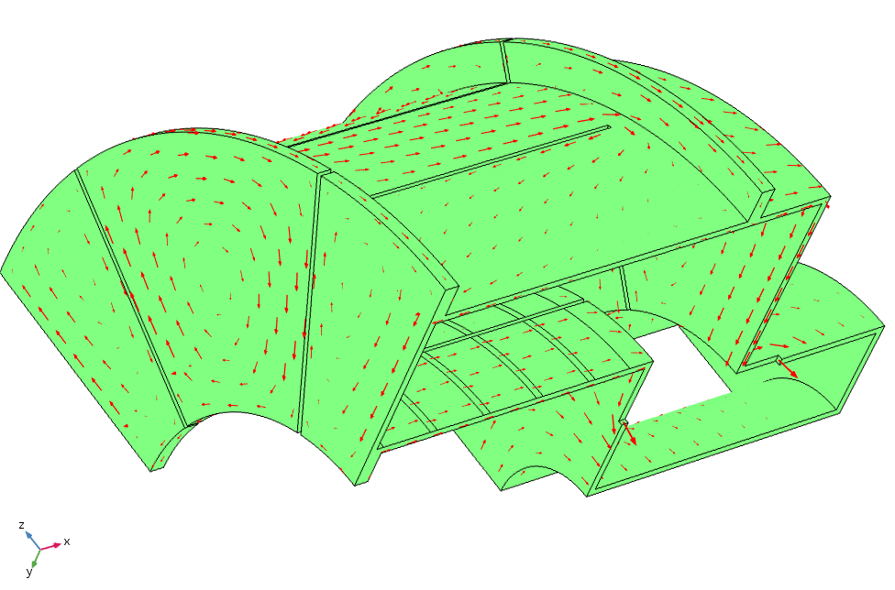

Fig. 26. Eddy currents in the shell with extended slots

Fig. 27 shows the transfer functions in the case. Although, as expected, we see some effect of this way of restricting the eddy currents, this effect is not strong. Practically, no big difference exists between this case with the extended cuts and the case with limited cutting just on the cylindrical surface.

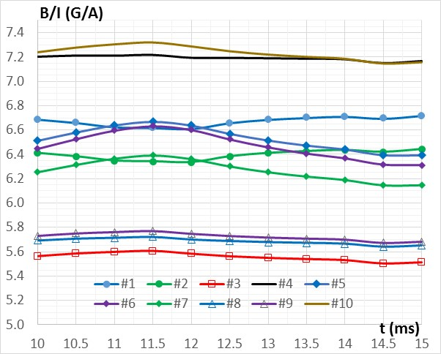

Fig. 27. Transfer functions for the 3 mm thick shell with 25 µm copper coating and extended slotting.

Cutting through flanges brings the transfer functions for the points at the boundary (1 and 2) and in the middle (5 ÷ 7) of each segment closer; this means that the field in the garnet blocks is more uniform azimuthally. As we see clear advantage of more aggressive cutting, let’s try to make the shell consisting of eight segments. The following modifications were made to the previous model:

* The slots that separate quarters of the shell were made extending to the flanges and to the outer cylinder of the shell.
* Additional through slots were made at the azimuth φ = 45⁰.
* Slots located at the azimuths φ = 22.5⁰ and φ = 67.5⁰ were only cutting through one of the flanges, thus allowing just one U-shaped cooling pipe in each octant.

Corresponding geometry is shown in Fig. 28 and the eddy current surface flow is in Fig. 29.

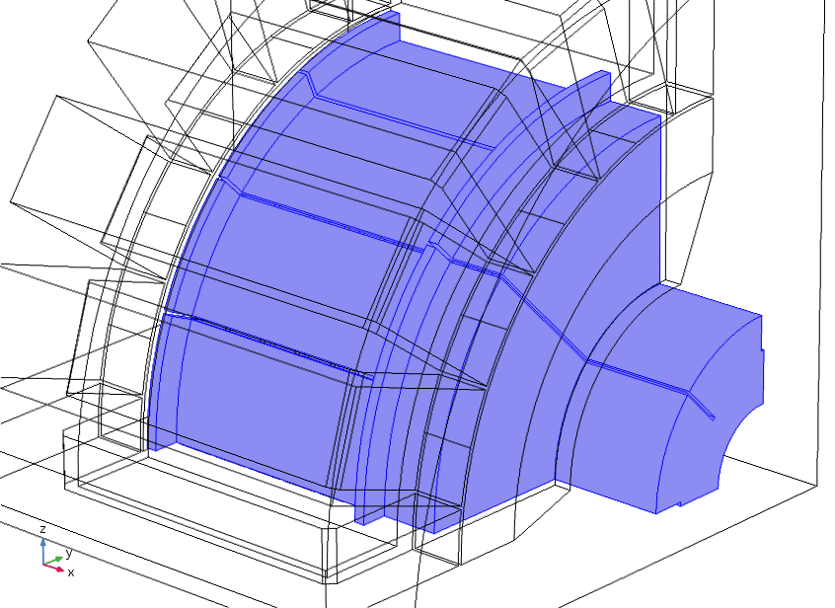

Fig. 29. Aggressive slotting of the shell to limit eddy current.

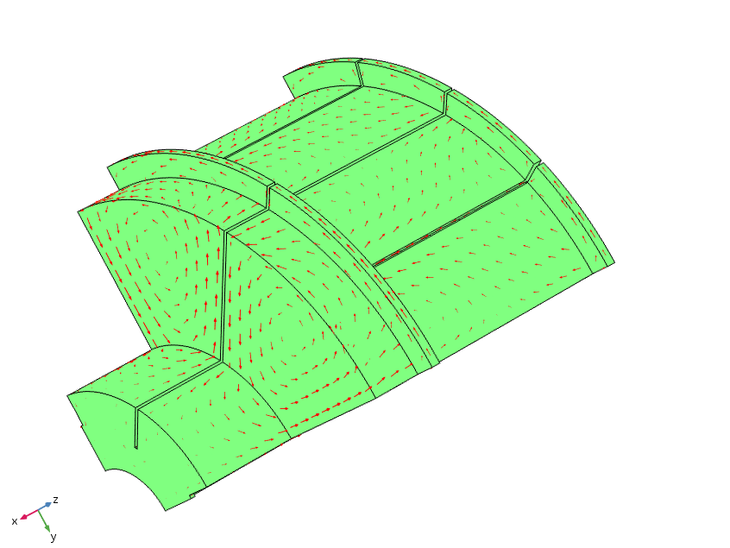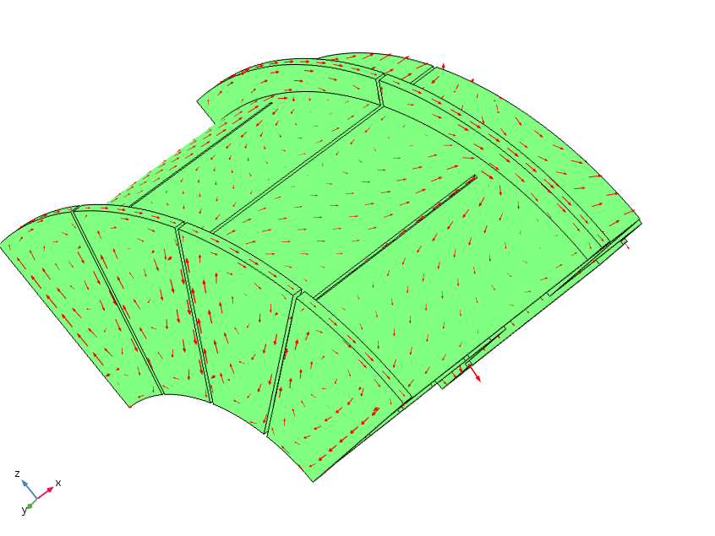

Fig. 30. Eddy currents for the aggressive cutting case.

Traces of the magnetic field and the transfer functions at the base point locations are shown in Fig. 31.

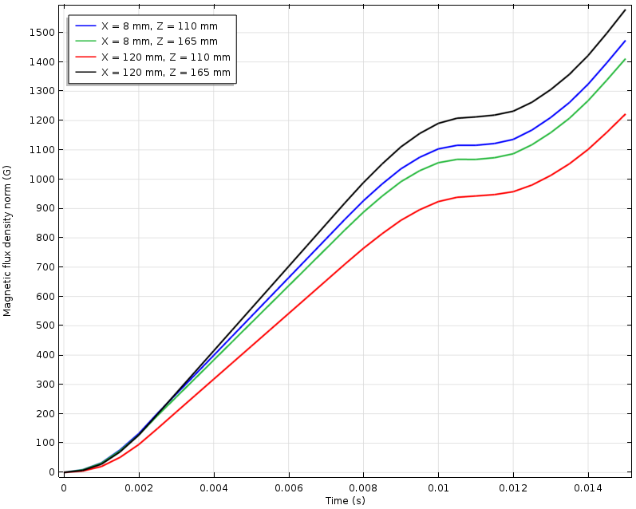 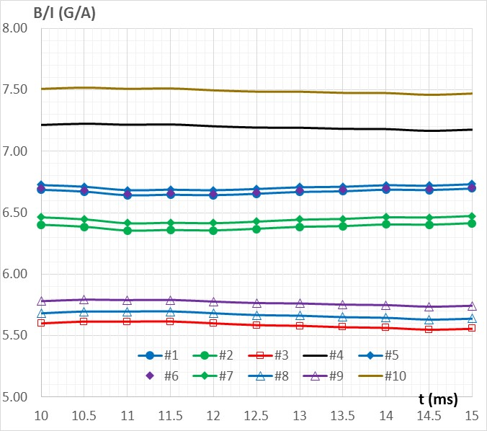

Fig. 31. Magnetic field and the transfer functions at the base point locations.

As we see a significant improvement in the shape of the transfer functions (meaning flatter curves at the beginning of the injection period t = 11 ms and very shallow sags at the injection), it is useful to understand to which extent the higher initial current rise rate can make things worse. Graphs in Fig. 33 and Fig. 34 compare transfer functions for the “eight sectors” design obtained using different setting current rise rates, which represent the slowest possible rise (like in Fig. 2) and the fastest one (like in Fig 6). This set of curves will be compared later with those for the “four sectors” case.

 

Fig. 33. d(Iw)/dt|set = 1000 A/ms; Injection starts at t = 11 ms

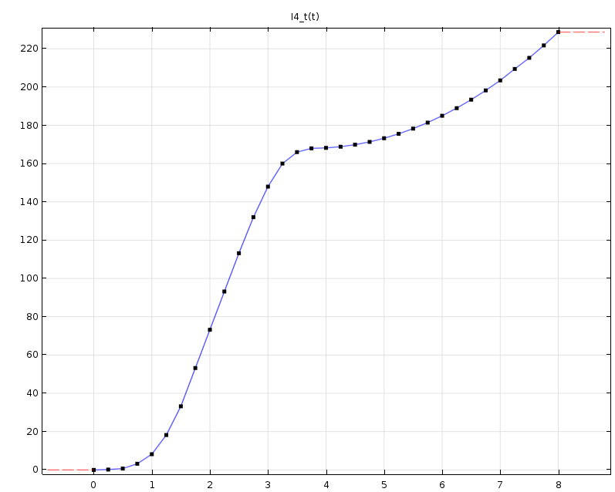 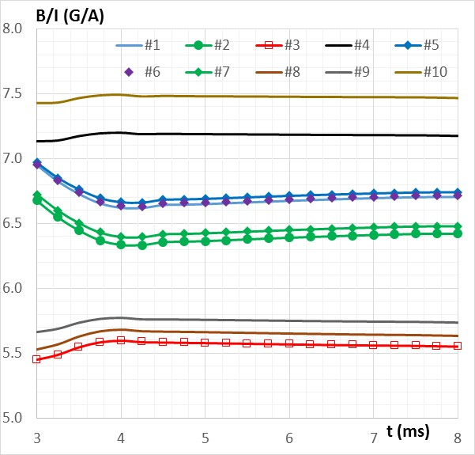

Fig. 34. d(Iw)/dt|set = 4000 A/ms; Injection starts at t = 3.75 ms

For the “eight segments” case, no significant difference in the transfer functions is found that would limit our choice of the setting current rise rate. This statement is supported by the data in Table 1 that shows the values of the transfer function at the base points of the study at the moment when injection starts for three bias current scenarios with different setting current rise rates: 1000 A-turns/ms, 2200 A-turns/ms, and 4000 A-turns/ms.

Table 1. Transfer function at the start of the injection cycle for the “eight segments” shell design and different setting current rise rates.

|  |  |  |  |  |  |  |  |  |  |  |
| --- | --- | --- | --- | --- | --- | --- | --- | --- | --- | --- |
| Point # | 1 | 2 | 3 | 4 | 5 | 6 | 7 | 8 | 9 | 10 |
| 1.0 kA/ms | 6.64 | 6.35 | 5.61 | 7.22 | 6.68 | 6.65 | 6.42 | 5.69 | 5.79 | 7.51 |
| 2.2 kA/ms | 6.64 | 6.35 | 5.59 | 7.20 | 6.68 | 6.65 | 6.41 | 5.68 | 5.77 | 7.49 |
| 4.0 kA/ms | 6.66 | 6.37 | 5.59 | 7.19 | 6.70 | 6.67 | 6.43 | 5.67 | 5.77 | 7.49 |

Similar data for the “four segments” design are shown in Table 2.

Table 2. Transfer function at the start of the injection cycle for the “four segments” shell design and different setting current rise rates.

|  |  |  |  |  |  |  |  |  |  |  |
| --- | --- | --- | --- | --- | --- | --- | --- | --- | --- | --- |
| Point # | 1 | 2 | 3 | 4 | 5 | 6 | 7 | 8 | 9 | 10 |
| 1.0 kA/ms | 6.65 | 6.37 | 5.54 | 7.16 | 6.36 | 6.23 | 6.12 | 5.67 | 5.71 | 7.20 |
| 2.2 kA/ms | 6.64 | 6.36 | 5.57 | 7.19 | 6.55 | 6.48 | 6.29 | 5.70 | 5.74 | 7.26 |
| 4.0 kA/ms | 6.62 | 6.35 | 5.60 | 7.21 | 6.64 | 6.60 | 6.37 | 5.71 | 5.76 | 7.30 |

The “four segments” design shows more pronounced impact of the current rise rate. Relative change of the transfer function at injection reaches ~6% for the point #6in the “four quadrants” case and is only 0.3% for “the eight quadrants” case.

Traces that were used to generate data in Table 2 are in Fig. 35, for the 1 kA/ms ramp rate, in Fig. 36 for the 2.2 kA/ms rate, and in Fig. 37 for the 4 kA/ms rate.

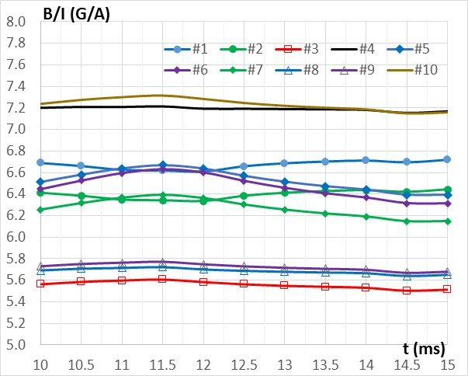

Fig. 35. Transfer functions for the “four segments” case with d(Iw)/dt|set = 1000 A/ms; injection cycle starts at t = 11 ms.

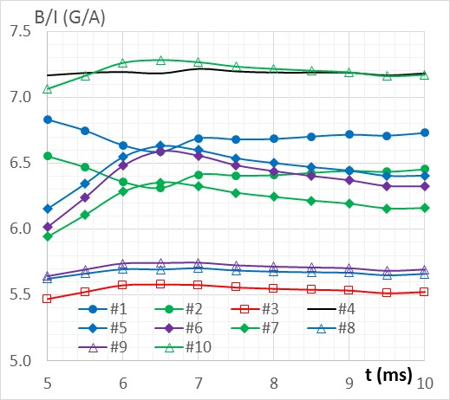

Fig. 36. Transfer functions for the “four segments” case with d(Iw)/dt|set = 2200 A/ms; injection cycle starts at t = 6 ms.

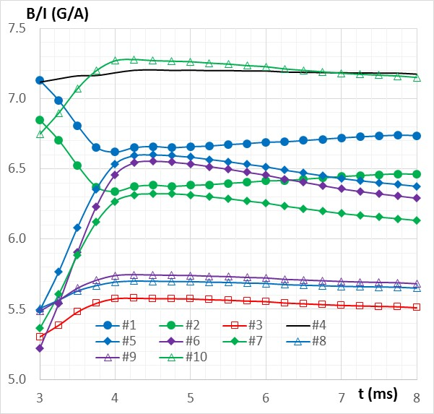

Fig. 37. Transfer functions for the “four segments” case with d(Iw)/dt|set = 4000 A/ms; injection cycle starts at t = 3.75 ms.

1. **Making sense of the data**

The modeling that was made for several different cases meant to help in choosing a design approach for the shell. Obviously, this choice is not so straightforward as it was considered before this study was attempted. Some additional information below may help. First, in figures 38 to 40, azimuthal dependence of the transfer functions is shown for the cases of four-segment design without slots, four-segment design with simple slots, and for the eight-segment design. The lines correspond to the cases of the inner and the outer radii of the garnet’s first and the last blocks. They do not go through the points #1 to #10, so the data is bit different. The setting current rise rate if 2.2 kA/s for all the cases.

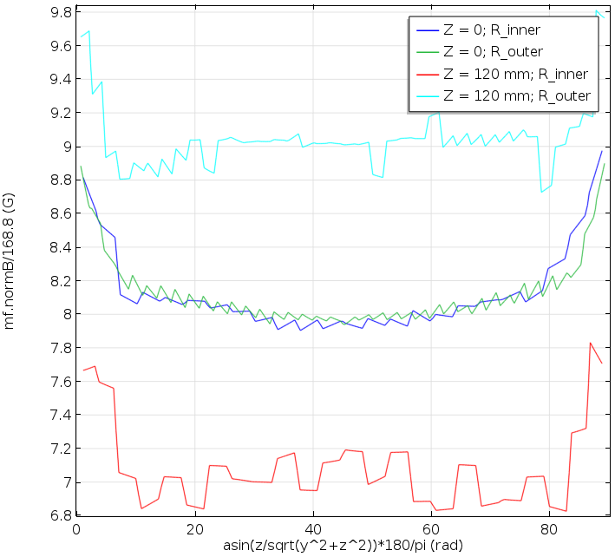

Fig. 38. Azimuthal dependence of the transfer function: “four-segment” case; no slots.

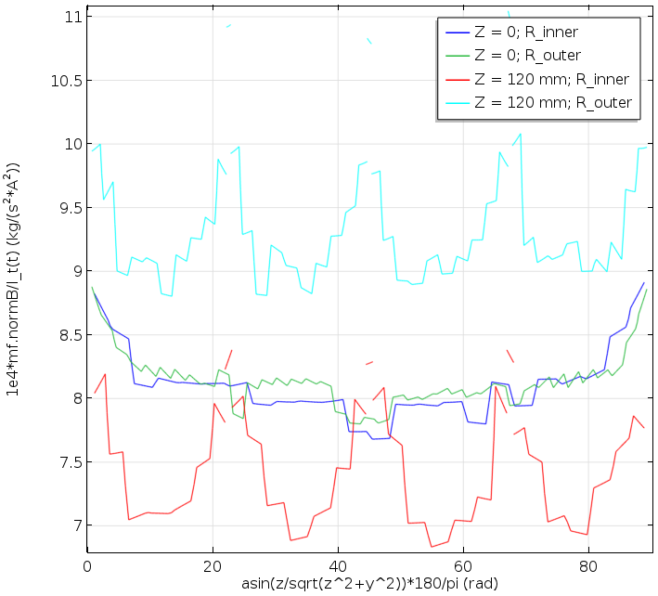

Fig. 39. Azimuthal dependence of the transfer function: “four-segment” case with simple slots.

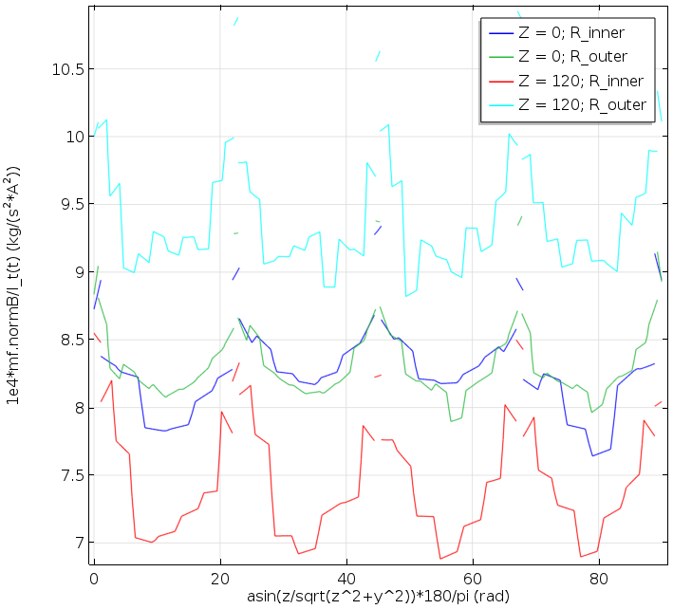

Fig. 40. Azimuthal dependence of the transfer function: “eight segments” case

Another set of data to consider is a table that summarize the results obtained earlier for the time moment of the injection start, which is different for different choice of the setting current rise. Totally there were eleven cases which are classified as the following:

Option Description

0 Axial symm; transparent shell

1 Axial symm; 3 mm; 2.2 kA/ms

2 Four segm.; no cuts; 3 mm; 2.2 kA/ms

3 Four segm.; simple cuts; 3 mm; 2.2 kA/ms

4 Four segm.; simple cuts; 3 mm; 1 kA/ms

5 Four segm.; simple cuts; 4 mm; 1 kA/ms

6 Four segm.; extended cuts; 4 mm; 4 kA/ms

7 Four segm.; extended cuts; 4 mm; 2.2 kA/ms

8 Four segm.; extended cuts; 4 mm; 1 kA/ms

9 Eight segm.; 4 mm; 4 kA/ms

10 Eight segm.; 4 mm; 2.2 kA/ms

11 Eight segm.; 4 mm; 1 kA/ms

Sampling point numbers are as described below; additional information at the top of the table just repeat this definition.



Graph in Fig. 41 illustrates the table. Here the value of the transfer function change (in the percentage points) relative to the ideally transparent shell at the start of the injection for every point is shown as a function of the case number (options 1 ÷ 11). Filled markers refer to the first block (Z = 0) and the markers without filling are for the points in the last block (Z = 120 mm). Connecting line is added for convenience to follow the change of the transfer function for every sampling point. Cases “0” (magnetically transparent shell) and “1” (azimuthally symmetric design) are not shown in the figure.

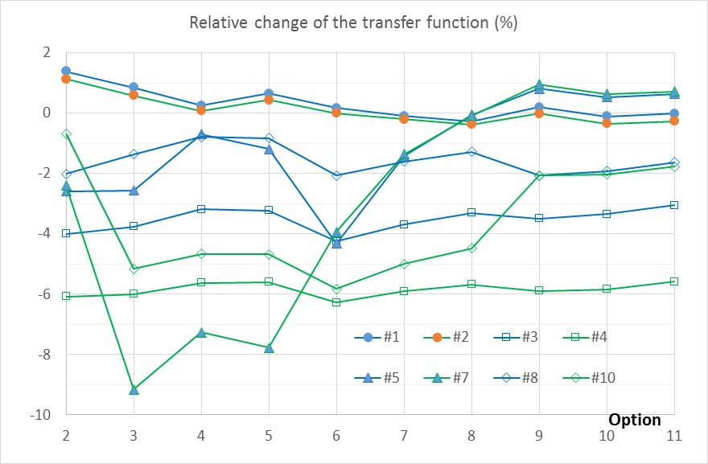

Fig. 41. Change of the transfer function at the start of the injection for sampling points 1, 2, 3, 4, 5, 7, 8, and 10 as a function of the shell design features.

We see that although transfer functions for the “eight segments” design (cases 9 – 11) are different from those for the “four segments” case with the extended slots (cases 6 – 8), this difference is purely quantitative, not qualitative.

**Conclusio**n.

A study was made to understand impact of eddy current on the penetration of magnetic field in the tuner of the 2-nd harmonic cavity of FNAL Booster. Several case studies made with different geometry of the shell, configuration of the slots, and current rise time of the bias current. Although making slots does lead to better field penetration, the most pronounced effect can be obtained by increasing the number of segments in the shell design.

Nevertheless, even with the “four segments” design, the impact of eddy current can be limited if the current shape pulse frequency spectrum is limited to low frequencies. If a pulsed power supply is used as a source of the bias current, as long as possible setting time must be considered.

**References**:

1. I. Terechkine, “Magnetic Bias System for the Second Harmonic Cavity of the FNAL Booster”, FNAL TD note TD-16-012, July 12, 2016.
2. S. Y. Tan, private communication.
3. I. Terechkine and G. Romanov, “Evaluation of Temperature Distribution in the Tuner of the FNAL Booster’s Tunable Second Harmonic Cavity”.
4. C.Y. Tan, R.L. Madrak, W.A. Pellico, G. Romanov, D. Sun, and I. Terechkine, “A Perpendicular Biased 2-nd Harmonic Cavity for the Fermilab Booster”, IPAC 2015, Richmond, VA, Proceedings, pp. 3358 – 3360
5. Matt Kufer, private communication.