Conceptual Design Study of NuMI Operation for PIP-I+
PHASE I – EN0006346

C. Crowley, K. Yonehara

3/30/2017
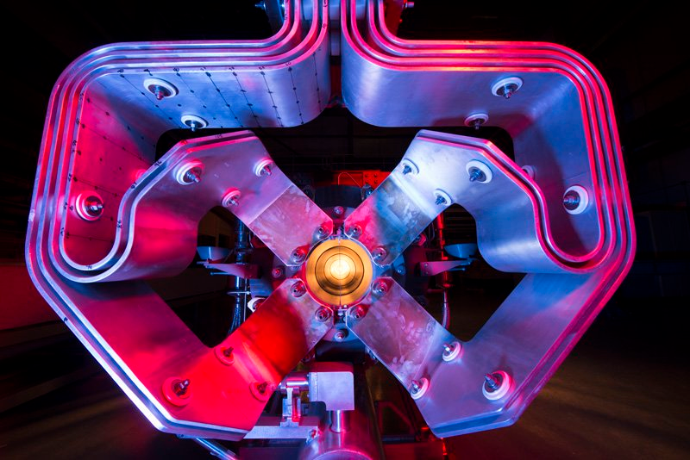

Table of Contents
- Introduction 3
- Beam Parameters / MARS Simulations / Tritium Production 4
- Pre-Target Beam Window 5
- NOvA Target Baffle & Core 6
- NOvA Horn 1 Conductors & Electrical Bus 8
- Target & Horn Modules 10
- Electrical Bus Penetrations 12
- Power Supply 13
- RAW Systems 15
- Target Chase Chiller Unit 16
- Target Chase Air Handling Units 18
- Target Chase Shielding 20
- Decay Pipe & Windows 22
- Hadron Beam Absorber 24
- Hadron Monitors 25
- Technically Limited Upgrade Schedules 27

Introduction
Efforts by Accelerator Division towards reaching PIP-II have yielded a desire for a ramp-up project to bring the systems and experiments to the near megawatt range, or roughly 900kW. The activities encompassing this, and the resultant project, if deemed viable, would serve to act as a stepping stone towards the eventual 1.2MW goal set forth for PIP-II operation. This project was given the name: PIP-I+, and was named as such since it bridges the gap between the 700kW upgrade undertaken as part of the original proton improvement plan (PIP-I), and the aforementioned 1.2MW upgrade (PIP-II). An additional motivating factor for the higher intensity operation is the desire to reach experimental goals on data collection quicker than scheduled, which would yield long term operational cost savings. This would free up future funding for operation of new experiments at the lab, chiefly Mu2e, Muon G-2, & LBNF/DUNE.
PIP-I+ has been conceptually segmented into three phases for each part of the accelerator complex, the first of which, PHASE I, for which this report encompasses, discusses the existing systems at risk for the NuMI complex. Part of this work also entailed identifying peer reviewed upgrade work or options that could be exercised to reach the goals set forth, in addition to preliminary cost & schedule details for achieving those goals. The capability & upgrade review identified thresholds for various systems, which as they approach higher intensities, should trigger improvements to said systems if original service life or up-time is to be maintained. The findings & recommendations of the PIP-I+ PHASE I efforts follow in the sections below.
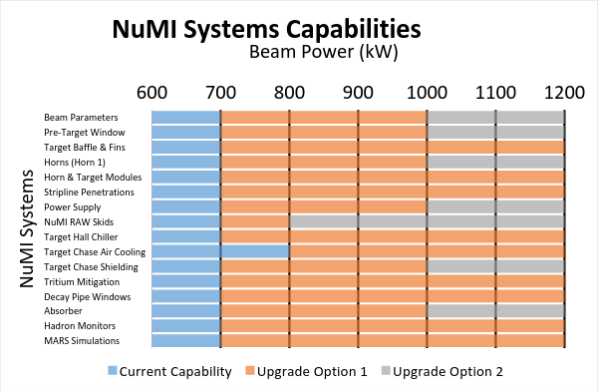

PIP-I+ Region
Graph 1.1 NuMI Systems Capability Listing & Upgrade Focus

Beam Parameters / MARS Simulations / Tritium Production

Present Status
Radiological analysis and simulation as a function of beam intensity are the primary sources to evaluate beamline interaction in the NuMI target hall, especially for the baffle, target, horns, modules, decay pipe and its windows, and hadron absorber. MARS is the default simulation code and has been used to provide beam energy deposition values for most finite element analysis completed on beamline components. It should be noted that since the last full scope evaluation with MARS had been done in 2006, it is required to re-evaluate the radiation assessment with the latest MARS code updates and correct beam parameters for any long-term increase in beam intensity.

Upgrade for High Intensity Operation
A repeat MARS run must be completed with the expected protons per pulse on target, at the expected beam energy and cyclic rate. Our current understanding of these parameters is:
- Roughly 6e13 Protons per spill
- 120GeV Beam Energy
- 1.2-1.3 second repetition rate.
- Beam spot size ranging from 1.3mm - 1.5mm

Beam spot size should be well defined, in addition to target core fin material selection and width. The current beam spot size sent to NuMI is roughly 1.4mm, which could potentially warrant an increase to 1.5mm or larger for window or fin life considerations. It should be noted that there is an iteration cycle among the engineering design group and the simulation results to maximize the physics output. An example of this would be the neutrino yield and its spectrum by changing the primary beam parameters and beam element geometries. G4NuMI, which is a GEANT 4 base numerical simulation code, is the most convenient tool to optimize those parameters. Of primary importance is the interaction between beam spot size and the primary beam window, baffle, and target fins.
In addition to direct mechanical component re-analysis, the tritium yields and activation of air and beam equipment must be re-evaluated for assessment of the radiation shielding. There is a significant uncertainty when predicting the tritium yield in the beam enclosure. Tritium is chemically active; therefore, most tritium is turned into water (HTO), and is accumulated by a dehumidifier. This tritium is captured and disposed of in a controlled manner, however, some amount of tritium evaporates from the surfaces of a solid material, such as the steel or concrete shielding present in the target chase. When the beam power goes up, the tritium yield is exponentially increased because a great amount of accumulated tritium is released. Some tritium is then taken through the under-drain system, into the sumps, where it’s then brought to the surface, finding its way into the ICW ponds. Extrapolation from past observed tritium yield suggests that the Tritium level is still acceptable and can be captured with the present dehumidification system, even at the PIP-I+ beam power regime.

Pre-Target Beam Window

Present Status
The pre-target window is the interface juncture between the primary beamline and the target chase. It has been operating trouble free for the last 3 years, after being replaced twice due to a failure of the braze joint between the beryllium window and the multi-metal frame & beampipe (Al, SS, & Ti) that ties it into the primary beamline. The design has undergone several iterations due to braze geometry changes and desired improvements to the pre-target support wall interface. It currently exhibits a flat window face, which yields the largest braze land area, and subsequently has the largest “break out” distance due to corrosion or fatigue of the braze alloy.
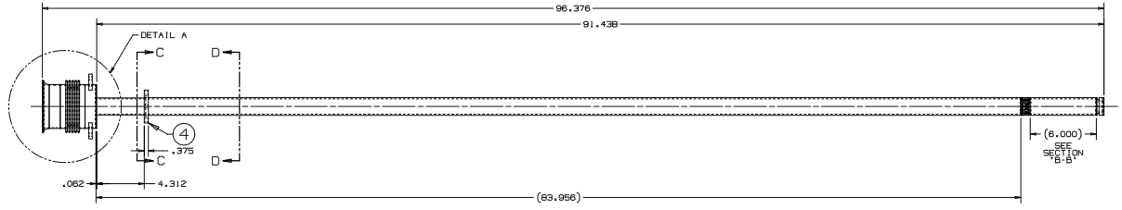
Figure 3.1 Depiction of Pre-Target Beam Window Assembly
This design was the original window style installed for NuMI at 400kW, after a domed replacement was created to help better distribute stress for the NOvA 700kW run. An unknown flaw with the domed window was that the pre-curvature of the window, which was a desirable feature, reduced the effective braze land area, which is an undesirable feature. This design holds promise however if the braze interface region can be redesigned while maintaining the stress distribution characteristics of the domed shape. The flaw was identified to exist within the fabrication techniques used from the vendor, not with the window design itself.
Currently the flat style window replacement has seen beam power in the range of 750kW as of 3/17/17, albeit for short periods of time. This is likely at the safe operational limits of the window for fatigue life considerations, and further increases in beam power will be potentially limited without a corresponding increase in beam spot size or reverting to a domed shape.

Upgrade for High Intensity Operation
As mentioned, beam spot size would likely have to be increased for the beryllium window to survive extended operations. Mechanical and thermal analysis efforts must be performed to show the relationship between beam spot size, window curvature, and the resultant maximum temperatures & stresses. It would be desirable for the window to meet the same lifetime requirement standard of the main beamline components in the chase, which is 100 million pulses.
Changes to the fabrication techniques of the domed design should also be carried out, so that the high intensity replacement has both the large break out distance at the braze region, and stress distribution characteristics desirable for fatigue life. These changes would have to be both confirmed and tracked during vendor fabrication process to ensure no repeat issue as mentioned previously.

NOvA Target Baffle & Core

Present Status
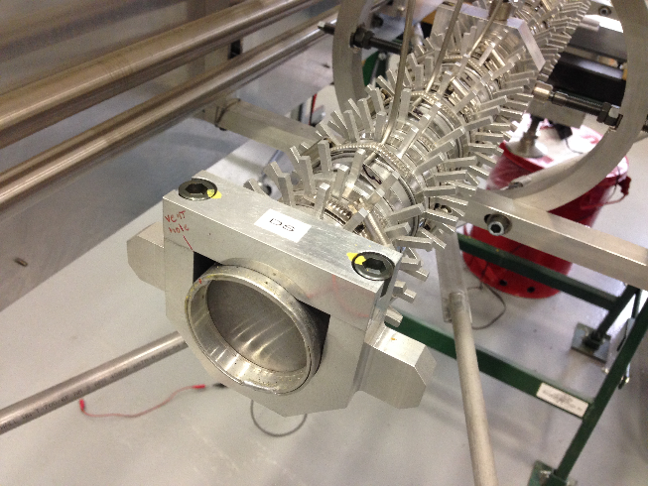
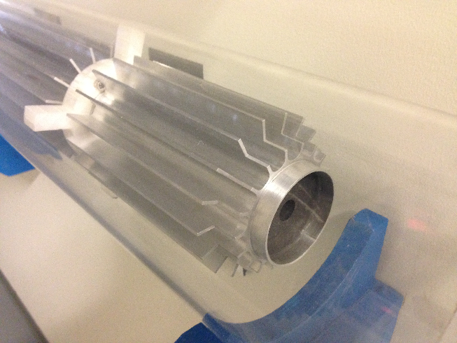
The target baffle for NOvA was twice redesigned to accept the higher beam power associated with 700kW operation. The first redesign from the NuMI low energy style was an increase in bore hole diameter & cooling pin count, followed by a subsequent redesign to increase cooling fin surface area and simplify component count & assembly time. Fabrication of the last redesign closely mimics that seen on many heat sinks, with a constant fin area / extruded cross section. This design is also sized to accommodate the current beam spot size of ~1.3mm, and thus the clearance should be subsequently increased for beam spot size growth past 1.5mm. This enlargement requires a thermal and structural analysis to ensure maximum aluminum temperatures do not undo the press-fit final assembly.

Figures 4.1 & 4.2 NuMI Style “Pin-Type” Baffle Cooling (Left) & New NOvA “Fin-Type” Upgrade
Arguably the most critical component in the beamline is the target, of which nearly all concerns are for the core, consisting of graphite and beryllium fins. The target core is the component which has the most extensive interaction with the proton beam (by design), and therefore is the most susceptible to thermal shock and stress from increased intensity. As with the other components described within this report, the current core, consisting of 7.4mm wide POCO Graphite grade ZXF-5Q fins, has seen beam intensities of 5.4e13 protons per spill. This represents an increase of 10% from its originally intended design intensity of 4.9e13 ppp. AD operations is considering further increases in intensity for the short term on the order of 5%, which is currently being debated within the target systems department.
Essentially all other target components and ancillary systems will have reactions to increased intensity on a somewhat linear scale. Temperature readbacks and alignment checks will show trackable changes. Eventually without addressing high intensity cooling concerns, or reassessing core alignment & stress, a sudden failure of any part is possible, which can be mitigated through the possession of multiple target spares. If target redesign becomes a priority, consideration should be given to working with the NOvA collaboration for redefining the idealized target geometry. Minor adjustments in fin shape, length, type, and spacing can be accounted for in a retrofitted target without major engineering revisions.

Upgrade for High Intensity Operation
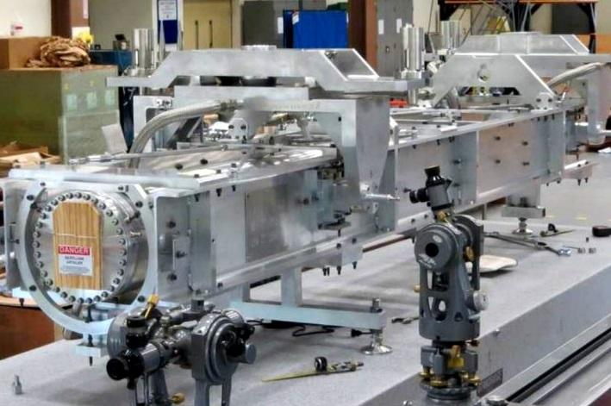
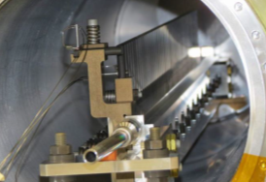
Current understanding of target life leaves the fin material (core) with an acceptable margin of safety up to around 10-15% higher intensity with a small increase in beam spot size. If the spot size is not kept at 1.4mm or the intensity runs higher than somewhere in the 5.4e13 - 5.7e13 range, it’s possible core failure could result requiring a target replacement. Chances are significant that it could impact the fatigue life and potentially require accelerated target replacements.

Figures 4.3 & 4.4 NOvA Target Carrier Assembly (Left) & Open Core with Fins (Right)
If the optics adjustment in beam spot increase runs past 1.5mm, the baffle would need a redesign as mentioned previously, but could potentially be limited to reaming out or reassembling an existing core with a larger I.D. on the graphite slugs. Due to the shrink fit assembly process and fragile nature of the slugs, it’s more likely a new baffle would be made, and retrofitted on a NOvA target chassis so as to avoid a total target carrier redesign. Past a 15% increase in intensity, the core & baffle would need to be re-analyzed and possibly redesigned to accommodate larger fins for new beam spot optics, as current convention has the target fin width and baffle hole radius being a function of ~5X beam sigma.
Additional analysis on supporting components would be geared towards the D.S. window, as this was the point of failure on the target replaced during the 2016 summer shutdown. One concern is the internal pressure applied to the window during a beam pulse, as there exists both the primary effect of instantaneous energy deposition in the window center, coupled with the secondary effect of helium expansion inside the containment vessel, which will increase with intensity. Other supporting components include the target can and hanger cooling loops, as these respectively affect the core containment cooling and positioning in the chase.
One aspect of target redesign or replacement is to consider the expanded or complete use of beryllium fins as opposed to the graphite units. Three beryllium fins have been installed in the current target, and if autopsying efforts can be performed after a change-out, there is the potential for beryllium target fin fabrication and replacement in the 900kW target design.

NOvA Horn 1 Conductors & Electrical Bus

Present Status
The NOvA Horn 1 is an updated version of the NuMI Horn 1, with 90% of the construction shared between the two designs. Updates were required to reach 700kW from the original 400kW specification due to heating concerns in portions of the main conductor assemblies, and other ancillary systems. Significant newly designed elements include a new current supply bus on the downstream end of the horn, as well as a beryllium crosshair for beam based alignment. Several sub-assemblies required updating due to heat loads as well, namely:
- Water spray cooling systems
- Water collection tank structures
- D.S. flange cooling loop circuits
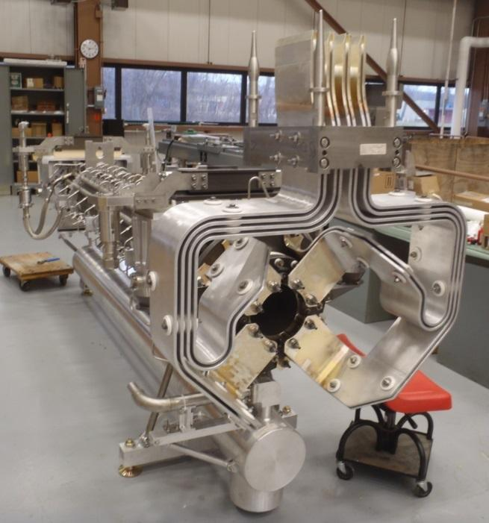
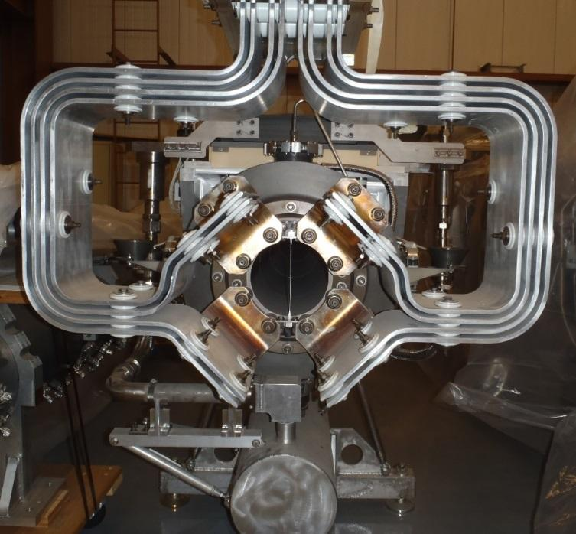
- Structural connects to support modules

Figures 5.1. & 5.2 NuMI Horn 1 (Left) & NOvA Horn 1 with Original Stripline (Right)
This horn design was placed into service at the completion of the NOvA 700kW upgrade, and had a service life of approximately 1.5 years before failing. The medium energy horn design failed after ~27 million pulses due to an electrical bus breakage towards the connection to the main conductor; the cause eventually determined to be rooted in excessive displacement due to vibration. The redesigned electrical supply bus was modeled after the design used on Horn 2, as it afforded a more direct air pathway for conductor cooling in the chase air stream. The access to chase air flow was a trade-off with design rigidity, and analysis efforts detailing the expected operating temperature and stresses could not accurately predict vibration displacements, and so this portion was not explored analytically.

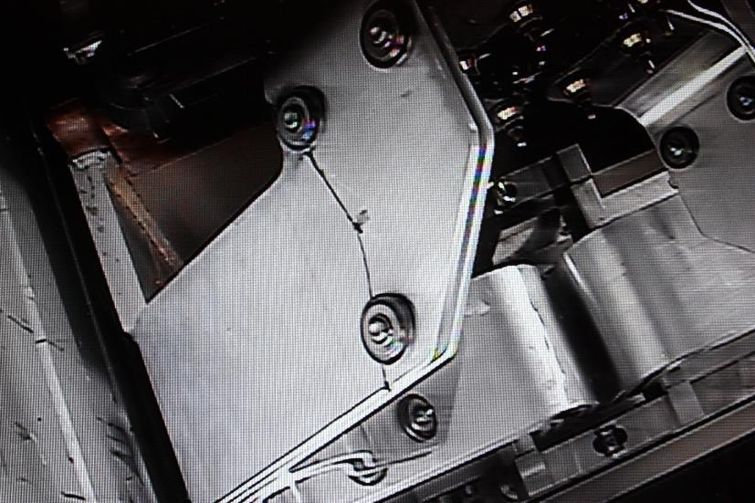
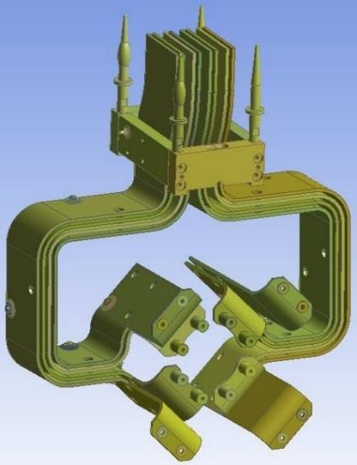
The redesigned electrical bus that better addresses temperature and fatigue stress concerns is currently in the fabrication cycle, with an estimated completion date of 8/1/17 as of 3/15/17. This new bus is a major horn component, and vital to achieving the required horn lifetime of 100 million pulses before failure. The current spare horn 1 has the old-style bus, which as stated, could potentially fatigue and fail after a fraction of the required pulses.

Figures 5.3 & 5.4 Original NOvA Horn 1 Stripline Fracture (Left) & Redesigned Geometry (Right)
Horn inner conductor temperatures and stresses are of vital concern as well, as the horn 1 inner conductor “neck”, is of sufficiently small diameter to undergo significant joule heating from the current pulse. This is compounded by beam heating from its location directly downstream from the particle spray produced by the target, and the combination of the two stressors to the inner conductor tests the material limits of its construction.
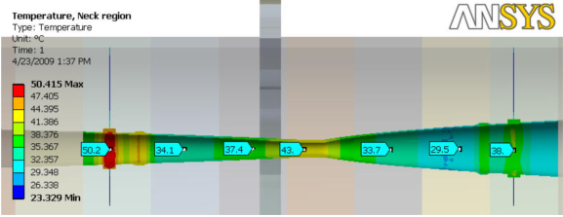
Figure 5.5 NOvA Horn 1 Inner Conductor Temperatures.
Initial investigations into the viability of Horn 2 for increased beam power show no action items. It’s position further down in the chase, coupled with its robust conductor structures and near flawless operational history lend it to higher beam power with no issue. Further validation of the design occurred during multiple iterations of the LBNF beamline, of which the reference design utilizes a NuMI horn 2 at 1.2MW. For the purposes of PIP-I+, it would not be investigated.

Upgrade for High Intensity Operation
Consideration of the NOvA Horn 1 for higher than 700kW steady state operation should encompass analysis studies to verify expected operating temperatures of the inner conductor, D.S. flange, and electrical bus near beam centerline where it mounts to the horn. These studies and possible resultant design changes are needed to prevent a catastrophic component failure, the definition of which being any failure that requires horn replacement for normal operations. A specific listing of factors that need to be looked at are:
- Horn neck and transition region operating temperatures & stresses.
- Horn Conductor differential expansion & impact on alignment.
- D.S. flange and main isolation ceramic temperatures & stresses.
- Electrical bus temperatures & stresses.
- D.S. Beryllium crosshair temperatures & stresses.

Possible solutions to remedy expected issues with the 700kW horn design would include the following:
- Reduction in power supply pulse width to balance increase in beam heating.
- Chase air cooling upgrade to maintain or lower operating temperature and negate differential expansion effects.
- Increase cooling water flow to primary manifolds.
- Redesign of wind diverter for stripline or material changeover to robust aerospace grade of aluminum (complete use of 6013-T651 plate).
- Thermal isolation of Beryllium crosshair from flange connecting frame.

Target & Horn Modules

Present Status
Current condition of the Target and Horn modules is such that they are not presently capable of completing the full range of motion they were intended to have. Original construction of module components was primarily steel based, and used some common coatings at the time for corrosion resistance. These coatings were primarily either paint, nickel plating, or for sliding interfaces, Dicronite dry film treatment. Due to the atmosphere in the target chase and the overall age of the components, none of the original coatings remain, and the structures have generally corroded to the point where kinetic interfaces are frozen.
The Target module transverse drives are frozen, but both the U.S. and D.S. vertical drives are functioning. The horn 1 transverse drives are also frozen, and the vertical drives must be manually operated due to stiffness in the members and poor motor controller wiring due to radiation damage. Problems with the vertical drives became readily apparent during the 2016 summer shutdown, as positional accuracy was lost due to deteriorated bushings, costing an additional 2 weeks of downtime to repair. Luckily, the horn 2 position requirement in the chase is of such accuracy that it does not require precise positioning, and therefore does not have delicate vertical drives. The horizontal adjustments for this horn are also performed manually.

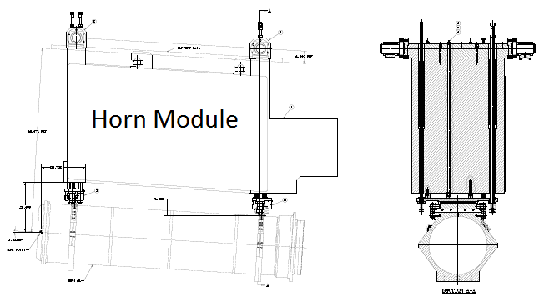
Figure 6.1 Horn Module Position Relative to Horn
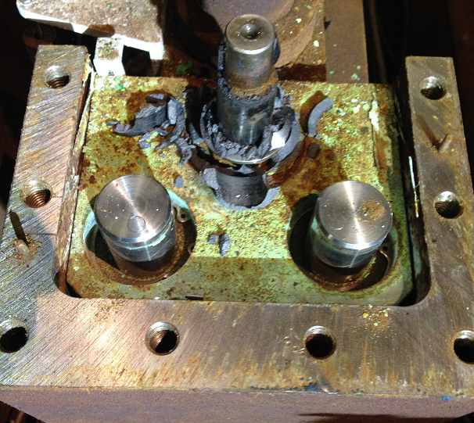
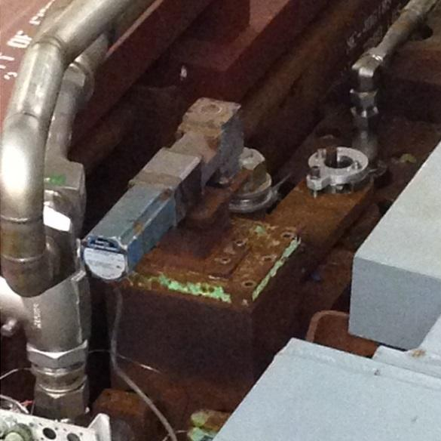
Module heating is of a concern for higher beam power operation, but as per the SNuMI report for 1.2MW operation, thermal expansion is not an issue based on the available overhead for alignment tolerances for NOvA. This beam requires horn alignment tolerances of 1.5mm both horizontally and vertically (1mm for MINERvA), and the alignment is indeed set and verified during each component changeout procedure. This was further confirmed during the analysis efforts performed to determine module thermal expansion for the 700kW upgrade, as the horizontal and vertical offsets were found to be 0.4mm and 0.8mm respectively. Comparatively, module expansion during NuMI 400kW operation was just over half that seen for NOvA. Rough extrapolation shows this should be OK.

Figures 6.2 & 6.3 Module Drive Mechanism (Left) & Failure (Right)

Upgrade for High Intensity Operation
The Primary concern for high intensity operation is the repair or retrofitting of the module drive mechanisms. Further corrosion is expected, and if vertical drive mechanisms begin to freeze, there will be no recourse for correcting the target or horn position in the chase to meet either the on-axis or off-axis tolerances required by the experiments. As the modules are highly activated, they would likely require some significant cool down period to be able to diagnose / fix / retrofit. The risks and benefits should be weighed by operations to determine if work should be completed after a shutdown cool-off period, or saved until true failure to meet tolerances during a component change out. A recommended option would be to engineer & procure replacement drive system components, essentially keeping them in spare inventory in the event they are immediately needed.

Electrical Bus Penetrations

Present Status
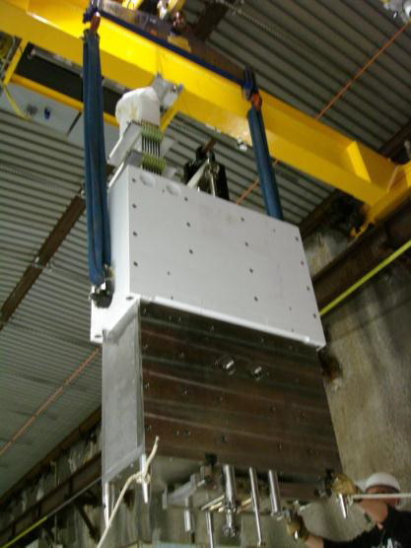
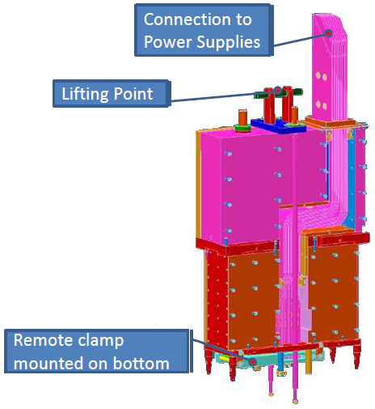
The electrical bus penetration on the D.S. end of the modules, commonly referred to as the stripline block, are of concern due to current operating temperatures. This shield block, and its internal bus, have the same contributing factors to its heat load as the horns themselves: energy deposition from beam heating, as well as joule heating from the current pulse. Prior analysis completed for NOvA operation has the bottom end of the stripline block operating at roughly the set engineering temperature limit for aluminum, or roughly 100C. Further increases in beam power should ideally be matched by new air diverter systems to provide cooling to this critical juncture in the bus, as failure could potentially result in the replacement of both Horn 1 and it’s stripline block.

Figures 7.1 & 7.2 NuMI / NOvA Stripline Block

Upgrade for High Intensity Operation
The primary concern for these structures at high intensity operation is the cooling of the horn 1 electrical bus inside the block. It does not have any direct cooling source other than minor air leaks through the chase shielding. Remedies for this lack of sufficient cooling include the use of a new HVAC system which supplies a separate air stream to one of two features:
- Dedicated shielding block with internal air passageways, directed at the D.S. lower portion of the stripline block.
- Retrofitted stripline block duct work, directing a focused air stream down the existing stripline block labyrinth and out through the remote clamp area. This would be the preferred method based on the total coverage of affected components.

Other structural components of the block are not in danger of failure. The steel, stainless steel, and other materials are resistant to high temperature operation and pose no alignment issues with regards to horn positioning. It’s likely that the directed air flow through the stripline block will also serve to remove enough heat from these structures. This overall solution would essentially be a duplication of design efforts for the MiniBooNE (BNB Horn) stripline penetration.

Power Supply

Present Status
The NuMI Power Supply was tested and commissioned to provide a 205kA half sine wave pulse to the horns over a pulse length duration of 5.2ms, every 1.87 seconds. The pulse parameters are produced from the series-parallel arrangement capacitor bank, which can operate up to about 1kV (1.34kV theoretical maximum) to push the current pulse to the two horns in series. The pulse supply is capable of reaching 240kA, however limitations on practical capacitance and the horn 1 neck prohibit this. Actual operating parameters for both NuMI and NOvA have the power bank supplying roughly 200kA over a pulse width of 2.3ms, and as such, the system is essentially operating at a fraction of its design power.
For NOvA operation, the repetition rate was increased to every 1.33 seconds in conjunction with the higher beam power in order to reach 700kW. This also corresponded to an operating voltage increase from the theoretical 680V to 787V (742V in practice), due to the additional stripline needed for reaching the medium energy horn 2 position. For high intensity operation, it is envisioned that the repetition rate will be further increased to 1.2 seconds, with another corresponding increase in beam power, to reach the 900kW+ range. The power supply can accommodate the increased repetition rate with little or no upgrades required.
The single identified change to the power supply, assuming a constant pulse width, is the connection of the auxiliary chiller unit for cabinet cooling. At the time of the upgrade, the capacitor bank will be reaching 15 years of age. It’s in the best interests of the PIP-I+ project to proactively protect against capacitor degradation, as replacement is exceedingly expensive for a multi-capacitor bank replacement.
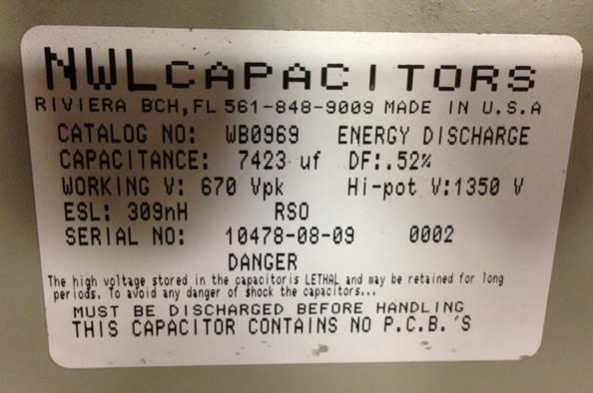
Figure 8.1 Power Supply Capacitor Specifications
A risk to PIP-I+ operation however, is the combined heating load on the horn inner conductor from beam and joule heating. The beam heating variable cannot be altered as a result of 900kW+ running, and so if redesign of the conductor is precluded due to cost or schedule constraints, and it is indeed verified that there is an operational risk of horn failure due to the scaled heat load, the only alternative would be to shorten the current pulse width from the power supply. This shortening of the pulse width would reduce the neck heating in the horn, thus potentially re-acquiring the 100 million pulse life goal set out to achieve with horn designs.

Upgrade for High Intensity Operation
Achieving the reduction in pulse length is conceptually possible by eliminating 2 pairs of capacitors from each 5-pair cell. The removal of the pairs would essentially drop the current pulse width to 77% of the current 2.3ms, which in conjunction with a higher driving voltage, could potentially eliminate 12% of the total joule heating to the horn. This reduction incorporates the new 1.2s repetition rate, while still maintaining the 200kA peak current required for focusing of the pions. Elimination of cells would consist of removing the electrical jumpers from select groups, and then remaking electrical bus connection to the cells still required in the circuit. The old cells would essentially be abandoned in place, allowing for future reconnection if warranted.
Driving the voltage from 787V to the estimated 1032V would require the use of both power supplies available, comprising the main unit, used 100% of the time, and the backup unit, never used. The backup unit would need a basic startup plan and recommissioning if necessary due to its disuse, but there are no factors present that would prohibit a speedy return to operation. These power supplies would then have to be connected in series, as each is capable of a maximum of 800V. An additional factor for consideration of the higher driving voltage, is the rated voltages of the capacitors. Running the system at 1032V would still be within 80% of the working voltage of the capacitors, as each is rated for 670V. When put in series and de-rated by 80%, the maximum recommended working voltage becomes (670V X 2 X 0.8) = 1072V.
If further reduction in current pulse is pursued, a significant quantity of spare capacitors should be procured and kept as spares in the event of a bank failure. This is because utilizing 2/5 pairs will increase voltage to 1,264V, surpassing the 80% functional limit for reliable capacitor life. Further analysis and verification of system voltages, pulse widths, and currents will need to be undertaken by EE support. Electrical bus material & machining estimates must include replacements of known weak links caused by maintenance & switching efforts from neutrino to anti-neutrino mode.

RAW Systems

Present Status
RAW Systems present in the MI-65 underground RAW room, as well as further downstream in the absorber hall, are capable of higher beam power operation to some extent. As these systems function somewhat linearly with regards to beam power sent to NuMI, the feedback and readouts through ACNET can be monitored to understand high intensity running conditions. Alarm limits are already present on the RAW systems to pull the beam permit if supply temperatures to critical components fall outside a predefined range.
Every system was reviewed, with applicable changes being applied to safely reach 700kW during the NOvA shutdown. These changes allow some overhead for good engineering practice, but a several hundred kilowatt increase in power will require a secondary system review, which has been partially completed, followed by focused upgrades or operational changes to the skids.
In general, however, RAW systems have been running without issue for some time. The heat exchangers for the horns and targets are already sized at 71kW to take a massive increase in thermal load from the beam energy deposition. Limitation of the skids and system as a whole are actually on the supply pumps and return piping. The supply pumps are at their operational limit, splitting water into two circuits: cooling to components and a DI clean-up loop. Further cooling flow to components cannot be achieved, as the corresponding decrease in flow to the DI clean-up loop will raise the conductivity of the water past the alarm limits, creating a potential short path inside the horns.
The secondary limitation with the supply feed is the return system is not sized to remove the resultant volume of water from a flow increase. Water return is presently achieved by use of an ejector system, by means of an 80GPM flow per circuit which sucks out approximately 30GPM by use of a venturi nozzle at the top of the modules. Upsizing this system would require an extensive piping upgrade and possible re-coring of holes through the shielding penetration into the RAW room to make room for the new system piping. This activity, if needed, would considerably affect the cost and schedule of the upgrade.
Minor issues with RAW systems that would need to be addressed for reliable high power operation are pressure, flow, and temperature sensor locations and designs. Existing sensors have a relatively short life expectancy due to both the proximity to the irradiated water, as well as the specific construction of the sensing element from each respective vendor. Failure of the sensors will trip the alarms or give inaccurate data, potentially leading to a subsequent failure of a major beamline component.

Upgrade for High Intensity Operation
There were several upgrades identified to better tailor the system for 700kW+ operation. The following list identifies the major ones that are recommended by the Fluids Group.
- Increase water line size run to target & horn for corresponding increase in pump size & flow.
- New hole core through penetration separating RAW room from target chase for larger line run.
- Modification of the “Feed & Bleed” system to account for higher pump outlet pressures. The system will become unbalanced with the higher pump output pressure and will be unable to operate the system to reduce the tritium concentration. Piping and pressure reconfigurations must be completed to preserve functionality.
- Complete change-out and partial relocation of pressure, flow, and temperature sensors.
- A complete inspection or overhaul of the absorber intermediate skid should be performed, as it is not typically maintained.
- Operation past 700kW should prompt the startup and re-commissioning of the D.S. Decay pipe chiller. Its operation also attenuates heat build-up at the D.S. decay pipe window, which cannot be directly removed through the earthen surround of the decay pipe itself as with other portions. This chiller has not run in some time however, and there remains the potential that its current condition does not lend itself to reliable operation. In this event, it was suggested by multiple groups that the chiller be abandoned in place, and a new heat exchanger installed adjacent to it for equal heat removal at a fraction of the maintenance cost.
- A final flush and full exchange of all water for the decay pipe cooling skids should be performed to remove precipitates. RAW skids seals suffer from corrosion and particulate formation which acts as a wear accelerator. Completing this flush cycle simplifies future maintenance issues.
- Up-size pumps and double the cooling flow for the 12 cooling lines running the length of the decay pipe from 4.5GPM to 9PM if energy deposition is problematic. Unlikely for 900kW operation but should be verified.
- Argon gas system to be reassessed for higher flow due to increased beam based ionization and dissociation of atmosphere & water spray inside the horns.

Target Chase Chiller Unit

Present Status
The target chase chiller unit consists of the 8 compressors and heat exchangers tied into a single system located on the MI-65 2nd floor mezzanine. These eight compressor modules exchange heat from the target chase air handling cooling loop, which removes heat from the target chase and dehumidification systems, with the CUB water, provided to the main injector at 44 degrees Fahrenheit. Compressors of this type are rated for a constant duty cycle, however do have a set service life advertised by the manufacturer. Strenuous operation from our environment, most notably precipitate formation in the cooling water, has degraded coil performance for some time.
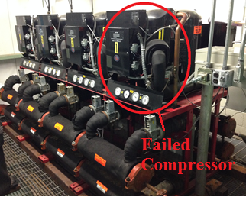
Figure 10.1 Target Chase Chiller on MI-65 Mezzanine
Long term operation and the degrading characteristics of the coolant have left one of the 8 modules completely dead, as a breach occurred between the heat exchanger and its corresponding compressor process loop. The remaining 7 compressors are generally operating near 100% capacity (93% as of 3/20/17), and it is apparent that this system will present the first “hard” limit to what beam power can be run outside of administrative limits. Failure to maintain chase air supply temperature greatly impacts nearly all components in the beamline, and raising the operating temperature will further expose electrical bus in the chase to higher operating temperatures, thus decreasing the life expectancy.
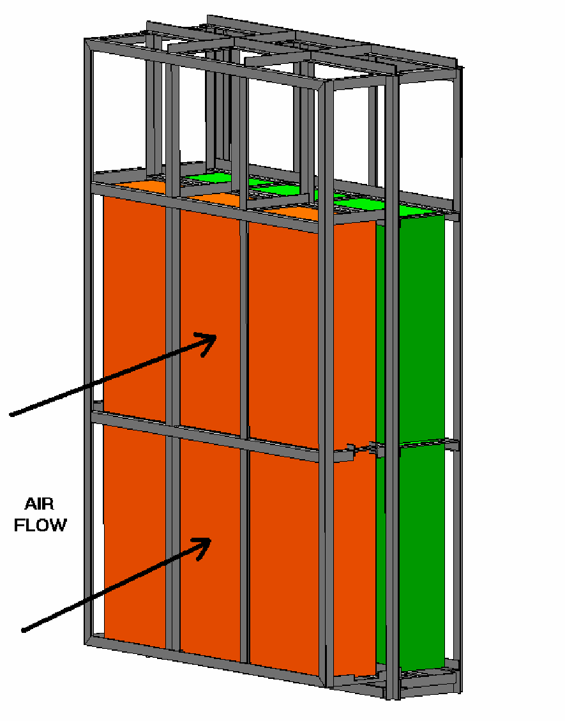
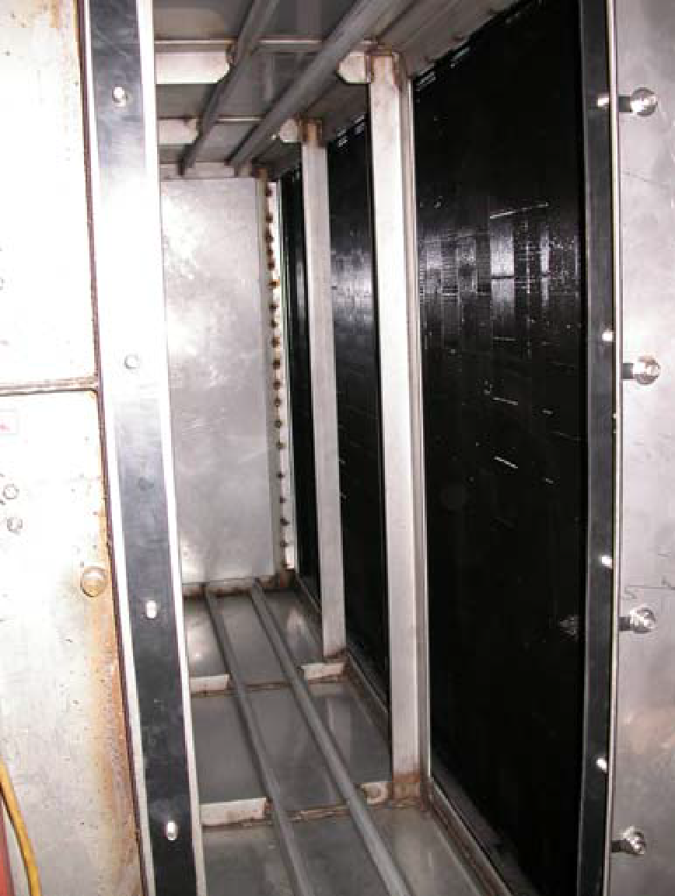
System limitations are also present on the ability to exchange heat with the target hall, as the current cooling coil banks have specified heat removal capacity that falls outside of the bounds of what a 900kW+ beam power will deposit. The coil bank was originally upgraded for NOvA operation by the removal of an unused damper system, followed by subsequent installation of an auxiliary cooling coil. Fortunately, the air bank was designed to accept two banks of coils, the second of which remains partially open, obstructed only by an unused damper. Expansion of the coil capacity in the existing air system is indeed possible, and likely required for the heat exchanges between systems.

Figures 10.2 & 10.3 Proposed Coil Addition (Left) & Open Bay in Coil Box (Right)
Addition of a second coil bank would require a doubling in cooling water flow to the bank to maximize efficiency. The existing piping is 4” steel, hooked up to alternating centrifugal pumps on the mezzanine that push the water through the target hall and back up to the chiller unit. FESS has identified this piping as being a bottleneck with regards to doubling flow, as the losses are nearing the range where a larger pump to push the coolant faster would likely just add heat to the system instead of remove it quicker. It would likely be a wash if piping is not upgraded or at least analyzed for optimum flow & pressure. There might be some tradeoff where flow cannot double, but instead is raised to the limits of the piping.

Upgrade for High Intensity Operation
Upgrades for high intensity operation are already underway in part due to the limits and performance issues described above. FESS is aware of the system limitations and impending issues to NuMI operations. Because of this, the system is slated to be partially expanded during the 2017 summer shutdown to include the use of a heat exchanger either in conjunction with, or prior to the chiller.
Efforts are ongoing to either initially upsize the heat exchanger to accommodate high intensity operation, or at least be easily expandable to reach that point with additional funding. A recommendation during the PIP-I+ upgrade reviews was to not decommission the chiller, but rather to keep it operational for either post processing the chilled water to a lower temperature, or to use as a system bypass in the event of heat exchanger maintenance or failure / damage / performance degradation.
The remaining damper in the cooling coil bank would need to be removed, and associated supply piping around the area reworked. Insertion of a complete set of identical coils would ensue, requiring piping expansions off the 4” steel future lines that were installed several years ago. Associated instrumentation and feedbacks for the new coils would again need to be added, chiefly for validation of analysis assumptions and expected performance.

Target Chase Air Handling Units

Present Status
The main air handling system in the NuMI target hall is the primary recirculation system for the chase air. This system is powered by a 100hp centrifugal fan which provides cooling air for all beamline components, as well as the shielding steel and concrete which makeup the chase bathtub. This air is routed past the heated beamline structures, through a filter bank, and then drawn past the cooling coils prior to being re-pressurized by the fan to complete the loop.
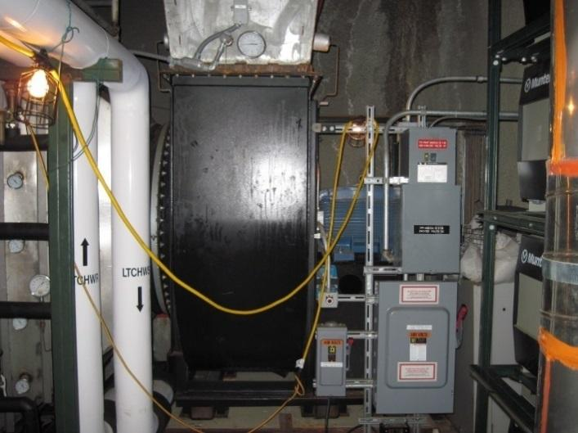
Figure 11.1 NuMI Target Chase Fan
Several air monitoring devices are also present in the target chase air handling system to monitor filter bank pressures and temperatures. Most are from the original commissioning of NuMI, and are in need of replacement. Costs & time associated with replacement are generally out of the scope of existing maintenance budgets, so part of the PIP-I+ project should be replacement of these sensors if possible. Failure of any multitude of pressure sensors, specifically related to the pressure differential across the filter bank, will pull the beam permit and take on the order of days to fix correctly.
Several other air handling systems contribute to the overall air quality and conditioning required for operations. These primarily consist of the main dehumidification units for the chase air, as well as subsequent input and output balancing fans for controlled radionuclide release. Other dehumidification systems are present which control air handling for the decay pipe passageway, in addition to the absorber hall. Presently, these systems have been upgraded or their operating capabilities expanded to run relatively trouble free in adverse environments. It is not believed the maintenance impact will be such to require specific upgrades as part of the PIP-I+ project. Most advancements will be made as part of current operations, using the existing budgetary resources available for this work.
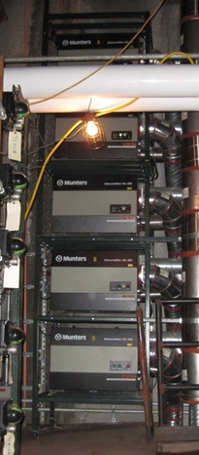
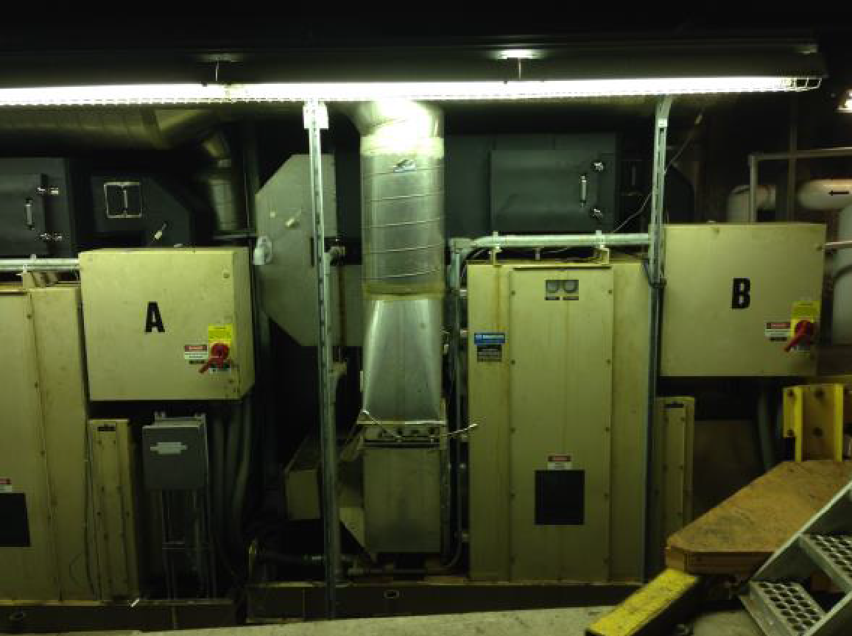
Figures 11.2 & 11.3 D.P. Passageway Dehumidification Systems (Left) & Target Chase Units (Right)

Upgrade for High Intensity Operation
The primary system needing attention during an upgrade is the variable frequency motor drive for the 100hp chase fan, which is an older unit with minimal spare parts support. This unit operates without issue 99.9% of the time, but a cooling fan failure, which has twice occurred, will result in a 3 week downtime to repair the cooling fan for which no spare parts exist. NuMI has fortunately had these failures during scheduled summer downtimes, although a failure could certainly occur during the normal operating season. Refreshing this system with one that has spare parts support could prevent an extended down time. In addition to the VFD, activities related to replacing or repairing existing instrumentation for the chase air supply is warranted. Several indicators of air system integrity are no longer available, are have historically been at engineers’ disposal to identify and diagnose air system issues.

Target Chase Shielding

Present Status
Shielding concerns for PIP-I+ were originally identified as an area of concern for the SNuMI study, and as such were re-analyzed for beam powers up to 1.2MW. Current shielding in the target hall and decay pipe, from an omnidirectional standpoint, is acceptable for limiting prompt radiation dose or subsequent activation of surrounding ground water & rock. The limitation arises with regards to prompt dose in support room areas such as the DI room, power supply room, and shaft area, all of which are typically accessible during beamline operations. The SNuMI study identified that the dose rates while running high intensity beam will likely inhibit unfettered access to these areas for support & maintenance operations, and in fact would likely make these posted radiation areas that require radiation safety permission or oversight to access.
The cause for this prompt dose is not the beam from the target chase enclosure, but in fact, from the RAW room which is already a posted radiation area. The activated water return from beamline components to their corresponding heat transfer systems essentially negates the 28’ of earthen shielding between the support rooms and target hall. The “shine” from the water is then able to make its way over the shield walls in the RAW room, into the DI room, and then through the doors that separate each support area. This effect has been observed when nearing 700kW operation, as the DI room is now a posted area, and for a time, the power supply room was limited access only. A semi-permanent shielding blanket was constructed in the DI room to limit the shine, thus restoring normal access to the power supply room, however higher than 700kW operating will again require subsequent shielding in the RAW room at the source, or additional shielding blankets in the DI room.
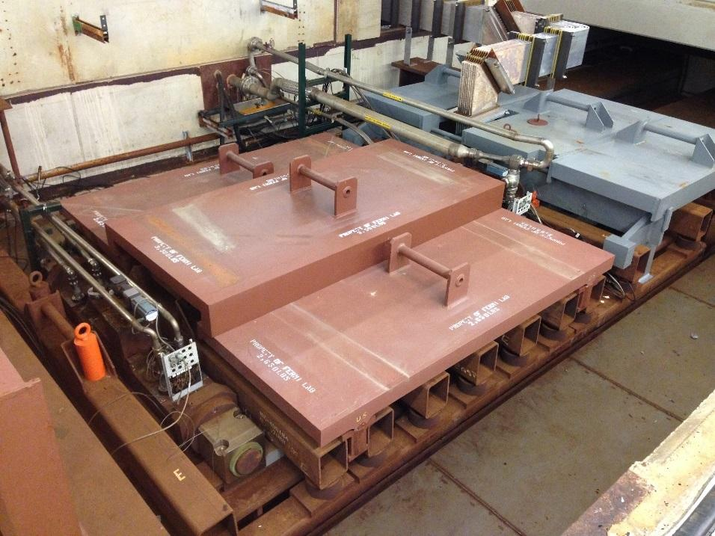
Figure 12.1 Auxiliary Chase shielding Panels
Target chase shielding also encompasses the temporary shielding required to perform change-outs of beamline components, primary beam windows, targets, and horns. Due to dose rates at the D.S. end of horn 1, the area above the module near the top of the electrical bus (stripline block) that must be disassembled and reassembled, has become a hot spot for technicians. Several additional shielding plates were created over the last several years to help attenuate the absorbed dose, although the rates in this area remain high due to difficult to cover chase geometries, and limitations of attachment points for the plates.
High intensity operation will obviously raise these rates, providing more of an incentive for additional shielding plates to be designed, and for all intents and purposes, requiring their implementation to allow technician access to break and makeup connections prior to remote handling.

Upgrade for high intensity operation
Shielding upgrades can be easily defined globally, but hard to define locally. As mentioned, shielding must be added to the RAW room and target chase to allow standard access and maintenance activites to continue as planned, but the method for accomplishing this in each area varies. For the RAW room, the immediate solution would be to:
- Add on to the existing South and West shielding to better attenuate dose through the walls into the DI and power supply rooms.
- Finish out the separation wall between the RAW room and DI room to eliminate shine from the ceiling being reflected down and throughout the support rooms. This will limit radioactivity to working its way through the entry door only, which is a portion of the area presently available from wall voids underneath the ceiling.
- As mentioned, subsequent lead blankets around the door area will reduce dose rates in the DI room, which in turn should allow the area outside the locked double doors to remain open to access with an elevator key

Local shielding for the target chase would have to be engineered and implemented on a case by case basis. This would essentially function as “conformal shielding”, consisting of closely shaped panels to the activated components. Noted areas that likely could be expanded upon are the side gaps underneath the module shielding plates, which allow chase radiation to exit towards workers. Additionally, a secondary shield wall could be constructed for the D.S. carriage beam supporting Horn 1 to further isolate D.S. shine making its way back under the shielding blocks that line the top of the chase. Longer cool down times will be incurred until the available shielding will reduce the dose rate to an acceptable range for work to commence. These longer cool down times are not linear, and the anticipated wait time could increase by several weeks to months until rad safety grants approval to work on chase components.

Decay Pipe & Windows

Present Status
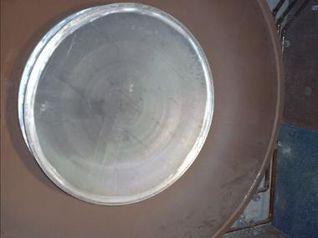
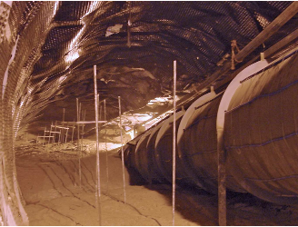
The water-cooled decay pipe is a 2m diameter, 675m long steel tube, with sealed beam entrance and exit windows at both ends of the pipe. The decay pipe was designed for & operated under an evacuated condition (1 torr) when NuMI beam operation began in 2004, however around 2007, the decay pipe was filled with helium gas, slightly below atmospheric pressure (0.9 atm), after discoloration and suspected corrosion was found on the window at beam spot center. Helium gas keeps operational temperatures and pressure of the pipe and the beam windows well within design limits, while additionally reducing the likelihood of an upstream window failure due to pressure differentials or maintenance activities. Since the change to a helium backfill, there have been no issues for the NOvA run at 700kW.

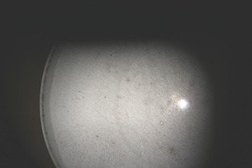
Figures 13.1, 13.2, & 13.3 Decay Pipe & U.S. Window
Since the decay pipe operates in a high humidity, high heat, and radio-activated air and water environment, corrosion on exposed metal, such as a cooling water pipe, is of concern. These water pipes were cut to be visually inspected throughout the 2014-2016 summer maintenance days, and no damage or degradation other than discoloration was found. The findings suggest that the estimated lifetime of the water pipe will be sufficient for PIP-I+ operation, so long as other flow or temperature parameters are carefully assessed if increased.
Conversely to the water supply pipes, the aluminum entrance window has been discolored at the beam center area, which shows a plausible material or surface effect from radiation damage. Although most likely a direct cause of operating temperature, the true mechanism for discoloration is unknown (heat or corrosion or both). It is most likely that this is oxidized aluminum, caused by heating due to energy deposition and an abundant source of moisture during early operation. These surface effects, including the potential depth of the discolored region, caused by some thermal or chemical reaction processes, has not yet been investigated. Service life expectancy of the window is unknown due to inability to closely monitor material condition and surface defect formation. We anticipate this becomes a risk for PIP-I+ operation. Unfortunately, there are limited invasive methods for further determining window health, as even the most gentle or direct still have some risk associated with them. Lack of time for any reasonable assessment has been the limiting factor however.

Upgrade for high intensity operation
Mechanical analysis on the decay pipe window was undertaken for the SNuMI study in 2006. The result shows that the window can endure up to 1.7 MW in its as-designed configuration, but it does not account for material defects as witnessed in its current condition. The decay pipe can endure beam power up to 2 MW by means of flow doubling of active cooling loops as covered in the RAW skid section, although the doubling could potentially help the U.S. window as well, since it’s physically welded to the structure and there is a conduction path for heat removal. As previously mentioned, a numerical study must be re-evaluated for PIP-I+ operation to confirm this analysis with correct beam parameters.
As the material thickness and surface state of the decay pipe window is not precisely known, a remote-control machine (RC Robot) can be made to measure the window thickness by using a calibrated ultrasound material thickness gauge in the target chase. These techniques are not uncommon and several issues among the external beamline experiments have proven the viability of remote robot inspection abilities. If the ultrasonic inspection method is deemed invasive, through the residue that would be left on the window, or too inaccurate, due to the radiation hardened material, a high definition camera would be the fallback plan to determine window health. There are also concepts available if needed to disassemble the old window and weld the new one on remotely if needed in the event of a failure. A corrosion-resistant aluminum can be used (ex. 6061→5083) for example as a new window material. One possibility is a Beryllium center window if the radiation damage is expected to be severe.
It should be noted that failure of the decay pipe window would create an extended downtime for NuMI, negating any effect of a beam power increase. Best estimates for window replacement range over a year between cool down, replacement fabrication / testing, & primarily the replacement activity. Confirmation of window health and consensus on operating intensity maximums is crucial prior to any serious upgrade efforts.
A recommendation to reduce the possible down time in event of a failure, is to build a spare decay pipe window, as well as the removal / replacement mechanism, & associated testing, before significant time has passed at high intensity operation. This would allow readily available components and tested processes to be immediately used in the event of a failure, which would limit any delay to cooldown and replacement time.

Hadron Beam Absorber

Present Status
The hadron beam absorber is located downstream of the decay pipe and the hadron monitor, and has a core consisting of aluminum and steel blocks, which are cooled by the RAW skids in the adjacent absorber hall enclosure area. The aluminum and steel core is then surrounded by a series of stacked concrete blocks, which finish out the total assembly as can be viewed in the figure below.
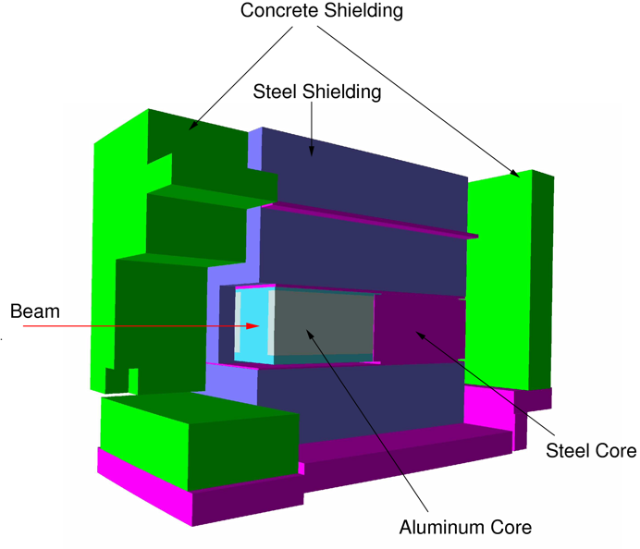
Figure 14.1 Hadron Absorber Cross-Section
The main function of the absorber is to eliminate the residual high-energy charged particles in the secondary flux, apart from muons, which travel onward to the muon alcoves for detection by separate monitors. Since a large portion of the beam energy is deposited in the absorber core, removing that heat is critical to ensuring the aluminum does not reach ~150C, or fatigue failure due to creep becomes a real concern. It should be noted that the current operating temperatures of the absorber core in the peak interaction region are only 46C, with alarm limits set at 52C. The present absorber is capable of accepting normal 700 kW beam operation, as well as an accident condition, in which a full intensity beam pulse caused by mistargeting, could potentially be sent to the absorber.

Upgrade for high intensity operation
The absorber has been evaluated in the SNuMI study in 2006, with findings that it can endure up to 1.2 MW beam operation by ramping up cooling water flow and decreasing RAW supply temperatures by the addition of plate heat exchangers or auxiliary chiller units. Upgrades required for this system are nearly all RAW related, and thus covered in the RAW section.
As mentioned in the beam parameters section, the beam spot size of the primary beam on the target will be increased to mitigate thermal shocks on the beam elements downstream of the target. The energy deposition in the absorber will be changed as a result of this, the extent of which could be estimated, but not known with certainty until the thermal analysis is completed and resultant stresses solved for.

Hadron Monitors

Present Status
The Hadron Monitors function as an ionization chamber based beam profile monitor, which is installed downstream of the target. Its nomenclature originates from the primary particle in the monitor, i.e., a hadron, and detection of the hadrons is accomplished by suppling helium gas as an ionization media to the chamber. The first monitor is located after the decay pipe downstream window to align the primary proton beam on the target.
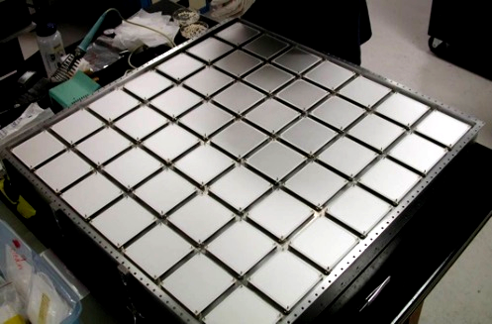
Figure 15.1 Hadron Monitor Assembly
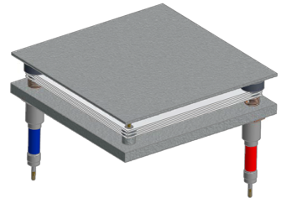
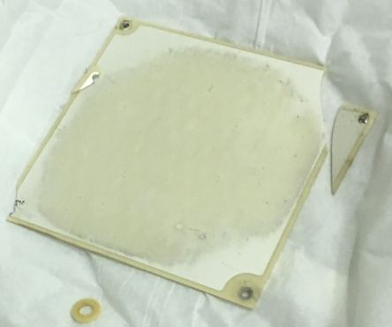
Construction of the monitor must be robust, or “RAD-HARD”, since the entire detector body is exposed to extremely intense radiation, which is one of the major issues with monitor longevity. Other monitors, such as the muon monitor, are located downstream of the absorber to measure muon profiles, which do not have a radiation exposure issue due to the rock shielding between the two chambers. Upgrading of the hadron monitor is the main concerning for PIP-I+ operation with regards to downstream instrumentation.

Figures 15.2 & 15.3 Hadron Monitor Pixel Array (Left) & Damaged Ceramic Plate (Right)
Primary issues with the hadron monitor are electrically based, such as the insulator resistivity of an electrical feedthrough and coaxial cable had dropped at some point, promoting a current leakage. Visual inspection of the chamber after several beam runs would appear to indicate that metal plating on the ceramic insulator and the insulator near the gas exhaust port exhibits discoloration. To this date there is not an accurate assessment of how long the hadron monitors will function due to unknown corrosion issues and general electronic component degradation. Best estimates are that the monitors have a roughly 3-year life expectancy.

Upgrade for High Intensity Operation
There are two approaches for high intensity operation upgrades. One option is a redesign of the existing hadron monitor, incorporating a more suitable radiation resistant insulator for the feed through connection. In addition, avoidance of the discoloration and possible corrosion caused by ionization gas impurities could be rectified using a gas purifier after the gas regulation system. Lastly, a bubbler (gas trap) can be retrofitted on the exhaust gas line to block backward gas injection into the chamber.
A second option for high intensity operation would be the application of alternate beam profile monitor technology. There are two types of monitors that hold promise for this application. The first is a secondary electron emission monitor (SEM), which has been investigated. Because the structure is very similar to the ionization chamber, similar radiation issues should be addressed in the SEM regarding electrical isolation and gas purity. A second option is using a multi-cell gas-filled RF cavity. The basic theory behind its operation is that the gas permittivity is proportionally changed by the amount of beam-induced gas plasma in the cavity. The permittivity shift for each RF cavity is then observed by measuring the RF modulation to reconstruct the beam profile. R&D of these techniques have been in progress and are ongoing.

Technically Limited Upgrade Schedules

Major Component Lead Time
Estimated technically driven lead times for the basic upgrade options required for 900kW+ operation were generated for comparison and planning purposes. It should be noted that these times reflect the current understanding of the beamline prior to extensive analysis efforts, and generally represent a conservative view towards upgrades by assuming all work planned is required. The system / component schedules cannot be assumed to occur concurrently. Application of realistic resource and funding limitations must occur, and the lead times can compound on one another due to these shortages.

Graph 16.1 Estimated Project Time for System Upgrades

Graph 16.2 Estimated Project Time for System Upgrades

Additional References
- K. Anderson, et.al., The NuMI Facility Technical Design Report, Version 1.0, October 1998
- M. Martens, NuMI Phase II Upgrades, November 2006
- SNuMI Conceptual Design Report, November 2006
- S. Tariq, NOvA Horn 1 Alignment Offsets, CD-2/3a DOE Review Presentation, October 2007
- R. Zwaska, PIP I+: NuMI Target Systems, December 2016

“MARS Code System”, mars.fnal.gov
“NuMI Beam Simulation”, https://cdcvs.fnal.gov/redmine/projects/numi-beam-sim/wiki/G4numi
“120 GeV Targeting Overview”, J. Hylen, Accelerator Physics and Technology Workshop for Project X, Nov. 12-13, 2007.

