Strain Gauge Installation for HRMT43
Alyssa R Miller | 2018.12.13

Four graphite cylinders (“slugs”) were placed in the HiRadMat Facility at CERN to be tested as a target material as part of the HRMT43 experiment. They were delivered 440 GeV beam with varied intensities to study their thermal shock response in real time.
The gauges are linear and measure strain in one direction. The cylindrical surface of the slugs are outfitted with strain gauges oriented to measure the circumferential and axial strains, as well as one temperature gauge to measure the beam-induced temperature response. The gauges are glued to the slugs with VPG Micro Measurements M-Bond 610 adhesive. Three bondable terminals, one for each gauge, are also glued to the slugs’ surfaces using Loctite 401 adhesive. Three 28 AWG wires are soldered to each of the two terminals coupled with the strain gauges. Two 30 AWD wires are soldered from the temperature gauge to a bondable terminal, and two 28 AWD wires are soldered to that terminal. Each terminal was soldered by a technician and terminated in a connector card.
Instructions come from VPG Micro Measurements Instruction Bulletin B-130. Not all steps in the bulletin are necessary for this project. This document is intended to be complimentary to the VPG instructional bulletin.

Materials
HBM 1-LY17-1.5/120 strain gauges
HBM TT-3/100 temperature gauge
Teflon tape
Loctite 401 adhesive
Kimwipes
Gauze sponges
Fine tweezers
Spring clamps (>70 kN/m^2)
Custom printed clamp adapters
Silicone rubber pads
CM Inc. Model 1216 FL Rapid Temp Furnace
30 AWD wire
28 AWD wire
X-acto knife
Large glass surface
Microscope

VPG Micro Measurements products:
M-Bond 610 adhesive
M-Line GC-6 Isopropyl Alcohol
M-Prep Conditioner A
M-Prep Neutralizer 5A
M-Line Rosin Solvent
MJG-2 Mylar tape
GEC-50D bondable terminals

Surface preparation

- Clean the surface of a large piece of glass set on a benchtop with M-Line GC-6 Isopropyl Alcohol. Working with the sensors and the Mylar tape is made easier with a clean surface.

- Clean the graphite surface with the alcohol. Apply the alcohol to the gauze and wipe the surface in one direction. Wiping the gauze back and forth will reintroduce contaminants to a cleaned area.
  - Cleaning surfaces with gauze sponges is helpful because the gauze is abrasive, but if the samples are to be cleaned with a chemical after the installation of the gauges, the use of a Kimwipe is advisable, as the gauze may catch the corners and edges of the gauges.

- Apply M-Prep Conditioner A to the graphite surface and wipe it off the surface in one direction.
  - The conditioner is a chemical used in the wet abrading of the bond surface. The necessity of the use of conditioner is unclear in this case, but it was used as instructed in case it was still important for the bond.

- Apply M-Prep Neutralizer 5A to the graphite surface to neutralize its pH. Wipe it off in one direction.

Gauge installation

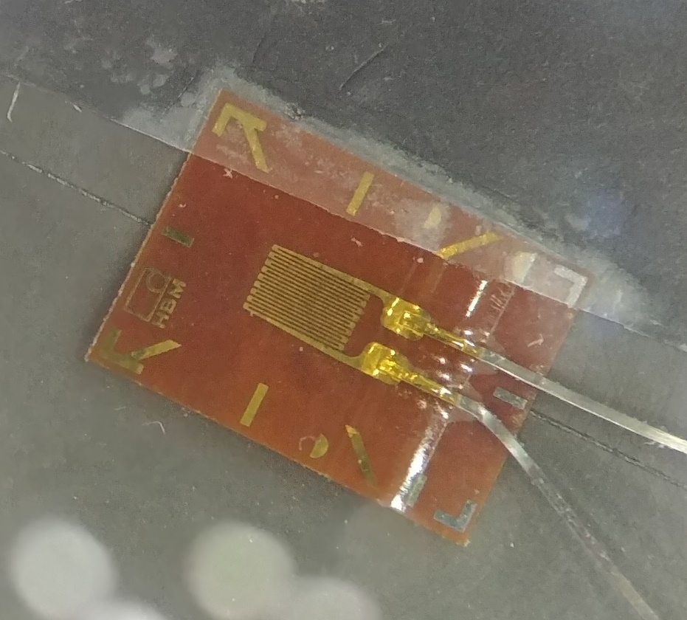
Figure 1: HBM strain gauge under a microscope with visible alignment markings on both the gauge and graphite surface, measurement grid and leads.

- Take a strain gauge out of its packaging with a pair of tweezers, making sure to touch only the edges of the gauge (carrier material) and its leads. Lay the gauge out on the clean glass surface.

- Pull off a clean piece of Mylar tape and position it to cover a small portion of the edge of the gauge. Do not stretch the tape, as this will cause the gauge to contract later and affect its “zero” reading. Lightly push the tape onto the sensor.
  - Make sure the tape does not cover the alignment markings to be used in the gauge installation, if possible.
  - The graphite slugs used in this project have only been marked for alignment in one plane for each of the two strain gauges. It is possible that precision alignment will be necessary in both planes and will be marked accordingly, requiring tape to be set over one of the four available alignment markers. This can be seen in Figure 1.

- Pull the edge of the tape away from the glass at a shallow angle to bring the gauge up and away with it.

- Align the gauge on the graphite surface to the alignment markings with the tape.
  - The gauges will be aligned a second time following the application of the adhesive, so the positioning does not need to be precise yet.
  - In this step you’ll realize if you can see the markings that you need for alignment.
  - If components to be glued onto the graphite surface are close together, place Mylar tape over an edge of the gauge on the glass and use an X-acto knife to cut precision edges that won’t overlap with anything else on the installation surface. Be careful not to lay Mylar tape over an edge with an alignment marking. The alignment marks cannot be seen well enough through the tape.

- Pull the tape and the gauge away from the graphite surface for adhesive prep. Allow for the tape on one side of the gauge to act as a hinge by keeping it stuck to the surface, as seen in Figure 2 below.
  - This will hold the gauge up and away from the surface.
  - When holding the gauges away from the surface to prep them for adhesive application, the gauges will need to stay flat, relatively parallel to the ground, so that the glue will not distribute itself unevenly under the force of gravity. This may require more tape to hold the gauges back or some other brand of ingenuity.

- Apply a thin layer of the M-Bond 610 adhesive to both the gauge and the graphite surface. Wipe the brush on the inside of the bottle to get excess adhesive off.
  - The M-Bond 610 was very difficult to get to stick to the graphite. When applying the adhesive to the surface directly it immediately and fully soaks into the porous graphite. Applying the smallest amount of the adhesive to the under sides of the gauges, as the instructions dictate, give the gauges very little with which to hold onto the graphite, and they tend to come up and away from the surface after the high temperature curing process. Allowing for a very shallow pool of the adhesive to be applied on the backs of the gauges yielded uniform distribution and a substantially better bond.
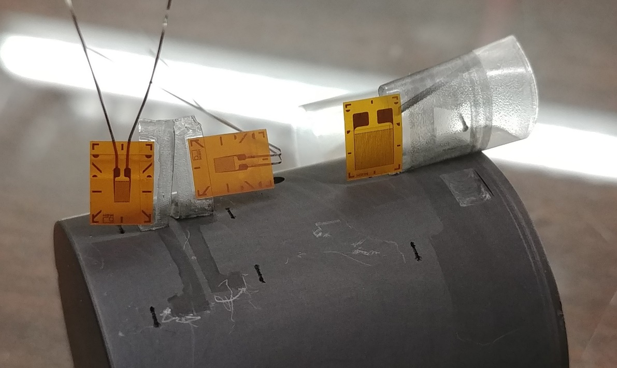
Figure 2: Two strain gauges and a temperature gauge held on to graphite surface after rough alignment. These gauges are awaiting application of M-Bond 610 adhesive, but must be held parallel to the ground, which is not shown here. The gauges must be laying flat so the adhesive does not spread unevenly on the surface due to gravity.

- Allow the adhesive to dry on the gauges in the open air for 5 to 30 minutes.

- Use tweezers and a microscope to set the final alignment of the strain gauges.

- Cut another piece of Mylar tape large enough to cover the entire gauge. Position the tape over the gauge accordingly and push the gauge down onto the surface, moving perpendicular to the surface. Use a gauze sponge to push the tape over the gauge.

- Lay a piece of Teflon tape over the top of the secured gauge. Secure the edges of the Teflon with Mylar tape.
  - This ensures the Mylar tape will not come away from the graphite surface until it is ready to be removed. The clamps and silicone rubber pads involved in the next steps may stick to the tape during the high temperature curing process. The Mylar tape will need to be removed very carefully so as not to compromise the bond between the gauges and the graphite.
  - With the exception of Teflon tape, only use Mylar tape for components that will stay in the furnace for the curing procedure. Mylar tape will melt at temperatures above 204°C.

- Center an appropriately sized silicone rubber pad over the installed gauges. This may need to be taped in place with Mylar tape.

- Position a fully rounded clamp adapter over the rubber pad.
  - Make note of the circumferential center of where the gauges are aligned to center the clamps on them for equal pressure distribution.
  - Adapters for the clamps have been specially designed and 3D printed to securely seat the graphite slugs. Taping this half of the adapter in place on the slug may be desirable so it doesn’t move. If it moves, the alignment could be compromised. These adapters are printed from Formlabs High Temp Resin for heat resistance and can withstand 289°C. These pieces started to disintegrate in the middle of the high temperature curing process, but some printed pieces are suspected not to have been properly hardness cured. Other pieces made of the same materials under the same pressure were not affected.

- Position a partially rounded adapter on the other side of the graphite slug. The flat portion of the adapter must align with the flat portion of the slug.

- Secure the clamp around both halves of the clamp adapter, as seen in Figure 3 below. Center the clamp on the circumferential position of the gauges on the slug. Make sure the clamp is also centered axially down the length of the slug.

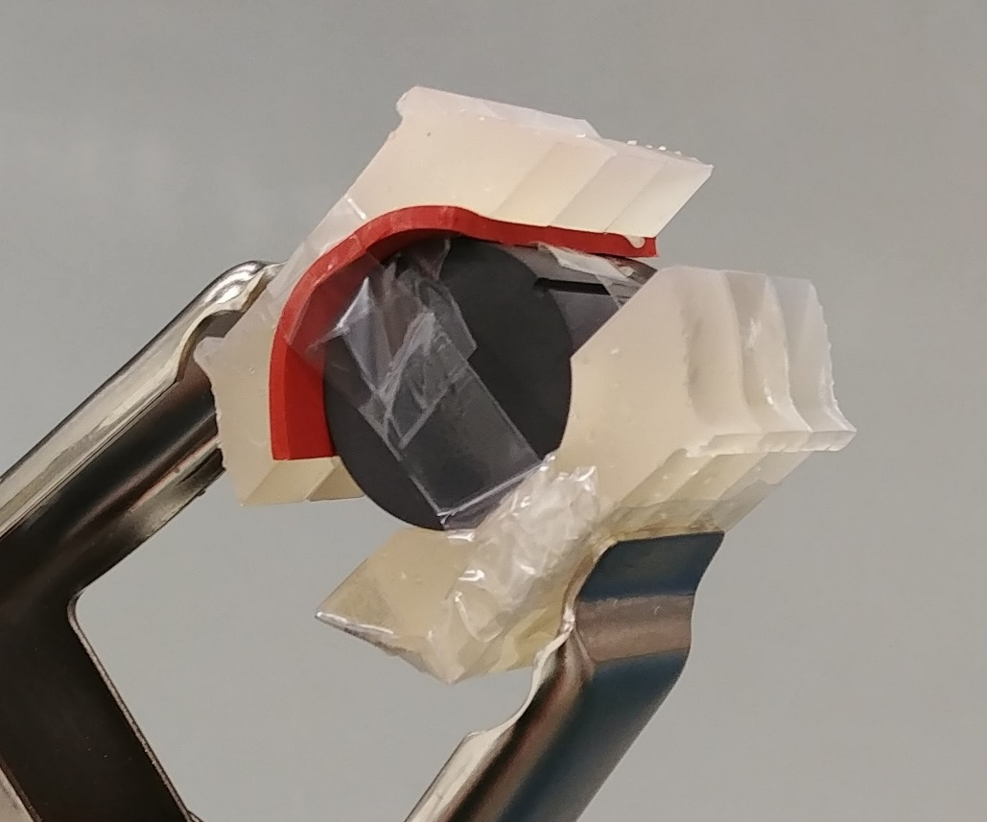
Figure 3: Graphite slug outfitted with precisely aligned gauges, held in place with Mylar tape, protected by Teflon tape, and clamped with rubber pads, custom 3D printed fittings, and spring clamps providing the prescribed amount of pressure. This slug is ready for curing in the furnace.

Adhesive curing
M-Bond 610 requires high temperature curing and postcuring. The instructions include a plot of cure temperature over time, both of which vary. The adhesive can cure at 177°C for one hour and postcure at 217°C for two hours, which is what was selected for this project.
The postcure must be at a temperature 30-40°C above either the curing temperature or the operating temperature, whichever is higher, as dictated by the instructions. In this case, the beam-induced temperature near the strain gages on the graphite slug’s surface is expected to be much lower than the curing temperature. The temperature sensor is the only bonded element requiring the postcuring process, as indicated in the instructions for transducers. The postcuring process is not necessary for the strain gauges, but will not damage them.

- Place the clamped graphite slug in the furnace. The furnace has been programmed to ramp to 177°C at a rate of 5°C per minute, dwell at 177°C for one hour, then come back to room temperature.
  - The instructions allow for the temperature to ramp at a rate of 3-11°C.

- Remove the slug from the furnace between cure and postcure to remove the clamps, Teflon and Mylar tape.
  - The slug should not be removed from the furnace until it has reached at least 55°C. Allowing the adhesive to cool down too quickly may compromise the bond. The furnace takes about three hours to cool to this temperature.

- Dissolve the tape mastic with M-Line Rosin Solvent when removing the tape from the gauges.
  - This allows the tape to come away from the surface without pulling on the gauges. Although the adhesive bond has been formed by this point, take extra care not to disturb the gauges in this process.

- Place the slug back in the furnace once the gauges are all that remain on the graphite surface. The furnace has been programmed to ramp to 217°C at a rate of 5°C per minute, dwell at 217°C for two hours, then come back to room temperature.
  - Similar to the curing process, the slug should not be taken out of the furnace until it drops to 55°C.
Bondable terminal installation
The strain gauge leads are too thin and fragile to be attached directly to the wires that will carry their outputs to the electronics. Bondable terminals, or soldering pads, are used as a more durable contact point for the leads, although the entire assembly should still be treated with great care once the soldering is completed.

- Cut out a set of soldering pads for each gauge on the slug. Orient them so there is a split pad on the left (positioned like an upside-down letter “Y”) and a straight pad on the right.
  - The strain gauges need soldering pads to split one of the leads into two signals.

- Set the slug and the soldering pads on the glass for visual alignment. Position the pads beneath the gauge leads to be soldered to them. The desired final position in shown in Figure 4 below.

- Secure the pads in place on the glass with a piece of Mylar tape. Peel the tape back so it brings the pads with it, similar to how the gauges were installed.

- Secure the tape and the pads to the slug in their desired position beneath the gauge leads.
  - Keep about an eighth inch of the top edge of the tape positioned directly beneath the gauges. Flatten this tape edge to the graphite and use it like a hinge when folding back the pads to apply adhesive.

- Fold back the pads using the tape as a hinge and apply Loctite 401 to their back sides.

- Fold the tape and the pads back down to their desired positions and flatten them on the graphite.
  - Use another piece of tape to keep the pads stuck down if necessary.

- Fit the clamps around the pads to apply extra pressure and keep the pads from coming away from the graphite. This is similar to how the gauges were clamped for curing.

- Let the glue set under pressure for 30 minutes, then remove the clamps.

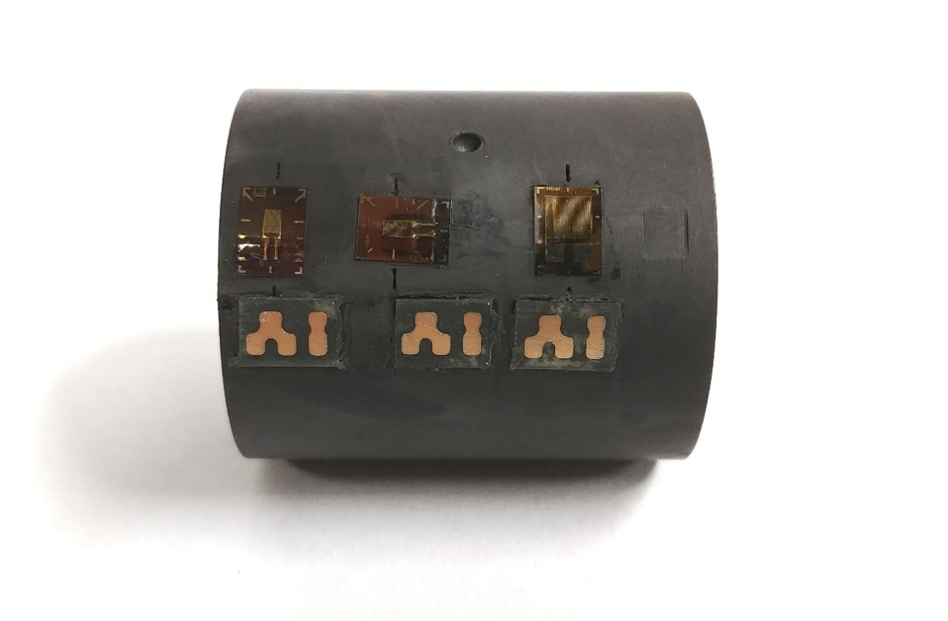
Figure 4: Photo of the practice slug. Pictured is the position of the soldering pads relative to the strain gauges, which are missing their leads here.
Soldering
Precision soldering was done by electronics technician Paula Lippert, in the Infrastructure and Support Department at Fermilab.
The leads from the circumferential and axial strain gauges are soldered to the two top sections of the solder pads. Two 36 AWD wires, which are not included on the temperature gauge, are soldered from the temperature gauge terminals to the solder pads. Three 28 AWD wires are soldered onto the bottom three sections of each soldering pad.
The 28 AWD wires are initially cut to be 3 feet long to accommodate temperature calibration measurements from the furnace used for curing the adhesive. 28 AWD wire was selected for the gauges because these will be soldered to a collection of 28 AWD connectors in a Burndy pin which will read out response data.

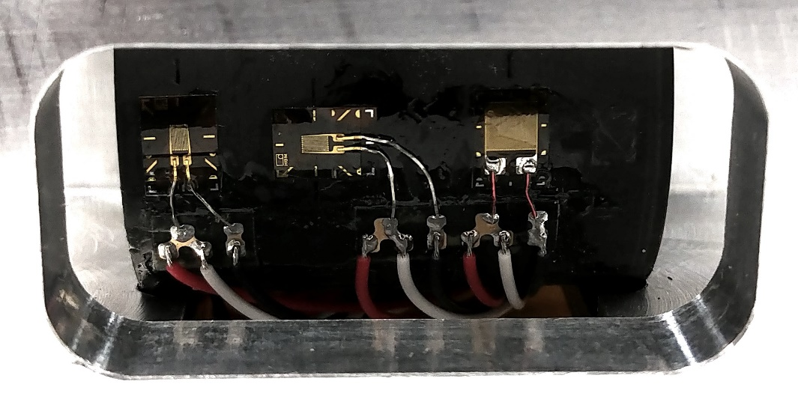
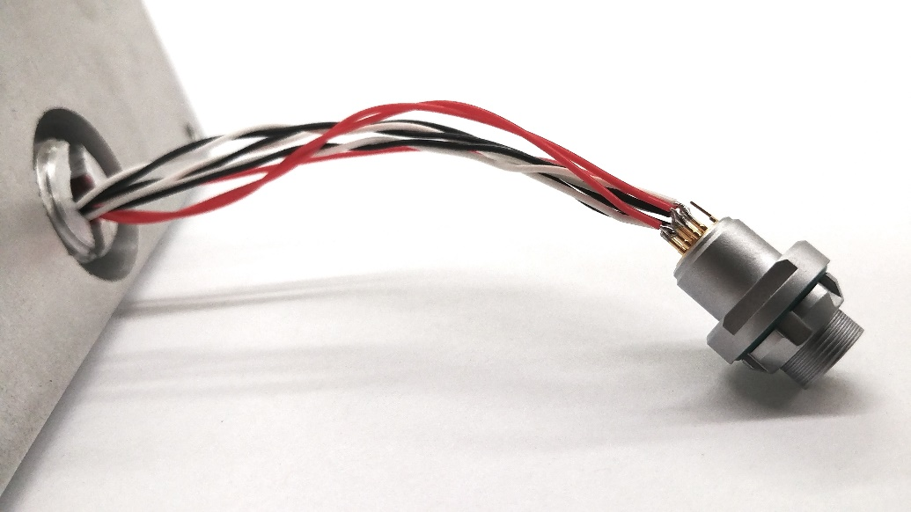
Figure 5: Finished work on the gauges and soldering pads (top), as well as the terminated ends of the cables (bottom). Pictured is the housing the graphite slugs fit into for the HRMT43 experiment, as well as the connector on the terminated cables for signal readout.
Relevant Resources
Micro Measurements Instruction Bulletin B-130
Strain Gauge Installations with M-Bond 43-B, 600, and 610 Adhesive Systems
http://www.vishaypg.com/docs/11130/11130B130.pdf
Micro Measurements M-Bond 610
Strain Gauge Adhesive for Stress Analysis and Transducer Applications
http://www.vishaypg.com/docs/11013/bond610.pdf
Micro Measurements Installation Tools and Accessories
General Information and Selection
http://www.vishaypg.com/docs/11021/insttool.pdf
HBM LY Linear Strain Gauges with 1 Measuring Grid
https://www.hbm.com/en/4561/ly-linear-strain-gauges-with-1-measurement-grid/
HBM TT-3/100: Sensor for Measuring Temperature
https://www.hbm.com/en/3070/strain-gauge-tt-3-temperature-sensor/

