g-2 design, realistic and observed muon flux
November 26, 2018
J. Morgan

Introduction
The Muon g-2 experiment at Fermilab began commissioning in Spring 2017, then resumed after the summer shutdown the following Fall. Over the past year since the last Accelerator Advisory Committee (ACC) Review in November 2017, there has been significant progress towards delivering the design muon flux to the experiment. However, due to a combination of factors in both the accelerator and g-2 Storage Ring, the muon rates observed by the experiment are about half of what was shown in the Technical Design Report (TDR). This document attempts to quantify the progress over the past year, while describing some of the challenges in measuring the delivered muon flux that is within the momentum acceptance of the g-2 Ring. There will also be comments about the simulations used in the g-2 TDR and how modern simulations differ and affect beam transport. There will also be a discussion of the programmatic constraints that reduce the number of cycles sent to g-2 when NOvA or the SY120 program are running.
Muon rate, Design Reports versus observed performance
The TDR for the g-2 experiment used a g4beamline simulation to calculate the muon rate in their storage ring. The simulation modeled the upstream beamlines, beginning at the Target Station (actually using MARS output from the Target Station) and included turns in the Delivery Ring for proton removal. However, the simulation ended after three turns in the Delivery Ring instead of four actually needed and did not include beam transport to the experiment or a vacuum window at the end of the beamline. The simulation did faithfully represent most of the vacuum chamber apertures along the beamlines, which had a design specification of a 40 pi-mm-mr acceptance (up from 30 pi-mm-mr for the original Antiproton Source).
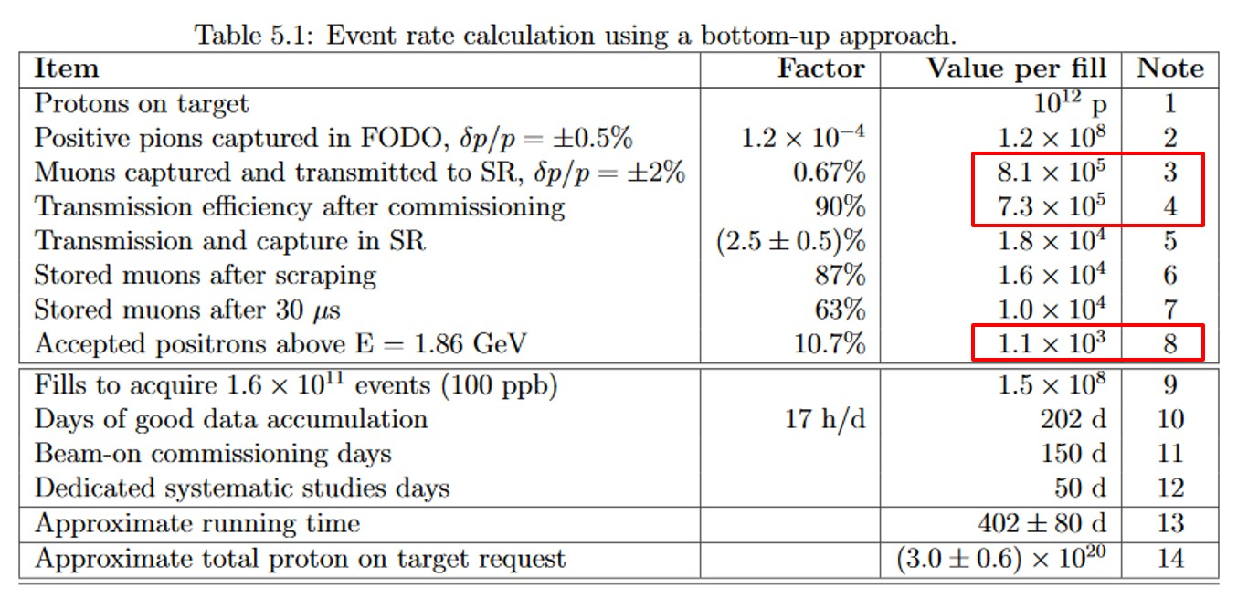
The design value for stored muons in the g-2 Storage Ring after 30 us is 10,000 per fill, or 120,000 per second (12 Hz cycle time). This corresponded to 1,100 positron decays above E = 1.86 GeV per fill (13,200 per second) by the experiment (see table from g-2 TDR below). This rate would allow the experiment to gather the desired 1.6 x 10¹¹ events within two years of operation, originally thought to be the available run time for the experiment. Another important calculated value from the TDR is the 8.1 x 10⁵ muons per fill delivered to the g-2 Storage Ring, which is useful for comparing the current simulation with the original used in the TDR. There is also a factor of 90% built into the TDR named “Transmission efficiency after commissioning” that was intended to account for the likelihood that all accelerator and g-2 Storage Ring systems would not be running at peak efficiency concurrently, leading to some loss of efficiency.
The rates shown in the g-2 TDR had a significant increase over those that were in the Conceptual Design Report (CDR), which used both a “top-down” and “bottoms-up” approach to calculating the expected rates. The top down approach scaled expected improvements at Fermilab versus the previous experimental run at BNL and generated calculated values of 6,000 stored muons per fill or 72,000 per second and 720 positron decays. The bottom-up approach was based on planned design features for the muon accelerator complex and arrived at a range of 2,800 – 6,600 stored muons per fill (33,600 – 79,200 muons per second) and 264 – 624 decay positrons per fill (3,168 – 7,488 per second). The difference in rates, in large part, was due to simulation parameters that weren’t optimized. Specifically, the target to lens distance (focal length) and beam spot size.
The beamline simulation used to calculate muon rates for the TDR did not properly represent several key restricting apertures, due to limitations in the geometries available in the simulation. Specifically, the asymmetrical upper aperture of Q303 which injected beam passes through, the injection, extraction and abort kickers and the extraction Lambertson were modeled as much larger apertures than they really are. Thus, the TDR beamline simulation arrived at a somewhat larger muon count at the experiment than modern simulations (which better represents the limiting apertures, but still exaggerates their size somewhat). Also the design rate of 12 Hz was not actually achievable due to programmatic constraints imposed by coexisting with the neutrino and SY120 programs. The actual maximum cycle rate possible when NOvA is running is 11.4 Hz, reduced to 10.4 Hz when SY120 is operating. The TDR also increased pion flux by 35% from the Target Station from what was shown in the CDR. This was based on a 20% increase due to incorrect assumptions on the Target to Lens geometry in the CDR model and a 15% increase from reducing the beam spot size on target from a sigma of 0.50 mm to a very ambitious 0.15 mm. The spot size reduction was challenging to achieve due to extremely low beta functions that are required, approximately .07 m in both planes!
The programmatic reduction in cycle time to the experiment translates to a reduction of 5% from the TDR rate of 120,000 muons per second to 114,000 muons per second. The reduced apertures in the modern simulation versus the one used in the TDR does not significantly reduce the number of stored muons predicted for the g-2 Storage Ring, only the total particle flux which is mostly made up of particles outside the momentum acceptance of the ring. The particles most likely to be lost on restricting apertures or in dispersive areas are already unlikely to reach the Storage Ring and be stored as they fall out of the momentum acceptance of the Ring. Although the goal is to meet and exceed the TDR rates for stored muons, it’s instructive to compare the observed muon flux to what was originally predicted in the TDR, as it provides an upper limit to what can actually be transported through the muon beamlines. The modern simulation that factors in the smaller apertures more closely represents the muon beamlines as specified, designed, built and operated.
The best performance, as measured by the g-2 Experiment, can be scaled from the recorded decay positrons per fill (shown as “Accepted Positrons… in the TDR). The largest number recorded for an extended period is 580, which is 53% of the design value of 1,100. This represents the combined performance of both the accelerator and g-2 Storage Ring. The predicted storage efficiency of the experimental ring was based on several key systems performing as designed, in particular the kickers and quads. Both of these systems have had issues that have been demonstrated to cause a reduction of storage efficiency. Most notably, the kicker strength has been weaker than designed and has a “ringing” field at the end of the pulse. Charging supplies were unable to reach full amplitude during the 10 ms interval between pulses and matching problems between the power supply and kickers resulted in the ringing waveform. The figure below shows the kicker waveform, which includes arrows to mark successive beam revolutions in the g-2 Ring. Ideally, the kicker pulse would be limited the first turn of beam and be completely off after that. The oscillating waveform on following turns causes steering kicks to the circulating beam, which in turn results in a loss of efficiency. The overall loss of storage efficiency can only be estimated and has fallen in the range of 20 – 35%. This implies that the stored muons per pulse in the g-2 Ring would have been in the 66% - 81% (580/1100 stored muons observed, increased by storage inefficiency) range if the storage efficiency would have been at design values. This percentage range provides our best estimate of the delivery of storable muons to the g-2 Ring, which can’t be directly measured.

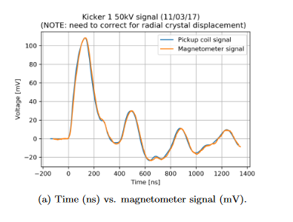
Measured beam intensity and estimated muon rate
The only quantitative instrumentation installed in the secondary beam path are ion chambers, which measure all charged particles that pass through them. In the M2 Line, M3 Line and Delivery Ring, protons dominate the particle mix being measured by the ion chambers. Muons only represent a small fraction of the beam measured by IC740, an ion chamber in the M3 Line located about 80% of the way between the Target Station and Delivery Ring. Ion chambers in the Delivery Ring suffer from the same problem of a proton-dominated beam mix. The situation is better in the M4 and M5 Lines, after proton removal in the Delivery Ring. However, there are still a significant number of positrons that are transported with the muons and must be accounted for in estimating the total muon flux (of all momenta) to the g-2 Storage Ring.
Measured beam intensity on IC740 has been about 90% of what is predicted in the modern simulation. About 5% of that can be attributed to a modestly larger spot size on target, 0.23 mm versus the TDR value of 0.15 mm. The source of the remaining 5% discrepancy between observation and simulation likely falls within the uncertainty of the beam model and ion chamber calibration. The TDR simulation predicted 8.1 x 10⁵ muons per fill within ±2% transmitted to storage ring, whereas the modern simulation has 5.2 x 10⁵ muons of all momenta per fill. However, the momentum acceptance of the beamline is slightly larger than ±2% and positrons are mixed with the muons in a ratio of approximately 60% muons to 40% positrons (as measured by the experiment during a lead foil study and estimated by an accelerator study). Taking these factors into account, the current simulation has 9.5 x 10⁵ total particles to the end of the M5 Line, as compared with a measured 5.8 x 10⁵ on IC025, the ion chamber at the end of M5 (61% of TDR). Since the muons outside the narrow momentum acceptance of the g-2 Ring are more likely to be lost on upstream beamline apertures, the measured 61% of the TDR muon rate delivered to the g-2 Ring represents the lowest possible accelerator performance. It’s likely that the storable muons efficiency is higher than that for all momenta, since their displacement is larger in dispersive areas in the beamline.
Muon rate, progress in past 12 months
In the fall of 2017, proton removal in the Delivery Ring had not yet been implemented, greatly limiting the amount of beam sent to the g-2 experiment. There is roughly a factor of 100 times more protons in the secondary beam entering the Delivery Ring than muons and other particles, so restrictions on the radiation levels in the MC-1 building limited beam delivery to approximately 0.3E12 per pulse to the production target - a rate of only 0.1 Hz (as compared to TDR levels of 1.0E12 per pulse and 12 Hz). Proton removal was commissioned in December 2017 and both the protons on target and pulse rate were increased steadily through the winter. By the end of February, the design intensity per pulse and pulse rate had been met (actually 11.4 Hz due to programmatic issues, as previously described).
The stored muons per pulse also increased through the fall and winter of 2017 due to efforts in both the accelerator and g-2 Storage Ring. Considerable tuning was required to improve Delivery Ring efficiency after proton removal was implemented, complicated by the limited diagnostics that can be used with the low secondary beam intensity. Yield from the Muon Target Station was improved by reducing the beam spot size, aided by physics support from the APC in improving the primary beam optics. Meanwhile, the g-2 experimenters had performed numerous kicker studies that demonstrated that the kicker system was not able to produce the design strength and was significantly reducing storage efficiency. They were able to improve the situation somewhat by pushing the kicker voltage as high as could be tolerated by the system, before sparking would occur. The performance plot shown below runs from December 1, 2017 to July 1, 2018 and shows the average protons on target in green and decay positrons in the g-2 Storage Ring (proportional to stored muons) in red. The plotted parameter that measured average protons on target was created in early April, and by then the per pulse intensity was already close to the design value of 1E12. The rapid increase in decay positrons during April was largely due to the g-2 kicker voltage being increased and the peak of 600 decay positrons (g-2 TDR has 1,100 for comparison) occurred in April when the g-2 kickers were run at their highest voltage. Due to component failures, however, the kicker voltage had to be reduced which explains most of the reduction in efficiency that followed. The kicker voltage clearly had a strong affect on g-2 Storage Ring efficiency.
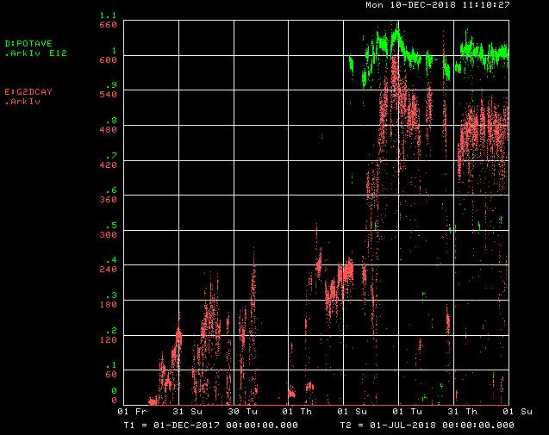

Plan to reach design goal of 112k - 120k muons per second
As already described, although the design rate in the g-2 TDR is 120k muons per second, the programmatic reduction in the cycle time from 12 Hz to 11.4 Hz reduces the practical design rate to 114k per second. The best performance to date as measured by the experiment, can be scaled from their observed decay positrons per fill, which is only 53% of what is shown in the TDR. The following improvements have been implemented or are planned for implementation after the g-2 experiment resumes operation.
Accelerator efficiency: Although difficult to quantify, the transmission efficiency of muons through the Muon Campus beamlines is less than what simulations show. Approximately 5% of the lost efficiency is due to the spot size on the target, which is larger than the ambitious sigma of 0.15 mm shown in the g-2 TDR. Considerable effort has been made to get the spot size as close to the design goal as possible, so this will be difficult to improve on. There is also an observed beamline optics issue in downstream M3 that causes the beam to be significantly larger than what is expected. Although this problem disproportionately affects particles that are outside of the narrow momentum width that can be stored in the g-2 Ring, it is likely some muons within the Storage Ring’s acceptance are lost as well. Accelerator optics studies and modeling indicate the problem stems from some combination of steering errors and/or alignment errors that are amplified through the regions designed to maximize muon transport. A thorough check of the alignment data is being performed (although early indications suggest that there are no major issues) and steering studies are planned to either improve performance or demonstrate that this isn’t the cause. Work towards improving accelerator efficiency will likely only provide a modest gain in performance, since considerable time has already been spent optimizing performance through tuning and accelerator studies.
The most promising improvement is expected to come from the Ionization Cooling Wedges, which were not part of the original accelerator design for g-2. The concept was developed by the Accelerator Muon Department and their Laboratory Directed Research and Development program (LDRD) proposal was accepted and funded. The Wedge devices take advantage of the wide momentum spread of the muons in the Delivery Ring and connecting beamline to the experiment, to increase the number of muons within the momentum acceptance of the g-2 Storage Ring. Wedge shaped material with the most favorable properties, presently polyurethane is the material of choice, are inserted in dispersive locations where the beam position is partly defined by the momentum of the particle. Higher momentum particles pass through more of the wedge material, shifting their momentum lower. Overall, more muons are shifted into the momentum acceptance of the g-2 Ring than are shifted out, but there is some loss in transport and storage efficiency due to scattering from these devices. Overall, simulations indicate that stored muons in the g-2 Ring will be increase by 20% or more when the Wedges are inserted. The Wedge assemblies (that can remotely insert or retract the Wedges) were installed during the summer shutdown and are ready for commissioning when beam operation resumes.
The vacuum window at the end of the M5 Line causes scattering and a loss of storage efficiency. The original vacuum window was found to be thicker than what was needed to satisfy the engineering requirements for windows at Fermilab. The original window was .08” thick Titanium, which was determined to be a factor of two thicker than what the engineering analysis required (including appropriate safety factors). A new vacuum window was fabricated with a thickness of .04” Titanium, which should be ready for installation prior to resuming routine beam operation to the g-2 experiment. Simulations indicate that the thinner vacuum window will increase stored muons in the g-2 Ring by 4 – 5%.
g-2 Ring storage efficiency: The g-2 experiment has spent considerable time and effort understanding how the shortcomings in kicker performance affects storage efficiency in their Ring. There is still some question about the actual loss of efficiency and whether the incoming bunch shape plays a significant role. The kicker primarily had two problems, the most serious being a lack of strength and a ringing waveform after the pulse. Improvements implemented during the summer, fall and early winter are expected to mitigate the lack of strength, by improving the charging power supplies, high voltage feed-throughs and several other component upgrades. The ringing waveform is not easy to address and will remain for now. The quads had improvements to the spacing and routing of their high voltage conductors within the vacuum chamber to reduce sparking. Quad sparking and related vacuum activity also affected kicker performance, so this improvement was needed to help the kickers too. Estimates for the reduction in storage efficiency due to the combination of kickers (less the ringing, which doesn’t have a solution at present) and quads range from 10 – 25%. Thus, gains from the fixes implemented to those systems over the past six months should be expected to fall in the 1.11 – 1.33 range (1/0.9 – 1/0.75).
Overall improvement: Improvement to the accelerator, g-2 kickers and quads are essentially independent from each other. Therefore, the expected improvements in stored muons to the g-2 experiment can be estimated by multiplying the individual scaling factors together. A factor of 1.2 is assigned for the Wedges, 1.045 for the vacuum window and a range of 1.25 – 1.54 for the g-2 Ring upgrades. Applying all of the factors to the current performance of 53% of the g-2 TDR, the expected rates will be 0.53*1.2*1.045*(1.11 to 1.33) or 74% to 88% of the g-2 TDR. In conclusion, the expected improvements should improve performance, but will likely fall short of the design rates by a significant amount, how significant depends on the assumptions of the gains from the g-2 Ring improvements. To make up the difference, additional improvement is most likely to come from either the M2/M3 optics issues that causes beam to grow or the Wedges offering a larger improvement than 20%, which may be possible with the proper optics matching in downstream M5.
Looking beyond the immediate running period, a new Inflector magnet is scheduled for installation during the summer shutdown. The Inflector produces a magnetic field that is equal in strength and in the opposite direction as the main g-2 Storage Ring field, so that injected beam passing through the Inflector passes through a region with minimal magnetic field. Without the Inflector, beam entering through the hole in the Storage Ring yoke would be strongly bent to the right and lost. The existing Inflector has substantial aluminum caps on each end, which cause considerable scattering of the incoming muons. Simulations show that the new Inflector would increase stored muons in the Ring by 40%, by far the most promising improvement from all of the proposed upgrades. It would also increase the muon rate to the g-2 experiment above the TDR rate.

